|  |  |
| --- | --- |
|  | **2014** |
|  | The Company  Martien Huijsmans |

|  |
| --- |
| **[Build Environment** |
| Installation and configuration of Gerrit |

Inhoud

Introduction 2

Installation 2

Staring Gerrit 2

Configuration 2

Add a project 2

Delete a project 3

Testing 3

Gerrit Tutorial 3

# Introduction

Home page: <https://code.google.com/p/gerrit/>

# Installation

Instruction for enterprise setup: <https://gerrit-documentation.storage.googleapis.com/Documentation/2.8.2/install.html>

Instruction for quick setup: <https://gerrit-documentation.storage.googleapis.com/Documentation/2.8.2/install-quick.html>

Updated port in config file  
$ nano ~/gerrit_site/etc/gerrit.config

Also changed [auth] to type= OPENID, because that only works with public IP-hostname.  
Used: type = DEVELOPMENT_BECOME_ANY_ACCOUNT

I added user: Martien Huijsmans  
with username: martien  
ssh key was generated before and under windows was located at  
C:\Users\mahu\.ssh  
in file: id_rsa.pub

# Starting Gerrit

$ sudo su gerrit2  
$ ~/gerrit_testsite/bin/gerrit.sh start

Ref: <https://gerrit-documentation.storage.googleapis.com/Documentation/2.8.2/install-quick.html>

# Configuration

## Add a project

Opened a Git Bash shell on windows

Created project in gerrit as described in Quick setup.  
I has already an existing project in GIT.  
$ ssh <user>@guestserver.com -p 29418 gerrit create-project --name <name-project>  
Note: guestserver.com is defined in windows hosts file and has as ip-address, the ip address of the VM.

Above command can be given any directory.  
For next command I went into the <name-project> dir with the .git repo.  
Next entered command:  
$ git push ssh://<user>@guestserver.com:29418/<name-project> *:*   
This generated following output:

Counting objects: 25, done.  
Delta compression using up to 4 threads.  
Compressing objects: 100% (10/10), done.  
Writing objects: 100% (25/25), 1.98 KiB | 0 bytes/s, done.  
Total 25 (delta 1), reused 0 (delta 0)  
remote: Resolving deltas: 100% (1/1)  
remote: Processing changes: refs: 2, done  
To ssh://<user>@guestserver.com:29418/TestApp3  
 * [new branch] master -> master  
 * [new branch] gs/master -> gs/master

After this command the project <name-project> became visible in Gerrit.  
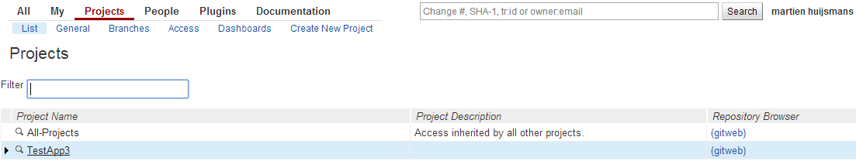

## Delete a project

Apparently no good support today, so flow

* Ref: <http://stackoverflow.com/questions/8723716/in-gerrit-how-to-delete-a-project>
* Delete the git repo for the project
  + $ Sudo su gerrit2
  + $ cd (home)
  + $ rm –rf gerrit_testsite/git/<project.git>
* Restart GerritServer

## Testing

In LUNA (Eclipse RCP course) I installed M2E and the connectors for SVN and EGIT.

Used URL, whichpoints to GIT server.  
ssh://<user>@guestserver.com:29418/<name-project>

# Gerrit Tutorial

<http://www.eclipsecon.org/2013/sites/eclipsecon.org.2013/files/Deploying%20Gerrit%20Code%20Review.pdf>