|  |  |
| --- | --- |
|  | **2014** |
|  | The Company  Huijsmans, Martien |

|  |
| --- |
| **[Rundeck]** |
| Installation, configuration and management |

Inhoud

Installation 2

Rundeck core 2

Jenkins Rundeck 2

Rundeck Plugins 3

Configuration 3

Starting Rundesk 3

Getting started 3

Created first project 3

Created First Job 3

Understanding Rundeck 3

Management 4

# Installation

## Rundeck core

http://rundeck.org/ , an open source workflow engine

Used: <http://rundeck.org/downloads.html> and used the Debian/Ubuntu install.  
$ dpkg -i rundeck-2.1.1-1-GA.deb  
See starting.

## Jenkins Rundeck

I want a Jenkins built to trigger Rundeck to schedule a Job. For this I installed the Rundeck plugin in Jenkins.  
Next I configured the Plugin settings under: Jenkins -> Manage Jenkins -> Configure System  
I set URL (http:/localhost:4440, which is the rundeck default URL), user/psw and tested the connection.

Next turned to this which describes integration of Jenkins and RunDesk.  
<https://wiki.jenkins-ci.org/display/JENKINS/RunDeck+Plugin>

* JobId has to be UUID of the job in RunDeck  
  When the correct UUID has been entered, Jenkins-Rundeck plugin will display something like:  
  Your Rundeck job is : <uuid> [project-name] job-name.  
    
  Note: Jenkins also shows for a project the involved plugin’s.  
  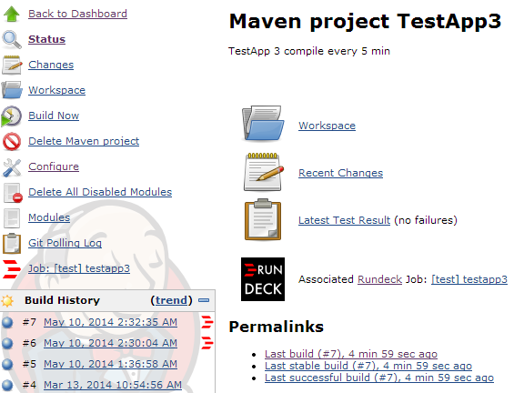  
  Note: This makes it hard to maintain.  
  Note: here is a discussion about rationale and some freethinking: <https://groups.google.com/forum/#!topic/rundeck-discuss/GaRoFkxOgfg>
* I didn’t use a SCM tag, but it allows to control (and register in SCM) from SCM which builds start a RunDeck Job.

Source code. It easy to read.  
<https://github.com/vbehar/jenkins-rundeck-plugin>

## Rundeck Plugins

# Configuration

Getting started: <http://rundeck.org/docs/manual/getting-started.html>

# Starting Rundesk

If rundeck is not running (visit <http://localhost:4440> to check this).  
$ service rundeckd start  
Default user/psw after install is: admin/admin

# Getting started

## Created first project

First step is about. I just entered a name and pressed create.   
I did not fill in all fields, which felt strange. Are they optional ? Confusing.  
Why is there no default set?  
SSH key-storage is something that SSH needs. Leaving it open is strange.

A project has

* A name
* Uses SSH to run commands remote
* Uses SCP for transfers of data

## Created First Job

But how to get a value from Jenkins  
<http://guestserver.com:8080/plugin/rundeck/options/artifact?project=TestApp3&build=lastSuccessful>   
It works, but the answer is []  
The parameter build can be lastSuccessful, lastStable or an integer(build-number).

# Understanding Rundeck

## What is local for Rundeck

Job that was executed locally with following command  
$ pwd;whoami   
returns   
> /var/log/rundeck  
> rundeck

## Nodes

Although Nodes exists as a menu option, there is a supported in GUI to add nodes. You need to edit xml.files.  
ref: <https://groups.google.com/forum/#!msg/rundeck-discuss/UTLBGyDigPw/hWbyM4dhzGYJ>   
Nodes are also defined on a per project basis  
I edited the project specific resources file mentioned at project configuration page (see below) and added a node.  
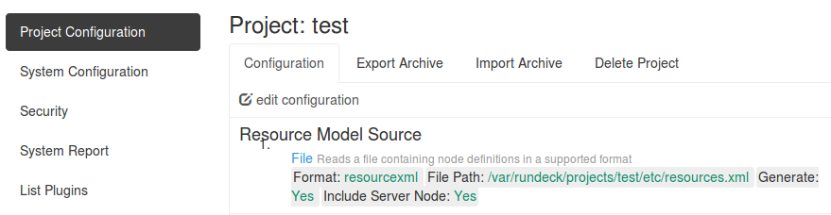

The updated config file looked like this:  
  
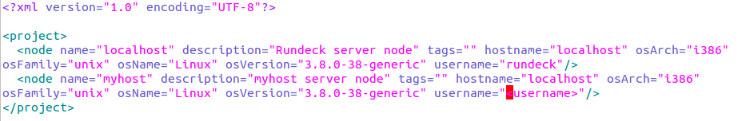

Next I open a shell to test that I can login without using a password to the target server. I fixed any issued. For details, see Ubuntu.doc for how.  
Then I copied the id_rsa (with the private key) file the place mentioned at the project config page.  


# Management

todo