|  |  |
| --- | --- |
|  | **2014** |
|  | The Company  Huijsmans, Martien |

|  |
| --- |
| **[Wildfly]** |
| Installation, configuration and management |

# Installation

downloaded wildfly from: <http://wildfly.org/downloads/>   
Unzipped to c:\myPrograms  
Read readme.txt

## Starting the first time

$ cd C:\MyPrograms\wildfly-8.1.0.CR1\bin  
$ standalone.bat

Open webbrowser and goto: http:localhost:8080.  
You will see an EAP6 console.  
Select “administration console”  
That open a new webpage that tell to define a user.

$ add_user.bat  
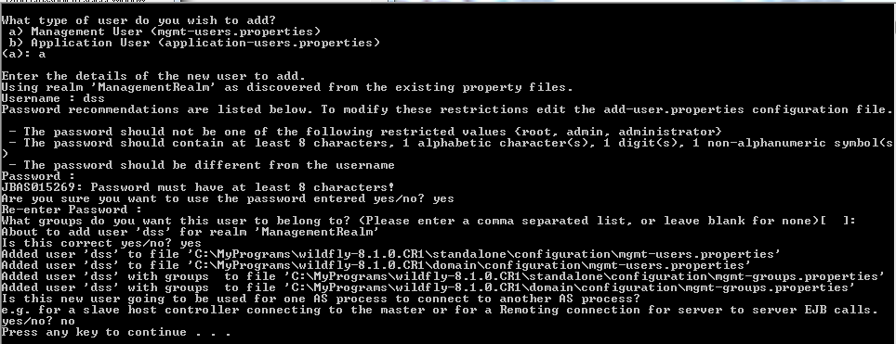

Open: there was a question on “groups that user shall belong to”. Unclear.