Osmosis   
with   
Red Blood Cell   
  
a Scratch-based Learning Unit

**Manganaro Clizia Giorgia**

**2017897**

Course of Methods in Computer Science Education: Analysis

A.Y. 2022/2023

# Introduction

The purpose of this report is to describe and demonstrate the building of a Learning Unit using *Scratch,* having the objective of teaching the phenomenon of osmosis in eukaryote cells. In that case red blood cells will be used as an example.

# Prerequisites and Class

## This Learning unit is aimed at a class of high school students during natural science lessons. More precisely, in a third year of scientific high school (ind. “*scienze applicate”*).

## As a result of ministerial programs, students in the natural sciences classes will have to learn the discipline knowledge and methodologies typical of earth sciences, chemistry and biology.

In fact, for this unit of learning will be necessary knowledge of chemistry and biology as it will focus on the phenomenon of osmosis in eukaryotic cells.

The focus will be on the measurement of osmotic pressure. Consequently, it will be crucial to have a well-established base on certain chemistry topics.

The **chemistry** topics required to carry out the work are:

* The mole: the chemistry unit
* The molar mass: a quantity of practical use
* Formula and composition of a compound:
  + the percentage composition
  + minimum formula of a compound
* Solutions: solute and solvent
* The molarity
* The molality

Regarding the **biology** topics required to build the teaching unit, we find: the cell definition, the structure of cell membranes and the ways in which the cell carries out the transport of substances entering and leaving.

The **computer science’s prerequisites** are: knowledge of loop functions, if-then-else construction, variables, assigning variables.

# Learning Objectives and motivations

Through the learning unit, students will have basic knowledge of scratch, block-based programming style, the concept of event, messages passed through a parallel calculation and learn the structure of a program.

On the biology side, have understood that living beings follow the same physical and chemical laws that govern the inanimate world and have learned the phenomenon of osmosis as diffusion of water molecules from a region with higher water potential to a potential region lower water through partially permeable membranes.

From a chemical point of view, the student will have understood and analyzed the osmotic pressure and the effects that the cell undergoes as the relationships of solute and solvent change. They will also have understood the concept of osmotic pressure in biological-medical field.

The guidelines that will be given to students are as follows:

*“Using the scratch system that you studied during the course, you will have to simulate the phenomenon of osmosis in a eukaryotic cell, in red blood cells. The first step you will have to carry out is to create an isotonic saline solution with respect to the fluid present in the cell (i.e., a physiological saline solution with a concentration of 0.9% NaCl, i.e., 9 gr/l). Finally, with the aim of showing the effects of osmosis on the cell, it will be necessary to calculate the osmotic pressure of the solution as the amount of solvent and solute varies.”*

Formulas and data given:

* Osmotic pressure: $π=RTMi$ where:
  + R= ideal gas constant (0.821 (l*atm)/(mol*K))
  + i = van 't Hoff index (take in mind that in NaCl is equal to 2)
  + M =molar concentration of solute
  + T = temperature in Kelvin (take in mind that you can convert the temperature from Celsius in Kelvin by adding 273.15)
* Molar concentration: $M=\frac{n}{v}$ where:
  + n = moles of solute
  + v =liters of solution
* moles of solute $n.moles=\frac{mass}{Mm}$ where:
  + mass = mass of solute (gr.)
  + Mm= molar mass of solute (NaCl=58.44 g/mol)

Nb. Assuming a temperature equal to 37°

# Structure of the lectures

The learning unit will be delivered during the last month of the third year. In fact, students at the end of the year will have acquired the necessary skills in both computer science, chemistry, and biology to carry out the project.

Three lessons will be needed to explain the Scratch environment and in the 4th lesson the students will be given the project assignment that they will have to carry out during school hours. In total there are 8 lessons scheduled for the entire Learning Unit.

During the sixth lesson the students will be asked to show the work done to receive feedback. The last lesson will be needed to show the project and make the final revision and give them the marks.

# Evaluation Grid

|  |  |
| --- | --- |
| **Description** | **Marks** |
| The student has learned all the interdisciplinary concepts concerning chemistry, biology, and computer science.  Performed all the calculations correctly and applied the formulas correctly.  Knew rigorously how to implement the concept of event through the broadcasting and receiving of messages | Well done |
| The student completed the work assigned despite some inaccuracies in the conversion of the formulas and in the development of the code. | Good |
| The student has incomplete or partial knowledge of the topics. Performed the work without considering the changes in cell state caused by the increase in solute and solvent. | Sufficient |
| The student does not have full knowledge of the topics. Did not get the project done properly, did not understand the use of messages, events, did not implement the formulas. | Insufficient |

# Development

1. 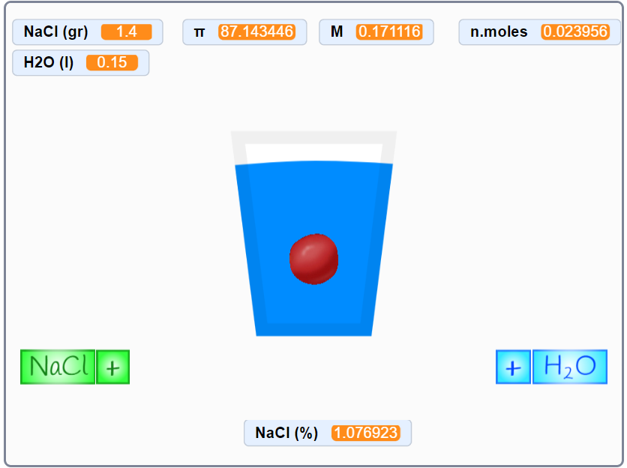**Optimal solution**

Nella soluzione ottimale lo studente ha scritto un codice modulare, commentato e con il corretto passaggio di messaggi ed eventi tra gli sprites.

Ha considerate inoltre i casi limite. Ha compreso appieno gli argomenti spiegati e ha implementato nel modo corretto l’effetto dell’osmosi sulla cellula al variare della pressione osmotica, pertanto è stato effettutato il controllo del passaggio tra soluzione isotonica, ipertonica e ipotonica

1. **Sufficient Solution**

Nella soluzione sufficiente lo studente non ha utilizzato lo scambio di messaggi tra gli sprites. In particolare per ciò che concerne l’aggiunta di NaCl di H2O nella soluzione.

Inoltre lo studente non ha considerato l’effetto dell’osmosi nella cellula.

Tutte le formule sono implementate in modo corretto o parzialmente corretto.

L’implementazione del codice risulta quindi più semplice e meno modulare.