SIO 229 Geomag Homework #2

1.

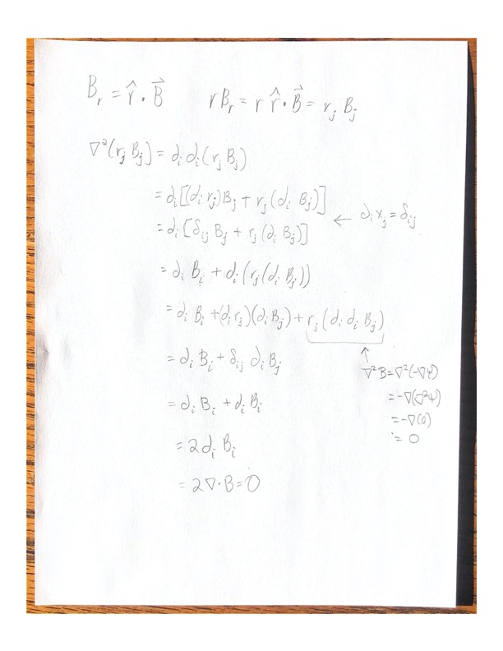

2a)

For all of problem 2, the code is in the appendix and sectioned off per question.

I set up the data vector to be d = [x1, … , x1,y1,… ,y11, z1, … ,z11]T.

2b)

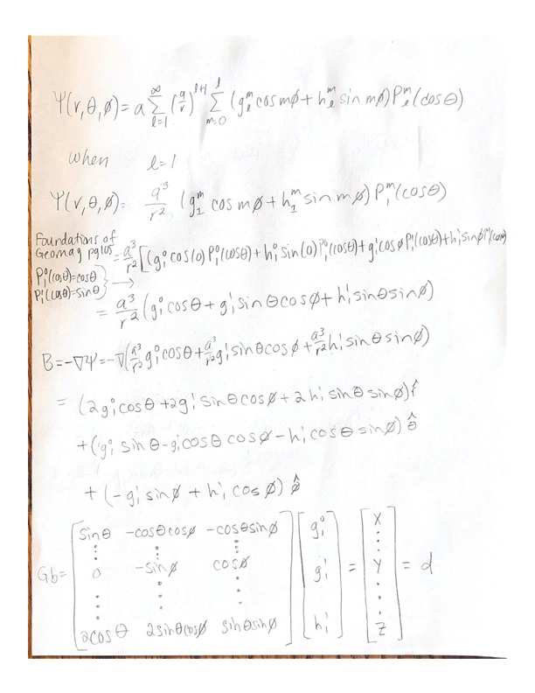

Let r =a

2c)

2d)

GTG:

GTd:

(GTG)-1:

2e)

The Gauss coefficients were g10 = -28253 nT, g11 = -3976 nT, and h11 = 4480 nT.

I used matlab’s inverse function \, where b = G\d.

2f)

The 2020 IGRF coefficients are g10 = -29404 nT, g11 = -1450 nT, and h11 = 4652 nT.

In comparing the 2020 IGRF and the calculated coefficients I used the percent error.

The error was 3.9%, 174%, and 3.7% for g10, g11, and h11, respectively. My results for the g10 and h11 coefficient are in the same range, but the g11 coefficient is not. Considering the magnetic dipole dominates the field, g10 and h11 make sense but g11 does not. There could be an error with my g11 coefficient, which likely came from the G matrix.

2g)

Figure 1: The magdata_2020 station location for longitude and latitude

The results do depend on the data distribution. First, the G matrix is built off of the latitude and longitude locations. Figure 1 shows the data location distribution and it’s fairly spread out. The data location distribution is more important than the amount of data because we’re trying to calculate the longest wavelength. There would be more error if we only used data clustered in North America compared to the rest of the world.

2h)

The approximate size of the error would be 0.34% from the flattening f ~ 1/298.257.

3)

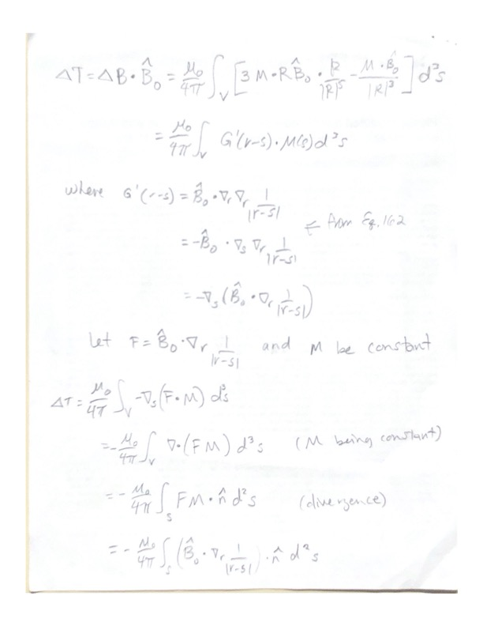

4)

H is the magnetic field intensity with M being the magnetic dipole moment. g is the gravitational force.

Assuming a constant density and magnetization direction throughout the body, both the magnetic field intensity and gravity can be related through the distribution of the body volume. The relationship is given below where α is the magnetic direction.

The big assumptions are constant density and uniform magnetization. On a first order approximation the Poisson’s relationship might be ok to use but the assumptions are rarely the case.

Reference:

Bocchio, F. (1998) On some implications of the Poisson relation. *Geophys. J. Int*. 133, 207-208

MATLAB CODE:









