报错

|  |
| --- |
| java.lang.NoClassDefFoundError: org/apache/flink/api/common/functions/FlatMapFunction  at java.lang.Class.getDeclaredMethods0(Native Method)  at java.lang.Class.privateGetDeclaredMethods(Class.java:2701)  at java.lang.Class.privateGetMethodRecursive(Class.java:3048)  at java.lang.Class.getMethod0(Class.java:3018)  at java.lang.Class.getMethod(Class.java:1784)  at sun.launcher.LauncherHelper.validateMainClass(LauncherHelper.java:544)  at sun.launcher.LauncherHelper.checkAndLoadMain(LauncherHelper.java:526)  Caused by: java.lang.ClassNotFoundException: org.apache.flink.api.common.functions.FlatMapFunction  at java.net.URLClassLoader.findClass(URLClassLoader.java:382)  at java.lang.ClassLoader.loadClass(ClassLoader.java:424)  at sun.misc.Launcher$AppClassLoader.loadClass(Launcher.java:349)  at java.lang.ClassLoader.loadClass(ClassLoader.java:357)  ... 7 more |

|  |
| --- |
| <dependency>  <groupId>org.apache.flink</groupId>  <artifactId>flink-streaming-java</artifactId>  <version>${flink.version}</version>  **<scope>provided</scope>**  </dependency> |

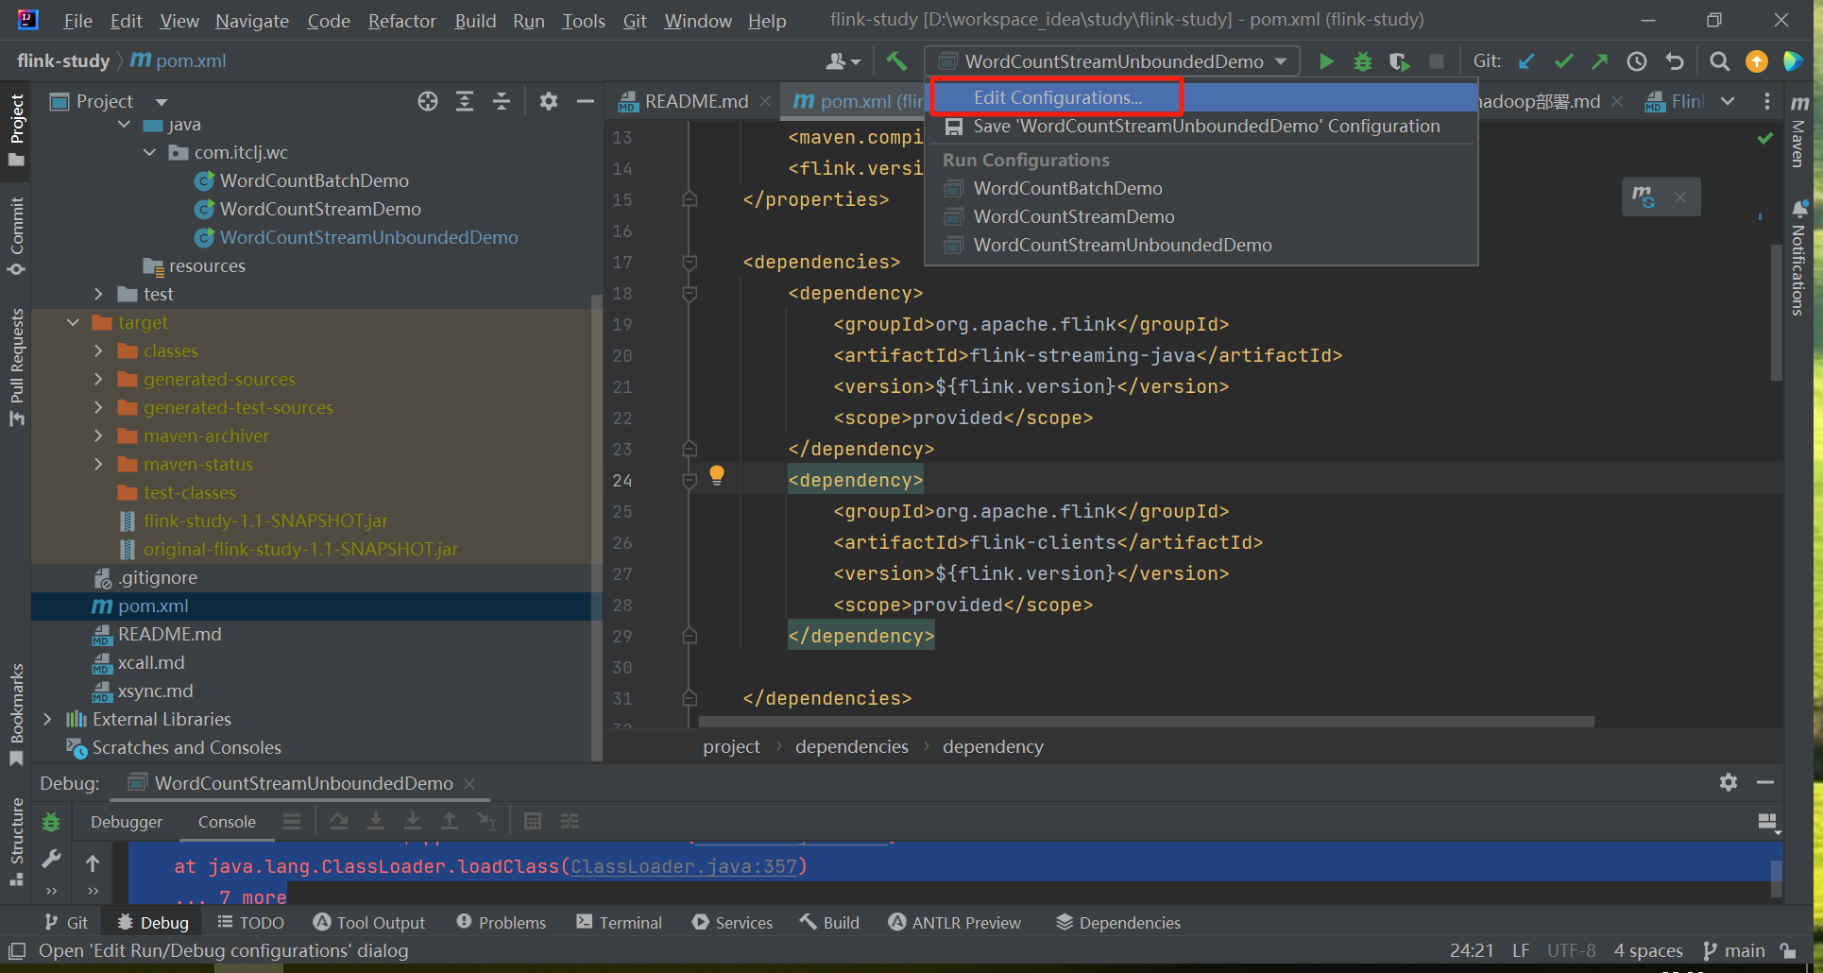

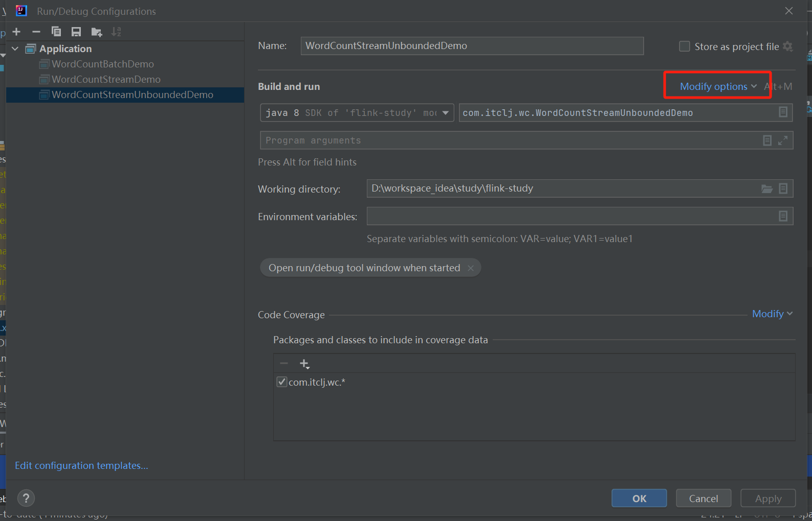

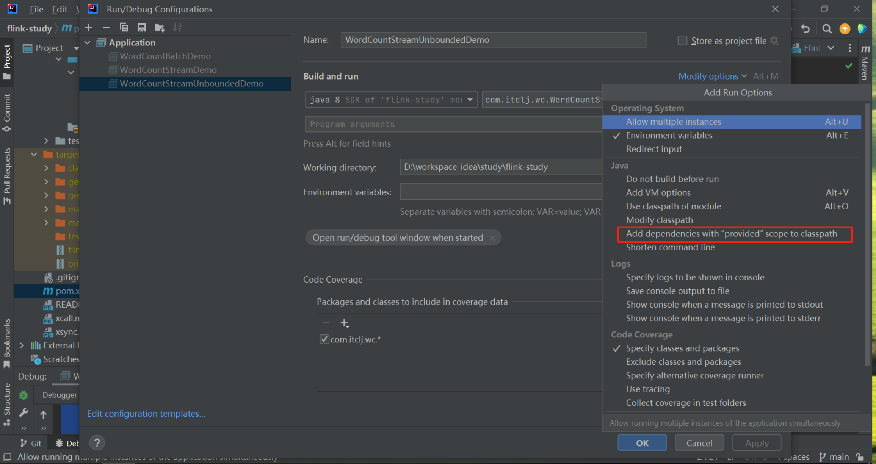

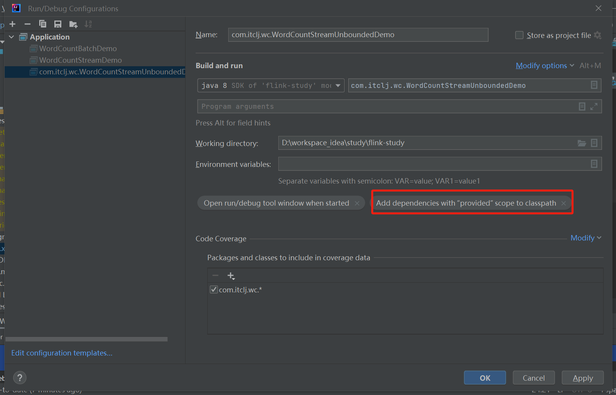

默认自动导入

