Supporting Information for
‘Depths in a day - A new era of rapid-response Raman-based barometry using fluid inclusions’

Charlotte L. DeVitre^{1*}, Penny E. Wieser¹, Alex Bearden¹, Raela Richie¹, Berenise Rangel¹, Matthew Gleeson¹, John Grimsich¹, Kendra Lynn², Drew Downs², Natalia Deligne² and Katie Mullike²

*Charlotte L. DeVitre
Email: cl.devitre@gmail.com


ORCiD (CLD): 0000-0002-7167-7997


ORCiD (KJL): 0000-0001-7886-4376


ORCiD (DTD): 0000-0002-9056-1404

ORCiD (NID): 0000-0001-9221-8581

Contents of this file

Text S1 to S8
S1. Sample collection and preparation
S2. Raman analyses
S3. Epoxy mount making and polishing.
S4. EDS analysis
S5. Identifying and resolving bottlenecks
S6. Effect of H₂O on calculated pressures
S7. Sensitivity of the EOS method for FI to entrapment temperature – Extended
S8. Global melt inclusion compilation

Figures S1 to S9

Additional Supporting Information (Files uploaded separately)

Data S2 and S3:
S2 is the fluid inclusion dataset
S3 is the global melt inclusion compilation
S4 FI Navigation image compilation

All other raw data (spectra, metadata, FI images) as well as raw Jupyter processing notebooks can be found on a Github repository (https://github.com/cljdevitre/RapidresponseFI_Kilauea_Sept2023) which will be archived at Zenodo upon acceptance.

Text S1. Sample collection and preparation

Tephra samples (USGS code KS33-588) representing the first ~14 hours of the September 10, 2023, eruption of Kīlauea were collected by U.S. Geological Survey Hawaiian Volcano Observatory (HVO) geologists on September 12 and shipped on Friday September 15 at ~5 pm HST (Fig. S1). This tephra was erupted from a fissure which opened at 15:36 local time on September 10 (~22 minutes after the eruption started, between 15:13 and 15:14 local time) and ceased erupting between 06:16 and 06:18 am local time on September 11. Following receipt of the samples at the University of California (UC), Berkeley, on Tuesday September 19, material was processed in a jaw crusher in the VIBE lab, which was thoroughly cleaned the week before and the morning of the simulation, and then sieved into >2, 1–2, and 0.5–1 mm size fraction. Crystals were picked from the 1–2 and 0.5–1 mm size fraction using three different binocular microscopes (one of which had the ability to cross polars). Then, crystals were individually mounted in CrystalBond™* on glass slides and progressively polished with 1200-2500-10000 grade wet and dry paper to find fluid inclusions (FI). Grains containing FI were then passed onto a team member on a research-grade microscope to take reflected and transmitted light images to aid with Raman navigation. These images were pasted into a Google slides document so all lab personnel at UC could access them immediately (images are compiled in supplement S4 FI Image Compilation as an example).
A lava flow sample (USGS code KS33-587) was collected in a molten state and quenched with water at 6:30 AM HST on the 11 of September 2023. The sample was entirely glassy, and fragments were mounted in a 1” epoxy round and polished for microprobe analysis.

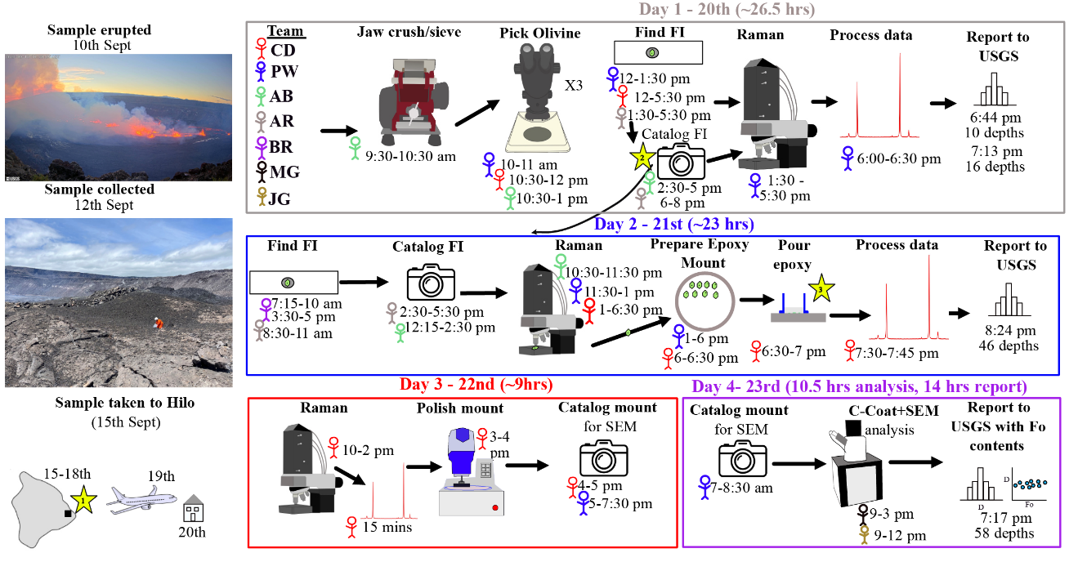
Figure S1. Workflow of the study, all times on this figure are Pacific Standard Time (PST). Stick people show the contribution of individual team members, to indicate the total time associated with each step. We note that AB was trained in these procedures during the simulation and all reports were sent to the USGS Hawaiian Volcano Observatory (HVO) prior to 5:30 pm Hawaii Standard Time (HST), thus allowing for decision-making for the following day.

Text S2. Raman analyses
Raman spectra were acquired using a WiTec Alpha 300R Raman spectrometer at the Department of Earth and Planetary Science at the University of California, Berkeley. The relationship between CO₂ density and spectral features was determined from a gas calibration cell following the methods of DeVitre and Wieser (2024). All spectra were acquired from samples heated to 37 ℃. Spectra were processed and corrected for drift using the Python tool DiadFit v0.0.73 (Wieser and DeVitre, 2024). We report ratios of SO₂ to CO₂ peak areas. We filtered the final dataset for SO₂/CO₂ ratio < 0.22 (Fig. 1d) to ensure use of the pure CO₂ EOS was valid (given an instrumental efficiency of 1 for our Raman, this corresponds to <10 mol% SO₂). No fluid inclusions contained carbonate peaks nor any gaseous species other than CO₂. We calculated densities from the Raman-measured separation of the Fermi diad using the appropriate calibrated density equations for our instrument in DiadFit v.0.073 (Wieser and DeVitre, 2024). For the final dataset (Day 4), we took a mean of duplicate analyses, and calculated pressures using the EOS of Span and Wagner (1996) using an entrapment temperature estimated from the Fo content close to the FI (DeVitre and Wieser, 2024). Entrapment depths in Fig. 1 were calculated using a constant crustal density of 2300 kg/m³ and a normally distributed 1σ error of 100 kg/m³. Error in the CO₂ density for each FI was determined from the error in each peak fit, the Ne line drift correction model, and the densimeter (Wieser and DeVitre, 2024). We used a 40℃ error for temperature (DeVitre and Wieser, 2024). We propagated these three sources of uncertainty in FI depths using Monte Carlo simulations implemented in DiadFit v0.0.73. We later recalculated pressures using the EOS of Duan and Zhang (2006) implemented in a newer version of DiadFit (v.0.0.85) to assess the effect of XH₂O on our results (Fig. 1d “H₂O effect” histogram). Further details can be found in section S6 of this supplement (“Text S6. Effect of H₂O on calculated pressures”). In total we analyzed 62 FI hosted in 31 olivine crystals. Our workflow is detailed in Fig. S1. Pictures of each FI and host crystal are available in the repository linked at the beginning. We note here that the initial data reported for days 1 and 2 did not account for repeated analyses (1 repeated FI in Day 1 and 6 in Day 2; we took a mean of repetitions on Day 4), pressures were calculated using an estimated entrapment temperature of 1150˚C (Wieser et al., 2021; DeVitre and Wieser, 2024), and depth was calculated using the crustal density model in Ryan (1987) and Lerner et al. (2021).

Text S3. Epoxy mount making and polishing

After Raman analysis, crystals were removed from CrystalBond^{TM*} using a hotplate and placed in acetone. They were then mounted on double-sided sticky tape with their polished side down. EpoFix^{TM*} resin was used to impregnate the samples in a Cast-N-Vac vacuum pourer. After curing, the epoxy mount was polished using an EcoMet30 automatic polisher, with 9, 3, and 1 µm diamond pastes. A reflected light map and image of each crystal was taken using the Raman microscope to aid SEM sample navigation. The location within each FI in the reflected light image was cataloged so the scanning electron microscope (SEM) operator knew where to analyze to obtain an approximate Fo content for each FI.

Text S4. EDS analysis

Samples were carbon coated to an approximate thickness of 25–30 µm for EDS analysis. Chemical data for each host crystal in the proximity of each FI were determined using a Zeiss EVO MA-10 SEM and a single AMETEK EDAX 10 mm² detector at the University of California, Berkeley. The beam was rastered over a 30-by-30 µm area for ~75–80s (a live time of 60 seconds with ~30% dead time). For all analyses we used an accelerating voltage of 20 kV and a 30 µm aperture, giving an approximate beam current of 5 nA. EDS data reduction was performed using an in-built standardless quantification routine (including a ZAF matrix correction), alongside pre-determined “Standardless Element Coefficients” (SECs). The SECs act as correction factors for each element in the standardless quantification routine and have been determined through several years of repeat analyses of multiple different silicate standard materials and glasses. This method returns an estimate for the relative abundance of each element in the analyzed material and, if a normalization to 100% is assumed, can be used to return semi-quantitative chemical analysis of elemental or oxide weight percent values. However, for the purposes of this study we simply focused on the relative abundance of Mg and Fe in the EDS analyses to calculate the Fo content of the olivine host crystals. Furthermore, by calculating the molar Si/(Mg+Fe) ratio of each analysis we were able to provide a stoichiometric check of data quality: we obtained an average Si/(Mg+Fe) ratio of 0.497±0.006 on Kīlauea olivine crystals, close to the ideal value of ~0.5. Precision and accuracy were determined through repeat measurements of the San Carlos and Springwater olivines, which were not used as part of the standard quantification routine. We estimate the precision and accuracy of the method using repeat analyses of secondary standards (5 at start, 5 at end of day), which have Fo contents similar to our samples (see supplementary dataset S3). The Smithsonian-preferred Fo content (Jarosewich et al., 1980) for the San Carlos secondary standard is 90.2 mol% Fo, and we obtained a mean of 89.84±0.07 mol% Fo. For Springwater, the preferred value is 82.4 mol% Fo, and we obtained a mean of 82.1±0.2 mol% Fo. We also analyzed a Kīlauea olivine crystal previously measured on the USGS Menlo Park EPMA. The average Fo content obtained at Menlo Park was 87.8±0.1 mol% Fo, and at the University of California, Berkeley, SEM, 88.5±0.1. Notably, such offsets also exist between different EPMA labs (Wieser et al., 2023b). Considering these probable differences, we compared data acquired at Stanford University to that obtained at Cambridge University on the olivine crystals of Wieser et al. (2021). The difference observed amounts to ~0.62 mol% at Fo~82 and 0.78 mol% at Fo90 (DeVitre and Wieser, 2024). Thus, EDS errors are within uncertainty of offsets between different microprobe labs.

Text S5. Identifying and Resolving Bottlenecks

The yellow stars on Fig. S1 identify current bottlenecks in the process that could be easily improved. We note that the first version of this manuscript was submitted to a journal for review on September 27th, 2023, one week after sample receipt.

Star 1 – Shipping and receiving samples

Distributing samples to the University of California, Berkeley was not a top priority for HVO because this simulation was being attempted for the first time, and as such, there was no guarantee of obtaining magma storage depths in a timely manner. Samples were shipped from Hilo on a Friday at ~5 pm HST. HVO was asked to ship samples to a private residence under the assumption that they might arrive over the weekend. However, no packages leave Hilo after 4pm on Friday over the weekend, so the samples started their transit to California on Monday. Had the package been taken to the courier’s office on Friday morning, it would likely have arrived on Sunday. The tracking information indicated arrival on Wednesday, which is when we planned to start the simulation. However, the samples arrived at the private residence on Tuesday morning during working hours, without notification that the package had been delivered (and no one was home).
We have demonstrated that this technique adds valuable quantitative depth information that expands on HVO’s routine near-real-time chemical monitoring with bulk rock ED-XRF (Gansecki et al., 2019). Under ideal circumstances, HVO geologists would sample tephra or molten lava from the eruption on Day 1 (morning) and dry the samples in the lab on Day 1 (afternoon), dropping the samples for shipment on the evening of Day 1, which would go out early on Day 2 (as long as the drop-off did not occur Friday afternoon or over the weekend). Same-day shipping from Hawaii to California is not realistic, but samples shipping Monday through Thursday mornings would allow for arrival on Day 3. Additionally, it would be possible to get samples to the University of California, Berkeley, within 24 hours if someone in Hawai’i were to take a flight to San Francisco or Oakland airport with the samples, or within ~30 hours if someone based in the University of California, Berkeley, flew to Hawai’i, picked up the samples, and returned home immediately.
We note that this bottleneck can be avoided entirely if observatories rely on local research expertise (for example, in collaboration with local academic research groups) and/or establish in-house workflows for this type of work. In such a case, next-day information could readily be obtained. As this is not an option for HVO, the Hawaii-California connection will serve as the fastest way to conduct this rapid-response barometry.

Star 2 – Sample cataloging

The WiTec Raman microscope used in this study does not have a condenser in its optical path, which can make it difficult to navigate and find FIs directly, particularly in volcanic crystals that are commonly coated in glass. The first 7–10 crystals were analyzed immediately after preparation with no navigation photos, so finding the FI on the Raman scope added some time. After AB had finished crushing, sieving, and picking, he began taking photos on a research-grade microscope to help the Raman operator find the FIs they were supposed to be analyzing. Late on Day 2, when students were not available, Wieser began photographing crystals holding her phone to the eyepiece of the teaching-collection reflected light and transmitted light microscopes. This provided enough textural context to easily find FIs on the Raman (See Image Compilation S4 in the repository). The main advantage of using smartphones is that the person who found each FI could identify it, rather than passing it off to another person who then must work out where the FI is before photographing it. This would greatly reduce the number of people needed for the simulation, as we almost always had one person taking photos.

Star 3 – Epoxy impregnation

We used EpoFixTM epoxy in our laboratory because it gives low backgrounds during SIMS analysis. After pouring the epoxy at ~7 pm, it was removed from its mount at ~9 am the next morning. The epoxy was still noticeably soft (to the extent it cracked coming out of the mold). This meant that we could not start polishing immediately. Instead, we had to wait another ~5 hours for it to cure sufficiently to polish. If fast-curing epoxies were available, it is very possible that a team member could have stayed and polished and cataloged the sample overnight, allowing SEM analysis on Friday (Day 3) rather than Saturday.

Text S6. Effect of H₂O on calculated pressures

The exsolved fluid phase in shallow magmatic systems like Kīlauea is not pure CO₂, but rather contains a proportion of H₂O. Fluid inclusion studies typically assume that H₂O has been lost and therefore the measured CO₂ density must be corrected based on the molar fraction of H₂O and molar ratios (see Hansteen and Klügel, 2008). With this, pressures can be calculated using a mixed H₂O–CO₂ equation of state. Although it was not possible to implement these calculations during our simulation, a recent paper (Yoshimura, 2023) made it possible to implement these corrections starting in DiadFit v0.0.85. We recalculated pressures for our fluid inclusions using mol fractions of H₂O in the exsolved fluid calculated based on the polynomial equations for Kīlauea in DeVitre and Wieser (2024). We iterated measurements 5 times and show $X_{H_{2}O}$ calculated on Fig S2; the data for iteration 5 are reported are the full FI dataset (Dataset S3) and the Jupyter notebook is available in the repository. We plot the recalculated histogram of depths on Fig.1d. We note that for all 3 days, the mean and median correction factor is ~10%. Most FI have correction factors <20%. These correction factors do not shift our FI from one reservoir to another, therefore they do not affect the interpretation of our results.

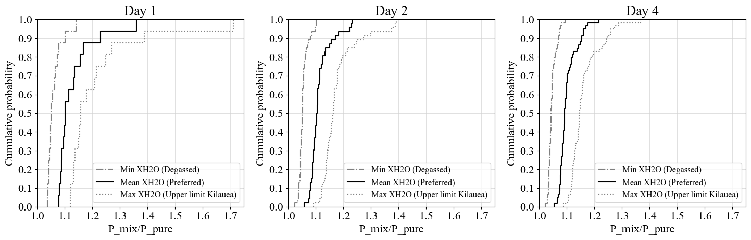
Fig. S2. Cumulative probability plot of the ratio of pressures from the mixed fluid EOS and pure CO₂ EOS depending on the $X_{H_{2}O}$ function applied from (DeVitre and Wieser, 2024) for each day of the simulation.

Text. S7. Sensitivity of the EOS method for FI to entrapment temperature – Extended

We test the sensitivity of 3 equations of state for CO₂ available in DiadFit: two are for pure CO₂ (Sterner and Pitzer, 1994; Span and Wagner, 1996) and one for CO₂-H₂O mixtures (Duan and Zhang, 2006). For this, we calculated pressures using all three EOS at different magmatically relevant entrapment temperatures (for the mixed H₂O-CO₂ EOS we used $X_{H_{2}O}$ = 0.1), which encompass the entire range of measured olivine-saturated liquid temperatures at Kīlauea (1100,1150, 1240 and 1350 ˚C). Overall, none of the three equations of state are significantly sensitive to temperature at these magmatic temperatures (Fig. S3-S6). The shaded box in Fig. S3 shows storage conditions relevant to Kīlauea. In the worst case, at the depth of the HMM reservoir (1 km), the absolute uncertainty in depth due to temperature is ~0.15 km and at depths corresponding to the SC reservoir (~4 km) it is ~0.7 km. We plot in detail on Figs S4-S6 the temperature sensitivity for each of the EOS at general conditions and conditions specifically relevant to Kīlauea.

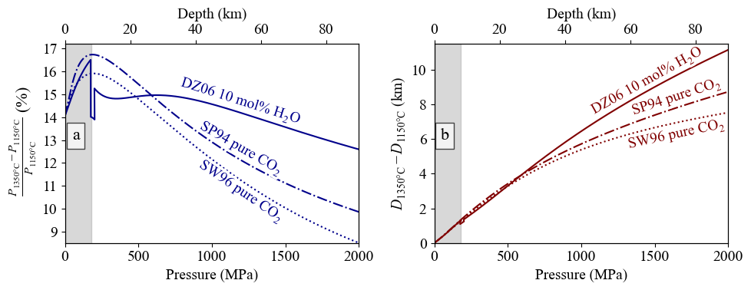
Fig. S3. % Percentage difference in pressure (a) and absolute difference in depths (b) for pressures calculated at 1350and 1150˚C using two pure CO₂ EOS (SW96, Span and Wagner, 1996; SP94, Sterner and Pitzer, 1994) and one mixed H₂O-CO₂ EOS (DZ06, Duan and Zhang, 2006). Shaded areas indicate pressures and depth relevant to Kīlauea pre-eruptive magma storage.

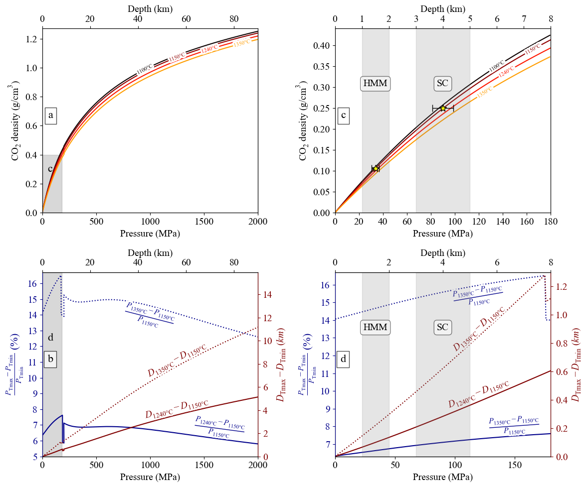
Fig. S4. Temperature sensitivity of the mixed CO₂-H₂O equation of state at 0.1 mol% H₂O (Duan and Zhang, 2006). (a) Pressure vs CO₂ density calculated for various entrapment temperatures relevant at Kīlauea. 1150 ˚C was our initial fixed temperature for days 1 and 2; 1240 ˚C is the rounded mean and median of all measured temperatures in our final dataset. (b) Depth and pressure differences induced by uncertainty in temperature. Blue curves show the % difference in pressure (or depth) and maroon curves show the absolute difference in depth in km. (c) Close-up of panel a, representing relevant PT conditions for Kīlauea. Gray boxes show the depth range of the magma storage reservoirs – HMM for Halema’uma’u reservoir and SC for south caldera reservoir – inferred from FI and MI barometry as well as geophysics (DeVitre and Wieser, 2024; Lerner et al., 2024). Stars show hypothetical FI trapped at HMM and SC reservoirs with error bars representing 1σ uncertainty from Monte Carlo simulations using a temperature uncertainty of ±150 K. (d) Close-up of panel b, showing depth and pressure differences induced by uncertainty in temperature for PT conditions relevant to Kīlauea. Blue curves show the % difference in pressure (or depth) and maroon curves show the absolute difference in depth in km.

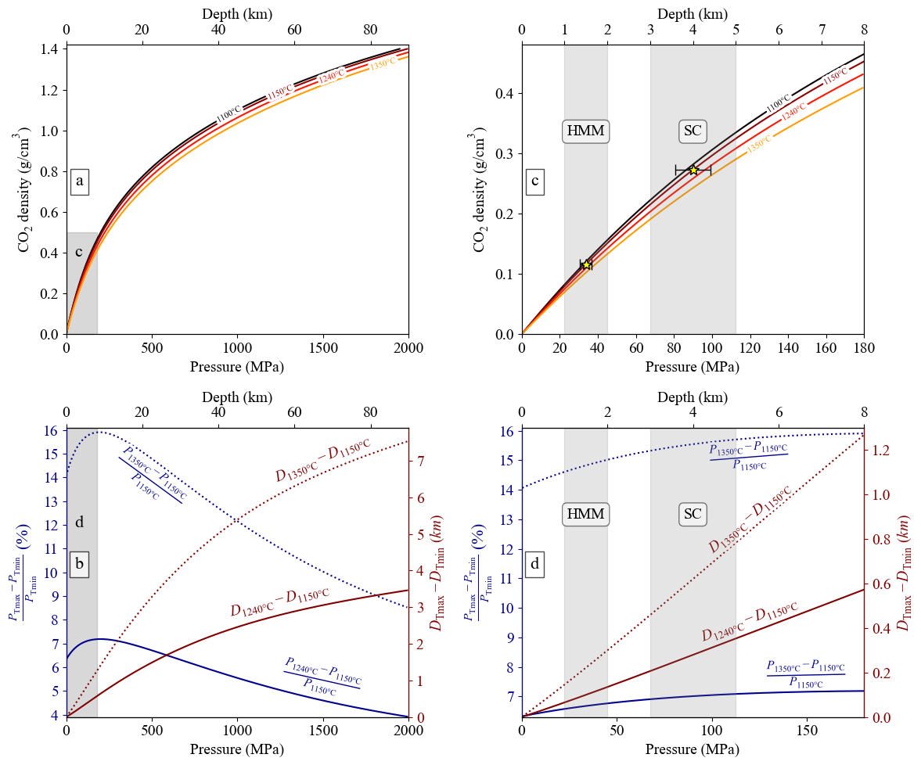
Fig. S5. Temperature sensitivity of Span and Wagner (1996) pure CO₂ equation of state.

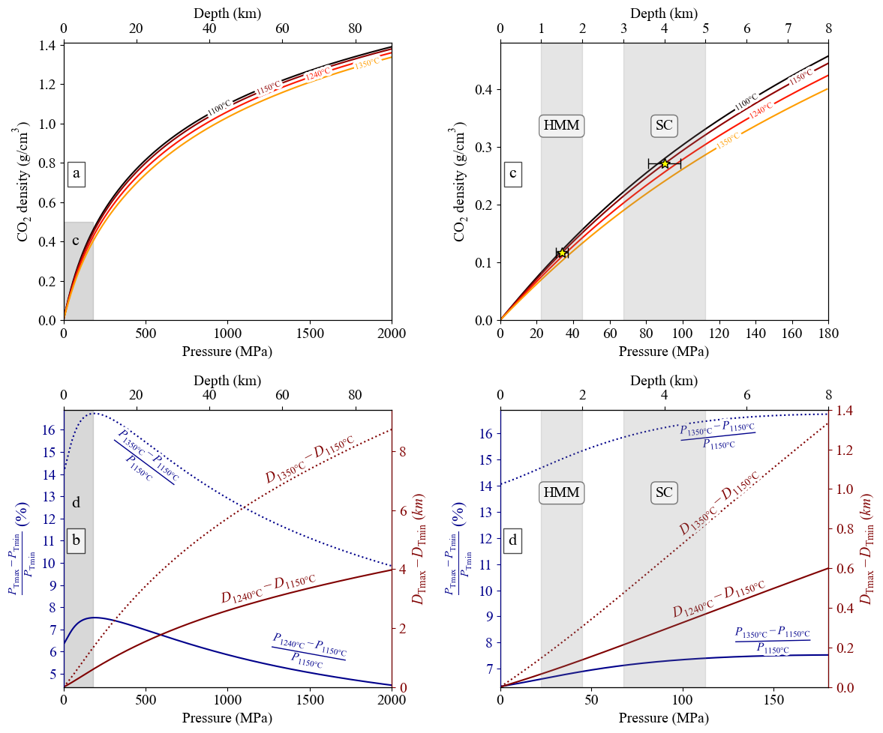
Fig S6. Temperature sensitivity of Sterner and Pitzer (1994) pure CO₂ equation of state.

Text S8. Global Melt inclusion compilation

We compiled melt inclusion datasets with published major element data, H₂O and CO₂ concentrations in the glass from EarthChem (https://www.earthchem.org/), Georoc (https://georoc.eu/), Rasmussen et al. (2022), DeVitre et al. (2023) and Wieser et al. (2023c) as well as other MI datasets from the literature (Harris and Anderson Jr, 1983; Anderson and Brown, 1993; Roggensack et al., 1997; Roggensack, 2001a, 2001b; Saal et al., 2002; Cervantes and Wallace, 2003; Wade et al., 2006; Benjamin et al., 2007; Sadofsky et al., 2008; Vigouroux et al., 2008; Auer et al., 2009; Famin et al., 2009; Johnson et al., 2009; Kelley and Cottrell, 2009; Koleszar et al., 2009; Roberge et al., 2009; Zimmer, 2009; Cooper et al., 2010, 2022; Kelley et al., 2010; Ruscitto et al., 2010, 2011; Shaw et al., 2010; Zimmer et al., 2010; Esposito et al., 2011; Head et al., 2011; Helo et al., 2011; Mormone et al., 2011; Schipper et al., 2011; Berlo et al., 2012; Bouvet de Maisonneuve et al., 2012; Field et al., 2012; Rose-Koga et al., 2012; Wanless and Shaw, 2012; Wysoczanski et al., 2012; de Moor et al., 2013; Lloyd et al., 2013; Brounce et al., 2014; Hartley et al., 2014; Métrich et al., 2014; Myers et al., 2014; Sides et al., 2014; Wanless et al., 2014, 2015; Cassidy et al., 2015; Colman et al., 2015; Hudgins et al., 2015; Moore et al., 2015, 2018, 2021; Plechov et al., 2015; Ribeiro et al., 2015; Wallace et al., 2015; Aster et al., 2016; Druitt et al., 2016; Ruth et al., 2016; Venugopal et al., 2016, 2020, 2020; Walowski et al., 2016, 2019; Donovan et al., 2017; Hauri et al., 2017, 2021; Longpré et al., 2017; Rasmussen et al., 2017; Robidoux et al., 2017, 2018; Allison, 2018; Bali et al., 2018; Bennett et al., 2019; Gennaro et al., 2019; Manzini et al., 2019; Miller et al., 2019; Taracsák et al., 2019; Iddon and Edmonds, 2020; Allison et al., 2021; Hernandez Nava et al., 2021; Lerner et al., 2021; Rasmussen and Plank, 2021; Wieser et al., 2021; Gleeson et al., 2022; DeVitre et al., 2023; Wong et al., 2023).
We calculated saturation pressures and the fraction of H₂O in the exsolved fluid phase ($X_{H_{2}O}$) using the MagmaSat solubility model (Ghiorso and Gualda, 2015) implemented in VESIcal (Iacovino et al., 2021). Whenever measurements were available, we used total CO₂ contents calculated from mass balance for Raman-measured MI bubbles, otherwise we use glass-only CO₂. When possible, we use post-entrapment crystallization corrected MI concentrations. As a first approximation, temperatures were calculated from major element data using the CaO liquid-only thermometer of Helz and Thornber (1987) implemented in Thermobar (Wieser et al., 2022) as it is not pressure sensitive. From there we calculated saturation pressures using MagmaSat in VESIcal (Iacovino et al., 2021). We then used these approximated pressures to recalculate temperatures with the more appropriate ol-liq equation 22 of Putirka (2008) implemented in Thermobar (Wieser et al., 2022)). As we did not have access to olivine-host chemistry, we used the Thermobar function “T_Put2008_eq22_BeattDMg,” which couples a theoretical calculation of the D_{Mg} from Beattie (1993) to calculate equilibrium olivine compositions so that equation 22 of Putirka (2008) can be used as a liquid-only thermometer. Equation 22 of Putirka (2008) has recently been identified as the most robust liquid-only thermometer across a wide range of compositions (Wieser et al., 2023a). Lastly, we recalculated saturation pressures using MagmaSat and our refined temperatures. We did not recalculate saturation pressures, temperatures or $X_{H_{2}O}$ for MI in the Cascades compilation of (Wieser et al., 2023c) or for (Dayton et al., 2024) except for Ruscitto et al. (2010). It is a known issue that MagmaSat may fail to converge and/or crash during saturation pressure calculations, which can be problematic when calculating saturation pressures on large datasets such as our >4000 MI compilation. To circumvent crashing issues, we implemented a Python multiprocessing routine along with a try-except block using the Python package “multiprocessing.” The dataset is divided into chunks corresponding to 5 times the number of cores available (e.g., for a laptop with 8 logical core processors, the dataset is divided into chunks of 40 samples) to limit the overhead on the processors which can cause memory saturation and crashing. Each chunk is assigned to a processor and run simultaneously. In the case of this study a Dell Inspiron 15 with i7 8 core processor 16 GB memory was used, which limited to a maximum of 8 chunks run simultaneously. Within each chunk, the MI were run one by one within a try-except block such that whenever an error occurred, NaN values were returned along with the error message from VESIcal (Iacovino et al., 2021). Any MI for which MagmaSat did not converge were filtered out in the final dataset. The notebook is included in the data repository. We provide both the complete unfiltered $X_{H_{2}O}$ compilation, and the compilation filtered for MagmaSat errors, SiO₂ < 57 wt% and MgO < 16 wt%. As discussed in previous sections, our method is not applicable to systems and magmas where $X_{H_{2}O}$ is very high, like for example in high-silica magmas where H₂O is concentrated due to fractional crystallization and CO₂ is lost due to extensive degassing. Therefore, to identify locations in the world where the rapid-response fluid inclusion barometry technique could be relevant, we plot only mafic MI with SiO₂ <57 wt% (Fig. S7). Such magmas are likely representative of recharge magmas regardless of tectonic setting. Interestingly, it is evident that $X_{H_{2}O}$ tends to be higher at alkaline intraplate volcanoes than their tholeiitic counterparts at similar pressures (Fig. 3 main text).
We then plot $X_{H_{2}O}$ against pressure at each unique location, grouped by tectonic settings (Fig. S8a-e). It is notable that there is a marked increase in $X_{H_{2}O}$ at very low pressures (<50 MPa). We filter the dataset presented on Fig 4, and Fig S10 considering a pressure cutoff of 20 MPa, where $X_{H_{2}O}$ is very high regardless of setting.
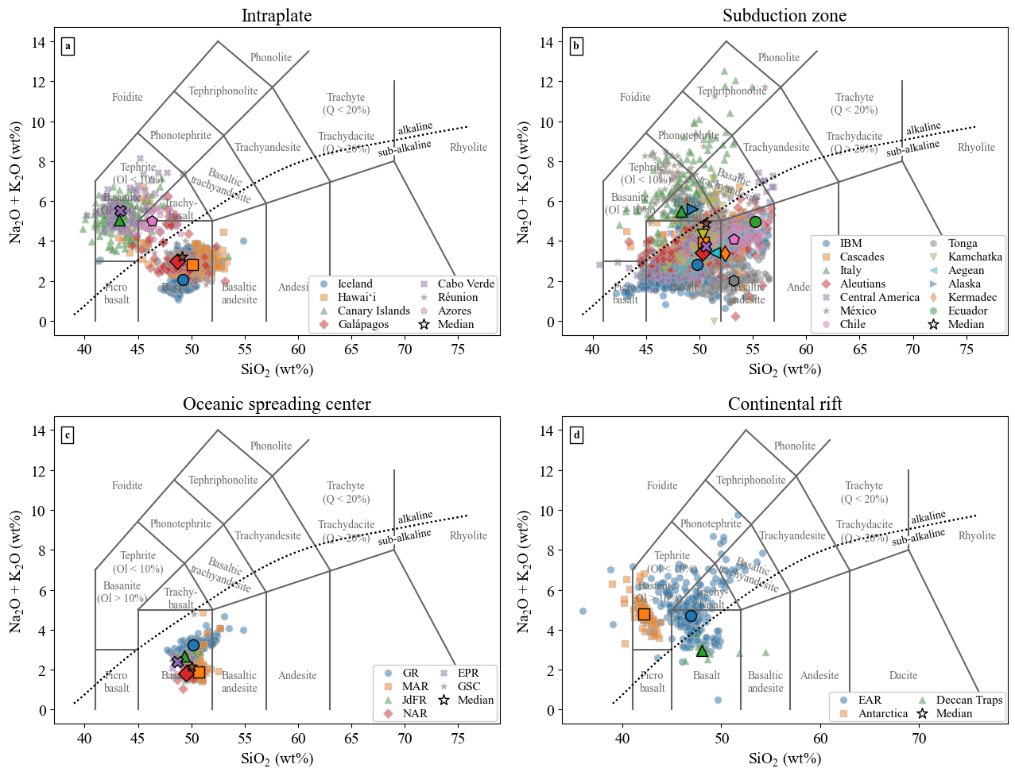
Figure S7. Total Alkalis vs Silica diagram for all the MI <57 wt% SiO₂ and MgO <16 wt% in our compilation. Larger black edged symbols indicate the medians of specific locations. (a) Intraplate (oceanic and continental) volcanoes in the compilation. We separate OIB-tholeiitic and OIB-alkaline locations based on the medians on this plot. (b) Subduction zone volcanoes. (c) Mid-ocean ridges. (d) Continental rifts.

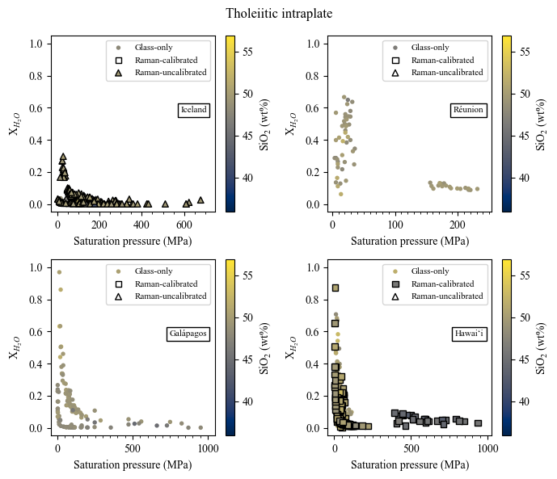
Figure S8a. Pressure vs $X_{H_{2}O}$ at tholeiitic OIB locations.

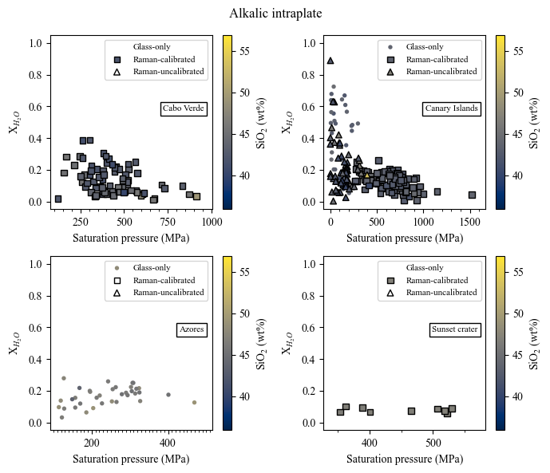
Figure S8b. Pressure vs $X_{H_{2}O}$ at alkaline OIB locations and Sunset Crater (an alkaline continental intraplate volcano).

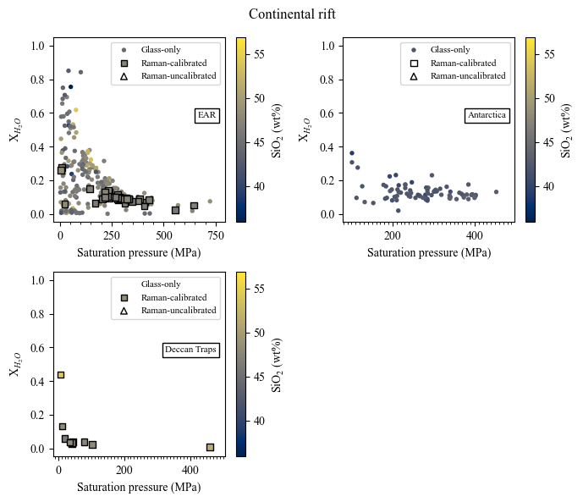
Figure S8c. Pressure vs $X_{H_{2}O}$ at continental rift locations.

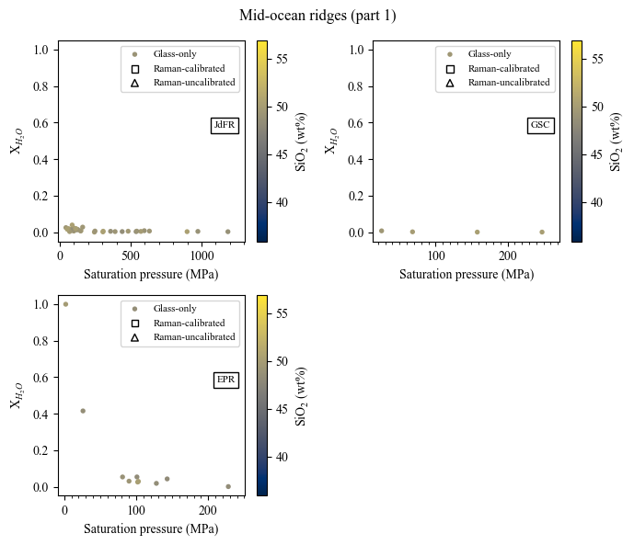
Figure S8d. Pressure vs $X_{H_{2}O}$ at mid-ocean ridge locations (Part 1). JdFR – Juan de Fuca Ridge, GSC – Galápagos Spreading Center, EPR – East Pacific Rise.

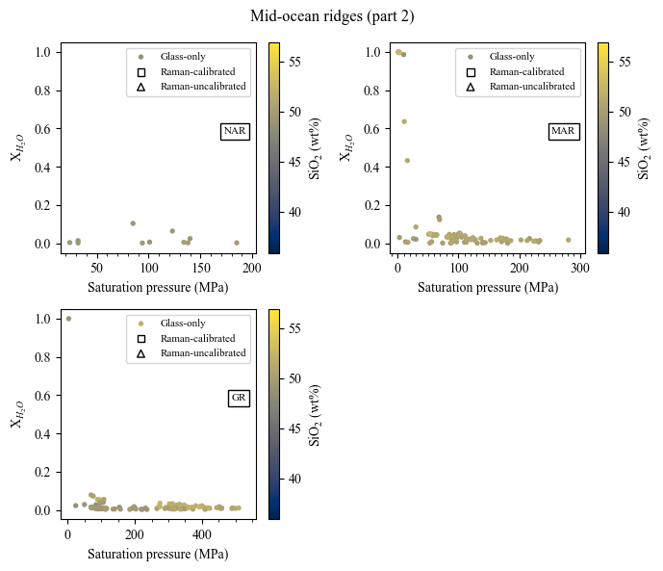
Figure S8e. Pressure vs $X_{H_{2}O}$ at mid-ocean ridge locations (Part 2). NAR – North Atlantic Ridge, MAR – Mid-Atlantic Ridge, GR – Gakkel Ridge.

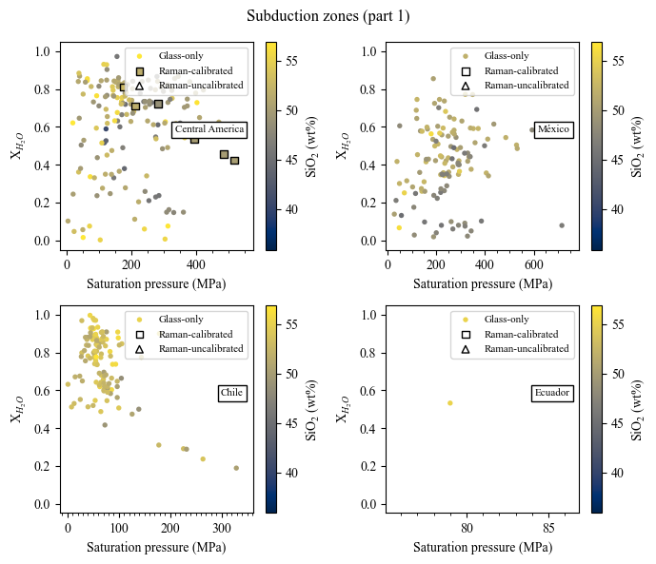
Figure S8f. Pressure vs $X_{H_{2}O}$ at subduction zones (Part 1).

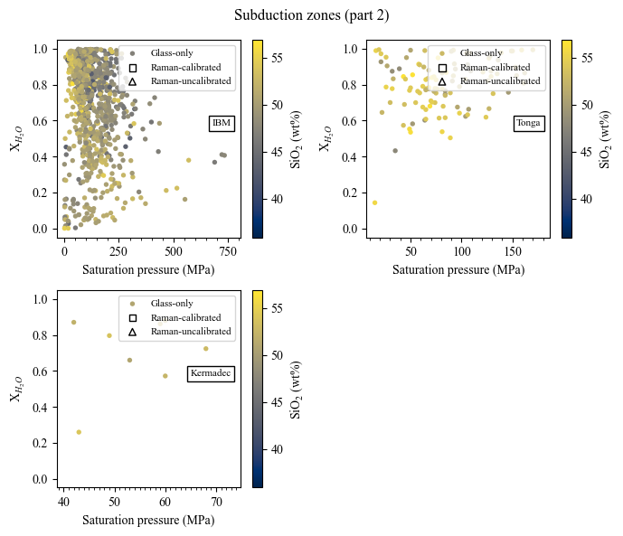
Figure S8g. Pressure vs $X_{H_{2}O}$ at subduction zones (Part 2).

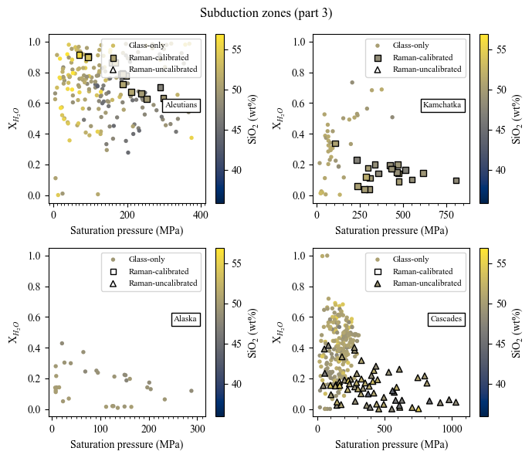
Figure S8h. Pressure vs $X_{H_{2}O}$ at subduction zones (Part 3).

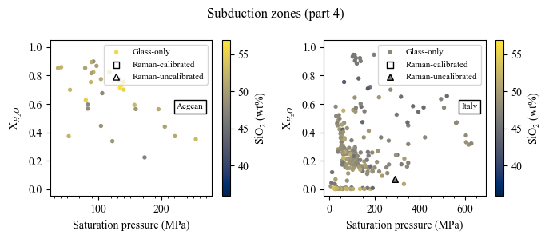
Figure S8i. Pressure vs $X_{H_{2}O}$ at subduction zones (Part 4).

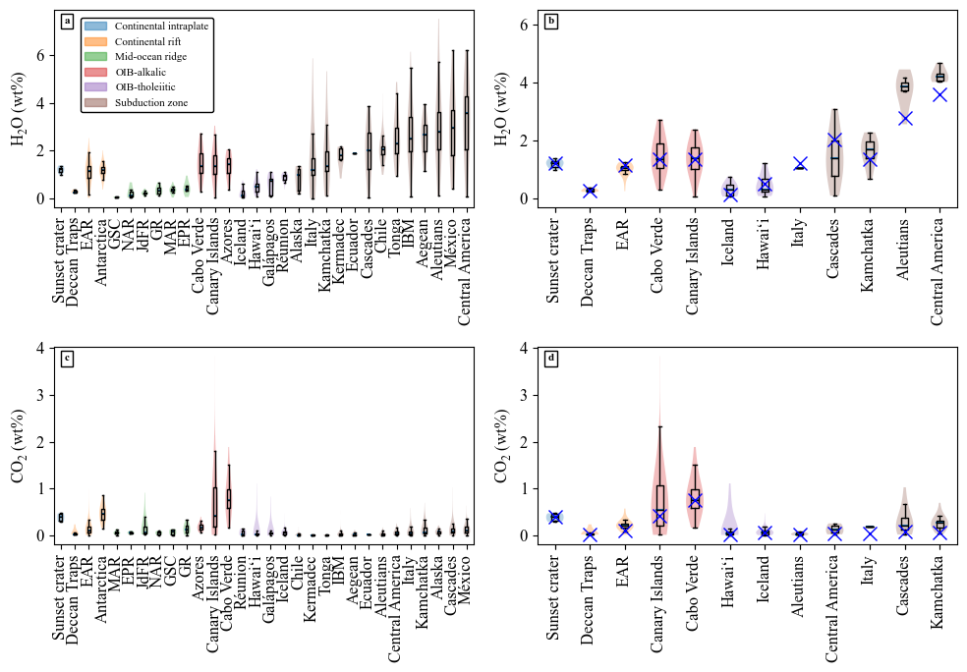
Figure S9. Boxplots and violin plots of H₂O and CO₂ contents of melt inclusions in the compilation. Filtered to SiO₂ < 57 wt%, MgO < 16 wt% and saturation pressure > 20MPa.

Data S2. (separate file)
Fluid inclusion dataset for this study.

Data S3. (separate file)
Global melt inclusion compilation (described in previous sections).

Image Compilation S4 (separate file)

Compilation of images used for navigation during the simulation. These are presented as they were used during the simulation as an example of what is necessary for the technique.

Supplementary references
Allison, C. M. (2018). Highly explosive mafic volcanism: the role of volatiles. Arizona State University.
Allison, C. M., Roggensack, K. & Clarke, A. B. (2021). Highly explosive basaltic eruptions driven by CO 2 exsolution. Nature Communications. Nature Publishing Group 12, 217.
Anderson, A. T. & Brown, G. G. (1993). CO2 contents and formation pressures of some Kilauean melt inclusions. American Mineralogist. GeoScienceWorld 78, 794–803.
Aster, E. M., Wallace, P. J., Moore, L. R., Watkins, J., Gazel, E. & Bodnar, R. J. (2016). Reconstructing CO2 concentrations in basaltic melt inclusions using Raman analysis of vapor bubbles. Journal of Volcanology and Geothermal Research 323, 148–162.
Auer, S., Bindeman, I., Wallace, P., Ponomareva, V. & Portnyagin, M. (2009). The origin of hydrous, high-δ18O voluminous volcanism: diverse oxygen isotope values and high magmatic water contents within the volcanic record of Klyuchevskoy volcano, Kamchatka, Russia. Contributions to Mineralogy and Petrology 157, 209–230.
Bali, E., Hartley, M. E., Halldórsson, S. A., Gudfinnsson, G. H. & Jakobsson, S. (2018). Melt inclusion constraints on volatile systematics and degassing history of the 2014–2015 Holuhraun eruption, Iceland. Contributions to Mineralogy and Petrology 173, 9.
Beattie, P. (1993). Olivine-melt and orthopyroxene-melt equilibria. Contributions to Mineralogy and Petrology 115, 103–111.
Benjamin, E. R., Plank, T., Wade, J. A., Kelley, K. A., Hauri, E. H. & Alvarado, G. E. (2007). High water contents in basaltic magmas from Irazú Volcano, Costa Rica. Journal of Volcanology and Geothermal Research 168, 68–92.
Bennett, E. N., Jenner, F. E., Millet, M.-A., Cashman, K. V. & Lissenberg, C. J. (2019). Deep roots for mid-ocean-ridge volcanoes revealed by plagioclase-hosted melt inclusions. Nature. Nature Publishing Group 572, 235–239.
Berlo, K., Stix, J., Roggensack, K. & Ghaleb, B. (2012). A tale of two magmas, Fuego, Guatemala. Bulletin of Volcanology 74, 377–390.
Bouvet de Maisonneuve, C., Dungan, M. A., Bachmann, O. & Burgisser, A. (2012). Insights into shallow magma storage and crystallization at Volcán Llaima (Andean Southern Volcanic Zone, Chile). Journal of Volcanology and Geothermal Research 211–212, 76–91.
Brounce, M. N., Kelley, K. A. & Cottrell, E. (2014). Variations in Fe3+/∑Fe of Mariana Arc Basalts and Mantle Wedge fO2. Journal of Petrology 55, 2513–2536.
Cassidy, M., Edmonds, M., Watt, S. F. L., Palmer, M. R. & Gernon, T. M. (2015). Origin of Basalts by Hybridization in Andesite-dominated Arcs. Journal of Petrology 56, 325–346.
Cervantes, P. & Wallace, P. (2003). Magma degassing and basaltic eruption styles: a case study of ∼2000 year BP Xitle volcano in central Mexico. Journal of Volcanology and Geothermal Research 120, 249–270.
Colman, A., Sinton, J. M. & Wanless, V. D. (2015). Constraints from melt inclusions on depths of magma residence at intermediate magma supply along the Galápagos Spreading Center. Earth and Planetary Science Letters 412, 122–131.
Cooper, L. B., Plank, T., Arculus, R. J., Hauri, E. H., Hall, P. S. & Parman, S. W. (2010). High-Ca boninites from the active Tonga Arc. Journal of Geophysical Research: Solid Earth 115.
Cooper, L., Plank, T., Arculus, R., Hauri, E. & Kelley, K. A. (2022). Arc–Backarc Exchange Along the Tonga–Lau System: Constraints From Volatile Elements. Journal of Petrology 63, egac072.
Dayton, K., Gazel, E., Wieser, P. E., Troll, V. R., Carracedo, J. C., Aulinas, M. & Perez-Torrado, F. J. (2024). Magmatic Storage and Volatile Fluxes of the 2021 La Palma Eruption. Geochemistry, Geophysics, Geosystems 25, e2024GC011491.
de Moor, J. M., Fischer, T. P., King, P. L., Botcharnikov, R. E., Hervig, R. L., Hilton, D. R., Barry, P. H., Mangasini, F. & Ramirez, C. (2013). Volatile-rich silicate melts from Oldoinyo Lengai volcano (Tanzania): Implications for carbonatite genesis and eruptive behavior. Earth and Planetary Science Letters 361, 379–390.
DeVitre, C. L. et al. (2023). Oceanic intraplate explosive eruptions fed directly from the mantle. Proceedings of the National Academy of Sciences. Proceedings of the National Academy of Sciences 120, e2302093120.
DeVitre, C. L. & Wieser, P. E. (2024). Reliability of Raman analyses of CO2-rich fluid inclusions as a geobarometer at Kīlauea. Geochemical Perspectives Letters 29, 1–8.
Donovan, A., Blundy, J., Oppenheimer, C. & Buisman, I. (2017). The 2011 eruption of Nabro volcano, Eritrea: perspectives on magmatic processes from melt inclusions. Contributions to Mineralogy and Petrology 173, 1.
Druitt, T. H., Mercier, M., Florentin, L., Deloule, E., Cluzel, N., Flaherty, T., Médard, E. & Cadoux, A. (2016). Magma Storage and Extraction Associated with Plinian and Interplinian Activity at Santorini Caldera (Greece). Journal of Petrology 57, 461–494.
Duan, Z. & Zhang, Z. (2006). Equation of state of the H2O, CO2, and H2O–CO2 systems up to 10 GPa and 2573.15K: Molecular dynamics simulations with ab initio potential surface. Geochimica et Cosmochimica Acta 70, 2311–2324.
Esposito, R., Bodnar, R. J., Danyushevsky, L. V., De Vivo, B., Fedele, L., Hunter, J., Lima, A. & Shimizu, N. (2011). Volatile Evolution of Magma Associated with the Solchiaro Eruption in the Phlegrean Volcanic District (Italy). Journal of Petrology 52, 2431–2460.
Famin, V., Welsch, B., Okumura, S., Bachèlery, P. & Nakashima, S. (2009). Three differentiation stages of a single magma at Piton de la Fournaise volcano (Reunion hot spot). Geochemistry, Geophysics, Geosystems 10.
Field, L., Blundy, J., Brooker, R. A., Wright, T. & Yirgu, G. (2012). Magma storage conditions beneath Dabbahu Volcano (Ethiopia) constrained by petrology, seismicity and satellite geodesy. Bulletin of Volcanology 74, 981–1004.
Gansecki, C., Lee, R. L., Shea, T., Lundblad, S. P., Hon, K. & Parcheta, C. (2019). The tangled tale of Kīlauea’s 2018 eruption as told by geochemical monitoring. Science. American Association for the Advancement of Science 366, eaaz0147.
Gennaro, E., Iacono-Marziano, G., Paonita, A., Rotolo, S. G., Martel, C., Rizzo, A. L., Pichavant, M. & Liotta, M. (2019). Melt inclusions track melt evolution and degassing of Etnean magmas in the last 15 ka. Lithos 324–325, 716–732.
Ghiorso, M. S. & Gualda, G. A. R. (2015). An H2O–CO2 mixed fluid saturation model compatible with rhyolite-MELTS. Contributions to Mineralogy and Petrology 169, 53.
Gleeson, M. L. M., Gibson, S. A. & Stock, M. J. (2022). Constraints on the behaviour and content of volatiles in Galápagos magmas from melt inclusions and nominally anhydrous minerals. Geochimica et Cosmochimica Acta 319, 168–190.
Hansteen, T. H. & Klügel, A. (2008). Fluid Inclusion Thermobarometry as a Tracer for Magmatic Processes. Reviews in Mineralogy and Geochemistry 69, 143–177.
Harris, D. M. & Anderson Jr, A. T. (1983). Concentrations, sources, and losses of H2O, CO2, and S in Kilauean basalt. Geochimica et Cosmochimica Acta. Elsevier 47, 1139–1150.
Hartley, M. E., Maclennan, J., Edmonds, M. & Thordarson, T. (2014). Reconstructing the deep CO2 degassing behaviour of large basaltic fissure eruptions. Earth and Planetary Science Letters 393, 120–131.
Hauri, E. H., Maclennan, J., McKenzie, D., Gronvold, K., Oskarsson, N. & Shimizu, N. (2017). CO2 content beneath northern Iceland and the variability of mantle carbon. Geology 46, 55–58.
Hauri, E., Plank, T., Fischer, T. P., Tamura, Y. & Ishizuka, O. (2021). Melt Inclusion data from the Marianas and Izu volcanic arcs, and Mariana Trough back-arc basin. https://ecl.earthchem.org/view.php?id=2036: EARTHCHEM.
Head, E. M., Shaw, A. M., Wallace, P. J., Sims, K. W. W. & Carn, S. A. (2011). Insight into volatile behavior at Nyamuragira volcano (D.R. Congo, Africa) through olivine-hosted melt inclusions. Geochemistry, Geophysics, Geosystems 12.
Helo, C., Longpré, M.-A., Shimizu, N., Clague, D. A. & Stix, J. (2011). Explosive eruptions at mid-ocean ridges driven by CO2-rich magmas. Nature Geoscience. Nature Publishing Group 4, 260–263.
Helz, R. T. & Thornber, C. R. (1987). Geothermometry of Kilauea Iki lava lake, Hawaii. Bulletin of Volcanology 49, 651–668.
Hernandez Nava, A., Black, B. A., Gibson, S. A., Bodnar, R. J., Renne, P. R. & Vanderkluysen, L. (2021). Reconciling early Deccan Traps CO2 outgassing and pre-KPB global climate. Proceedings of the National Academy of Sciences. Proceedings of the National Academy of Sciences 118, e2007797118.
Hudgins, T. R., Mukasa, S. B., Simon, A. C., Moore, G. & Barifaijo, E. (2015). Melt inclusion evidence for CO2-rich melts beneath the western branch of the East African Rift: implications for long-term storage of volatiles in the deep lithospheric mantle. Contributions to Mineralogy and Petrology 169, 46.
Iacovino, K., Matthews, S., Wieser, P. E., Moore, G. M. & Bégué, F. (2021). VESIcal Part I: An Open-Source Thermodynamic Model Engine for Mixed Volatile (H2O-CO2) Solubility in Silicate Melts. Earth and Space Science 8, e2020EA001584.
Iddon, F. & Edmonds, M. (2020). Volatile-Rich Magmas Distributed Through the Upper Crust in the Main Ethiopian Rift. Geochemistry, Geophysics, Geosystems 21, e2019GC008904.
Jarosewich, E., Nelen, J. A. & Norberg, J. A. (1980). Reference samples for electron microprobe analysis. Geostandards Newsletter. Wiley Online Library 4, 43–47.
Johnson, E. R., Wallace, P. J., Delgado Granados, H., Manea, V. C., Kent, A. J. R., Bindeman, I. N. & Donegan, C. S. (2009). Subduction-related Volatile Recycling and Magma Generation beneath Central Mexico: Insights from Melt Inclusions, Oxygen Isotopes and Geodynamic Models. Journal of Petrology 50, 1729–1764.
Kelley, K. A. & Cottrell, E. (2009). Water and the Oxidation State of Subduction Zone Magmas. Science. American Association for the Advancement of Science 325, 605–607.
Kelley, K. A., Plank, T., Newman, S., Stolper, E. M., Grove, T. L., Parman, S. & Hauri, E. H. (2010). Mantle Melting as a Function of Water Content beneath the Mariana Arc. Journal of Petrology 51, 1711–1738.
Koleszar, A. M., Saal, A. E., Hauri, E. H., Nagle, A. N., Liang, Y. & Kurz, M. D. (2009). The volatile contents of the Galapagos plume; evidence for H2O and F open system behavior in melt inclusions. Earth and Planetary Science Letters. Elsevier 287, 442–452.
Lerner, A. H. et al. (2021). The petrologic and degassing behavior of sulfur and other magmatic volatiles from the 2018 eruption of Kīlauea, Hawaiʻi: melt concentrations, magma storage depths, and magma recycling. Bulletin of Volcanology. Springer 83, 1–32.
Lerner, A. H., Sublett, D. M., Wallace, P. J., Cauley, C. & Bodnar, R. J. (2024). Insights into magma storage depths and eruption controls at Kīlauea Volcano during explosive and effusive periods of the past 500 years based on melt and fluid inclusions. Earth and Planetary Science Letters 628, 118579.
Lloyd, A. S., Plank, T., Ruprecht, P., Hauri, E. H. & Rose, W. (2013). Volatile loss from melt inclusions in pyroclasts of differing sizes. Contributions to Mineralogy and Petrology 165, 129–153.
Longpré, M.-A., Stix, J., Klügel, A. & Shimizu, N. (2017). Mantle to surface degassing of carbon- and sulphur-rich alkaline magma at El Hierro, Canary Islands. Earth and Planetary Science Letters 460, 268–280.
Manzini, M., Bouvier, A.-S., Baumgartner, L. P., Rose-Koga, E. F., Schiano, P. & Shimizu, N. (2019). Grain scale processes recorded by oxygen isotopes in olivine-hosted melt inclusions from two MORB samples. Chemical Geology 511, 11–20.
Métrich, N., Zanon, V., Créon, L., Hildenbrand, A., Moreira, M. & Marques, F. O. (2014). Is the ‘Azores Hotspot’ a Wetspot? Insights from the Geochemistry of Fluid and Melt Inclusions in Olivine of Pico Basalts. Journal of Petrology 55, 377–393.
Miller, W. G. R., Maclennan, J., Shorttle, O., Gaetani, G. A., Le Roux, V. & Klein, F. (2019). Estimating the carbon content of the deep mantle with Icelandic melt inclusions. Earth and Planetary Science Letters 523, 115699.
Moore, L. R. et al. (2015). Bubbles matter: An assessment of the contribution of vapor bubbles to melt inclusion volatile budgets. American Mineralogist. Mineralogical Society of America 100, 806–823.
Moore, L. R., Gazel, E. & Bodnar, R. J. (2021). The volatile budget of Hawaiian magmatism: Constraints from melt inclusions from Haleakala volcano, Hawaii. Journal of Volcanology and Geothermal Research 410, 107144.
Moore, L. R., Mironov, N., Portnyagin, M., Gazel, E. & Bodnar, R. J. (2018). Volatile contents of primitive bubble-bearing melt inclusions from Klyuchevskoy volcano, Kamchatka: Comparison of volatile contents determined by mass-balance versus experimental homogenization. Journal of Volcanology and Geothermal Research 358, 124–131.
Mormone, A., Piochi, M., Bellatreccia, F., De Astis, G., Moretti, R., Ventura, G. D., Cavallo, A. & Mangiacapra, A. (2011). A CO2-rich magma source beneath the Phlegraean Volcanic District (Southern Italy): Evidence from a melt inclusion study. Chemical Geology 287, 66–80.
Myers, M. L., Geist, D. J., Rowe, M. C., Harpp, K. S., Wallace, P. J. & Dufek, J. (2014). Replenishment of volatile-rich mafic magma into a degassed chamber drives mixing and eruption of Tungurahua volcano. Bulletin of Volcanology 76, 872.
Plechov, P., Blundy, J., Nekrylov, N., Melekhova, E., Shcherbakov, V. & Tikhonova, M. S. (2015). Petrology and volatile content of magmas erupted from Tolbachik Volcano, Kamchatka, 2012–13. Journal of Volcanology and Geothermal Research 307, 182–199.
Putirka, K. D. (2008). Thermometers and barometers for volcanic systems. Reviews in mineralogy and geochemistry. Mineralogical Society of America 69, 61–120.
Rasmussen, D. J., Kyle, P. R., Wallace, P. J., Sims, K. W. W., Gaetani, G. A. & Phillips, E. H. (2017). Understanding Degassing and Transport of CO2-rich Alkalic Magmas at Ross Island, Antarctica using Olivine-Hosted Melt Inclusions. Journal of Petrology 58, 841–861.
Rasmussen, D. J. & Plank, T. (2021). Melt inclusion data for the central-eastern Aleutian volcanoes. https://ecl.earthchem.org/view.php?id=1873: EARTHCHEM.
Rasmussen, D. J., Plank, T., Cottrell, E., Johansson, A., Lehnert, K. & Hauri, E. (2022). DCO-EarthChem Melt Inclusion Expert Dataset. https://ecl.earthchem.org/view.php?id=2364: EARTHCHEM.
Ribeiro, J. M., Stern, R. J., Kelley, K. A., Shaw, A. M., Martinez, F. & Ohara, Y. (2015). Composition of the slab-derived fluids released beneath the Mariana forearc: Evidence for shallow dehydration of the subducting plate. Earth and Planetary Science Letters 418, 136–148.
Roberge, J., Delgado-Granados, H. & Wallace, P. J. (2009). Mafic magma recharge supplies high CO2 and SO2 gas fluxes from Popocatépetl volcano, Mexico. Geology 37, 107–110.
Robidoux, P., Frezzotti, M. L., Hauri, E. H. & Aiuppa, A. (2018). Shrinkage Bubbles: The C–O–H–S Magmatic Fluid System at San Cristóbal Volcano. Journal of Petrology 59, 2093–2122.
Robidoux, P., Rotolo, S. G., Aiuppa, A., Lanzo, G. & Hauri, E. H. (2017). Geochemistry and volatile content of magmas feeding explosive eruptions at Telica volcano (Nicaragua). Journal of Volcanology and Geothermal Research 341, 131–148.
Roggensack, K. (2001a). Unraveling the 1974 eruption of Fuego volcano (Guatemala) with small crystals and their young melt inclusions. Geology 29, 911–914.
Roggensack, K. (2001b). Sizing up crystals and their melt inclusions: a new approach to crystallization studies. Earth and Planetary Science Letters 187, 221–237.
Roggensack, K., Hervig, R. L., McKnight, S. B. & Williams, S. N. (1997). Explosive basaltic volcanism from Cerro Negro volcano: influence of volatiles on eruptive style. Science. American Association for the Advancement of Science 277, 1639–1642.
Rose-Koga, E. F., Koga, K. T., Schiano, P., Le Voyer, M., Shimizu, N., Whitehouse, M. J. & Clocchiatti, R. (2012). Mantle source heterogeneity for South Tyrrhenian magmas revealed by Pb isotopes and halogen contents of olivine-hosted melt inclusions. Chemical Geology 334, 266–279.
Ruscitto, D. M., Wallace, P. J., Johnson, E. R., Kent, A. J. R. & Bindeman, I. N. (2010). Volatile contents of mafic magmas from cinder cones in the Central Oregon High Cascades: Implications for magma formation and mantle conditions in a hot arc. Earth and Planetary Science Letters 298, 153–161.
Ruscitto, D. M., Wallace, P. J. & Kent, A. J. R. (2011). Revisiting the compositions and volatile contents of olivine-hosted melt inclusions from the Mount Shasta region: implications for the formation of high-Mg andesites. Contributions to Mineralogy and Petrology 162, 109–132.
Ruth, D. C. S., Cottrell, E., Cortés, J. A., Kelley, K. A. & Calder, E. S. (2016). From Passive Degassing to Violent Strombolian Eruption: the Case of the 2008 Eruption of Llaima Volcano, Chile. Journal of Petrology 57, 1833–1864.
Ryan, M. P. (1987). The elasticity and contractancy of Hawaiian olivine tholeiite, and its role in the stability and structural evolution of sub-caldera magma reservoirs and rift systems. In Volcanism in Hawaii. US Geol. Surv. Prof. Pap. 1350, 1395–1447.
Saal, A. E., Hauri, E. H., Langmuir, C. H. & Perfit, M. R. (2002). Vapour undersaturation in primitive mid-ocean-ridge basalt and the volatile content of Earth’s upper mantle. Nature. Nature Publishing Group 419, 451–455.
Sadofsky, S. J., Portnyagin, M., Hoernle, K. & van den Bogaard, P. (2008). Subduction cycling of volatiles and trace elements through the Central American volcanic arc: evidence from melt inclusions. Contributions to Mineralogy and Petrology 155, 433–456.
Schipper, C. I., White, J. D. L. & Houghton, B. F. (2011). Textural, geochemical, and volatile evidence for a Strombolian-like eruption sequence at Lō`ihi Seamount, Hawai`i. Journal of Volcanology and Geothermal Research 207, 16–32.
Shaw, A. M., Behn, M. D., Humphris, S. E., Sohn, R. A. & Gregg, P. M. (2010). Deep pooling of low degree melts and volatile fluxes at the 85°E segment of the Gakkel Ridge: Evidence from olivine-hosted melt inclusions and glasses. Earth and Planetary Science Letters 289, 311–322.
Sides, I., Edmonds, M., Maclennan, J., Houghton, B. F., Swanson, D. A. & Steele-MacInnis, M. J. (2014). Magma mixing and high fountaining during the 1959 Kīlauea Iki eruption, Hawai ‘i. Earth and Planetary Science Letters. Elsevier 400, 102–112.
Span, R. & Wagner, W. (1996). A new equation of state for carbon dioxide covering the fluid region from the triple‐point temperature to 1100 K at pressures up to 800 MPa. Journal of physical and chemical reference data. American Institute of Physics for the National Institute of Standards and … 25, 1509–1596.
Sterner, S. M. & Pitzer, K. S. (1994). An equation of state for carbon dioxide valid from zero to extreme pressures. Contributions to Mineralogy and Petrology. Springer 117, 362–374.
Taracsák, Z., Hartley, M. E., Burgess, R., Edmonds, M., Iddon, F. & Longpré, M.-A. (2019). High fluxes of deep volatiles from ocean island volcanoes: Insights from El Hierro, Canary Islands. Geochimica et Cosmochimica Acta 258, 19–36.
Venugopal, S., Moune, S. & Williams-Jones, G. (2016). Investigating the subsurface connection beneath Cerro Negro volcano and the El Hoyo Complex, Nicaragua. Journal of Volcanology and Geothermal Research 325, 211–224.
Venugopal, S., Moune, S., Williams-Jones, G., Druitt, T., Vigouroux, N., Wilson, A. & Russell, J. K. (2020). Two distinct mantle sources beneath the Garibaldi Volcanic Belt: Insight from olivine-hosted melt inclusions. Chemical Geology 532, 119346.
Vigouroux, N., Wallace, P. J. & Kent, A. J. R. (2008). Volatiles in High-K Magmas from the Western Trans-Mexican Volcanic Belt: Evidence for Fluid Fluxing and Extreme Enrichment of the Mantle Wedge by Subduction Processes. Journal of Petrology 49, 1589–1618.
Wade, J. A., Plank, T., Melson, W. G., Soto, G. J. & Hauri, E. H. (2006). The volatile content of magmas from Arenal volcano, Costa Rica. Journal of Volcanology and Geothermal Research 157, 94–120.
Wallace, P. J., Kamenetsky, V. S. & Cervantes, P. (2015). Melt inclusion CO2 contents, pressures of olivine crystallization, and the problem of shrinkage bubbles. American Mineralogist. GeoScienceWorld 100, 787–794.
Walowski, K. J., Kirstein, L. A., De Hoog, J. C. M., Elliott, T. R., Savov, I. P. & Jones, R. E. (2019). Investigating ocean island mantle source heterogeneity with boron isotopes in melt inclusions. Earth and Planetary Science Letters 508, 97–108.
Walowski, K. J., Wallace, P. J., Clynne, M. A., Rasmussen, D. J. & Weis, D. (2016). Slab melting and magma formation beneath the southern Cascade arc. Earth and Planetary Science Letters 446, 100–112.
Wanless, V. D., Behn, M. D., Shaw, A. M. & Plank, T. (2014). Variations in melting dynamics and mantle compositions along the Eastern Volcanic Zone of the Gakkel Ridge: insights from olivine-hosted melt inclusions. Contributions to Mineralogy and Petrology 167, 1005.
Wanless, V. D. & Shaw, A. M. (2012). Lower crustal crystallization and melt evolution at mid-ocean ridges. Nature Geoscience. Nature Publishing Group 5, 651–655.
Wanless, V. D., Shaw, A. M., Behn, M. D., Soule, S. A., Escartín, J. & Hamelin, C. (2015). Magmatic plumbing at Lucky Strike volcano based on olivine-hosted melt inclusion compositions. Geochemistry, Geophysics, Geosystems 16, 126–147.
Wieser, P. E. et al. (2021). Reconstructing Magma Storage Depths for the 2018 Kı̄lauean Eruption From Melt Inclusion CO2 Contents: The Importance of Vapor Bubbles. Geochemistry, Geophysics, Geosystems 22, e2020GC009364.
Wieser, P. E. & DeVitre, C. (2024). DiadFit: An open-source Python3 tool for peak fitting of Raman data from silicate melts and CO2 fluids. Volcanica 7, 335–359.
Wieser, P. E., Gleeson, M., Matthews, S., DeVitre, C. L. & Gazel, E. (2023a). Determining the Pressure – Temperature – Composition (P-T-X) conditions of magma storage. EarthArXiv.
Wieser, P. E., Kent, A. J. R., Till, C. B., Donovan, J., Neave, D. A., Blatter, D. L. & Krawczynski, M. J. (2023b). Barometers Behaving Badly I: Assessing the Influence of Analytical and Experimental Uncertainty on Clinopyroxene Thermobarometry Calculations at Crustal Conditions. Journal of Petrology 64, egac126.
Wieser, P. E., Kent, A., Till, C. & Abers, G. (2023c). Geophysical and Geochemical Constraints on Magma Storage Depths along the Cascade Arc: Knowns and Unknowns. EarthArXiv.
Wieser, P., Petrelli, M., Lubbers, J., Wieser, E., Ozaydin, S., Kent, A. & Till, C. (2022). Thermobar: An open-source Python3 tool for thermobarometry and hygrometry. Volcanica 5, 349–384.
Wong, K., Ferguson, D., Wieser, P., Morgan, D., Edmonds, M., Tadesse, A. Z., Yirgu, G., Harvey, J. & Hammond, S. (2023). Focused Mid-Crustal Magma Intrusion During Continental Break-Up in Ethiopia. Geophysical Research Letters 50, e2023GL103257.
Wysoczanski, R. J., Handler, M. R., Schipper, C. I., Leybourne, M. I., Creech, J., Rotella, M. D., Nichols, A. R. L., Wilson, C. J. N. & Stewart, R. B. (2012). The Tectonomagmatic Source of Ore Metals and Volatile Elements in the Southern Kermadec Arc. Economic Geology 107, 1539–1556.
Yoshimura, S. (2023). Carbon dioxide and water in the crust. Part 1: Equation of state for the fluid. Journal of Mineralogical and Petrological Sciences 118, 221224a.
Zimmer, M. M. (2009). Water in Aleutian Magmas: its origins in the subduction zone and its effects on magma evolution. ProQuest.
Zimmer, M. M. et al. (2010). The Role of Water in Generating the Calc-alkaline Trend: New Volatile Data for Aleutian Magmas and a New Tholeiitic Index. Journal of Petrology 51, 2411–2444.

