SternerLearn User Manual

Table of Contents

User Manual 1

# Introduction

There are many applications which provide students with access their grades and assignments in a convenient fashion. However, less has been done for parents of younger students who want to play an active part in their child’s education. In an attempt to rectify this, we decided to create SternerLearn, which is designed to assist parents in their quest to educate their children. SternerLearn provides the ability to view a child’s grades, assignments, and infractions. In addition, it also provides additional functionality for parents with particularly reluctant children. By logging data on the student’s phone, SternerLearn can allow parents to view their child’s location as well as their text messages.

# How to Use

The application is a native Android application. After installing the application, which is available through our github site, the user interaction should be intuitive based on the use of other Android applications. To enter data in text fields, the user simply can click on the field to open the on-screen keyboard on their device. For scrolling data fields or radio buttons, they simply must be clicked as appropriate for the user’s preferences. The application supports both portrait and landscape mode.

# Handling Errors

There are several different types of errors the application could produce when provided with invalid input. We will go through the different types individually. However, one overarching potential error is the lack of service. If the phone does not have internet access, none of the functionality will be supported, as communication with web services is required to both retrieve and add any data. Some more details about the specific situations can be seen later in detailed step-by-step instructions with screenshots of the application.

## Registration

Other than the lack of connection, there are two types of errors in registration. Either the user has already registered an account, or their passwords do not match. Unfortunately at this time we do not provide customized error messages (only the fact that there was an error), so the user will have to determine which of these caused their error.

## Logging In

If the account does not exist in the database or a connection cannot be made with the database, then the login process will fail. A generic message is provided to indicate an error.

## Viewing Data

When viewing any data, the only prerequisite is that there is an internet connection. Otherwise, no data can be retrieved. The specific way this is handled can depend on the page where it is being retrieved.

## Adding Data

The only account type that can add data is the teacher. However, if they add new data, such as a new grade, then there is a message provided whether the action was successful. A failure can occur due to not recognizing some data that was entered. In the grade example, the teacher must enter the student name and assignment name. If either of these do not match valid items in the database, then the grade will not be added and the failure message will be provided.

# Sample Interaction

The application can easily be split into three portions: student, teacher, and parent. When registering for a new account, the user selects one of these three account types and from then on will only have access to those materials. We will go through each account type in turn. Most of this can also be seen in the project video.

## Student

The student-oriented portion is the most limited, because this application was more focused from a parent perspective.

First a student must register for a new account. To do this, they must enter all of the required information and select “Register”.

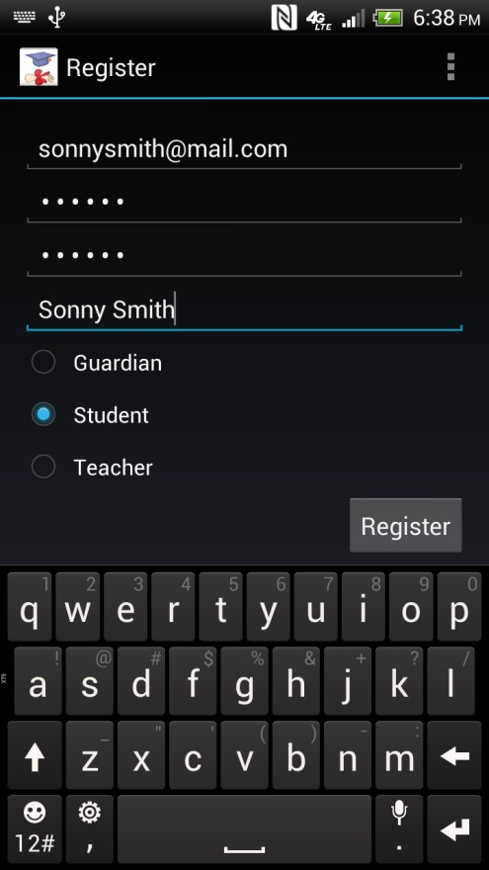

After registering, they are brought to the main menu for students, which just provides access to grades and assignments.

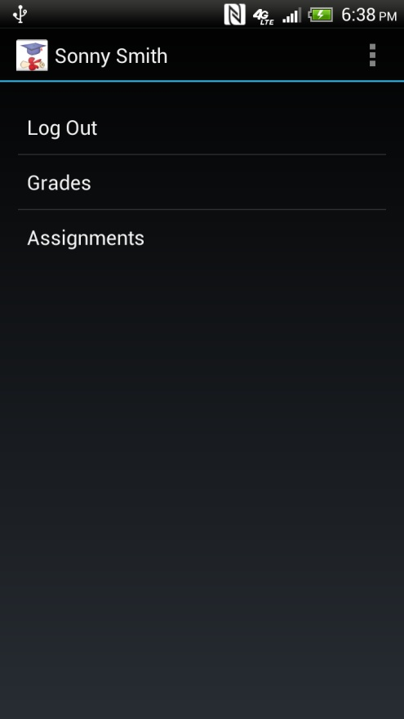

Clicking on “Grades” will display a list of classes the student is enrolled in.

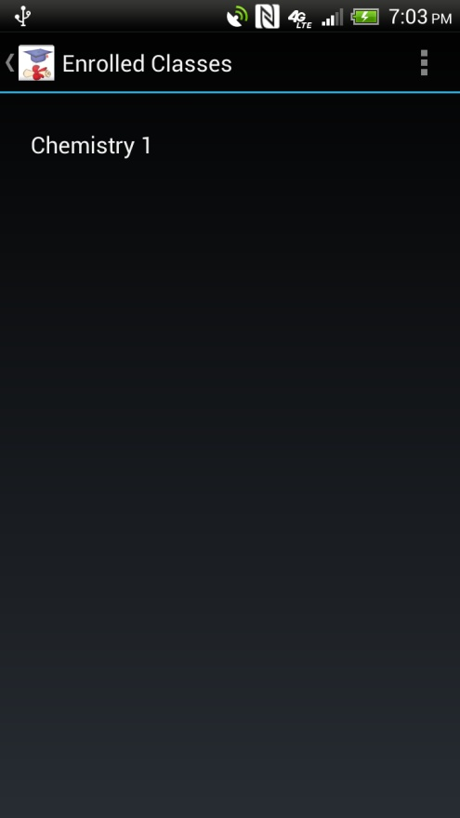

Selecting any class will display the list of grades the student has received for that class.

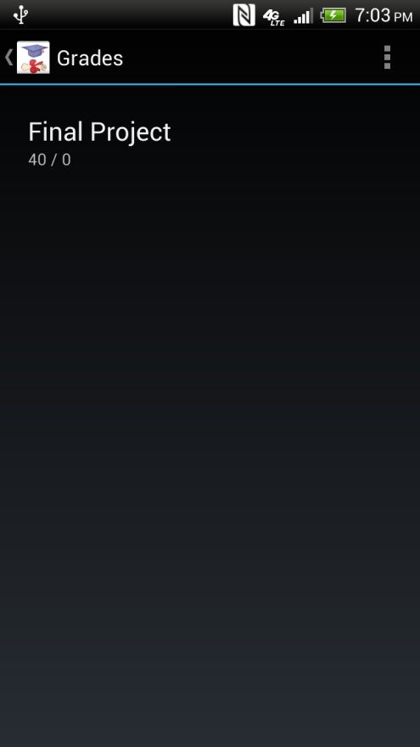

Alternatively, clicking on Assignments will display a list of the upcoming assignments.

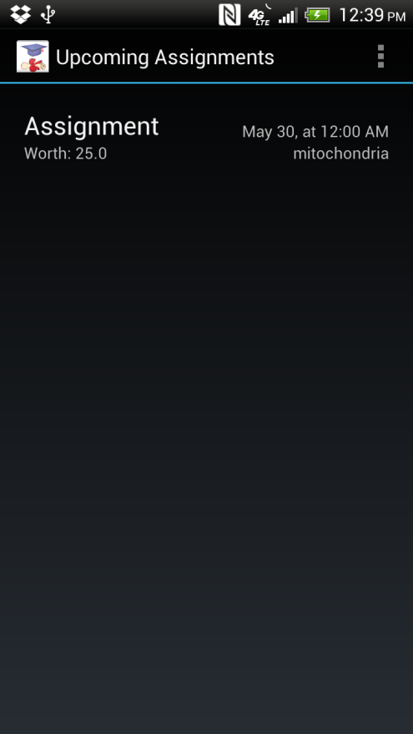

## Teacher

Teachers are those that create all of the content that other users can view. They have many options like adding classes, adding students to the classes, adding assignments, adding grades, and giving out infractions. We’ll go through their options below. This assumes they have already created a teacher account, similarly to how a student account is created above, but simply choosing the Teacher type instead.

When originally creating a teacher account, they will not have any classes, so their main menu will be relatively bare.

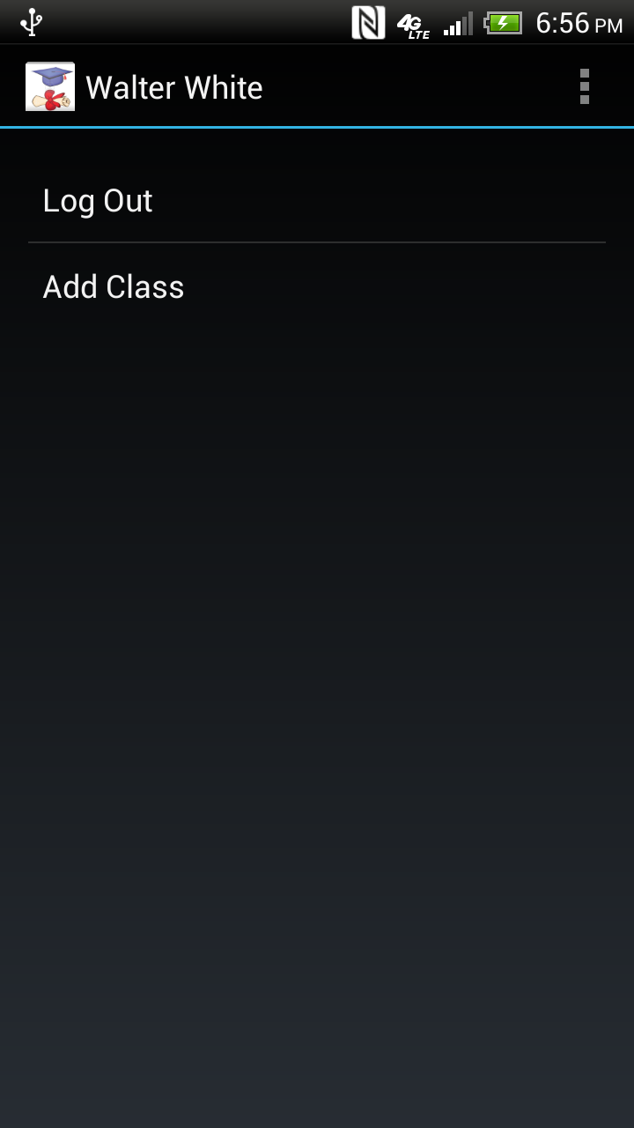

If we click “Add Class” we can get access to the other features.

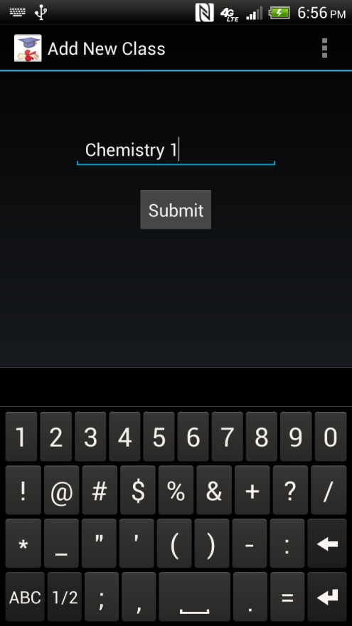

After this class is created, we can see it in the main menu. Clicking on it from there brings us to a new page which has the features described above.

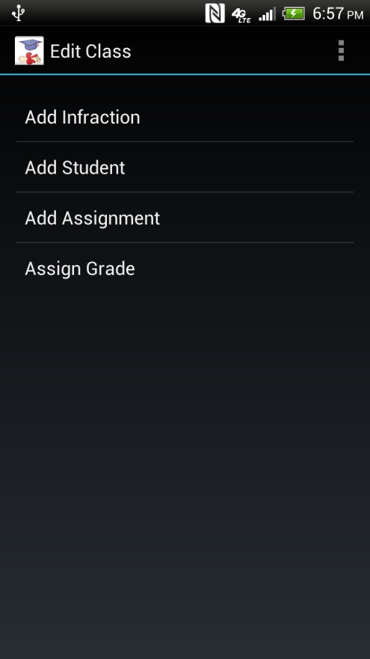

Clicking Add Student adds a new student to this class.

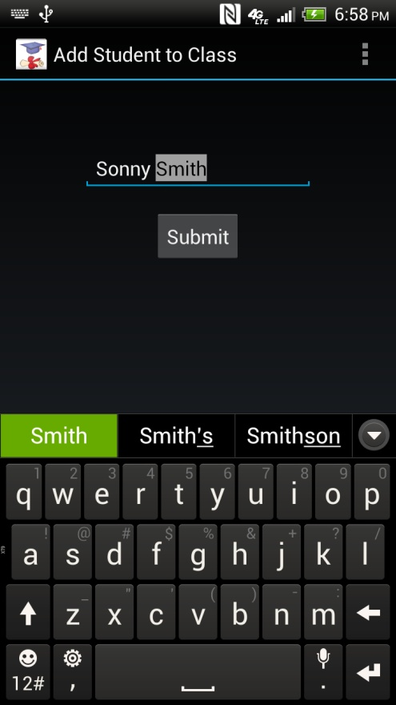

Clicking Add Assignment adds an assignment to this class.

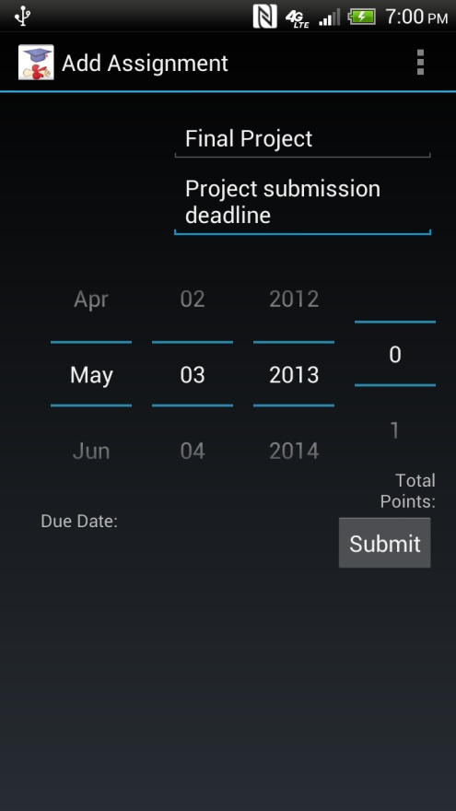

Clicking Assign Grade adds a grade to an assignment for a particular student.

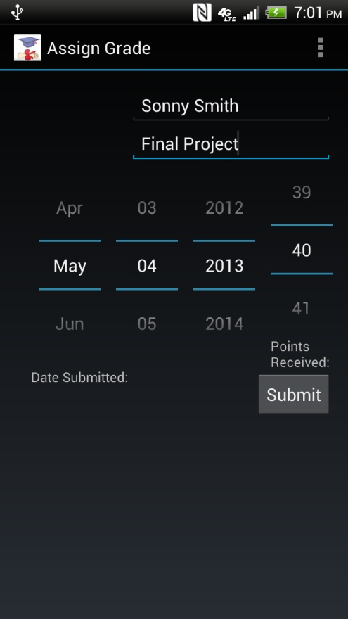

Clicking Add Infraction adds an infraction to a particular student.

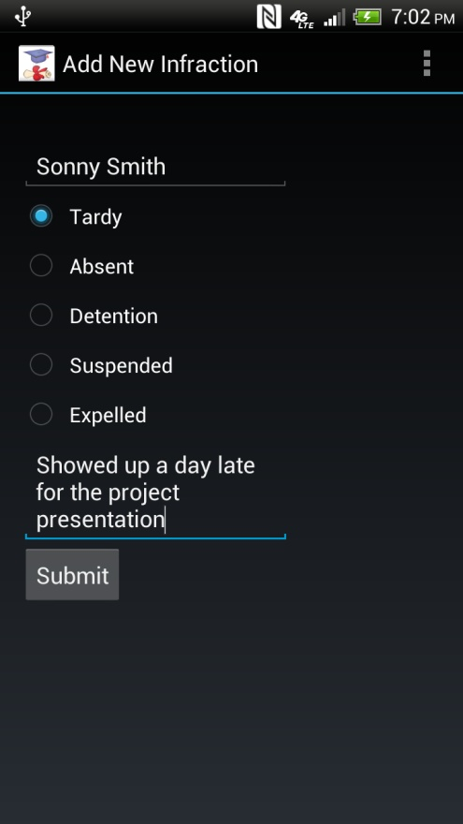

## Parent

Finally we arrive at the parent account. This is where the most interesting features can be seen. Firstly, after a parent registers, they must first link their account with a student. To do this, they are required to have the login information of that student.

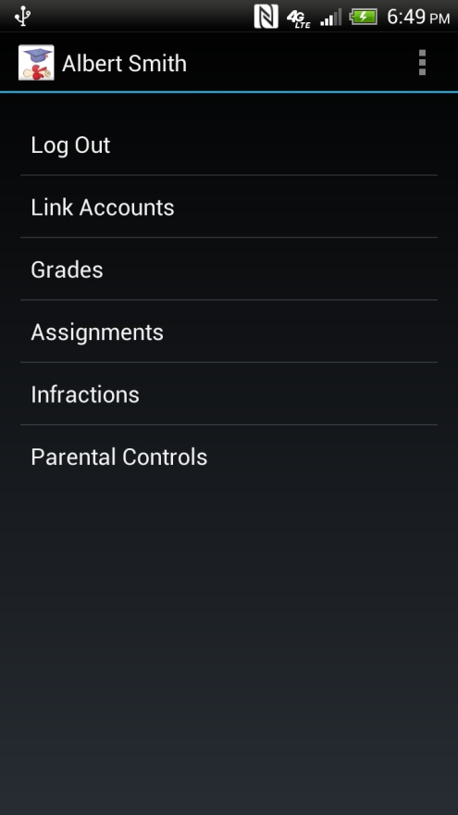

To do this, we click “Link Accounts”.

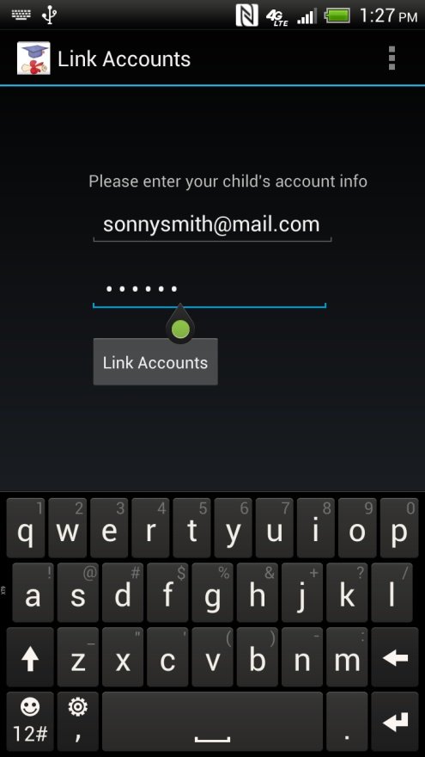

After doing this, the parent can view the other options available on the main menu and it will retrieve the data for the linked student. For the grades and assignments it is the same behavior as the student, which can be seen above, so we will skip those. We will click on Infractions first, which brings us to a list of infractions the student received.

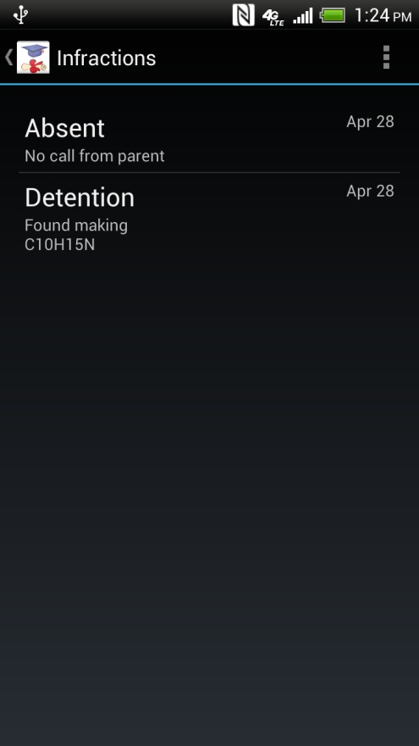

This brings us to the most interesting features of the application, the location tracking and text messages. Both of these are within the parental controls section, so we first click “Parental Controls”. If we then click Track Location, we are brought first to the selection screen, where the parent can choose a date and time to view locations from, up until the current time.

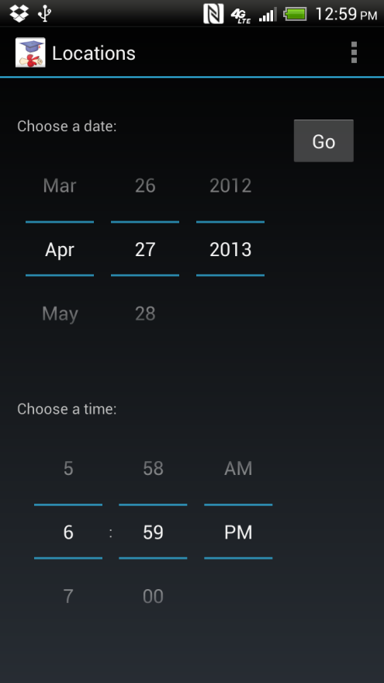

Selecting Go will bring you to the map page, which contains the locations on a map for the given time frame. Clicking one displays the exact time the student was at that location.

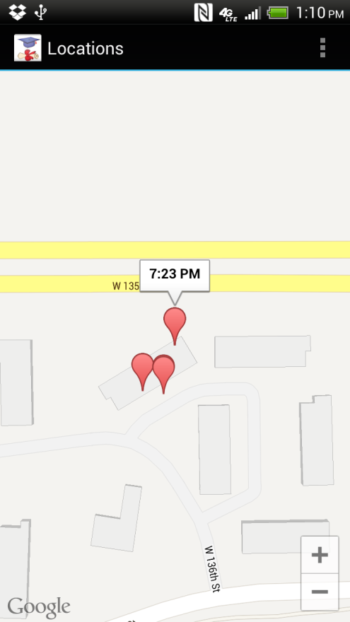

Going back to the main parental controls page, if we select the Text Messages, we are brought to a similar setup, where we select the day it view text messages for.

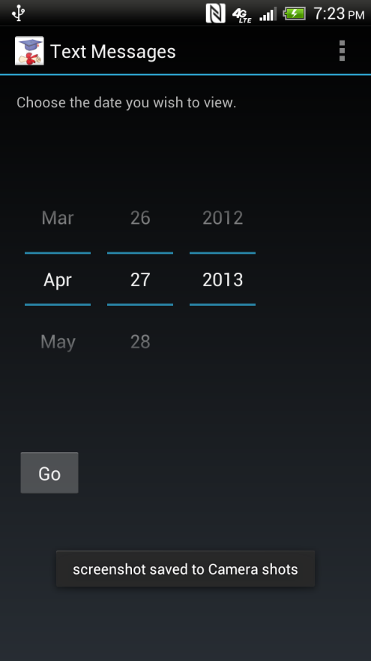

Selecting Go brings us to a list of the text messages for that date.

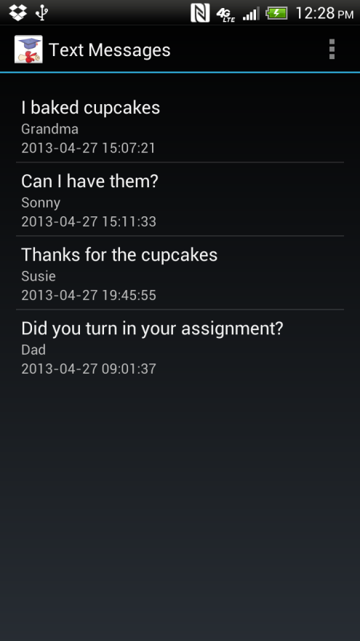

Using all of these features, a parent can monitor their student’s behavior more easily and ensure they are correctly dedicating their lives to their schoolwork.

# Known Bugs and Deficiencies

1. If the student uninstalls or logs out of their application, the parent will no longer be updated with text messages or location data.
2. Teachers must exactly enter the names of assignments and students when adding them, otherwise it will fail.
3. Teachers must add a grade individually for every student and every assignment, rather than being able to do so in bulk.
4. There are no known “bugs” at this time.