# Diagrams

## Conceptual Model/Multiplicities for the Data Model

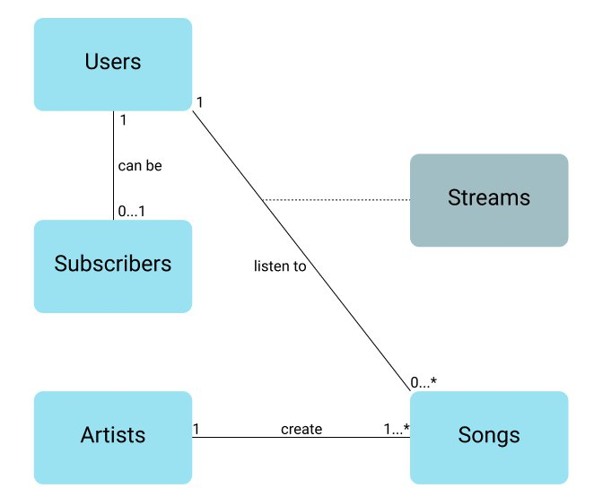

## Logical Model for the Data Model

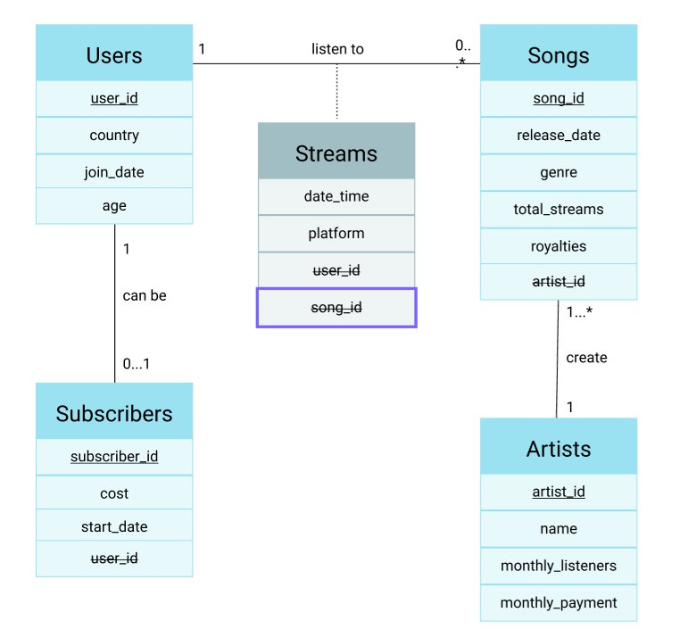

## Stakeholder Activity Topic Question Mind Map

