#include <stdio.h>

#include <stdlib.h>

#include <string.h>

#define MAX 100

void getstring(char *string,char *file){

FILE *fp;

int i=0;

if((fp=fopen(file,"r"))==NULL){

printf("Can't open %s\n",file);

}else{

while(!feof(fp)){

string[i]=fgetc(fp);

i++;

}

//fgets(string,15,fp);

}

}

int getInt(char *string,int *Ascstring){

int i;

for(i=0;i<strlen(string)-1;i++){

Ascstring[i]=string[i];

}

return i;

}

void initable(int *AscToInt,int *rule,int ruleresult[2][3]){

int j,i;

for(j=0;j<95;j++){

AscToInt[j]=j+32;

}

for(j=0;j<95;j++){

if((j>32 && j<59) || (j>64 && j<91)){

rule[j]=1;//表示是字母

}else if(j>15 && j<26){

rule[j]=2;//表示是数字

}else{

rule[j]=0;//表示字母数字都不是

}

}

for(j=0;j<3;j++){

for(i=0;i<2;i++){

if(i==0 && j==0){

ruleresult[i][j]=0;

}else if(i==1 && j==0){

ruleresult[i][j]=0;

}else if(i==0 && j==1){

ruleresult[i][j]=1;

}else if(i==1 && j==1){

ruleresult[i][j]=1;

}else if(i==0 && j==2){

ruleresult[i][j]=0;

}else if(i==1 && j==2){

ruleresult[i][j]=1;

}

}

}

}

int judgestring(int *Ascstring,int *AscToInt,int *rule,int *ruleresult[2][3],int length){

int flag=0,i=0,tmp,j;

for(i;i<length;i++){

for(j=0;j<95;j++){

if(AscToInt[j]==Ascstring[i]) break;

}

tmp=rule[j];

if(ruleresult[flag][tmp]==0){

flag=0;

break;

}else{

flag=1;

}

i++;

}

return flag;

}

int main()

{

char myfile[20];

char string[MAX];

int AscString[MAX],j,AscToInt[MAX],rule[MAX],ruleresult[2][3],flag=0;

printf("Enter the file name:");

scanf("%s",myfile);

getstring(string,myfile);

int i=0;

while(string[i]!=NULL){

printf("%c",string[i]);

i++;

}

j=getInt(string,AscString);

for(i=0;i<j;i++){

printf("%d\n",AscString[i]);

}

initable(AscToInt,rule,ruleresult);

flag=judgestring(AscString,AscToInt,rule,ruleresult,j);

if(flag==1){

printf("输入的字符串符合规则");

}else{

printf("输入的字符串不符合规则");

}

return 0;

}

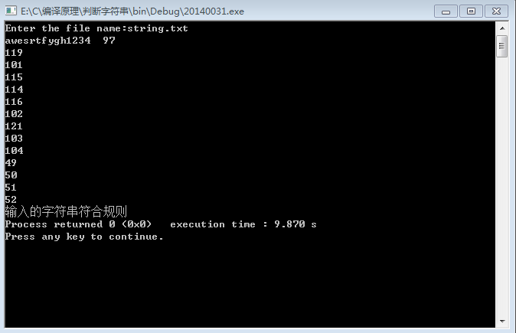

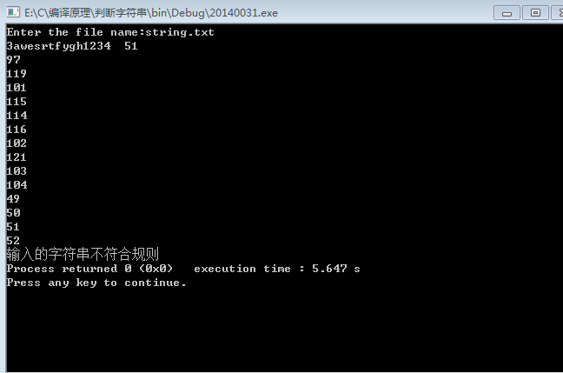

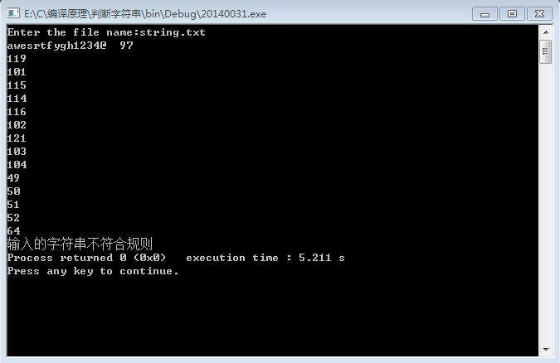

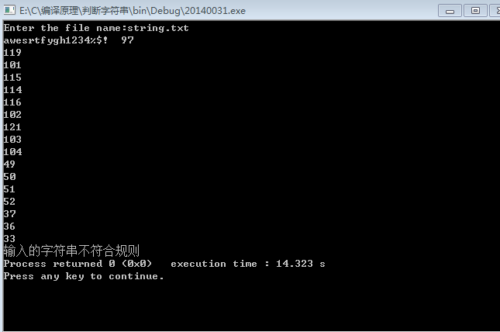

#include<iostream>

#include<string>

using namespace std;

#define MAX 100

struct Split{

char string2[MAX];

};

Split* Pk(char *A,int *B,int *C){

Split cut[MAX];

char *p = A;

int i,j,m=0,n=0,k=0,flag1=0,flag2=0;

while(*p!=NULL){

for(j=0;j<6;j++){

if(*p == C[j]){

cut[n].string2[k] = *p;

n++;

m=0;

p++;

flag1=1;

break;

}

}

for(i=0;i<3;i++){

if(*p == B[i]){

n++;

m=0;

p++;

flag2=1;

break;

}

}

if(flag1 == 0 && flag2 == 0){

cut[n].string2[m] = *p;

m++;

p++;

}

flag1 = 0; flag2 = 0;

}

return cut;

}

int main(){

Split *Coll;

int i,j;

int Split_1[] = {32,10,9};

int Split_2[] = {44,59,123,125,40,41};

char *string1 = "main (){int i,j,k23,mab;}";

Coll = Pk(string1,Split_1,Split_2);

for(i=0;i<10;i++){

for(j=0;j<4;j++){

if(Coll[i].string2[j]!=NULL){

cout<<Coll[i].string2[j];

}

}

cout<<endl;

}

//cout<<Coll[9].string2[0];

return 0;

}

