当前状态 | 扫视字符 | 语义处理操作或接受动作 | 后继状态
0 | d | {n=0;p=0;e=1;w=d} | 1
0 | · | { w=0;n=0;p=0;e=1} | 3
0 | other | 识别失败 | NULL
1 | d | {w=w*10+d} | 1
1 | · |  | 2
1 | E |  | 4
1 | other | {回送整常数ICON=w} | 结束
2 | d | {n++;w=w*10+d} | 2
2 | E |  | 4
2 | Other | {回送实常数FCON=w*pow(10,e*p-n)} | 结束
3 | d | {n++;w=w*10+d;} | 2
3 | Other | 识别失败 | NULL
4 | d | {p=p*10+d} | 6
4 | + |  | 5
4 | - | {e=-1;} | 5
4 | other | 识别失败 | NULL
5 | d | {p=p*10+d;} | 6
5 | other | 识别失败 | NULL
6 | d | {p=p*10+d;} | 6
6 | other | {回送实常数FCON=w*pow (10,e*p-n) } | 结束

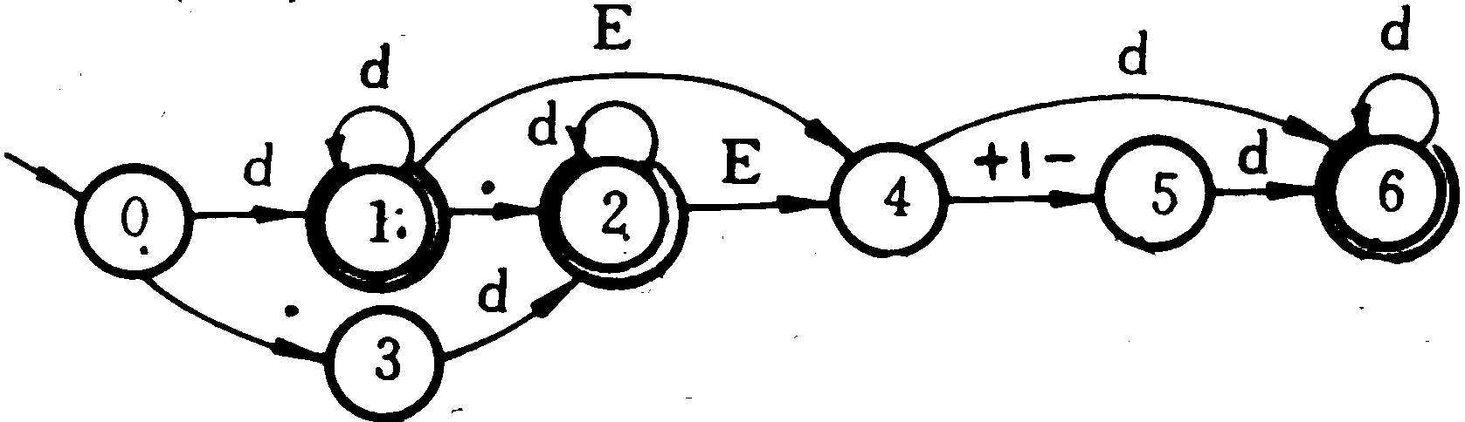

1 #include＜stdio. h＞
2 #include＜ctype. h＞
3 #include＜math. h＞
4 #define LETTER 0
5 #define DIGIT 1
6 #define POINT 2
7 #define OTHER 3
8 #define POWER 4
9 #define PLUS 5
10 #define MINUS 6
11 #define ClassNo 100 //Suppose the class of number is 100
12 #define ClassOther 200
13 #define EndState -1
14 int w, n, p, e, d;
15 int Class; //Used to indicate class of the word
16 int ICON;
17 float FCON;
18 static int CurrentState; //Used to present current state, the initial value:0
19
20 int GetChar( void );
21 int EXCUTE( int, int );
22 int LEX( void )
23 int HandleWord ( void )
24 { return ClassOther;
25 }
26 int HandleError ( void )
27 { printf ( 〃Error! \n〃); return 0;}
28
29 int GetChar ( void )
30 {
31 int c;
32 c=getchar ( );
33 if ( isdigit ( c ) ) {d=c-‘0′; return DIGIT ; }
34 if ( c= =′.′) return POINT ;
35 if ( c= =′E′|| c= =′e′) return POWER;
36 if ( c= =′+′) return PLUS ;
37 if ( c= =′-′) return MINUS ;
38 return OTHER;
39 }
40 int EXCUTE ( int state, int symbol )
41 {
42 swithch ( state )
43 {
44 case 0: switch ( symbol )
45 {
46 case DIGIT:n=0;p=0;e=1;w=d;CurrentState=1;Class=CalssNo;break;
47 case POINT:w=0;n=0;p=0;e=1;CurrentState=3;Class=CalssNo;break;
48 default :HandleError( );Class=ClassOther;
49 CurrentState=EndState;
50 }
51 break;
52 case 1:switch ( symbol )
53 {
54 case DIGIT:w=w*10+d;break; //CurrentState=1
55 case POINT;Currentstate=2;break;
56 case POWER;Currentstate=4;break;
57 default :ICON=w;CurrentState=EndState;
58 }
59 break;
60 case 2:switch ( symbol )
61 {
62 case DIGIT:n++;w=w*10+d;break;
63 case POWER:CurrentState=4;break;
64 default: FCON=w*pow ( 10, e*p-n ); CurrentState=Endstate;
65 }
66 break;
67 case 3:switch ( symbol )
68 {
69 case DIGIT: n++;w=w*10+d;CurrentState=2; break;
70 default :HandleError ( ); Class=ClassOther;
CurrentState=EndState;
71 }
72 break
73 case 4:switch ( symbol )
74 {
75 case DIGIT :p=p*10+d;CurrentState=6;break;
76 case MINUS:e=-1;CurrentState=5;break;
77 case P LUS:CurrentState=5;break;
78 default :HandleError ( ); Class=ClassOther;
CurrentState=EndState;
79 }
80 break;
81 case 5: switch ( symbol )
82 {
83 case DIGIT: p=p*10+d;CurrentState=6;break;
84 default: HandleError ( ); Class=ClassOther;
CurrentState=EndState;
85 }
86 break
87 case6:switch ( symbol )
88 {
89 case: DIGIT: p=p*10+d; break;
90 default:FCON=w*pow ( 10,e*p-n ); CurrentState = Endstate;
91 }
92 break;
93 }
94 return CurrentState;
95 }
96 int Lex ( void )
97 {
98 int ch;
99 CurrentState=0
100 while ( CurrentState! =EndState )
101 {
102 ch=GetChar ( );
103 EXCUTE ( CurrentState, ch );
104 }
105 return Class；
106 }

