PROVISIONAL PATENT APPLICATION

Title: COMPUTATIONAL METHODOLOGY FOR DIMERIC CANNABINOID PREDICTION WITH CONSENT-GATED TRADITIONAL KNOWLEDGE INTEGRATION AND FDA SCHEDULE 3 COMPLIANCE SUPPORT

Inventor: Contessa Petrini

Assignee: Cloak and Quill Research, Inc.

Filing Date: [Date to be Assigned]

CROSS-REFERENCE TO RELATED APPLICATIONS

[0001] This application may claim priority to and benefit of related applications covering consent-gated research infrastructure platforms, blockchain-based attribution and benefit-sharing coordination systems, and traditional knowledge validation methodologies. Any such related applications are incorporated herein by reference in their entirety to the extent applicable to the present invention.

STATEMENT REGARDING PROPHETIC EXAMPLES

[0002] This application describes computational methodologies and system architectures using prophetic examples per USPTO guidelines for chemical and computational inventions. Prophetic examples describe methods and systems predicted to function as specified based on established scientific principles and computational techniques.

[0003] The described methodologies build upon operational consent-gated infrastructure platforms (referenced in related applications) and apply established computational chemistry principles, machine learning architectures, and blockchain coordination mechanisms to the novel application domains of dimeric cannabinoid prediction with traditional knowledge protection and FDA regulatory compliance support.

[0004] Where operational implementation has not yet been completed, the application describes intended functionality based on known scientific methods and computational approaches. The methodology validation employs three characterized dimeric cannabinoids as reference standards, with acknowledgment that expanded validation will occur as predicted novel dimeric structures are synthesized and characterized.

[0005] The FDA regulatory compliance support capabilities build upon established documentation standards and submission requirements, adapted to the specific application domain of botanical cannabinoid therapeutics transitioning from Schedule I to Schedule III classification under the Controlled Substances Act.

FIELD OF THE INVENTION

[0006] This invention relates to computational methodologies for botanical therapeutic discovery with integrated regulatory compliance support. Specifically, the invention relates to methods for predicting methylene-bridged dimeric cannabinoid formation through computational modeling of oxidative aging processes, with integration of traditional knowledge validation, consent-gated processing to ensure ethical community benefit-sharing, and automated generation of documentation supporting FDA regulatory submissions for Schedule III cannabis-derived pharmaceuticals.

BACKGROUND OF THE INVENTION

1. The Dimeric Cannabinoid Discovery Challenge

[0007] Recent peer-reviewed research has validated that rare dimeric cannabinoids possess therapeutic properties substantially superior to their parent monomeric compounds. Cannabizetol, a cannabigerol dimer discovered in September 2025 and characterized in the Journal of Natural Products, demonstrated enhanced anti-inflammatory activity through superior NF-κB pathway inhibition compared to cannabigerol monomer. This discovery validates the therapeutic potential of dimeric cannabinoid structures.

[0008] However, dimeric cannabinoids occur at natural concentrations below 0.1 percent in aged cannabis plant material, making extraction commercially infeasible. These compounds form through non-enzymatic oxidative processes during plant material aging, where methylene bridges link two cannabinoid molecules.

[0009] The specific conditions favoring dimeric formation, the range of possible dimeric structures from different parent cannabinoids, and the therapeutic properties of predicted dimers remain poorly characterized. Current approaches require synthesis-first methodologies where compounds must be physically created before any evaluation of therapeutic potential.

[0010] This creates substantial resource inefficiency, as researchers must synthesize dozens of dimeric candidates without prior knowledge of which structures will exhibit superior therapeutic properties or even whether predicted structures will be chemically stable and synthetically accessible.

[0011] No existing computational methodology enables prediction of which dimeric cannabinoid structures will form under specific oxidative aging conditions, what therapeutic properties those dimeric structures will exhibit, or how to prioritize synthesis efforts based on predicted therapeutic value and synthetic feasibility.

2. Traditional Knowledge and Dimeric Cannabinoid Formation

[0012] Many traditional cannabis preparation methods involve extended aging, curing, or oxidative processing of plant material. These traditional processes may concentrate dimeric cannabinoids through the same oxidative mechanisms that form methylene bridges.

[0013] Traditional knowledge holders developed these preparation methods over generations without access to modern analytical chemistry, yet their methods may have selected for processing conditions that favor therapeutically superior dimeric compound formation.

[0014] Integration of traditional knowledge into modern pharmaceutical research has historically occurred through extraction and appropriation rather than respectful partnership with fair compensation. No existing computational platform enforces free, prior, and informed consent before processing traditional botanical knowledge or provides automated benefit-sharing mechanisms when traditional knowledge contributes to commercial discoveries.

3. Schedule III Reclassification and FDA Regulatory Barriers

[0016] The pending reclassification of cannabis from Schedule I to Schedule III under the Controlled Substances Act creates urgent need for FDA-compliant regulatory submission documentation. Schedule III classification requires pharmaceutical manufacturers to demonstrate safety and efficacy through FDA approval processes rather than operating under state-level medical cannabis programs.

[0017] Cannabis companies currently operating under state medical and recreational frameworks face imminent regulatory transition requiring:

- (a) Chemistry, Manufacturing, and Controls (CMC) documentation detailing compound identification, quantification, and quality control processes
- (b) Pharmacology data packages demonstrating mechanism of action for specific cannabinoid compounds
- (c) Clinical efficacy evidence supporting therapeutic claims for approved medical conditions
- (d) Isolated compound characterization distinguishing therapeutic effects of individual cannabinoids from whole-plant preparations

[0018] Current research infrastructure has focused on whole-plant cannabis preparations suitable for Schedule I research exemptions but inadequate for Schedule III pharmaceutical approval. The transition to Schedule III creates demand for computational tools that can rapidly generate FDA-submission-ready documentation for cannabinoid compounds.

[0019] No existing computational platform provides integrated dimeric cannabinoid prediction with automated generation of regulatory documentation formatted for FDA submission requirements. Cannabis companies face choosing between expensive manual documentation processes or delayed market entry while building internal compliance capabilities.

4. Regulatory Research Barriers Under Current Schedule I Classification

[0020] Cannabis remains classified as Schedule I under current Controlled Substances Act regulations, creating severe research bottlenecks during the transition period before Schedule III implementation. Researchers face

twelve to eighteen month delays to obtain DEA licenses merely to possess cannabinoid reference standards for analytical work.

[0021] These delays prevent timely investigation of potentially therapeutic compounds and substantially increase research costs. Computational prediction methodologies that enable virtual screening before physical synthesis could reduce research timelines by identifying promising dimeric candidates before DEA license applications.

[0022] However, no existing system provides this computational research pathway for dimeric cannabinoid discovery integrated with regulatory compliance documentation generation.

SUMMARY OF THE INVENTION

[0025] The present invention provides computational methodologies for predicting methylene-bridged dimeric cannabinoid formation with integrated traditional knowledge validation, consent-gated processing, and automated generation of FDA Schedule III regulatory compliance documentation.

[0026] The methodology enables researchers to computationally predict which dimeric structures will form under specified oxidative aging conditions, prioritize synthesis efforts based on predicted therapeutic value, generate documentation supporting FDA approval submissions, and ensure ethical traditional knowledge integration through automated consent enforcement and benefit-sharing execution.

[0027] The invention comprises five integrated methodological innovations described as follows.

1. Computational Dimeric Structure Prediction Methodology

[0028] The core methodology predicts methylene-bridged dimeric cannabinoid formation from parent cannabinoid molecular structures and oxidative aging condition parameters. The methodology employs graph-based analysis of parent cannabinoid molecular structures to identify reactive sites amenable to methylene bridge formation, calculates geometric compatibility through three-dimensional conformational analysis, models oxidative environment effects, and generates predicted homodimeric and heterodimeric structures with formation probability scores.

[0029] This methodology enables researchers to computationally screen thousands of potential dimeric structures before committing resources to physical compound creation.

2. Machine Learning Architecture for Prediction Refinement

[0030] The methodology incorporates supervised machine learning approaches that refine formation probability predictions as experimental validation data accumulate. Initial implementation employs gradient boosting decision trees suitable for small training datasets, with transition to neural network architectures as validation expands.

[0031] The machine learning framework includes uncertainty quantification providing confidence intervals, active learning strategies directing synthesis toward most informative predictions, and continuous model retraining triggered by data accumulation.

[0032] This adaptive learning enables systematic improvement from initial bootstrap models toward highly accurate predictions as experimental datasets expand.

3. FDA Schedule III Regulatory Compliance Support

[0033] The methodology generates documentation formatted for FDA regulatory submissions supporting Schedule III cannabis pharmaceutical approval. Compliance support capabilities include automated generation of Chemistry, Manufacturing, and Controls documentation, pharmacology data packages, comparative efficacy analysis, and quality control specifications.

[0034] This regulatory support addresses the urgent industry need created by Schedule III reclassification requiring FDA approval pathways for cannabis-derived therapeutics.

4. Consent-Gated Processing Integration

[0035] The methodology integrates with operational consent-gated infrastructure platforms to enforce traditional knowledge consent requirements. When dimeric cannabinoid research involves traditional preparation methods, the methodology validates community permissions through blockchain-verified consent artifacts before proceeding with computational analysis.

5. Traditional Knowledge Linkage and Automated Benefit-Sharing

[0036] The methodology identifies connections between traditional botanical preparation methods and dimeric cannabinoid formation. When traditional knowledge contributes to dimeric discoveries, the methodology generates cryptographically signed manifests documenting contributions and enables automated benefit-sharing execution through blockchain smart contracts.

BRIEF DESCRIPTION OF THE DRAWINGS

[0042] Figure 1 illustrates the high-level system architecture showing consent-gated foundational infrastructure, analytical processing framework, and dimeric prediction methodology implementation.

[0043] Figure 2 depicts the dimeric cannabinoid structure prediction workflow showing parent cannabinoid input, reactive site identification, formation probability calculation, and predicted structure output.

[0044] Figure 3 illustrates traditional knowledge consent validation integration showing consent artifact validation and analysis authorization.

[0045] Figure 4 shows the traditional knowledge linkage methodology depicting preparation method parameter extraction and mapping to dimeric formation models.

[0046] Figure 5 details automated benefit-sharing execution showing manifest generation and proportional distribution via blockchain smart contracts.

[0047] Figure 6 illustrates FDA Schedule III regulatory compliance documentation generation workflow.

[0048] Figure 7 depicts modular analytical processing architecture showing separation between disclosed methodology and proprietary implementations accessed through APIs.

[0049] Figure 8 shows continuous learning and model refinement workflow depicting validation data ingestion and automated retraining.

FIG. 1. High-level system architecture showing consent-gated foundational infrastructure, analytical processing framework, and dimeric prediction methodology implementation.
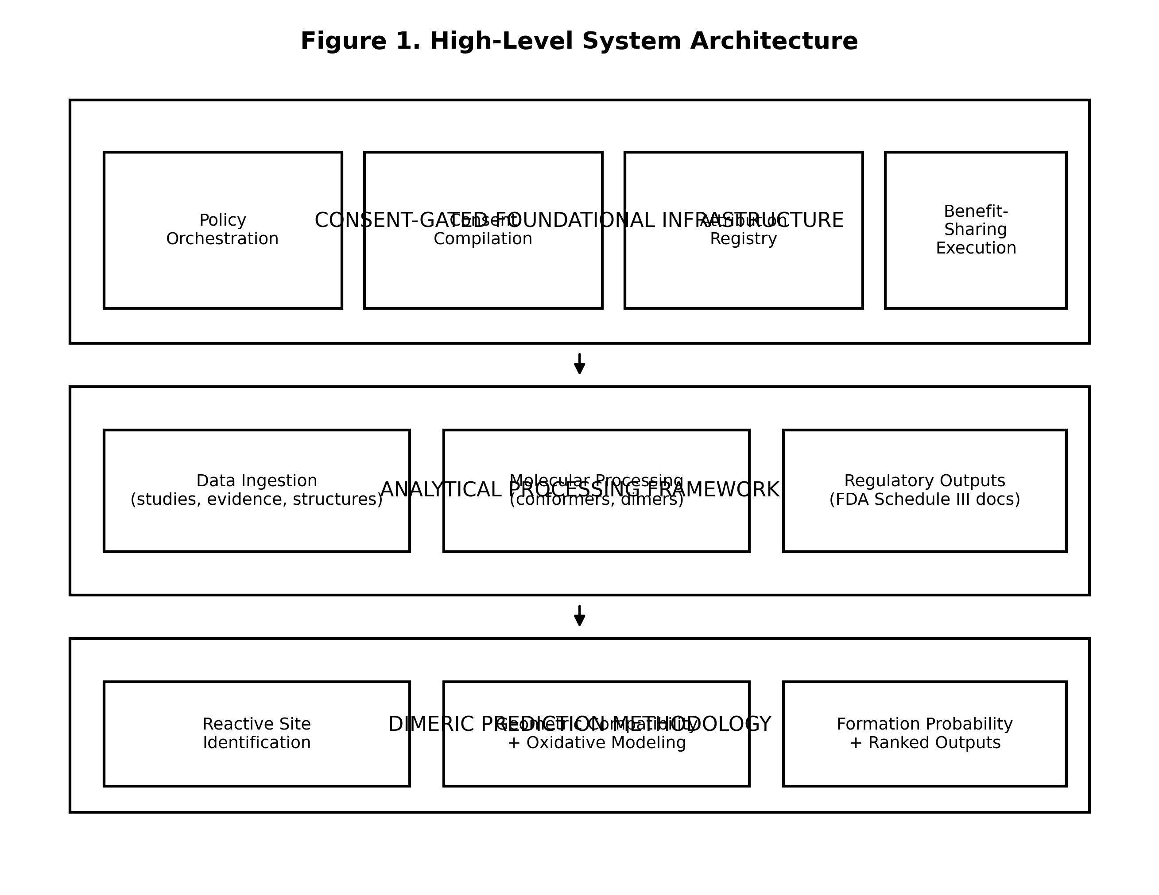

FIG. 2. Dimeric cannabinoid structure prediction workflow showing parent cannabinoid input, reactive site identification, formation probability calculation, and predicted structure output.
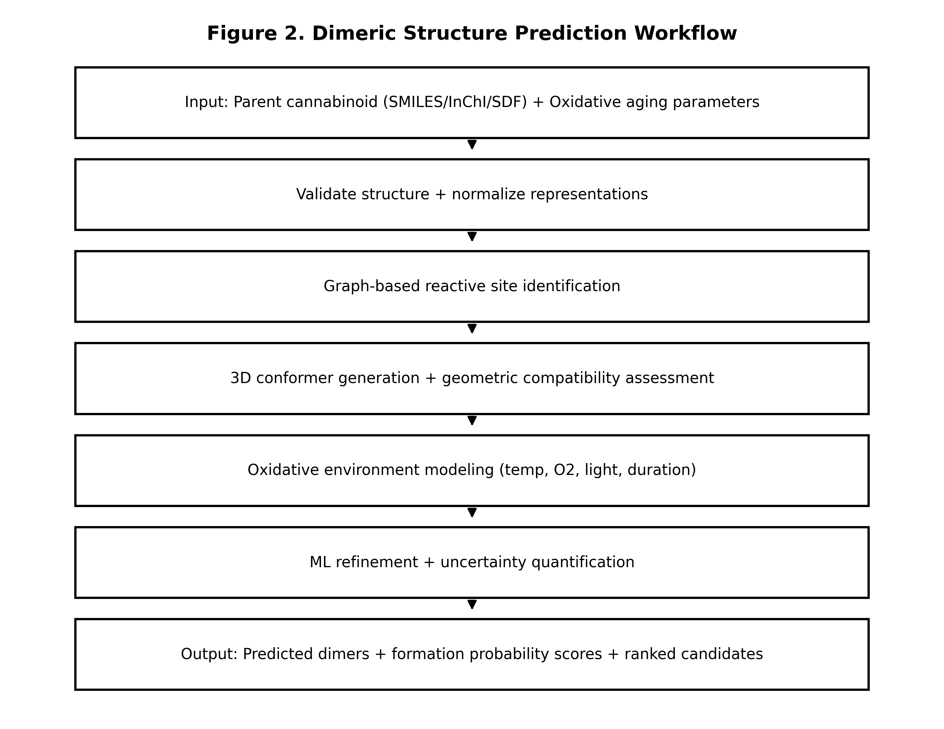

FIG. 3. Traditional knowledge consent validation integration showing consent artifact validation and analysis authorization.
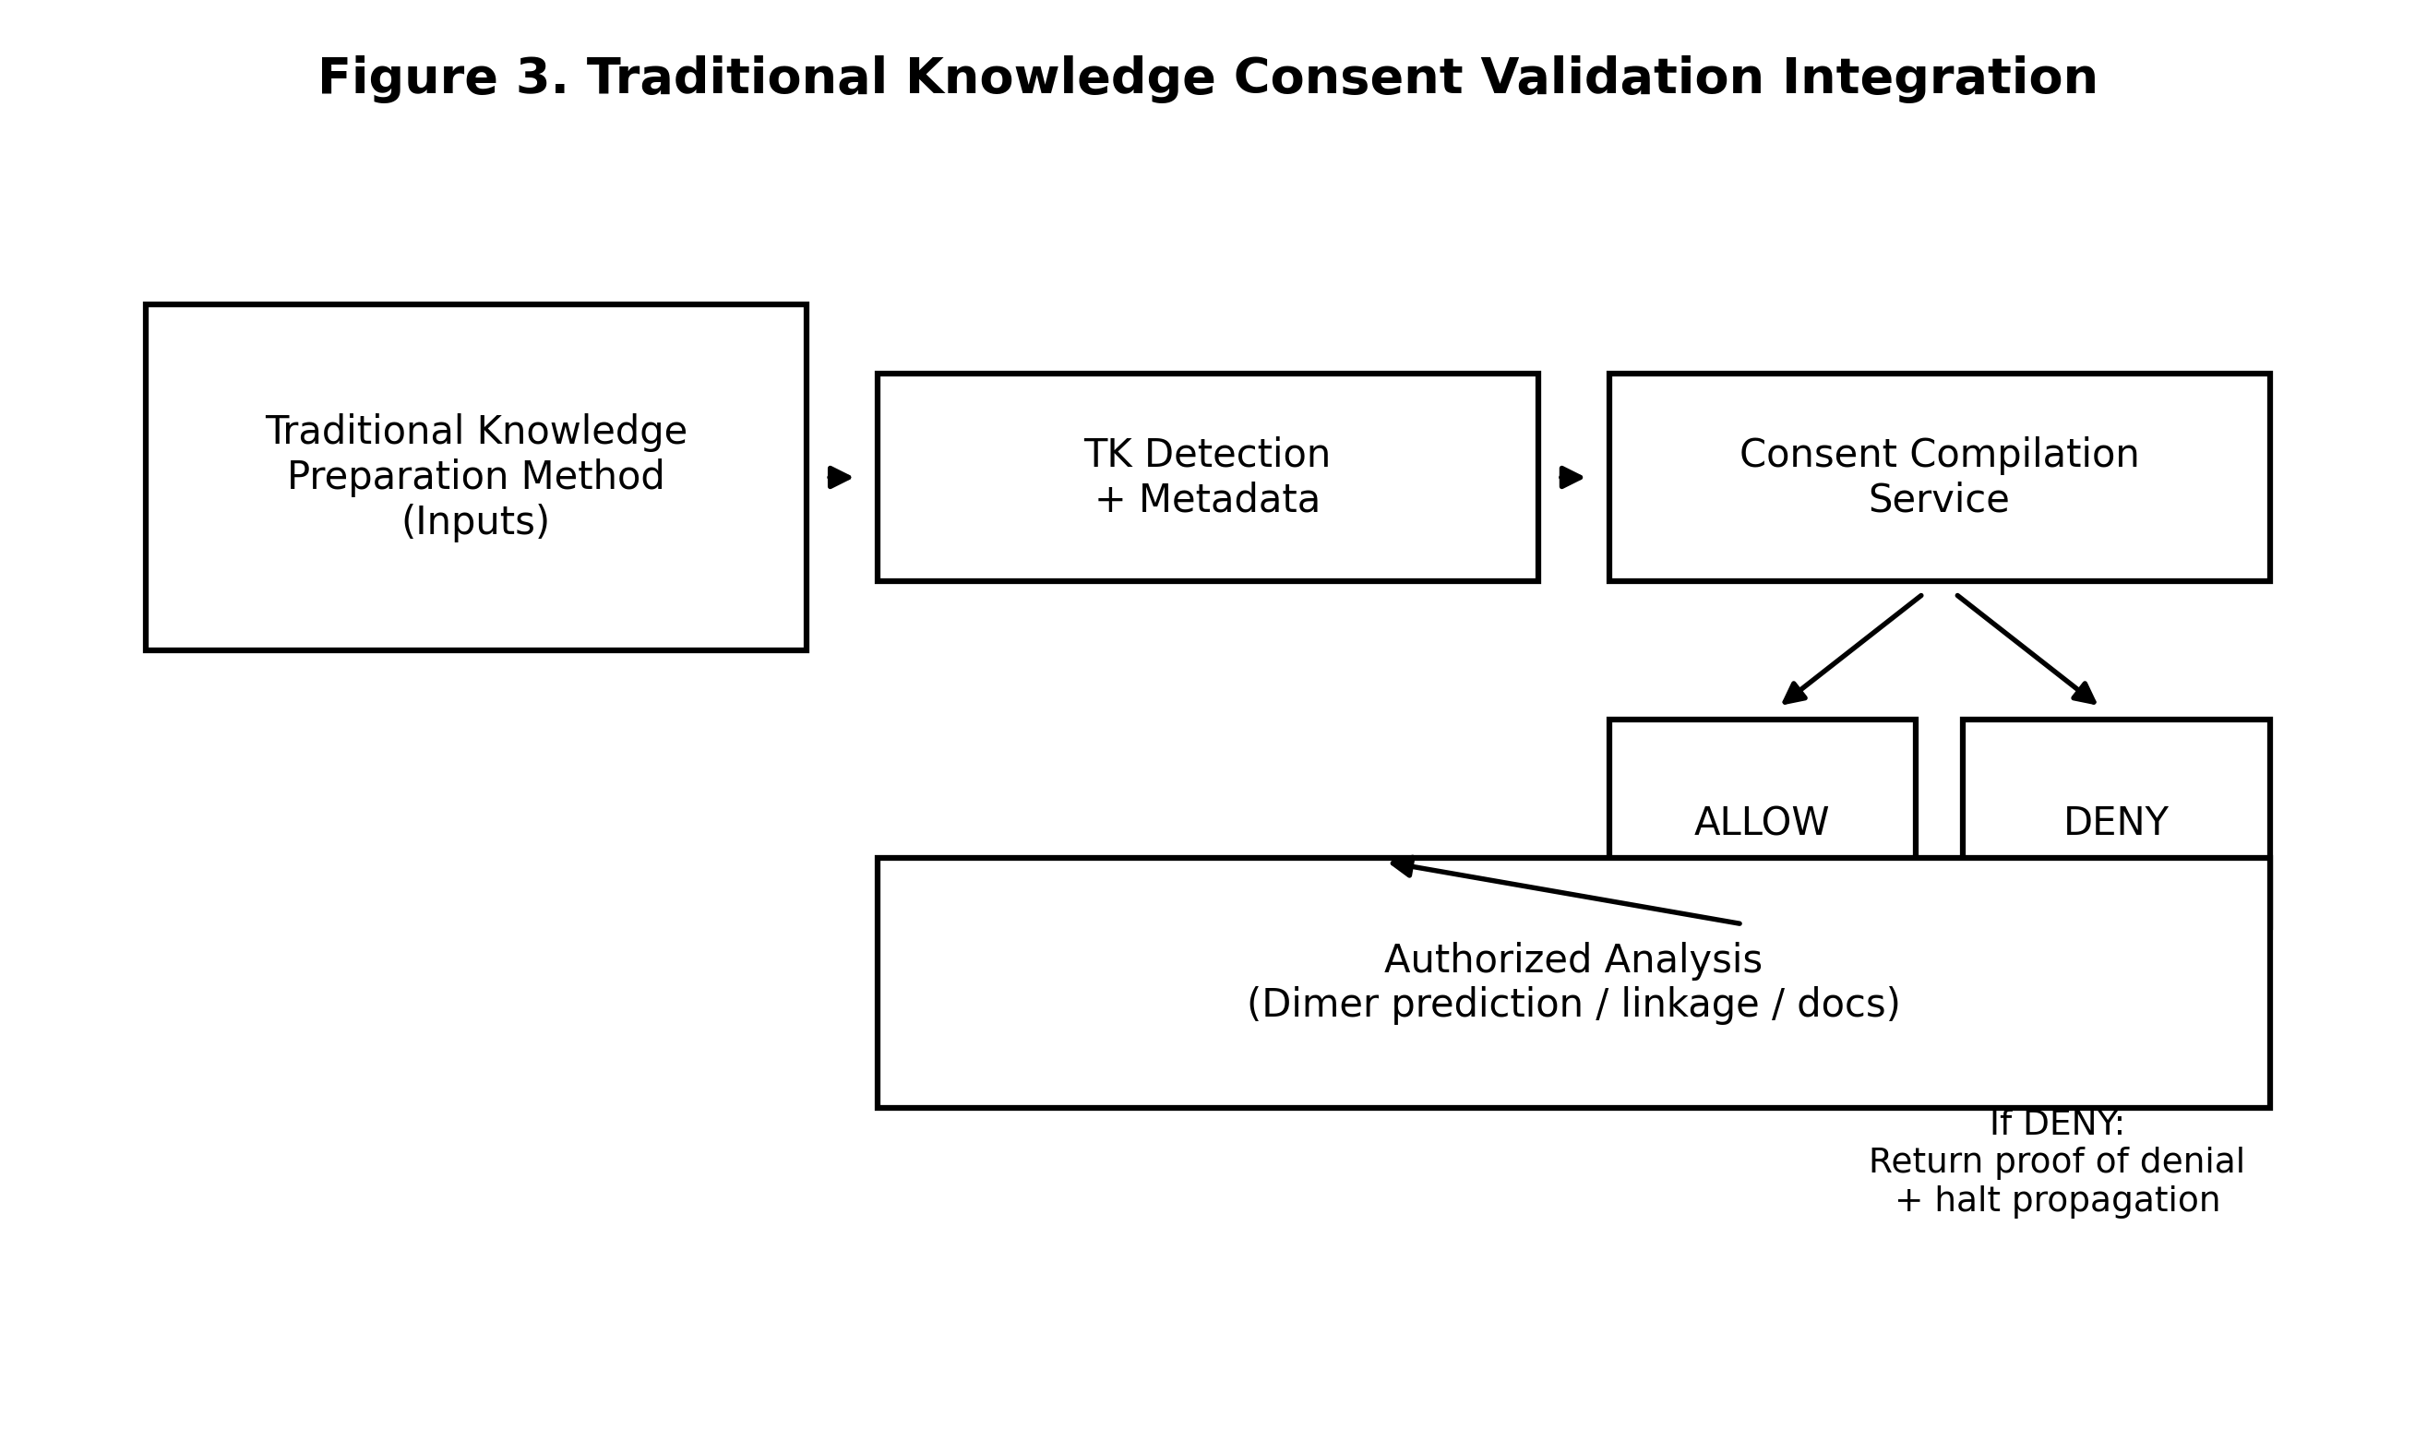

FIG. 4. Traditional knowledge linkage methodology depicting preparation method parameter extraction and mapping to dimeric formation models.
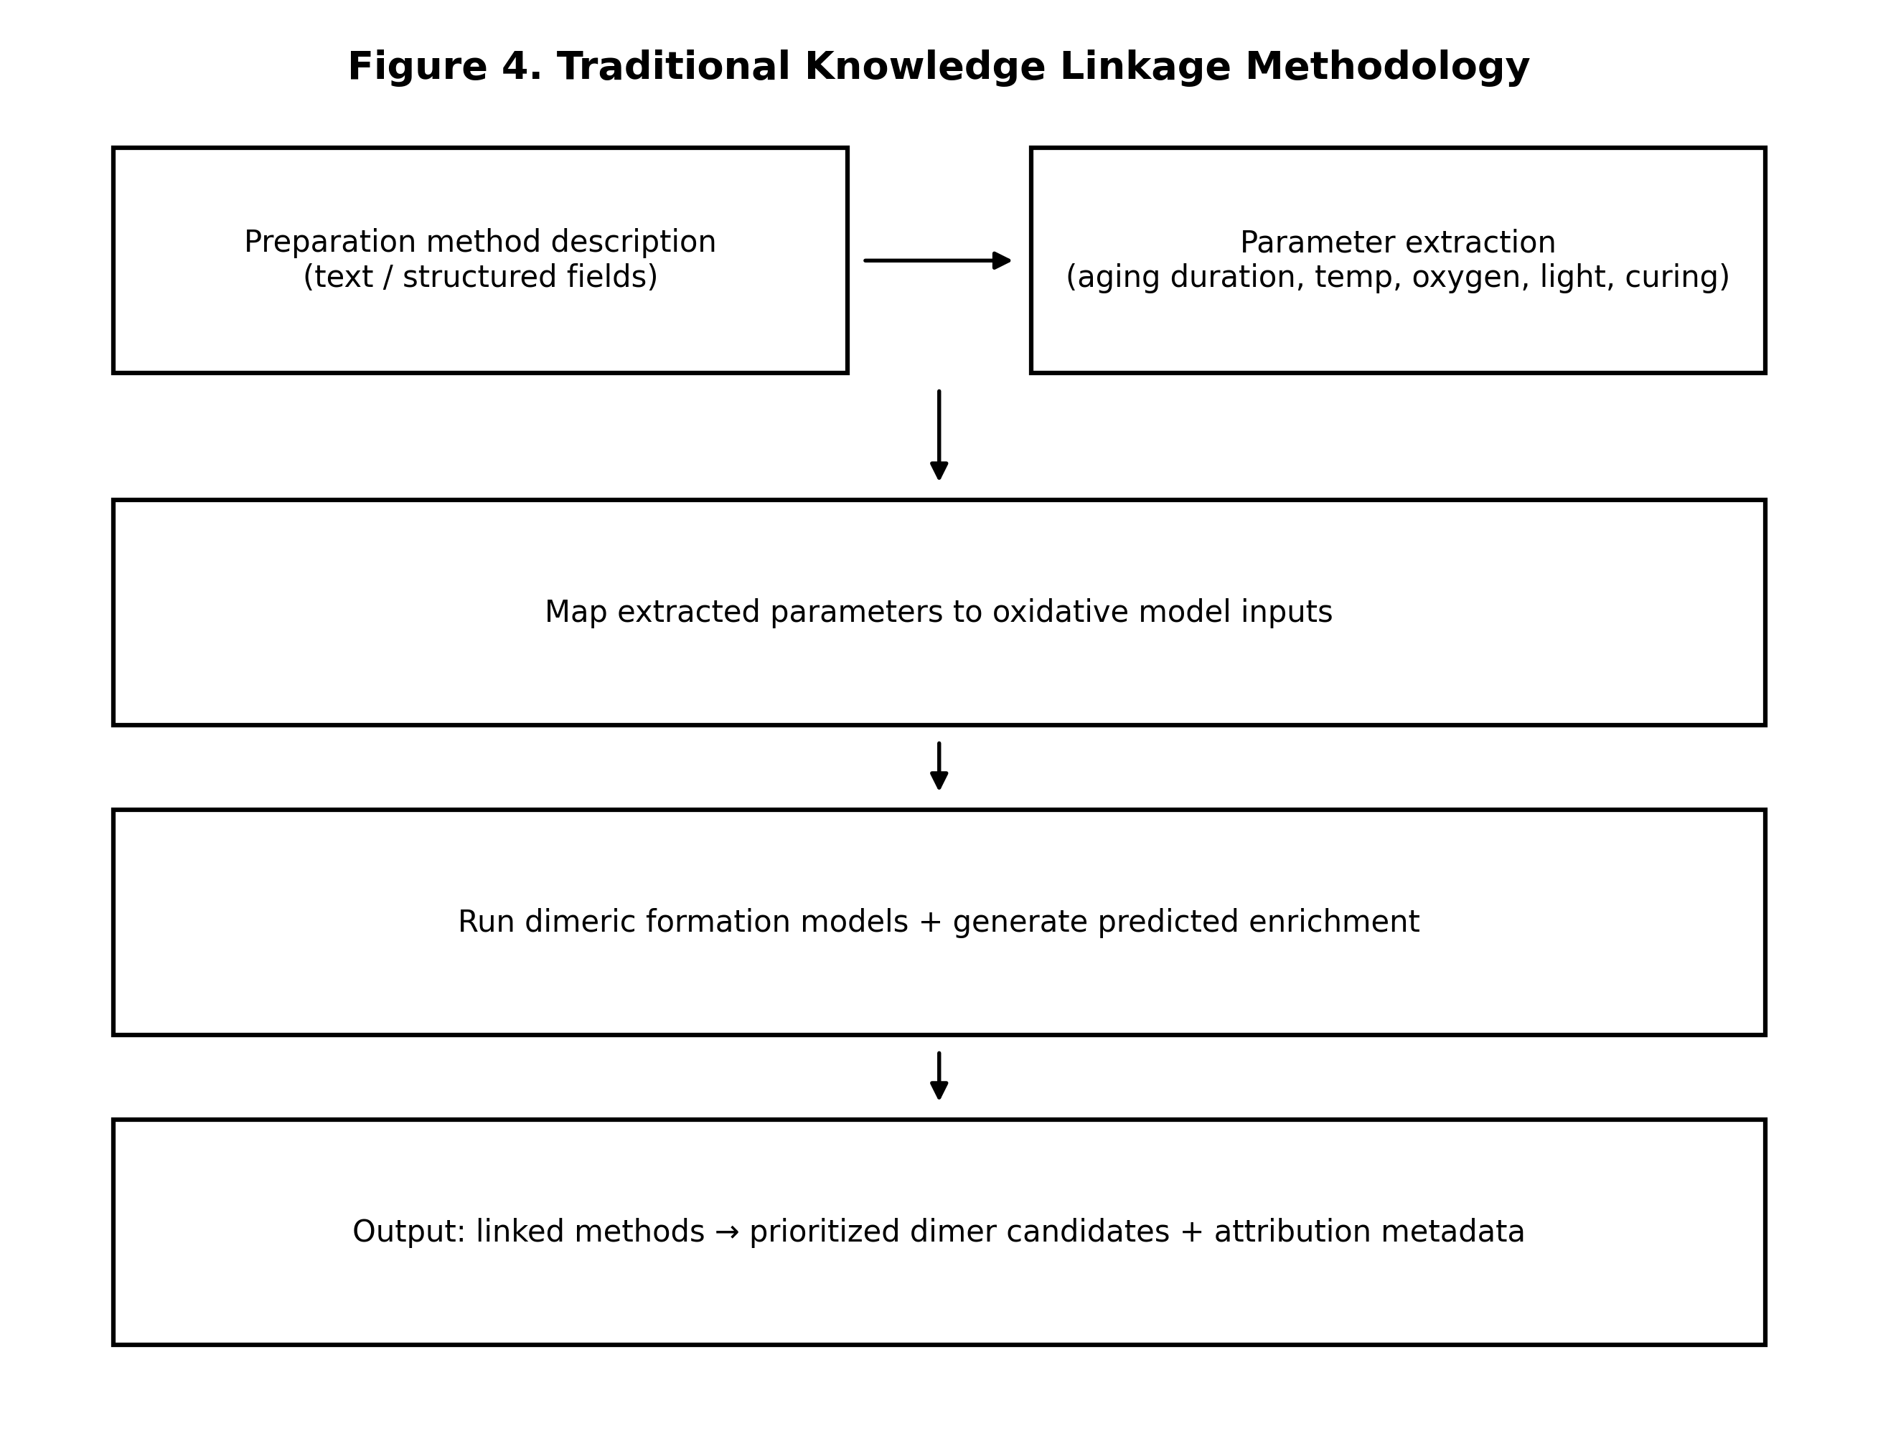

FIG. 5. Automated benefit-sharing execution showing manifest generation and proportional distribution via blockchain smart contracts.
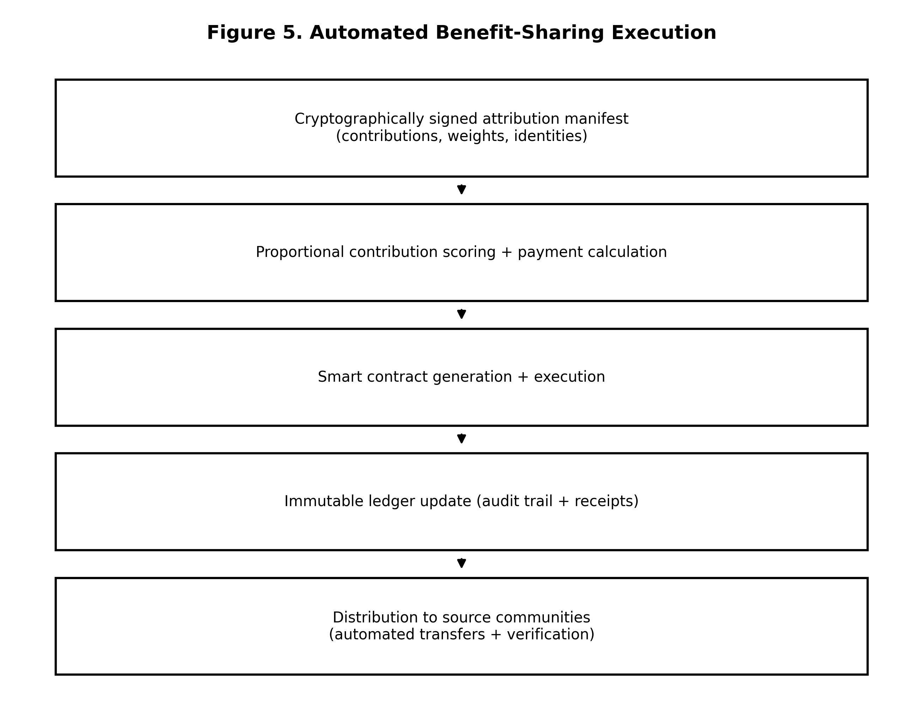

FIG. 6. FDA Schedule III regulatory compliance documentation generation workflow.
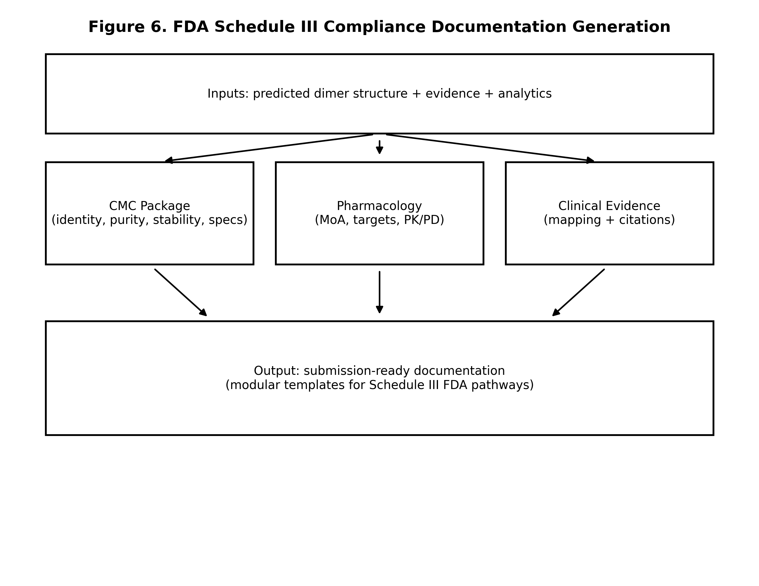

FIG. 7. Modular analytical processing architecture showing separation between disclosed methodology and proprietary implementations accessed through APIs.
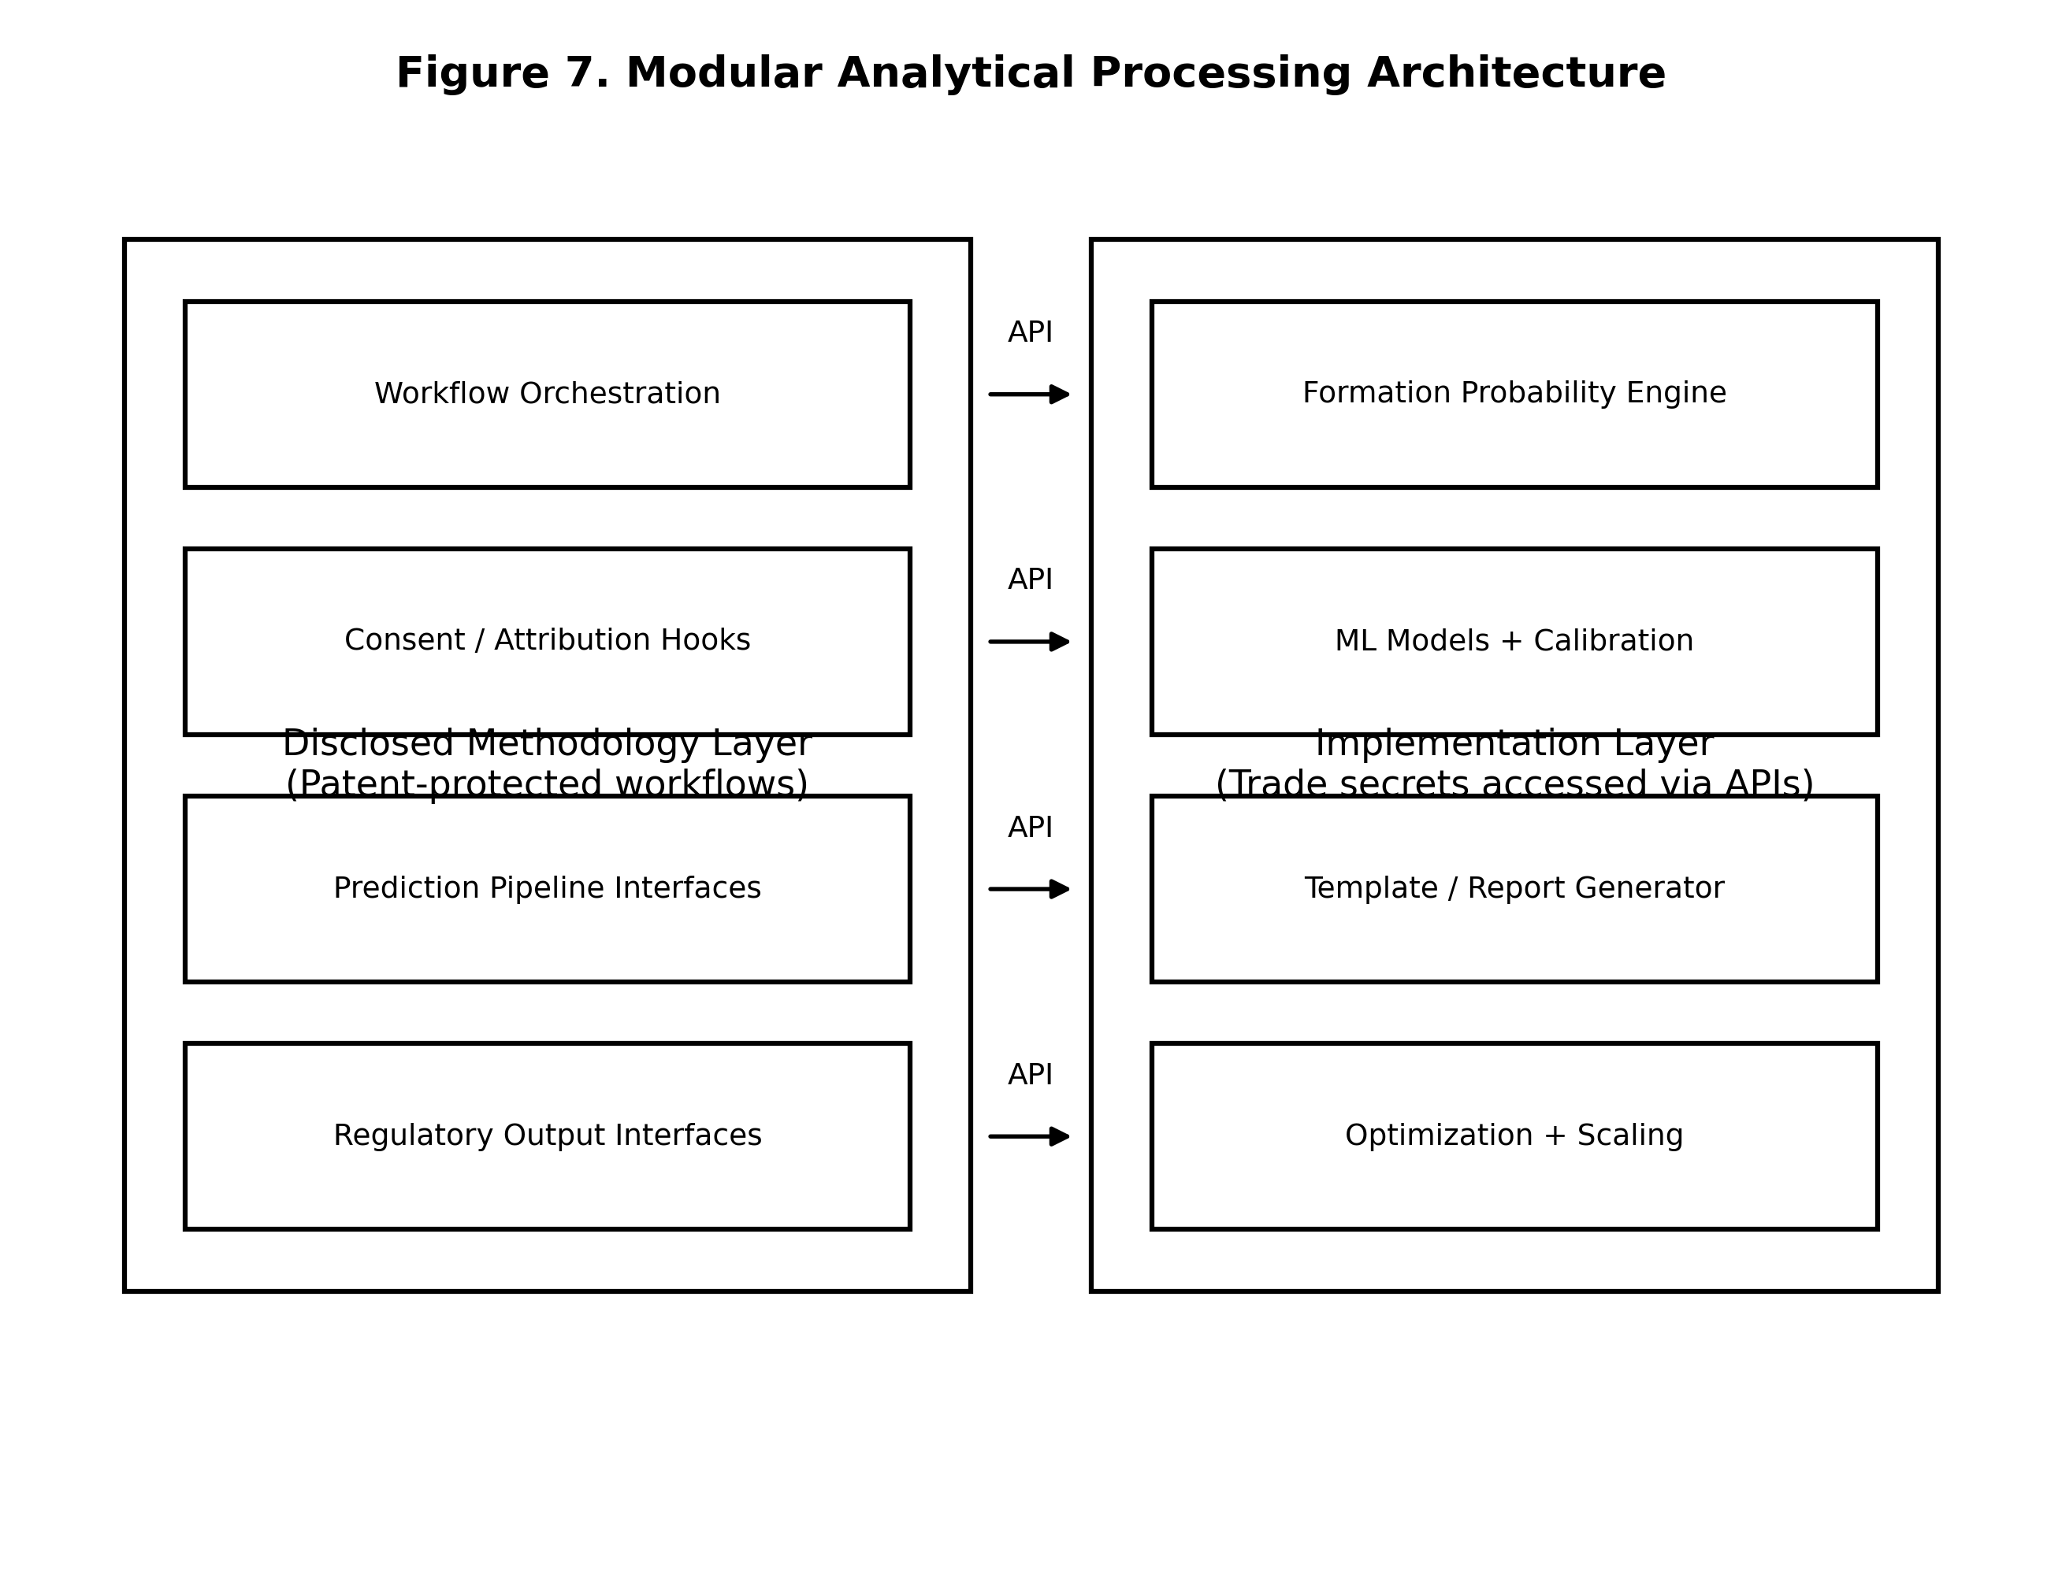

FIG. 8. Continuous learning and model refinement workflow depicting validation data ingestion and automated retraining.
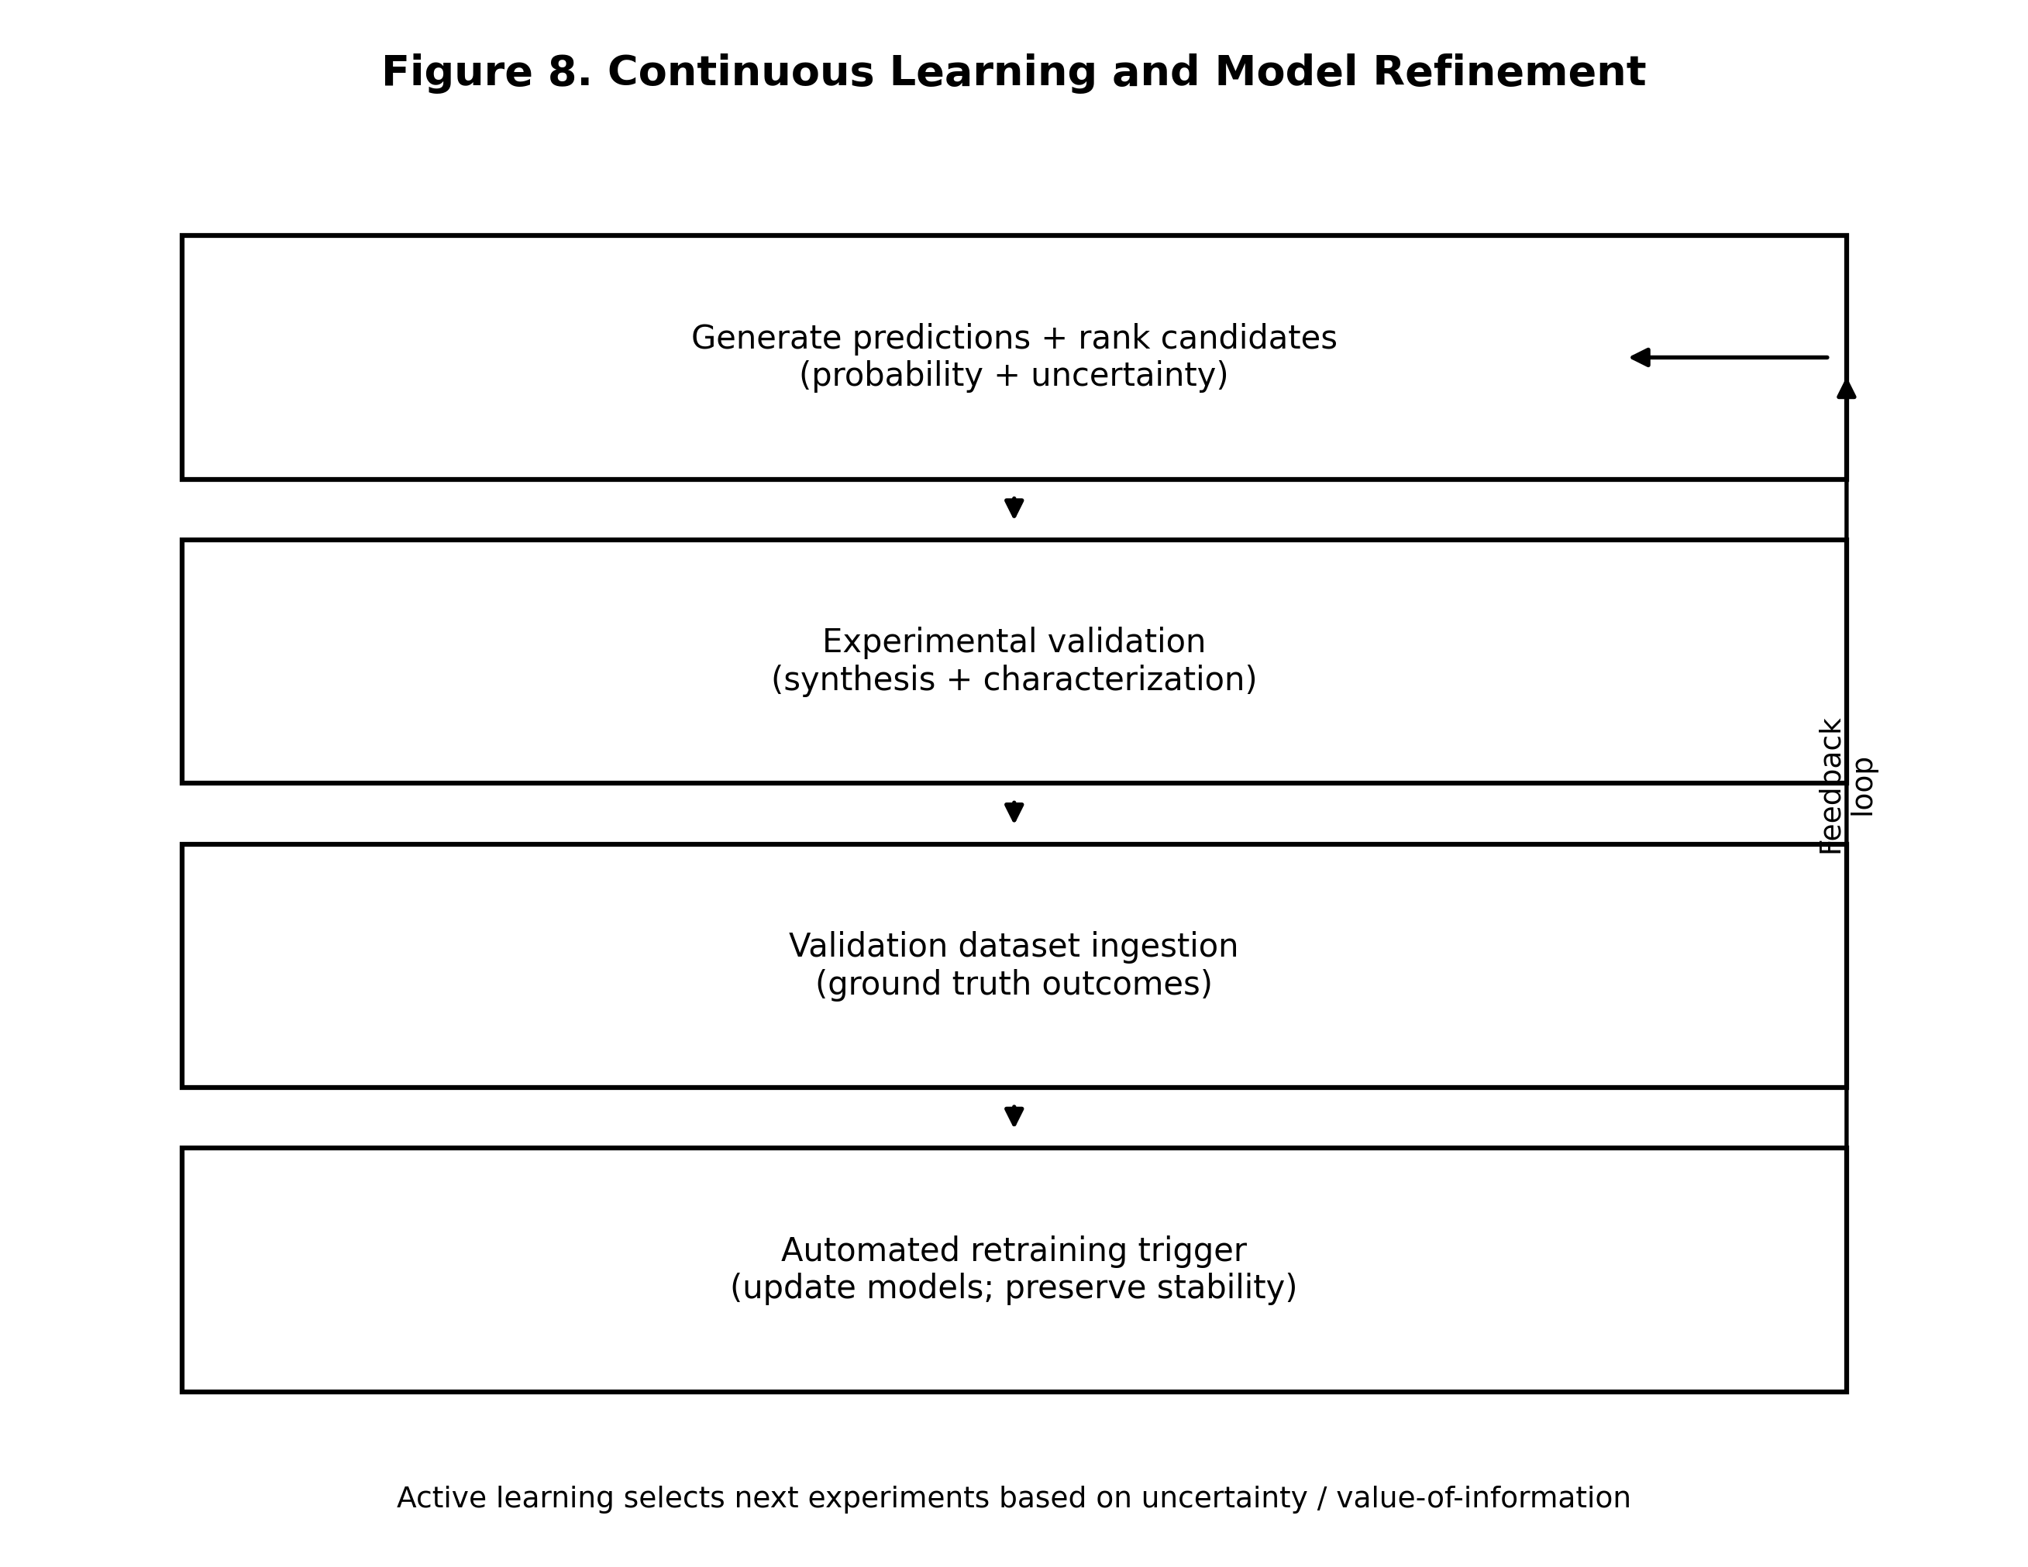

DETAILED DESCRIPTION OF THE INVENTION

1. System Architecture and Modular Design Philosophy

[0050] The computational methodology for dimeric cannabinoid prediction with FDA regulatory compliance support employs a modular architecture that separates system integration methodology (disclosed herein for patent protection) from proprietary analytical implementations (maintained as trade secrets accessed through application programming interfaces).

[0051] The modular design philosophy provides several strategic advantages for intellectual property protection and commercial competitiveness:

Policy Orchestration Service:

[0052] Coordinates consent validation across distributed systems. When botanical preparation methods reference traditional knowledge, the service queries consent registries to verify approved research purposes before allowing dimeric prediction analysis.

Attribution Registry:

[0053] Maintains immutable records linking traditional knowledge sources to dimeric cannabinoid predictions. Attribution metadata enables automated benefit-sharing when predictions lead to commercial products.

Benefit-Sharing Execution Service:

[0054] Calculates proportional compensation based on traditional knowledge contribution levels and executes cryptocurrency transfers via blockchain smart contracts.

Consent Compilation Service:

[0055] Validates traditional knowledge permissions by querying distributed consent artifacts. Returns authorization status with cryptographic proof of consent validity or denial.

Policy Orchestration Service (Detailed):

[0056] The policy orchestration service enforces consent requirements at the integration layer, coordinating authorization checks across prediction workflow stages. When traditional preparation methods reference traditional knowledge, consent validation occurs before computational analysis proceeds.

1.1 Modular Architecture Rationale

[0061] The methodology identifies three layers in the system architecture:

Infrastructure Layer (Operational):

Provides cryptographic authentication using RSA-4096 and ECDSA-P384 standards, distributed policy orchestration with sub-two-second halt propagation, blockchain-based attribution via immutable ledgers, and automated benefit-sharing through smart contracts.

Methodology Layer (Patent-Protected):

Defines computational workflows for dimeric structure prediction, traditional knowledge consent validation, automated benefit-sharing execution, and regulatory documentation generation.

Implementation Layer (Trade Secrets):

Contains proprietary algorithms for formation probability scoring, machine learning model architectures, regulatory template generation, and optimization strategies accessed exclusively through APIs.

2. Core Dimeric Cannabinoid Prediction Methodology

[0070] The core methodology predicts methylene-bridged dimeric cannabinoid formation from parent cannabinoid structures. This section describes the computational workflow enabling researchers to identify promising dimeric synthesis candidates without physical compound creation.

2.1 Parent Cannabinoid Structure Representation

[0071] The methodology accepts parent cannabinoid molecular structures as input using standard molecular representation formats including SMILES strings, InChI identifiers, or SDF structure files. Input validation confirms molecular structure integrity before proceeding with dimeric prediction analysis.

2.2 Graph-Based Reactive Site Identification

[0080] The methodology converts parent cannabinoid structures to graph-based molecular representations where nodes represent atoms and edges represent chemical bonds. Graph traversal algorithms identify reactive sites amenable to methylene bridge formation based on local chemical environment analysis.

Reactive site identification considers:

- Hydroxyl groups at aromatic ring positions
- Electron-donating substituents increasing nucleophilicity
- Steric accessibility for methylene bridge attachment
- Resonance stabilization after bridge formation

2.3 Geometric Compatibility Assessment

[0090] For identified reactive site pairs, the methodology calculates geometric compatibility for methylene bridge formation. Three-dimensional conformational analysis generates low-energy conformers for parent cannabinoids and evaluates spatial positioning enabling bridge formation.

Geometric compatibility assessment includes:

- Distance between reactive sites (optimal 3–5 Å)
- Angular alignment favoring bridge formation
- Conformational flexibility enabling reactive site approach
- Steric hindrance from neighboring functional groups

2.4 Oxidative Environment Modeling

[0098] The methodology models oxidative aging conditions affecting dimeric cannabinoid formation probability. Environmental parameters include temperature, oxygen concentration, light exposure, and aging duration. The model predicts formation kinetics under specified conditions.

2.5 Machine Learning Refinement

[0106] The methodology incorporates machine learning models that refine formation probability predictions as experimental validation data accumulate. Bootstrap training uses three characterized dimeric cannabinoids (cannabizetol, cannabidiolic acid dimer CBD-C3, tetrahydrocannabinolic acid dimer THC-C2) as reference standards.

Machine learning architecture employs:

- Gradient boosting decision trees for small training datasets (< 10 characterized dimers)
- Neural network architectures for expanded datasets (> 10 characterized dimers)
- Uncertainty quantification providing confidence intervals
- Active learning directing synthesis validation toward informative predictions

2.6 Formation Probability Scoring

[0116] The methodology assigns formation probability scores to predicted dimeric structures integrating reactive site favorability, geometric compatibility, oxidative environment modeling, and machine learning refinement. Probability scores enable synthesis prioritization.

2.7 Predictive Model Validation

[0128] The methodology validates predictive models using three characterized dimeric cannabinoids as reference standards. Validation metrics include:

- Prediction accuracy for known dimeric structures
- Calibration of probability scores against experimental outcomes
- Systematic bias detection and correction
- Cross-validation stability across training subsets

Expanded validation will occur as predicted structures are synthesized and characterized, with continuous model refinement improving accuracy.

3. FDA Schedule III Compliance Support

[0133] The methodology generates documentation formatted for FDA regulatory submissions supporting Schedule III cannabis pharmaceutical approval.

3.1 Chemistry Manufacturing and Controls Documentation

[0141] Chemistry Manufacturing and Controls (CMC) documentation describes molecular characterization, manufacturing processes, quality control specifications, and analytical methods for dimeric cannabinoid therapeutics.

CMC documentation includes:

- Molecular structure diagrams and physicochemical properties
- Synthesis pathway descriptions and reaction conditions
- Analytical method validation for identity and purity testing
- Stability data under proposed storage conditions
- Batch release specifications and acceptance criteria

3.2 Pharmacology Data Packages

[0151] Pharmacology data packages demonstrate therapeutic mechanisms and comparative efficacy for predicted dimeric cannabinoids. Packages include mechanism-of-action descriptions, target receptor binding profiles, pharmacokinetic parameter predictions, and comparative efficacy analysis versus parent monomeric cannabinoids.

4. Consent-Gated Processing

[0168] The methodology integrates with operational consent-gated infrastructure platforms to enforce traditional knowledge consent requirements before processing botanical preparation methods.

4.1 Traditional Knowledge Detection

[0177] Traditional knowledge detection identifies preparation methods referencing traditional botanical practices. Detection triggers consent validation before proceeding with dimeric cannabinoid analysis.

4.2 Consent Validation Integration

[0188] When traditional knowledge is detected, the methodology queries consent compilation services to validate community permissions. Consent validation confirms approved research purposes, temporal validity, and authorized users before analysis proceeds.

5. Traditional Knowledge Attribution and Benefit-Sharing

[0195] The methodology identifies connections between traditional preparation methods and dimeric cannabinoid formation, enabling attribution tracking and automated benefit-sharing when traditional knowledge contributes to commercial discoveries.

5.1 Traditional Knowledge Linkage

[0207] Traditional knowledge linkage extracts oxidative processing parameters from preparation method descriptions and maps parameters to dimeric formation probability models, identifying methods likely to concentrate dimeric cannabinoids.

5.2 Attribution Manifest Generation

[0219] Attribution manifests document traditional knowledge contributions to dimeric cannabinoid predictions using cryptographically signed records stored on immutable blockchain ledgers.

5.3 Automated Benefit-Sharing Execution

[0233] Automated benefit-sharing executes proportional compensation when traditional knowledge contributes to commercially successful dimeric cannabinoid products. Benefit-sharing distribution occurs via cryptocurrency smart contracts with cryptographically signed payment receipts.

6. Modular Analytical Processing Architecture

[0241] The methodology separates disclosed system integration from proprietary analytical implementations accessed through application programming interfaces.

7. Continuous Learning and Model Refinement

[0259] The methodology incorporates continuous learning mechanisms that systematically improve prediction accuracy as experimental validation data accumulate.

7.1 Experimental Validation Data Integration

[0268] Experimental validation data from characterized dimeric cannabinoids feeds back into model training, enabling continuous refinement toward higher accuracy predictions.

7.2 Automated Retraining and Model Updates

[0280] Automated retraining triggers when validation datasets reach accumulation thresholds, updating models while maintaining prediction stability and avoiding overfitting to small datasets.

CLAIMS

Claim 1. A computational method for predicting methylene-bridged dimeric cannabinoid formation with consent-gated traditional knowledge integration and FDA Schedule 3 compliance support, comprising:

(a) receiving parent cannabinoid molecular structure data in standard molecular representation format and oxidative aging condition parameters specifying temperature, oxygen concentration, light exposure, and storage duration;

(b) converting parent cannabinoid structures to graph-based molecular representations where nodes represent atoms and edges represent chemical bonds;

(c) identifying reactive sites amenable to methylene bridge formation through graph-based analysis of molecular topology and local chemical environment;

(d) calculating geometric compatibility for methylene bridge formation between identified reactive sites through three-dimensional conformational analysis;

(e) modeling oxidative environment effects on methylene bridge formation probability based on specified aging condition parameters;

(f) generating predicted dimeric cannabinoid structures by computationally forming methylene bridges between geometrically compatible reactive sites;

(g) assigning formation probability scores to predicted dimeric structures based on integrated assessment of reactive site favorability, geometric compatibility, and oxidative environment modeling, wherein formation probability scores include uncertainty quantification providing confidence intervals alongside point estimates;

(h) when botanical preparation method descriptions include traditional knowledge metadata, querying a consent compilation service to validate community permissions before proceeding with dimeric prediction analysis;

(i) generating cryptographically signed manifests for predicted dimeric structures including attribution metadata documenting traditional knowledge contributions to predictions; and

(j) generating FDA regulatory submission documentation formatted for Schedule III cannabis pharmaceutical approval including Chemistry Manufacturing and Controls templates, pharmacology data packages, and comparative efficacy analysis.

Claim 2. The method of Claim 1, wherein reactive site identification employs graph traversal algorithms detecting hydroxyl groups, electron-donating substituents, steric accessibility, and resonance stabilization patterns.

Claim 3. The method of Claim 1, further comprising refining formation probability predictions through machine learning models trained on characterized dimeric cannabinoid validation datasets.

Claim 4. The method of Claim 3, wherein machine learning employs gradient boosting decision trees for small training datasets and neural network architectures for expanded datasets.

Claim 5. The method of Claim 1, further comprising extracting oxidative processing parameters from traditional preparation method descriptions and mapping parameters to dimeric formation probability models.

Claim 6. The method of Claim 1, wherein consent validation queries blockchain-verified consent artifacts confirming approved research purposes and temporal validity.

Claim 7. The method of Claim 1, further comprising executing automated benefit-sharing when traditional knowledge contributes to commercially successful dimeric cannabinoid products via cryptocurrency smart contracts.

Claim 8. The method of Claim 1, wherein FDA regulatory documentation includes molecular characterization, synthesis pathways, analytical method validation, and stability data formatted for Chemistry Manufacturing and Controls submissions.

Claim 9. The method of Claim 1, further comprising continuous model refinement triggered by experimental validation data accumulation with automated retraining maintaining prediction stability.

Claim 10. The method of Claim 1, wherein traditional knowledge attribution manifests are cryptographically signed and stored on immutable blockchain ledgers enabling proportional benefit-sharing calculation.

Claim 11. A system for dimeric cannabinoid prediction with traditional knowledge protection and regulatory compliance, comprising:

(a) a computational processing module accepting parent cannabinoid molecular structures and oxidative aging condition parameters;

(b) a graph-based reactive site identification module detecting methylene bridge formation sites;

(c) a geometric compatibility assessment module calculating spatial positioning enabling bridge formation;

(d) a machine learning prediction module refining formation probability scores through continuous training on validation datasets;

(e) a consent validation module querying distributed consent artifacts before processing traditional botanical knowledge;

(f) an attribution tracking module generating cryptographically signed manifests documenting traditional knowledge contributions; and

(g) a regulatory documentation module generating FDA-formatted submission packages for Schedule III approval.

Claim 12. The system of Claim 11, wherein the machine learning prediction module employs active learning strategies directing synthesis validation toward most informative dimeric structure predictions.

Claim 13. The system of Claim 11, further comprising a benefit-sharing execution module calculating proportional compensation and executing cryptocurrency transfers via blockchain smart contracts.

Claim 14. The system of Claim 11, wherein the regulatory documentation module generates Chemistry Manufacturing and Controls templates, pharmacology data packages, and comparative efficacy analysis.

Claim 15. The system of Claim 11, wherein the consent validation module enforces free, prior, and informed consent requirements before processing traditional botanical preparation methods.

Claim 16. A method for integrating traditional knowledge into dimeric cannabinoid prediction with automated benefit-sharing, comprising:

(a) detecting traditional knowledge references in botanical preparation method descriptions;

(b) extracting oxidative processing parameters from traditional preparation methods;

(c) mapping extracted parameters to dimeric cannabinoid formation probability models;

(d) identifying traditional methods predicted to concentrate dimeric cannabinoids;

(e) generating attribution manifests documenting traditional knowledge contributions to dimeric predictions;

(f) detecting commercial utilization of dimeric cannabinoid predictions derived from traditional knowledge; and

(g) executing proportional benefit-sharing distribution to traditional knowledge source communities via blockchain smart contracts.

Claim 17. The method of Claim 16, wherein attribution manifests are cryptographically signed using RSA-4096 or ECDSA-P384 standards and stored on immutable distributed ledgers.

Claim 18. The method of Claim 16, further comprising validating community consent before processing traditional knowledge, with consent artifacts confirming approved research purposes and authorized users.

Claim 19. The method of Claim 16, wherein benefit-sharing calculation considers traditional knowledge contribution levels, commercial product revenue, and proportional attribution from manifests.

Claim 20. The method of Claim 16, further comprising generating cryptographically signed payment receipts documenting benefit-sharing transfers with immutable audit trails for verification.

ABSTRACT

A computational methodology for predicting methylene-bridged dimeric cannabinoid formation from parent cannabinoid structures and oxidative aging conditions with integrated FDA Schedule 3 regulatory compliance support. The methodology employs graph-based molecular analysis to identify reactive sites, conformational modeling to assess geometric compatibility, machine learning models refined through continuous learning to calculate formation probabilities with uncertainty quantification, and oxidative environment modeling. Traditional knowledge integration identifies connections between traditional preparation methods and dimeric concentration, enforces consent requirements through blockchain-verified permissions, and executes automated benefit-sharing via cryptocurrency smart contracts. Cryptographically signed manifests document contributions enabling proportional attribution. FDA regulatory compliance support generates Chemistry Manufacturing and Controls documentation, pharmacology data packages, and comparative efficacy analysis formatted for Schedule III approval. The methodology builds upon operational consent-gated infrastructure providing cryptographic authentication, distributed policy orchestration, and immutable audit trails. Modular architecture separates patent-protected integration methodology from trade secret analytical implementations accessed through APIs, enabling sustained competitive advantage while supporting ethical traditional knowledge integration and regulatory pathway acceleration.

END OF PROVISIONAL PATENT APPLICATION

Document Status: NeuroBotanica Provisional Patent Application

Version: 4.0 (Revised)

Date: December 15, 2025

Filing Date: [Date to be Assigned]

Compliance: USPTO 2025 Requirements

Total Claims: 20

