5.07 Assignment Instructions: Passwords

Instructions: Write a program to generate random passwords; the user should be able to select the character set and the length.

- Create a new project called 5.07 Password Generator in the Mod05 Assignments folder.  - Create a class called Password in the newly created project folder.  - Display a menu giving the user a choice of character sets to use to construct the password. (Note: Do not use the first range of punctuation symbols with ASCII values from 33-47). | 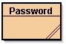
- Allow the user to select the number of characters in the password (at least up to 14).
- Create a randomly generated password from the character sets selected by the user.
- Check the strength of three passwords of different length from each menu option with the password checker. Tabulate the strength of your 12 passwords (see instructions below).
- Re-read the Strong Passwords: How to Create and Use Them article and write a short paragraph giving your opinion about the effectiveness of randomly generated passwords vs. memorable passwords (see instructions below).
- Follow the 6 steps in the article to create two strong, memorable passwords and test them with the password checker. Report your memorable passwords, what they stand for, and their strength (see instructions below).

Suggestions: Make an outline on paper, use pseudocode, or diagram logic sections with a
flowchart. Would it be easier to write the 1st or the 4th menu option first?.

Expected Output: The output of your program should resemble the following screen shot.

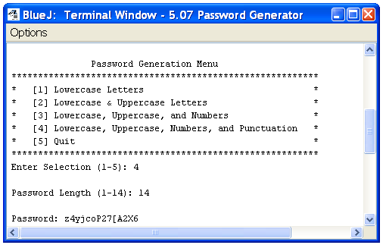

Some additional sample results from the program are shown below with their strength ratings determined by the password checker.

Menu Selection | Password Length | Password | Strength
1  2  3  4 | 6  10  12  14 | mwpvys  KIxsmhhJyR  j4xUnj4E7Nkv  {C5lEak]\qQ0Ly | Weak  Medium  Strong  Best

Copy and paste the following information into a Word document to submit along with your program. Answer the questions and fill-in the table. Adjust the spacing as needed to adequately answer each question.

- List your two memorable passwords and what they stand for.

- In your opinion, are memorable or random passwords better? Explain your answer.

- Highlight each of the following that apply to you.

- Have you told anyone your password?
- Is your password written down somewhere?
- Are you still using the default password for any accounts (e.g. password, , student, your user name, etc.)?
- Do you use the same password for multiple accounts?
- Is your password more than 6 months old?
- Does your password only contain letters?
- Is your password less than eight characters long?
- Does your password contain any recognizable words?
- Does your password contain the name of a pet, friend, or relative?

- Fill-in the following table for each of your randomly created passwords.
Menu Selection | Password Length | Password | Strength
1  1  2  2  3  3  4  4 | 10  10  10  10  12  14  17  21 | wdynsicvcb  czxaqdjrir  ERMEUPAKGS  COWHKEAWFJ  HjQRyVbHxywy  dWnhhRKSofatUk  N)&<CHj|=;A?7>$WT  RvU?U4NM8~y8;l:Vg8<fi | Medium  Medium  Medium  Medium  Medium  Strong  Strongest  Strongest

