Introduction
CSCI 101 is a new class being offered next semester that is designed to give students a general understanding of basic computer science concepts. To make the class more interactive and engaging for students, our client, Keith Hellman, is looking to design several games that interface with Nintendo Wii controllers (“Wiimotes”). The goal of team “Wii Can Do It!” was to develop a Wiimote framework that can be easily integrated with more of these games as the class evolves. This framework essentially takes care of all the input from Wiimotes, so future developers just need to focus on game logic. It was also our goal to use this framework to implement two initial games, one where teams of players are racing to balance a binary tree, and one where players are trying to route packets on a theoretical network.

Functional Requirements
The functionality of this project can be broken into three components: the Wiimote framework, the balanced tree game, and the network game.

Framework
The framework, which consists of the Wiimote Manager, Wii Event Parser, and Game Event Parser, converts the stream of data from the wiimotes into a consistent format that is suitable for game development. The Wiimote manager and Wii Event Parser analyze the data to find “Wii Events,” such as player 1 pressed A or player 3 flicked to the right. The game event parser then can read these events and test to see if functions need to be called based on the input. The purpose of this feature is so that future developers can simply create a file that contains what combinations of input a player can do and what function each calls. Outside of that, the developers can focus solely on game logic and graphics.

Binary Tree Game
The overall goal with the binary tree game is to make a fun way to introduce binary tree concepts to students. To achieve this, we developed a game that allowed users to manually manipulate several aspects of creating and balancing a tree, such as using rotation algorithms to balance the tree and finding what a “worst case” scenario for inserting numbers into a tree would be.
We implemented this game with a single game mode, which is a three-on-three game. Each team is supplied with a single node that starts a tree, an insert slot holding the first number to be inserted into the tree, and a queue, a list of numbers that need to be inserted into the tree. The first player of each team (the “sorter”) is supposed to “sabotage” the opponents queue by rearranging the numbers in it so that the opponents have to rotate their tree as much as possible to re-balance the tree. The second player of each team (“inserter”) must insert new data into the tree. The player flicks their Wiimote left or right to correctly sort the number in the insert slot based on the number in the node beneath it. This sorting uses the standard method for sorting trees with left children having lesser values than their parent nodes, and right children having greater values. The third player (“rotator”) has to balance the tree, when necessary, by rotating different parts of the tree. A prototype of what the game will look like is shown in figure 1, and more detailed gameplay is described in the Use Cases section below.
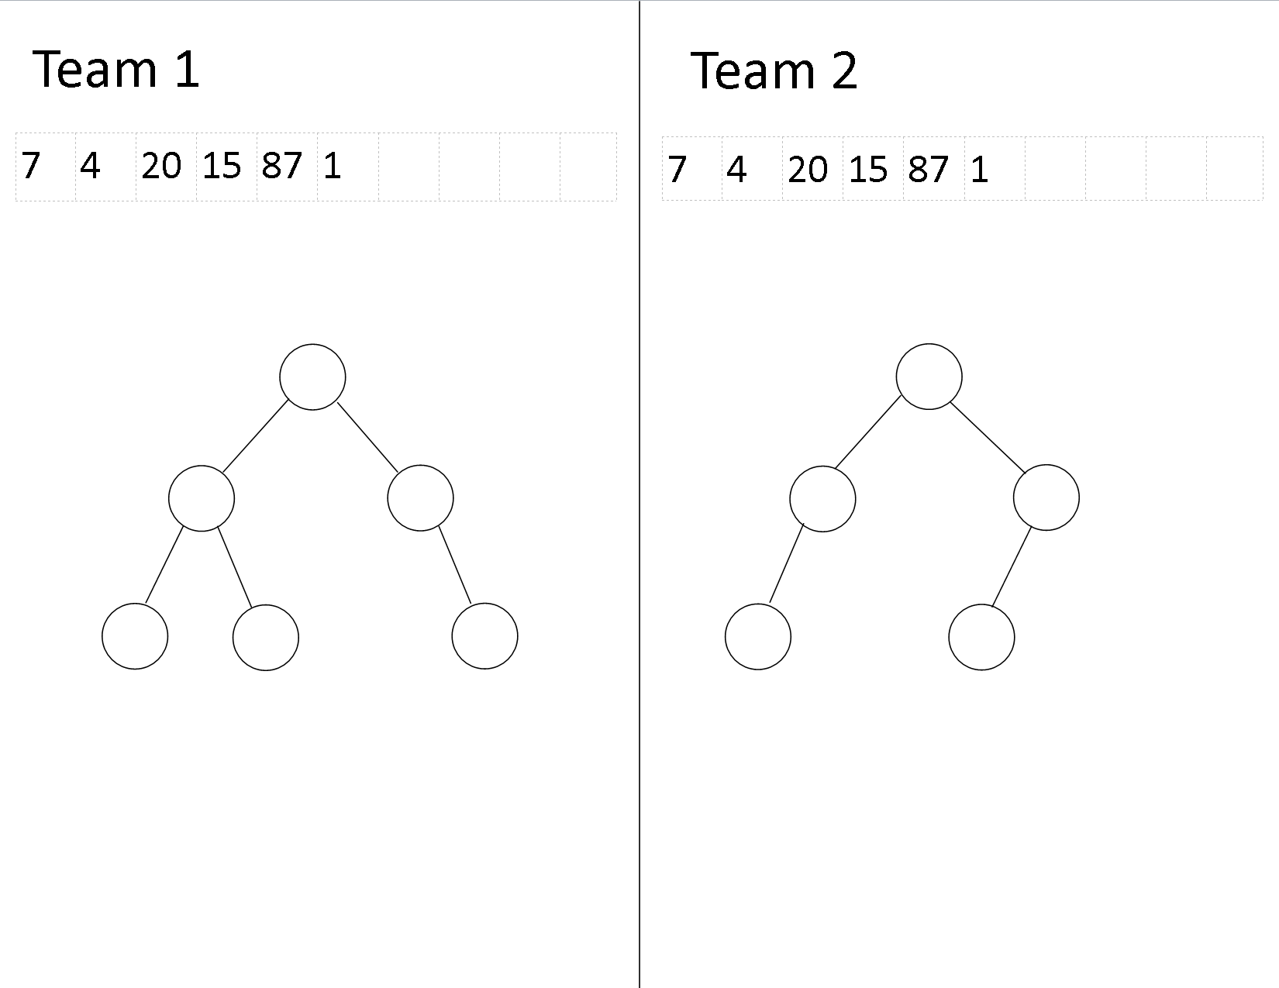
Figure 1. Balanced Tree game prototype *Chris: I think we should replace this with an actual screen shot of our game it would help with the explanation*

Network Routing Game
The network game was already developed in the .NET architecture when we began this project, and it was our job to port the game to Python. However, since we are making a framework to handle input as well as make several changes to attempt to make game development easy, we ended up coding the system from scratch, using the .NET code simply as a guide to the logic of the game. The network game is a much simpler concept than the balanced tree game. Each player is assigned a node. As packets are received by that node, the player has to flick the Wiimote to send them on to their destination node, with the direction of the flick(up, down, left, right) determining the direction the packet is sent. However, each edge is assigned a weight, and the player needs to try to use a least cost path to get the packets to their destination. A screenshot of the current game, as implemented in .Net, is shown in figure 2.
Along with porting the game, our client would like us to add several features. In particular, he would like to have access to the “map” of the game (the graph with player nodes and assigned edges). This way, while students are playing the game, he can add edges, remove edges, and change edge weight, to cause students to have to continuously recalculate what the least cost path to move a packet. Our client would also like to see a system that keeps track of how players did in respect to the optimum way to move the packets.
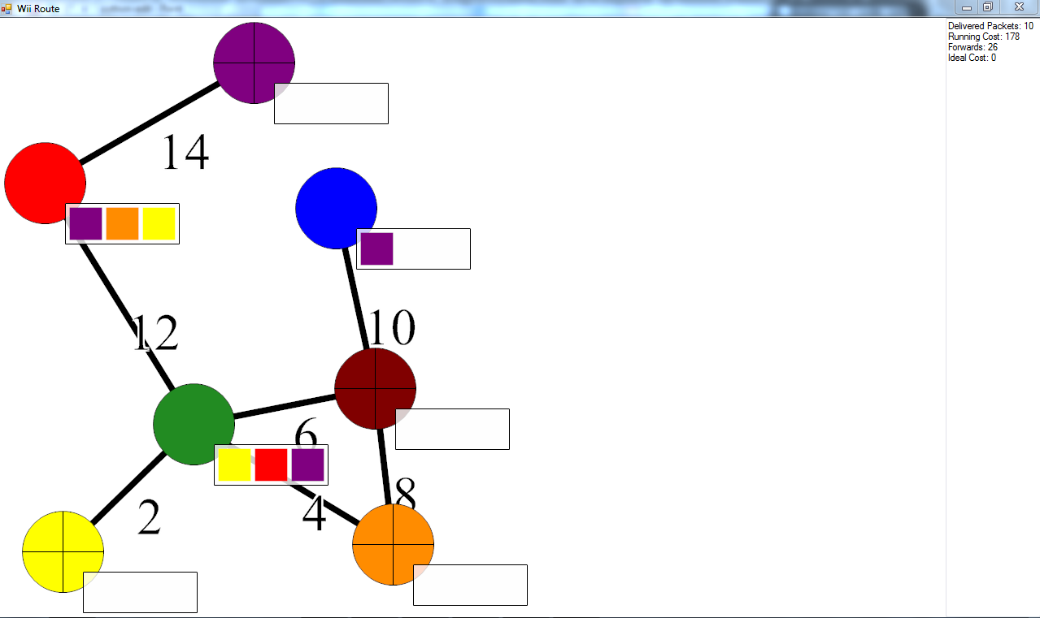
Figure 2. Screenshot of Network Game in .Net

Non-Functional Requirements
As with any code designed to be used in the future, our programs need to be well documented. For documentation, we used a combination of docstrings for all classes and functions that we developed, as well as creating a full documentation of our software using reStructured Text. This is because reStructured Text is easily read in both source and rendered formats. Also, using reStructured Text will make future developers’ jobs of making manual pages or HTML readme files easier. We used the Bazaar distributed version control system to store all of our code. All of the code was written in Python, and we used cwiid to interface with Wiimotes. A detailed explanation of cwiid is contained in the System Architecture section.

Binary Tree Game: Use Cases
Player one manipulates the opponents’ queue to create an insertion pattern that causes for the most re-balancing of the opposing team's tree. They do this by switching numbers in the queue.
- Player 1 selects a number in the queue
- Player 1 flicks the number left or right
a. If there is a neighboring number in the direction flicked, the two numbers switch locations
b. If there is no number in that location, nothing happens.
- Repeat 1 through 3

The job of player 2 is to insert numbers in their queue into the tree
- Player 2 receives a number to be sorted into their tree.
- The player “flicks” the Wiimote down one branch of the tree
  - If the player chooses to go down the correct path, the number will move to the next node
  - If the player chooses to go down the wrong path, no action will be taken
- Repeat 2 until the number reaches the end of the tree and is sorted
- Return to 1 on condition that the tree is balanced

Player three balances the tree whenever it is needed
- The tree is unbalanced, so player two is not receiving new numbers to sort
- Player three chooses a node that needs to be rotated
- Player three selects the node with the Wiimote, and rotates the Wiimote
- The tree rotates based off of the direction the Wiimote is rotated.
- Repeat 2-4 until the tree is balanced

Network Routing Game: Use Case
- Player receives a packet.
- Player flicks Wiimote in a particular direction
  - If there is a path in that direction, the packet is sent down that path
  - If there is no path in that direction, no action is taken.

System Architecture
We used two libraries to provide needed functionality. The first system is cwiid, a library that provides a usable interface to communicate with Wiimotes. For instance, cwiid creates an object that syncs with a Wiimote in discoverable mode and allows for direct variable changes to adjust the L.E.Ds and rumble. This object also can call a function that takes Wiimote data as a parameter. This “callback function” can perform all necessary analysis of the data it is given. By using cwiid, we do not need to directly work with the Bluetooth stack in order to receive information from the Wiimotes. This library will be the foundation of the Wiimote Framework.
The other main system we used was Pygame to implement the two games. This is a game engine that allows us to easily develop the graphical representation of our games as well as providing functions for other game mechanics(such as handling keyboard and mouse events for working with menus and buttons). We chose Pygame because it is a well-documented and popular two-dimensional game engine. We determined it would not prove too difficult to learn the engine because of the documentation, and we could then focus on providing solid game logic as opposed to constantly troubleshooting graphics issues.

System Design
The high level design of this project has four main components: the Wii Event Parser, the Game Event Parser, the Network Routing Game, and the Binary Tree Game.

The Wii Event Parser interacts directly with the Wiimotes. This module gathers the raw data from the Wiimotes and converts it to a standardized format we have dubbed a “Wii Event.” The Game Event Parser accepts these “Wii Events” and then converts them to the appropriate “Game Event” or, more precisely, the appropriate function call within the game. The remaining modules are the actual games described above. The details of these modules are explored below.

Wii Event Parser
The entire Wii Event Parser is comprised of two parts. The first is a Wiimote manager. This module keeps track of all Wiimote control classes currently associated with the program. The Wiimote control object contains the location of a wiimote object made by the cwiid library, the id the manager has assigned it, and a callback function for cwiid to use to fire data over the socket every time the Wiimote reports information. This function creates a raw data object, compresses it using Python’s “pickle” module, and sends it over the socket designated for raw data.
The purpose of the socket between the Wiimote manager and the Wii Event Parser is for abstraction. With this implementation, the Wii Event Parser can read data from any source, as long as it is compressed into a raw data event and sent over a the appropriate socket. The raw data class itself is abstracted, with one instance of the class passing button press events and a second passing a stream of accelerometer events. Each Raw data event contains the timestamp of the event and the appropriate data for the event. The accelerometer raw data contains the acceleration values for the x, y, and z directions. The button class contains a binary string of what buttons are currently pressed on the wiimote.
The Wii Event Parser module is what reads data from the socket that raw data is being sent to, tests for appropriate events, and sends those events over a socket to the game event parser. The parser contains a list of accelerometer, button control, and roll pitch classes--one for each possible Wiimote that is on the Bluetooth stack. These classes test the raw data for events in different ways:
Accelerometer. The accelerometer class contains the logic in testing for a flick. For the current version, this means testing the accelerometer data against thresholds of what would constitute a flick of the Wiimote. If the data passes one of these flicks, the accelerometer data then calls a magnitude tracker class. This keeps track of if the accelerometer is in a lockout state, as well as computes the magnitude of a flick. The lockout of an accelerometer prevents multiple flicks from being registered with one motion by not allowing a flick event to be sent more than every three tenths of a second. The magnitude of a flick is found by repeatedly comparing a given acceleration to what was previously passed to the object, waiting for the value of the acceleration to decrease.
Button Control. The button control class contains the prior state of what buttons are pressed in a set of Boolean variables. When the class receives a new set of data, the button control first converts the information into a second set of Boolean variables. Once this is complete, the class checks each button to see if there is a change in if that particular button is pressed, firing off an event every time it sees a change.
Roll Pitch. The Roll pitch class takes the acceleration values of a given piece of raw data and calculates the approximate roll and pitch of the wiimote, assuming it is being held still. This is done by taking the inverse tangent of two accelerometer values. The roll is calculated by taking arctan( x / z ), while the roll is calculated by taking the arctan( y / z ). The resulting roll and pitch value is then compared against a prior threshold, seeing if and how many roll events need to be fired. The threshold for a roll is every .3 radians, and a pitch event is every .2 radians. This means that every time the wiimote gets rolled .3 radians in a direction, the parser sends out an event symbolizing the roll.
When an event is triggered, each of the subclasses listed above create a Wii Event, compress it using the pickle module, and send it over a socket to the game event parser. Wii Events represent the simplest action a user would perform with the Wiimote. Examples of Wii Events are “press A”, “release A”, “flick right”, and so on. Here is a list of Wii Events our framework supports. This list can very easily be expanded to support other types of Wii Events, such as input from the Wii Nunchuck attachment, by adjusting the name of the event and flick.
- buttons (up, down, left, right, a, b, +, -, 1, 2, home)
- “flick” (x, y, z)
- roll
- pitch

Each Wii Event holds three pieces of information, the ID of the Wiimote (an arbitrary number assigned when a Wiimote is connected), the name of the event (e.g., “A”, “FlickX”, “Roll”), and a modifier. This modifier holds different information depending on the action that triggered the Wii Event, as described below.

Buttons:
For button events, the modifier is simply +1 or – 1 to determine whether the button was pressed or released.

Flicks:
For flick events in any of the three directions, the modifier will be a positive or negative number with the sign determining direction along the specific axis. The magnitude of the modifier is equal to the peak magnitude of the flick given by the accelerometer sensor.

Roll and Pitch:
Just as with the button events, the modifier is merely a +1 or -1 to designate direction of the roll, for example the sign determines whether it is a positive roll (clockwise) or negative roll (counter-clockwise).

Once a Wii Event has been triggered, the Wii Event Parser sends the Wii Event over a network socket to the Game Event Parser.

Game Event Parser
The Game Event Parser is intended to transform sequences of atomic Wii Events into game logic. The Game Event Parser makes it very simple for game developers to bind sequences of Wii Events to a game function call without having to rewrite any logic that listens for combinations of Wii Events. Developers only have to create a Python file of bindings, which is simply a function name associated with a sequence of Wii Events. The Game Event Parser will take this list of bindings, listen for Wii Events from the Wii Event Parser, and call the proper game function when the corresponding sequence of Wii Events is received.
For a more concrete explanation, consider the following list of bindings, which is very similar to the actual syntax for declaring bindings.
bind_functionA = ['pressA', 'releaseA']
bind_functionB = ['pressB', 'flickX', 'releaseB']
bind_functionC = [ ['pressA', 'pressB'], 'flickX', ['releaseB', 'releaseA']]

The first binding connects a function called functionA in the game class to a simple press of the A button. The middle binding represents selecting something and flicking it left or right, an action we use several times in our games. The last binding shows the flexibility of the Game Event Parser. Bindings can be composed of Python's collection data types to represent different variations of events. In this case, the list ['pressA', 'pressB'] indicates that the A and B buttons should be pressed simultaneously.

A high level overview of the Game Event Parser is shown in Figure 2. The program is constantly listening for Wii Events. Every time it receives one, it iterates through the list of bindings looking for sequences that match the received Wii Event. For each event binding, the parser stores a pointer to the next event in the sequence. If the received Wii Event matches the binding's next pointer, the program will move the pointer to the next event in the binding's sequence. If the received Wii Event does not match this pointer, then the user is performing a different sequence of actions, so the program resets the pointer to the beginning of the binding's event sequence.

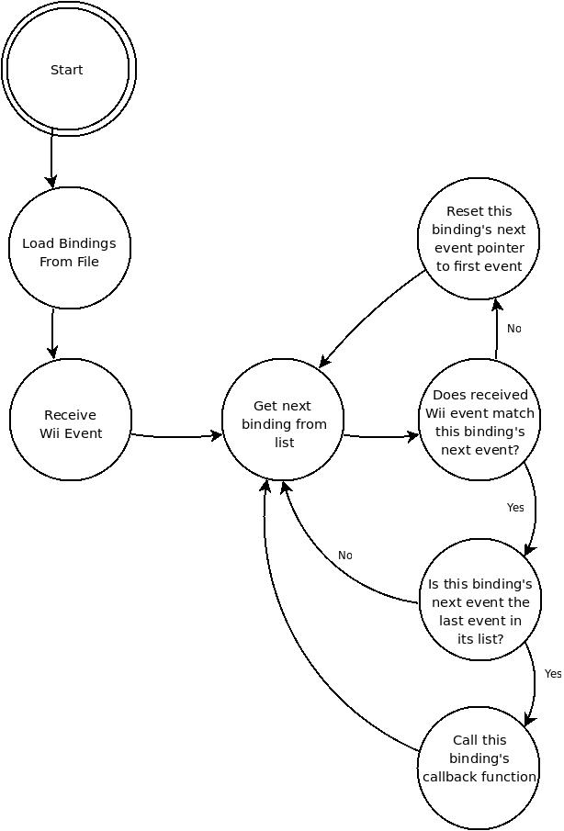
Figure 2: The Game Event Parse Finite State Machine
The Game Event Parser relies heavily on Python's dynamic typing scheme. Since lists in Python do not care what type of data they store, our bindings can be very flexible. Game developers can specify a set of Wii Events that should happen simultaneously simply by inserting a list inside the binding's event sequence list. Another unique Python feature the Game Event Parser uses is every object's power of introspection. The list of bindings is actually a subclass of the main Game Event Parser class. The object will look at all of its internal member functions and variables. Variables that are prefixed by a specified word are considered to be bindings, so they are all gathered into a list to allow easy iterating. When a game function needs to be triggered, the Game Event Parser changes the scope of the variable name to the game class and calls the corresponding game class method. A list of information about the sequence, such as the magnitude and direction of the flick, roll and pitch data, and duration of the sequence is sent as a parameter to the game function.
The Game Event Parser is actually a bit more complex than the finite state diagram above suggests. To handle more complicated Wii Events, like pitch and roll, must be handled differently than simple events like pressing a button. The Wii Event Parser is configured to be sensitive to pitch and roll movements, so it sends pitch and roll Wii Events very frequently – as often as a few times per second. Normally, when the Game Event Parser receives a roll event, the player is not really trying to peform a roll; often, they intended to do a flick or are just holding the Wiimote relatively still. To account for all these extra roll events, the Game Event Parser filters out all roll events unless a binding explicitly asks for them. Also, roll events come from the Wii Event Parser in small chunks of 0.3 radians. If the player tries to perform a roll of, say, one radian, the Game Event Parser will receive 3 atomic Wii Events in rapid succession, which it will integrate into one event.
The Game Event Parser includes a small selection of “pseudo-Wii Events”. These events do not correspond to actions on the Wiimote, but instead are events like “timeout” or “lock”. If a binding specifies a timeout, the Game Event Parser will stop listening for Wii Events for the specified time. A “lock” will make the current binding the sole active binding; so it is impossible for other sequences to trigger game events. Our games are too simple to use this functionality, but we decided that a “pseudo-Wii Event” was a common enough use case to justify inclusion into the Game Event Parser.

Network Routing Game
The Network Routing Game has two minor, albeit important classes, the Player and RouterNode classes, and two major classes the Game and Map classes.
The Player class is used to represent human players in the game. This class holds a wiiID variable which is just an integer that connects the Player to a Wiimote's data in the Wii Event Parser. Player objects also hold a color varaible which connects them to a specific RouterNode when the Game is being played.
The RouterNode class represents a Network Node for use in the game. Objects of this class have a color variable that identifies what color Packet or, more appropriately, what string they accept, since in the Game logic Packets are merely strings of color names, “RED”, “BLUE”, :GREEN” etc. RouterNode objects also hold a queue that holds all the “Packets” at that node. The RouterNode also holds the coordinates as a percentage of the screen. These coordinates represent where the node should appear on the screen.
Neither of these classes provide significant functionality, but they are absoloutely necessaryu for the Game and Map classes to function.
The Game class handles all the information between the Map class, where all the actual game functionality happens, and the Game Event Parser, which calls functions in the Game class when Flick Events are received. The Game class holds all the player objects and the Map object that is actually being played. The Game class has one major function, filterInput. The filterInput function is what is directly called by the Game Event Parser. This function takes the player ID sent by the Game Event Parser and checks it against the wiiID of all the Game object's player objects. If the function finds a match, it continues and tries to find the RouterNode object in the Map object that corresponds to the player's color. If it is able to find a RouterNode that means the player is actually playing. Next, the function normalizes the “flickx” and “flickz” data to be -1 if the value was negative or 1 if the data was positive (the data is already zero if there was no flick in the corresponding direction) and then tells its Map object to try and send a Packet from the RouterNode the Player controls.
This normalization is used to simplify the arrangement of the graph to only use 8 directions, since the accelerometer data used for the flicks is so sensitive. Different people can flick with different strengths and with a large and inconsistent range from the desired direction. Because of these variables, using the strengths of the different flicks to determine an angled direction is extremely difficult, if not impossible, to do without infuriating the user. However, this does not mean the graphical versions of the maps are limited to these eight directions. Edges may vary in their direction, but only one may be in each of the eight sectors of direction. How exactly this is handled will be explained in the Map class description.
The Map class holds all the major functionality for the actual gameplay and all the variables that need to be kept track of, such as the score, the maximum number of packets to add to the map, the number of packets the players have routed successfully, and the penalty for losing a packet. Map objects can make edges between two of their RouterNodes by use of the makeNeighbors function. This function takes the two RouterNode objects that will be connected and the wieght between them. This function will take the coordinates of the two RouterNode objects and find the direction between the two, by subtracting the x and y values of the coordinates and dividing each by the magnitude of their associated vector. These new x and y values are then rounded to -1, 0, or 1 to allow the more varied displays mentioned above. After collecting this direction information, the makeNeighbors function builds a dictionary with both of the RouterNode objects as keys to their specific direction to the other node. The function finally adds the string “weight” as the key to the numeric value of the weight given as a parameter to the function.
Map objects also have the trySend function which is the function called by the filterInput function described above. This function takes a RouterNode and an x and y direction and then determines whether the provided node actually has an edge in the provided direction. If the node does, the Map starts a timer based on the weight of the edge. This timer corresponds to the length of time the packet is traveling along an edge, so that higher weighted edges actually take longer to send packets. When this timer finishes it calls the tryReceive function. The tryReceive function increments the score for the players with the weight of the edge used, then, checks if the Packet received is the same color as the node, if so, it exits the function. If the Packet isn't the same color, the function checks if the node has room in its queue for the new Packet. If the node does not, the Map object adds the penalty for losing a Packet to the score. Otherwise, the node receives the Packet, and the Map checks if the node that received the packet is controlled by a computer. If the node is, the Map finds the least-cost path for the computer to send the Packet and then calls trySend to actually send the Packet.
The final functionality that Map objects hold is the ability to add packets at random to random nodes. The Map continuously starts a timer for between 0 and 8 seconds after which the Map randomly picks a node that doesn't have a full queue and then randomly picks a Packet color that is not the color of the selected node. After both of these are picked, the Map object calls the tryReceive function and actually adds the Packet to the node's queue. The Map continues to do this until the max number of Packets have been added, after which it waits for all Packets the node's hold to reach their destinations and then ends the game.
The gameplay design for the routing game is rather simple, as illustrated in Figure 3. When players connect their Wiimotes, they are assigned a color; this color also designates which node in a map the player will control. Once all players have chosen their color and a level has been selected, the map will appear and packets will randomly appear on the screen at random nodes. Players must then ‘flick’ their Wiimotes in the direction of a neighboring node to route packets to the node with the same color. Score is determined by the weight of each edge used, so the lower the score the more efficient the routing (i.e., the lower the score, the better the team did). Some maps may have more nodes than the number of players; in this case, a simple script will control the non-player nodes and will send packets along the most efficient route automatically.
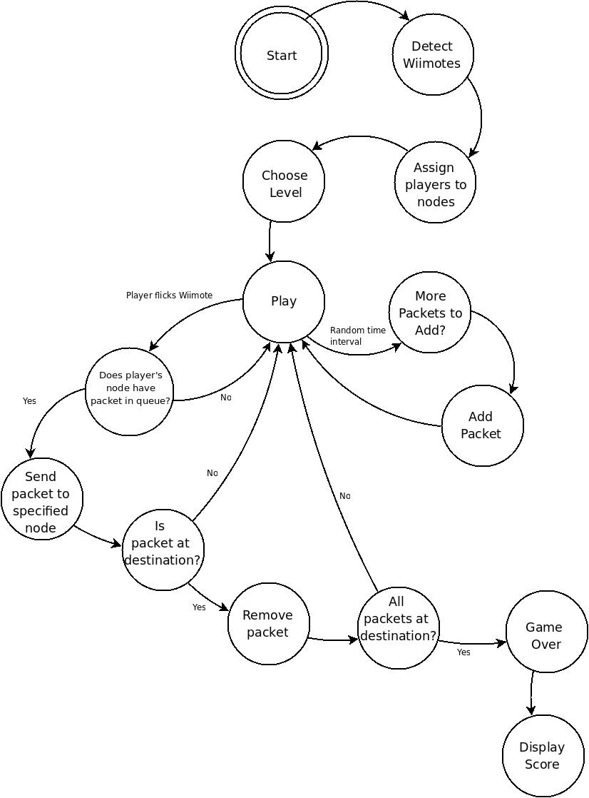
Figure 3: Network Routing Game Finite State Machine

Binary Tree Game
The Binary Tree Game has four main classes, the Player, Team, Tree, and TwoTeamVersusMode classes. The Player class is an abstract class that contains a ‘Wiimote ID’ to connect the player to a Wiimote and abstract functions for all the game actions players can take. These methods will be defined in its three children classes, one for each role in the game: sorter, inserter, and rotator. This allows the same Wiimote inputs to do different actions based on a player’s role. The Player class also holds a current variable which specifies something unique to each player and a selected boolean that tells whether a player has selected their current. Each player also has an association to their team. However, every instantiation of the Player class may require more variables(such as the Sorter Class described next). To allow for future extension, Player objects are initialized with a dictionary that must hold 'player' and 'team' as keys to the Player's Wiimote ID and Team object respectively. This dictionary can then hold more data that each of the individual subclasses may need as well. The Player class also holds dummy versions of all of its subclasses function that can be called by Wiimote actions. This is to ensure all Players can do whatever they want with their Wiimote without having an accidental call to a function that isn't defined.
The Sorter Class is the first subclass of the Player Class. A Sorter object makes use of the dictionary mentioned above. Since a Sorter's purpose in the game is to 'sabotage' the opposing team's queue, a Sorter object must have a reference to that opposing team's queue. This was accomplished by passing an extra parameter in the dictionary that held the value for the opposing Team object. For a Sorter object, the current variable holds an index of the opposing team's queue that designates where in the queue the Sorter is. The Soter's only other method to note is its shove method. This is the method called when a player flicks their Wiimote, regardless of direction. For a Sorter, this method either moves the Sorter's current in the specified direction or swaps the numbers in the queue if the Sorter has selected.
The Inserter Class is the next subclass of the Player class used in our game. The Inserter holds an extra variable called center. This variable holds the node from the Inserter's Team's tree and serves as the reference the Inserter is inserting against to keep the tree balanced. The Inserter's current holds the value of the number that needs to be inserted. The Inserter's shove function communicates with the Team's Tree object to check if the direction was the valid direction based off the Inserter's center node's value.
The Rotator is the final subclass of the Player Class. The Rotator's current designates the node in the Team's Tree that the player is currently at. The Rotator's shove allows traversal of the tree, with left moving to the current's left child, right moving to the right child, and up moving to the current's parent. The Rotator also holds the two rotate functions, which allow reordering of the Team';s Tree to try and balance it.
The Team class holds pointers to all three of its players and their gameboard, which consists of the team's queue and tree. The queue is merely a list of numbers rather than an actual collection version of a queue as used in the Network game. This is because collection queues do not allow easy manipulation of internal values, which is essential to this gameplay of the Sorters. The Tree is its own class and will be discussed next. The Team class also handles all functions that affect its tree and then checks to see if the action has balanced the tree. If it has, the Team class will pop the next number from its queue and provide it to the inserter.
The Tree class holds most of the central game methods specifically checking if the tree is balanced and allowing rotation within the tree. Also, the Tree class allows insertions and checks if an Inserter has attempted their insertion correctly at every level through the tree.
The TwoTeamVersusMode class is the class that builds both Team objects and all 6 Players and handles all the Wiimote interaction for our Game Mode. It is also a subclass of the GameMode class, which allows for communication with GUI and a way to return to the Main Screen of the Game. The TwoTeamVersusMode class first builds both teams and then proceeds to add players based on Wiimote input. Then, after all 6 players have been added, it starts the game. Now, the gameplay starts and players are able to perform their various actions, while the TwoTeamVersusMode class determines which actions correspond to which player. The TwoTeamVersusMode also interacts with GUI to tell it when to update the screen.
The gameplay design for the Binary Tree Game is significantly more complex than the routing game. For a state-based description, see Figure 4. To start, players will connect their Wiimotes and then begin the game. Once this happens, a dialog will appear that prompts a player to fulfill each role for each of the two teams (sorter, inserter, and rotator). Once all 6 roles (one of each role for each team) are filled, the actual game begins.
Each team gets a random sequence of 6 or 14 numbers (so the balanced tree is always full) to sort and a random number as the root of their tree. The sorter will be trying to sort the opposing team’s sequence of numbers so that they spend the most time rotating the tree after insertions, giving the sorter’s team more time to finish their tree. This sequence of numbers acts as a queue so that, whenever the tree is in a balanced state, the first number in the sequence can be placed in the ‘insertion slot’. This ‘insertion slot’ is simply a space on the screen to tell the inserter for each team that they need to insert that number into their team’s tree before they can continue. The inserter does this by flicking the Wiimote left or right to sort the node; the number then moves to the next node if it was sorted correctly (i.e., the player motioned left if the insertion number is less than the node at or right if greater) otherwise there will be an animation that designates the player made the wrong choice and the insertion restarts.
This continues until the insertion number is a leaf of the tree, at which point the game will check if the tree is still balanced or not. If it is balanced, the first number of the team’s sequence will get placed in the insertion slot and the game starts over again. If the tree is not balanced, player 3 must rotate the tree so that it becomes balanced. Player 3 does this by selecting a node (pressing the A button while their cursor is on the node) and then rolling the Wiimote in the desired direction and then letting go of the node (releasing the A button). However, if, by rotating the tree, the players have actually made it harder on themselves, the tree will reset and let the player try again, similar to how insertion restarts if they insert the number so the tree is not sorted. This process continues until a team reaches a balanced tree and has no numbers in their queue. At this point, that team has won, and the game returns to the main screen so play may continue if users wish.
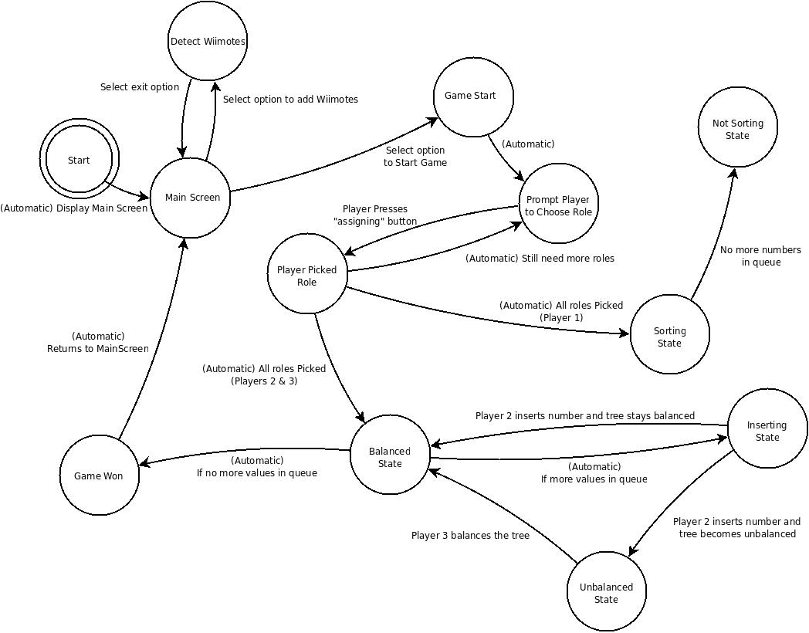
Figure 4: Binary Tree Finite State Machine

Testing
We have several layers of tests for all the modules. The basic classes of the Wii Event Parser, such as Accelerometer and button control, have unit tests for their functionality. The network game also has mock-up unit tests. The Binary tree game also contains some unit tests for the rotate and sorting algorithms. Above that, there is logging at the Raw data, Wii Event, and Game event levels. Each of these logs can be passed through the appropriate socket, allowing for recreations of bugs to be repeatedly tested to ensure it is fixed.

Implementation Details

As mentioned in the project requirements section above, our client had several implementation requirements. The most important, and the most obvious, is that all code should be written in Python. Keith left the choice of Python version up to us. This may sound like a trivial decision, but Python 2.4, 2.5, 2.6, and 3.0 are all widely used on different systems, and code is not always portable between versions. We decided to develop on Python 2.5, because that was the version installed on the Alamode machines. However, one of our testing laptops ran version 2.6 and encountered only minor incompatibilities with starting and killing the processes that ran the parsers. Our framework and games should run with little difficulty on any implementation of Python 2.5 or 2.6. We did not test on Python 3.0.

Besides using Python, Keith also specified that our project should be developed for Debian-based systems, because that is the operating system he will be using when teaching the class. Luckily, the Alamode lab runs Ubuntu, which is built off Debian, so we had access to a suitable development environment. The only other implementation requirement Keith specified was that we use a Python program called WMGui to read raw data from the Wiimotes. Investigating WMGui revealed that it is just a front-end to the cwiid library, so we used cwiid communicate with the Wiimotes.

After cwiid, the next most important implementation decision we made was to use the Pygame library to handle graphics for our games. We chose Pygame instead of other Python graphics libraries primarily because of the community surrounding Pygame. It is much more widely used than its competitors, which means it has much better documentation, tutorials, and support forums. Also, the complexity level of our games did not seem to warrant an OpenGL-based graphics engine, though our framework would certainly enable future game developers to take that route. Pygame was lacking in some respects, particularly in its drawing functions; our version of Pygame does not even support drawing anti-aliased circles. Overall for our games, Pygame was a very good fit because it balanced ease of use, features, and programmer documentation.

Apart from external libraries, we had a few design decisions that need explanation. First, we decided with Keith that communication between all parts of the system should be done with network sockets. This made it very easy to develop and test each piece in parallel. For example, instead of needing to build from the ground up – from reading raw data towards the game event parser – we were able to develop each piece in parallel by sending “fake” input over socket. Also, Keith has plans for future network-based games. Since sockets are a fundamental part of the framework, developing network games will be painfully easy. To ease our development process, we chose to use the connection-less UDP protocol instead of the more reliable TCP. This allowed us to, for example, test the Wii Event Parser without needing to have an instance of the Game Event Parser running and listening for connections. Also, the relative importance of individual packets is small, so the framework can easily tolerate a few lost packets. However, future developers may choose to change communication to TCP.

Another design decision needing justification is our use of processes instead of threads for each component of the framework. It might seem natural to have the game process start the Wiimote Manager, Wii Event Parser, Game Event Parser, and Game Event Listener in separate threads. When the game is over, the process would simply kill all the threads. This is the direction we took initially, but much to our chagrin, threads are very difficult to use properly. We spent countless hours tracking down errors resulting from threads before Keith advised us to de-thread and use processes instead. In retrospect, it was foolish to use threads in the first place. Almost all communication between the components happens over sockets – as opposed to directly sharing memory – so threads are superfluous.

Running each component as a separate process greatly increased the flexibility of our games. The games can function as a stand-alone application, starting and stopping the subprocesses when needed, but the processes can also be run separately. For example, while developing, we would often want to run the game several times without the hassle of re-syncing Wiimotes every time. Since the Wiimote Manager runs in its own process, we were able to sync the Wiimotes once, leave the process running, and continue testing. This flexibility will also be very useful for Keith when he is teaching with the games, because he will not have to waste valuable class time re-syncing Wiimotes.

The framework does still run one thread. Since the Game Event Listener directly calls functions in the game class, it needs to have access to the same memory space as the game. Games must start the Game Event Listener thread, which will start the Wii Event Parser and Game Event Parser processes. However, for the game developer, the burden of using the framework is absolutely minimal; they need only create a Game Event Listener object then call that object's startup method.

Lessons learned
With the size and complexity of this project, it was inevitable that we would learn a few things along the way. Here are a few lessons that we walked away from this project with.
- Threads, while easy to implement, are very difficult to implement right. Our original way of combining the parser involved threads, and we ran into many issues with them not starting or stopping properly. Using processes instead is a much more reliable and simple way to allow for multiple functions to be executed at once.
- Sockets are very useful when trying to decouple a program. Especially once you remove the overhead of connecting and disconnecting, they provide an efficient, solid interface between parts of a program. They are also useful in their ability to abstract data, and allow for easy logging and use of those logs.
- Python is a very powerful programming language. It is very easy to use, and is able to accomplish quite a bit. Python also has a very extensive list of modules. If you need to do a specific task, there is a decent chance of there being a python module to do the work for you.
- It is very helpful to be the administrator of your development environment. We ran into many problems in the Alamode lab trying to get Bluetooth to work, among other things. In the end, the primary testing machine that interfaced with Bluetooth turned out to be a laptop that we could fully access and manipulate.
- Agile methods actually work. For developing the Wii Event Parser, it was very helpful to start by reading basic data, then take it up to reading data from a Wiimote, then managing several wiimotes, then abstracting the parser and the Wiimote manager, until the module was finished. The “war room” method was also very helpful with keeping our group on task.

Future Work
There is a lot that can, and most likely will, be done with this project. First and foremost, future developers could implement features that we could not complete within our project scope. Though we were able to implement the necessary modules for our project – the parsers, the binary tree game, the network game – there are many additional requirements that Keith would like to see within the games themselves. For instance, the network game could have the ability for a separate user to dynamically alter the map students are playing on. Also, there can be multiple play modes for the binary tree game. There is also always the ability to write more programs, be it games or other teaching tools, using the Wiimote framework.
The main way to work off of the parsers themselves is to allow them to work on a higher level. After working with our framework. Our client has determined that it would be very useful to have a server that handles the Wiimote connections. This could allow for more than seven wiimotes (the maximum allowed on a single Bluetooth daemon), as well as multiple games able to communicate and be played at once. This could eventually, if given enough polish, be distributed as a Debian package and distributed as an open source project.
