Appendix
Figure Title Page Number
Figure 6: Binary Tree Game UML B
Figure 7: Binary Tree GUI UML C
Figure 8: The GUI Objects UML D
Figure 9: Network Game UML E
Figure 10: Wii Event Parser UML F
Figure 11: Screenshot of Network Game in .Net G
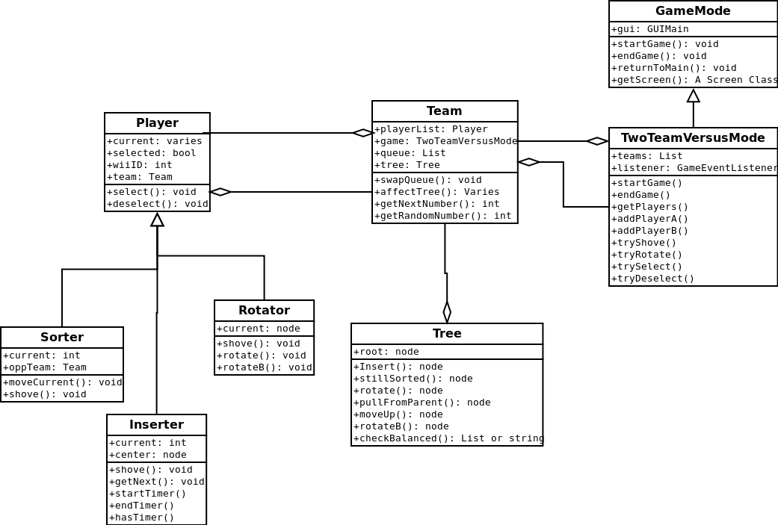
Figure 6: Binary Tree Game UML
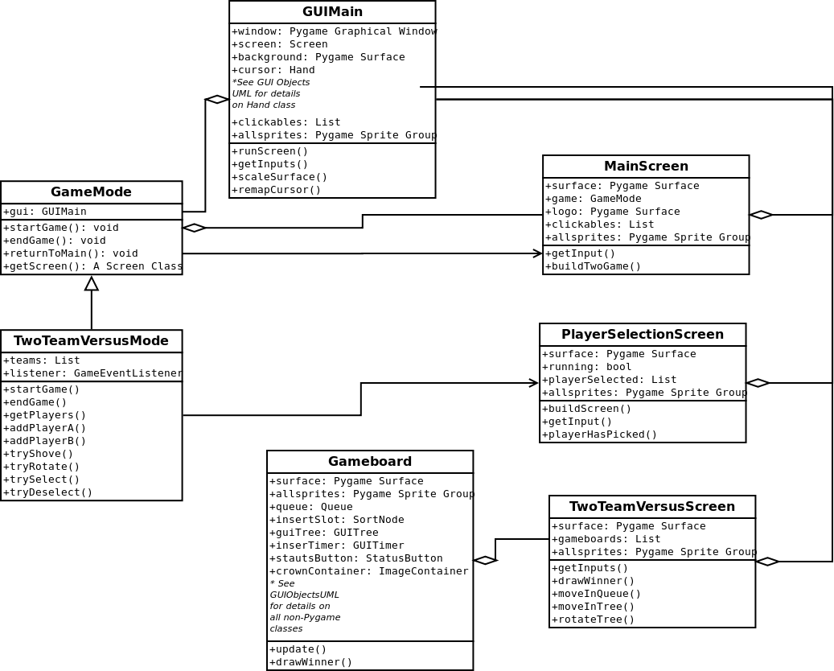
Figure 7: Binary Tree GUI UML

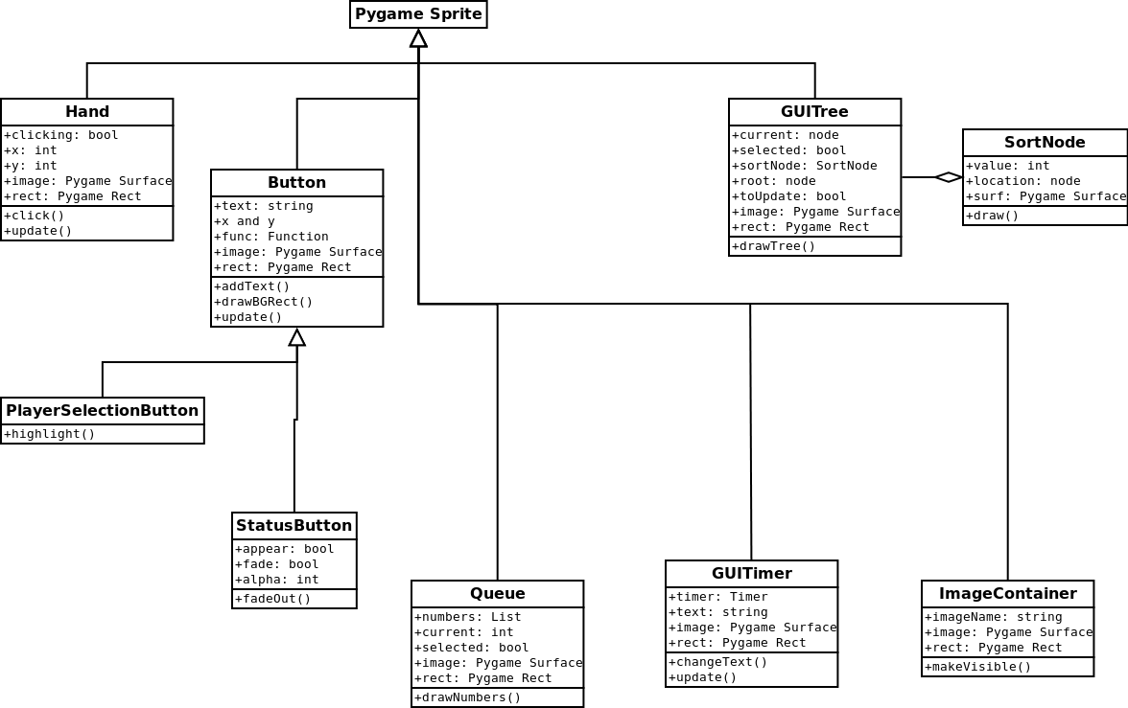
Figure 8: The GUI Objects UML
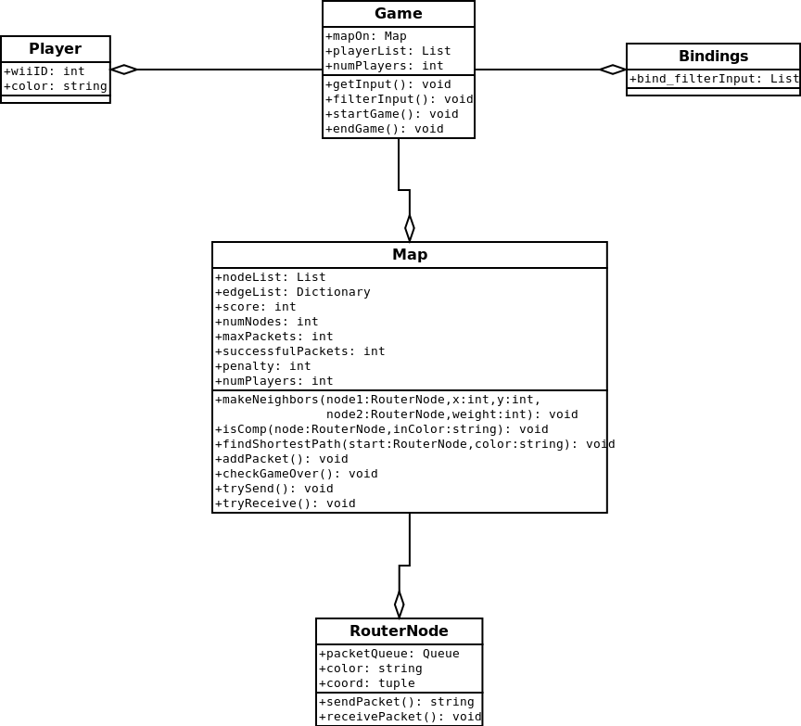
Figure 9: Network Game UML

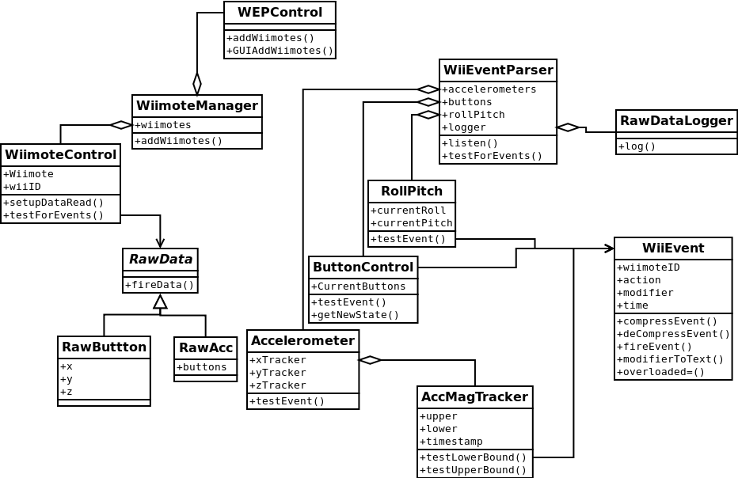
Figure 10: Wii Event Parser UML

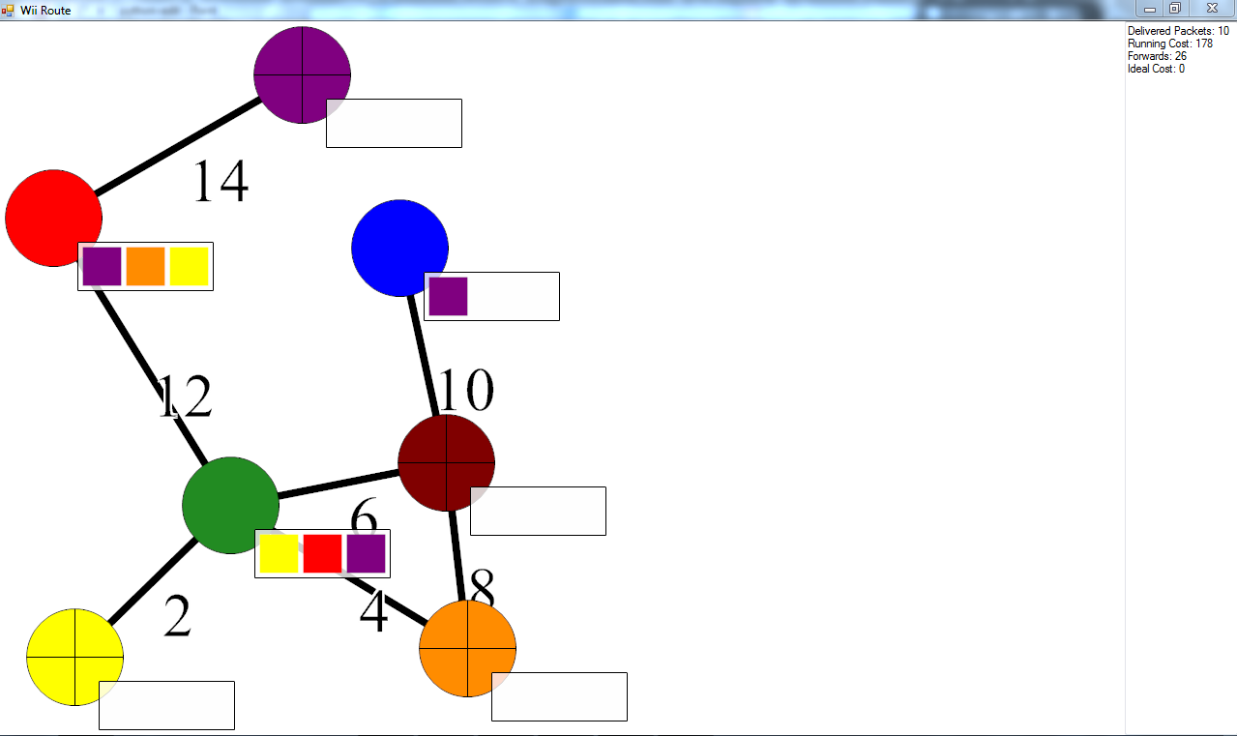
Figure 11: Screenshot of Network Game in .Net

