A/B Testing

Data Preparation
library(dplyr)
library(ggplot2)
library(tidyr)
library(knitr)
library(scales)
library(lubridate)
control <- read.csv("/Users/chloeshin/Downloads/archive/control_group.csv",
sep = ";")
test <- read.csv("/Users/chloeshin/Downloads/archive/test_group.csv",
sep = ";")
colnames(control) <- c("Campaign", "Date", "Spend", "Impressions", "Reaches",
"Clicks", "Searches", "Views", "Cart", "Purchases")
colnames(test) <- colnames(control)
df <- rbind(control, test)
df$Date <- dmy(df$Date)
df <- df %>%
distinct() %>%
drop_na()

Key Metrics
camp_avgs <- df %>%
group_by(Campaign) %>%
summarise(avg_imp = mean(Impressions), avg_clicks = mean(Clicks),
avg_purch = mean(Purchases))

Impressions
ggplot(df, aes(x = Date, y = Impressions, color = Campaign, group = Campaign)) +
geom_line(size = 1) + geom_hline(data = camp_avgs, aes(yintercept = avg_imp,
color = Campaign), linetype = "dotted", linewidth = 0.7) + scale_y_continuous(labels = label_number(scale = 0.001,
suffix = "k")) + scale_x_date(date_breaks = "5 days", date_labels = "%m.%d") +
scale_color_manual(values = c(`Control Campaign` = "red", `Test Campaign` = "blue")) +
labs(title = "Daily Impressions", x = "Date", y = "Number of Impressions",
) + theme_minimal() + theme(plot.title = element_text(margin = margin(b = 20),
size = 15, face = "bold"), axis.title.x = element_text(margin = margin(t = 15)),
axis.title.y = element_text(margin = margin(r = 15)), legend.position = "bottom")
## Warning: Using `size` aesthetic for lines was deprecated in ggplot2 3.4.0.
## ℹ Please use `linewidth` instead.
## This warning is displayed once every 8 hours.
## Call `lifecycle::last_lifecycle_warnings()` to see where this warning was
## generated.
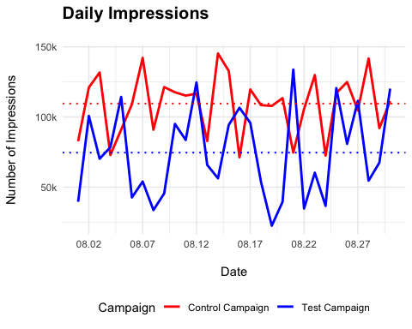

Clicks
ggplot(df, aes(x = Date, y = Clicks, color = Campaign, group = Campaign)) +
geom_line(size = 1) + geom_hline(data = camp_avgs, aes(yintercept = avg_clicks,
color = Campaign), linetype = "dotted", linewidth = 0.7) + scale_y_continuous(labels = label_number(scale = 0.001,
suffix = "k")) + scale_x_date(date_breaks = "5 days", date_labels = "%m.%d") +
scale_color_manual(values = c(`Control Campaign` = "red", `Test Campaign` = "blue")) +
labs(title = "Daily Clicks", x = "Date", y = "Number of Clicks",
) + theme_minimal() + theme(plot.title = element_text(margin = margin(b = 20),
size = 15, face = "bold"), axis.title.x = element_text(margin = margin(t = 15)),
axis.title.y = element_text(margin = margin(r = 15)), legend.position = "bottom")
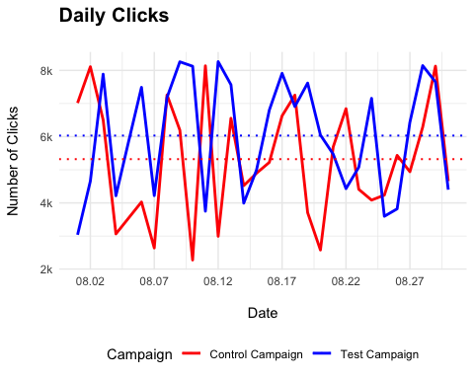

Purchases
ggplot(df, aes(x = Date, y = Purchases, color = Campaign, group = Campaign)) +
geom_line(size = 1) + geom_hline(data = camp_avgs, aes(yintercept = avg_purch,
color = Campaign), linetype = "dotted", linewidth = 0.7) + scale_x_date(date_breaks = "5 days",
date_labels = "%m.%d") + scale_color_manual(values = c(`Control Campaign` = "red",
`Test Campaign` = "blue")) + labs(title = "Daily Purchases", x = "Date",
y = "Number of Purchases", ) + theme_minimal() + theme(plot.title = element_text(margin = margin(b = 20),
size = 15, face = "bold"), axis.title.x = element_text(margin = margin(t = 15)),
axis.title.y = element_text(margin = margin(r = 15)), legend.position = "bottom")
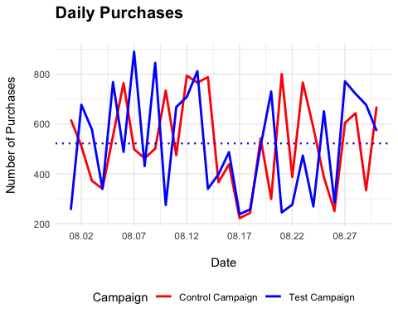

Marketing KPIs
kpi_sum <- df %>%
group_by(Campaign) %>%
summarise(avg_CTR = round((sum(Clicks)/sum(Impressions)) * 100, digits = 2),
avg_CVR = round((sum(Purchases)/sum(Clicks)) * 100, digits = 2),
avg_CPC = round((sum(Spend)/sum(Clicks)), digits = 2), avg_CPP = round((sum(Spend)/sum(Purchases)),
digits = 2))
kable(kpi_sum, col.names = c(" ", "CTR", "CVR", "CPC", "CPP"))
 | CTR | CVR | CPC | CPP
Control Campaign | 4.86 | 9.83 | 0.43 | 4.41
Test Campaign | 8.09 | 8.64 | 0.42 | 4.92

Hypothesis Testing
H0: There is no statistically significant difference (KPI) between control and test campaigns.
Ha: There is a statistically significant difference (KPI) between control and test campaigns.

Click Through Rate
ctr_cvr <- df %>%
group_by(Campaign) %>%
summarise(tot_imp = sum(Impressions), tot_clicks = sum(Clicks), tot_purch = sum(Purchases))
ctr_test <- prop.test(ctr_cvr$tot_clicks, ctr_cvr$tot_imp)
ctr_test
##
## 2-sample test for equality of proportions with continuity correction
##
## data: ctr_cvr$tot_clicks out of ctr_cvr$tot_imp
## X-squared = 23602, df = 1, p-value < 2.2e-16
## alternative hypothesis: two.sided
## 95 percent confidence interval:
## -0.03274238 -0.03188490
## sample estimates:
## prop 1 prop 2
## 0.04856521 0.08087886
Test Campaign has a significantly higher click through rate compared to control campaign. It is more engaging and relevant to the audience.

Conversion Rate
cvr_test <- prop.test(ctr_cvr$tot_purch, ctr_cvr$tot_clicks)
cvr_test
##
## 2-sample test for equality of proportions with continuity correction
##
## data: ctr_cvr$tot_purch out of ctr_cvr$tot_clicks
## X-squared = 140.01, df = 1, p-value < 2.2e-16
## alternative hypothesis: two.sided
## 95 percent confidence interval:
## 0.009872006 0.013824286
## sample estimates:
## prop 1 prop 2
## 0.09825473 0.08640659
Test Campaign has a significantly higher conversion rate compared to control campaign. Users are more likely to purchase after landing at the test campaign.

Cost Per Click
cpc_cpp <- df %>%
mutate(daily_cpc = Spend/Clicks, daily_cpp = Spend/Purchases)
cpc_test <- t.test(daily_cpc ~ Campaign, data = cpc_cpp)
cpc_test
##
## Welch Two Sample t-test
##
## data: daily_cpc by Campaign
## t = 0.49967, df = 53.802, p-value = 0.6193
## alternative hypothesis: true difference in means between group Control Campaign and group Test Campaign is not equal to 0
## 95 percent confidence interval:
## -0.07890321 0.13128327
## sample estimates:
## mean in group Control Campaign mean in group Test Campaign
## 0.4949079 0.4687178
There is no significant difference in cost per click between two campaigns.
qqnorm(cpc_cpp$daily_cpc)
qqline(cpc_cpp$daily_cpc, col = "red")
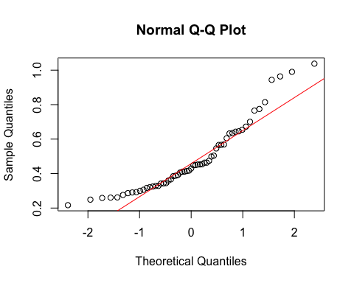

Cost Per Purchase
cpp_test <- t.test(daily_cpp ~ Campaign, data = cpc_cpp)
cpp_test
##
## Welch Two Sample t-test
##
## data: daily_cpp by Campaign
## t = -1.3136, df = 53.907, p-value = 0.1946
## alternative hypothesis: true difference in means between group Control Campaign and group Test Campaign is not equal to 0
## 95 percent confidence interval:
## -2.1404415 0.4459401
## sample estimates:
## mean in group Control Campaign mean in group Test Campaign
## 5.052339 5.899589
There is no significant difference in cost per purchase between two campaigns.
qqnorm(cpc_cpp$daily_cpp)
qqline(cpc_cpp$daily_cpp, col = "red")
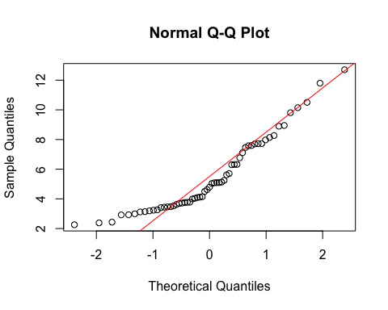
Test campaign is much efficient than the control campaign, as it has significantly higher CTR and CVR while paying the same price for each click and purchases.

