**C868 – Software Capstone Project Summary**

**User Guide**

|  |  |
| --- | --- |
| **Capstone Proposal Project Name:** | Farm Inventory: Cost Tracker |
| **Student Name:** | Craig Lohrman |

Table of Contents

**User Guide** 3

**Introduction** 3

**Installation and Using the Application** 3

**Java Installation** 3

**MySQL Installation** 5

**Configuring MySQL and Database** 15

**Installing NetBeans** 20

**NetBeans Setup for the Application** 23

# **User Guide**

## **Introduction**

This is how to install and set up all the required software to run the application. There will be step-by-step pictures with explanations under each screenshot.

## **Installation and Using the Application**

### **Java Installation**

We will install or update Java to version 8.0. [Download it from here.](http://www.java.com/download/)

Click the “Download Java” button on the page, start downloading the installer file, then run the file.

Click the install button.



Wait for the installation to finish.

When the installer is finished, click on the closed button. Now Java is installed and up to date.

### **MySQL Installation**

Now we are going to install MySQL. Download it by [Clicking Here](http://www.mysql.com/downloads).

Click on this link, “MySQL Community (GPL) Downloads.”

Now click on this link, “MySQL Installer for Windows.”

Download the bigger file.

Click on “No thanks, just start my download,” and the download will start, then run the file.

Select Custom and then click Next.

Select each one in A and click B.

When there is only Server, Workbench, and Connector/J, click next.

Click Execute

Click Next.

Click next.

Leave as default and click next.

Click next.

Type in a password you want to use to log into the root account of MySQL Server.

After you type in a password, click next.

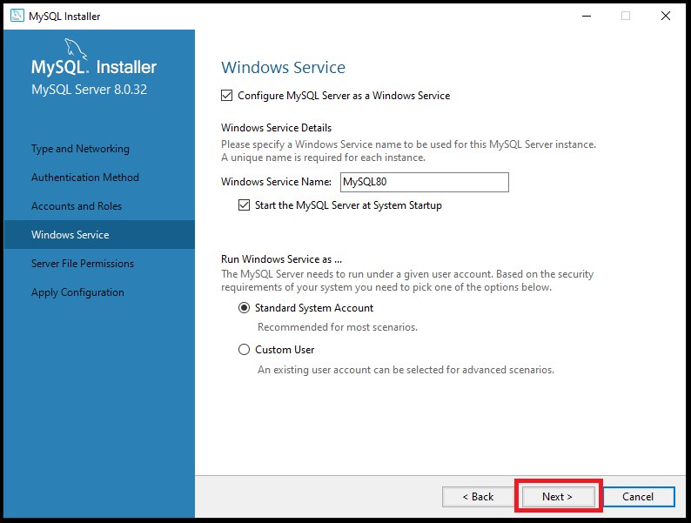

Click Next.

Click Next.

Click Execute.

Click Finish.

Click Next.

Finally, click Finish. And now, on to configuring the connection and creating the database.

### **Configuring MySQL and Database**

Click on the + sign to create a new connection.

Type the password you typed in above for the root.

If the password is correct, you will get this message, click ok.

You can now click ok.

Now click on the newly created connection.

Now we can create a new database and add the sample data. The zip file contains a folder called “Required to Run” with two files, “Create All Tables” and “Add Sample Data.” First, open the Create All Tables, copy all of it, and paste it into the Query 1 tab on the MySQL Workbench.

Once it is copied, click on the lightning bolt and then the refresh button next to Schemas. You will see the new database called “farm_inventory.”

Click on the new SQL Tab button on the top left, and a new SQL File tab will open where you can paste in the other file called Add Sample Data in the tab and click the lightning bolt again. This will add sample data to all the tables.

When you hover over a table name, it shows three icons. Clicking on the last one that looks like a calendar (A) will make a tab (B) that shows everything that is in table (C). That completes the installation and setup of MySQL.

### **Installing NetBeans**

To install NetBeans, which can be downloaded [here.](https://netbeans.apache.org/download/)

Click “Download.”

To avoid confusion, version numbers have been blacked out. Download the Windows-x64 link.

Click the suggested site link, and the download should start. Run the downloaded file.

Click Next.

Check the accept box and click next.

Click Next.

Click next again.

Now click finish.

## NetBeans Setup for the Application

Before you do this, make sure the zip file is extracted and you know the location of the files. Click on the NetBeans icon to open it.

Click on Open a Project or go to File >> Open Project.

Go to the location where the application was extracted and click Open Project. Go to File >> Project Properties (FarmInventory).

Click on Libraries.

Click the + sign under the Compile Tab, and select Add Library.

Click on Create…

Rename the Library to “JavaFX.”

Click Ok.

Ensure you are on the Classpath tab and click “Add JAR/Folder…”

Go to the location of the extracted zip file. Navigate to the “Required to Run” >> javafx-sdk-17.0.1 >> lib.

Select all the JAR files and click “Add JAR/Folder”.

Click Ok.

Make sure the new JavaFX Library is selected and click Add Library button.

Click the bottom + sign again, but select “Add JAR/Folder…”

It should be in the Required to Run folder when it is opened. If not, navigate to the same as JavaFX and select MySQL-connector-j-8.0.32.jar and click Open.

Click on the Run tab.

Ensure you are on the Run tab, click the Top + sign, and select Add Library.

Select the same library as before JavaFX and click Add Library.

Verify that the JavaFX library was added and click Ok.

Click on Run in the left-hand list. In the VM Options, type in without quotes.

“--add-modules javafx.fxml,javafx.controls,javafx.graphics” then click Ok.

Click Library on the Project List. Confirm there are two JavaFX listed and the MySQL connector.

Select dao (A) and open JDBC.java (B) in the project section. In the open file, look for a line with the user name and password inside the quotes type in the username and password you created MySQL Connection with.

The same User and Password you used here.

Now go to Tools >> Options >> Java (A), then select JavaFX (B), and then click Next on the window that pops up.

This might pop up if it does; click accept checkbox and Install button. Finally, click Ok.

## **How to Use the Application**

Type in your Username and Password, then click Login.

You can click on Medications, Animals, Food/Supplies, or Visits to add, update, or delete. The Reports Menu is where you can get a list for all or a selected animal for a 30, 90, or season of a specified year. The guide will go into more detail about each screen/button and describe what each field holds.

To start, click the Animals button to add, update, or delete an animal.

* Type – this is a dropdown menu to select which animal type you are adding.
* Name – this is the name of the animal.
* Date of Birth – this is the date the animal was born.
* Gender – this is Male or Female from a dropdown list.
* Altered – this yes or no means the animal has been fixed.
* Color – this is the color of the animal.
* Breed – this is for the breed of the animal.
* Add/Update – if you have not clicked on an animal in the list or clicked Clear, it is a new animal and will be added to the database and list. If you click on an animal in the list and change some of the data, it will update the database and list with the new information.
* Clear – this clears all the fields and sets all the dropdown lists to blank.
* Home – this takes you back to the Home Screen. If you have data in a field, it pops up and confirms that you want to leave the screen without saving. If you do not, it will go not pop up.

Now for the Medication button to add, update, or delete medication.

* Name – for the medication’s name.
* Date of Purchase – the date the medication was bought.
* Cost – this is the amount paid for the medication.
* Emergency – this yes or no means was the medication bought because of an emergency.
* Animal For is the name of the animal the medication was for.
* Reason – this is so you can put any notes as to why the medication was needed.
* Add/Update – if you have not clicked on a medication in the list or clicked on Clear, it is a new medication and will be added to the database and list. If you click on medicine in the list and change some of the data, it will update the database and list with the new information.
* Clear – this clears all the fields and sets all the dropdown lists to blank.
* Home – this takes you back to the Home Screen. If you have data in a field, it pops up and confirms that you want to leave the screen without saving. If you do not, it will go not pop up.

On the Food/Supplies button to add, update, or delete items.

* Type – this is to select food, supply, or other from a dropdown menu.
* Name – this is the name of the item.
* Date of Purchase – the date it was bought.
* Cost – the amount paid for this item.
* Animal For – the animal’s name the item is for.
* Reason – this is for any notes on why this was needed.
* Add/Update – if you have not clicked on an item in the list or clicked on Clear, it is a new item and will be added to the database and list. If you click on an item in the list and change some of the data, it will update the database and list with the new information.
* Clear – this clears all the fields and sets all the dropdown lists to blank.
* Home – this takes you back to the Home Screen. If you have data in a field, it pops up and confirms that you want to leave the screen without saving. If you do not, it will go not pop up.

The next button is Visit. This is the screen to add, update, or delete visits.

* Type – this is to select Vet, Ferrier, or Other.
* Name – the name of the person visiting.
* Animal For – the animal’s name the visit is for.
* Cost – the amount paid for this visit.
* Emergency – this yes or no means was the visit an emergency.
* Date of Service – the date of the visit.
* Reason – this is for any notes on why this was needed.
* Add/Update – if you have not clicked on a visit in the list or clicked on Clear, it is a new visit and will be added to the database and list. If you click on a visit in the list and change some of the data, it will update the database and list with the new information.
* Clear – this clears all the fields and sets all the dropdown lists to blank.
* Home – this takes you back to the Home Screen. If you have data in a field, it pops up and confirms that you want to leave the screen without saving. If you do not, it will go not pop up.

Now for the Reports Menu.

Here you can click on what you want a report on Visits, Items, or Medications. You can select an animal or all from there for 30 or 90 days. You can choose a year and a season for that animal or all.

The Visit Report screen shows the list of the selected animal and year.

* Which Animal – a dropdown list of all the animals from the animals’ table.
* All – this has no filter on and shows all the visits.
* 30 Days – after selecting an animal name or all, this shows the last 30 days of visits.
* 90 Days – after selecting an animal name or all, this shows the last 90 days of visits.
* Which Year – a dropdown list of all the years stored in the visits’ table.
* Spring – after you select an animal and year, this shows their spring months of visits.
* Summer – after you select an animal and year, this shows their summer months of visits.
* Fall – after you select an animal and year, this shows their fall months of visits.
* Winter – after you select an animal and year, this shows their winter months of visits.
* Reports Menu – takes you back to the report’s menu.
* Home - this takes you back to the Home Screen.

The Medication Report screen shows the list of the selected animal and year.

* Which Animal – a dropdown list of all the animals from the animals’ table.
* All – this has no filter on and shows all the medication.
* 30 Days – after selecting an animal name or all, this shows the last 30 days of medication.
* 90 Days – after selecting an animal name or all, this shows the last 90 days of medication.
* Which Year – a dropdown list of all the years stored in the medication table.
* Spring – after you select an animal and year, this shows their spring months of medication.
* Summer – after you select an animal and year, this shows their summer months of medication.
* Fall – after you select an animal and year, this shows their fall months of medication.
* Winter – after you select an animal and year, this shows their winter months of medication.
* Reports Menu – takes you back to the report’s menu.
* Home - this takes you back to the Home Screen.

The Food/Supplies Report screen shows the list of the selected animal and year.

* Which Animal – a dropdown list of all the animals from the animals’ table.
* All – this has no filter on and shows all the items.
* 30 Days – after selecting an animal name or all, this shows the last 30 days of items.
* 90 Days – after selecting an animal name or all, this shows the last 90 days of items.
* Which Year – a dropdown list of all the years stored in the items table.
* Spring – after you select an animal and year, this shows their spring months of items.
* Summer – after you select an animal and year, this shows their summer months of items.
* Fall – after you select an animal and year, this shows their fall months of items.
* Winter – after you select an animal and year, this shows their winter months of items.
* Reports Menu – takes you back to the report’s menu.
* Home - this takes you back to the Home Screen.

The Animals Report screen shows the list of all the animals.

* Reports Menu – takes you back to the report’s menu.
* Home - this takes you back to the Home Screen.