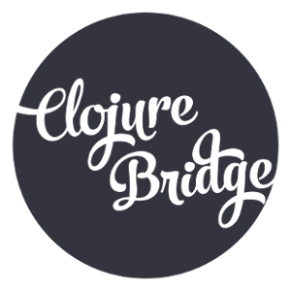
ClojureBridge Minneapolis Waiver

I (name of parent or legal guardian) ___________________________ confirm that I am the

legal guardian of ____________________________ (the“Student”). I allow the Student to
participate in the ClojureBridge Workshop for Women, held at DevJam Studios, from May 16, 2014 to May 17, 2014. I assume all risks, dangers and hazards on behalf of the Student, and
recognize that the ClojureBridge volunteers are not liable for the Student's safety or wellbeing. I also confirm that the Student will abide by all local laws of Minneapolis, Minnesota, including those regarding the consumption of alcohol.

______________________________ ______________________________
Guardian Signature and Date Printed Name

