**ANNOUNCING CLOJUREBRIDGE NYC 2017**

**CLOJUREBRIDGE NYC 2017** **is a FREE computer programming workshop for women**.

This hands-on course introduces participants to functional programming in a professional and empowering environment. The event has two tracks catering both to novices as well as programmers familiar with imperative languages such Python and JavaScript. During the workshop, participants use the Clojure programming language to build working applications in a friendly and collaborative setting. Professional developers and experienced instructors are on hand throughout the workshop. ClojureBridge NYC 2017 is open to 200 participants. Breakfast, lunch and refreshments are graciously provided by our sponsors. The event will take place at the weekend of June 2nd - June 4th, 2017

The official website for the event is**:** [**http://clojurebridge.lispnyc.org**](http://clojurebridge.lispnyc.org/)

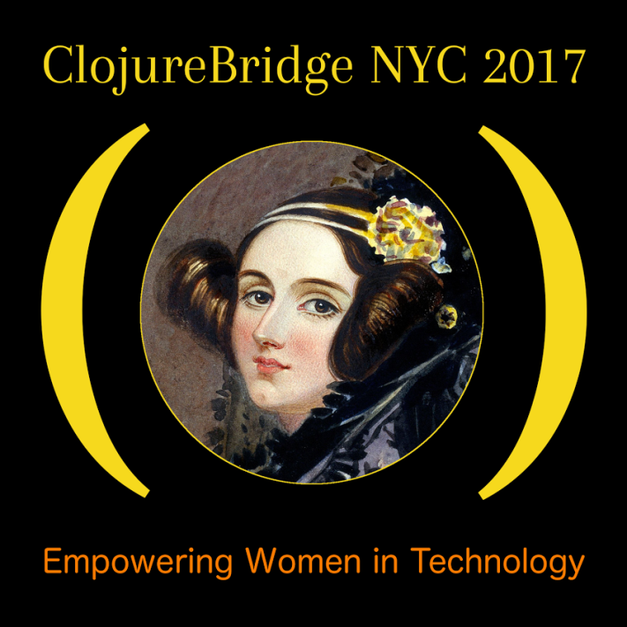 

**REGISTRATION** starts on **Monday April 24th**.

**MOTIVATION** Why Clojure? Please visit: [**http://clojurebridge.lispnyc.org/why-clojure**](http://clojurebridge.lispnyc.org/why-clojure)

**VOLUNTEERING** We are looking for motivated and empowered individuals to help with both the organizational and operational aspects of the event. As an official ClojureBridge Volunteer you will receive a free ClojureBridge NYC 2017 T-Shirt and you will be credited on the website.

If you are interested please email [**clojurebridge-volunteers@lispnyc.org**](mailto:clojurebridge-volunteers@lispnyc.org)

For all other inquiries contact [**clojurebridge-info@lispnyc.org**](mailto:clojurebridge-info@lispnyc.org)