Portfolio 2

GitHub: <https://github.com/clolesen/methods4-portfolio2>

# 1.

*What's Riccardo's estimated knowledge of CogSci? What is the probability he knows more than chance (0.5) [try figuring this out. if you can't peek into chapters 3.1 and 3.2 and/or the slides]?*

*- First implement a grid approximation (hint check paragraph 2.4.1!) with a uniform prior, calculate the posterior and plot the results*

*- Then implement a quadratic approximation (hint check paragraph 2.4.2!).*

*- N.B. for the rest of the exercise just keep using the grid approximation (we'll move to quadratic approximations in two classes)*

There is a 50% probability that Riccardo’s CogSci knowledge is above chance. This was calculated by summing up all the posterior probabilities above 0.5 in the grid. This also makes perfect sense when looking at the plot below, where the distribution centers around 0.5 and looks normally distributed. The quadratic approximation estimates the mean to be 0.5 with a standard deviation of 0.2.

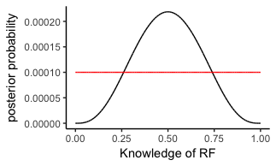

Plot 1 - Plot showing the posterior distribution (black line) and the prior (red line) of the model.

# 2.

*Estimate all the teachers' knowledge of CogSci. Who's best? Use grid approximation. Comment on the posteriors of Riccardo and Mikkel.*

*2a. Produce plots of the prior, and posterior for each teacher.*

In the table below