Agenda

* Initial Design
  + Key Concepts
    - Project ( description page,add video to description, editing form )
    - Updates (media for updates, advice format)
    - Donors ( payment system)
    - Alums/Students( authentication : email )
  + Features
    - filtering or matching
    - posting updates (youtube, pictures, text)
    - advice/commenting on projects
    - secure payment system
  + Wireframe (Similar site’s UI)
  + Data Model

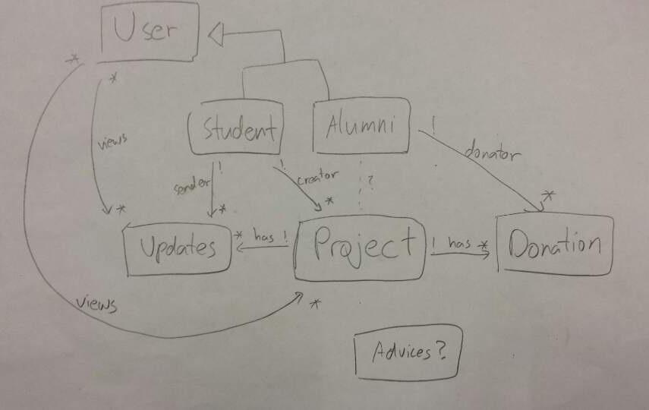

* Third Party Library (Paypal or Venmo)
* Feedback on the presentation
* MVP(Subset of Features to implement)
  + posting updates(text, pictures, youtube link)
  + secure payment system
  + comment / advice section
  + authentication of email