aCRF Annotation Engine
User Guide

What it does
The aCRF Annotation Engine automates the creation of SDTM-annotated CRFs. It extracts every collected field from a blank CRF, maps it to the correct SDTM domain and variable in compliance with CDISC SDTM-MSG v2.0, and produces a submission-ready annotated PDF alongside a field-level traceability export. Programmers can review the annotations in Acrobat directly, correct, and sign off on the first-draft CRF.

1. How it works
- Upload — accepts any standard AZ-EDC CRF export (Blank, RSG, or DB format) — no pre-cleaning required.
- Extract — reads every page to identify forms, visits, and collected fields, filtering out non-collected noise.
- Map — resolves each field to its SDTM domain, variable, codelist, and qualifier, with a confidence score and supplemental-dataset support.
- Output — produces a colour-coded, MSG-compliant annotated PDF plus a CSV traceability file.
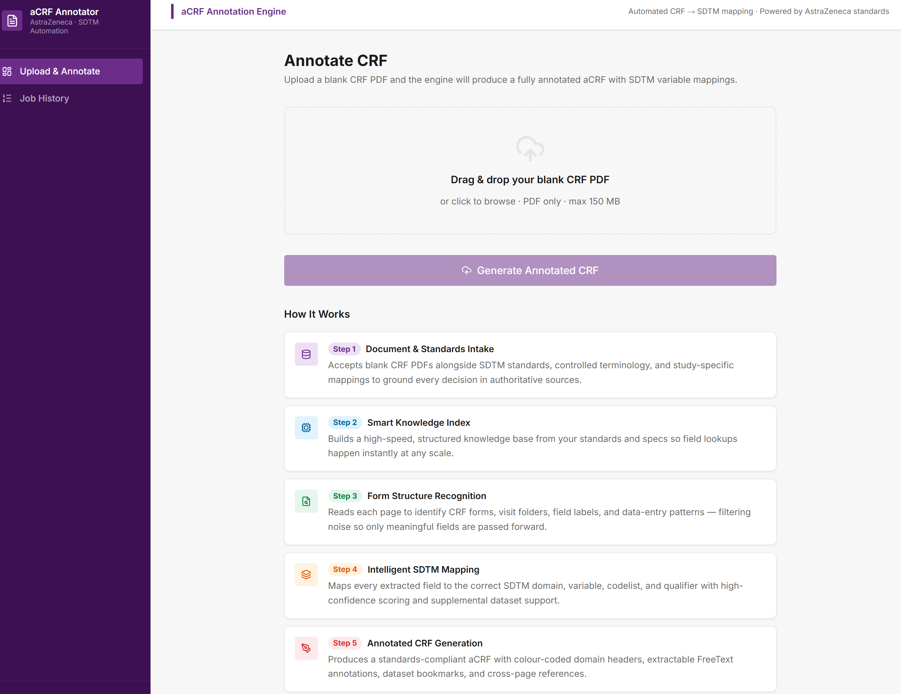
Figure: Upload screen — drag-and-drop with a five-step summary of the pipeline.

2. Reading the results dashboard
Processing takes 30–90 seconds. The job page shows four summary cards:
Metric | What it tells you
Resolution Rate | Share of fields mapped to an SDTM variable (or marked NOT SUBMITTED)
Annotations Written | Annotation boxes placed in the output PDF
Fields Extracted | Total fields read from the CRF vs. dropped as noise
Unique Forms | Distinct CRF form types detected

The Resolution Tier Breakdown shows how each mapping was decided — High Confidence, SDTM Standards, Standards Lookup, Not Submitted, or Unresolved. Higher tiers need less review.
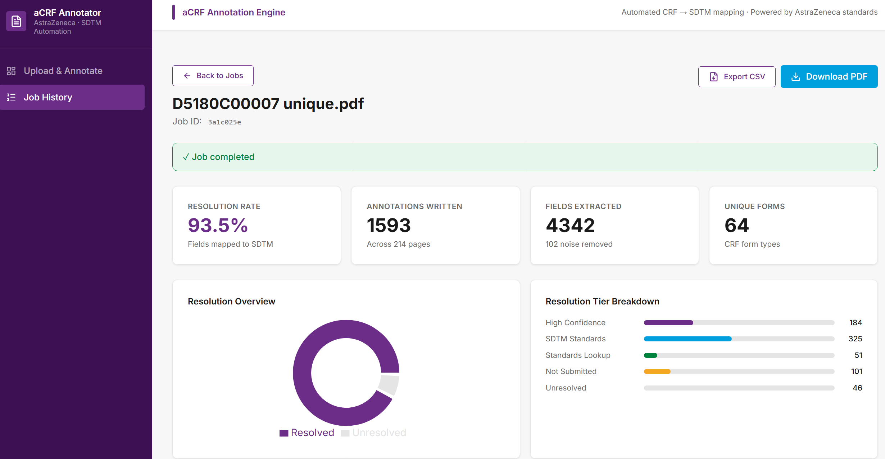
Figure: Job dashboard — quality metrics, resolution rate, and tier breakdown.

3. Field-mappings table
Every extracted field is listed with its CRF label, SDTM annotation, domain, variable, and confidence score. Two tabs split the view: Resolved and Unresolved (fields needing attention).
Filter by free-text search, form name, SDTM class, or confidence threshold (≥90 / ≥95 / ≥98%) to focus review on the weakest mappings first.
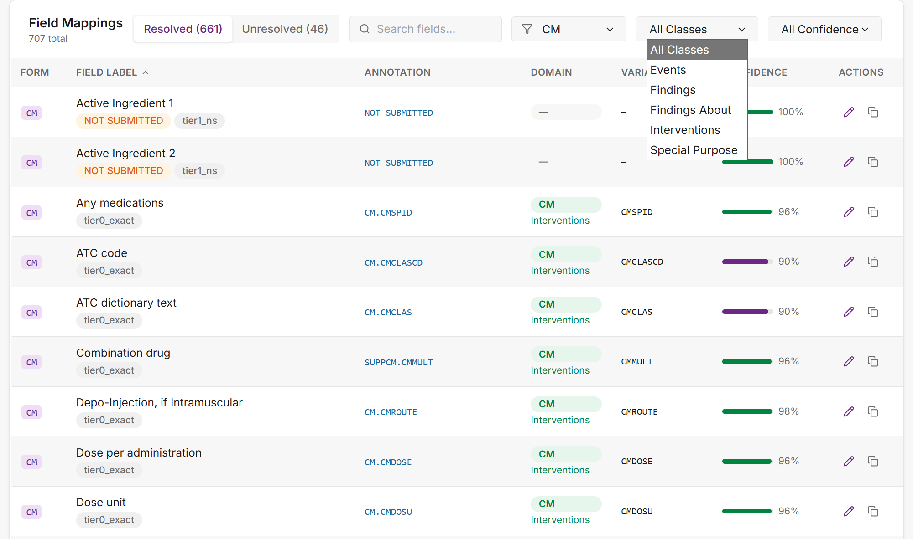
Figure: Field-mappings table with confidence scores, filters, and Resolved/Unresolved tabs.

4. Correcting and regenerating
Click the pencil icon on any row to edit its annotation (comma-separate multiple variables on one field). Stage edits with Enter — nothing commits until you click Save & Regenerate PDF, which rewrites the output with your corrections.
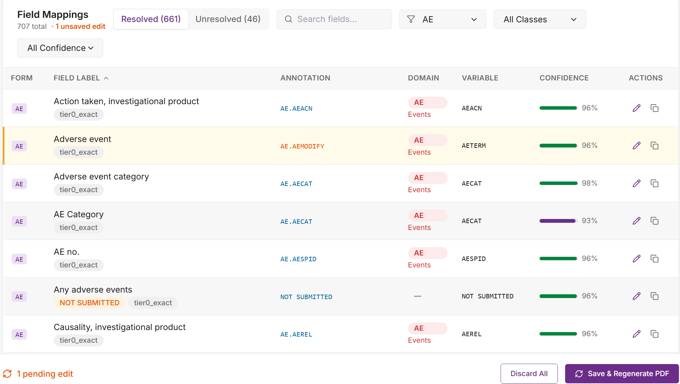
Figure: A staged edit highlights the row and raises the “Save & Regenerate PDF” footer.

5. The annotated PDF output
Download PDF gives you the annotated aCRF; Export CSV gives the field-level traceability spreadsheet for review sign-off and downstream specs.
The PDF follows SDTM-MSG v2.0 conventions: colour-coded domain headers, variable annotation boxes per field, and dashed [NOT SUBMITTED] markers for non-collected fields. All annotations are editable FreeText boxes in Acrobat — drag, resize, or retype as needed.
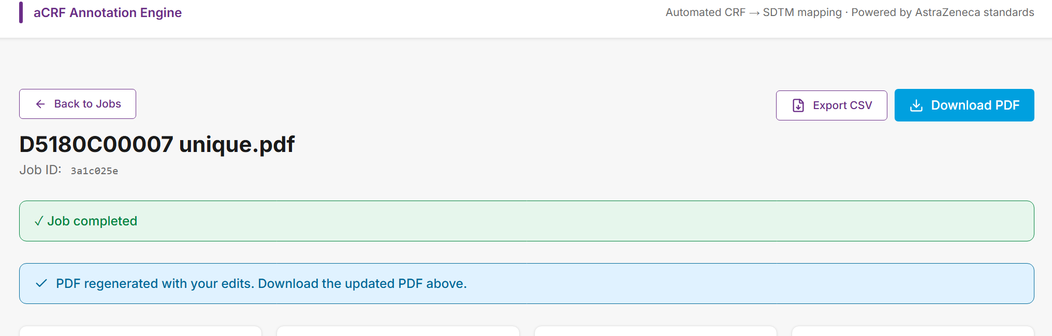
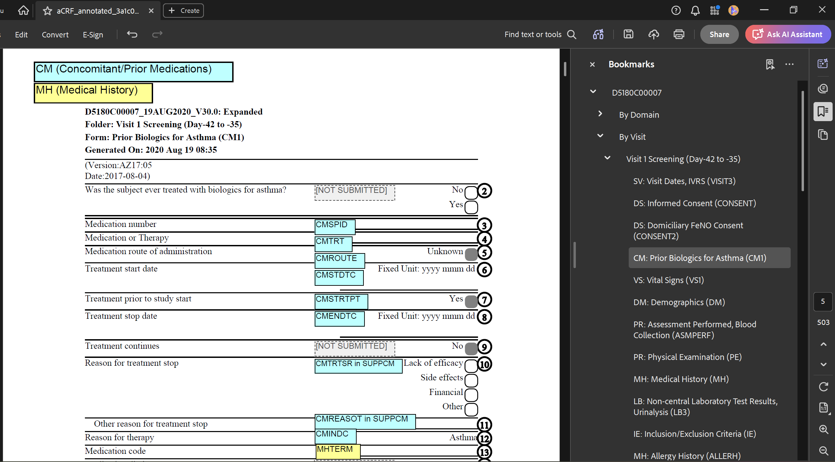
Figure: Annotated PDF output — colour-coded annotations, NOT SUBMITTED markers, and bookmarks.

6. Job history
Every run persisted with its filename, annotation count, resolution rate, and status. Reopen any previous job to re-download or continue editing.
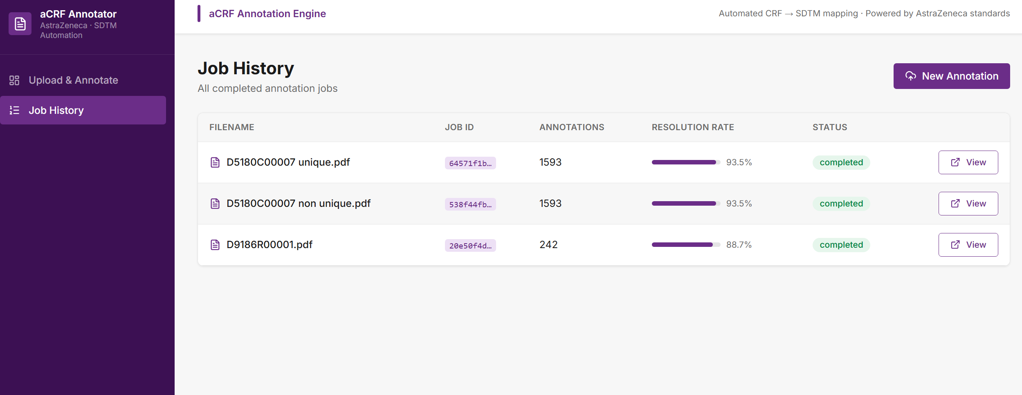
Figure: Job History — re-open, re-download, or keep editing any previous run.

