aCRF Annotation Engine
Leadership Overview · SDTM Automation for Respiratory & Immunology

What it does
The aCRF Annotation Engine turns a blank study CRF into a fully SDTM-annotated CRF automatically — work that is otherwise done by hand over several days for every study. It maps each collected field to its SDTM domain and variable following CDISC SDTM-MSG v2.0, then produces a submission-ready annotated PDF with a full field-level traceability export. A programmer reviews and signs off rather than annotating from scratch.

At a glance
Speed | Annotates a ~500-page CRF in under two minutes, versus days of manual work per study.
Coverage | ~93% of fields auto-mapped to the correct SDTM domain and variable on a representative R&I study.
Compliance | Output follows CDISC SDTM-MSG v2.0 annotation conventions, supporting FDA Study Data Technical Conformance Guide expectations for the aCRF.
Risk control | Human-in-the-loop by design — every mapping is surfaced for review with a confidence score; nothing reaches the deliverable unvalidated.
Reproducibility | Each run is versioned and stamped with its tool/rule provenance, and persisted in a job history for audit.

How it works
- Upload any standard AZ-EDC CRF export (Blank, RSG, or DB format) — no pre-cleaning required; EDC scaffolding is detected and skipped.
- Extract reads every page to identify forms, visits and collected fields, filtering out non-collected noise.
- Map resolves each field to its SDTM domain, variable, codelist and qualifier, with a confidence score and supplemental-dataset support.
- Output a colour-coded, MSG-compliant annotated PDF plus a CSV traceability file.
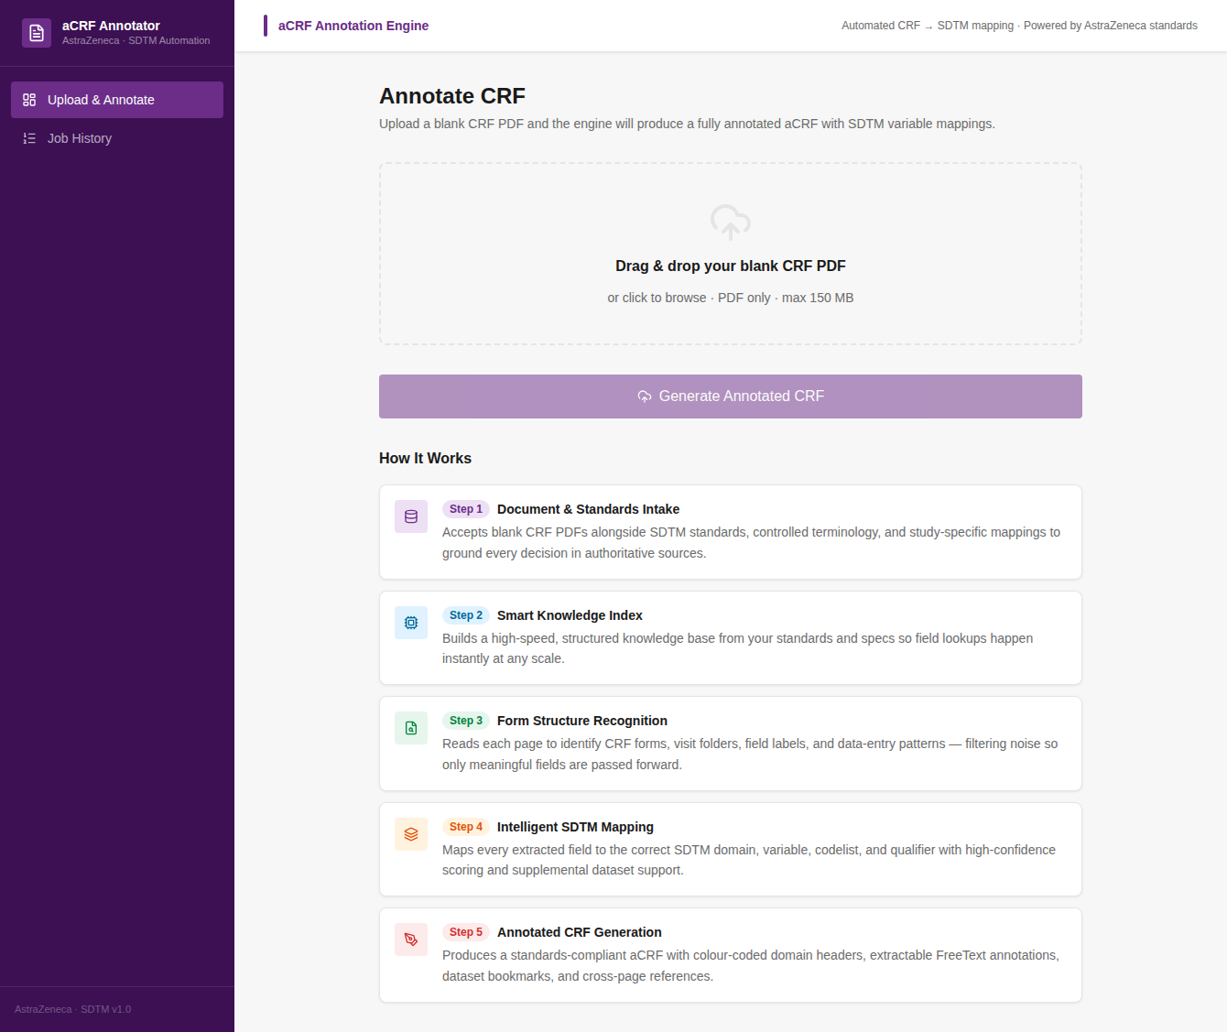

Quality assurance
Every run opens on a quality dashboard that makes coverage and trustworthiness visible at a glance:
Metric | What it means
Resolution Rate | Share of extracted fields mapped to an SDTM variable (or marked NOT SUBMITTED) — the headline coverage number.
Confidence tiering | Each mapping is graded — High Confidence (exact rules), SDTM Standards, Standards Lookup, Not Submitted, Unresolved — so review effort targets the weakest mappings, not the whole CRF.
Annotations / Forms | Volume placed in the output and the breadth of CRF forms covered.

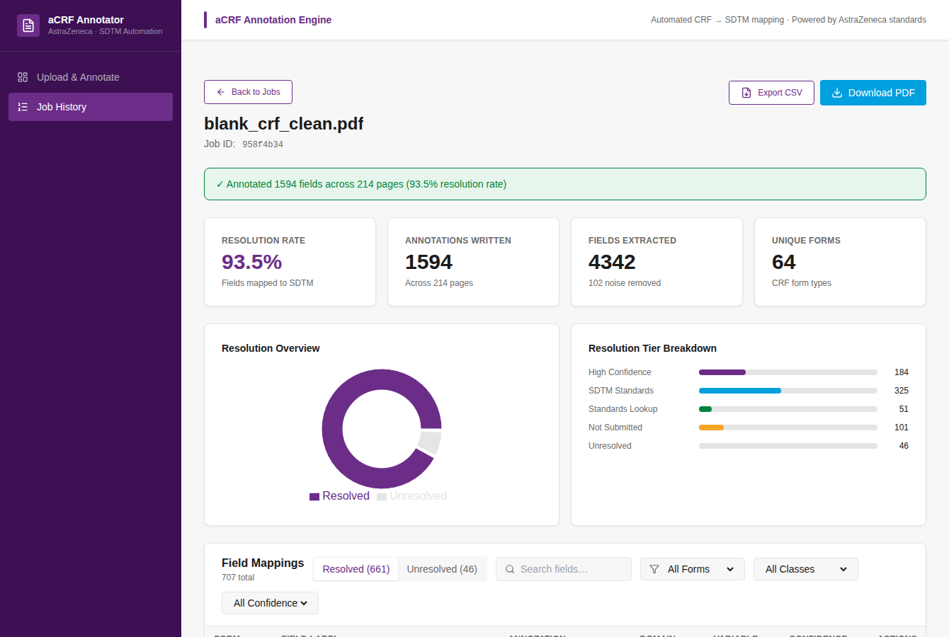

Human review & override
The engine's output is a starting point, not a locked deliverable. Every mapping is reviewable in a filterable table split by Resolved / Unresolved; programmers focus on low-confidence annotations and leave exact, rule-based matches with minimal scrutiny. Any annotation can be corrected inline and the PDF regenerated in one click — keeping a qualified programmer accountable for the final result.
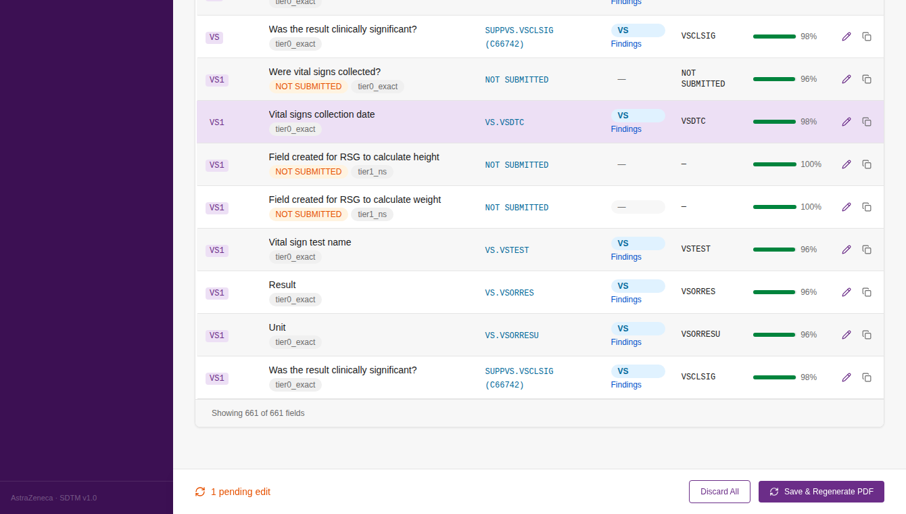

Output & compliance
The deliverable is a fully SDTM-MSG v2.0-compliant annotated PDF with colour-coded domain headers, editable FreeText annotation boxes (adjustable in Adobe Acrobat) and [NOT SUBMITTED] markers for non-collected fields. A companion CSV provides field-level traceability for review sign-off and downstream SDTM spec generation. Because the annotations are real PDF objects rather than flattened images, the output drops directly into the existing submission workflow and remains fully adjustable.
