aCRF Annotation Engine
Knowledge Transfer · Technical Handover for SDTM Programmers
Respiratory & Immunology · SDTM-MSG v2.0 · Internal R&I Tool
Purpose of this document. This is a complete technical knowledge transfer for the aCRF Annotation Engine, written for statistical programmers who annotate CRFs by hand today. It explains what the tool does, the SDTM mapping logic behind it (in the detail you would scrutinise a spec with), the architecture, the knowledge base it draws on, how it is validated, how to run and maintain it, and where the boundaries and next steps are. No web or Python background is assumed — where a software concept appears, it is tied back to the equivalent in a SAS / SDTM workflow.

1. What the tool is, in one paragraph
Annotating a blank CRF is normally a manual job: a programmer opens the blank CRF PDF, and for every collected field decides the SDTM domain, variable, codelist and any qualifier, then draws a text box on the page in Adobe Acrobat. For a full study that is several days of careful, repetitive work. The aCRF Annotation Engine does that first pass automatically. You give it the blank CRF PDF; it reads every page, identifies the real collected fields, maps each one to its SDTM domain and variable following CDISC SDTM-MSG v2.0, and writes a colour-coded annotated PDF with real, editable annotation boxes plus a CSV mapping spec. A multi-hundred-page CRF is annotated in under two minutes. You then review, correct anything you disagree with, and regenerate — so the programmer stays in control of the final, submission-quality output.
Manual workflow (today) | With the engine
Programmer reads each field, recalls the mapping | Engine proposes the mapping with a confidence score
Draws each box by hand in Acrobat | Boxes placed automatically, aligned to each field row
Days per study; error-prone, hard to QC | Minutes per study; every decision logged to a CSV
Consistency depends on the individual | Same rules + standards applied identically every time
No reuse between studies | A learned-mappings table reuses prior annotated CRFs

2. Inputs and outputs

2.1 What you feed in
- Blank / production CRF the standard numbered AZ-EDC export. Every field carries a 1–3 digit number used as a parsing anchor.
- Annotated-style / RSG CRF position-based layouts where fields are not numbered; positions are recovered from page geometry.
- DB / Raw dataset CRF spec-table style exports (Field Name / Data Type / SAS Label). EDC scaffolding pages are detected and skipped.
PDF only, up to 150 MB. No pre-cleaning needed — headers, visit folders, EDC variable definitions and instructions are filtered out automatically.

2.2 What you get back
- Annotated PDF colour-coded by domain (SDTM-MSG v2.0 colour sequence), with a coloured dataset header box per form. Boxes are real PDF FreeText annotations — in Acrobat you can click, drag, resize and edit them exactly like a hand-annotated CRF. Derived / dictionary-coded variables carry a dashed border (Origin = Assigned); genuinely non-submitted fields are marked [NOT SUBMITTED].
- CSV mapping spec one row per field: form, label, annotation, domain, variable, codelist, confidence, and which resolution tier decided it. This is your traceability / review artefact and feeds downstream specs.
- Run statistics resolution rate, annotation count, fields extracted vs dropped as noise, and a tier breakdown so you know how much of the output to trust.

3. How a CRF flows through the engine
Internally the run is a fixed pipeline (see app/services.py → run_pipeline). Each stage is deterministic and inspectable — there is no black box in the core path. The optional LLM step is the only non-deterministic component and is off unless an API key is configured.
Stage | What happens
1. Parse the PDF | Read every page; extract text with x/y positions; parse headers for form code + visit; identify fields by the number-anchor pattern (label → format hint → field number → response options).
1.5 Study context | From the set of form codes, detect therapeutic-area context (e.g. oncology) so domain inference is study-aware.
2. Noise filter | Drop non-data text that leaked through parsing — headers, instructions, EDC plumbing. Fields that pass WILL be annotated or left explicitly unresolved; dictionary fields (MedDRA / WHODrug) are KEPT.
2.5 De-duplicate | Resolve each unique (form, label) only once — a form repeated across many visit folders is mapped one time, then the result is reused on every page, so counts are not inflated.
3. Resolve to SDTM | The heart of the tool. Each unique field is run through the resolution tiers (Section 4) until one returns a mapping or it is left unresolved.
4. Write the PDF | Place a colour-coded FreeText box on each field's row, with overlap avoidance and dashed borders for derived variables; add domain header boxes and cross-page 'continued' / 'see page' references.
4.5 Write the CSV | Emit the full field-level mapping spec for traceability and human review.

4. The SDTM mapping logic (the part that matters most)
This is where the engine reproduces the judgement a programmer applies by hand. It is a tiered cascade: cheap, exact, high-confidence rules are tried first; only what they cannot answer falls through to broader, lower-confidence strategies. Every result carries the tier that produced it and a confidence score, both of which appear in the UI and the CSV so you can target review at the weakest mappings.

4.1 Tier 1 — NOT SUBMITTED (runs first)
A deterministic classifier for fields that genuinely do not go into any submission dataset — RSG/internal fields, calculation-only fields, explicit 'do not submit' markers, and CRF workflow instructions. These are matched by pattern and regex, never guessed. Important nuance fixed recently: dictionary-coded fields (MedDRA PT/LLT/SOC, WHODrug preferred name, ATC class, dictionary versions) are NOT treated as NOT SUBMITTED — they have real SDTM destinations and are handled by Tier 0 (see Section 4.5).

4.2 Tier 0 — deterministic rules, standards & spec (the workhorse)
Tier 0 carries the great majority of mappings. It is itself layered, and the layer that matched sets the confidence band:
Layer | Source | Confidence
Exact rules | Form-aware deterministic rules + the learned-mappings table built from prior annotated CRFs (Section 5). | ≥ 0.98 (High)
SDTM Standards | CDISC SDTM IG standard variable labels, matched by normalised label. | ≥ 0.92 (Standards)
AZ Spec lookup | AZ RAW→SDTM specification template + corporate standards, including fuzzy / semantic matching. | < 0.92 (Lookup)
Domain inference | Study-agnostic fallback: scores the most likely domain(s) from form code + form name when no direct label match exists. | varies

Tier 0 also enriches a result: it adds supplemental-qualifier mappings (SUPP--), attaches controlled-terminology codelists, flags derived / assigned variables (AGE, --DECOD, --DY, …) so the PDF draws them with a dashed border, and resolves multi-domain fields that map to more than one variable.

4.3 Tier 3 — optional LLM fallback
Only the fields that survive every deterministic tier reach Tier 3. If an Anthropic API key is configured, the field label + form context is sent to Claude, which proposes an SDTM variable with a rationale; the result is flagged for human review and never allowed to invent a variable outside the standard. With no key set, Tier 3 is a no-op and the field is simply left Unresolved for a programmer to handle. The core tool ships fully functional without any LLM.

4.4 Findings where-clauses & value-level decode
- TESTCD where-clauses for Findings domains (VS, LB, EG, …) the engine carries the test code as a where-clause qualifier — e.g. VSORRES when VSTESTCD = "WEIGHT" — exactly as a hand-annotated CRF does for repeating test panels.
- Value-level decode controlled-response questions get a value-level decode showing how each response option maps to its submission value — e.g. for an 'Condition ongoing? [Yes/No]' field mapping to MHENRTPT, the decode is 'ONGOING = Yes'.
- Repeating-structure awareness the usage guard understands that in repeating Findings structures the same variable (LBORRES) legitimately recurs for every test in a panel — so it is not falsely de-duplicated.

4.5 Dictionary-coded fields (MedDRA / WHODrug / ATC)
Older CRFs display the dictionary-coding columns directly on the form (Dictionary-Derived Term, Lowest Level Term, Body System or Organ Class, Medication dictionary text, Preferred Name, ATC code, Active Ingredient, dictionary versions). Per SDTM-MSG these are not 'unsubmitted' — the coded variables (--DECOD, --BODSYS, --LLT, …) are submitted with Origin = Assigned, and dictionary versions go to the SUPP-- qualifiers (MEDDRAV / WHODRGV). The engine maps each of these to its real variable, derives the domain from the form (so the same label resolves to AEDECOD on an AE form and CMDECOD on a CM form), and draws them with the dashed 'derived' border.

5. The knowledge base the engine reasons over
None of the mapping logic is hard-coded study knowledge. It is driven by a set of pre-built lookup files (the cache/ directory), compiled once from the authoritative source spreadsheets and reference aCRFs. Think of these as the engine's standards library and its memory of past work.
Knowledge file | What it holds (and the source)
sdtm_spec_by_dataset.json | CDISC SDTM IG standard variables and labels per dataset — the baseline standard.
az_spec_lookup.json | AZ RAW→SDTM Specification Template — the company's study-build mappings.
ct_lookup.json | Controlled Terminology (codelists) used to attach the right codelist to a mapped variable.
corporate_variables.json | AZ Corporate SDTM Standards variables / datasets.
map_rules.json | AZ Map Rule spec — deterministic mapping rules.
learned_mappings.json | ~7,600 label→variable mappings extracted from ~20 already-annotated reference aCRFs. This is the engine's reuse memory and the reason reproduction accuracy is high.
sdtm_not_submitted_labels.json | Dictionary-derived label reference (now mapped to real variables, not NOT SUBMITTED).
cdisc_index.faiss / az_spec_index.faiss | Vector indexes for semantic (meaning-based) lookup when an exact label match is not found.

These are rebuilt with scripts/build_cache.py whenever the source spreadsheets or reference aCRFs change. The learned-mappings table is the one most worth growing over time (Section 9).

6. How well it works, and how that is measured
Accuracy is measured against a ground-truth set of 5,073 fields taken from reference annotated CRFs, using scripts/accuracy_report.py. Two numbers are reported because they answer two different questions:
Metric | Meaning
≈ 96% reproduction (learned table ON) | On CRFs similar to ones it has seen, with the learned-mappings memory enabled, the engine reproduces the human annotation for ~96% of fields. This is the day-to-day mode.
≈ 8% generalisation (learned table OFF) | With the reuse memory disabled — pure rules + standards on unseen fields — exact domain+variable match. This is the hard floor on a brand-new CRF and is the honest measure of out-of-the-box generalisation.

The gap between the two is exactly why the learned table and the human-in-the-loop review matter: every correction a programmer makes can be fed back to raise the floor over time. Confidence scores should be interpreted as review priority, not as a guarantee — the 'All Confidence' filter in the UI exists so you can focus review on the weakest mappings first.

7. Using the application
The tool ships as a small web application: a browser front-end for upload, review and correction, talking to a Python service that runs the pipeline. A programmer never touches code to use it.
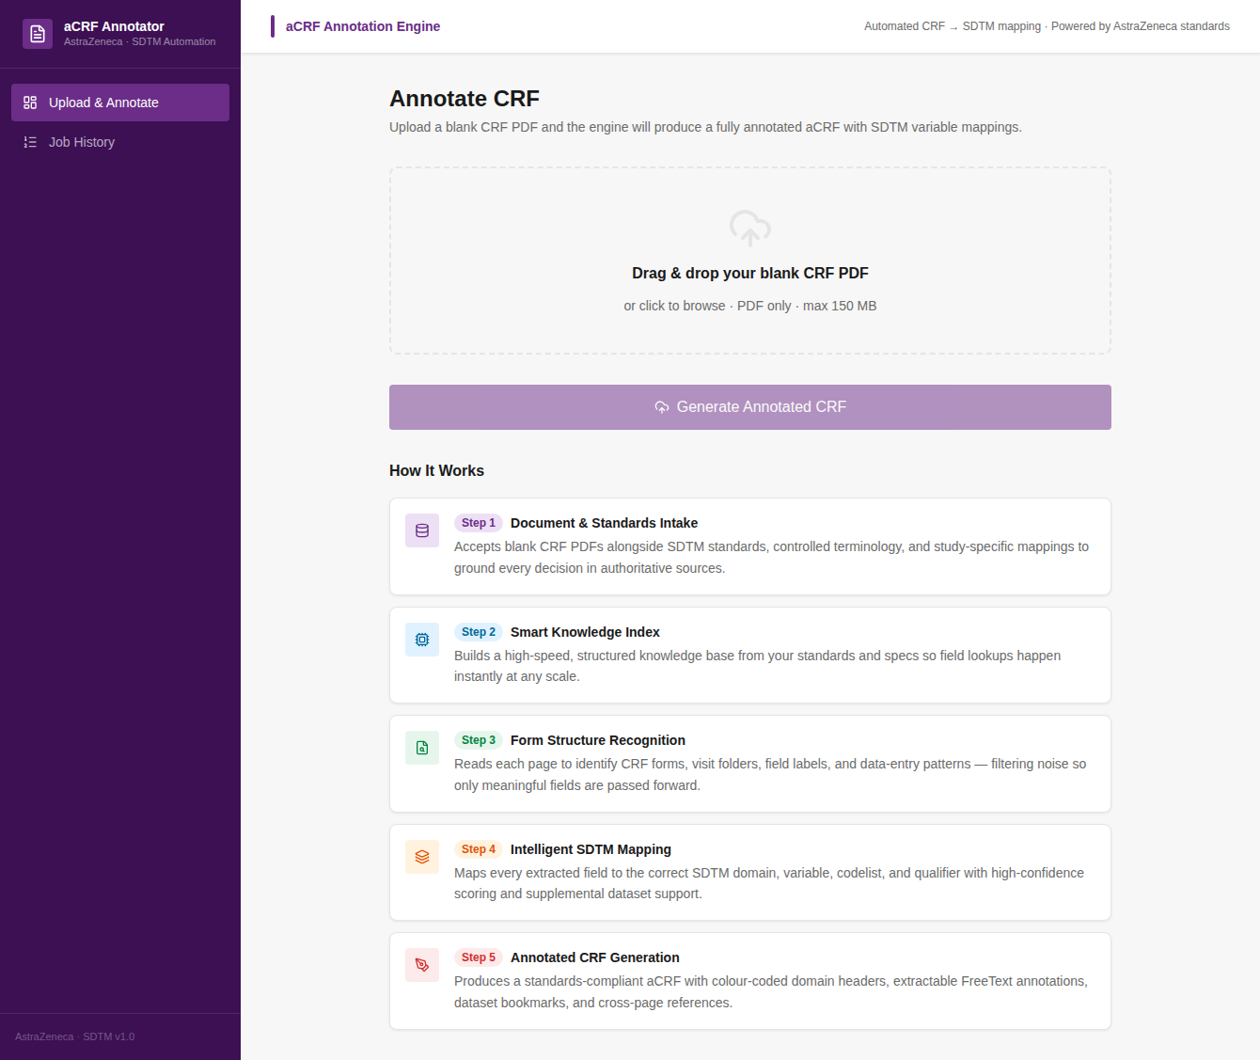
Figure: Upload screen — drag in a blank CRF PDF; the engine processes it and opens the results automatically.
On the job page, four cards summarise quality (resolution rate, annotations written, fields extracted vs noise, unique forms), a donut shows resolved vs unresolved, and a tier breakdown shows HOW each mapping was decided.
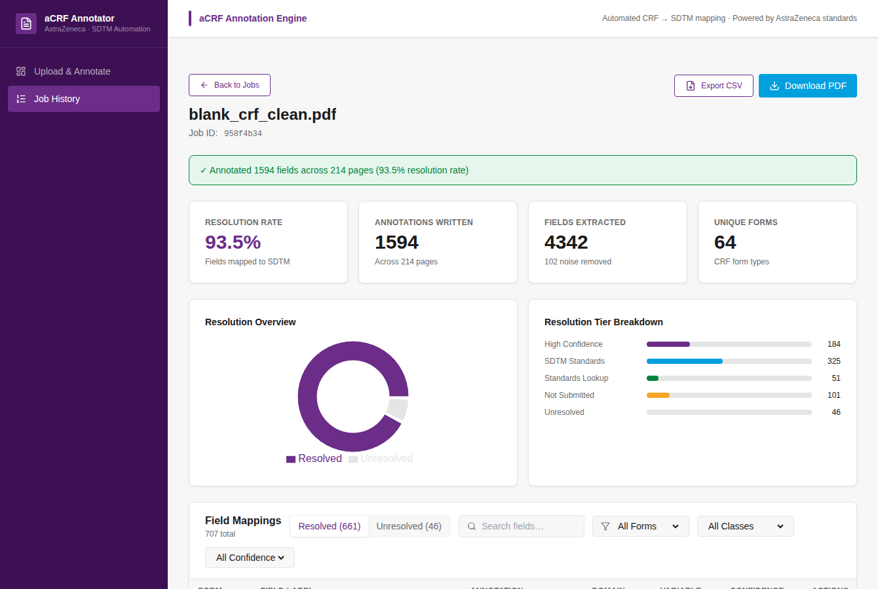
Figure: Job dashboard — quality metrics, resolution donut, tier breakdown, and the filterable mappings table.
Every field is listed with its annotation, domain, variable and a confidence bar, split into Resolved / Unresolved tabs. Filter by form, SDTM class, confidence threshold, or free text; sort on any column.
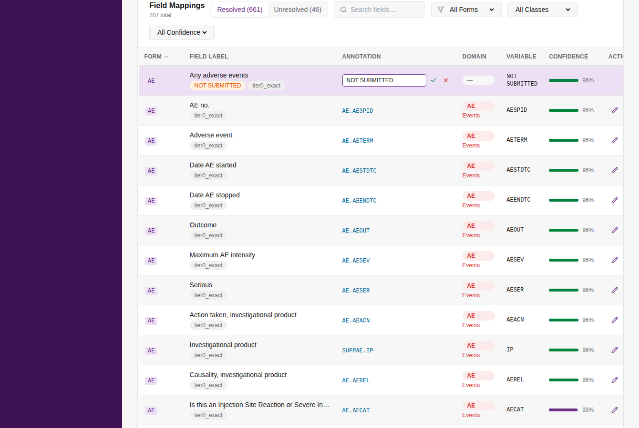
Figure: Field-mappings table with one row open for inline editing.

7.1 Human-in-the-loop correction
This is the key point for a programmer audience: the engine's output is a starting point you control, not a final answer it imposes.
- Click the pencil on any row to edit the annotation.
- Type the corrected mapping (comma-separate multiple annotations on one field, e.g. VS.VSORRES, VS.VSTESTCD).
- Press the green check to stage it — staged, not yet committed.
- Click 'Save & Regenerate PDF' in the sticky footer; the engine rewrites the annotated PDF with your corrections. 'Discard All' reverts.
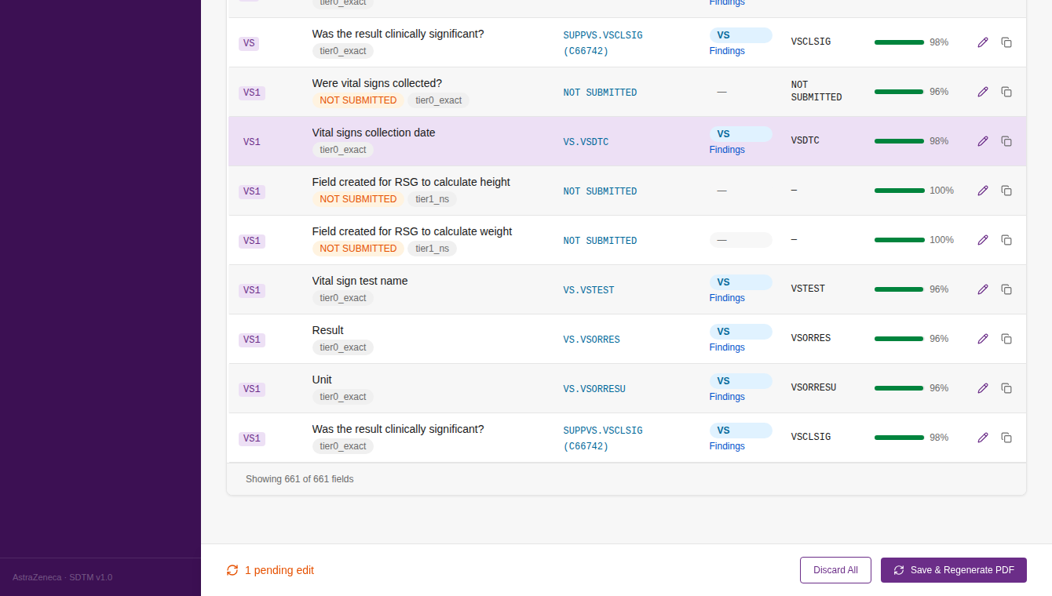
Figure: A staged edit highlights the row and raises the Save & Regenerate footer.
Every run is kept in Job History — re-open, re-download the PDF, export the CSV, or keep editing any previous study.
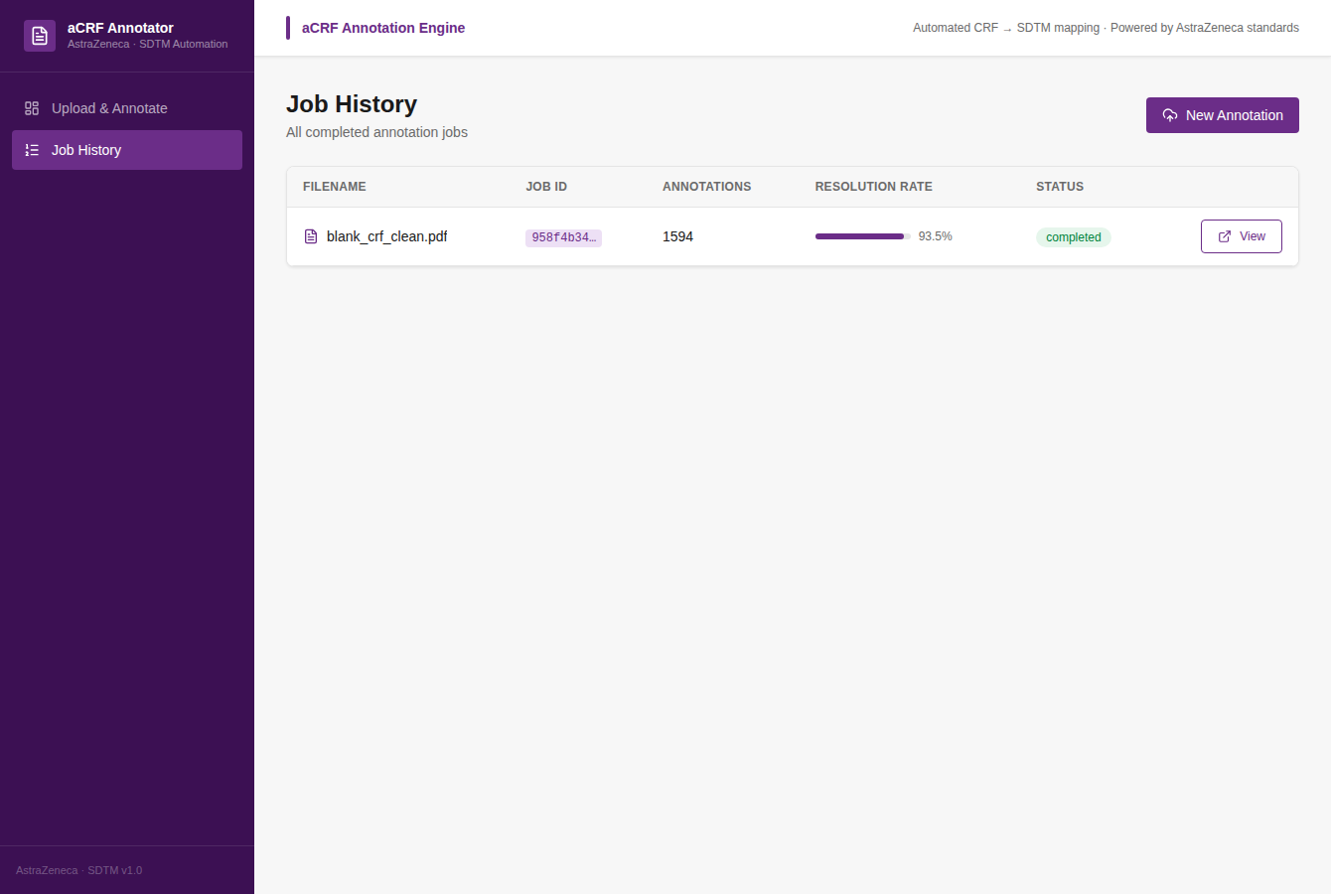
Figure: Job History — every annotation run, re-openable and re-downloadable.
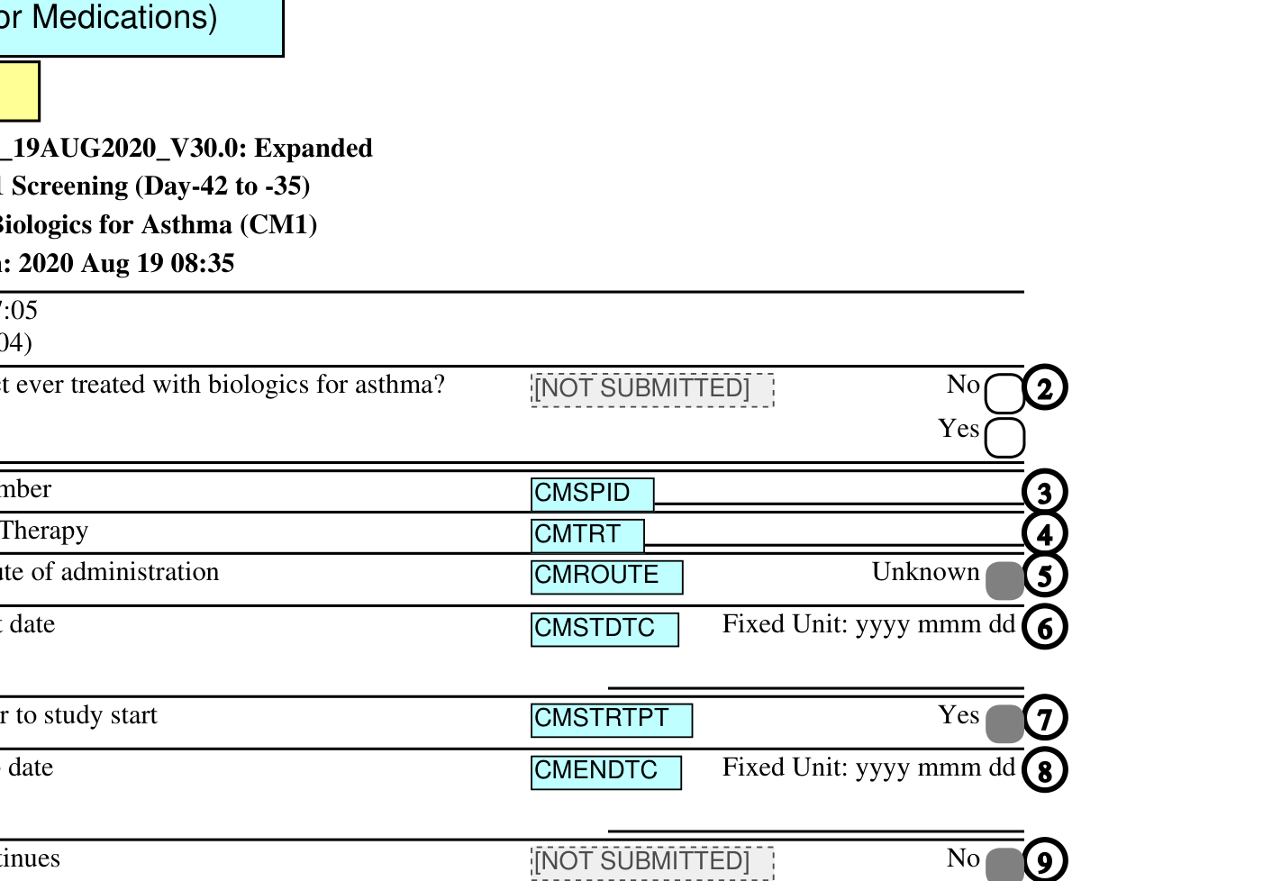
Figure: Output detail — editable, colour-coded FreeText boxes and dashed derived / NOT SUBMITTED markers, aligned to each CRF field row.

8. Architecture & technology (for whoever maintains it)
The stack, in plain terms with the SDTM-programmer equivalent where useful:
Component | Technology | Role
PDF engine | Python + PyMuPDF (fitz) | Reads the blank CRF and writes the annotated PDF with real FreeText annotation objects.
Resolution engine | Python (src/resolution/*) | The tiered SDTM mapping logic — the equivalent of your annotation judgement, codified.
API service | FastAPI + uvicorn | Receives the upload, runs the pipeline, serves stats / downloads. Like a stored procedure exposed over the web.
Front-end | React + TypeScript (Vite) | The browser UI — upload, dashboard, mappings table, inline edit.
Test suite | pytest (78 tests) | Locks in extractor, mapping, annotation-format and regression behaviour.

8.1 Where things live in the repository
Path | Contents
src/pdf_parser/ | PDF reading: extractor, field identification (number-anchor), header parsing, context windows.
src/resolution/ | The mapping tiers: tier0_rules, tier1_not_submitted, tier3_llm, domain_inferencer, findings_qualifier, value_decoder, noise_filter, usage_guard, models.
src/annotator/ | pdf_writer (box placement, colours, dashed borders, overlap avoidance) and mapping_export (CSV).
src/cache_builder/ | Parsers that compile the source spreadsheets into the cache/ lookup files.
app/ | FastAPI service: routers/annotate.py (endpoints), services.py (run_pipeline), schemas.py.
frontend/ | React app (pages: Upload, JobDetail, Jobs).
cache/ | The pre-built knowledge base (Section 5).
scripts/ | build_cache, accuracy_report/metrics, doc builders, extract_from_acrf (grows the learned table).
tests/ | The pytest suite.
config/settings.py | All paths, thresholds and tuneables in one place.

9. Running, maintaining and extending it

9.1 Run it
Command-line, one CRF (no web UI needed):
python run.py input/my_crf.pdf --output output/annotated.pdf
Start the web application (API + served front-end):
uvicorn app.main:app --host 0.0.0.0 --port 8000
Run the test suite / the accuracy harness:
python -m pytest -q
python scripts/accuracy_report.py

9.2 Maintain the knowledge base
- Rebuild caches — scripts/build_cache.py when the AZ spec spreadsheets, controlled terminology, or corporate standards change, rebuild the lookups.
- Grow the learned table point scripts/extract_from_acrf.py at newly annotated reference aCRFs to add their label→variable mappings to learned_mappings.json. This is the single highest-leverage maintenance task — it directly raises reproduction accuracy on future studies.
- Tune rules deterministic rules live in config/rules and src/resolution/tier0_rules. Add or refine a rule when a class of fields is consistently mis-mapped.

9.3 Recent engineering work (context for the new owner)
- MedDRA / WHODrug mapping fix dictionary-coded fields (MedDRA / WHODrug / ATC) now map to their real SDTM variables and SUPP qualifiers instead of being marked NOT SUBMITTED (Section 4.5).
- Annotation drift fix on tightly-pitched findings forms, annotation boxes used to cascade downward off their field rows; box density is now detected by actual row pitch, eliminating the drift (measured: 354 drifted boxes → 0 on a reference CRF).
- UX & edge cases clearer upload progress (live staged checklist) and friendly handling of password-protected, scanned/image-only, corrupt, and non-CRF PDFs.

10. Known limitations & boundaries
- Generalisation floor a brand-new CRF with unfamiliar labels relies on rules + standards only (~8% exact out-of-the-box); the learned table and human review close the gap. Treat first-pass output on a novel CRF as a draft.
- Image-only CRFs scanned / image-only PDFs have no extractable text; the engine now detects and rejects these with a clear message rather than producing nothing. (OCR is a future enhancement.)
- No silent guessing the deterministic core never invents variables. The optional LLM tier can propose unseen mappings but is off by default and always flagged for review.
- Confidence ≠ guarantee confidence is a review-priority signal, not a validated probability — it should not be used as an automated accept/reject gate without human sign-off.

10.1 Production-readiness roadmap (forward-looking)
The mapping engine is mature; the surrounding service is currently a single-instance prototype. To run it as a shared, validated service the main items are: persistent storage for jobs and artefacts (today they live in memory and temp folders), asynchronous job processing (today the pipeline runs inside one HTTP request), authentication / access control, and an audit trail of who annotated and edited what (relevant for GxP / 21 CFR Part 11). These are infrastructure concerns and do not affect the correctness of the annotation logic described above.

11. Glossary — software term ↔ familiar concept
Term in this doc | Think of it as
Pipeline | The ordered set of steps a CRF goes through, like a program flow.
Tier (0/1/3) | A mapping strategy, tried in priority order — exact rules first, broad/fuzzy last.
Learned-mappings table | The engine's memory of how fields were annotated on past studies, reused on new ones.
Cache files | The pre-compiled standards library (SDTM IG, AZ spec, CT) the engine looks up against.
FreeText annotation | A real, clickable text box in the PDF — the same object you create by hand in Acrobat.
Derived / dashed border | Origin = Assigned variables (--DECOD, AGE, study day) — not collected, shown dashed per SDTM-MSG.
API / FastAPI | The service layer that runs the engine; like a stored procedure called over the web.
Front-end / React | The browser screens used to upload and review.
pytest | The automated regression test suite that guards behaviour.

Questions on any section can be walked through live against the running tool and the source files referenced above.

