**Activities.html validation**

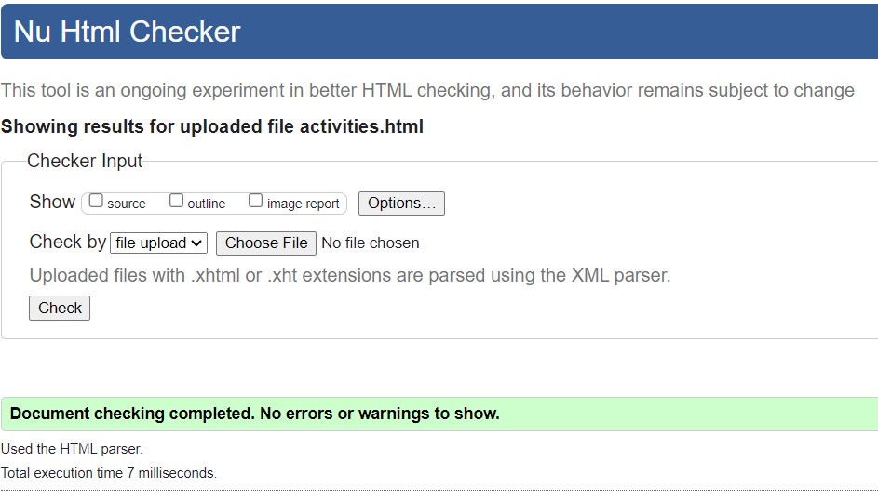

**Index.html validation**

**Yurt.html validation**

**Reservations.html validation**

**Shop.html validation**

**Pacific.css validation**

[**https://clonga.s3.amazonaws.com/ch12/pacific12/index.html**](https://clonga.s3.amazonaws.com/ch12/pacific12/index.html)