Report Name

Authors: Daniel Nolte, Zachary Coon, Hunter Hughes

Section a.

1. Visual Verification of input data

The group looked through the entirety of the data set, pulled out images that seemed concerning, but that only brought our accuracy up by about .5%. Given that the held-out data set was generated in the same way, we decided to use the entire dataset for training/testing/validation.

1. Training, Validation, and Testing data splits

Training set size is 8800 images (80% of total).   
Validation set size is 1100 images (10% of total).  
Testing set size is 1100 images (10% of total).

1. Input image size used for training/testing.

Original image size was 101 x 101 pixels. After processing, the image size used in the learning algorithm was 35 x 35 pixels.

1. Parameters of logistic regression

N/A???

1. Optimizer type and Corresponding Parameters

Mini Batch Gradient Descent with Momentum was the optimizer.   
Learning Rate = .01  
Beta = .95

1. Termination Criteria

We use early stopping criteria to make sure that we do not overfit our model. We do this by monitoring the loss on a separate validation data set. Once the validation loss has not decreased for 20 epochs, training is halted, and the model is considered converged.

Section b.

1. 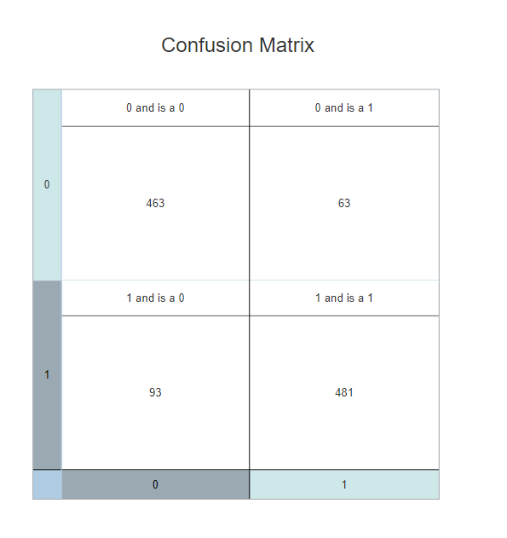Testing information presented as a confusion matrix.

Model Accuracies-

Testing -85.81% accuracy

Validation – 85.54% accuracy

Training – 87.72% accuracy

Section c.

1. Training and Testing execution times

Train time = 20.902 Seconds

Test time = .007001 Seconds