Project 4 Report

Authors: Daniel Nolte, Zachary Coon, Hunter Hughes

1. Training Information
2. Visual Verification of input data

The group looked through the entirety of the data set, pulled out images that seemed concerning, but that only brought our accuracy up by about 0.5%. Since the held-out data set was generated in the same way, which might have similar errors, we decided to use the entire dataset for training/validation/testing.

1. Training, Validation, and Testing data splits

Training set size is 8800 images (80% of total).   
Validation set size is 1100 images (10% of total).  
Testing set size is 1100 images (10% of total).

The data was randomly shuffled and then split. Different data splits were tested to ensure generalizing capability of the model.

1. Input image size used for training/testing.

Original image size was 101 x 101 pixels. The images were preprocessed by gaussian blur, then image closing, then resizing the images to 35x35 pixels, then performing edge detection which also binarized the images. So, the image size used for training and testing was 35x35 pixels. The images were also vectorized and divided by 255 for normalization.

1. Parameters of logistic regression

We used softmax logistic regression without regularization and without feature transformation, so no parameters are involved.

1. Optimizer type and Corresponding Parameters

Mini Batch Gradient Descent with Momentum was the optimizer with the following parameters:   
Learning Rate = 0.01  
Beta = 0.95

1. Termination Criteria

We use early stopping criteria to make sure that we did not overfit the training data. We did that by monitoring the loss on a separate validation data set. Once the validation loss did not decrease for 20 epochs, training was halted, and the model was considered converged.

1. Testing information presented as a confusion matrix. 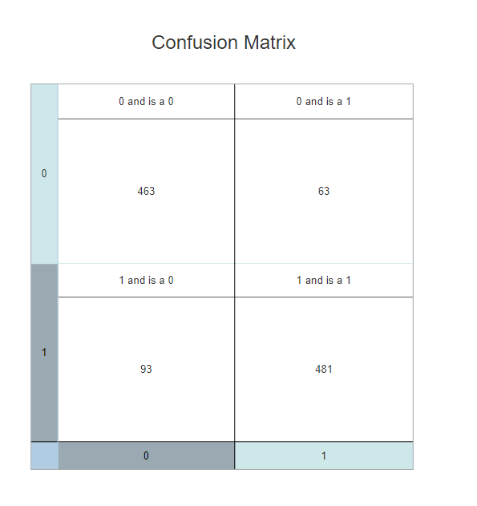

Model Accuracies:

Testing - 85.81% accuracy

Validation - 85.54% accuracy

Training - 87.72% accuracy

1. Training and Testing execution times

Train time = 20.902 Seconds (on 8800 images)

Test time = .007001 Seconds (on 1100 images)