Camunda Archive Session 6 - History Tables, Byte Array Dependencies, and Manual Archive Plan
High-Level Design and Technical Reference

1. Objective
This document covers the core implementation questions from the Session 6 analysis for a Camunda 7 archival design:
- Identify all Camunda history tables that are candidates for archival.
- Capture table relationships and foreign-key style dependencies.
- Document byte-array handling for ACT_GE_BYTEARRAY and BYTEARRAY_ID_ references.
- Define a manual archive workflow and data validation flow.
- Prepare a safe archive/delete sequence that prevents destructive actions before validation passes.
---

2. History tables relevant to archiving
The relevant archival tables are the ACT_HI_* history tables. These are the main tables that store completed process, task, variable, job, and case information after runtime data has moved beyond the active lifecycle.
History table | Purpose | Key dependency / special handling
`ACT_HI_PROCINST` | Completed process instances | Linked to `ACT_RU_EXECUTION`, `ACT_RE_PROCDEF`, `ACT_HI_ACTINST`
`ACT_HI_ACTINST` | Activity execution history | Contains process and activity lifecycle history
`ACT_HI_TASKINST` | Task history | Linked to `ACT_RU_TASK` and `ACT_HI_ACTINST`
`ACT_HI_VARINST` | Latest variable state history | Often references `ACT_GE_BYTEARRAY` via `BYTEARRAY_ID_`
`ACT_HI_DETAIL` | Variable update audit trail | Full variable change log; byte-array sensitive
`ACT_HI_JOB_LOG` | Job execution history | Stores retries and exception stack references
`ACT_HI_EXT_TASK_LOG` | External task execution history | May store `ERROR_DETAILS_ID_` references
`ACT_HI_INCIDENT` | Incident lifecycle history | Source is runtime incident data
`ACT_HI_IDENTITYLINK` | User/group assignment history | Links to runtime identity link data
`ACT_HI_BATCH` | Batch history | Records batch lifecycle details
`ACT_HI_OP_LOG` | Operation log | Audit trail for administrative changes
`ACT_HI_COMMENT` | Process/task comments | May use process or task IDs
`ACT_HI_ATTACHMENT` | Attachment metadata | Usually references `ACT_GE_BYTEARRAY` content
`ACT_HI_DECINST` | Decision instance history | Decision execution lifecycle
`ACT_HI_DEC_IN` | Decision input history | Value payloads may be large
`ACT_HI_DEC_OUT` | Decision output history | Value payloads may be large
`ACT_HI_CASEINST` | Case instance history | CMMN case lifecycle
`ACT_HI_CASEACTINST` | Case activity history | CMMN activity lifecycle
`ACT_HI_CASETASKINST` | Case task history | CMMN task history
> ACT_GE_BYTEARRAY is not a history table, but it is a critical dependency because many history rows may point to binary payloads such as variable values, stack traces, attachments, and decision payloads.
---

3. History tables and byte-array dependency map

3.1 Byte-array dependency summary
History table | Byte-array dependency | Notes
`ACT_HI_VARINST` | `BYTEARRAY_ID_` | Variable values may be stored as physical bytes
`ACT_HI_DETAIL` | `BYTEARRAY_ID_` | Variable update records can retain binary payloads
`ACT_HI_JOB_LOG` | `JOB_EXCEPTION_STACK_ID_` | Stack trace may be stored in `ACT_GE_BYTEARRAY`
`ACT_HI_EXT_TASK_LOG` | `ERROR_DETAILS_ID_` | Error payloads may be stored as binary
`ACT_HI_ATTACHMENT` | `CONTENT_ID_` | File content or attachments are stored in byte-array table
`ACT_HI_DEC_IN` | `BYTEARRAY_ID_` | Decision inputs can include large payloads
`ACT_HI_DEC_OUT` | `BYTEARRAY_ID_` | Decision outputs may be binary or serialized

3.2 Key relationship model
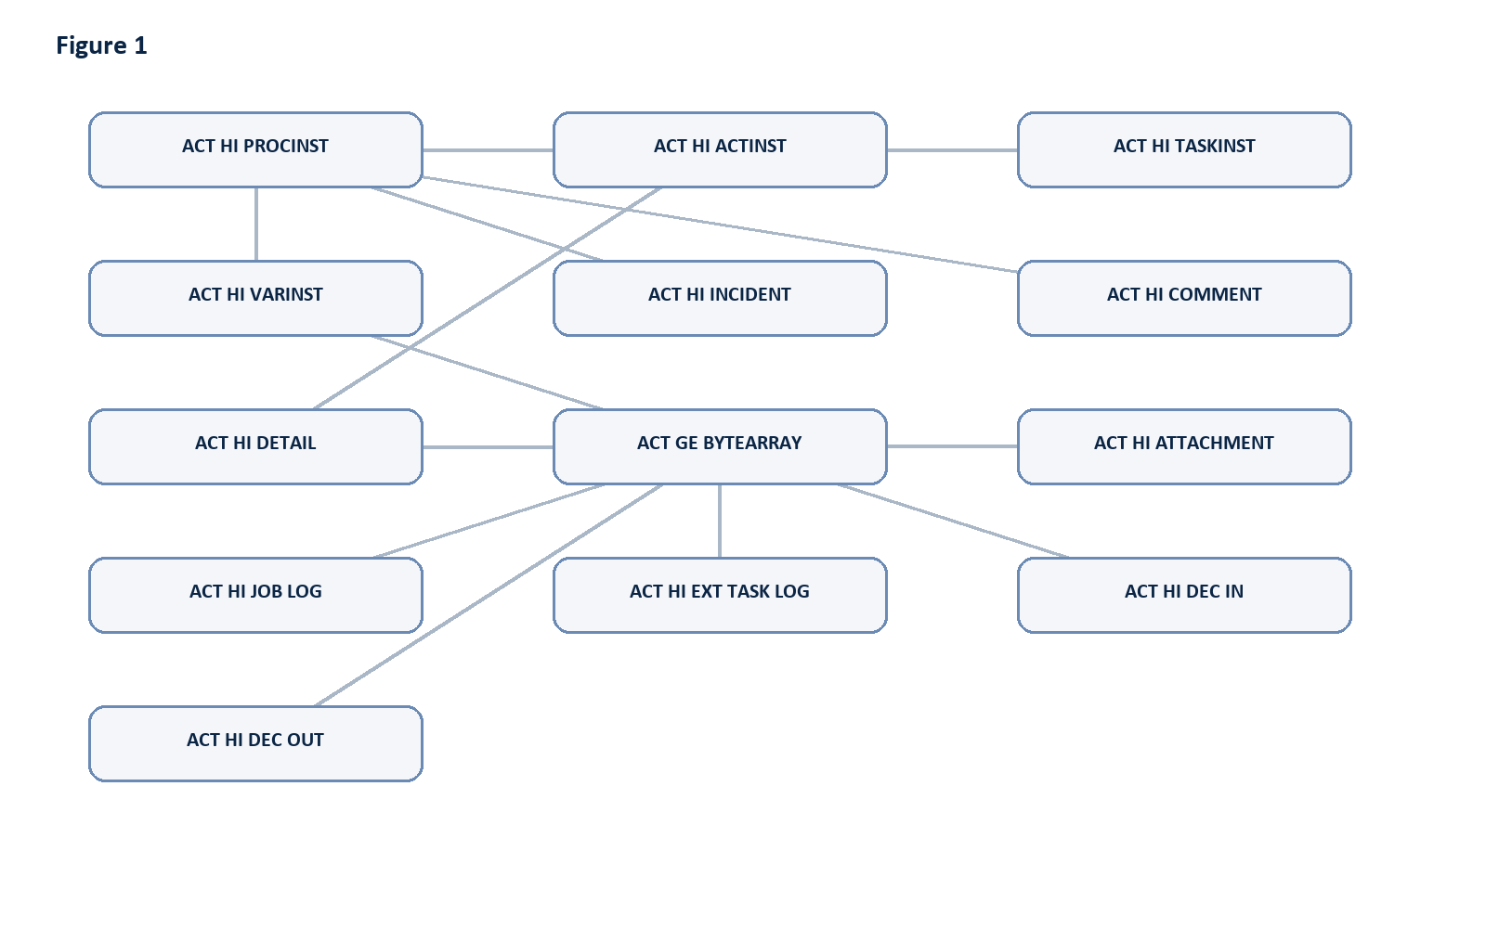
Figure 1: Diagram generated from the source Markdown.
This diagram shows the most important dependency pattern: the history tables are linked to each other by process, task, activity, and execution IDs, while byte-array storage sits underneath as the shared binary payload store for large or serialized values.
---

4. Table relationships and dependencies
The archive logic must respect the relationship chain rather than treat every table as independent.

4.1 Core process lineage
- ACT_HI_PROCINST is the root for a completed process instance.
- ACT_HI_ACTINST records each activity inside that process instance.
- ACT_HI_TASKINST records tasks related to activities or user tasks.
- ACT_HI_VARINST and ACT_HI_DETAIL represent variable data belonging to execution or activity scope.
- ACT_HI_INCIDENT, ACT_HI_BATCH, and ACT_HI_JOB_LOG are side-lifecycle records associated to the same process or execution chain.

4.2 Dependency rules
Parent / source | Related history table | Relationship key
Process instance | `ACT_HI_ACTINST` | `PROC_INST_ID_`
Process instance | `ACT_HI_TASKINST` | `PROC_INST_ID_`
Process instance | `ACT_HI_VARINST` | `PROC_INST_ID_`
Process instance | `ACT_HI_INCIDENT` | `PROC_INST_ID_`
Activity instance | `ACT_HI_DETAIL` | `ACT_INST_ID_`
Task instance | `ACT_HI_COMMENT` | `TASK_ID_` or `PROC_INST_ID_`
Job execution | `ACT_HI_JOB_LOG` | `JOB_ID_`
External task | `ACT_HI_EXT_TASK_LOG` | `EXECUTION_ID_` or related task record
Decision execution | `ACT_HI_DEC_IN` / `ACT_HI_DEC_OUT` | `DEC_INST_ID_`

4.3 Critical validation rule
Archive must be performed in dependency order, not in arbitrary table order. A safe sequence is:
- Identify process instance or task window.
- Validate related history rows in parent tables first.
- Retrieve associated byte-array records from ACT_GE_BYTEARRAY.
- Archive child rows and binary payloads.
- Validate row counts and references.
- Only after validation passes, delete source records.
---

5. Manual archive approach plan

5.1 Step-by-step manual flow
- Filter by date range
- Use START_TIME_, END_TIME_, CREATE_TIME_, or TIME_ depending on the table.
- Limit the archive candidate set to completed or closed records.
- Select only completed process/task scope
- Include only ACT_HI_PROCINST rows matching completed states.
- Exclude any active, running, suspended, or failed process records unless the design explicitly includes them.
- Detect related records before archiving
- Gather all ACT_HI_ACTINST, ACT_HI_TASKINST, ACT_HI_VARINST, ACT_HI_DETAIL, ACT_HI_JOB_LOG, and ACT_HI_INCIDENT rows tied to the selected process IDs.
- Check for open incidents, failed jobs, running tasks, or runtime references that should block the archive.
- Resolve ACT_GE_BYTEARRAY references
- Locate every BYTEARRAY_ID_, CONTENT_ID_, JOB_EXCEPTION_STACK_ID_, ERROR_DETAILS_ID_, and related data element.
- Check whether the byte array is shared across multiple rows before deleting it.
- Store a complete archive payload for the binary data before removal.
- Archive to the external store
- Write rows to archive tables or an external storage data set.
- Preserve original IDs and timestamps to allow re-sync or restore.
- Keep a batch ID and archive timestamp for every chunk.
- Validate results
- Compare source row counts against archive row counts.
- Validate key constraints and foreign-key references.
- Confirm byte-array payloads were archived completely.
- Confirm no partial records remain in the archive or source store.
- Delete only after successful validation
- Delete from source history tables only when archive validation passes.
- If any batch or validation fails, stop and keep source data unchanged.
- Store audit logs
- Log batch ID, date range, filters, process IDs, task IDs, table names, counts, status, errors, timestamps, and archive result.
---

6. Source-to-target mapping guidance
Source table | Archive target | Notes
`ACT_HI_PROCINST` | Archive process history table | Root record for each process instance
`ACT_HI_ACTINST` | Archive activity history table | Child records under process instance
`ACT_HI_TASKINST` | Archive task history table | User task lifecycle details
`ACT_HI_VARINST` | Archive variable history table | Latest version of variable state
`ACT_HI_DETAIL` | Archive variable detail history table | Full update trail
`ACT_HI_JOB_LOG` | Archive job history table | Execution events and exceptions
`ACT_HI_EXT_TASK_LOG` | Archive external-task history table | Worker retries and errors
`ACT_HI_INCIDENT` | Archive incident history table | Resolved or closed incidents
`ACT_HI_IDENTITYLINK` | Archive identity-link history table | Assignment history
`ACT_HI_BATCH` | Archive batch history table | Batch lifecycle records
`ACT_HI_ATTACHMENT` | Archive attachment payload table | Includes binary content
`ACT_HI_COMMENT` | Archive comment history table | Optional human-readable data
`ACT_HI_DECINST` / `ACT_HI_DEC_IN` / `ACT_HI_DEC_OUT` | Archive decision history tables | Decision execution evidence
`ACT_GE_BYTEARRAY` | Archive binary payload store | Must be moved with dependency checks
---

7. Safety checks before deletion
The deletion phase should only proceed if all of the following conditions pass:
- All selected records are successfully archived.
- All referenced byte-array entries are accounted for.
- No active runtime process still references the archived IDs.
- No failed jobs or incidents are still unresolved for the selected batch.
- Row counts match between source and archive for each table.
- The sequence is reversible in the event of rollback requirements.
If any check fails, the archive job must be marked as failed and the delete operation must not proceed.
---

8. Validation and rollback rules

8.1 Validation checklist
- Compare record counts by date range and process ID.
- Validate all PROC_INST_ID_, TASK_ID_, ACT_INST_ID_, and DEC_INST_ID_ links.
- Check that all byte-array references are present in the archive store.
- Confirm no orphan rows exist in the archive set.
- Confirm source records are still intact if an archive step fails.

8.2 Rollback guidance
- Rollback should be possible batch-by-batch, not just across the entire dataset.
- If one table in the dependency chain fails, no additional delete should occur for that batch.
- Keep a recovery copy of archive payloads and metadata until validation is complete.
---

9. Archive log requirements
Every archive batch should produce a complete audit record containing:
- Batch ID
- Archive date and time
- Date-range filter
- Process and task filters
- Source and target table names
- Row counts per table
- Archive status (success, partial, failed)
- Byte-array references and count
- Validation result
- Error details and retry count
- Operator or system user
- Final deletion status
---

10. Manual archive execution sequence
text block
Filter by date range
-> Select completed process/task window
-> Validate no active runtime dependencies remain
-> Identify related ACT_HI_* rows
-> Resolve ACT_GE_BYTEARRAY references
-> Archive all dependent records
-> Validate source vs archive counts
-> Validate byte-array payload integrity
-> Delete source rows only after success
-> Store archive audit log
---

11. Conclusion
The architectural direction is clear: archive the completed history data in a dependency-aware sequence, pay special attention to the shared binary payloads stored in ACT_GE_BYTEARRAY, and never delete source records before validation has proven the archive is complete and consistent.
This gives the project a safe manual process that can later be automated with scheduler, batch, or workflow-driven orchestration.

