DESIGN AND IMPLEMENTATION OF AN ADAPTIVE TEXT-BASED E-LEARNING QUIZ GENERATION SYSTEM

BY

IYAMU, WISDOM OSARHUNMWESE
(21CG029866)

A PROJECT SUBMITTED TO THE DEPARTMENT OF COMPUTER AND INFORMATION SCIENCES, COLLEGE OF SCIENCE AND TECHNOLOGY, COVENANT UNIVERSITY OTA, OGUN STATE.

IN PARTIAL FULFILMENT OF THE REQUIREMENTS FOR THE AWARD OF THE BACHELOR OF SCIENCE (HONOURS) DEGREE IN COMPUTER SCIENCE.

JULY, 2025

CERTIFICATION
I hereby certify that this project, was completed by Wisdom Osarhunmwese Iyamu in the Department of Computer and Information Sciences, College of Science and Technology, Covenant University, Ota, Ogun State, Nigeria, under my supervision.

Mr. Henry Ogbu  Supervisor | Signature and Date

Prof. Aderonke A. Oni  Head of Department | Signature and Date

DEDICATION
I dedicate this final year project to my beloved family, who have illuminated my path and surrounded me with unwavering love. To my dearest family, this work is a testament to your profound influence on my life, and I share every achievement with you.

ACKNOWLEDGEMENTS
First and foremost, I give all glory and honour to Almighty God for His unfailing grace, wisdom, and divine guidance throughout the course of this work. His mercy and blessings have been my source of strength, perseverance, and inspiration, without which this achievement would not have been possible. I also express my sincere appreciation to the Chancellor for providing a conducive academic environment that fosters excellence and innovation, and to my Head of Department for his exemplary leadership and commitment to academic growth, which have greatly influenced my development.
My profound gratitude goes to my departmental supervisor for his invaluable guidance, encouragement, and constructive feedback, which significantly contributed to the success of this research. I am equally indebted to my project advisor for his keen insights, patience, and unwavering support throughout the project’s execution. Finally, I acknowledge with gratitude the contributions of my colleagues, friends, and family whose prayers, encouragement, and moral support have been instrumental in the completion of this work.

TABLE OF CONTENTS
CONTENT PAGES
COVER PAGE i
CERTIFICATION ii
DEDICATION iii
ACKNOWLEDGEMENTS iv
TABLE OF CONTENTS v
LIST OF FIGURES ix
LIST OF TABLES x
ABBREVIATIONS xi
ABSTRACT xii
CHAPTER ONE: INTRODUCTION 1
1.1. Background Information 1
1.2. Statement of the Problem 2
1.3. Aim and Objectives 3
1.4. Methodology 4
1.5. Significance of the Study 5
1.6. Project Outline 6
CHAPTER TWO: LITERATURE REVIEW 7
2.1. Preamble 7
2.2. Conceptual Review 7
2.2.1. Designing for E-Learning and Assessment 8
2.2.2. Machine Learning Natural Language Processing (NLP) 8
2.2.3. Automation 8
2.3. Review of Related Concepts 9
2.3.1. E-Learning Systems 9
2.3.2. Quiz Generation 10
2.3.3. Techniques for Quiz Generation 11
2.3.4. Natural Language Processing (NLP) and Its Role in Education 12
2.4. Review of Existing Methods 13
2.4.1. Rule-Based Question Generation 13
2.4.2. Template-Based Question Generation 14
2.4.3. Machine Learning-Based Question Generation 14
2.4.4. Semantic-Based Question Generation 15
2.4.5. Comparison of quiz generation techniques 16
2.5. Review of Existing Systems 19
2.5.1. Quillionz 19
2.5.2. AutoQG (Automatic Question Generator) 20
2.5.3. Summary and Implications 21
2.6. Review of Related Works 21
2.6.1. Education Technology 21
2.6.2. Automatic question generation and answer assessment 22
2.6.3. Automatic question generation 23
2.6.4. BloomLLM 23
2.7. Gaps in Literature Review 25
CHAPTER THREE: SYSTEM ANALYSIS DESIGN 28
3.1. Introduction 28
3.2. System Development Methodology 28
3.3. System Requirement Analysis 29
3.3.1. Functional Requirements 30
3.3.2. Non-Functional Requirements 30
3.4. System Design and Analysis 31
3.4.1. Physical Design 31
3.4.2. Logical Design 31
3.5. System Modelling 32
3.5.1. Use Case Diagram 33
3.5.2. Activity Diagram 35
3.5.3. Sequence Diagram 37
3.5.4. Class Diagram 38
3.6. System Architecture 40
3.6.1. Client Tier 40
3.6.2. Application Tier 41
3.7. Bloom’s Taxonomy in Adaptive Quiz Generation 41
3.7.1. Cognitive Structure and Levels 42
3.7.2. The Revised Taxonomy and Modern Adaptation 42
3.7.3. Integration Into the Quiz Generation System 43
3.7.4. Pedagogical Value and Significance 44
3.8. Large Language Models (LLMs) 44
3.8.1. LLM Architecture and Components: 44
3.8.2. Implementation Considerations 45
3.9. System Pipeline 45
3.9.1. Document Extraction 46
3.9.2. Document Splitting and Chunking 47
3.9.3. Embedding the Chunks 47
3.9.4. Storing Embeddings in the Vector Store 49
3.9.5. Similarity Search & Retrieval 50
3.9.6. Prompt Construction & Contextualization for the LLM 51
3.9.7. LLaMA Inference and Text Generation 52
3.9.8. Output Parsing and Postprocessing 53
3.9.9. Limitations of the system 55
3.9.10. Optimisation of the system 57
CHAPTER FOUR: SYSTEM IMPLEMENTATION 60
4.1. Introduction 60
4.2. System Requirements 60
4.2.1. Hardware Requirements 60
4.2.2. Software Requirements 61
4.2.3. Implementation Tools 62
4.3. System Development Process 63
4.3.1. Frontend Development 63
4.3.2. Backend Development 66
4.4. System Implementation Details 69
4.4.1. Frontend Implementation 69
4.4.2. Backend Implementation 70
4.5. Usability Testing 71
4.5.1. Usability Test 71
4.5.2. Participants and Test Environment 71
4.5.3. Tasks and User Journey 72
4.5.4. Observations and User Feedback 73
4.5.5. Identified Usability Issues and Recommendations 74
4.5.6. Summary of Findings 74
CHAPTER FIVE: SUMMARY, CONCLUSION, AND RECOMMENDATIONS 75
5.1. Summary 75
5.2. Limitations of the Study 75
5.3. Recommendations 76
5.3.1. System Improvements 76
5.3.2. Educational Applications 77
5.4. Conclusion 77
REFERENCES 78

LIST OF FIGURES
FIRGURE TITLE OF FIGURE PAGE
2.1 Question Generation Approaches 22
2.2 Classification of automatic question generation models 23
2.3 Comparison of preference between BloomGPT vs ChatGPT 24
3.1 Use-case diagram for the system 33
3.2 Activity Diagram for the system 36
3.3 Sequence Diagram for the system 38
3.4 Class Diagram for the system 39
3.5 Architectural Diagram for the system 40
3.6 Simplified Bloom’s Taxonomy Matrix Mapping 43
4.1 Quizzes & Files interface. 63
4.2 Quiz interface with a multiple-choice question 64
4.3 Feedback page showing user performance 65
4.4 Document Endpoint 66
4.5 Quiz Endpoint 67
4.6 Bloom-based prompting structure 68
4.7 List of entities in the system 69

LIST OF TABLES
TABLE TITLE OF TABLE PAGE
1.1 Project Methodology 4
2.1 Comparison of Quiz Generation Techniques 17
2.2 Related work summary. 26
3.1 Agile Sprint Breakdown 29
3.2 Use Case Narrative 34
3.3 Overview of the System Pipeline 46
3.4 Limitations of the System Pipeline 55
3.5 Optimisation of the System Pipeline 57
4.1 Hardware Requirements 61
4.2 Software Requirements 61
4.3 Usability Testing Results Summary 72
4.4 Identified Usability Issues and Recommendations 74

ABBREVIATIONS
AI Artificial Intelligence
API Application Programming Interface
AQG Automatic Question Generation
BERT Bidirectional Encoder Representations from Transformers
CSV Comma-Separated Values
GPT Generative Pre-trained Transformer
JSON JavaScript Object Notation
LLM Large Language Model
ML Machine Learning
NER Named Entity Recognition
NLP Natural Language Processing
OCR Optical Character Recognition
PDF Portable Document Format
RAG Retrieval-Augmented Generation
RNN Recurrent Neural Network
SFT Supervised Fine-Tuning
UML Unified Modeling Language
UI User Interface
UX User Experience
XML eXtensible Markup Language

ABSTRACT
Manual quiz creation is often time-consuming, inconsistent, and poorly adapted to individual learner needs. This project proposes an adaptive e-learning quiz generation system that automates question creation from raw educational content using natural language processing and large language models (LLMs). The system employs a local-first architecture that includes document chunking, semantic embedding, Bloom’s Taxonomy-based difficulty mapping, and vector similarity search to generate personalised quizzes dynamically. It also evaluates user performance and identifies weak topic areas to create future quizzes tailored to those weaknesses. Experimental results demonstrate that the system can produce contextually relevant, difficulty-aligned quizzes without reliance on internet access or external APIs, making it a scalable solution for modern educational environments.
Keywords: adaptive learning, quiz generation, Bloom’s Taxonomy, large language model, vector search, offline AI, educational technology.

CHAPTER ONE

INTRODUCTION

Background Information
The modern world of digital technologies has imposed the necessity of using e-learning platforms in the contemporary sector. All these platforms provide accessible and inexpensive ways to learn and are flexible, which has been significantly boosted by the post-COVID embrace of digital-first learning (Ohei, 2023). Using electronic media, digital resources, and web-based delivery models, e-learning platforms have increasingly filled educational gaps between geographies and learning preferences (Haleem et al., 2022).
Assessment is one of the most critical components of an efficient e-learning system that gauges learners' knowledge and monitors academic performance. Unluckily, the conventional approaches to assessment design are usually laborious and manual, and educators must go through enormous amounts of teaching materials to develop relevant questions. It is time-consuming and challenging to scale to large or diverse populations of learners (Adom et al., 2020).
Assessment generation has been automated to counter such issues due to newer Artificial Intelligence (AI) and Natural Language Processing (NLP) innovations. Such technologies can process raw educational materials, extract essential ideas, and generate questions usually corresponding to targeted learning outcomes. Automating the quiz production process through such systems will free the instructors of the tedious administrative process of classes and encourage them to learn persistently (Igbokwe, 2023). The tools based on NLP can comprehend the structure and semantics of natural language, making the questions more specific and relevant, not only in content, but also in the difficulty level.
This development paves the way to developing more dynamic learning systems, whereby the quizzes are dynamic and not fixed, like in the case of an adaptive learning system. This system can target an area where the learner is weakest by examining the user's historical data and the responses to past questions. This more individualised method enhances learning effectiveness and keeps the learners motivated since learning gaps are addressed through the right questions and difficulty levels (Marienko et al., 2020).
This project seeks to build a backend system, which is capable of automatically generating different type of questions, and this project in the designing of the E-Learning Quiz Generator is intended to create various forms of questions (multiple choice questions, fill in the blanks, and actual/false questions) just by simply uploading an educational document in any of the following formats: .PDF, DOCx, PPTx, and .TXT. Through the NLP methods, the system divides the documents into logically organised pieces, identifies the most critical topics and constructs quizzes according to the Bloom Taxonomy, which offers a pedagogical classification of the cognitive skills ranging from basic recall up to higher-order thoughts (Ullrich & Geierhos, n.d.). Every quiz taken is examined to provide information and the further development of more individual follow-up quizzes. Since the number of intelligent, scalable and interactive educational tools is increasing, this system has come at the right time. Adding to this, it not only streamlines the cumbersome process of quiz authoring, but one result of this method is an augmented learning experience with built-in context-sensitive testing, feedback and challenge matching (Marienko et al., 2020). This system can be a valuable tool for educators, institutions, and ed-tech platforms seeking to integrate intelligent assessment modules into their digital learning environments.

Statement of the Problem
The increasing popularity of e-learning sites has transformed the educational sector so that more students across the globe can learn conveniently and easily. Nonetheless, the interactive nature of e-learning content, such as quizzes that enrich learning results, has immensely contributed to the success of the same (Martín-Sómer et al., 2024). The usual approach to quiz development is time-consuming and manual, and it demands that the educator possess extensive knowledge of the subject, which results in the uneven quality of the questions in the assessments. This is a significant limitation, and it is not necessarily overcome in practice by the instructors who may have less time or capacity to design wholesome quizzes to demonstrate their course objectives.
Moreover, earlier systems had conventional rule-like methods or crude quiz generation strategies that were time-consuming, non-scalable, and incapable of adapting to various educational materials. In other systems, keyword matching was performed, but contextual relevance could not be computed, generating low-quality or simplistic quizzes. Others used pre-crafted templates that reduced flexibility and customisation (Olateju et al., 2024). These weaknesses raised the question of a more intelligent method of using Natural Language Processing (NLP) and Machine Learning that would create adaptive and high-quality quizzes related to a particular educational material.

Aim and Objectives
This study aims to design and implement an Adaptive text-based E-Learning Quiz Generation system.
To achieve the study’s aim, the following objectives must be completed:
- Conduct a requirement analysis to identify the functional and non-functional needs of the text-based quiz generator system.
- Design and model the architecture of the quiz generator system.
- Implement the adaptive quiz generation engine using Bloom’s Taxonomy and local LLMs.
- Evaluate users’ quiz performance and the system’s adaptability.

Methodology
Table 1.1 explains the approach used to conduct the project. It provides a description of the methods, processes, and tools used.
Table 1.1: Project Methodology
S/N | Objective | Methodology
 | Conduct a requirement analysis to identify the functional and non-functional needs of the text-based quiz generator system. | i. Defined user and system requirements based on self-study challenges and adaptive learning needs.  ii. Reviewed literature on Bloom’s Taxonomy, quiz generation, and intelligent tutoring systems using sources like Google Scholar and IEEE Xplore.
 | Design and model the architecture of the quiz generator system. | i. Developed a modular system architecture using NestJS for the backend and Flutter for the mobile app.  ii. Modelled the document pipeline using document loaders, embedding models, vector stores, LLM chains, and output parsers.  iii. Designed system-level data flow and database schema using pgvector, TypeORM, and UML diagrams.
 | Implement the adaptive quiz generation engine using Bloom’s Taxonomy and local LLMs. | i. Integrated a local LLaMA 3.1 8B model using GGUF for offline inference.  ii. Embedded document content using HuggingFace’s BGE model and stored it in PostgreSQL using pgvector.  iii. Generated quizzes using prompt templates that adapt difficulty based on Bloom’s levels, user performance, and selected topics.  iv. Built the frontend in Flutter using BLoC for state management and designed an interactive quiz interface.
 | Evaluate users’ quiz performance and the system’s adaptability. | i. LLM-based evaluation prompts were used to determine the correctness of user answers and score attempts.  ii. Measured and stored user accuracy, difficulty levels, and weak topic areas for personalised feedback.  iii. Validated system logic through internal testing and iteration.

Significance of the Study
This study holds significant value for various stakeholders in the educational field by providing a tool that enhances learning experiences and streamlines assessment creation. The following are the key benefits of this study:
- The system saves educators valuable time by automating the creation of high-quality quizzes.
- It promotes personalised learning for students, improving engagement and comprehension.
- The system provides educational institutions with modern, digital solutions for curriculum delivery.
- It enables scalable, efficient assessment creation, making learning accessible to a broader audience.
- It improves learning outcomes through tailored quizzes that adapt to individual student needs.

Project Outline
This project is structured into five chapters to present the research and development process comprehensively. Chapter One introduces the study, outlining its background, objectives, scope, significance, methodology, and justification for the project’s direction. Chapter Two presents a detailed conceptual and methodological review based on existing literature, offering insights into related technologies, approaches, and academic findings that inform the proposed solution. Chapter Three focuses on the design and architecture of the proposed system, including tools, frameworks, and models used in its development. Chapter four details the system's implementation and assesses its performance by giving the results and insight into the testing and interaction of the user. Chapter Five is a conclusion of the project, it summarises the main results, provides findings and gives recommendations about future improvements and research topics.

CHAPTER TWO

LITERATURE REVIEW

Preamble
Using digital tools in education has transformed education into something less accessible, flexible, and personalised. Nevertheless, developing such assessment materials as quizzes is still time-consuming among educators. The capabilities of artificial intelligence (AI) and natural language processing (NLP) bring much promise that the creation of assessments based on text materials will be automated. This technology saves instructional staff effort and improves the level of student interest. It has also been previously indicated that emerging AI-based technologies will be able to automate most feedback processes in education, particularly those involving unstructured textual data and constructive output production. This chapter overviews the literature on the available materials in e-learning systems, application of education-oriented NLP methods and automated quiz-generation methods. It intends to point to the theoretical foundation, evaluate the existing approaches, and define gaps that the existing systems fail to cover to justify this research.

Conceptual Review
The E-Learning Quiz Generator rests on the principles of a combination of theoretical and technological ideas to change the standard approach to assessment. The key components of this system are e-learning, natural language processing (NLP) and automation, and each of the mentioned plays a vital part in streamlining the creation of quizzes. E-learning promotes flexible digital access to educational materials. NLP is used to help the system read and derive meaning out of unstructured text, and automation enables the quiz content to work dynamically and change as needed (Jim et al., 2024). Combining these ideas creates one of the pillars of a framework that lightens the weight of manual quiz generation and makes learning scalable and personalised.

Designing for E-Learning and Assessment
The e-learning systems have brought changes in education provision as education can be learnt in any location, and digital methods of knowledge dissemination. The formative tests used on such websites enhance learners' retention, understanding, and participation. Bloom’s Taxonomy offers a structure for creating education examinations by grouping academic goals into six cognitive levels: remembering, understanding, applying, analysing, evaluating and creating (Momen et al., 2023).

Machine Learning Natural Language Processing (NLP)
The set of educational works may be converted into applicable evaluations based on Natural Language Processing (NLP). NLP allows working with the historical knowledge of a text, granting its accurate and relevant interpretation, due to the usage of such a powerful model as BERT or GPT. Such models are based on transformer architectures that enable them to work, considering the context and semantics of the text. This is because they are best suited when finding main ideas, correlations, and formulation of assessment questions based on learning objectives. With NLP-driven systems, conventional ways of content generation have taken a different dimension since the processes are now being automated, but with contextual accuracy (Jim et al., 2024). Using these models, it is possible to point out essential ideas within the text, produce falsity instances, and group questions into difficulty bands.

Automation
Automation of educational tools has a defining role in making content creation simple, as well as being precise and scalable. The Natural Language Processing (NLP) and Machine Learning (ML) algorithms can be utilised to make systems generate contextually relevant quiz questions with the proper difficulty levels. Such developments have transformed the old modes of assessment into dynamic and changeable systems that accommodate the various and changing needs of learners. Automation integration aligns with efficiency in the learning procedures and individualised learning experiences. This consideration forms the basis of creating the quiz generator system, whose performance is guaranteed by the possibility of producing valuable and learner-centred tests (Alqahtani et al., 2023).

Review of Related Concepts
In this section, the background ideas and principles of the study are considered to understand the context of the study's objectives. It explores important concepts like e-learning systems, automation in education and natural language processing (NLP), and their applicability in quiz generation. Discussing these interrelated concepts, the study reveals the improvements and constraints made in the sphere. It sheds light on their importance in terms of the problem of creating effective and scalable assessments. The given review established the basis on which the solution will be aligned with the known theories and technologies, and thoroughly understand the context in which the research work is being carried out.

E-Learning Systems
Electronic or e-learning systems are educational systems or environments that utilise technology to present educational materials and interactive learning experiences. These are virtual learning systems, smartphone and mobile learning applications, and education-specific content management systems. They intend to personalise and make education accessible to people of diverse backgrounds. E-learning has also spread because it is flexible; learners can access materials anytime or anywhere. Digital technology advancements and growing internet penetration have considerably contributed towards the popularity of e-learning platforms worldwide (Haleem et al., 2022). E learning systems have immense benefits that make e learning popular in contemporary learning. These advantages consist of:
- Flexibility: E-learning enables learners to access their coursework and learn at their own pace, at their own time and from their places. The flexibility allows different learning styles and preferences, which makes education accessible to more students who may have time limitations or geographical constraints.
- Scalability: Since such systems can serve multiple students effectively, they are helping educational institutions to bridge the gap between physical classrooms and the rest of the world. The global reach of e-learning breaks geographical boundaries since all institutions can use it to reach students across different regions, making quality education accessible to more students worldwide.
- Cost effectiveness: E-learning minimises the dependency on physical infrastructure, e.g. classroom, printed books, and materials, which lowers the operational cost of an educational organisation considerably. This makes it a cheaper alternative, especially if the institutions want to cut costs, especially when dealing with massive programs.
Although e-learning systems are associated with many benefits, several shortcomings are identified as weaknesses that may impair the success of e-learning systems. Such challenges are:
- No Personalised Interaction: E-learning systems do not offer the direct and personalised form of interaction as in the conventional classroom environment. This may cause a feeling of alienation in the learners and minimise chances of live time instructor feedback, guidance and support.
- Digital Divide: Students in minority or rural locations can have difficulty accessing e-learning due to irregular internet accessibility or a lack of devices. Such an internet gap may fuel educational disparities and deny several students an opportunity to enjoy the full benefits of internet-based learning.
- Limited Capabilities in Assessment Generation: Dynamic and context-aware assessment generation by e-learning systems is complex, with many systems generating quizzes and other assessments. The conventional forms of assessment can also be too heavy or simplistic to record the various learning needs of students or the complexity of the subject matter.

Quiz Generation
Quiz generation is an automatic procedure that is supposed to examine the knowledge and abilities of learners in education settings, as it is related to Bloom’s Taxonomy, to check the levels of cognition. Cognitive skills are grouped in the Bloom Taxonomy classification scheme and can be classified into lower thinking, including remembering and understanding, and higher thinking, including analysing, evaluating and creating. Automatic quiz generation systems could help develop various questions that could evaluate students on all these levels so that their capabilities can be thoroughly analysed. As an example, any simple knowledge questions concern knowledge (remembering), and complex questions might also ask students to apply concepts (applying), analyse relationships (analysing), or criticise ideas (evaluating) (Momen et al., 2023). Automating this process can be customised to different cognitive domains, to reinforce the learning process and give immediate and specific feedback.
Traditionally, quiz creation was manual and required the instructors' effort in quiz design. Such an approach may be biased, time-consuming, and subjective, hindering evaluation and scalability. On the other hand, Automated quiz generation systems incorporate sophisticated algorithms and artificial intelligence to dynamically generate quizzes based on the educational materials. Such systems improve efficiency and measurement scale, and can produce tremendous amounts of differentiated questions in far less time than human scribes. In addition, they can provide an opportunity towards more personalised learning by meeting individual learner needs and adapting the complexity of, and type of questions to an individual learner, thus making the assessment process more optimal (Swiecki et al., 2022).

Techniques for Quiz Generation
The techniques deal with distinct domains of quiz creation and are effective subject to the context of use. The template method might be a good solution in simple cases, but NLP and knowledge-based techniques will be more appropriate in implementing the dynamic and individualised assessment. However, the weaknesses of these systems prove that the automation of making quizzes is still in the process of innovation.
    - Template-based offers are dependent on a set of pre-formulated structures or question sets to make quizzes. The content is added manually by educators or developers, so generating standardised and customizable questions should not be an issue (Willert & Thiemann, 2024). The approach applies to tests focusing more on uniformity, such as the standardised tests. Template systems are not dynamic and cannot be driven to a learner-dependent context. They have difficulties in real-time with modification or complex, open-ended questions.
    - Natural Language Processing Based: It is one of the methodologies based on advanced calculations that are done specifically to analyse and derive important data from essentials such as textbooks or lecture notes. Knowing how and when to break the sentence and context enables NLP to formulate various and practical questions (Khurana et al., 2023). They are very suitable when dealing with a large, dynamic content environment and generate higher-order questions based on the Bloom Taxonomy. However, they are highly computationally intensive, often demand high-quality training data, and can deliver poor results when confronted with unclear or poorly created inputs.
    - Knowledge-based systems use a structured representation, ontology, or concept map to produce the questions that will aid in assessing knowledge on related concepts (Rodrigues et al., 2024). They are useful within fields where the structure is quite well defined, such as biology or computer science, and are good at measuring conceptual knowledge. However, the quality of the knowledge base limits its usefulness, and it is less valuable in regions with disorganised or dynamic information.

Natural Language Processing (NLP) and Its Role in Education
Natural Language Processing (NLP) is a subarea of artificial intelligence that looks into how computers and human languages interact. It uses computational methods to process and analyse large collections of natural language data. NLP has extensive educational use, especially in the automation of grading, feedback, content summary, and quiz information generation (Christopher et al., 2024). Some of the revolutionary educational applications of NLP are:
- Automated Essay Scoring: NLP methods can mark written essays and provide grammar, structure, and coherence feedback. The systems match essays against high-quality ones to give objective and consistent evaluations, saving educational workers time (Ramesh & Sanampudi, 2022).
- Personalised Learning: NLP systems can monitor the reactions and involvement of students in order to recommend additional learning or progress. The assistance of NLP makes chatbots capable of leading through lessons, clarifying, and answering real-time questions, making the experience more effective (Khurana et al., 2023).
- Question Generation: NLP plays a significant role in generating tests and extracting key information from educational sources. This entails creating various question types, including multiple options, fill-in-the-blank, and short-answer questions, and the assessment development process becomes more effective (Kic-Drgas & Kılıçkaya, 2024).
- Text Summarisation: NLP algorithms can summarise long learning texts, saving students time to learn the highlights. Such an ability can be helpful in large online courses, and digital content can be read; speed is essential (Khurana et al., 2023).
- Sentiment Analysis: The NLP will be able to analyse the written responses or the open-ended questions to gauge the students' emotional response. The understanding can inform educators how students feel about the course and how they can improve (Jim et al., 2024).

Review of Existing Methods
E-learning Quiz generation. This is an essential part of the e-learning systems, and it tests learners' knowledge automatically. Various quiz generation methods are based on various approaches, such as rule-based systems, template-based systems, machine learning and semantic techniques.

Rule-Based Question Generation
The process of rule-based question generation is based on a set of predetermined rules and patterns which conventionalise the content extraction process out of a single learning text. These are rules that are formulated normally by the developers or teachers. They detect specific segments of the reading that can be cast off into questions, e.g. facts, dates or definitions. It is easily undertaken with predictable outcomes and can be easily controlled. It is effective with textbooks and other structured, factual types of content. It is not flexible and scalable. Rule-based systems can only create questions with predetermined patterns and therefore find it hard to manipulate complex, finer or changing information. Furthermore, the variety of question types is narrow, and output may be repetitious (Kurdi et al., 2020). In this context, Equation 2.1 defines the process of extracting key elements from a text.
(2.1)
$$E=\text{Extract}\left(T,R\right)$$
Here, T is the input text, and $R=\left\{r_{1},r_{2},...,r_{n}\right\},$ denotes the set of predefined rules. The result E represents the set of extracted elements deemed suitable for question formation. Once the elements have been extracted, they are transformed into question formats using the same or additional rules. This transformation process is formalized in Equation 2.2
(2.2)
$$Q=\text{Transform}(E,R)$$
Where Q is the generated question. Together, Equations 2.1 and 2.2 describe a two-step process in which the system first identifies candidate content and then applies structural templates to convert it into question form. This method is straightforward and produces predictable outputs but lacks the flexibility to adapt to complex or nuanced content (Kurdi et al., 2020).

Template-Based Question Generation
Template-based question generation uses predetermined templates of differing questions (e.g., multiple-choice, true/false, fill-in-the-blank). Information extracted from these systems is important because it is used to fill in the blanks on the templates. Template-based systems are more flexible than rule-based systems and can answer several questions (Kurdi et al., 2020). One is that they are easier to implement and control, as well as capable of housing dynamic text in a better way. Nevertheless, they still have no adequate knowledge of the material. Templates have more variety but lack range and are prone to repetitive or trivially good questions due to careless control. They also need the appropriate textual structure to operate at an optimum level. Equation 2.3 captures the extraction of important keywords or entities from the text.
(2.3)
$$K=\text{ExtractKeyPhrases}\left(T\right)$$
Where $K=\{k_{1},k_{2},...,k_{m}\}$ represents the set of key concepts extracted from the input text T. These key concepts are then inserted into one of several predefined templates. Equation 2.4 formalizes the population of a question template:
(2.4)
$$Q=\text{FillTemplate}\left(θ_{i},K\right)$$
Here, θᵢ is a selected template from the set $Θ=\left\{θ_{1},θ_{2},...,θ_{n}\right\}$and Q is the resulting question. Equations 2.3 and 2.4 work together to extract meaningful data and structure it into readable and consistent quiz formats (Kurdi et al., 2020).

Machine Learning-Based Question Generation
Machine-based learning approaches employ sophisticated algorithms like Recurrent Neural Networks (RNNs) and Transformer-based models, including GPT and BERT, to automate the creation of questions based on educational material. Such models acquire the patterns and relationships built over a large amount of data and can ask questions within context and according to varying learning needs (Abbas & Masood, 2024). They can process unstructured material and therefore are flexible, enabling them to give simple factual-type questions, or questions that require higher-order thinking skills, including analysis, synthesis, and application. This adaptability renders machine learning methods a potent instrument for creating evaluations that foster greater study and critical thinking. Equation 2.5 expresses the direct use of a trained model to generate a question:
$$Q=M(C,A)$$
Where C is the context or passage, A is an optional answer (in cases of answer-aware generation), and M is the model. The output Q is the generated question. Alternatively, Equation 2.6 gives a probabilistic view of generation:
(2.6)
(2.5)
$$Q=arg⁡\underset{q}{max⁡}P(q∣C,A;θ)$$
This finds the question q with the highest probability given the context and answer, with θ representing the parameters of the model. Together, Equations 2.5 and 2.6 highlight how modern NLP systems generate contextually accurate and diverse questions (Abbas & Masood, 2024).

Semantic-Based Question Generation
Techniques of question generation based on semantics pay special attention to learning the meaning and context of the educational material instead of paying any attention to its surface structure only. These methods use the latest Natural Language Processing (NLP) algorithms to reveal the semantics of the text and its deeper conceptual understanding, allowing them to generate questions that are not limited to simple fact retrieval (Hussen et al., 2021). This is especially beneficial when considering complex or advanced educational content, as it allows formulating questions to test the learner at application, reasoning and understanding- key aspects of higher-order thinking in education. Equation 2.7 performs a semantic parse of the input:
(2.7)
$$S=\text{SemanticParse}\left(T\right)$$
This produces a structured semantic representation S of the text T. The next step is to identify concepts relevant for question creation. Equation 2.8 captures this step:
(2.8)
$$C=\text{IdentifyConcepts}\left(S\right)$$
Where C represents key conceptual elements derived from the semantic structure. Finally, these concepts are transformed into questions using Equation 2.9:
(2.9)
$$Q=\text{GenerateQuestion}(C,S)$$
These three equations work sequentially to parse, identify, and structure meaningfully rich questions, particularly useful in assessing higher-order cognitive skills like analysis and evaluation (Hussen et al., 2021).
The strengths of the semantic-based technique include that such techniques can generate contextually accurate and helpful questions. All these questions are associated with Bloom’s taxonomy since they touch upon higher-order thinking skills, including applying knowledge, analysing concepts, or evaluating ideas (West, 2023). Nonetheless, implementing a semantic-based generation of the questions is very challenging. The presented techniques are intricate and necessitate advanced NLP models and an in-depth comprehension of the context behind the text, which, in most cases, demands significant data processing resources and expertise. Moreover, the reliability and consistency of the created questions require a long process of fine-tuning and validation. Despite these difficulties, semantic-based approaches offer a significant new direction towards the development of assessment, which would promote autonomy of thought and a more immersive learning experience with the educational material.

Comparison of quiz generation techniques
A structured comparison of the major quiz generation styles addressed in this paragraph is provided in Table 2.1. It also outlines their main characteristics, advantages, and weaknesses in order to give a basic review of their application in different learning settings

Table 2.1: Comparison of Quiz Generation Techniques
Techniques | Semantic-Based | Machine Learning-Based | Template-Based | Rule-Based
Complexity | High complexity; involves semantic analysis and advanced NLP models. | High complexity; needs large datasets and algorithms for training. | Moderate complexity; requires creating and managing templates. | Simple to implement, based on predefined rules with low adaptability.
Flexibility | Very flexible; adapts to complex content and generates diverse questions. | Highly flexible; adapts to various content and learning styles. | Limited by the structure of templates. | Rigid and limited to predefined rules.
Quality | Very high quality; produces semantically rich, contextually meaningful questions. | High quality; generates nuanced, contextually accurate questions. | Moderate quality; generates structured but often repetitive questions. | Low quality; produces basic, factual questions with minimal depth.
Resource Needs | High cost; requires deep learning models and large data sets. | It is high-cost and requires computational resources for training and inference. | It has a low cost and relies on manual input and setup. | Low cost, minimal resources needed.
Scalability | High scalability; needs quality data but adapts well. | High scalability; improves with more data and resources. | Moderate scalability; slow as templates grow. | Poor scalability; requires manual updates.
Ease of Maintenance | Challenging to maintain, semantic models require continuous tuning. | Difficult to maintain; models require retraining with new data. | Moderate maintenance; templates need regular updates. | Easy to maintain; rules can be updated manually.
Accuracy | Very high accuracy; semantically precise and deeply relevant. | High accuracy; generates contextually relevant questions. | Moderate accuracy; constrained by templates and structure. | Low accuracy; lacks depth and context awareness.
Best Use Cases | Higher-order thinking tasks like critical reasoning and application. | Adaptive, personalised quizzes requiring varying complexities. | Structured tests, such as fill-in-the-blank or multiple choice. | Basic quizzes for factual recall.

Review of Existing Systems
Automated quiz generation in e-learning has had significant growth, which has been catalysed by the necessity to personalise evaluation, enhance participation, and decongest educators. To accomplish such goals, various systems have integrated different technical approaches, such as lightweight natural language methods, into complex ontology-based frameworks. This chapter examines three best-known systems, Quillionz and AutoQG, to sample the varied designs and maturity of approaches in quiz creation aids.

Quillionz
Quillionz is an automated web-based question-generating system that uses natural language processing (NLP) to generate multiple-choice and short-answer questions based on text documents. It is targeted to assist learners by making the assessment creation process faster, especially when dealing with learning scenarios based on revision and understanding. After entering a text, the system performs shallow parsing and a named entity recognition process, which helps it identify important content areas. These are subsequently projected into templated question formats to introduce the-blank, true/false formats.
Ease of use and accessibility are two of the main features of Quillionz. Teachers can develop assessments easily and do not require technical knowledge or the ability to program. The system provides lower-order questions corresponding to the levels of remembering and understanding of Bloom’s Taxonomy. It is therefore apt as introductory or revision-based activities. As Nguyen et al. (2024) note, Quillionz has trouble formulating higher-order questions necessitating contextual understanding, inference, or arguments. It provides a generic type of question output, and it cannot adjust its question-generation process depending on the learner’s performance or an academic objective. Also, Quillionz offers no reporting interface to analyse students' answers or performance over a more extended period to produce feedback. Its contribution is in making the basic question generation (rapidly), but it cannot be used in comprehensive or adaptive assessment utilities.

AutoQG (Automatic Question Generator)
AutoQG is a more technically savvy and modular system that applies rule-based logic and NLP models to generate questions in structured academic works like textbooks, lecture notes, and syllabi. The pipeline consists of multiple stages that first start with text pre-processing. These are noise reduction, sentence segregation and part-of-speech tagging. It then uses a key phrase extraction step based on syntactic and statistical analysis to extract conceptually significant words. Question templates are rooted in these terms that are created based on transformation rules and linguistic heuristics.
AutoQG, in contrast to simpler systems, accepts various question types: definition, fill-in-the-blank and contextual multiple-choice ones with distractors. It is stated that (Ushio et al., 2023), rule-based syntactic transformation integration enables AutoQG to create syntactically correct and semantically valid questions. Moreover, it also allows for generating a limited number of distractors based on synonyms and near-miss semantic patterns in outward lexical sources such as the WordNet. Moreover, it does not analyse the learner's performance or adjust the questions, as AutoQG is a one-way system that provides only the questions. It lacks adaptive logic or a performance feedback loop, rendering the system less ideal at individualised learning experiences than static assessments. AutoQG is still a stepping-stone to the nearer future of semi-automated assessment systems. It is transitional in the template-based and more intelligent, adaptive systems continuum.

Summary and Implications
The changing scope of technology in the generation of quizzes is depicted in these systems. Quillionz is fast and easy to use, but lacks domain flexibility and cognitive depth. AutoQG gives more power and variety over questions, but is also sensitive to the input and cannot be very personal. The knowledge of the strengths and weaknesses of these systems aids in establishing the area of design that should be the focus of future tools. For example, a hybrid method that provides scalable, purpose-sensitive queries can retain flexibility by incorporating NLP techniques with the domain-aware knowledge modelling approach. In addition, including learner feedback loops and performance analytics could enable subsequent systems to facilitate real-time personalisation, enhancing the effectiveness and appeal of e-learning tests.

Review of Related Works
This chapter gives an organised literature review of automatic question generation (AQG) and intelligent assessment technologies. In the works reviewed, methodologies, challenges, and developments shaping adaptive e-learning tools have been emphasised. Both studies can contribute to the discovery of the ways semantic modelling, learner cognition, and machine learning can be used to enhance a quiz generation system.

Education Technology
They conducted an extensive literature analysis to study the role of educational technologies such as AQG systems in boosting students' learning in higher education. The analysis indicates the possible ways in which AI-based systems can enhance learners' engagement, personalised learning tracks, and rationalise the instruction process. One of the focal points in their work is the value of the adaptive assessment Olateju Temitope Akintayo et al. (2024). The authors believe cognitive retention and attention soar when relatively specific questions are posed to individual learners. Nonetheless, the research also reveals two obstacles: inadequate digital infrastructure and asymmetrical access to learning devices of learning, which can influence the rate of adoption at an institutional level. The review finished with the suggestion to conduct additional empirical studies on the adjudged long-term effects of AQG tools, mainly when used in poorly represented student groups. Insights align with this project’s emphasis on designing inclusive and adaptive systems.

Automatic question generation and answer assessment
The paper provides a survey that classifies AQG systems into three categories: rule-based, template-based, and machine learning-based. Rule-based methods are characterised by their simplicity but lack contextual flexibility. Template-based systems, though structured, are often too rigid for complex content (Das et al., 2021).
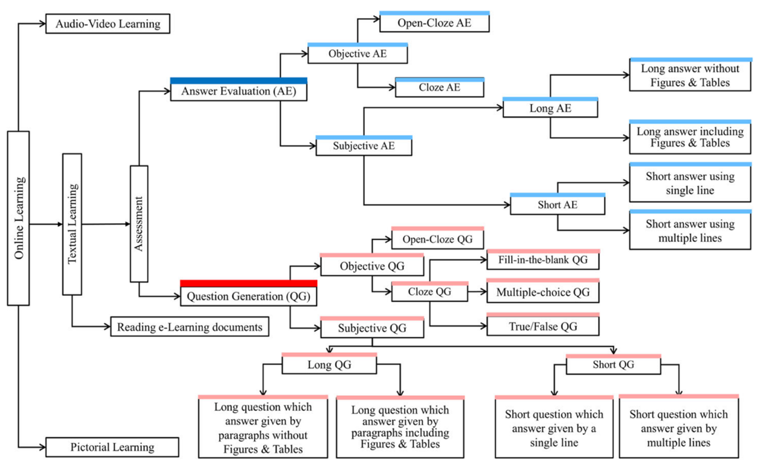
Machine learning-based models demonstrate the highest degree of adaptability. These systems can generate more diverse questions and adapt to different datasets, but they demand extensive computational resources and large annotated datasets. The authors also evaluate standard AQG datasets and discuss metrics used for performance. Before the study's conclusion, the authors visually categorise AQG methods. Figure 2.1 captures the core generation strategies and their corresponding evaluation techniques.

Figure 2.1: Question Generation Approaches

Automatic question generation
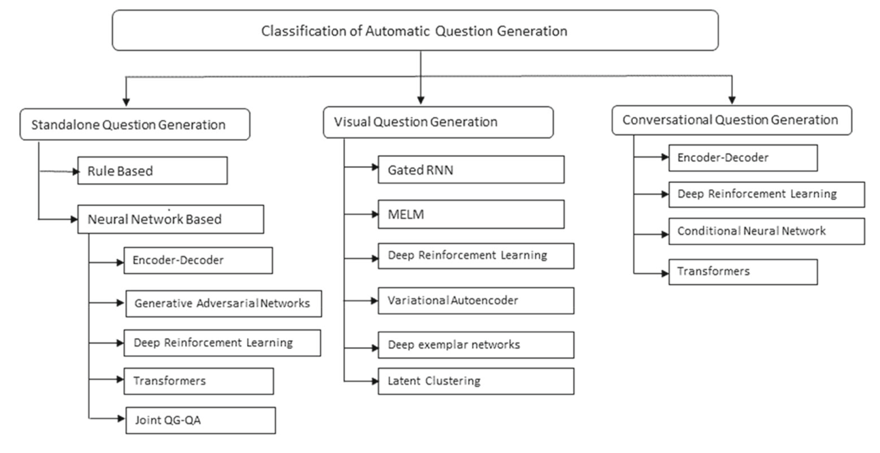
The authors extend the scope of AQG beyond traditional text-based systems by reviewing visual and conversational AQG systems. They group AQG systems into three types: standalone systems using static text, visual systems using multimedia inputs, and conversational agents that generate questions interactively. Their review emphasises the importance of semantic depth in NLP models for producing contextually relevant and meaningful questions (Mulla & Gharpure, 2023). This is particularly relevant to domains like medicine and engineering, where question precision is critical. The study also outlines the role of domain-specific datasets in enhancing model accuracy. It explores the advantages of both automated and human evaluation frameworks, noting that hybrid methods offer the most complete assessment of question quality. Figure 2.2 shows a comprehensive visual model categorising AQG systems by input type and output logic.

Figure 2.2: Classification of automatic question generation models

BloomLLM
A recent and highly relevant advancement in the field is BloomLLM, introduced by Duong-Trung et al., 2024. This system integrates Bloom’s Revised Taxonomy into training a fine-tuned large language model, specifically ChatGPT-3.5-turbo. The BloomLLM framework addresses three key challenges observed in standard LLMs. First, it corrects the lack of semantic interdependence between Bloom’s taxonomy levels. Second, it reduces hallucinated outputs commonly seen in higher-order questions. Third, it improves the cognitive alignment of generated questions across all levels, from remembering to creating. The system was developed using 1026 questions annotated by domain experts across two master-level courses. The training data were designed to reflect academic rigour, curriculum goals, and learning outcomes. A supervised fine-tuning approach was applied, ensuring that the generated questions mirrored the complexity of educational objectives.
The researchers conducted empirical evaluations with 46 students to compare BloomLLM against ChatGPT-4. Student feedback revealed a consistent preference for Bloom’s LLM, especially in generating questions at the analyse, evaluate, and create levels. These findings suggest that fine-tuned models grounded in cognitive theory outperform generic LLMs in educational settings. The system was deployed at scale, serving over 4,000 academic staff, and is accessible through an internal platform. Its successful institutional deployment and open-source availability establish it as a replicable and scalable solution for intelligent quiz generation. Figure 2.3 compares users' preferences for the questions generated for the different cognitive levels by ChatGPT and the fine-tuned model, BloomGPT.
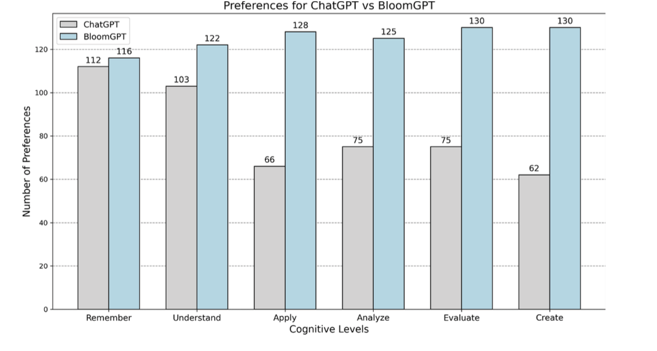
Figure 2.3: Comparison of preference between BloomGPT vs ChatGPT

Across these studies, several patterns emerge. Effective AQG systems require grammatical accuracy, cognitive relevance, domain alignment, and learner adaptability. Traditional rule and template-based approaches provide structure but lack flexibility. More recent machine learning-based and hybrid models, such as BloomLLM, have shown great alignment and compatibility with educational systems such as the taxonomy of Bloom. The insights help to drive the points of utilising high-quality training data, incorporating semantic evaluation measures, and making ethical and accessible deployment. The works provide a theoretical background of how a critical assessment of adaptive cognitive-driven assessment capabilities can be embedded in mobile e-learning applications.

Gaps in Literature Review
This section systematically synthesises the meaningful scholarly work in automated question generation (AQG) and educational assessment systems. Although the previous research provides valuable knowledge concerning the technical, cognitive, and pedagogical directions of AQG, numerous issues still require further development. They are restricted in implementation in the real world, have low correspondence to cognitive learning structures, and have poor application of fine-tuned language models (LLMs) in a defined learning structure. The existing gaps in the research are illustrated in a tabular form. Table 2.2 describes the issues central to every research paper, the methods used, and the related research weaknesses or gaps. This comparison demonstrates the disconnectedness of the existing approaches and assists in situating this project in the context of the academic field.

Table 2.2 Related work summary.
Author(s) | Problem Solved | Methodology | Gaps in Literature
Mulla & Gharpure (2023) | Comprehensive review of AQG approaches, datasets, and evaluation metrics | Classified AQG systems into standalone, visual, and conversational types; analysed NLP techniques and semantic modelling | Insufficient research on multimodal AQG systems that integrate text with visual or contextual inputs
Das et al. (2021) | Survey of rule-based, template-based, and ML-based AQG techniques | Compared traditional and ML-based AQG models; reviewed datasets and evaluation metrics | Lack of real-time implementation and weak focus on integration into scalable, user-facing platforms
Julia et al. (2021) | Analysis of scalable instructional design models in MOOCs | Reviewed pedagogical frameworks and learner scalability in large online classrooms | Did not explore the use of AI for adaptive, personalised quiz generation in MOOC environments
Kic-Drgas & Kılıçkaya (2024) | Use of AI to generate standardised exam questions for language learners | Applied NLP-based models to design questions based on test blueprints | Minimal focus on contextual understanding or question personalisation through deeper NLP models
Kurdi et al. (2020) | Review of AQG tools used in education | Evaluated AQG tools across multiple pedagogical settings | Did not investigate the application of transformer-based architectures such as BERT or GPT
Rodrigues et al. (2024) | Assessment of GPT-4’s performance in evaluating short answers | Applied GPT-4 to assess short textual answers using custom quality metrics | Lacks comprehensive benchmarking against other state-of-the-art LLMs across multiple learning domains
West (2023) | Application of Bloom’s Taxonomy in teacher training | Aligned authentic learning tasks with Bloom’s framework for instructional design | Did not explore automation or taxonomy-aligned question generation for personalised assessments
Duong-Trung et al. (2024) | Integration of Bloom’s Taxonomy into question generation using fine-tuned LLMs | Developed BloomLLM by fine-tuning ChatGPT-3.5-turbo using expert-curated questions across Bloom’s six cognitive levels | Current research does not yet explore BloomLLM’s adaptation across non-STEM fields or low-resource academic environments

CHAPTER THREE

SYSTEM ANALYSIS DESIGN

Introduction
This chapter discusses the design paradigm adopted in developing the Textual-Based E-Quiz Generator. It outlines the functional and non-functional requirements essential for successfully implementing the application. The system architecture also gives a structural overview of the major components and their interactions. This chapter also includes the Unified Modelling Language (UML) diagrams used to model the system’s behaviour and interactions with users and external components.

System Development Methodology
There are various methodologies, and each implementation method is relative to what each project requires, depending on its size, complexity, available resources and how the team prefers to work (Mohammad A., 2023). This project uses the Agile Software Development Methodology. It was selected based on its iterative and gumby character, which means that it could be developed in stages, have feedback on the go, and be adjusted to the changing needs and demands on the part of the user and new technological discoveries. Agile consists of dividing development into manageable units, colloquially called sprints. Every sprint delivers a working increment of the system, such as the possibility to extract text from different documents or create quizzes. The feedback is taken at the end of each sprint, and revisions or changes are performed in the subsequent cycles. It is also consistent with the experimental, exploratory process of creating adaptive systems, in which it is important to test features such as adaptive quiz logic as soon as possible. Its methodology makes it easy to align with the user's expectations, especially with the engagement of the stakeholders, such as students and educators involved. Agile can also promote modular and maintainable code practices in line with the non-functional requirements of maintainability and scalability (Behrens et al., 2021). In summary, the Agile methodology would facilitate the objectives of the project, which include rapid iteration, feature testing, and continuous improvement and would suit the complexity of incorporating machine learning aspects and natural language processing. The agile sprint used in this project is broken down as presented in Table 3.1.

Table 3.1: Agile Sprint Breakdown
Sprint | Focus Area | Deliverables
1 | File Upload & Text Extraction | Support uploading PDFs, PPTX, and image files; extract text using libraries and OCR (Tesseract).
2 | Quiz Generation | Use LLMs (LLaMa 3.1) to generate multiple-choice, true/false, and short-answer questions from extracted content.
3 | Answer Evaluation & Feedback | Evaluate user responses, provide scoring, and deliver contextual feedback instead of relying on rule-based logic.
4 | Adaptive Quiz Logic | Generate follow-up questions targeting user-identified weak areas, improving learning outcomes.
5 | Mobile App Integration | Build and connect the Flutter mobile app interface to the backend APIs for user interaction.
6 | Testing & Final Optimisation | Conducted functional and usability testing, fixed bugs, improved performance, and prepared final deployment.

System Requirement Analysis
System requirements identify a software system's necessary characteristics and limitations to be well-developed and functioning. These requirements are anchored on the tendencies of those to whom the application will be used, including students and teachers, and they build the framework around which the application is to be developed. The system's functional and non-functional requirements are all classified into those of the quiz generation mobile application.

Functional Requirements
Functional requirements explain what fundamental services the system should provide and how the system should react to particular user inputs under specific circumstances. The most important functional requirements of the quiz generation system are:
- The system should allow users to post files in PDF, PowerPoint (PPTX), and Word (DOCX) formats.
- The system should be able to effectively parse the uploaded files and extract texts with the help of proper parsing tools.
- Based on the retrieved data, the system should be capable of creating several questions on a quiz (e.g., multiple-choice, short answer).
- The system should analyse users' responses and give feedback about the correctness.
- This system needs to monitor users' performance and the areas of weakness, as shown by the previous quiz records.
- Bloom should help the system create new adaptive quizzes that depend on the knowledge gaps that the user has.
- The system must provide a mobile-compatible user interface for quiz-taking and displaying the results.
- The system should have backend APIs for text extraction, quizzes, and answer checks.

Non-Functional Requirements
Non-functional requirements specify the attributes of the quality of the system, which are usability, performance, and reliability. These factors are important for the proper functionality of the system. Non-functional requirements of the system are:
- The extraction of texts should be followed by completing the quiz generation process in less than one minute.
- The user interface should be intuitive and easy to operate so people of different technical levels can use it.
- The system must handle any files whose format is not supported or corrupted gracefully and present complete information on the errors.
- These files are uploaded by other users, and their information should be handled securely and deleted once they are no longer needed.
- The application should run on both the Android and iOS platforms.
- The system must be modular and well-documented in order to allow maintenance and upgrades in the future.

System Design and Analysis
System design and analysis entails a thorough planning of the architecture, modules, and data flow to guarantee that the application developed satisfies the functional and non-functional requirements established earlier. The project employs the system to receive user-uploaded data and extract meaningful textual data, making adaptive quizzes with the help of Large Language Models (LLMs). This chapter describes the structure, logic and components used in the development and implementation. System analysis is the process of identifying pertinent functions of the system and their interaction in achieving the anticipated results. It guarantees a clear interpretation of the system's behaviour and harmonises the design with user requirements and system limitations.

Physical Design
The physical design concerns user interaction with the system, data processing, and results display. It is the description of the actual organisation of the application and entails:
- User Interface Design: End-users have interactive screens through the mobile front (uploading documents, taking, and viewing results). It is developed to be compatible with Android and iOS users.
- Process Design: Files are uploaded and processed through backend APIs, which carry out text extraction, quiz generation using LLM and evaluation of answers.
- Data Design: Texts, responses provided by the user, history of the functional performance, and built tests are stored and processed efficiently and temporarily to guarantee an optimised, secure processing.

Logical Design
The logical design represents an abstract view of how data flows through the system and how different components interact. It defines what the system should do without focusing on how it will be physically implemented. This includes:
- Input: Uploads from users in PDFs, PPTX, or images.
- Processing: Backend services extract text (including OCR for images), use LLM prompts to generate quiz content, and evaluate responses.
- Output: Quizzes, immediate feedback, and performance summaries are displayed in the app.
- Database (or Temporary Storage): Session-based storage is used for performance tracking and adapting future quizzes.
- Functions/Methods: Modular services handle tasks like document parsing, quiz generation, scoring, and feedback delivery.

System Modelling
Unified Modelling Language (UML) is a standardised modelling language introduced by Grady Booch, James Rumbaugh, and Ivar Jacobson at Rational Software in 1995. It was adopted by the Object Management Group in 1997 as the standard for modelling software systems. UML consists of various diagram types used to visually represent a system's structure and behaviour. For the quiz-generation system, the following UML diagrams are essential for representing the key components and interactions within the system:
- Use Case Diagram
- Activity Diagram
- Sequence Diagram
- Class Diagram

Use Case Diagram
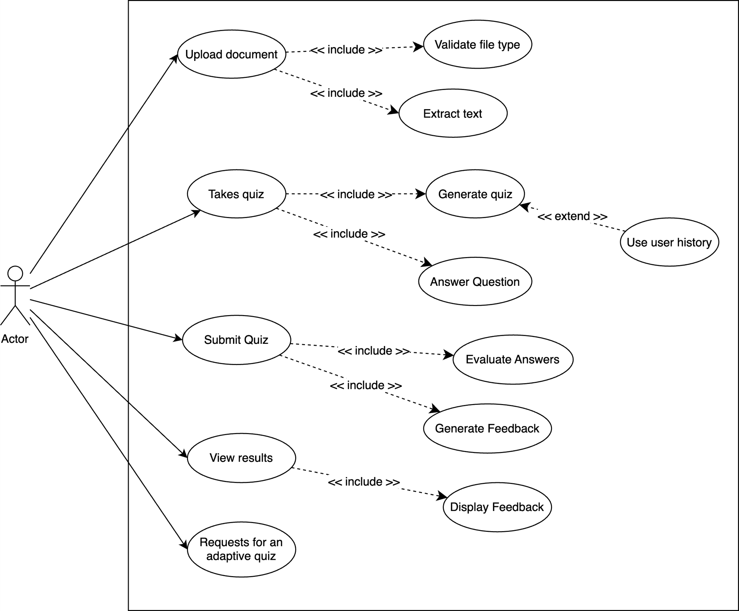
Use cases, initially derived by Ivar Jacobson in 1987, have become a fundamental component of the Unified Modelling Language (UML). They represent the series of interactions between a user and a system to achieve a specific goal (Nicky, 2022). Figure 3.1 illustrates the use case diagram of the quiz generation system. The system is designed to help users generate quizzes from uploaded documents and track their learning progress. The use case diagram in Figure 3.1 outlines the key interactions between the user (student) and the system. The description of each use case is as follows:

Figure 3.1: Use-case diagram for the system
- Upload Document: The user uploads a file (PDF, PPTX or image format) into the system. It involves checking the validity of the file type and removing the text data to prepare quizzes.
- Take Quiz: The user takes a quiz created based on the previously extracted content. This use case involves the creation of questions, responses and posting responses. If the user needs an adaptive quiz, the system continues the generation quiz process by studying the user's performance history and giving more questions focused on the weak spots.
- Submit Quiz: The user submits their responses once the quiz is completed. This involves reviewing the responses and creating feedback that gives a score to the performance.
- View Results: When the quiz is assessed, it provides the user with detailed feedback and evaluation. In this use case, the evaluation outcomes and historical trends are presented.
- Request Adaptive Quiz: The user can request an adaptive personalised quiz. This further enhances the quiz generation routine by including the previous performance of a user and working on areas of weakness, applying the adaptive learning logic.
Table 3.2 describes the use case within the system.
Table 3.2: Use Case Narrative
Actor Action | System Response
The user uploads a document | - The system validates the file type  - The system extracts text.  - The extracted text is forwarded to the Quiz Engine.
The user takes the quiz | - The system generates quiz questions. If adaptive, it extends by using user history.  - The user answers questions.
The user submits the quiz | - The system evaluates answers.  - The system generates feedback.
User views results | - The system displays feedback.  - The system shows performance metrics.
User requests an adaptive quiz | - The system analyses performance history.  - The system generates focused questions via the LLM.  - The adaptive quiz is presented.

Activity Diagram
A semi-formal semantic specification, an activity diagram, describes a system's dynamic behaviour and control flow between activities. Activity diagrams are valuable in modelling both high-level processes and low-level algorithmic logic (Al-Fedaghi, 2021). In developing this intelligent quiz generation system, the activity diagram plays a key role in visualising how users and the system interact through various stages of content processing and quiz delivery. The diagram consists of various standardised UML shapes to represent control flow:
    - Dark Circle: Represents the start of the activity flow.
    - Rounded Rectangle: Describes individual actions or operations.
    - Diamond: Denotes decision points with alternative flows.
    - Outlined Circle: Indicates the termination of the activity.
The activity diagram for the system is shown in Figure 3.2, illustrating the complete flow of interaction between the user and system components.
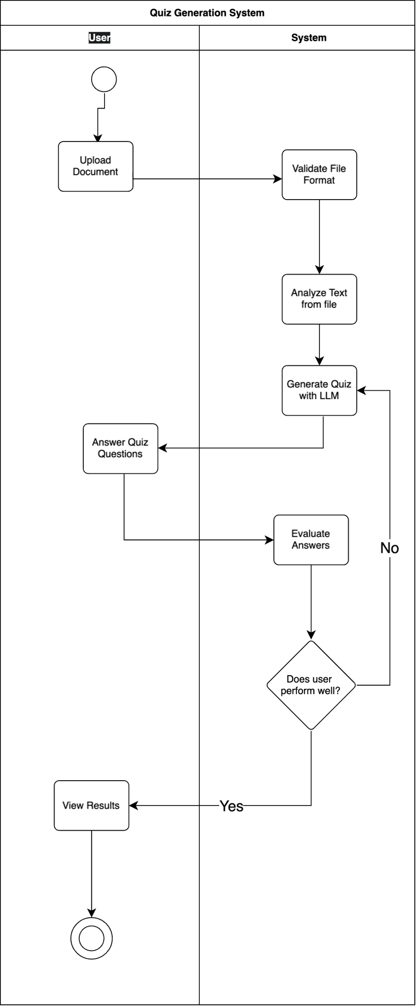
Figure 3.2: Activity Diagram for the system

Sequence Diagram
Sequence Diagrams, also referred to as object interaction diagrams, focus on the chronological sequence of messages exchanged between the user and system components (Kurniawan, Shidiq, & Sutoyo, 2020). In the architectural view of the system, sequence diagrams, sometimes called event diagrams, are typically used to visualise how use cases are realised in practice. The sequence diagram illustrates the flow of interactions between the user, the interface layer, and core system components such as the text extractor, quiz engine, answer module, and evaluation engine.
The sequence begins when the user uploads a learning document (e.g., PDF or PPTX). The system receives and delegates the file to the Text Extractor, which processes and extracts the content. The extracted text is then passed to the Quiz Engine, where relevant quiz questions are generated using a large language model (LLM). These questions are returned to the interface and displayed to the user. After the user completes the quiz and submits their answers, the system forwards the responses to the Answer Module, which then calls on the Evaluation Engine to assess the answers. Based on the evaluation, the system generates personalised feedback and displays it to the user. Finally, the quiz session and evaluation results are stored in the database for future reference. This interaction sequence captures the system’s core functionality, transforming raw text into interactive quizzes and providing tailored feedback based on users’ responses. Figure 3.3 represents the sequence diagram for the system.
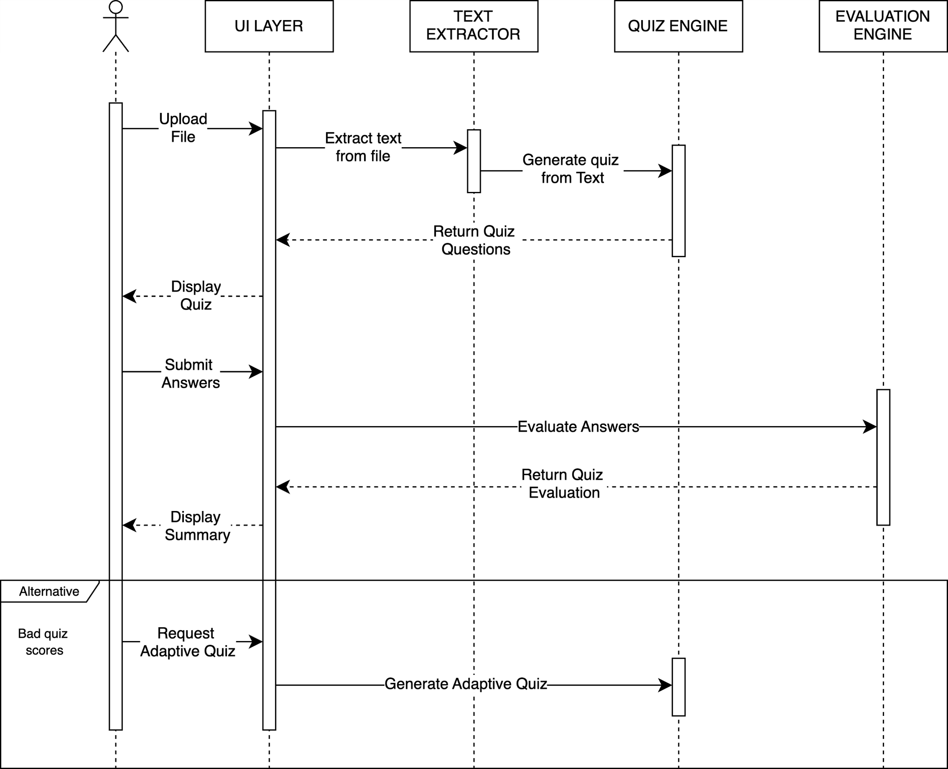
Figure 3.3: Sequence Diagram for the system

Class Diagram
A class diagram is a visual representation that outlines the structured layout of a system, emphasising the relationships, attributes, and functions of the individual components within that system. It is a fundamental tool for building maintainable, executable software and documenting various structural aspects of the application. In the context of this project, the class diagram represents and describes the major components and their interactions in the system, an e-learning quiz generator based on text content. It also provides insight into each class's roles, responsibilities, and constraints. The class diagram in Figure 3.4 demonstrates how different system parts (such as the user interface, document processor, quiz generator, and evaluation engine) collaborate to deliver intelligent quiz generation and adaptive feedback.

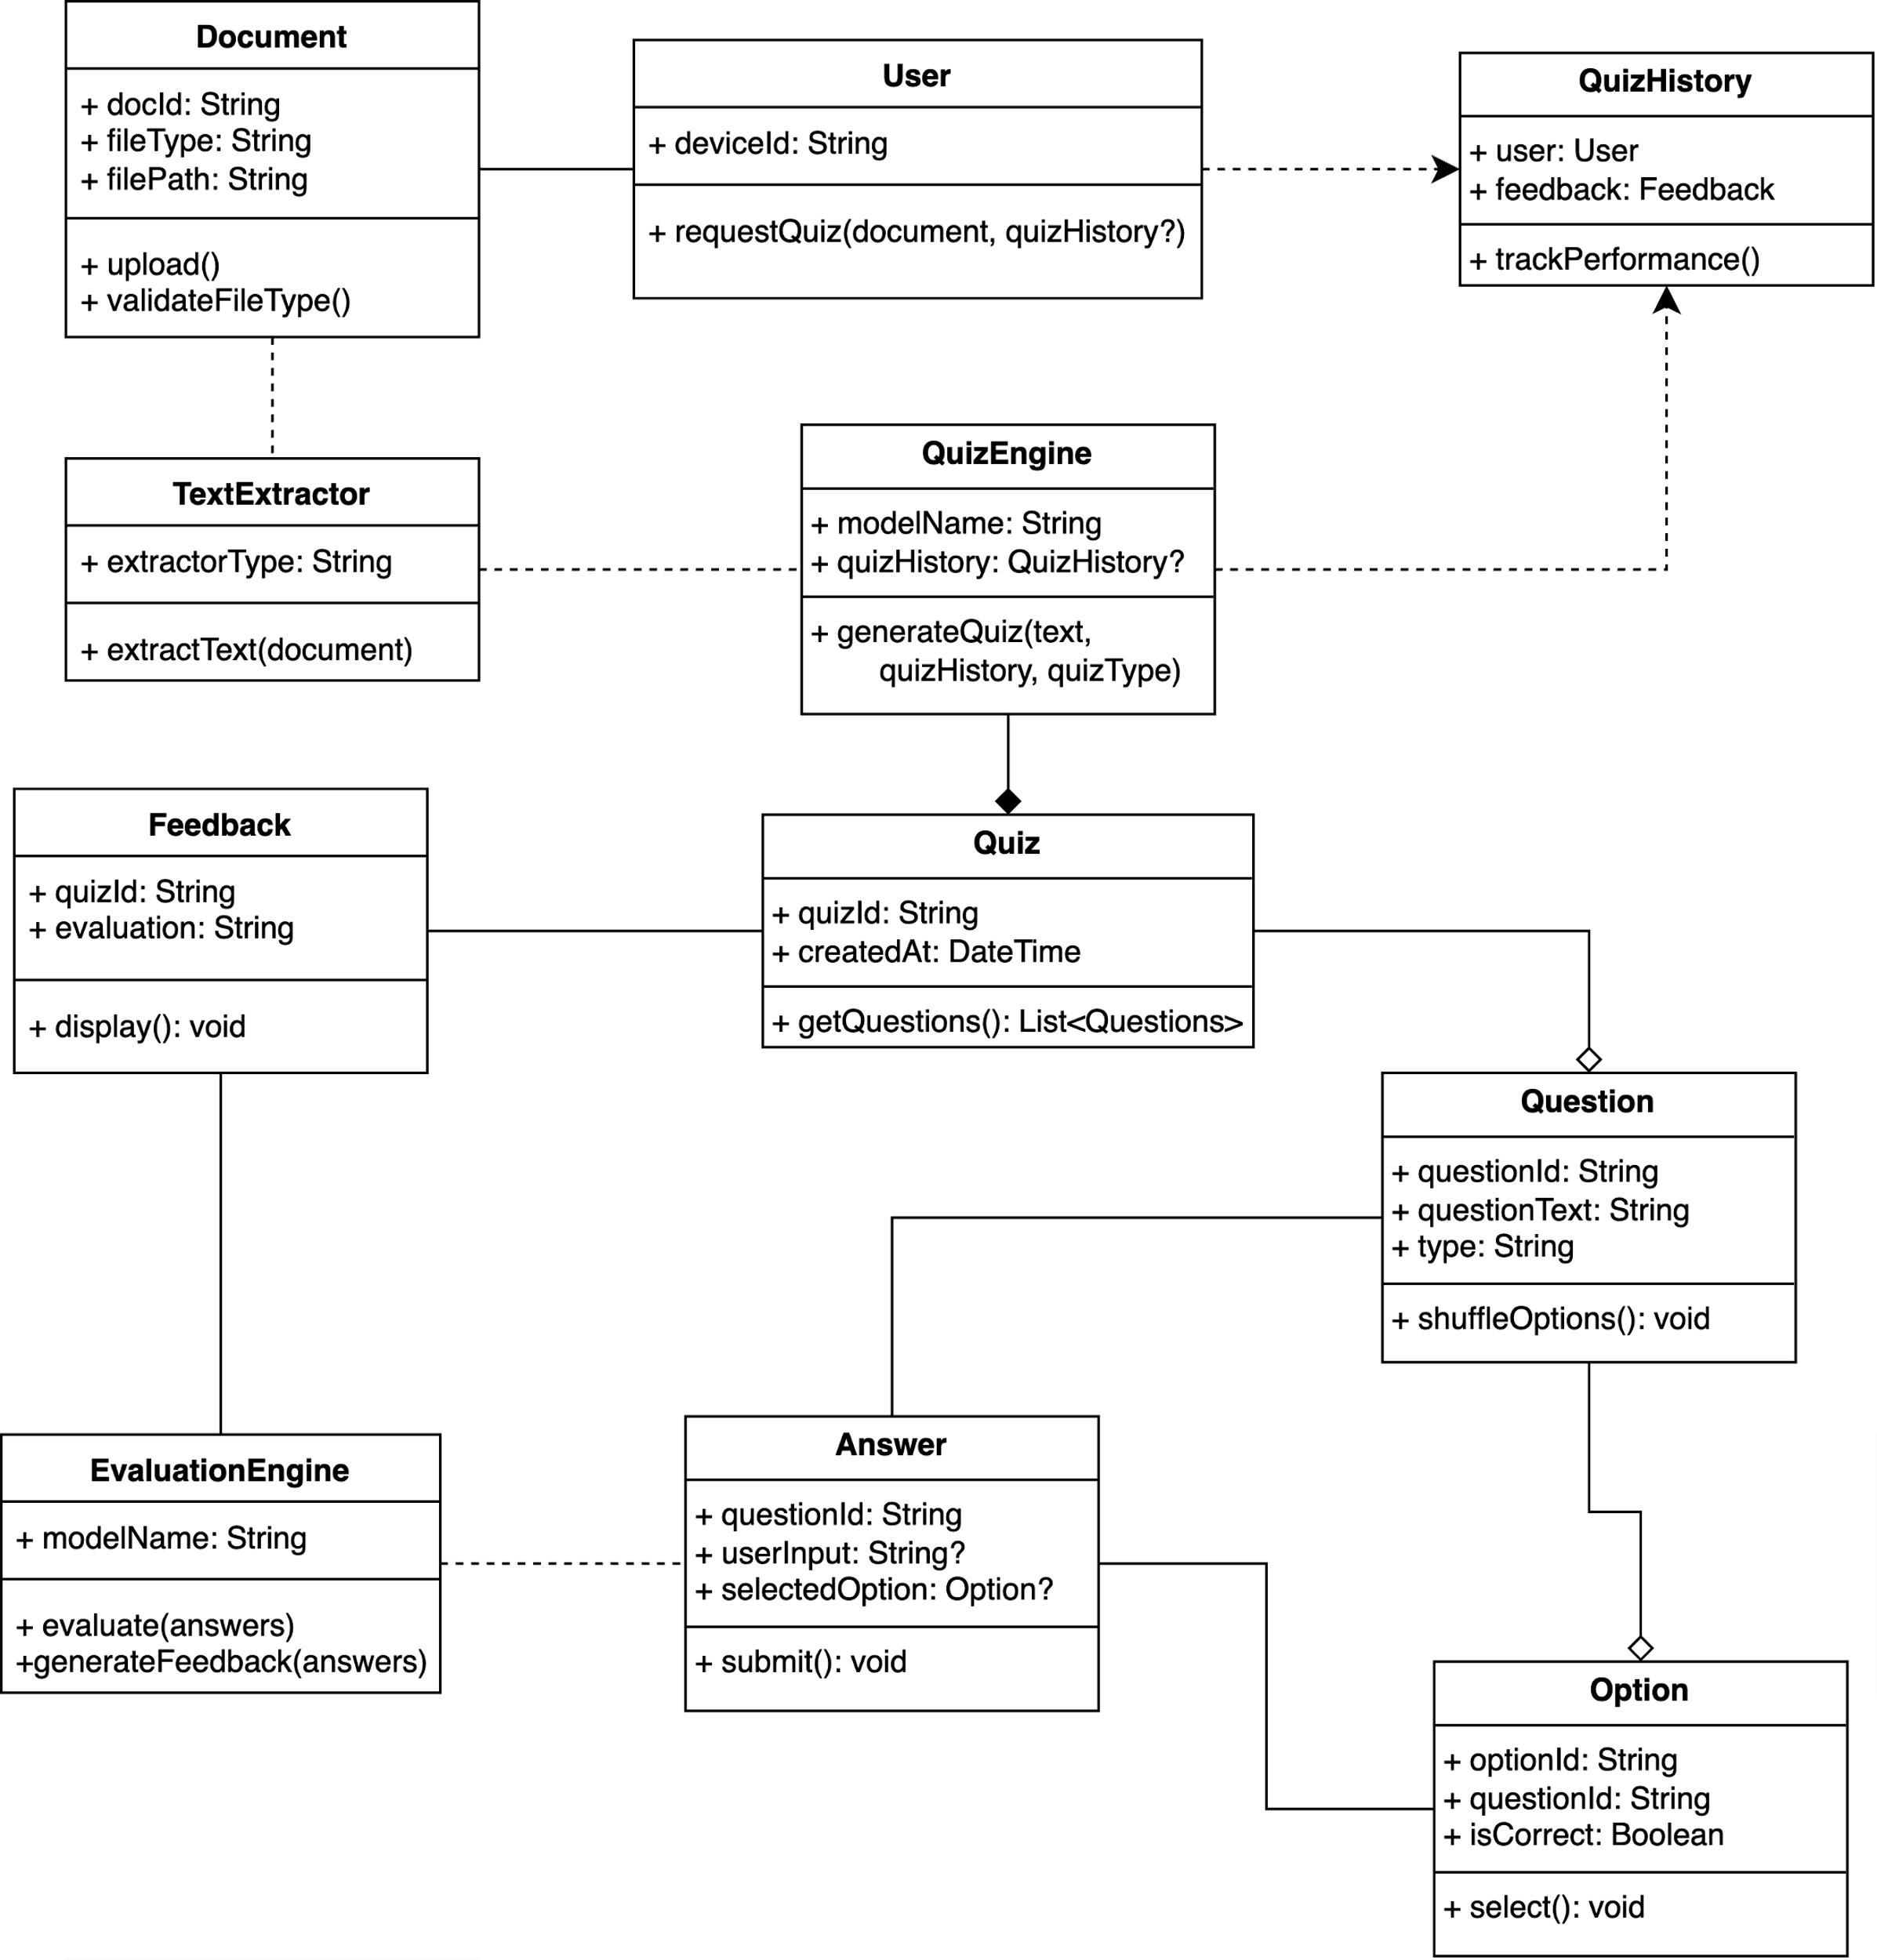
Figure 3.4: Class Diagram for the system

System Architecture
System architecture determines the structural build of a software solution; it details the components of the solution, its roles, and how they interact with one another in the greater system and the environment (Cameron, 2020). The model splits the system into two large layers: the Client Tier and the Application Tier. This architectural decision will make it modular, easier to maintain, and will provide easy communication between the interface facing the user and the backend logic. The architectural diagram of the system is displayed in Figure 3.5.
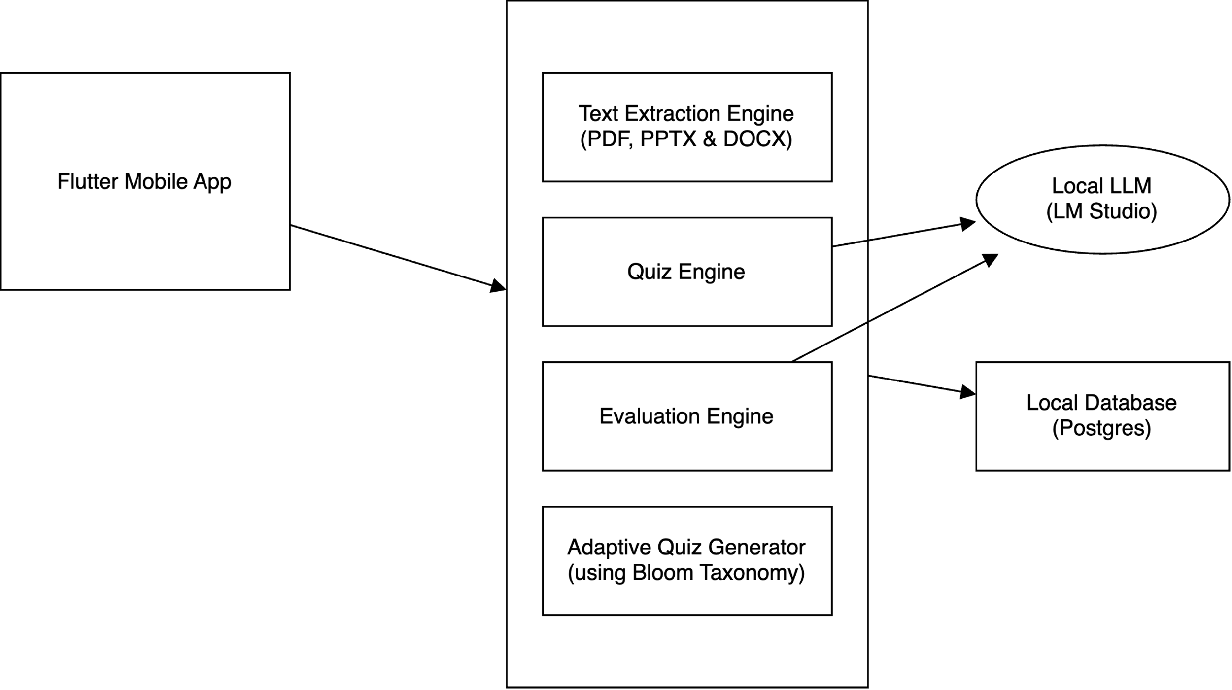
Figure 3.5: Architectural Diagram for the system

Client Tier
The Client Tier or the Presentation Layer is the system's front end, where the user has direct contact with the application. It is in charge of:
- Capturing user input (e.g., uploading a document, taking quizzes).
- Displaying output such as generated questions, evaluation results, and feedback.
- Facilitating seamless interaction with the backend services.
This layer is created in this system with Flutter, a new cross-platform framework for responsive mobile apps. The system can be used via a mobile application that interacts with the backend on the internet. This level has no core logic; it is a communication and presentation layer.

Application Tier
The Logic Layer or Middle Layer, also called the Application Tier, is the part of the system that deals with the overall business logic and intelligent operations. It is a liaison between the customer and any data storage or machine learning models. To this system, the following functions of this level are significant:
- Document handling: Receiving uploaded documents and extracting textual content using parsing tools.
- Quiz generation: Using a language model (LLM) to analyse the text and generate contextually relevant questions.
- Evaluation and feedback: Analysing submitted answers and generating feedback or personalised quiz recommendations.
This layer is implemented in Node.js with the NestJS framework, an evolving Node.js framework to create highly efficient and scalable backend software. In NestJS, TypeScript is the default, combining Object-Oriented Programming, Functional Programming and Functional Reactive Programming concepts. The framework offers a substantial framework with decorators, dependency injection, and a modular organisational structure, making it maintainable and testable. Presentation tier: All logic-heavy work goes through properly built controllers, services, and modules that pass results through the application tier in a structured format, like JSON responses. This architecture produces scalability, maintainability, and separation of concerns since the user interface, logic, and processißng layer are isolated.

Bloom’s Taxonomy in Adaptive Quiz Generation
Bloom’s Taxonomy is a widely adopted framework for categorising educational objectives within the cognitive domain. Developed in 1956 by Benjamin Bloom and collaborators, the taxonomy was introduced to bring structure and clarity to curriculum design, assessment development, and instructional strategies (West, 2023). Its central purpose was to assist educators in formulating learning objectives that progress from simple recall to complex reasoning, thereby promoting higher levels of understanding among learners. Since its inception, Bloom’s Taxonomy has become foundational in instructional design, owing to its versatility across disciplines and educational levels.

Cognitive Structure and Levels
The taxonomy defines a hierarchical model comprising six levels of cognitive skills. These levels, ordered from lowest to highest complexity, include:
  - Remembering: the ability to recall basic facts or concepts.
  - Understanding: the ability to interpret, explain, or summarise information.
  - Applying: the use of knowledge in new or practical situations.
  - Analysing: the ability to break down information into components and recognise patterns or relationships.
  - Evaluating: the ability to make informed judgments based on criteria or evidence.
  - Creating: the ability to produce original work by combining ideas in new ways.
Each level is built upon the mastery of the previous one, reflecting a progression from surface-level learning to deep, transferable cognitive engagement. This progression is beneficial for designing assessments that test knowledge and promote critical thinking and synthesis.

The Revised Taxonomy and Modern Adaptation
In 2001, Anderson and Krathwohl introduced a revised version of Bloom’s Taxonomy, reorganising the framework into the Knowledge Dimension and the Cognitive Process Dimension (Ullrich & Geierhos, n.d.). A significant change was the replacement of noun-based categories with verb forms to reflect more active engagement, such as “Applying” instead of “Application.” “Creating” was also repositioned at the top of the hierarchy, emphasising its role in 21st-century skills such as innovation and knowledge construction. This updated model better aligns with the needs of contemporary education, especially in digital environments where active and adaptive learning systems are key. Figure 3.6 illustrates how various action-oriented learning objectives can be mapped across five hierarchical thinking levels and four knowledge categories. This simplified version excludes the “Create” level to maintain visual clarity and focus, which typically appears at the top of Bloom’s hierarchy.
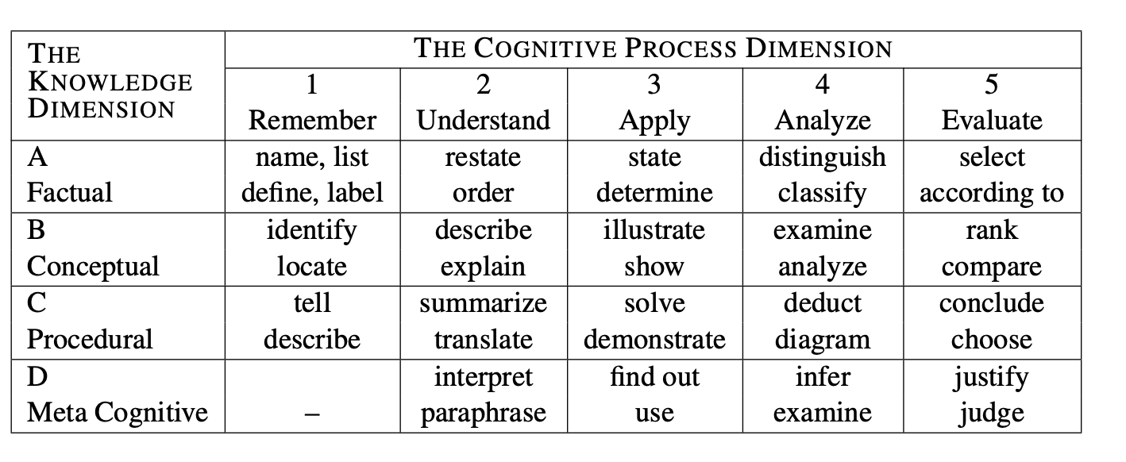
Figure 3.6: Simplified Bloom’s Taxonomy Matrix Mapping

Integration Into the Quiz Generation System
Bloom’s Taxonomy plays a critical role in this system by guiding the generation of quiz questions according to defined cognitive levels. The user selects a difficulty score from 1 to 10 during the quiz setup. This score is internally mapped to one of the six Bloom levels. The system maps user-selected difficulty scores to corresponding levels of Bloom’s Taxonomy to generate questions with appropriate cognitive depth. Since the “Creating” level is not utilised in this system, the difficulty levels are distributed across the first five levels as follows:
- Scores 1-2: generate questions at the Remembering level, focusing on basic recall of facts or definitions.
- Scores 3-4 correspond to the Understanding level, prompting learners to explain ideas or interpret meaning.
- Scores 56 target the Applying level, requiring the use of knowledge in practical or familiar situations.
- Scores 7-8: emphasise the Analysing level, involving the breakdown of concepts and identification of patterns or relationships.
- Scores 9-10 are aligned with the Evaluating level, encouraging critical thinking, comparison, or judgment based on criteria.
The system uses these mappings to generate prompts that instruct it to tailor questions accordingly. This ensures that each question is relevant to the document’s content and challenges the user at a cognitively appropriate level.

Pedagogical Value and Significance
The continued relevance of Bloom’s Taxonomy lies in its capacity to structure learning around thinking, nßΩΩΩΩ¸¸¸¸¸¸¸¸¸¸¸¸¸¸ßot just knowing (West, 2023). In this project, its integration ensures that:
  - Learners are assessed at appropriate cognitive depths based on their progress or intent.
  - Adaptive feedback becomes more meaningful by identifying performance relative to cognitive skill levels.
  - The system promotes long-term mastery by moving learners up the cognitive hierarchy.
By aligning automatic question generation with Bloom’s framework, the system mimics the questioning approach of a skilled educator, who adapts instruction not by chance but by cognitive intent. This makes Bloom’s Taxonomy not just a theoretical tool but a functional backbone of intelligent educational systems.

Large Language Models (LLMs)
Large Language Models (LLMs) are sophisticated artificial intelligence systems trained on vast amounts of text data to understand and generate human-like language. These models utilise deep learning architectures, particularly transformer networks, to process and generate text by predicting the most likely next word or sequence of words based on the context provided. In this adaptive quiz generation system, LLMs serve as the core intelligence that transforms educational content into meaningful, contextually appropriate quiz questions while maintaining pedagogical value and appropriate difficulty levels.

LLM Architecture and Components:
This subsection examines the key architectural components that enable natural language processing and question generation.
- Transformer Architecture: The foundation of modern LLMs relies on the self-attention mechanism that allows the model to weigh the importance of different words in a sentence when generating responses. This enables the model to understand the context and relationships between concepts in educational materials (Liu et al., 2024). The model processes input text through multiple layers of encoders that understand the content, followed by decoders that generate appropriate quiz questions based on the context and specified difficulty parameters.
- Training Process: LLMs undergo extensive pre-training on diverse text corpora, learning general language patterns, grammar, facts, and reasoning abilities that form the foundation for understanding educational content (Huang et al., 2023). The model is refined on specific educational datasets to better understand pedagogical concepts, question formatting, and appropriate difficulty progression aligned with educational standards.

Implementation Considerations
This section addresses the practical deployment decisions and optimisation techniques for the LLM implementation.
- Model Selection: This project utilises the Hermes LLaMA 8B model, chosen for its balance between performance capability and computational efficiency, making it suitable for local deployment while maintaining high-quality question generation.
- Performance Optimisation: Efficient handling of model weights and processing pipelines to ensure smooth operation on standard hardware configurations. Implementing caching mechanisms and optimised inference pipelines to provide quick question generation and adaptive responses.

System Pipeline
Before generating any quiz, summary, or answer, the system must go through a carefully orchestrated series of steps that transform raw, unstructured documents into structured, intelligent outputs. This end-to-end pipeline combines document parsing, semantic embedding, vector search, and LLM inference to simulate real understanding and reasoning. Table 3.3 outlines the complete flow from ingestion to generation that powers the adaptive quiz and retrieval system.

Table 3.3 Overview of the System Pipeline
Steps | System Pipeline
 | Raw documents are uploaded and parsed into text.
 | Text is chunked into semantically coherent segments.
 | Each chunk is embedded into a vector space using a transformer encoder.
 | Vectors are stored in a searchable database with metadata.
 | Similar chunks are retrieved based on query similarity.
 | A context-aware prompt is constructed and sent to LLaMA.
 | The model infers the following best output using transformers and attention.
 | The raw output is parsed into structured data for downstream use.

Document Extraction
The document extraction stage is responsible for ingesting raw content from various file formats, such as .pdf, .docx, .pptx, or .txt, into a machine-readable textual format. This step is crucial because documents in their native formats contain rich structural metadata, such as headings, paragraphs, fonts, layouts, or compressed encodings that NLP systems cannot directly interpret. Depending on the runtime environment, the system relies on libraries such as PDF.js, PyMuPDF, or even textract. For PDFs, if the file is text-based, the loader extracts the text by parsing the PDF stream; if it is scanned or image-based, it falls back to an OCR engine such as Tesseract, which utilises convolutional neural networks (CNNs) trained on character-level recognition to convert pixel regions into Unicode text.
This extraction process involves reading the bytes, interpreting the document structure, and encoding. This process aims to reduce structured documents into a linear stream of human-readable text. The result is a collection of strings, each representing a logical block, which is then wrapped in a Document class that can also include metadata such as filename, page number, or document type. This process abstracts away all format-specific complexity and produces clean, uniform input for the next stage in the pipeline, Splitting and Embedding.

Document Splitting and Chunking
Once raw textual data is extracted from various document formats, the following essential phase is document splitting, which transforms large, monolithic text blocks into smaller, semantically meaningful chunks that can be effectively processed by a large language model (LLM). This is necessary because most LLMs, including LLaMA, operate within a fixed context window, typically between 2,048 and 8,192 tokens for standard deployments. Tokens are not equivalent to words; they are units of meaning, such as sub-words or byte-pair encodings, meaning even moderately sized paragraphs can quickly exhaust the token limit. Thus, chunking is vital to preserve coherence while staying within the operational boundaries of the model.
The system uses a recursive descent algorithm to perform context-aware chunking. The algorithm takes a hierarchical list of splitting rules. For instance, try to split on paragraph breaks, then fall back to sentence breaks, then word breaks, and attempt each in sequence. It ensures that each resulting chunk is under a specified character or token limit. This algorithm is robust because it balances semantic integrity with technical constraints. Internally, this process also integrates token counting, using a tokeniser that reflects the LLM’s actual vocabulary encoding, ensuring the final chunks will not exceed model capacity.
Each output chunk becomes a self-contained unit of information, still linked to metadata like its document source, page number, or heading structure. These critical units will be embedded, indexed, and retrieved as independent knowledge representations. If the splitting is done poorly, for example, by slicing through ideas or topics, the embeddings will become semantically noisy, and downstream question-answering or quiz generation will be weak. Thus, chunking is both a technical pre-processing step and a semantic design decision to maximise model relevance and retrieval accuracy later in the pipeline.

Embedding the Chunks
After the document has been split into manageable and meaningful chunks, each chunk must be transformed from plain text into a machine-understandable mathematical representation. This is called embedding. In modern natural language processing (NLP), embedding converts a piece of text into a dense, fixed-size vector of floating-point numbers that captures the semantic meaning of that text. This transformation is crucial because it allows discrete data (words, phrases, sentences) to be handled in continuous vector spaces where similarity can be measured and indexed efficiently.
This is achieved using a pre-trained transformer encoder model, such as bge-large-en-v1.5, which maps input text to a high-dimensional vector, typically 384 to 1536 dimensions. The embedding model works by first tokenising the input using its trained vocabulary, a form of Byte Pair Encoding (BPE), which breaks the text into sub-word units. These token IDs are passed through the model’s encoder stack, which is composed of multi-head self-attention layers. Each attention head computes interactions between all pairs of tokens in the input, capturing relationships and dependencies. The outputs from each attention head are combined to form a unified representation. The combined output is passed through one or more feedforward layers for further transformation. Then, it aggregated into a final vector using pooling strategies. This final vector serves as the semantic fingerprint of the original chunk.
The fundamental idea is that similar meanings, not just similar words, should be mapped to geometrically close vectors in this space. For instance, “data encryption” and “secure communication” may not share many words, but a good embedding model will place them near each other in vector space if their meanings align. These embeddings are not handcrafted features. They are learned representations from vast corpora optimised during pretraining to understand the nuances of human language. We are projecting a variable-length input text into a fixed-dimensional vector space while preserving as much of its meaning as possible. This mathematical transformation enables fast, approximate search and retrieval, the backbone of modern LLM-powered systems. Once each chunk is embedded, it can be indexed and stored in a vector database, enabling similarity-based lookup during inference.

Storing Embeddings in the Vector Store
Once text chunks have been converted into fixed-dimensional embeddings, the next step is storing them in a vector database, a specialised system optimised for indexing and retrieving high-dimensional data. Traditional relational databases like PostgreSQL can only store structured data types, but embeddings are large floating-point vectors. Tools like pgvector, FAISS, Pinecone, or Weaviate are used to support this, each implementing different strategies for indexing and searching through these dense representations efficiently.
When using PostgreSQL with the pgvector extension, each embedding is stored as a single vector column alongside metadata such as document ID, page number, chunk index, and any extracted topics. Conceptually, a table might contain fields like id, embedding, and metadata. The embedding column uses a specialised vector type introduced by pgvector, allowing PostgreSQL to apply custom distance operators like for cosine similarity. Cosine similarity is commonly used here because it measures the angle between two vectors, which is ideal for semantic comparison. We care more about direction (meaning) than length (verbosity).
To optimise search speed, these databases use Approximate Nearest Neighbour (ANN) search algorithms such as:
- HNSW (Hierarchical Navigable Small Worlds): a graph-based indexing structure that connects similar vectors across multiple layers and allows for logarithmic-time traversal.
- IVF (Inverted File Index): clusters vectors into buckets (centroids) and only searches within the top-matching clusters.
- PQ (Product Quantisation): compresses vectors into low-bit codes to save memory and accelerate comparisons.
These ANN methods have trade-offs. They sacrifice exactness for performance, often achieving approximately 95% precision at a fraction of the time it would take to scan all vectors linearly. From a systems perspective, storing vectors with metadata supports hybrid search, and they can be filtered based on fields (e.g., lecture ID, topic, or page number) while also performing a similarity search. This enables highly targeted and semantically relevant document retrieval. By the end of this step, it has transformed human-readable content into a semantically indexed knowledge base, searchable not by keywords but by meaning.

Similarity Search & Retrieval
Once the document chunks have been embedded and stored in a vector database, the system must be able to retrieve the most relevant chunks when a user submits a query. This is where the similarity search comes in. Unlike keyword search, which matches exact or partial string patterns, similarity search works by comparing semantic meaning using vector distance metrics. The input query is first transformed into an embedding using the same embedding model used during ingestion. This ensures that the query and stored chunks are in the same semantic vector space and can be compared meaningfully.
The core operation here is finding the query vector's k-nearest neighbours (k-NN) within the stored document vectors. This involves calculating a distance metric between the query vector and each candidate vector in the database. The most common metric is cosine similarity, which measures the cosine of the angle between two vectors. Cosine similarity focuses on directionality, so two sentences with similar meanings yield high similarity, even if they differ in length or word choice. Mathematically, this is defined in Equation 3.1, where A and B are the input vectors:
(3.1)
cosine_similarity(A ,B) = $\frac{A·B}{\left|\left|A\right|\right||\left|B\right||}$
For small datasets, an exact brute-force search is often feasible. This means comparing the query vector to all stored vectors one by one and sorting the results. However, for larger scales, this becomes computationally expensive. To address this, vector stores use Approximate Nearest Neighbour (ANN) algorithms that construct optimised DSTA structures to prune irrelevant comparisons and retrieve only the most promising matches in sublinear time.
The result of a similarity search is a ranked list of text chunks, typically the top k results, that are considered most semantically relevant to the query. These results are then passed into the next phase, which becomes the context for an LLM prompt. This is a crucial step in ensuring that the LLM has the correct information grounded in facts when generating output.

Prompt Construction & Contextualization for the LLM
Once the top-k most relevant document chunks have been retrieved from the vector store, the system must construct a prompt, a structured input string to be passed to the language model (in this case, LLaMA). This step is called prompt engineering, and it is one of the most critical stages in the LLM pipeline because it directly determines the model’s behaviour, performance, and relevance of its output. At its core, a prompt is a textual representation of a task or instruction, often framed with supporting examples or context. In retrieval-augmented generation (RAG) systems, this prompt typically takes the form of:
Based on the following context, answer this question:
{context}
{query or instruction}
This structure dynamically injects values like context chunks, user questions, and format instructions into the LLM as prompts. Behind the scenes, this is pure string interpolation: the context (a concatenated string of retrieved chunks) is injected into a predefined template along with task-specific instructions.
The technical challenge here lies in context window limits. LLMs like LLaMA 8B have a finite number of tokens they can process simultaneously.
Therefore, the system must carefully balance:
- Number of context chunks
- Length of the user query
- Instructional scaffolding (formatting instructions and JSON requirements)
If the prompt exceeds the model’s context limit, it will truncate the input or fail. Context-aware splitting and chunk selection are significant in the earlier stages. Ultimately, the result of this step is a string of natural language containing the user’s intent, relevant context chunks, and model-specific instructions. This string becomes the raw input for the LLM’s forward pass, marking the handoff from prompt design to text generation.

LLaMA Inference and Text Generation
Inference is the heart of the LLM pipeline, where all previous steps converge to trigger the model’s ability to “understand” and generate natural language. Technically, inference refers to feeding a prompt into a pre-trained language model, such as LLaMA 3.1, and receiving generated text as output. While the model appears to be “understanding” or “thinking,” what is happening is a series of vectorised mathematical operations over billions of learned parameters in a transformer-based neural network.
The first step in inference is tokenisation. The input prompt, a raw text string, is passed through a tokeniser, typically trained using Byte-Pair Encoding (BPE), which splits the text into tokens. These tokens are mapped to unique integer IDs using a vocabulary file. For instance, the word “multiplexing” might be broken into multi and place, each with a separate token ID. These IDs are then converted into embedding vectors via a learned embedding matrix, effectively mapping each token into a continuous vector space.
Next, the transformer architecture takes over. The LLaMA model consists of a deep stack of decoder-only transformer blocks, each composed of multi-head self-attention layers. These allow each token to attend to every previous token in the sequence. The attention mechanism used here is the scaled dot-product attention, mathematically defined in Equation 3.2 as:
(3.2)
Attention (Q, K, V) = softmax$\left(\frac{QK^{T}}{\sqrt{dk}}\right)V$
Equation 3.2 defines the scaled dot-product attention mechanism, where each token computes a weighted representation of preceding tokens by comparing its query vector (Q) against the key vectors (K) of other tokens. The resulting attention weights are normalised using a softmax function and applied to the value vectors (V), allowing the model to dynamically focus on relevant parts of the input. The scaling factor $\sqrt{dk}$, where dk is the dimensionality of the key vectors, ensures numerical stability during training and inference. This mechanism enables the model to capture long-range dependencies and subtle contextual cues across tokens. Following attention, the transformer applies feedforward layers with non-linear activations to refine token embeddings, and during inference, uses autoregressive decoding to iteratively generate coherent output, token by token.

Text generation is controlled by decoding strategies, such as:
- Greedy decoding: it selects the most probable word at each step, making it fast and deterministic but often producing repetitive or generic text.
- Top-k sampling introduces randomness by selecting the most probable words from the top k, allowing for more diverse outputs while maintaining relevance.
- Top-up (nucleus) sampling refines this by choosing from the smallest possible set of words whose cumulative probability meets or exceeds a threshold p, resulting in more context-sensitive and naturally flowing text.
These strategies balance reliability and creativity. Top-p sampling with temperature control allows for more varied but plausible questions for quiz generation. Although LLMs are just performing numerical operations, their massive parameter sizes and training on diverse corpora allow them to capture semantic regularities, world knowledge, and even reasoning patterns. When LLaMA answers a question or generates a quiz, it is learned during pretraining. It does not “know” facts like a human; instead, it infers output by statistically modelling the next likely token based on the context provided. This entire process, from tokenisation to decoding, is called a forward pass and constitutes the model’s inference phase. It is where language understanding appears, though it is the product of billions of learned associations and parameter weights applied at scale.

Output Parsing and Postprocessing
Once LLaMA has generated its textual output during inference, whether quiz questions, topic summaries or answer choices, the raw output is still just unstructured text. Many real-world applications, including this system, would need to extract structured, machine-usable data from that output. This is the job of output parsing and postprocessing, the step that converts fluent, natural language into exact formats like arrays, objects, or key-value pairs. This process is handled by components called Output Parsers. These modular classes interpret and transform the output from the language model into a predefined structure, often in the form of TypeScript/JavaScript objects, JSON, or lists. Behind the scenes, output parsing is an application of text pattern recognition, syntax-guided extraction, and formal grammar matching. Let us take a closer look at how this works. Suppose the LLM prompt included a format instruction like:

“Return a list of comma-separated quiz topics.”
Or:
“Respond in this JSON format: {"answer": "...", "options": ["A," "B," "C," "D"]}.”
The parser is configured to expect output in one of these formats and will apply logic to match it. For comma-separated responses, the output string uses delimiters like commas and newlines, trims whitespace, and maps the result to a string list. It internally attempts to deserialise the output for more complex outputs using JSON.parse(). However, before doing so, they may validate the structure or repair minor syntax errors, like trailing commas, missing quotes, or improper brackets. This layer is necessary because LLMs, while capable, do not always generate perfectly formatted output, especially under long contexts or higher temperatures. These are referred to as leaky abstractions. The LLM may drift from instructions slightly unless guided tightly.
At a deeper level, this process borrows concepts from context-free grammars, finite state machines, and regular expressions, classic CS tools used to parse and evaluate language. In future versions, many systems may use LLM-as-a-parser architectures, where the model is trained to self-correct or parse its output using chain-of-thought or tool-calling prompts. After parsing, the structured result is passed back to the application for storage, rendering in the UI, or further processing, such as saving to a database or performing analytics. The final step ensures that a generative model's probabilistic output becomes reliable, interpretable, and actionable.

Limitations of the system
Despite its strengths, the system pipeline has inherent limitations that affect its scalability, accuracy, and resource efficiency. Table 3.4 shows the limitations in the system pipeline implemented in this project.
Table 3.4 Limitations of the System Pipeline
S/N | Stage | Limitations
 | Document Loading | OCR errors: OCR can misread low-quality scans, especially with math, tables, or non-standard fonts.  Structure loss: Formatting like headers, bullet points, and table structures is often flattened into plain text, losing semantic cues.
 | Text Splitting | Fragmentation: Sentences or topics can be cut mid-thought, reducing the coherence and meaning of each chunk.  Redundancy: Overlap increases vector count, storage size, and retrieval noise.  Token mismatch: Chunking by characters instead of actual model tokens can break LLM input constraints.
 | Embedding | Low-quality embeddings: Embedding models may fail to capture nuance in technical, legal, or medical texts.  Cut-off limit: Embedding models have internal limits, so longer input is truncated.  Semantic drift: Two different topics may end up near each other due to shared vocabulary.
 | Vector Storage | Storage cost: Thousands of chunks with high-dimensional vectors take up a lot of memory and disk space.  Reindexing cost: Updating or reindexing for ANN structures is time-consuming and not dynamic.  SQL limitation: pgvector supports cosine search but does not have actual ANN acceleration like FAISS.
 | Similarity Search | Semantic confusion: Semantically different chunks can appear close due to embedding model quirks.  False positives: Closest vectors are not always relevant to the query’s intent.
 | Prompt Construction | Overflow: Context + instructions + task can exceed LLM token limit, truncating inputs.  Brittleness: Small changes in wording can lead to drastically different outputs or failure.  Manual effort: Templates often require trial and error, which does not scale easily.
 | LLaMA Inference | Hallucination: Without grounded facts, LLMs may generate plausible but false information.  The model has no memory of previous interactions unless the user manually provides history.
 | Output Parsing | Format errors: LLMs might return malformed JSON or inconsistent delimiters even with format instructions.  Parser issues: Parsers often fail silently or throw errors on minor format mismatches.  Recovery cost: Fixing broken outputs requires a second LLM call or regex clean-up logic.

Optimisation of the system
The system pipeline incorporates several technical optimisations that enhance its adaptability, performance, and relevance to educational use cases. These decisions could improve efficiency, maintain contextual accuracy, and support offline functionality. Table 3.5 shows the optimisations in the system pipeline implemented in this project.
Table 3.5 Optimisation of the System Pipeline
S/N | Stage | Optimizations
 | Document Loading | Asynchronous ingestion: Load files concurrently using queues or workers to reduce bottlenecks.  Prefer extractable formats: Use .txt, .docx, or structured HTML instead of scanned PDFs. OCR tuning: Use domain-tuned OCR engines or preprocessing to improve accuracy.
 | Text Splitting | Semantic splitting: Split first by paragraphs, sentences, and tokens to preserve meaning.  Token-aware chunking: Use tokeniser-aware chunking to ensure LLM compatibility.  Adaptive overlap: Dynamically adjust chunk overlap size based on average chunk length to balance recall and noise.
 | Embedding | GPU acceleration: Batch encodes using CUDA or ONNX for faster processing of large datasets.  Model quantisation: Use int8/float16 models for faster and cheaper inference.  Embedding caching: Cache embeddings for unchanged text to avoid recomputing duplicates.
 | Vector Storage | Hybrid filtering: Combine semantic similarity with metadata filters for higher precision  Use specialised libraries: Use FAISS / HNSW / Qdrant for large-scale ANN search.  Compressed embeddings: Apply PCA or quantisation to reduce embedding size.
 | Similarity Search | Top-k re-ranking: Use a shallow LLM to re-score retrieved chunks based on context.  Contextual weighting: Weigh chunks based on their metadata.  Query caching: Precompute and store results for frequent or repeated queries.
 | Prompt Construction | Token control: Measure and limit prompt length dynamically based on the model context window.  Modular templates: Use reusable prompt templates and chaining for consistent structure.  Prompt compression: Use summarisation or embedding clustering to reduce the token size of the context.
 | LLaMA Inference | Quantised models: Run minor variants like Q4_K_M or Q6_K on the CPU for fast local inference.  Temperature tuning: Adjust generation parameters for more stable outputs.  Layer pruning / LoRA: Reduce model size or memory footprint without full retraining.
 | Output Parsing | Retry logic: Fallback to regex cleanup or LLM self-correction if the initial parse fails.  Schema validation: Use JSON schema or TypeScript validators to ensure correctness post-parse.

CHAPTER FOUR

SYSTEM IMPLEMENTATION

Introduction
This chapter presents the system's implementation phase, designed to generate quiz questions from educational content automatically. The implementation shows the mobile frontend, which interacts with users, and the backend engine, which handles document processing, topic extraction, and adaptive question generation using a large language model. The system was developed using a combination of Flutter and an LLM, Hermes LLaMA 8B, for backend logic and intelligent content generation. This chapter details the tools used, how each module was developed, how the system components were integrated, and how the entire system was tested.

System Requirements
System requirements refer to the essential hardware and software configurations a system must meet to ensure optimal performance, reliability, and functionality. These requirements define the minimum and recommended resources for the system to operate as designed. This project considered system requirements across three layers: hardware capabilities for model inference and processing, software dependencies for backend and frontend development, and key implementation tools that enabled local machine learning operations, quiz generation logic, and interactive user experience.

Hardware Requirements
The hardware requirements specify the minimum physical resources needed to run the system efficiently, particularly during local inference and document embedding using the LLaMA language model and vector similarity search. These requirements support the processing load of computation, quiz adaptation, and real-time mobile interaction. Table 4.1 shows the minimum hardware requirements used to carry out this project.

Table 4.1: Hardware Requirements
S/N | Requirement | Hardware
 | Processor | Apple M1/M2 chip or Intel Core i7 equivalent
 | Primary Memory | 32 GB RAM or higher
 | Architecture | ARM64 / x86_64
 | Secondary Storage | 64 GB SSD or higher (for model and documents)

Software Requirements
The software stack required for development and deployment includes programming environments, machine learning and vector storage dependencies, and local hosting and mobile development platforms. The system consists of a Flutter-based mobile app and a Node.js/NestJS-powered backend running LLaMA locally. Table 4.2 shows the minimum software requirements used to carry out this project.
Table 4.2: Software Requirements
S/N | Requirement | Software
 | Operating System | macOS 12+ / Ubuntu 22+ / Windows 11
 | Programming Language | TypeScript (NestJS), Dart (Flutter), Python (setup)
 | Machine Learning Frameworks | LangChain.js, HuggingFace Transformers (LLaMA GGUF)
 | Database Management System | PostgreSQL with pgvector extension
 | Frontend Development | Flutter SDK, Dart DevTools
 | Package Management | npm, pip, pub

Implementation Tools
These are the tools and libraries used across backend development, model integration, and mobile frontend design:
- NestJS (TypeScript): Used to build the backend API that handles document uploads, embedding, vector search, and quiz generation.
- PostgreSQL + pgvector: A relational database with vector extension storing document embeddings alongside metadata (e.g., topic, page number).
- Flutter: Used to develop the mobile quiz app with a smooth, adaptive user experience.
- Flutter BLoC Architecture: For efficient state management and modularity within the mobile app.
- LLaMA 3.1 8B (Hermes Fine-tuned): The local language model generates Bloom-level adaptive quizzes, summaries, and analysis.
- HuggingFace Transformers + GGUF: Used for running LLaMA in quantised form locally via LLAMA.cpp or LM Studio.
- Tesseract OCR: Enables PDF text extraction, especially for scanned or image-based notes.
- Visual Studio Code: Main development environment for both frontend and backend development.
- Node.js & npm: Dependency and project management for the backend.
- Dart + pub: Dependency management for the Flutter app.

System Development Process
This section describes the processes used in developing the system from initial prototyping to functional implementation. It includes snapshots of key modules across the frontend and backend.

Frontend Development
The mobile application was built using Flutter and follows the BLoC pattern for scalable state management.
- Home Screen: Allows users to upload a document for quiz generation and view created quizzes. Figure 4.1 displays the user interface for this section
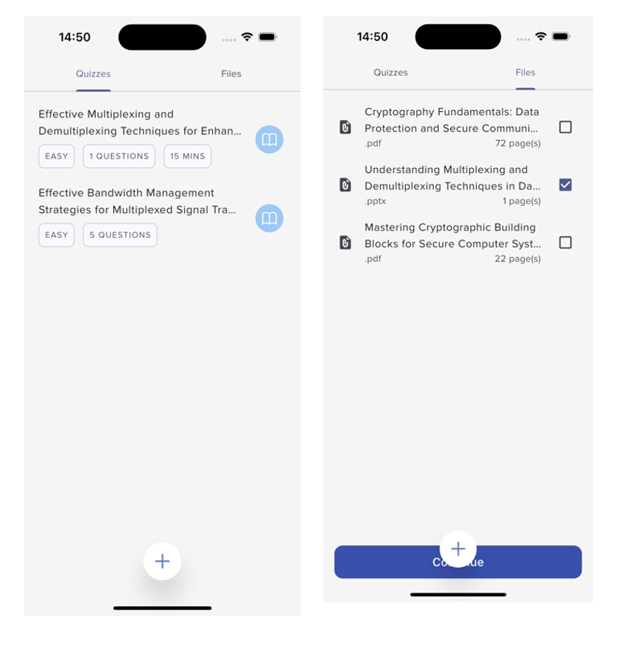
Figure 4.1: Quizzes & Files interface.
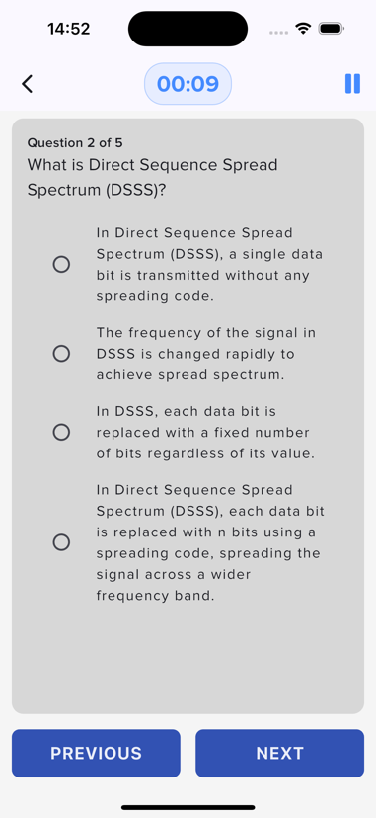
- Quiz Screen: Displays multiple-choice questions dynamically generated from backend content. Figure 4.2 displays the user interface for this section

Figure 4.2: Quiz interface with a multiple-choice question

- Performance Screen: Shows the user’s progress and identifies weak areas. Figure 4.3 displays the user interface for this section
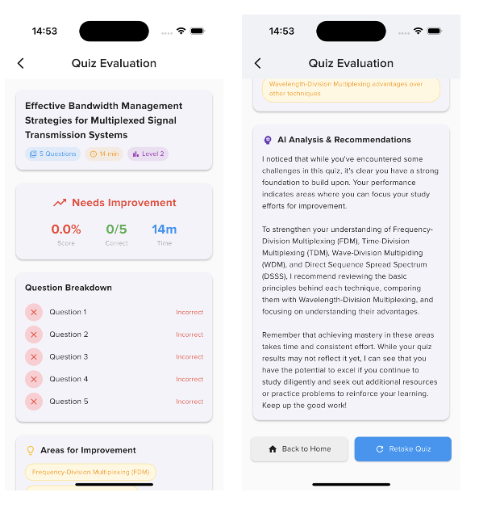
Figure 4.3: Feedback page showing user performance

Backend Development
The backend was developed using NestJS and integrated with LangChain.js for intelligent text processing and quiz generation. These are the key modules involved:
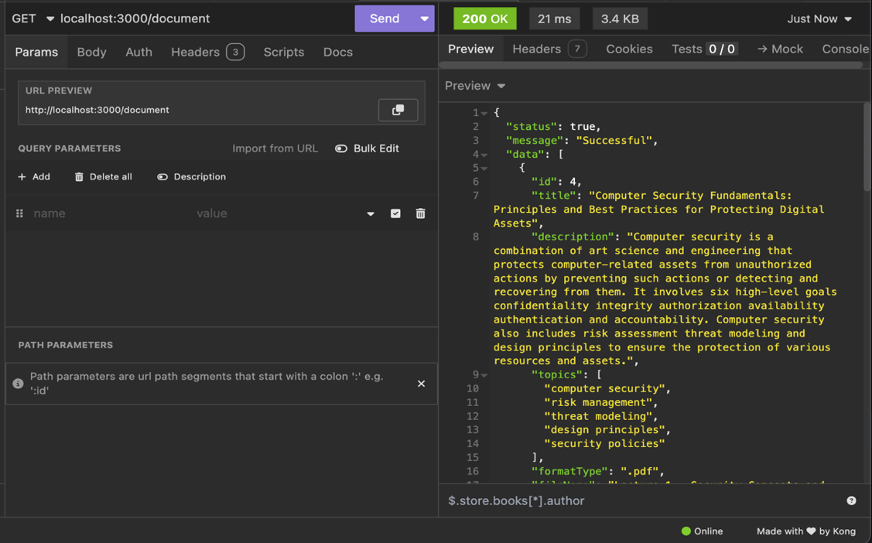
- Document Upload Endpoint: Receives and stores uploaded documents in the local /uploads folder. Figure 4.4 displays a sample document payload for this system.

Figure 4.4: Document Endpoint

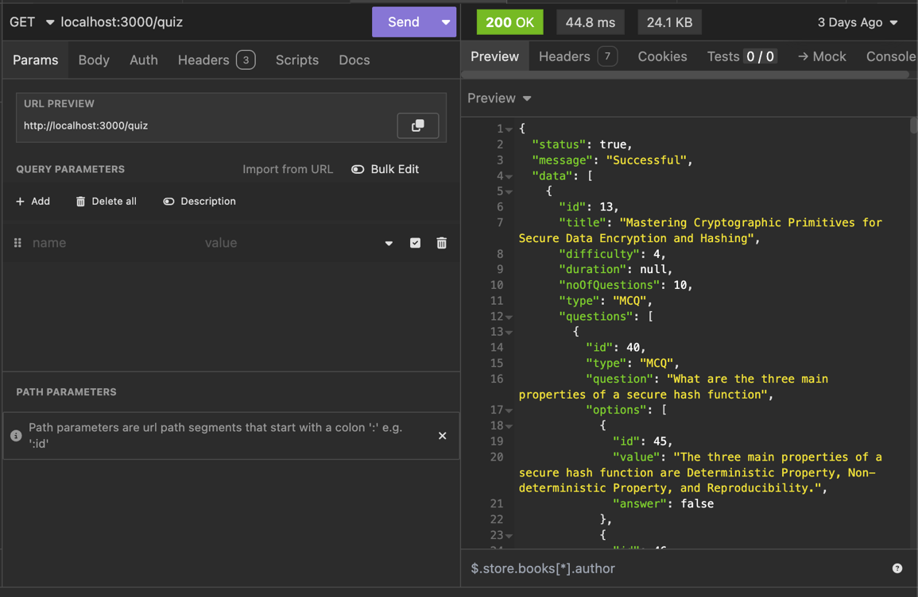
- Quiz Get Endpoint: Sends out all the quizzes the user generates, including information about the quiz history and structure. Figure 4.5 displays a sample quiz payload for this system.
Figure 4.5: Quiz Endpoint

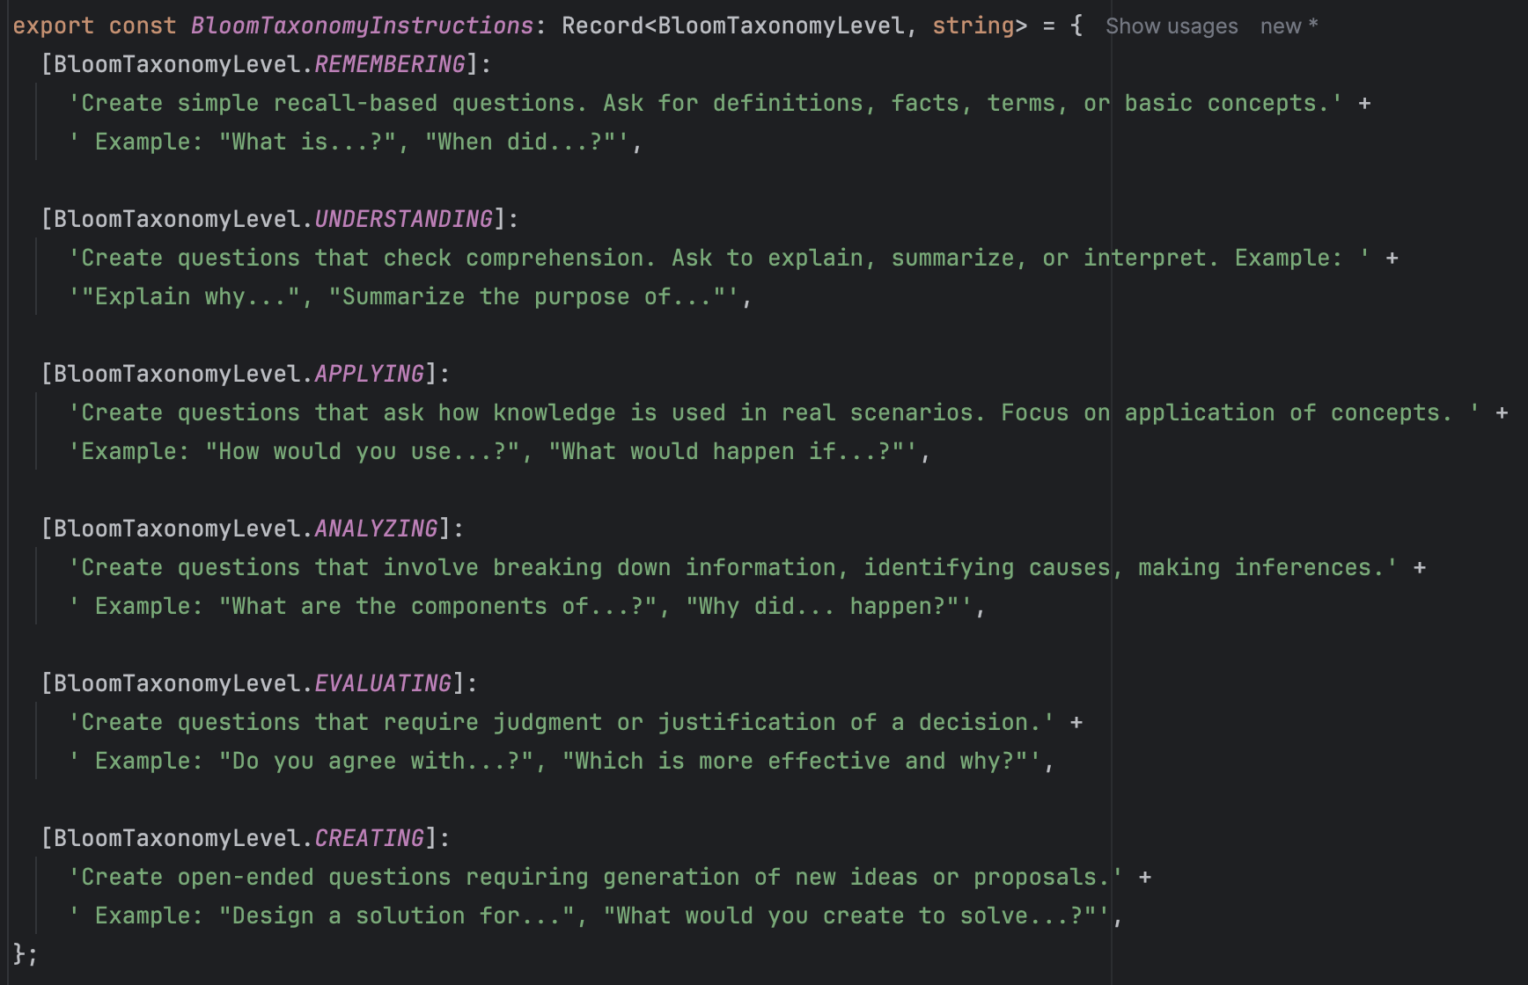
- Adaptive Quizzes: Uses Bloom’s Taxonomy and prior user history to adjust the complexity of generated questions. Figure 4.6 shows the structured prompts for each taxonomy.
Figure 4.6: Bloom-based prompting structure

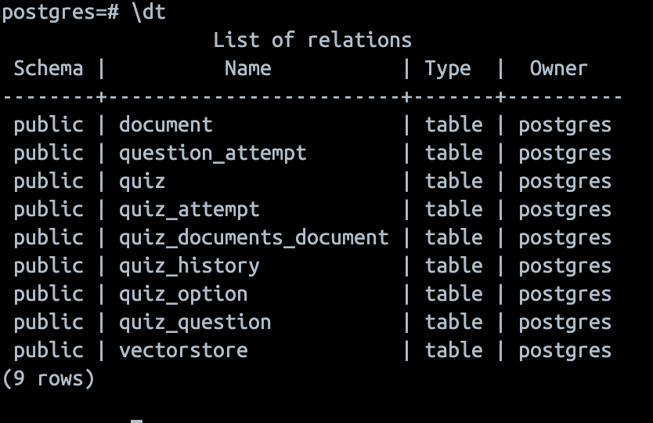
- Database Entities: Numerous entities and relationships were created in the system. Figure 4.7 shows an overview of the entities in the system.
Figure 4.7: List of entities in the system

System Implementation Details
This section describes how the system's core modules were implemented, including the frontend user interface, backend services, and the integration of machine learning components for adaptive quiz generation.

Frontend Implementation
The Flutter-based mobile application is the primary user interface. It handles document uploads, displays quiz questions, and tracks user performance.
- Document Upload: Users can select files in .pdf, .docx, .pptx, or .txt formats. The files are uploaded to the backend using a multipart HTTP request.
- Quiz Interface: Questions are rendered in a mobile-friendly layout. Users can choose answers, and feedback is optionally provided.
- UI/UX Features: Minimalist and educational design. Progress indicators for question sessions. Retry options for weak areas.

Backend Implementation
The backend is responsible for document processing, topic extraction, adaptive quiz generation, and intelligent question structuring using the Hermes LLaMA 8B model. It focuses more on local implementation, which does not use external APIs.
    - File Processing & Text Extraction: It is possible to custom load .pdf, .docx, .pptx, and .txt files. Context-sensitive chunking is used logically. Scanned records or PDF files are scanned using Tesseract OCR.
    - Topic Extraction: The topic extraction pipeline is applied to us on every text chunk. The extracted information is smartly divided into comma-separated topics and is saved along with complete, retrievable metadata to be used to find related topics efficiently during quiz generation.
    - Embeddings & Storage: Each text chunk is converted into high-quality embeddings with the bge-large-en-v1.5 model, executed locally, through HuggingFace Transformers for better privacy and performance. Such embeddings are saved in a PostgreSQL database with pgvector extensions to perform efficient semantic search activities. The storage system stores extensive metadata, such as lectureNoteId to track documents, chunkIndex to sequence them, pageNumber to locate within the content, and topics that get extrapolated so that they can form a thematic category.
    - Bloom Levels: The system will use Hermes LLaMA 8B to derive contextually appropriate questions from each chunk of text passed through, with the structure and difficulty of questions well supported by the Bloom Levels conceptualisation model. This is based on the intelligent system that evaluates the data on the performance of the user in order to adjust the cognitive level of any questions asked going forward through Remember (basic recall and multiple-choice questions), Understand (conceptual explanation exercises), Apply (real-life scenario based question), and up to the levels of Analyze, Evaluate, and Create that can only be reached by users with mastery of foundational levels. The adaptive difficulty mechanism considers the user's performance history on previous questions, identifies which Bloom's cognitive levels have been successfully mastered and evaluates the inherent complexity of the current topic to ensure optimal learning progression.
    - API Structure: The system provides a comprehensive RESTful API architecture with strategically designed endpoints: /upload manages complete document ingestion and processing workflows, /quiz handles both initial question generation and topic-specific quiz creation, /answer records user responses and provides detailed evaluation with performance analytics, and /adaptive intelligently generates targeted follow-up questions designed to address identified weak areas in specific Bloom's taxonomy levels or knowledge gaps in particular subject topics.

Usability Testing
This part shows the usability testing carried out on the system to determine the efficiency, effectiveness and satisfaction of the main functionalities of the system. The usability test was based on realistic scenarios of quiz generation using uploaded educational files of the user and subsequent feedback to him or her following the results. Functional testing of adaptive quizzes was also done, which became congruent with the project's goals to provide an adaptive and contextual assessment experience driven by personalisation.

Usability Test
The primary objective of the usability test was to assess the extent to which users could successfully navigate the application and complete key academic tasks. These goals included:
    - Evaluating the ease of uploading and processing educational documents.
    - Measuring the system’s ability to generate accurate and relevant quizzes from uploaded content.
    - Assessing the clarity and flow of the quiz-taking experience.
    - Validating the accuracy and usefulness of the feedback provided to users after quiz attempts.
    - Testing the adaptive quiz logic in generating follow-up questions based on identified weak areas.

Participants and Test Environment
A total of fourteen participants were involved in the test. These participants were undergraduate Computer Science, Biology, and Engineering students. The age range of participants was between 17 and 22 years. Six users tested the application on Android, while eight used iOS. The testing was conducted in in-person moderated sessions and remote asynchronous formats through screen recording and guided task flows. The environment simulated a typical learning scenario where students prepare for an exam using their mobile devices to revise lecture content.

Tasks and User Journey
Participants were asked to complete a set of tasks that represent the typical usage flow of the application. These tasks were:
    - Upload a document in .pdf or .docx format.
    - Generate quiz questions from the uploaded material.
    - Attempt a generated quiz by selecting answers.
    - Submit the quiz and view performance feedback.
    - The review identified weak areas.
    - Take a follow-up adaptive quiz based on the weak areas.
Each task was monitored for success rate, average completion time, user errors, and subjective ease-of-use ratings. Table 4.3 presents a summary of the usability test results.
Table 4.3: Usability Testing Results Summary
Task | Completion Rate | Avg. Time (s) | UX Rating (/5) | Errors
Upload Document | 100% | 12 | 4.7 | 0
Generate Quiz | 100% | 68 | 4.6 | 0
Attempt Quiz | 100% | 286 | 4.5 | 1
Submit Quiz | 100% | 32 | 4.8 | 0
View Evaluation | 87% | 14 | 4.1 | 2
Adaptive Quiz | 75% | 132 | 3.8 | 3
As shown in Table 4.3, most participants completed all core tasks. The highest friction was observed during the adaptive quiz retake, where some participants encountered repeated questions. Four users expressed confusion over the topic labels in the Evaluation task due to their technical phrasing.

Observations and User Feedback
Overall, users reported a smooth experience with the application. They commended the clarity of the quiz flow and the usefulness of the feedback. However, a few critical usability issues were identified:
- The Floating Upload button was not immediately visible, and it caused quite some confusion.
- There was no loading animation or indicator during quiz generation, leading to momentary confusion.
- The topic extraction sometimes produced technical terms that were difficult for students from non-technical backgrounds to understand.
- The adaptive quiz occasionally repeated questions from the initial quiz session, undermining its intent.
Feedback from participants highlighted appreciation for the adaptive nature of the system. One participant stated, “The fact that it knows my weak points and asks new questions based on them is incredible,” while another noted, “This could replace flipping through past questions.”. Overall, the users were quite satisfied with the system.

Identified Usability Issues and Recommendations
A severity-based assessment was used to prioritise fixes. Table 4.4 lists the issues, their severity, and recommended solutions.
Table 4.4: Identified Usability Issues and Recommendations
Issue | Severity | Recommendation
Hidden floating upload button | Medium | Implement a more descriptive design by adding an icon to indicate adding a file.
No loading feedback during quiz generation | High | Add a skeleton loader or spinner animation
Complex topic labels | Medium | Simplify terms or include explanatory tooltips
Repeated questions in an adaptive quiz | High | Enhance adaptive logic to track question IDs and prioritise new weak topics

All recommendations were reviewed and mapped to the development sprint timeline to ensure critical fixes are applied before the system is deployed to a broader user base.

Summary of Findings
The usability testing validated that the system is functionally stable and intuitive for student users. The success rates and satisfaction levels suggest the application achieves its core design goals. However, enhancements in adaptive logic and user interface responsiveness are essential for improving the overall experience. These findings support the system’s readiness for pilot deployment with a limited user group, after which iterative improvements can be made based on further user analytics and testing.

CHAPTER FIVE

SUMMARY, CONCLUSION, AND RECIMMENDATIONS

Summary
This project set out to design and implement a mobile-based adaptive e-learning quiz generator that leverages advanced language models to generate adaptive quizzes based on text content. The goal was to assist learners by transforming documents (lecture notes, slides, PDFs) into meaningful assessment materials that target their weak areas over time.
The system comprises:
- A Flutter mobile app that serves as the user interface.
- A Node.js backend and Hermes LLaMA 8B LLM, which processes documents and generates intelligent quizzes.
- Topic extraction, Bloom’s Taxonomy-based difficulty grading, and adaptive question generation were core innovations integrated into the system.
This project followed a structured approach:
- Chapter One introduced the project concept and defined the problem.
- Chapter Two reviewed related literature on e-learning, adaptive quizzes, Bloom’s Taxonomy, and LLMs.
- Chapter Three detailed the system design using diagrams and modelling tools.
- Chapter Four focused on implementing, testing, and evaluating system performance.

Limitations of the Study
This study was subject to a number of limitations that may have influenced its overall scope and effectiveness. Firstly, the system’s performance was dependent on the quality and clarity of the input educational documents. Poorly structured or overly complex text reduced the accuracy of topic extraction and Bloom-aligned question generation. Secondly, due to limited computational resources, only lightweight or quantized language models could be used during development. This restricted the complexity of inferences and scalability of the system, especially on mobile platforms.
Additionally, time constraints limited the depth of evaluation. While basic user testing and performance analysis were conducted, more extensive longitudinal studies involving a larger, more diverse group of learners and educators would provide deeper insights into real-world effectiveness. Finally, although Bloom’s Taxonomy was successfully used to adapt question difficulty, the adaptive algorithm did not account for user behavior factors such as response time or confidence levels, features that could have enhanced the precision of personalization in future versions.

Recommendations
Although the system exhibits considerable potential in adaptive and personalised assessment, multiple solutions could increase its effectiveness and scale and enhance its educational performance. Recommendations The recommendations are based on possible improvements, application in the learning environment and development for the future.

System Improvements
Based on system testing and user feedback, several improvements were identified to enhance performance, usability, and personalization. These include:
  - Greater Adaptation Algorithm: Perform a better response tracking mechanism that considers response time, lower and higher confidence levels, and complex and simple, straightforward patterns to offer more customised quiz creation.
  - Increased Question Formats: Different questions, including drag-and-drop items, matching games, and fill-in-the-blank ones, will be introduced to create a more interesting and broad adaptive system.
  - Improved Performance analytics: Introduce in-depth progression tracking to inform users of their progress during the course and reveal areas of improvement, such as progress mastery in a particular subject.
  - Offline Capability: Provide offline capability where students can still take an adaptive quiz even without an internet connection, which will ease the burden where not all students can get the system, since this may be limited by access/capacity in some learning settings.

Educational Applications
The system shows strong potential for integration into real-world learning environments. Recommended use cases include:
- Classroom Integration: An Adaptive quiz system may be used in university classrooms to let lecturers know which students require further assistance in a particular subject based on their quiz performance patterns.
- Study Tool for the Students: This system can also be used by students who need to prepare themselves, study, and check their progress through the exam. The adaptive characteristic ensures the student concentrates on the areas they need the most.
- Assessment Automation: Schools are one of the places that can take advantage of this system to ease out the use of manual quizzes and allow more personalised tasks for students during the assessment.

Conclusion
As has been shown by the implementation, the generation of adaptive quizzes based on raw educational text is viable and efficient. The system can provide individualised evaluation by introducing machine learning, topic analysis, and Bloom's Taxonomy to increase the learning results. Such innovation does not utilise one-size-fits-all quizzes and replaces them with questions that support learners based on their knowledge and areas of weakness. Furthermore, the local-first architecture makes it possible not only to allow users to take advantage of the state-of-the-art AI capabilities without an internet connection or the provision of external APIs.

REFERENCES
Abbas, A., & Masood, S. (2024). Neural Networks and Deep Learning: A Comprehensive Overview of Modern Techniques and Applications. https://doi.org/10.13140/RG.2.2.22416.58882
Alqahtani, T., Badreldin, H. A., Alrashed, M., Alshaya, A. I., Alghamdi, S. S., bin Saleh, K., Alowais, S. A., Alshaya, O. A., Rahman, I., Al Yami, M. S., & Albekairy, A. M. (2023). The emergent role of artificial intelligence, natural learning processing, and large language models in higher education and research. In Research in Social and Administrative Pharmacy (Vol. 19, Issue 8, pp. 1236–1242). Elsevier Inc. https://doi.org/10.1016/j.sapharm.2023.05.016
Behrens, A., Ofori, M., Noteboom, C., & Bishop, D. (2021). A systematic literature review: How agile is agile project management? Issues in Information Systems, 22(3), 278–295. https://doi.org/10.48009/3_iis_2021_298-316
Christopher, G., Ogunrinde, V., Dan, V., & George, C. (2024). Natural Language Processing in Education: Enhancing Communication and Understanding. https://www.researchgate.net/publication/380606077
Das, B., Majumder, M., Phadikar, S., & Sekh, A. A. (2021). Automatic question generation and answer assessment: a survey. In Research and Practice in Technology Enhanced Learning (Vol. 16, Issue 1). Springer. https://doi.org/10.1186/s41039-021-00151-1
Duong-Trung, N., Wang, X., & Kravčík, M. (2024). BloomLLM: Large Language Models Based Question Generation Combining Supervised Fine-Tuning and Bloom’s Taxonomy. Lecture Notes in Computer Science (Including Subseries Lecture Notes in Artificial Intelligence and Lecture Notes in Bioinformatics), 15160 LNCS, 93–98. https://doi.org/10.1007/978-3-031-72312-4_11
Haleem, A., Javaid, M., Qadri, M. A., & Suman, R. (2022). Understanding the role of digital technologies in education: A review. Sustainable Operations and Computers, 3, 275–285. https://doi.org/10.1016/j.susoc.2022.05.004
Huang, Y., Xu, J., Lai, J., Jiang, Z., Chen, T., Li, Z., Yao, Y., Ma, X., Yang, L., Chen, H., Li, S., & Zhao, P. (2023). Advancing Transformer Architecture in Long-Context Large Language Models: A Comprehensive Survey. http://arxiv.org/abs/2311.12351
Hussen Maulud, D., Zeebaree, S. R. M., Jacksi, K., Mohammed Sadeeq, M., & Hussein Sharif, K. (2021). State of the Art for Semantic Analysis of Natural Language Processing. Qubahan Academic Journal, 1(2), 21–28. https://doi.org/10.48161/qaj.v1n2a40
Jim, J. R., Talukder, M. A. R., Malakar, P., Kabir, M. M., Nur, K., & Mridha, M. F. (2024). Recent advancements and challenges of NLP-based sentiment analysis: A state-of-the-art review. Natural Language Processing Journal, 6, 100059. https://doi.org/10.1016/j.nlp.2024.100059
Khurana, D., Koli, A., Khatter, K., & Singh, S. (2023). Natural language processing: state of the art, current trends and challenges. Multimedia Tools and Applications, 82(3), 3713–3744. https://doi.org/10.1007/s11042-022-13428-4
Kic-Drgas, J., & Kılıçkaya, F. (2024). Using Artificial Intelligence (AI) to create language exam questions: A case study. XLinguae, 17(1), 20–33. https://doi.org/10.18355/XL.2024.17.01.02
Kurdi, G., Leo, J., Parsia, B., Sattler, U., & Al-Emari, S. (2020). A Systematic Review of Automatic Question Generation for Educational Purposes. International Journal of Artificial Intelligence in Education, 30(1), 121–204. https://doi.org/10.1007/s40593-019-00186-y
Liu, Y., He, H., Han, T., Zhang, X., Liu, M., Tian, J., Zhang, Y., Wang, J., Gao, X., Zhong, T., Pan, Y., Xu, S., Wu, Z., Liu, Z., Zhang, X., Zhang, S., Hu, X., Zhang, T., Qiang, N., … Ge, B. (2024). Understanding LLMs: A Comprehensive Overview from Training to Inference. http://arxiv.org/abs/2401.02038
Marienko, M., Nosenko, Y., Sukhikh, A., Tataurov, V., & Shyshkina, M. (202Personalisationtion of learning through adaptive technologies in the context of sustainable development of teachers’ education. E3S Web of Conferences, 166. https://doi.org/10.1051/e3sconf/202016610015
Martín-Sómer, M., Casado, C., & Gómez-Pozuelo, G. (2024). Utilising interactive applications as educational tools in higher education: Perspectives from teachers and students, and an analysis of academic outcomes. Education for Chemical Engineers, 46, 1–9. https://doi.org/10.1016/j.ece.2023.10.001
Mohammad A. (2023). Software Development Life Cycle (SDLC) Methodologies for Information Systems Project Management. International Journal For Multidisciplinary Research, 5(5). https://doi.org/10.36948/ijfmr.2023.v05i05.6223
Momen, A., Ebrahimi, M., & Hassan, A. M. (2023). Importance and Implications of Theory of Bloom’s Taxonomy in Different Fields of Education. Lecture Notes in Networks and Systems, 573 LNNS, 515–525. https://doi.org/10.1007/978-3-031-20429-6_47
Mulla, N., & Gharpure, P. (2023). Automatic question generation: a review of methodologies, datasets, evaluation metrics, and applications. In Progress in Artificial Intelligence (Vol. 12, Issue 1, pp. 1–32). Springer Science and Business Media Deutschland GmbH. https://doi.org/10.1007/s13748-023-00295-9
Nguyen, T. L., Nguyen, H. L., & Le, D. H. (2024). Teachers’ Perspectives on AI-Driven Quillionz for Generating EFL Reading Comprehension Quizzes. Proceedings of the AsiaCALL International Conference, 6, 20–34. https://doi.org/10.54855/paic.2462
Olateju Temitope Akintayo, Chima Abimbola Eden, Oyebola Olusola Ayeni, & Nneamaka Chisom Onyebuchi. (2024). Evaluating the impact of educational technology on learning outcomes in the higher education sector: a systematic review. International Journal of Management & Entrepreneurship Research, 6(5), 1395–1422. https://doi.org/10.51594/ijmer.v6i5.1091
Ramesh, D., & Sanampudi, S. K. (2022). An automated essay scoring systems: a systematic literature review. Artificial Intelligence Review, 55(3), 2495–2527. https://doi.org/10.1007/s10462-021-10068-2
Swiecki, Z., Khosravi, H., Chen, G., Martinez-Maldonado, R., Lodge, J. M., Milligan, S., Selwyn, N., & Gašević, D. (2022). Assessment in the age of artificial intelligence. Computers and Education: Artificial Intelligence, 3. https://doi.org/10.1016/j.caeai.2022.100075
Ullrich, S., & Geierhos, M. (n.d.). Using Bloom’s Taxonomy to Classify Question Complexity.
Ushio, A., Alva-Manchego, F., & Camacho-Collados, J. (2023). A practical toolkit for multilingual question and answer generation. Proceedings of the Annual Meeting of the Association for Computational Linguistics, 3, 86–94. https://doi.org/10.18653/v1/2023.acl-demo.8
West, J. (2023). Utilising Bloom’s taxonomy and authentic learning principles to promote preservice teachers’ pedagogical content knowledge. Social Sciences and Humanities Open, 8(1). https://doi.org/10.1016/j.ssaho.2023.100620

