### I. Mô tả usecase:

**Use case 2:**

- Deduce-alarm : nếu có alarm trên port switch nối với host bị DOWN => có alarm mất kết nối trên instrance ảnh hưởng => chuyển state của host và instance về WARNING, ERROR

- RCA: thêm mối quan hệ: alarm của port switch => alarm mất kết nối của instance

### II. Mô hình thử nghiệm:

Use case thử nghiệm trên cluster openstack, mô hình như sau:

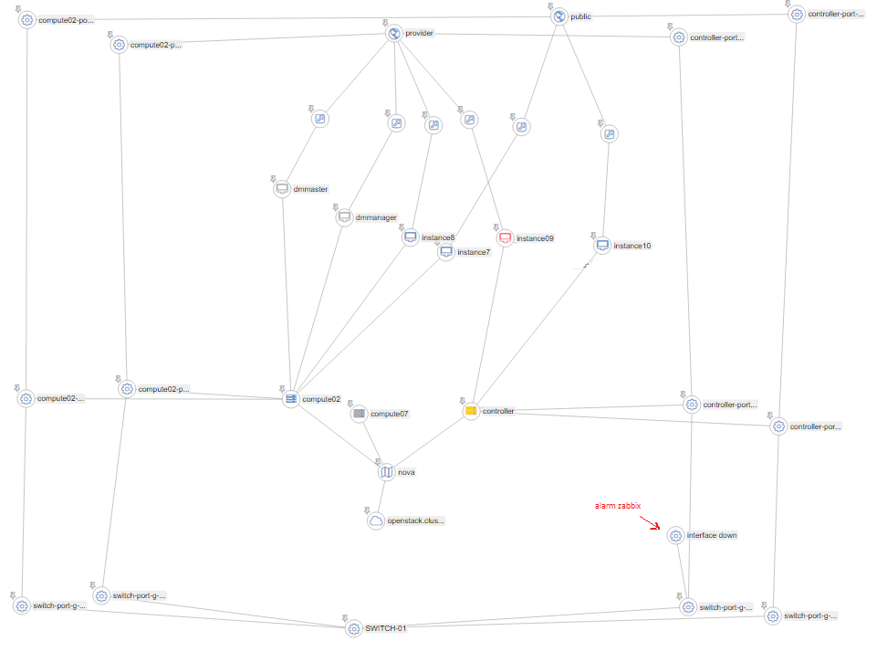

* Cluster có 2 host , tên “controller” và “compute02” đều cài nova-compute
* Cluster có 2 provider network: “provider” và “public”, mỗi network nối với một port ovs, port ovs nối với 1 port vật lý trên host. Port vật lý này nối vào 1 port của switch vật lý
* Alarm xuất hiện trên port của switch nối với host “controller”, port này cung cấp đường ra ngoài cho mạng “provider”
* Kết quả cần có:
  + Raise alarm , set-state trên instance ảnh hưởng, ở đây là instance09
  + Root cause các alarm được raise ở trên, cùng với alarm trên instance nếu có

### III. Cấu hình chuẩn bị:

#### 1. Cấu hình graph

*mục đích bước này là để tạo ra được graph thể hiện được yêu cầu của use case*

Mô hình liên quan tới một số thành phần vật lý : port host, port switch, switch.

Cần add static datasource như sau:

* Thêm file /etc/vitrage/static_datasources/port_host-controller.yaml mô tả port vật lý, port ovs của host controller:

|  |
| --- |
| metadata:  name: port of controller  description: network of controller host  definitions:  entities:  - static_id: br-provider  type: port_ovs  id: controller-port-br-provider  name: controller-port-br-provider  state: available  - static_id: br-public  type: port_ovs  id: controller-port-br-public  name: controller-port-br-public  state: available  - static_id: enp4s0f0  type: port_host  id: controller-port-enp4s0f0  name: controller-port-enp4s0f0  state: available  - static_id: enp130s0f1  type: port_host  id: controller-port-enp130s0f1  name: controller-port-enp130s0f1  state: available  - static_id: h1  type: nova.host  id: controller  # state: available  - static_id: provider-network  type: neutron.network  id: 2b0756c1-b74a-4d1f-835c-cc2f66a0bdd3  # state: active  - static_id: public-network  type: neutron.network  id: 14435664-baec-43ec-93e8-ac30ab916ee7  relationships:  - source: enp4s0f0  target: h1  relationship_type: attached  - source: enp130s0f1  target: h1  relationship_type: attached  - source: enp4s0f0  target: br-provider  relationship_type: connect  - source: enp130s0f1  target: br-public  relationship_type: connect  - source: br-provider  target: provider-network  relationship_type: attached  - source: br-public  target: public-network  relationship_type: attached |

* Thêm file /etc/vitrage/static_datasources/port_host-compute02.yamlmô tả port vật lý, port ovs của host compute02:

|  |
| --- |
| metadata:  name: port of compute02  description: port of compute02  definitions:  entities:  - static_id: br-provider  type: port_ovs  id: compute02-port-br-provider  name: compute02-port-br-provider  state: available  - static_id: br-public  type: port_ovs  id: compute02-port-br-public  name: compute02-port-br-public  state: available  - static_id: enp4s0f0  type: port_host  id: compute02-port-enp4s0f0  name: compute02-port-enp4s0f0  state: available  - static_id: enp130s0f1  type: port_host  id: compute02-port-enp130s0f1  name: compute02-port-enp130s0f1  state: available  - static_id: h1  type: nova.host  id: compute02  # state: AVAILABLE  - static_id: provider-network  type: neutron.network  id: 2b0756c1-b74a-4d1f-835c-cc2f66a0bdd3  state: active  - static_id: public-network  type: neutron.network  id: 14435664-baec-43ec-93e8-ac30ab916ee7  state: active  relationships:  - source: enp4s0f0  target: h1  relationship_type: attached  - source: enp130s0f1  target: h1  relationship_type: attached  - source: enp4s0f0  target: br-provider  relationship_type: connect  - source: enp130s0f1  target: br-public  relationship_type: connect  - source: br-public  target: public-network  relationship_type: attached  - source: br-provider  target: provider-network  relationship_type: attached |

* Thêm file /etc/vitrage/static_datasources/port_switch-01.yaml mô tả các port của switch

|  |
| --- |
| metadata:  name: port of switch  description: list port of switch  definitions:  entities:  - static_id: switch  type: switch  id: SWITCH-01  name: SWITCH-01  state: available  - static_id: g-1-0-22  type: port_switch  id: switch-port-g-1-0-22  name: switch-port-g-1-0-22  state: available  - static_id: g-1-0-20  type: port_switch  id: switch-port-g-1-0-20  name: switch-port-g-1-0-20  state: available  - static_id: g-1-0-21  type: port_switch  id: switch-port-g-1-0-21  name: switch-port-g-1-0-21  state: available  - static_id: g-1-0-23  type: port_switch  id: switch-port-g-1-0-23  name: switch-port-g-1-0-23  state: available  relationships:  - source: g-1-0-23  target: switch  relationship_type: attached  - source: g-1-0-22  target: switch  relationship_type: attached  - source: g-1-0-20  target: switch  relationship_type: attached  - source: g-1-0-21  target: switch  relationship_type: attached |

* Thêm file /etc/vitrage/static_datasources/connect_port.yaml mô tả kết nối port vật lý của host và switch:

|  |
| --- |
| metadata:  name: port of switch connect port of host  description: list port of switch  definitions:  entities:  - static_id: g-1-0-22  type: port_switch  id: switch-port-g-1-0-22  state: available  - static_id: g-1-0-20  type: port_switch  id: switch-port-g-1-0-20  state: available  - static_id: g-1-0-21  type: port_switch  id: switch-port-g-1-0-21  state: available  - static_id: g-1-0-23  type: port_switch  id: switch-port-g-1-0-23  state: available  - static_id: compute02-port-enp4s0f0  type: port_host  id: compute02-port-enp4s0f0  state: available  - static_id: compute02-port-enp130s0f1  type: port_host  id: compute02-port-enp130s0f1  state: available  - static_id: controller-port-enp4s0f0  type: port_host  id: controller-port-enp4s0f0  state: available  - static_id: controller-port-enp130s0f1  type: port_host  id: controller-port-enp130s0f1  state: available  relationships:  - source: g-1-0-22  target: compute02-port-enp4s0f0  relationship_type: connect  - source: g-1-0-23  target: compute02-port-enp130s0f1  relationship_type: connect  - source: g-1-0-20  target: controller-port-enp4s0f0  relationship_type: connect  - source: g-1-0-21  target: controller-port-enp130s0f1  relationship_type: connect |

#### 2. Cấu hình monitor

*mục đích bước này là lấy được alarm đầu vào cho vitarge*

1. chuẩn bị zabbix monitor port_switch:

* Cài đặt zabbix server trên host “controller”

<https://www.digitalocean.com/community/tutorials/how-to-install-and-configure-zabbix-to-securely-monitor-remote-servers-on-ubuntu-16-04>

* Ứng với mỗi port của switch, thêm 1 zabbix-host: Configuration > host > create host:

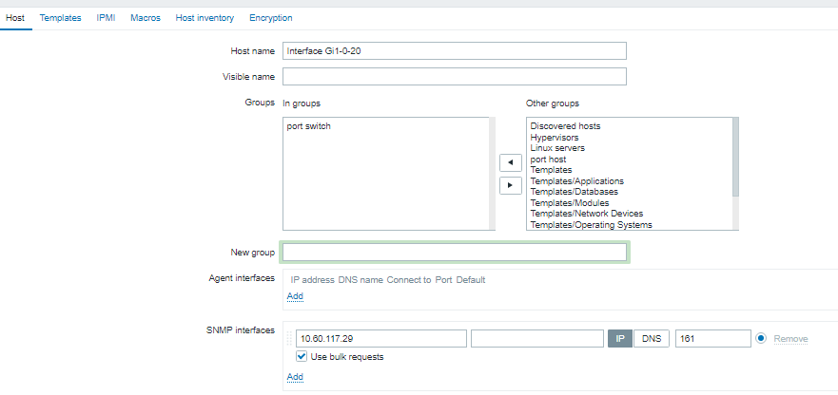

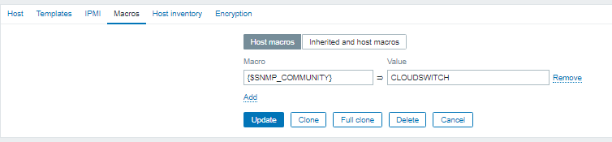

* Với mỗi host, tạo item và trigger để kiểm tra port switch có bị down:

tạo item: configuration > host > {tên zabbix-host} > item > create>item

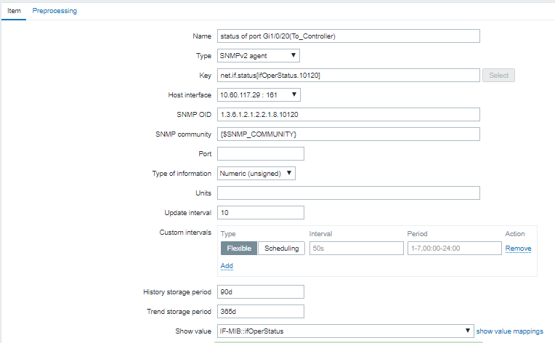

tạo trigger alarm nếu port down:

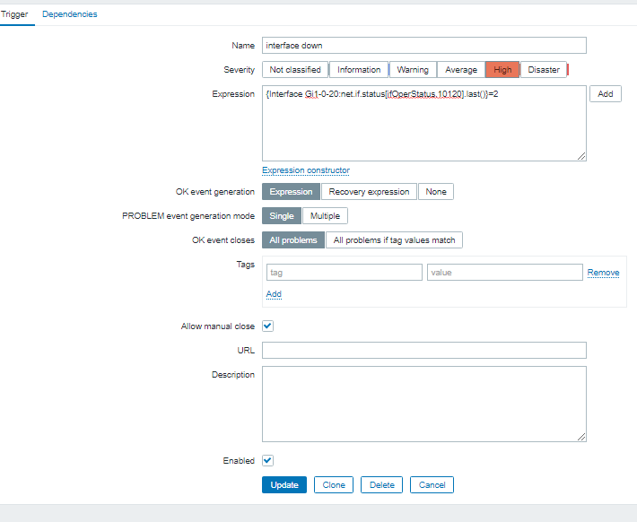

* Mapping alarm của zabbix lấy về vào entity node của graph:

Trên controller host, thêm file cấu hình /etc/vitrage/zabbix_conf.yaml nội dung:

|  |
| --- |
| zabbix:  - zabbix_host: controller port enp4s0f0  type: port_host  name: controller-port-enp4s0f0  - zabbix_host: controller port enp130s0f1  type: port_host  name: controller-port-enp130s0f1  - zabbix_host: compute02 port enp4s0f0  type: port_host  name: compute02-port-enp4s0f0  - zabbix_host: compute02 port enp130s0f1  type: port_host  name: compute02-port-enp130s0f1  - zabbix_host: Interface Gi1-0-21  type: port_switch  name: switch-port-g-1-0-21  - zabbix_host: Interface Gi1-0-20  type: port_switch  name: switch-port-g-1-0-20  - zabbix_host: Interface Gi1-0-22  type: port_switch  name: switch-port-g-1-0-22 |

### IV. Thêm template cho use-case.

#### Template để cho deduce alarm+ set-state của use-case này:

|  |
| --- |
| metadata:  name: port switch down template  description: for port switch down set state of switch warning and raise alarm of host connect port and instance of that host  definitions:  entities:  - entity:  category: ALARM  type: zabbix  rawtext: interface down  template_id: alarm  - entity:  category: RESOURCE  type: port_switch  template_id: port_switch  - entity:  category: RESOURCE  type: nova.host  template_id: host  - entity:  category: RESOURCE  type: port_host  template_id: port_host  - entity:  category: RESOURCE  type: port_ovs  template_id: port_ovs  - entity:  category: RESOURCE  type: nova.instance  template_id: instance  - entity:  category: RESOURCE  type: neutron.network  template_id: network  - entity:  category: RESOURCE  type: neutron.port  template_id: port_neutron  relationships:  - relationship:  source: alarm  target: port_switch  relationship_type: on  template_id : alarm_on_port_switch  - relationship:  source: port_switch  target: port_host  relationship_type: connect  template_id : port_switch_connect_port_host  - relationship:  source: port_host  target: host  relationship_type: attached  template_id : port_host_attached_host  - relationship:  source: host  target: instance  relationship_type: contains  template_id : host_contains_instance  - relationship:  source: port_host  target: port_ovs  relationship_type: connect  template_id : port_host_connect_port_ovs  - relationship:  source: port_ovs  target: network  relationship_type: attached  template_id : port_ovs_attached_network  - relationship:  source: network  target: port_neutron  relationship_type: contains  template_id : network_contains_port_neutron  - relationship:  source: port_neutron  target: instance  relationship_type: attached  template_id : port_neutron_attached_instance  scenarios:  - scenario:  condition: alarm_on_port_switch and port_switch_connect_port_host and port_host_attached_host  actions:  - action:  action_type: raise_alarm  properties:  alarm_name: host_connect_problem  severity: WARNING  action_target:  target: host  - action:  action_type: set_state  properties:  state: SUBOPTIMAL  action_target:  target: host  - scenario:  condition: alarm_on_port_switch and port_switch_connect_port_host and port_host_connect_port_ovs and port_ovs_attached_network and network_contains_port_neutron and port_neutron_attached_instance and port_host_attached_host and host_contains_instance  actions:  - action:  action_type: raise_alarm  properties:  alarm_name: instance_connect_problem  severity: CRITICAL  action_target:  target: instance  - action:  action_type: set_state  properties:  state: ERROR  action_target:  target: instance |

**Kết quả**

sau khi thêm deduce template:

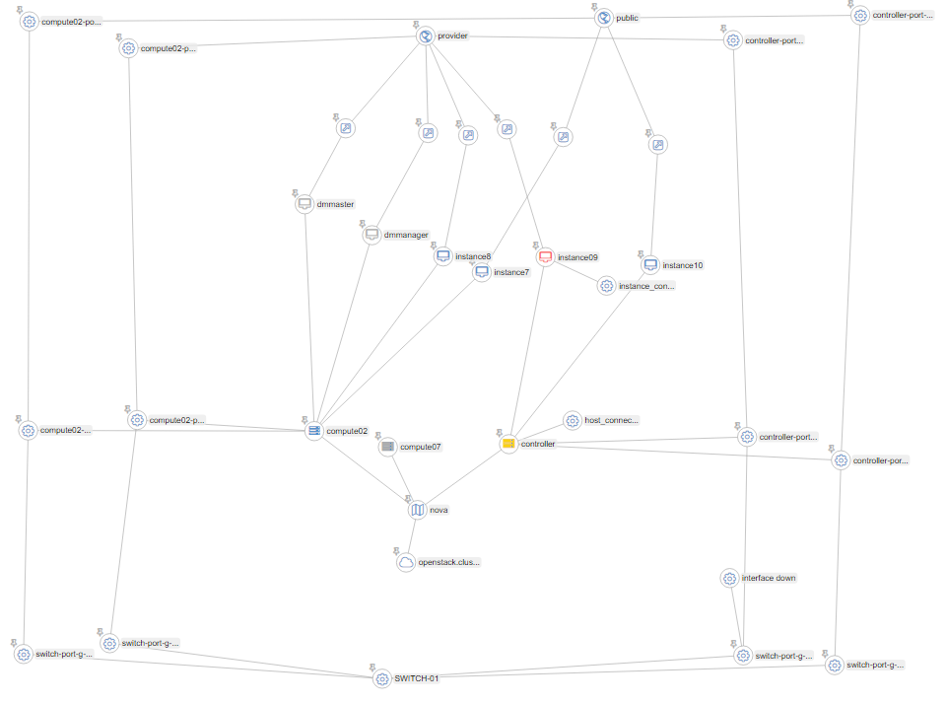

**Phân tích:**

Ta có instance bị ảnh hưởng bởi một port switch down với 2 điều kiện:

* (1) instance thuộc vào host có port bị ảnh hưởng bởi port switch down
* (2) instance nối với neutron network bị ảnh hưởng bởi port switch down.

( port switch down => port host ens4s0p0 disconnect => port ovs br-provider disconnect => network provider error)

Vậy có instance trên đồ thị sẽ là node giao của 2 subgraph như sau:

* điều kiện (1):

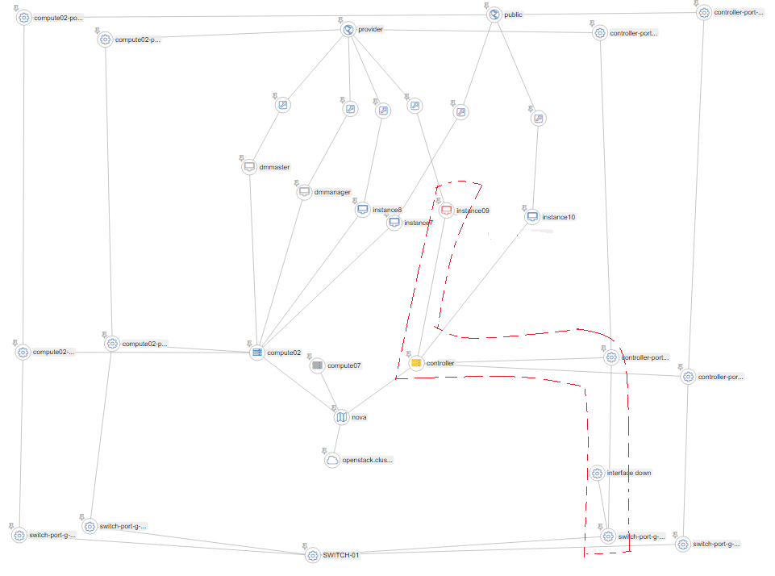

Trong template, condition để mô tả subgraph này:

alarm_on_port_switch **and**

port_switch_connect_port_host **and**

port_host_attached_host **and**

host_contains_instance

* điều kiện 2:

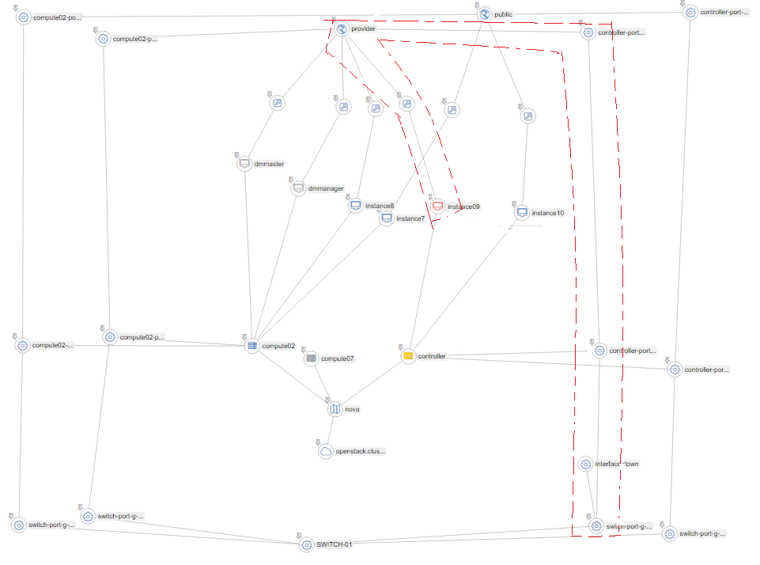

Trong template, condition để mô tả subgraph này:

alarm_on_port_switch **and**

port_switch_connect_port_host **and**

port_host_connect_port_ovs **and**

port_ovs_attached_network **and**

network_contains_port_neutron **and**

port_neutron_attached_instance

Kết hợp and 2 condition mô tả 2 subgraph trên, ta mới có thể lấy được đúng instance bị ảnh hưởng.

#### Template cho thực hiện Root-cause:

Cần thêm vào 2 template:

rca1.yaml : thêm quan hệ caused với alarm trên instance và alarm trên host

|  |
| --- |
| metadata:  name: rca of connect_problem on instance causeby connect_problem on host  description: rca of connect_problem  definitions:  entities:  - entity:  category: ALARM  name: host_connect_problem  template_id: host_alarm  - entity:  category: ALARM  name: instance_connect_problem  template_id: instance_alarm  - entity:  category: RESOURCE  type: nova.host  template_id: host  - entity:  category: RESOURCE  type: nova.instance  template_id: instance  relationships:  - relationship:  source: host_alarm  target: host  relationship_type: on  template_id : alarm_on_host  - relationship:  source: instance_alarm  target: instance  relationship_type: on  template_id : alarm_on_instance  - relationship:  source: host  target: instance  relationship_type: contains  template_id : host_contains_instance  scenarios:  - scenario:  condition: alarm_on_host and alarm_on_instance and host_contains_instance  actions:  - action:  action_type: add_causal_relationship  action_target:  source: host_alarm  target: instance_alarm |

rca2.yaml: thêm quan hệ caused với alarm trên host và alarm trên switch

|  |
| --- |
| metadata:  name: rca of connect_problem on host  description: rca of connect_problem on host  definitions:  entities:  - entity:  category: ALARM  name: host_connect_problem  template_id: alarm_host  - entity:  category: ALARM  type: zabbix  name: interface down  template_id: alarm_port_switch  - entity:  category: RESOURCE  type: port_switch  template_id: port_switch  - entity:  category: RESOURCE  type: nova.host  template_id: host  - entity:  category: RESOURCE  type: port_host  template_id: port_host  relationships:  - relationship:  source: alarm_host  target: host  relationship_type: on  template_id : alarm_on_host  - relationship:  source: alarm_port_switch  target: port_switch  relationship_type: on  template_id : alarm_on_port_switch  - relationship:  source: port_host  target: host  relationship_type: attached  template_id : port_attached_host  - relationship:  source: port_switch  target: port_host  relationship_type: connect  template_id : port_switch_connect_port_host  scenarios:  - scenario:  condition: alarm_on_host and alarm_on_port_switch and port_switch_connect_port_host and port_attached_host  actions:  - action:  action_type: add_causal_relationship  action_target:  source: alarm_port_switch  target: alarm_host |

Kết quả sau khi thên rca template:

