Cloud Instruments

CI-UP
Cloud Instruments Unified Protocol

Deployment and description

VERSIONS

Version | Date | Author | Description
001 | 2017/5/22 | M.Lucarelli | First draft
002 | 2017/5/23 | M.Lucarelli | Typo correction, JSON note
003 | 2017/6/21 | M.Lucarelli | TCP/IP, pipes, Maccor
004 | 2017/6/22 | M.Lucarelli | More details, protocol description, evolutionary proposal

Index
.Description 4
1 Deployment 4
2 Application generalities 5
.CI-UP protocol 6
1 Messages format 6
.COMPoNENTS 8
1 server side 8
..1.1 Arbin 8
..1.2 Maccor server DLL 8
2 client side 9
..2.1 Client DLL 10
.Evolutionary proposal 11

Description
This document describes the Cloud Instruments Unified Protocol (CI-UP). CI-UP is a unified protocol based on TCP/IP to interface battery testing instruments and hardware to user sw. The CI-UP is meant to hide to the final user software all the different protocols and mechanism required by any of the supported instruments.
The protocol is designed to support many-to-many one-to-many, many-to-one communication in any combination.
Obviuosly because the protocol is IP based, client and server application can reside on different PC as long the PC can connect each other through IP network.

Deployment
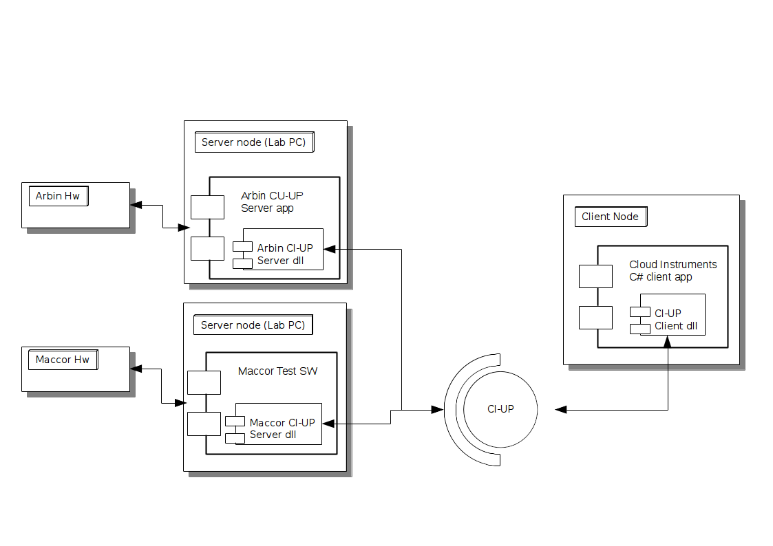
The CI-UP gives to user custom SW the ability to interface with any of the supported HW using the same procedure wich is mainly independent of the way any of the supported HW protocols implemented.
The server-side of the protocol is implemented by the ciupServer application. The client side is implemented in the ciupClientDll which will be included in client application.

Application generalities
The protocol is implemented in ‘CIUP’ Visual Studio 2015 solution.
Each of the application included is described in the included ReadMe.txt file.
Each of the included application can output on-line help if executed with the ‘-h’ flag.
Each of the application has level-filterable logging capabilities. To enable log use the ‘-l’ flag. To enable log filter use the ‘-f’ flag. Available log levels are: E=errors only, W=warnings+errors, T=trace+warnings+errors, D:all logs.
The CIUP solution includes some batch files in the ‘batch’ folder. This batch files can be used to run local tests.

CI-UP protocol
CI-UP is based on TCP/IP standard socket. CI-UP is routable so can be used to connect server and client side over any network infrastructures.

Messages format
CI-UP messages format is defined in ciupCommon files.
The protocol defined packet is composed as follows:
- 4 bytes: 'C','I','U','P'
- 1 byte: MESSAGE TYPE (see #define CIUP_MSG_*)
- 2 bytes: payload size (S) in bytes (MSB-LSB)
- S bytes: payload of variable size
- 1 byte: checksum (sum of previous bytes)
- 1 byte: checksum negated =0xFF-checksum
TCP/IP packet size is fixed to 512 Bytes to avoid problems with TCP packet fragmentation.
Implemented messare types are:

Message | meaning | payload
CIUP_MSG_SERVERINFO | Ask server info command,  server info packet answer | none (for command),  ciupServerInfo struct (for answer)
CIUP_MSG_DATAPOINT | Data point packet | ciupDataPoint struct
CIUP_MSG_START | Start send command | none
CIUP_MSG_STOP | Stop send command | none
CIUP_MSG_DISCONNECT | Disconnect command | none

The server info payload is defined as a struct in ciupCommon.h:
field | type | meaning
status | enum ciupStatus | Current status of the server side
id | char[CIUP_MAX_STRING_SIZE] | Free string for server id or description
mode | ciupServerRunMode | Running mode of the server (emulator, maccor, arbin, ecc)

The datapoint payload is defined as a struct in ciupCommon.h:
field | type | meaning
counter | USHORT | counter to control messages sequence
channel | USHORT | device channel of the data
Stime | float | data time in S
Ktemp | float | temperature in K
Acurr | float | current in A
Vdiff | float | Voltage in V
AHcap | float | capacity in Ah

COMPoNENTS

server side
The main application for the server-side is ‘ciupServer’ which internally implements diferent protocol for each of the supported hardware and externally communicate with client-side with CI-UP protocol.
The ciupServer application must be executed on any client side PC phisiccaly conneted to the test hardware. Which HW is connected must be communicate to the application using command line flags:
- -0 : enable hw emulator (generate emulated random data)
- -1 : enable Maccor connection
- -2 : enable Arbin connection
The ciup server application creates a server TCP/IP socket on the port specified as argument on the command line. This socket accepts connection from any ciupClient application. Once the connection is established the ciupServer wats for START command to begin send available data to the client.
Available commands (defined in cupCommon) are:
- Start : start send data
- Stop :stop send data
- Serverinfo : send serverinfo packet data
- Disconnect : close the connection
The ciupServer bufferizes collected data in a circular buffer. The circular buffer size is define in ciupServerCommon.h (actually 100K data points). Each new connected clients will receive all available data in the circular buffer.

Arbin
Arbin HW support is not yet included in ciupServer application.

Maccor server DLL
The Maccor server DLL is used and driven by the Maccor test software. The DLL implements the communication described as “user DLL” mechanism defined by hardware supplier (“Automated test system instruction manual – 11.3.2 user DLL functions”). The tests can be run normally while the Maccor software calls the ciup DLL passing data. That’s the complete path of data:
Maccor SW → ciupServerMaccorDll → ciupServer
The connection between Maccor SW and ciupServerMaccorDll is implemented through dll calling. The entry points of the dll are defined by Maccor (“Automated test system instruction manual – 11.3.2 user DLL functions”). The most important entry point of the DLL is the GetSetpointRevA function. This function is called by Maccor test SW up to 10 times a second poassing test point data. The function writes the data to a named pipe which is read bu ciupServer.
The connection between ciupServerMaccorDll and ciupServer is implemente through named pipe. This connection is designed to support multiple channels and multiple connections, so, if supported by Maccor Sw, more than one test can be run at the same time.
Each of the instances of ciupServerMaccorDll will connect a client endpoint to the same server pipe created by ciupSever. The named pipe (“ciuppipe”) is a message-type pipe so data are send an received in blocks. Named pipe has been chosen because involves the minimum overload to the calling application (the Maccor test sw) thus creating the minimum interference with the running test. If the ciupServer pipe is not available the dll try to reconnect it each call. The ciupServerMaccorDll doesn’t have any buffering option so data generated while the ciupServer is no available are lost.

The ciupServerMaccorDll is configured by the ini file:
C:\ciupServer\ciupServerMaccorDll.ini
The files includes this fields:
enablelog | 0: disable logging , 1:enable logging
loglevel | set log verbosity 0:error, 1:warnings, 2:trace, 3:debug
disablepipe | disable ciupServer communication (for debug use)
An example of the .ini file is included in the ‘ini’ folder of CIUP Visual Studio solution.
If enabled logs are generated in C:\ciupServer\log-ciupServerMaccorDll\

client side
The client side can be implemented in any language as long as the client DLL can be loaded. All the TCP connection and the protocl details are hidden to the user application inside the ciupClientDll.

Client DLL
The client DLL need to be included in any custom software. The client DLL interfaces to the server side using CI-UP protocol. From the client SW perspective, the client DLL gives the ability to interface with any of the supported hardware in the same way. The connection with one of the server sides mainly requires Ipaddr and port knowledge.
The clientDll implements reconnection capability. Data are bufferized in server side to complain short connection problems.

Entry points:
- ciupConnect: start a new connetcion with server side app
- cuipDisconnect: close connection
- ciupStart: start receiving data from the connection
- ciupStop: stop receiving data form the connection
- ciupInfo: get connection (server side) informations

The data are sent to the client application through two callback functions:
- ciupDataCb: callback for incoming data. Will be called every message received. NOTE: this function can pontentially be called thousand times every second, so must not be a time consuming function
- ciupErrorCB: called to communicate error messages

DataCb get points in JSON serialized format (string). Data can be parsed and deserialized in an object using standard way by any language using DLL functions.

Evolutionary proposal

- CI-UP is designed to be a real-time protocol. This real-time nature is actually mitigated by the bufferization capabilities of ciupServer. The Real-time nature could be eventually relaxed bufferizing data between hw and ciupServer (disk buffer) and, on the clientSide, between cuipClientDll and client application. The latter could permit to implement a request-based feed for data. In this case data could be passed to the user application in size-definable cluster instead of the actual real-time callback which handles only single datapoints and requires fast callback implementation.
- Actually the server side sent all available data to all connected cliens. A protocol level filter could be implemented to avoid application-level filter and to enlight network load. This filter could, for example, pass to a specific client only data coming form a defined channel.
- Actually CI-UP protocol does not implements any feddback command from the client to the HW. This kind of commands could be used to override running test behaviour for example to stop or suspend a procedure. This evolution could lead to a client-only driven test procedure (a test driven exclusively by the client side application without the intervention of server side software of the hw producer)
- The emulator mode of ciupServer application generates random data. A possibile evolution could add the capability to load real data store on file.
- All the application are windows-only. A future evolution could extends the support to multiple platforms.

document’s end

