Cloud Native  
Days Austria

:Style Guide

# Logos

The logo consists of an abstract Ferris wheel inspired by the Vienna Giant Ferris Wheel. The Ferris wheel is made up of 7 parts, referencing the Kubernetes logo. The logo is enclosed by a cloud, and beneath the Ferris wheel, the text "CNDA" is displayed. The "A" from CNDA is integrated into the design, serving as the pillar of the Ferris wheel.

There are 6 logo variations that meet all requirements for web and print, including versions with a colorful, black, or white Ferris wheel, a white or black cloud, as well as transparent, white, and black backgrounds. The logo has a 31:22 aspect

## Colorful Ferris wheel with black cloud and transparent background (31:22)

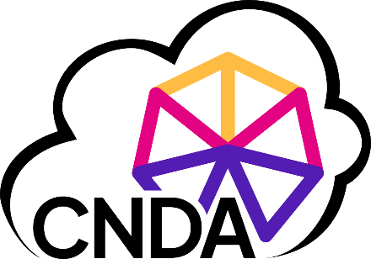

## Colorful Ferris wheel with black cloud and white background (31:22)

## Colorful Ferris wheel with white cloud and black background (31:22)

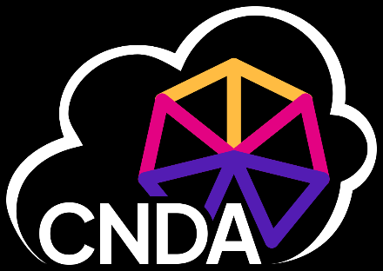

## Black Ferris wheel with black cloud and transparent background (31:22)

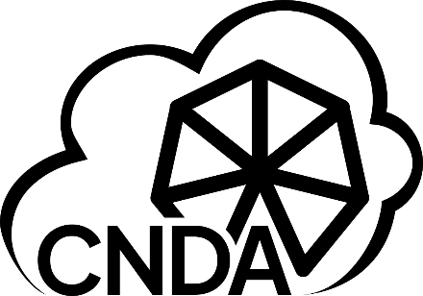

## Black Ferris wheel with black cloud and white background (31:22)

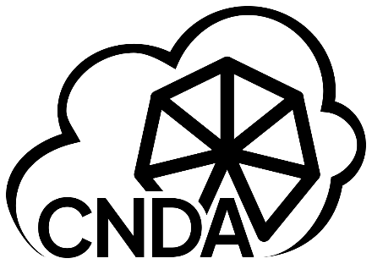

## White Ferris wheel with white cloud and black background (30:21)

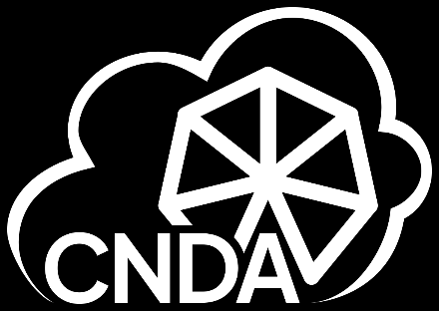

# Icons

In addition to the logo, there are round and square icons designed for use in spaces where the full logo does not fit. The icons feature the Ferris wheel (colorful, white, or black) along with the "A" from CNDA, which also serves as the pillar of the Ferris wheel. Each icon has a square or round background in white or black and always maintains a 1:1 aspect ratio.

## Colorful Ferris wheel with black A and square white background

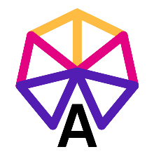

## Colorful Ferris wheel with white A and square black background

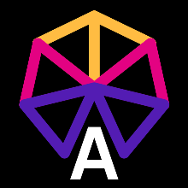

## Black Ferris wheel with black A and square white background

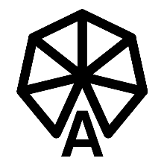

## White Ferris wheel with white A and square black background

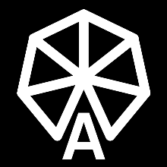

## Colorful Ferris wheel with black A and round white background

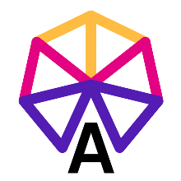

## Colorful Ferris wheel with white A and round black background

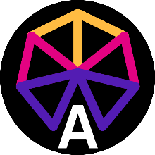

## Black Ferris wheel with black A and square round background

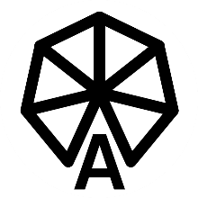

## White Ferris wheel with white A and square round background

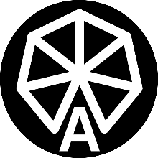

# Colors

## Primary colors

The primary colors of Cloud Native Days Austria are Blue (Chrysler Blue #531CB3), Pink (Mexican Pink #E30282), Yellow (Xanthous #FFBC42), White (#FFFFFF), and Black (#000000). These colors are used in the logo and the icons. The colorful Ferris wheel incorporates blue, pink, and yellow, while it also has variations in white or black. The text "CNDA" appears in black or white, and the cloud is also rendered in black or white. The same color variations apply to the round and square icons, ensuring consistency across all branding elements.

|  |  |
| --- | --- |
| Blue (Chrysler blue)  CMYK: C 81 / M 91 / Y 0 / K 0  RGB: R 83/ G 28 / B 179  HEX: #531CB3 | Pink (Mexican Pink)  CMYK: C 5 / M 99 / Y 9 / K 0  RGB:R 227 / G 2 / B 130  HEX: #E30282 |
| Yellow (Xanthous)  CMYK: C 0 / M 29 / Y 84 / K 0  RGB: R 255 / G 188 / B 66  HEX: #FFBC42 | White  CMYK: C 0 / M 0 / Y 0 / K 0  RGB: R 255 / G 255 / B 255  HEX: #FFFFFF |
| Black  CMYK: C 75/ M 58 / Y 67 / K 90  RGB: R 0 / G 0 / B 0  HEX: #000000 |  |

## Secondary Colors

Two secondary colors are used for accents: Blue (Azure #0086FF) and Light Grey (#F2F2F2). These colors are exclusively used on the website and should not be applied to the logo or icons.

|  |  |
| --- | --- |
| Blue (Azure)  CMYK: C 75/ M 46 / Y 0 / K 0  RGB: R 0 / G 134 / B 255  HEX: #0086FF | Grey  CMYK: C 4 / M 3 / Y 3 / K 0  RGB: R 242 / G 242 / B 242  HEX: #F2F2F2 |

# Fonts

Cloud Native Days Austria uses two fonts: Plus Jakarta Sans and Fira Code. Plus Jakarta Sans is used for all text in both online and print materials, as well as for the "CNDA" text in the logo and the "A" in the icon. Additionally, if "Cloud Native Days Austria" is used as a document title, it should always be set in Plus Jakarta Sans. Fira Code is a monospace font and should be used for headings and accents.

## Plus Jakarta Sans

Plus Jarkata Sans (<https://fonts.google.com/specimen/Plus+Jakarta+Sans>) is used for text (online and print) and for the logo.

|  |  |
| --- | --- |
| Aa | Plus Jarkata Sans |
| abcdefghijklmnopqrstuvqxyz  ABCDEFGHIJKLMNOPQRSTUVWXYZ  The quick brown fox jumps over the lazy dog.  1234567890 Áá Ää Öö Üü ß Çç Ññ Øø Ææ Åå Éé Èè Êê Îî Ôô Œœ !@#$%^&*()_+-=[]{}|;:'",.<>?/`~ π ∞ ∑ √ ∂ ∆ ∫ ≈ ≠ ≤ ≥ ± ÷ × µ Ω λ θ β α γ δ ψ ω ξ |

## Fira Code

Fira Code (<https://fonts.google.com/specimen/Fira+Code> ) is used for headings and accents

|  |  |
| --- | --- |
| Aa | Fira Code |
| abcdefghijklmnopqrstuvqxyz  ABCDEFGHIJKLMNOPQRSTUVWXYZ  The quick brown fox jumps over the lazy dog.  1234567890 Áá Ää Öö Üü ß Çç Ññ Øø Ææ Åå Éé Èè Êê Îî Ôô Œœ !@#$%^&* ()-=[]{}|;:'",.<>?/`~ π ∞ ∑ √ ∂ ∆ ∫ ≈ ≠ ≤ ≥ ± ÷ × µ Ω λ θ β α γ δ ψ ω ξ |

# Photos

## Mask for Portraits

All portraits use a mask in the shape of the Ferris wheel from the logo, ensuring a consistent and recognizable visual style across all materials.

 