Setting up Python Environment variables

1. **Find your Python folder path in windows**

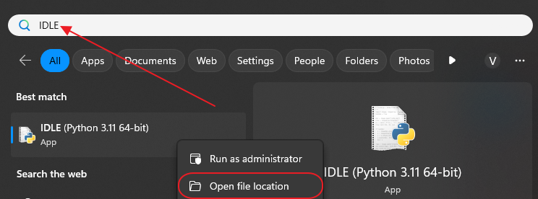

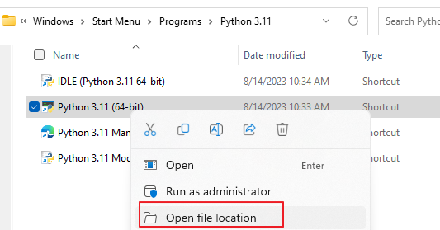

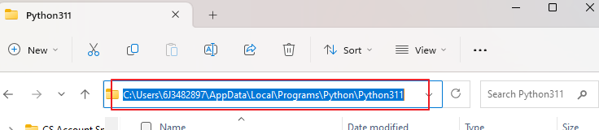

1. **Make sure Python is added to PATH.**

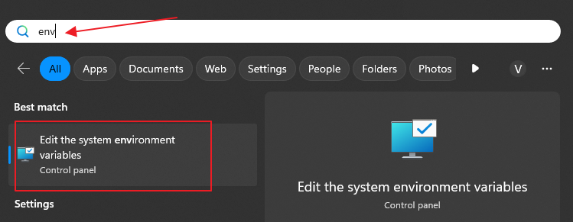

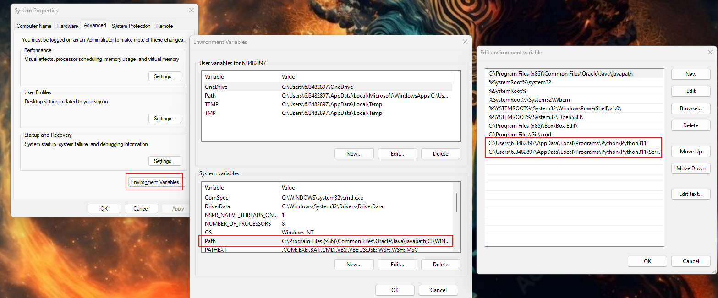

1. **install Microsoft C++ Build Tools**
2. Go to this page: <https://visualstudio.microsoft.com/visual-cpp-build-tools/>
3. Click on "Download Build Tools" and run what you downloaded
4. Click on "Install" (a window with different options to click should show up)
5. Click only on "Desktop Development with C++" and click on install (image for reference)
6. 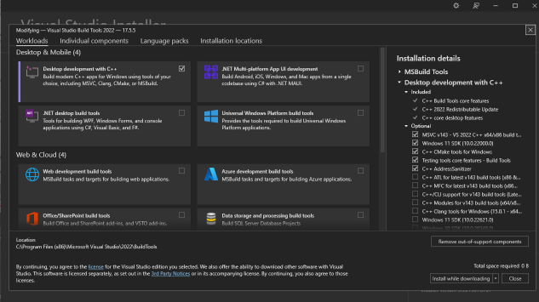
7. Reboot your system

**If you have already installed Microsoft C++ Build Tools before, it needs to be modified**

Search for build tools

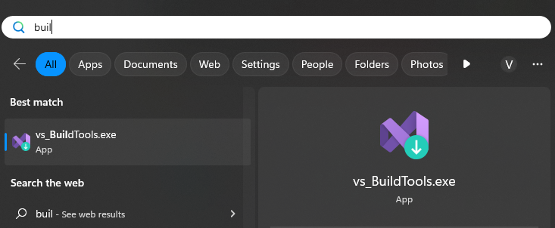

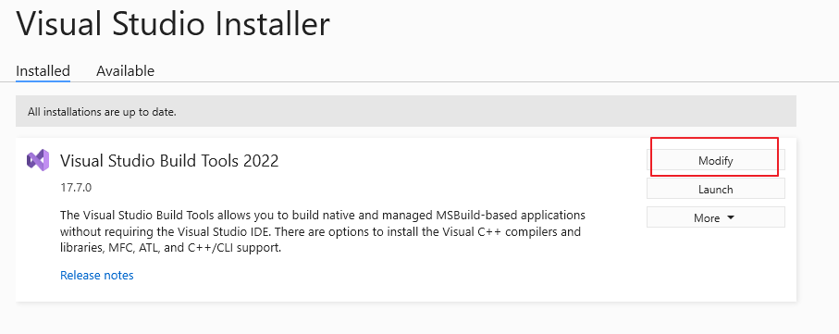

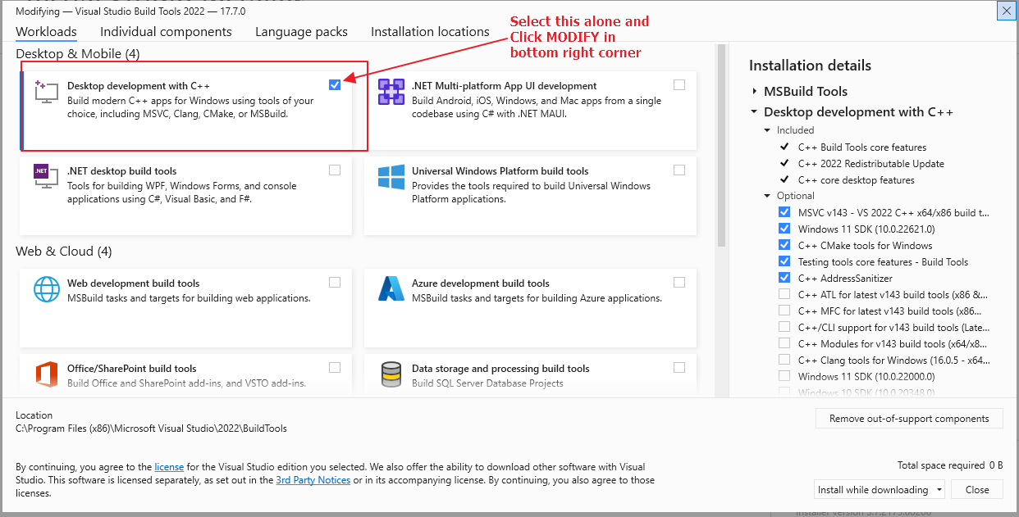

1. **Python Virtual Environment**

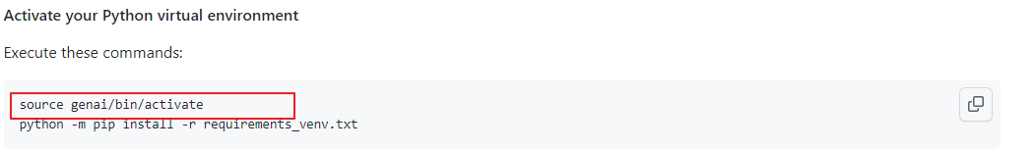

**Source doesn’t work in windows. Use this:** 

1. **Change requirements_venv.txt**

