PERSONALIZED LEARNING
RECOMMENDATION SYSTEM
A MACHINE LEARNING PROJECT REPORT
SUBMITTED BY
Roll Number | Registration Number | Student Code | Student Name
24103460084 | 24103002865 | BWU/BCA/24/088 | MEGHA PAL

Of in partial fulfillment for the award of the degree
BACHELOR OF COMPUTER APPLICATION
IN
DEPARTMENT OF COMPUTATIONAL SCIENCE

BRAINWARE UNIVERSITY
398, Ramkrishnapur Road, Barasat, North 24 Parganas, Kolkata - 700 125

ABSTRACT
The Personalized Learning Recommendation System is a Python-based machine learning project designed to recommend suitable learning resources according to an individual student's academic profile and learning preferences. The system uses information such as previous score, study hours, subject interest, learning preference, completed topics, weak topic, and difficulty level.
The recommendation process combines text-based similarity with rule-based scoring. Student and resource descriptions are converted into numerical vectors using CountVectorizer. Cosine similarity is then used to measure the similarity between the student profile and each learning resource. Additional score bonuses are applied for suitable difficulty, matching weak topics, preferred learning style, and study duration. Topics already marked as completed are removed before the final ranking.
The submitted datasets contain 100 student records and 60 learning-resource records. The system returns the top three resources for a selected student, displays the recommendations in the console and as a graph with a details table, and saves the results as a CSV file. Evaluation using the supplied evaluation logic produced a weak-topic match of 97.00%, completed-topic avoidance of 100.00%, suitable difficulty of 83.67%, and average recommendation score of 85.48%.
The project demonstrates how content-based similarity and transparent rule-based adjustments can be combined to create a simple personalized learning recommendation workflow.

INDEX
Chapter | Title | Page Number
1 | INTRODUCTION | 5
2 | LITERATURE SURVEY | 6
3 | SYSTEM ANALYSIS AND DESIGN | 7
4 | IMPLEMENTATION | 12
5 | OUTPUT SCREENSHOTS | 14
6 | SOURCE CODE | 16
7 | TESTING AND DEBUGGING | 30
8 | CONCLUSION AND FUTURE ENHANCEMENT | 31
9 | REFERENCES | 32

LIST OF FIGURES
- Fig. 3.1 – System architecture and data flow
- Fig. 3.2 – Student interest distribution
- Fig. 3.3 – Learning preference distribution
- Fig. 3.4 – Student difficulty levels
- Fig. 3.5 – Weak topic distribution
- Fig. 4.1 – Recommendation evaluation results

LIST OF TABLES
- Table 3.1 – Student dataset fields
- Table 3.2 – Resource dataset fields
- Table 4.1 – Recommendation scoring components
- Table 7.1 – Test cases

LIST OF SCREENSHOTS
- Student ID input and profile
- Personalized recommendations in console
- Recommendation graph and details table
- Saved recommendation CSV output

1. INTRODUCTION

1.1 Background
Students have different academic strengths, learning preferences, study schedules, and levels of understanding. A single learning resource or fixed learning path may not be equally useful for every student. A personalized recommendation approach can help identify resources that are more relevant to a student's current learning needs.
The Personalized Learning Recommendation System uses a student dataset and a learning-resource dataset to generate recommendations. Each student record describes academic performance and preferences, while each resource record describes its subject, topic, format, difficulty, learning style, and duration.

1.2 Problem Statement
Students may find it difficult to select learning materials that match their weak topics, current ability, preferred learning style, and available study time. The project addresses this problem by ranking learning resources against a student's profile and filtering out topics that the student has already completed.

1.3 Objectives
- To represent student learning profiles using academic and preference-related attributes.
- To maintain a structured dataset of learning resources.
- To convert profile and resource text into numerical vectors.
- To calculate similarity between a student profile and available resources.
- To adjust recommendation scores using difficulty, weak-topic, learning-style, and duration rules.
- To avoid recommending resources whose topics are already listed as completed.
- To display the top three recommendations and save them in CSV format.
- To evaluate the recommendation output using the supplied evaluation metrics.

1.4 Scope
The current implementation is a command-line Python application. It reads CSV datasets, accepts a student ID, displays the selected student's profile, generates up to three recommendations, plots a bar chart and details table, and stores the recommendations in an output CSV file. It does not include a web interface, online learning-platform integration, or a trained predictive model.

1.5 Organisation of the Report
This report presents the project background, related concepts, system analysis and design, implementation details, output placeholders, selected source code, testing approach, evaluation results, conclusion, and future enhancement opportunities.

2. LITERATURE SURVEY

2.1 Recommendation Systems
A recommendation system filters or ranks available items according to a user's interests or profile. Common approaches include collaborative filtering, content-based filtering, and hybrid recommendation. The submitted project follows a content-based approach because it compares attributes from the student's profile with attributes describing each learning resource.

2.2 Content-Based Recommendation
Content-based recommendation represents a user profile and candidate items using descriptive features. Items with more similar descriptions receive higher relevance. In this project, the student's interest, weak topic, learning preference, and difficulty level are combined into one text description. Each resource is represented using its subject, topic, resource type, learning style, and difficulty level.

2.3 Text Vectorization
CountVectorizer from Scikit-learn converts text into a document-term matrix. Each column represents a token found in the text collection, and the vector values represent token counts. This allows text descriptions to be compared using numerical methods.

2.4 Cosine Similarity
Cosine similarity measures the cosine of the angle between two non-zero vectors. It is commonly used to compare text vectors. A higher similarity value indicates greater overlap in the represented terms. The project calculates similarity between the student profile vector and every resource vector.

2.5 Rule-Based Personalization
The system supplements text similarity with simple rules. It adds bonuses when a resource matches a suitable difficulty level, the student's weak topic, the preferred learning style, or the available study duration. This makes the ranking logic easier to inspect and explain.

2.6 Summary
The project combines content-based text similarity and transparent rule-based scoring. It is a small educational prototype rather than a large-scale recommendation platform. Its results depend on the quality and coverage of the supplied CSV datasets.

3. SYSTEM ANALYSIS AND DESIGN

3.1 Existing System
Without a structured recommendation process, students may choose learning materials manually by searching different sources. This can require additional time and may lead to resources that do not match their current level, weak topics, or preferred learning format.

3.2 Proposed System
The proposed system accepts a student ID, loads the corresponding profile, compares that profile with available resources, filters completed topics, ranks the remaining resources, and presents the top three results.

3.3 Functional Requirements
- Load student and resource data from CSV files.
- Display available student IDs and accept a selected ID.
- Display the selected student's profile.
- Generate similarity and rule-based scores for resources.
- Remove resources belonging to completed topics.
- Sort resources by final score and return the top three.
- Display recommendations in the console and as a Matplotlib chart.
- Save recommendations to a student-specific CSV file.
- Calculate evaluation metrics for the complete student dataset.

3.4 Non-Functional Requirements
- Usability: clear console prompts and readable recommendation output.
- Maintainability: separate Python modules for student data, recommendation logic, preprocessing, evaluation, and visualisation.
- Portability: runs in a Python environment with the required libraries installed.
- Reliability: handles missing files, missing columns, invalid student IDs, and unexpected runtime errors in the main program.
- Performance: suitable for the small CSV datasets included with the project.

3.5 Dataset Description
The supplied student dataset contains 100 rows and 8 columns. The resource dataset contains 60 rows and 8 columns. The records are stored in data/students.csv and data/resources.csv.

Table 3.1 – Student Dataset Fields
Field | Description
Student_ID | Unique identifier used to select a student.
Previous_Score | Student's previous academic score.
Study_Hours | Available study time represented in hours.
Interest | Subject area of interest.
Learning_Preference | Preferred learning format.
Completed_Topics | Comma-separated list of topics already completed.
Weak_Topic | Topic requiring additional learning support.
Difficulty_Level | Student's stated difficulty level.

Table 3.2 – Resource Dataset Fields
Field | Description
Resource_ID | Unique identifier for a learning resource.
Resource_Name | Name of the learning material.
Subject / Topic | Subject and topic covered by the resource.
Resource_Type | Format or type of resource, such as Video, Notes, or Practice.
Difficulty_Level | Difficulty category of the resource.
Learning_Style | Style supported by the resource.
Duration_Minutes | Estimated time required to use the resource.

3.6 System Architecture
The system reads the student and resource CSV files. The selected student profile is transformed into text features and compared with resource descriptions. After completed-topic filtering and score adjustments, the top three resources are displayed and saved. The separate evaluation module checks recommendation quality across the student dataset.
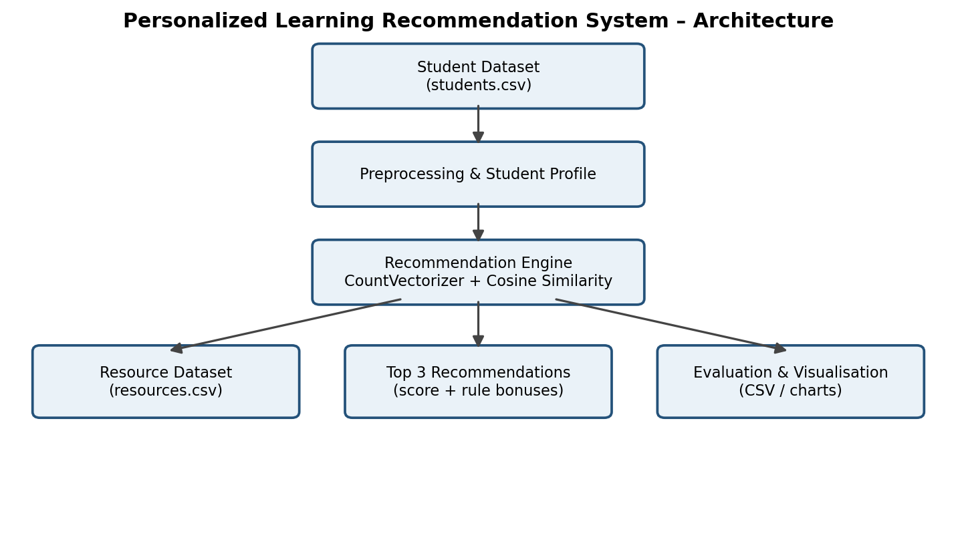
Fig. 3.1 – System architecture and data flow
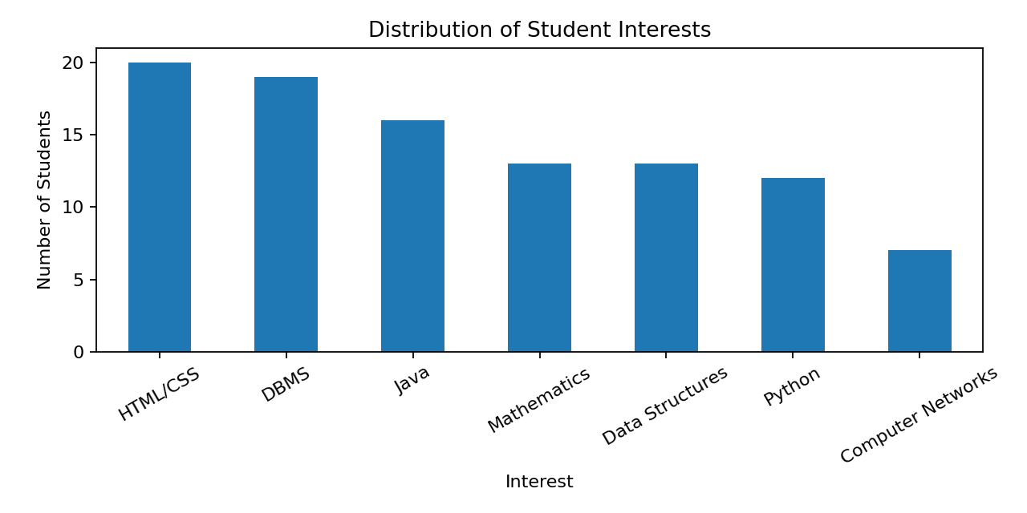
Distribution of Student Interests
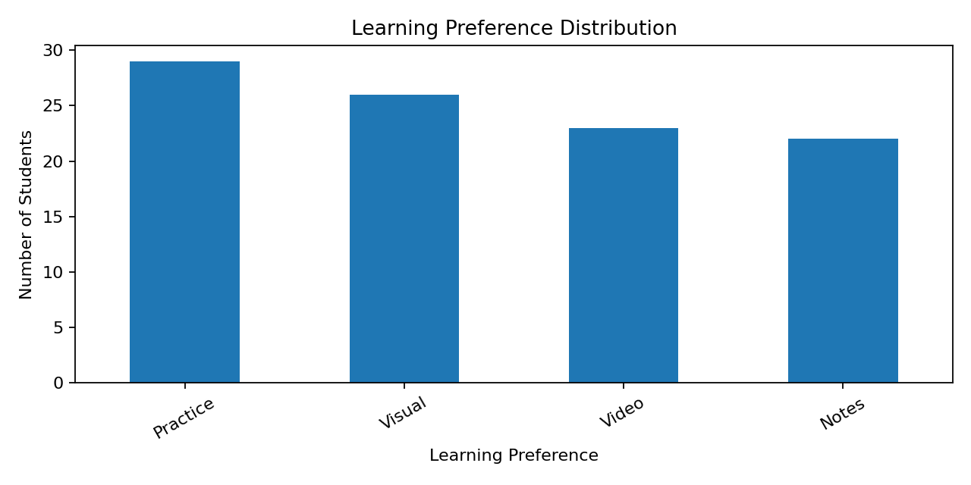
Learning Preference Distribution
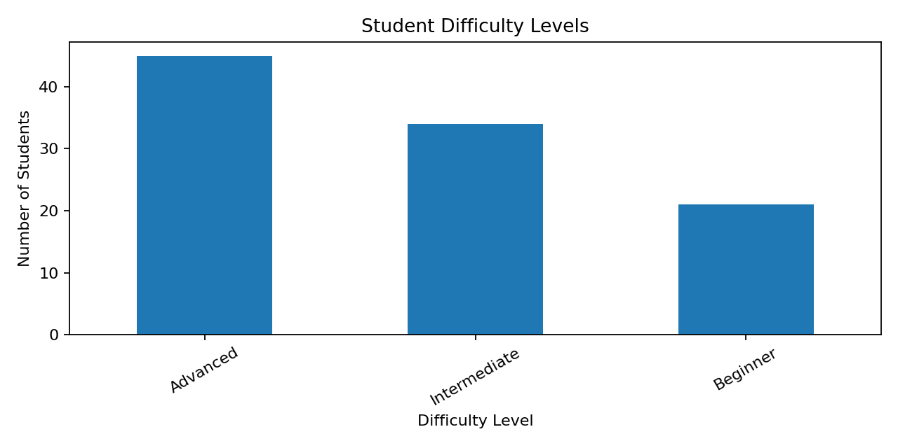
Student Difficulty Levels
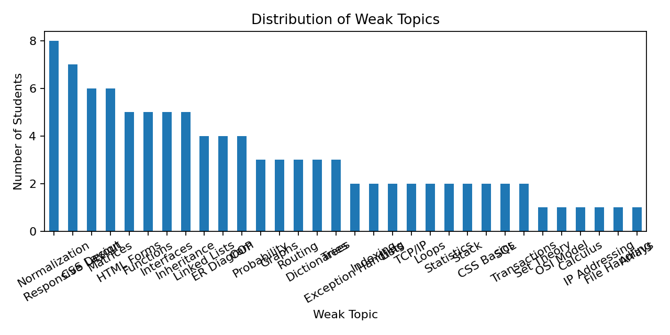
Distribution of Weak Topics

3.7 Algorithm and Scoring Design
The recommendation algorithm first creates a text description for the student and for every resource. CountVectorizer transforms the combined text list into numerical vectors. Cosine similarity is calculated between the student vector and each resource vector.
The system then removes resources whose topics appear in the student's Completed_Topics field. It calculates a difficulty bonus of 0.10, a weak-topic bonus of 0.20, a learning-preference bonus of 0.10, and a duration bonus of 0.05 when the corresponding rule is satisfied.

Table 3.3 – Recommendation Scoring Components
Component | Condition | Bonus
Difficulty bonus | Resource difficulty belongs to the score-based suitable level list. | 0.10
Weak-topic bonus | Resource topic equals the student's weak topic. | 0.20
Preference bonus | Resource learning style matches the mapped student preference. | 0.10
Duration bonus | Resource duration fits the study-time rule. | 0.05
Similarity score | Cosine similarity between student and resource text vectors. | Calculated

Final Score = Similarity Score + Difficulty Bonus + Weak-Topic Bonus + Preference Bonus + Duration Bonus.
The resources are sorted in descending order of Final_Score and the first three are returned.

4. IMPLEMENTATION

4.1 Development Environment
Component | Technology / File
Programming language | Python
Data handling | Pandas, NumPy
Machine learning utilities | Scikit-learn
Visualisation | Matplotlib
Input datasets | data/students.csv, data/resources.csv
Main execution | main.py
Recommendation logic | recommendation.py
Student profile class | student.py
Preprocessing | preprocessing.py
Exploratory analysis | eda.py
Evaluation | evaluation.py, evaluation_graph.py

4.2 Project Folder Structure
Personalized_Learning_Recommendation/
│
├── data/
│ ├── students.csv
│ └── resources.csv
│
├── output/
│ └── *_recommendations.csv
│
├── main.py
├── student.py
├── recommendation.py
├── preprocessing.py
├── eda.py
├── evaluation.py
└── evaluation_graph.py

4.3 Data Loading and Preprocessing
Pandas read_csv() loads both datasets. The preprocessing.py module checks missing values, removes duplicate rows, creates one-hot encoded versions of selected categorical columns using get_dummies(), and creates common feature tables for students and resources.
The main recommendation function currently constructs its own text features directly from the original student and resource columns. The encoded tables generated by preprocessing.py are displayed for inspection and are not passed into the recommendation function.

4.4 Recommendation Generation
The recommend_resources() function builds the student and resource text descriptions, applies CountVectorizer, calculates cosine similarity, removes completed topics, calculates the four rule-based bonuses, computes Final_Score, sorts the resources, and returns the top three.

4.5 Student Profile Handling
The Student class stores the selected student's ID, previous score, study hours, interest, learning preference, completed topics, weak topic, and difficulty level. Its display_profile() method prints these values in a structured format.

4.6 Output Generation
The main.py module displays each recommended resource with subject, topic, resource type, difficulty, and match score. It also displays a graph containing the top recommendation scores and a table containing resource details. The recommendations are saved to output/<student_id>_recommendations.csv.

4.7 Evaluation
The evaluation.py module checks whether the top recommendations include the student's weak topic, avoid completed topics, and match the difficulty levels determined from the previous score. It also calculates the mean of the final recommendation scores after limiting each score to a maximum of 1.0 for evaluation.

4.8 Evaluation Results
Evaluation Metric | Result
Weak Topic Match | 97.00%
Completed Topic Avoidance | 100.00%
Suitable Difficulty | 83.67%
Average Recommendation Score | 85.48%

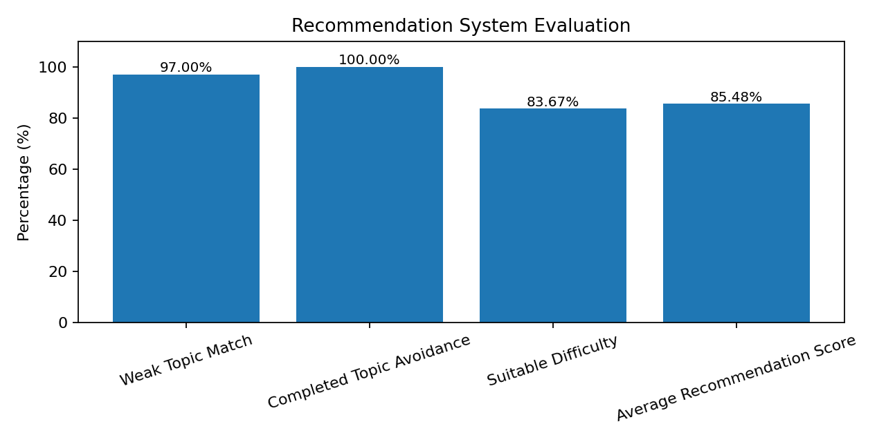
Fig. 4.1 – Recommendation system evaluation results
The reported values are produced by running the submitted recommendation and evaluation logic against the supplied CSV datasets. They describe this dataset and these rule definitions; they should not be interpreted as general predictive accuracy on unseen students.

5. OUTPUT SCREENSHOTS

5.1 – Student ID selection and student profile
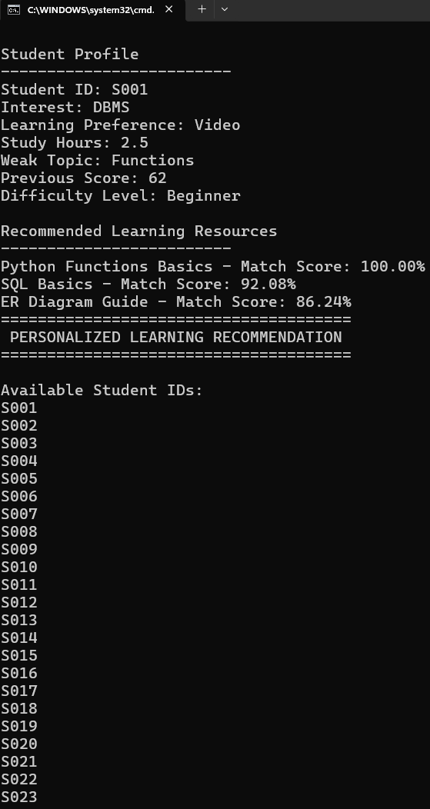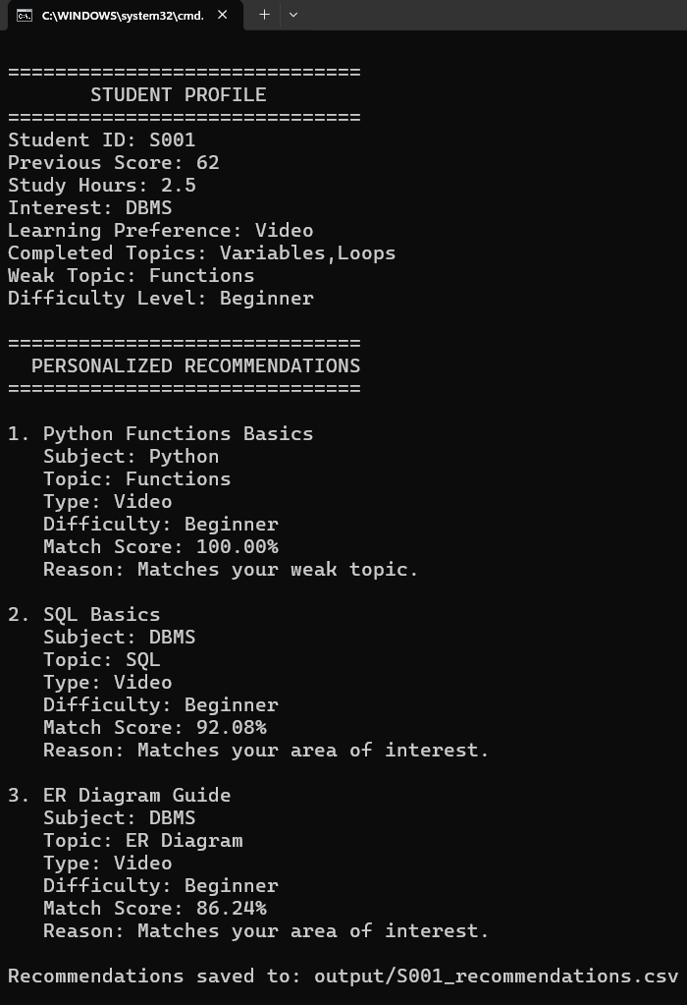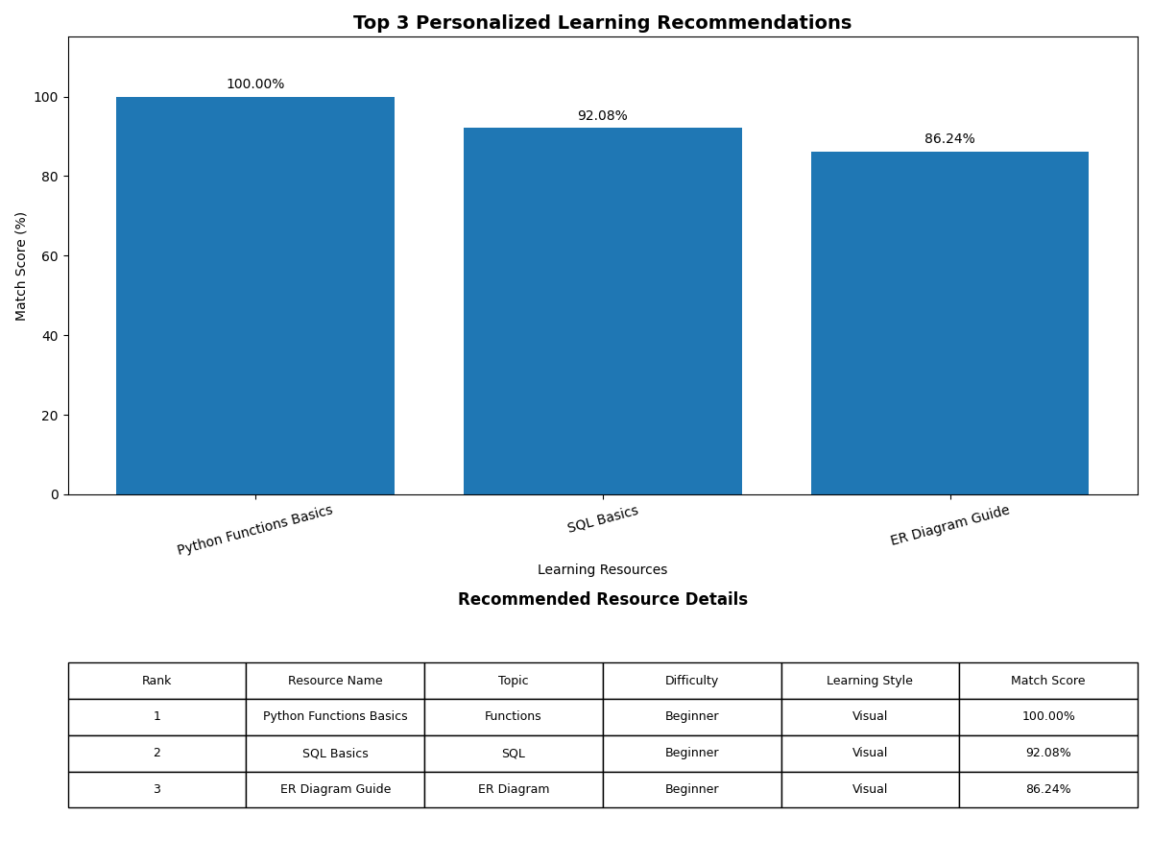

5.2 – Personalized recommendations displayed in the console
5.3 – Recommendation graph with resource details table

5.4 – Saved recommendation CSV file opened in a spreadsheet
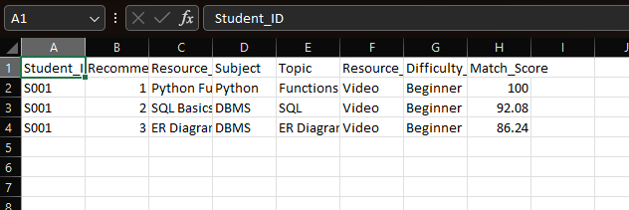

6. SOURCE CODE
The following source listings are taken from the submitted project. They show the main implementation logic. The original project archive contains the complete Python files and CSV datasets.

6.1 – student.py
class Student:
def __init__(
self,
student_id,
previous_score,
study_hours,
interest,
learning_preference,
completed_topics,
weak_topic,
difficulty_level
):
self.student_id = student_id
self.previous_score = previous_score
self.study_hours = study_hours
self.interest = interest
self.learning_preference = learning_preference
self.completed_topics = completed_topics
self.weak_topic = weak_topic
self.difficulty_level = difficulty_level
def display_profile(self):
print("\n==============================")
print(" STUDENT PROFILE")
print("==============================")
print("Student ID:", self.student_id)
print("Previous Score:", self.previous_score)
print("Study Hours:", self.study_hours)
print("Interest:", self.interest)
print("Learning Preference:", self.learning_preference)
print("Completed Topics:", self.completed_topics)
print("Weak Topic:", self.weak_topic)
print("Difficulty Level:", self.difficulty_level)
End of student.py listing.

6.2 – recommendation.py
import pandas as pd
from sklearn.feature_extraction.text import CountVectorizer
from sklearn.metrics.pairwise import cosine_similarity
def get_recommended_level(score):
if score < 50:
return ["Beginner"]
elif score < 70:
return ["Beginner", "Intermediate"]
else:
return ["Intermediate", "Advanced"]
def get_preference_match(preference, resource_style):
preference_map = {
"Video": "Visual",
"Notes": "Reading",
"Practice": "Practice",
"Visual": "Visual"
}
preferred_style = preference_map.get(
preference,
preference
)
return preferred_style == resource_style
def get_duration_match(study_hours, duration):
available_minutes = study_hours * 60
# Short resource for limited study time
if available_minutes <= 120:
return duration <= 30
# Medium resources for moderate study time
elif available_minutes <= 180:
return duration <= 40
# Longer resources are suitable for more study time
else:
return duration >= 30
def create_text_features(student, resources):
student_text = (
student["Interest"] + " " +
student["Weak_Topic"] + " " +
student["Learning_Preference"] + " " +
student["Difficulty_Level"]
)
resource_text = (
resources["Subject"] + " " +
resources["Topic"] + " " +
resources["Resource_Type"] + " " +
resources["Learning_Style"] + " " +
resources["Difficulty_Level"]
)
return student_text, resource_text
def recommend_resources(student, resources, top_n=3):
# Create text features
student_text, resource_text = create_text_features(
student,
resources
)
# Combine student and resource text
all_text = [student_text] + resource_text.tolist()
# Convert text into numerical vectors
vectorizer = CountVectorizer()
vectors = vectorizer.fit_transform(
all_text
)
# Calculate cosine similarity
similarity_scores = cosine_similarity(
vectors[0:1],
vectors[1:]
)[0]
# Copy resource data
recommendations = resources.copy()
# Add similarity score
recommendations["Similarity_Score"] = (
similarity_scores
)
# Remove completed topics
completed_topics = [
topic.strip()
for topic in student["Completed_Topics"].split(",")
]
recommendations = recommendations[
~recommendations["Topic"].isin(
completed_topics
)
].copy()
# Determine suitable difficulty
suitable_levels = get_recommended_level(
student["Previous_Score"]
)
# Difficulty bonus
recommendations["Difficulty_Bonus"] = (
recommendations["Difficulty_Level"]
.isin(suitable_levels)
.astype(int) * 0.10
)
# Weak topic bonus
recommendations["Weak_Topic_Bonus"] = (
recommendations["Topic"]
== student["Weak_Topic"]
).astype(int) * 0.20
# Learning preference bonus
recommendations["Preference_Bonus"] = (
recommendations.apply(
lambda row:
get_preference_match(
student["Learning_Preference"],
row["Learning_Style"]
),
axis=1
)
.astype(int) * 0.10
)
# Study duration bonus
recommendations["Duration_Bonus"] = (
recommendations.apply(
lambda row:
get_duration_match(
student["Study_Hours"],
row["Duration_Minutes"]
),
axis=1
)
.astype(int) * 0.05
)
# Calculate final recommendation score
recommendations["Final_Score"] = (
recommendations["Similarity_Score"]
+ recommendations["Difficulty_Bonus"]
+ recommendations["Weak_Topic_Bonus"]
+ recommendations["Preference_Bonus"]
+ recommendations["Duration_Bonus"]
)
# Sort recommendations by final score
recommendations = recommendations.sort_values(
by="Final_Score",
ascending=False
)
return recommendations.head(top_n)
# Load datasets
students = pd.read_csv(
"data/students.csv"
)
resources = pd.read_csv(
"data/resources.csv"
)
# Select first student for testing
student = students.iloc[0]
# Generate recommendations
recommendations = recommend_resources(
student,
resources
)
print("\nStudent Profile")
print("-------------------------")
print(
"Student ID:",
student["Student_ID"]
)
print(
"Interest:",
student["Interest"]
)
print(
"Learning Preference:",
student["Learning_Preference"]
)
print(
"Study Hours:",
student["Study_Hours"]
)
print(
"Weak Topic:",
student["Weak_Topic"]
)
print(
"Previous Score:",
student["Previous_Score"]
)
print(
"Difficulty Level:",
student["Difficulty_Level"]
)
print("\nRecommended Learning Resources")
print("-------------------------")
for index, resource in recommendations.iterrows():
score = min(
resource["Final_Score"] * 100,
100
)
print(
resource["Resource_Name"],
"- Match Score:",
f"{score:.2f}%"
)
End of recommendation.py listing.

6.3 – main.py
import pandas as pd
import matplotlib.pyplot as plt
from recommendation import recommend_resources
from student import Student
# Display recommendations in Shell
def display_recommendations(student, recommendations):
print("\n==============================")
print(" PERSONALIZED RECOMMENDATIONS")
print("==============================")
for number, (index, resource) in enumerate(
recommendations.iterrows(), start=1
):
score = min(resource["Final_Score"] * 100, 100)
print(f"\n{number}. {resource['Resource_Name']}")
print(" Subject:", resource["Subject"])
print(" Topic:", resource["Topic"])
print(" Type:", resource["Resource_Type"])
print(" Difficulty:", resource["Difficulty_Level"])
print(f" Match Score: {score:.2f}%")
if resource["Topic"] == student.weak_topic:
print(" Reason: Matches your weak topic.")
elif resource["Subject"] == student.interest:
print(" Reason: Matches your area of interest.")
else:
print(" Reason: Matches your learning profile.")
# Display recommendations in Graph format
def display_recommendation_graph(recommendations):
# Get resource names
resource_names = recommendations["Resource_Name"]
# Calculate match scores
match_scores = (
recommendations["Final_Score"] * 100
).clip(upper=100)
# Create figure with two sections
fig, (ax1, ax2) = plt.subplots(
2, 1,
figsize=(12, 9),
gridspec_kw={"height_ratios": [2, 1]}
)
# -------------------------------
# BAR GRAPH
# -------------------------------
bars = ax1.bar(
resource_names,
match_scores
)
ax1.set_title(
"Top 3 Personalized Learning Recommendations",
fontsize=14,
fontweight="bold"
)
ax1.set_xlabel("Learning Resources")
ax1.set_ylabel("Match Score (%)")
ax1.set_ylim(0, 115)
ax1.tick_params(
axis="x",
rotation=15
)
# Display percentage above bars
for bar, score in zip(bars, match_scores):
ax1.text(
bar.get_x() + bar.get_width() / 2,
bar.get_height() + 2,
f"{score:.2f}%",
ha="center",
fontsize=10
)
# -------------------------------
# RESOURCE DETAILS TABLE
# -------------------------------
table_data = []
for number, (index, resource) in enumerate(
recommendations.iterrows(), start=1
):
table_data.append([
number,
resource["Resource_Name"],
resource["Topic"],
resource["Difficulty_Level"],
resource["Learning_Style"],
f"{min(resource['Final_Score'] * 100, 100):.2f}%"
])
columns = [
"Rank",
"Resource Name",
"Topic",
"Difficulty",
"Learning Style",
"Match Score"
]
ax2.axis("off")
ax2.set_title(
"Recommended Resource Details",
fontsize=12,
fontweight="bold",
pad=12
)
table = ax2.table(
cellText=table_data,
colLabels=columns,
cellLoc="center",
loc="center"
)
table.auto_set_font_size(False)
table.set_fontsize(9)
table.scale(1, 2)
# Adjust layout
plt.tight_layout()
# Display graph and table
plt.show()
# Save recommendations in CSV file
def save_recommendations(student, recommendations):
output_data = []
for number, (index, resource) in enumerate(
recommendations.iterrows(), start=1
):
score = min(resource["Final_Score"] * 100, 100)
output_data.append({
"Student_ID": student.student_id,
"Recommendation_Rank": number,
"Resource_Name": resource["Resource_Name"],
"Subject": resource["Subject"],
"Topic": resource["Topic"],
"Resource_Type": resource["Resource_Type"],
"Difficulty_Level": resource["Difficulty_Level"],
"Match_Score": round(score, 2)
})
output_df = pd.DataFrame(output_data)
filename = (
"output/"
+ student.student_id
+ "_recommendations.csv"
)
output_df.to_csv(filename, index=False)
print("\nRecommendations saved to:", filename)
# Main function
def main():
try:
# Load datasets
students = pd.read_csv("data/students.csv")
resources = pd.read_csv("data/resources.csv")
print("======================================")
print(" PERSONALIZED LEARNING RECOMMENDATION")
print("======================================")
print("\nAvailable Student IDs:")
for student_id in students["Student_ID"]:
print(student_id)
student_id = input(
"\nEnter Student ID: "
).strip().upper()
student_data = students[
students["Student_ID"] == student_id
]
if student_data.empty:
print("\nStudent ID not found.")
return
data = student_data.iloc[0]
# Create Student object
student = Student(
data["Student_ID"],
data["Previous_Score"],
data["Study_Hours"],
data["Interest"],
data["Learning_Preference"],
data["Completed_Topics"],
data["Weak_Topic"],
data["Difficulty_Level"]
)
# Display student profile
student.display_profile()
# Generate recommendations
recommendations = recommend_resources(
data,
resources
)
if recommendations.empty:
print("\nNo suitable recommendations found.")
return
# Display recommendations in Shell
display_recommendations(
student,
recommendations
)
# Display recommendations in Graph
display_recommendation_graph(
recommendations
)
# Save recommendations
save_recommendations(
student,
recommendations
)
except FileNotFoundError:
print("\nError: Required dataset file was not found.")
except KeyError as error:
print("\nError: Required column is missing:", error)
except Exception as error:
print("\nAn unexpected error occurred:", error)
# Run main function
main()
End of main.py listing.

6.4 – preprocessing.py
import pandas as pd
def load_data():
students = pd.read_csv("data/students.csv")
resources = pd.read_csv("data/resources.csv")
return students, resources
def clean_data(students, resources):
# Check for missing values
print("\nMissing values in Students Dataset:")
print(students.isnull().sum())
print("\nMissing values in Resources Dataset:")
print(resources.isnull().sum())
# Remove duplicate rows
students = students.drop_duplicates()
resources = resources.drop_duplicates()
return students, resources
def encode_data(students, resources):
# Convert categorical student columns into numerical values
student_encoded = pd.get_dummies(
students,
columns=[
"Interest",
"Learning_Preference",
"Difficulty_Level"
]
)
# Convert categorical resource columns into numerical values
resource_encoded = pd.get_dummies(
resources,
columns=[
"Subject",
"Resource_Type",
"Difficulty_Level",
"Learning_Style"
]
)
return student_encoded, resource_encoded
def create_features(students, resources):
student_features = pd.DataFrame()
student_features["Subject"] = students["Interest"]
student_features["Topic"] = students["Weak_Topic"]
student_features["Learning_Style"] = students["Learning_Preference"]
student_features["Difficulty"] = students["Difficulty_Level"]
resource_features = pd.DataFrame()
resource_features["Subject"] = resources["Subject"]
resource_features["Topic"] = resources["Topic"]
resource_features["Learning_Style"] = resources["Learning_Style"]
resource_features["Difficulty"] = resources["Difficulty_Level"]
return student_features, resource_features
# Load datasets
students, resources = load_data()
# Clean datasets
students, resources = clean_data(students, resources)
# Encode categorical data
student_encoded, resource_encoded = encode_data(
students, resources
)
print("\nEncoded Student Dataset:")
print(student_encoded)
print("\nEncoded Resource Dataset:")
print(resource_encoded)
# Create common features
student_features, resource_features = create_features(
students, resources
)
print("\nStudent Features:")
print(student_features)
print("\nResource Features:")
print(resource_features)
End of preprocessing.py listing.

6.5 – evaluation.py
import pandas as pd
import numpy as np
from recommendation import recommend_resources
def evaluate_recommendations(students, resources):
total_students = len(students)
weak_topic_matches = 0
completed_topic_errors = 0
suitable_difficulty = 0
all_scores = []
for index, student in students.iterrows():
recommendations = recommend_resources(
student,
resources
)
# Check weak topic
if any(
recommendations["Topic"] == student["Weak_Topic"]
):
weak_topic_matches += 1
# Check completed topics
completed_topics = [
topic.strip()
for topic in student["Completed_Topics"].split(",")
]
for topic in recommendations["Topic"]:
if topic in completed_topics:
completed_topic_errors += 1
# Check suitable difficulty
score = student["Previous_Score"]
if score < 50:
suitable_levels = ["Beginner"]
elif score < 70:
suitable_levels = [
"Beginner",
"Intermediate"
]
else:
suitable_levels = [
"Intermediate",
"Advanced"
]
for level in recommendations["Difficulty_Level"]:
if level in suitable_levels:
suitable_difficulty += 1
# Store recommendation scores
for final_score in recommendations["Final_Score"]:
# Keep score between 0 and 1
final_score = min(final_score, 1.0)
all_scores.append(final_score)
total_recommendations = len(all_scores)
# Calculate evaluation percentages
weak_topic_percentage = (
weak_topic_matches / total_students
) * 100
completed_topic_percentage = (
1 -
(
completed_topic_errors /
total_recommendations
)
) * 100
difficulty_percentage = (
suitable_difficulty /
total_recommendations
) * 100
# Use NumPy to calculate average
average_score = np.mean(all_scores) * 100
print("\n======================================")
print(" RECOMMENDATION EVALUATION")
print("======================================")
print(
"\nWeak Topic Match:",
f"{weak_topic_percentage:.2f}%"
)
print(
"Completed Topic Avoidance:",
f"{completed_topic_percentage:.2f}%"
)
print(
"Suitable Difficulty:",
f"{difficulty_percentage:.2f}%"
)
print(
"Average Recommendation Score:",
f"{average_score:.2f}%"
)
# Load datasets
students = pd.read_csv("data/students.csv")
resources = pd.read_csv("data/resources.csv")
# Evaluate recommendation system
evaluate_recommendations(
students,
resources
)
End of evaluation.py listing.

6.6 – evaluation_graph.py
import matplotlib.pyplot as plt
# Evaluation results
metrics = [
"Weak Topic Match",
"Completed Topic Avoidance",
"Suitable Difficulty",
"Average Recommendation Score"
]
scores = [
97.00,
100.00,
83.33,
85.36
]
# Create bar chart
plt.figure(figsize=(9, 5))
plt.bar(metrics, scores)
plt.title("Recommendation System Evaluation")
plt.xlabel("Evaluation Metrics")
plt.ylabel("Percentage (%)")
plt.ylim(0, 110)
plt.xticks(rotation=20)
# Display values above bars
for i, score in enumerate(scores):
plt.text(
i,
score + 2,
f"{score:.2f}%",
ha="center"
)
plt.tight_layout()
plt.show()
End of evaluation_graph.py listing.

6.7 – eda.py
import pandas as pd
import matplotlib.pyplot as plt
# Load student dataset
students = pd.read_csv("data/students.csv")
# Display basic information
print("Student Dataset Information")
print("---------------------------")
print("Number of Students:", len(students))
print("\nAverage Previous Score:",
students["Previous_Score"].mean())
print("Average Study Hours:",
students["Study_Hours"].mean())
# -------------------------------
# Graph 1: Previous Score
# -------------------------------
plt.figure(figsize=(8, 5))
plt.hist(
students["Previous_Score"],
bins=5,
edgecolor="black"
)
plt.title("Distribution of Previous Scores")
plt.xlabel("Previous Score")
plt.ylabel("Number of Students")
plt.show()
# -------------------------------
# Graph 2: Study Hours
# -------------------------------
plt.figure(figsize=(8, 5))
plt.bar(
students["Student_ID"],
students["Study_Hours"]
)
plt.title("Study Hours of Students")
plt.xlabel("Student ID")
plt.ylabel("Study Hours per Day")
plt.xticks(rotation=45)
plt.show()
# -------------------------------
# Graph 3: Student Interests
# -------------------------------
interest_counts = students["Interest"].value_counts()
plt.figure(figsize=(8, 5))
plt.bar(
interest_counts.index,
interest_counts.values
)
plt.title("Student Interests")
plt.xlabel("Subject")
plt.ylabel("Number of Students")
plt.xticks(rotation=45)
plt.show()
# -------------------------------
# Graph 4: Learning Preferences
# -------------------------------
preference_counts = students[
"Learning_Preference"
].value_counts()
plt.figure(figsize=(8, 5))
plt.bar(
preference_counts.index,
preference_counts.values
)
plt.title("Learning Preferences")
plt.xlabel("Learning Preference")
plt.ylabel("Number of Students")
plt.show()
# -------------------------------
# Graph 5: Average Score by Interest
# -------------------------------
average_score = students.groupby(
"Interest"
)["Previous_Score"].mean()
plt.figure(figsize=(8, 5))
plt.bar(
average_score.index,
average_score.values
)
plt.title("Average Previous Score by Interest")
plt.xlabel("Interest")
plt.ylabel("Average Score")
plt.xticks(rotation=45)
plt.show()
# -------------------------------
# Graph 6: Study Hours vs Score
# -------------------------------
plt.figure(figsize=(8, 5))
plt.scatter(
students["Study_Hours"],
students["Previous_Score"]
)
plt.title("Study Hours vs Previous Score")
plt.xlabel("Study Hours per Day")
plt.ylabel("Previous Score")
plt.show()
# -------------------------------
# Graph 7: Difficulty Level
# -------------------------------
difficulty_counts = students[
"Difficulty_Level"
].value_counts()
plt.figure(figsize=(7, 7))
plt.pie(
difficulty_counts.values,
labels=difficulty_counts.index,
autopct="%1.1f%%"
)
plt.title("Student Difficulty Levels")
plt.show()
# -------------------------------
# Graph 8: Weak Topics
# -------------------------------
weak_topic_counts = students[
"Weak_Topic"
].value_counts()
plt.figure(figsize=(9, 5))
plt.bar(
weak_topic_counts.index,
weak_topic_counts.values
)
plt.title("Distribution of Weak Topics")
plt.xlabel("Weak Topic")
plt.ylabel("Number of Students")
plt.xticks(rotation=45)
plt.show()
# -------------------------------
# Graph 9: Study Hours by Learning Preference
# -------------------------------
average_study_hours = students.groupby(
"Learning_Preference"
)["Study_Hours"].mean()
plt.figure(figsize=(8, 5))
plt.bar(
average_study_hours.index,
average_study_hours.values
)
plt.title("Average Study Hours by Learning Preference")
plt.xlabel("Learning Preference")
plt.ylabel("Average Study Hours")
plt.show()
End of eda.py listing.

7. TESTING AND DEBUGGING

7.1 Testing Approach
Testing is used to check whether the application reads the datasets, accepts a valid student ID, creates recommendations, filters completed topics, displays results, and saves output correctly. The supplied code includes error handling in main.py for missing files, missing columns, and unexpected exceptions.

7.2 Test Cases
Test ID | Test Description | Input | Expected Result | Status
TC-01 | Load student and resource CSV files | Both CSV files are present and readable | DataFrames are loaded | To be verified
TC-02 | Enter a valid student ID | S001 | Student profile is displayed | To be verified
TC-03 | Enter an unknown student ID | S999 | 'Student ID not found' message is displayed | To be verified
TC-04 | Generate recommendations | Valid student profile | Up to three ranked resources are returned | To be verified
TC-05 | Completed-topic filtering | Student with completed topics | Resources for completed topics are excluded | To be verified
TC-06 | Save recommendations | Valid recommendation result | Student-specific CSV is written to output folder | To be verified
TC-07 | Missing dataset file | Rename or remove a required CSV file | File-not-found message is displayed | To be verified
TC-08 | Evaluate dataset | Run evaluation.py from project directory | Evaluation percentages are printed | Executed

Note: The status column is intentionally marked 'To be verified' for interactive tests so that it can be updated after the student runs each test on their own computer. The evaluation script was executed against the supplied data and printed the metrics included in Chapter 4.

7.3 Debugging Considerations
- Run the Python files from the project root folder so relative paths such as data/students.csv resolve correctly.
- Check that the required CSV column names match the names used in the Python scripts.
- Ensure the output folder exists before saving recommendation files.
- Check the spelling and case of learning preferences and resource learning styles because the matching function uses exact string comparison after its preference mapping.
- Review dataset values if recommendation results appear unexpected.

8. CONCLUSION AND FUTURE ENHANCEMENT

8.1 Conclusion
The Personalized Learning Recommendation System demonstrates a simple approach to recommending educational resources based on student profiles. It uses CountVectorizer and cosine similarity to compare text descriptions, then applies rule-based bonuses for weak topics, suitable difficulty, learning preference, and study duration. Completed topics are filtered before the final ranking.
The supplied dataset evaluation produced 97.00% weak-topic matching, 100.00% completed-topic avoidance, 83.67% suitable-difficulty matching, and an average recommendation score of 85.48%. The results show that the implemented rules can produce recommendations aligned with several profile attributes. However, the evaluation is based on the same supplied dataset and defined checks, so it does not establish generalisation to new students.

8.2 Limitations
- The project uses a small, predefined CSV dataset rather than continuously updated student activity.
- The current application is console-based and does not provide a graphical web interface.
- Recommendation quality depends on the correctness and coverage of the topic and resource labels.
- The system does not train a supervised model or learn from explicit student feedback.
- Evaluation metrics are rule-based checks and are not equivalent to standard held-out predictive accuracy.

8.3 Future Enhancement
- Develop a web-based interface where students can view and manage their profiles.
- Connect the system to a database so that student and resource records can be updated dynamically.
- Add feedback collection such as like, dislike, completion, and rating information.
- Explore collaborative filtering or a hybrid recommendation method when sufficient interaction data is available.
- Use a train-test evaluation strategy and compare recommendation quality using appropriate ranking metrics.
- Add resource links, estimated completion tracking, and progress dashboards.
- Improve text processing with TF-IDF, stemming, or semantic embeddings and compare the results with the current CountVectorizer approach.

9. REFERENCES
- Scikit-learn Documentation – CountVectorizer. https://scikit-learn.org/stable/modules/generated/sklearn.feature_extraction.text.CountVectorizer.html
- Scikit-learn Documentation – cosine_similarity. https://scikit-learn.org/stable/modules/generated/sklearn.metrics.pairwise.cosine_similarity.html
- Pandas Documentation. https://pandas.pydata.org/docs/
- NumPy Documentation. https://numpy.org/doc/
- Matplotlib Documentation. https://matplotlib.org/stable/
- Python Documentation. https://docs.python.org/3/
- Brainware University class notes and study materials.

PROJECT FILES: Personalized_Learning_Recommendation.zip (source code and CSV datasets supplied for this report).
END OF REPORT

