Fig. 1. A & B have the same utility function (same width).

Fig. 2. A & B have the same utility function (different widths).

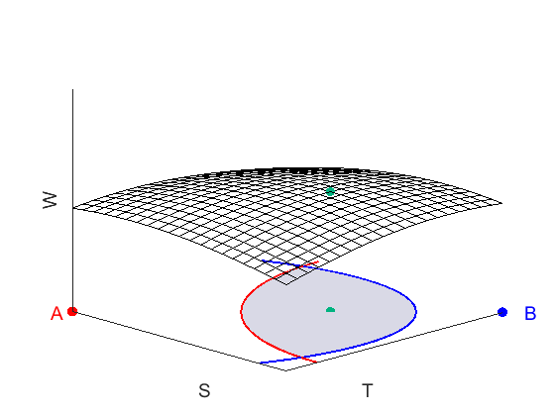

Fig. 3. A & B have different utility functions (same weight)

Fig. 4. A & B have the same utility function (different weights, 0.3 for A & 0.7 for B)

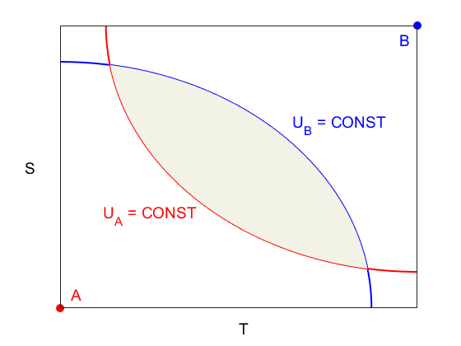

Fig. 5. Edgeworth box of Aand B, the shaded region shows the intersection of UA and UB

Fig. 6. Edgeworth box of Aand B with different covariance matrices, the shaded region shows the intersection of UA and UB

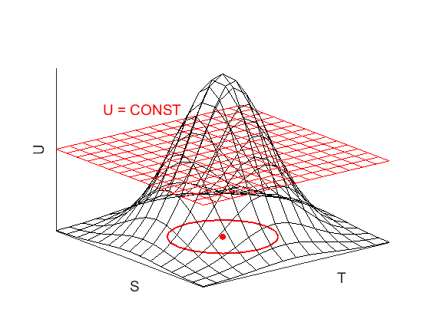

Fig 7. Gaussian function and the contour of $U\left(S, T\right)=U (a constant Utility)$.

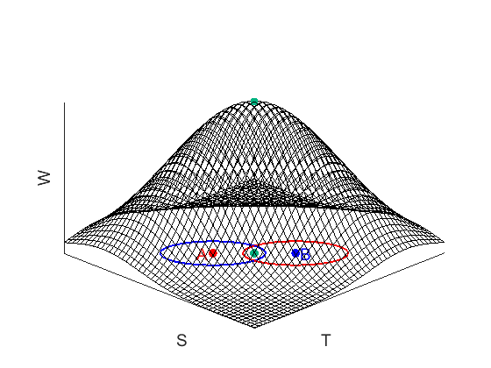

Fig 8. Summation of two Gaussian functions and two utility functions with centers A & B. Green dots indicate the points with maximum W on the surface and the S-T plane.