$$Let bivariate normal distribution of a vector X=\left[X_{1}, X_{2}\right],$$

$$X\sim N\left(μ, Σ\right), where μ is the mean vector and Σ is the covariance matrix.$$

$$Consider a utility plan, U=constant,$$

$$the contour is \frac{exp⁡(-\frac{1}{2}{\left(X-μ\right)}^{T}Σ^{-1}(X-μ))}{\sqrt{{(2π)}^{2}\left|Σ\right|}}=U (see Fig. 1)$$

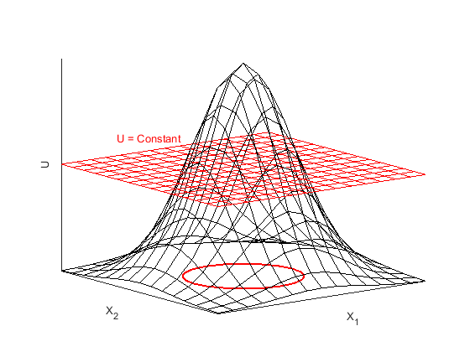

Fig 1. Bivariate normal distribution, utility plan, and contour with U = constant

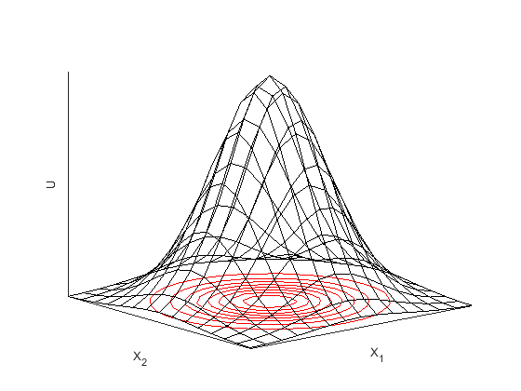

Fig 2. Bivariate normal distribution and contours with different utilities

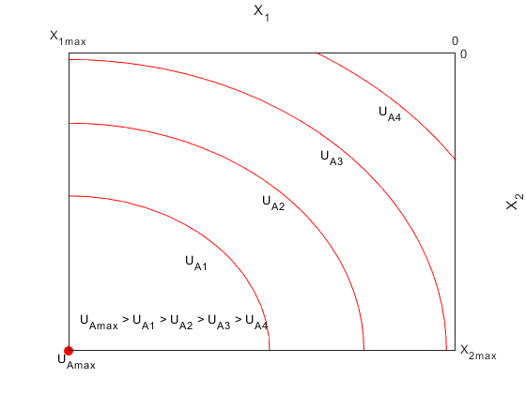

Fig 3. Utility of A, the maximum of UA = UAmax with X = [X1max, X2max], UA decreases when X1 and X2 decline

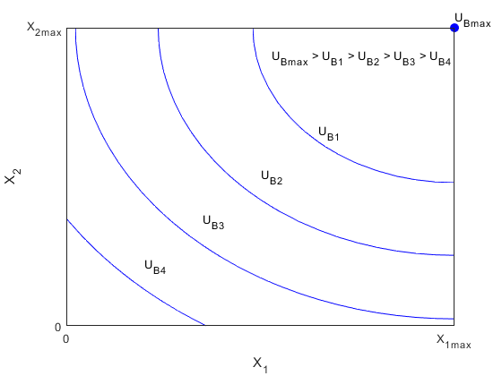

Fig 4. Utility of B, the maximum of UB = UBmax with X = [X1max, X2max], UB decreases when X1 and X2 decline

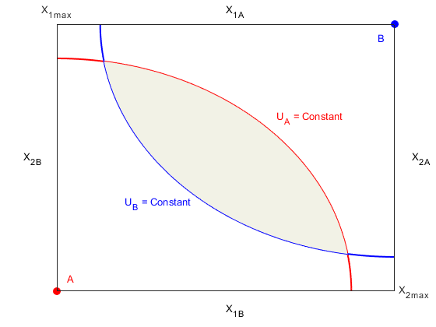

Fig 5. Edgeworth box of Aand B, shaded region shows the intersection of UA and UB

Fig 6. Edgeworth box of Aand B with different ΣA and ΣB