Let bivariate normal distribution of a vector X = [X1, X2],

(1)

A is the coefficient of amplitude, C1 and C2 indicate the center, and σ1 and σ2 are standard deviations.

Fig 1. Gaussian function (1) with center (C1, C2) and the same σ = σ1 = σ2; the plan and contour of $U\left(X_{1}, X_{2}\right)=U (a constant Utility)$.

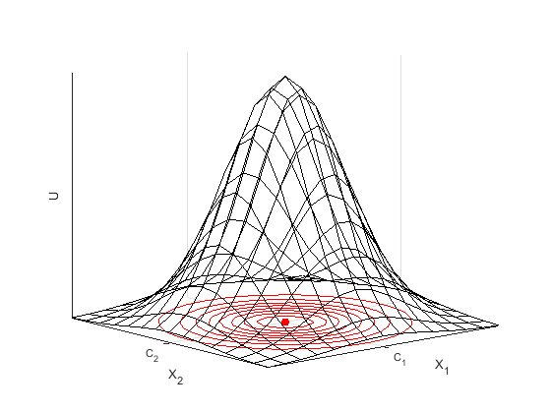

Fig 2. Gaussian function (1) and contours of different utility constants

Fig 3. Utility of A, the maximum of UA = UAmax with X = [C1, C2], UA decreases when X1 and X2 decline

Fig 4. Utility of B, the maximum of UB = UBmax with X = [C1, C2], UB decreases when X1 and X2 decline

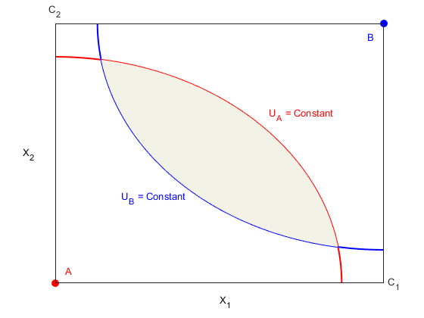

Fig 5. Edgeworth box of Aand B, the shaded region shows the intersection of UA and UB

Fig 6. Edgeworth box of Aand B with different covariance matrices, the shaded region shows the intersection of UA and UB

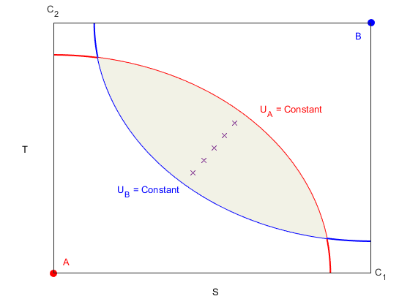

Fig 7. Edgeworth box of Aand B, changes the coordinate system from (X1, X2) to (S, T), and the crosses indicate the optimal solutions in the intersection region

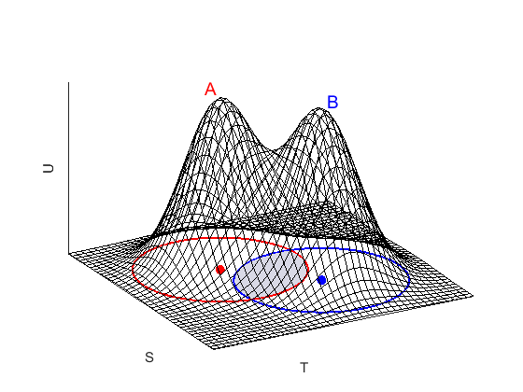

Fig 8. Sum of two Gaussian functions with different centers and their contours of the same constant utility.

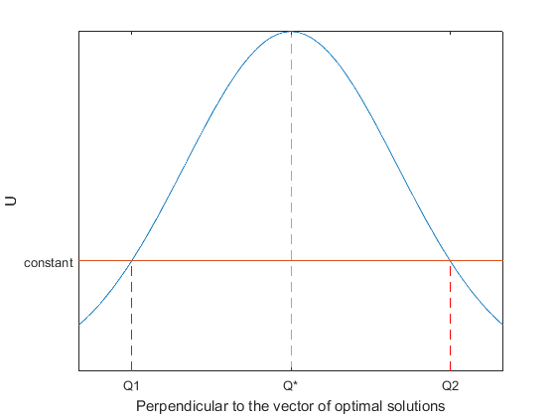

Fig 9. Sectional view of the intersection region (along the vector of optimal solutions) in Fig 8, Q\*, Q1, Q2 denote the middle and two ends of the intersection region.