1. **Round off problem of K(T), in page 3 of the document provided by Dr. Dynkin**

- The linear regression function of K(T) severely deviates from the raw data

- The large deviation is due to the rounds off problem of regression function.

-  Different decimal places for rounding affect the results significantly (see the following examples):

We perform K(T) regression using different decimal places (4th and 7th) for rounding

1. **4th decimal place** (same function provided by Dr. Dynkin)  
   0.0002*T^3 - 0.0168*T^2 + 0.6299*T - 7.1263 (function 1)

See the regression results in Fig 1. The regression function severely deviates from the raw data (NRMS = 92.6866).

2. **7th decimal place**  
    0.000150505*T^3 - 0.0167711*T^2 + 0.6298678*T - 7.1262900 (function 2)

See the regression results in Fig 2. The regression function fits the raw data well (NRMS = 0.2079).

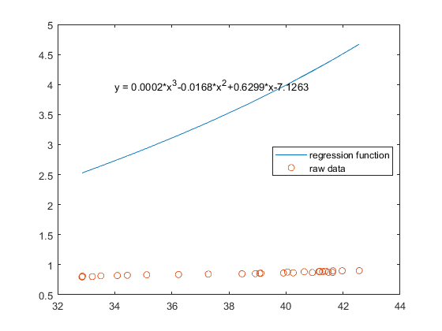

Fig 1. Regression function 1 and raw data, NRMS = 92.6866

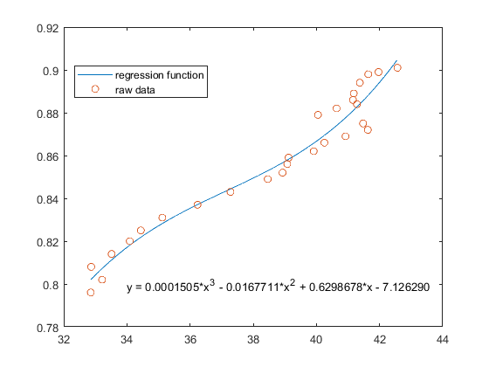

Fig 2. Regression function 2 and raw data, NRMS = 0.2079

1. **3D regression results of economic data**

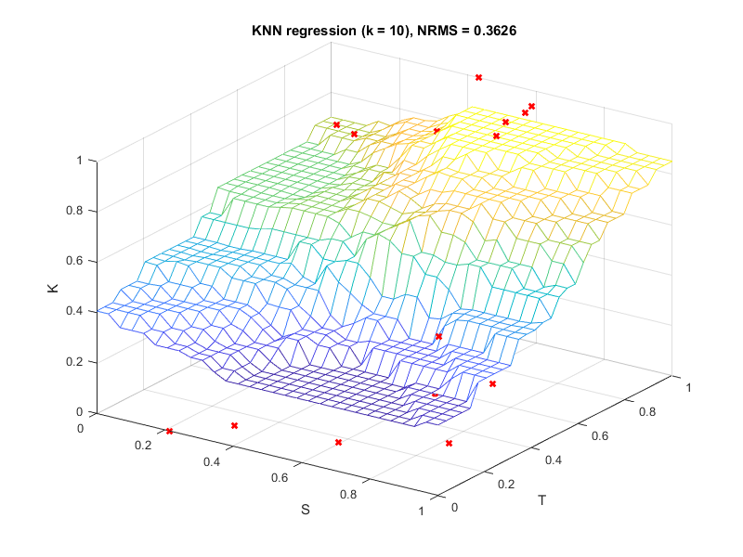

Fig 3. Regression results of economic data (K = human development index, S = Youth unemployment, and T = GPD) using KNN regression (K = 10), NRMS = 0.2079. Red crosses indicate the raw data.