**Scenario data (independent variable)**

- Sample size = 500

- Estimated parameters of multivariate normal distribution:

1. mean = [0.5, 0.5]

2. sigma = [0.01, 0; 0, 0.02]

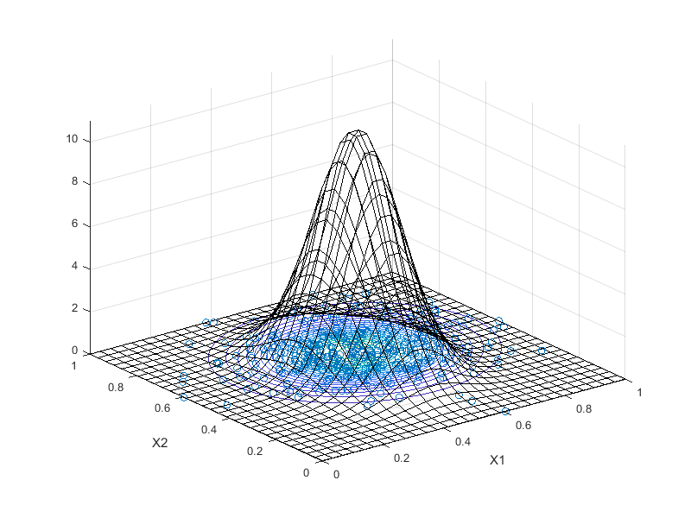

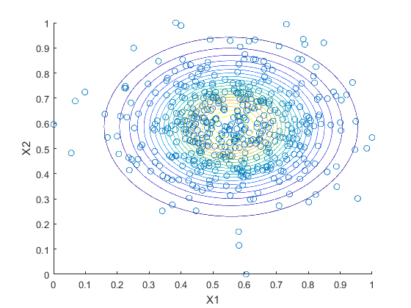

**Scenario data (dependent variable)**

- Sample size = 500

- Estimated parameters of multivariate normal distribution:

1. mean = [0.5, 0.5]

2. sigma = [0.01, -0.01; -0.01, 0.02]

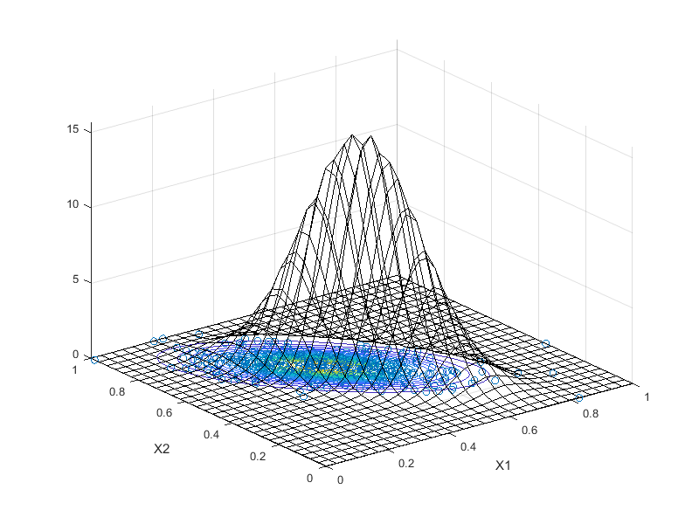

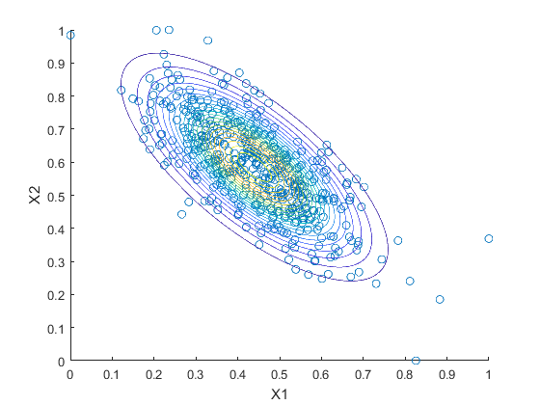

**SPY vs GLD (daily % change of closing price, 2018)**

- Sample size = 250

- Estimated parameters of multivariate normal distribution:

1. mean = [0.45, 0.39]

2. sigma = [0.0135, -0.0006; -0.0006, 0.0207]

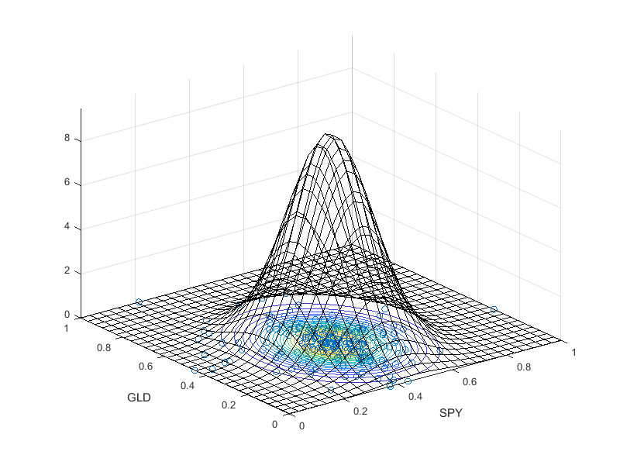

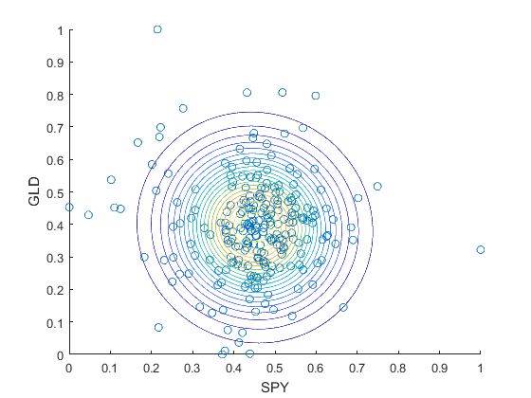

**SPY vs TLT (daily % change of closing price, 2018)**

- Sample size = 250

- Estimated parameters of multivariate normal distribution:

1. mean = [0.45, 0.44]

2. sigma = [0.0135, -0.0048; -0.0048, 0.0218]

