**Group Learning with different window size**

* **Handwritten digit images**
* **Binary classification 1 (positive vs. negative samples):**

Positive samples (digit 8, 28*28)



Negative samples (digit 5, 28*28)

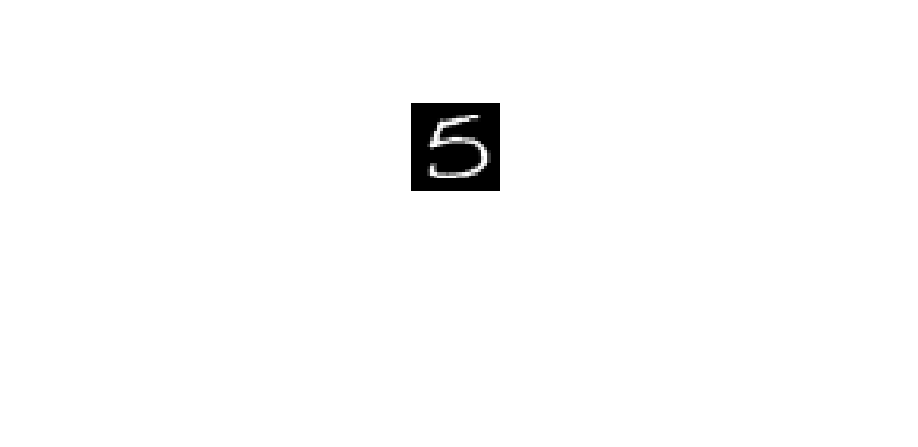

* **Experimental setting:**

Training data: 10 (5 per class)

Validation data (for SVM): 10 (5 per class)

Test data: 1000 (500 per class)

All experiments are repeat 10 times.

* **Results:**

SVM vs. SVM+GL

CNN vs. CNN+GL

* **Binary classification 2 (positive vs. negative samples):**

Positive samples (digit 3, 28*28)

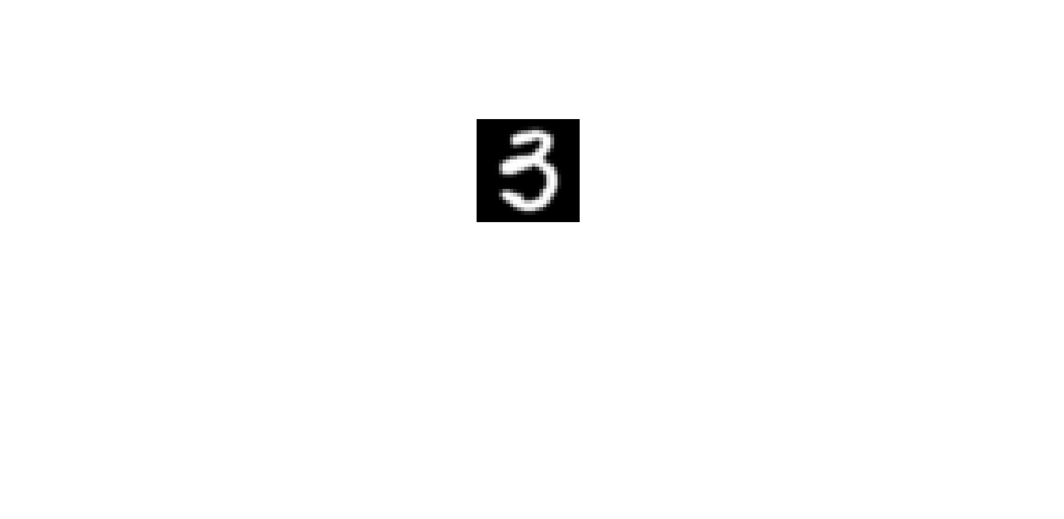

Negative samples (digit 5, 28*28)

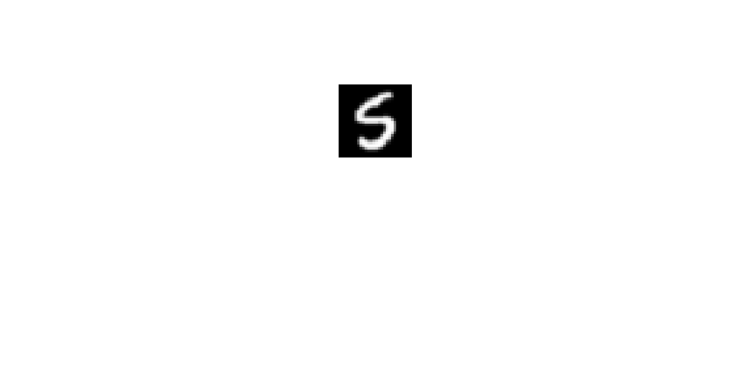

* **Experimental setting:**

Training data: 10 (5 per class)

Validation data (for SVM): 10 (5 per class)

Test data: 1000 (500 per class)

All experiments are repeat 10 times.

* **Results:**

SVM vs. SVM+GL

CNN vs. CNN+GL

* **Binary classification 3 (positive vs. negative samples):**

Positive samples (Letter e/E, 28*28)

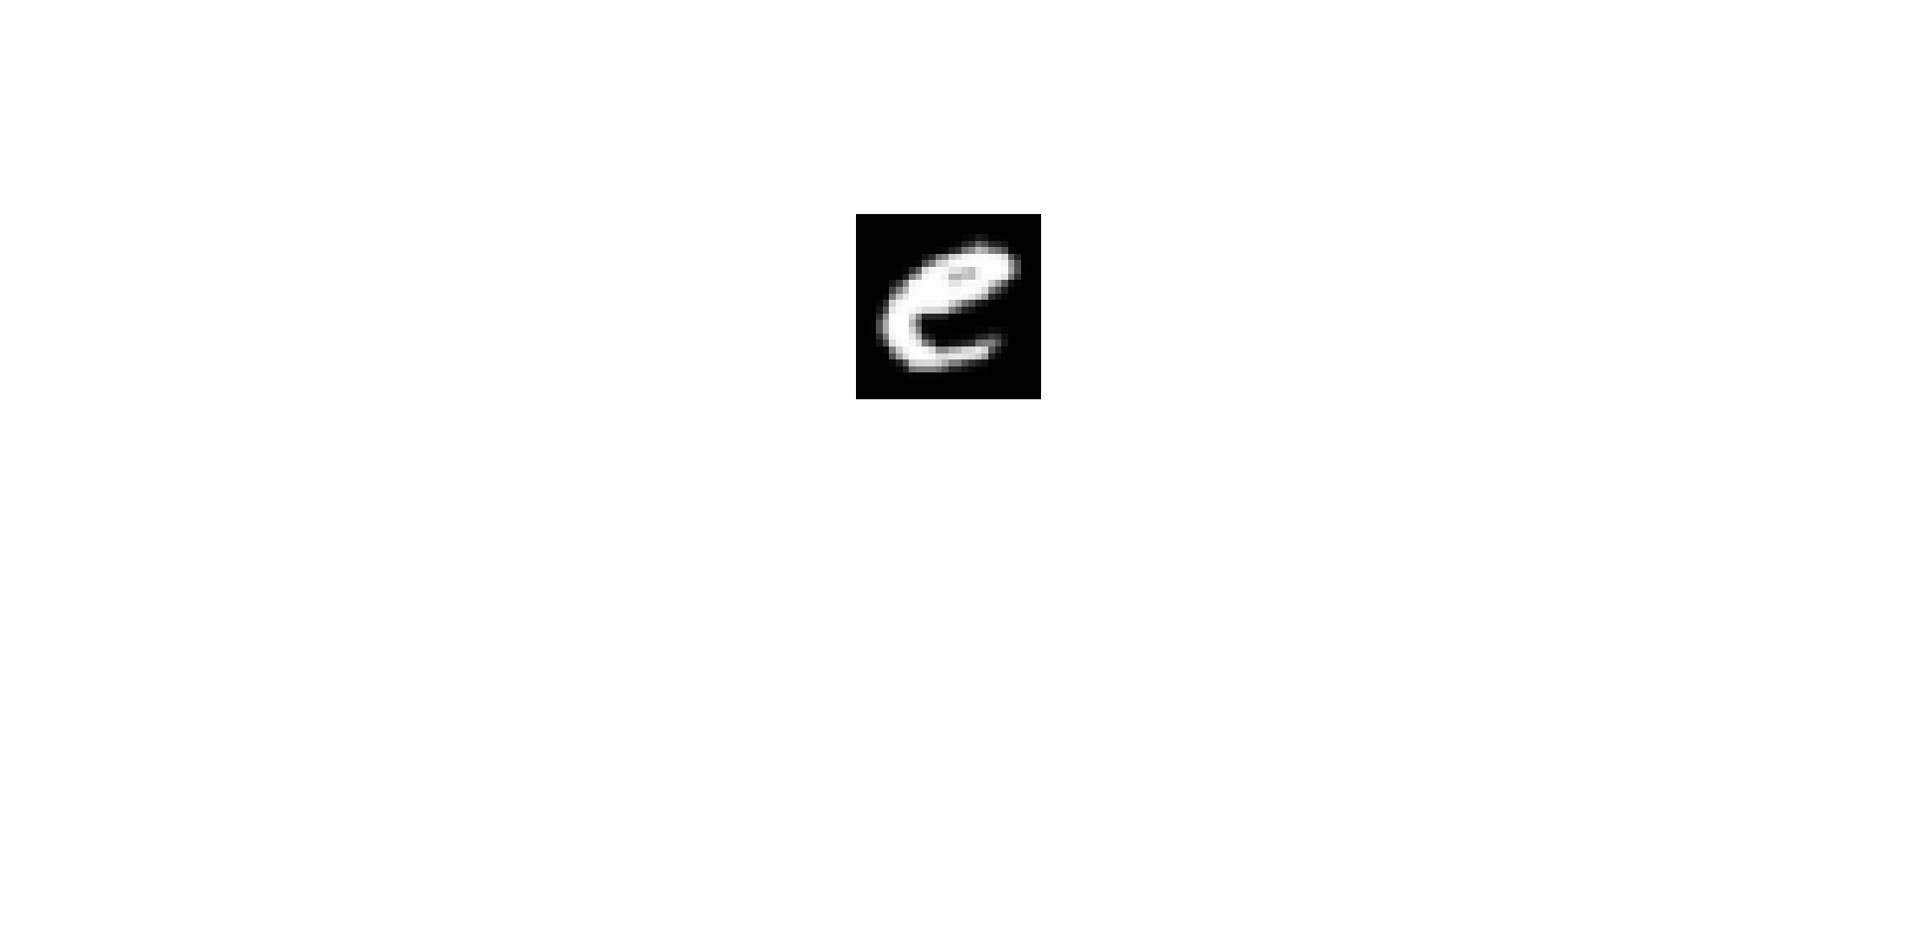 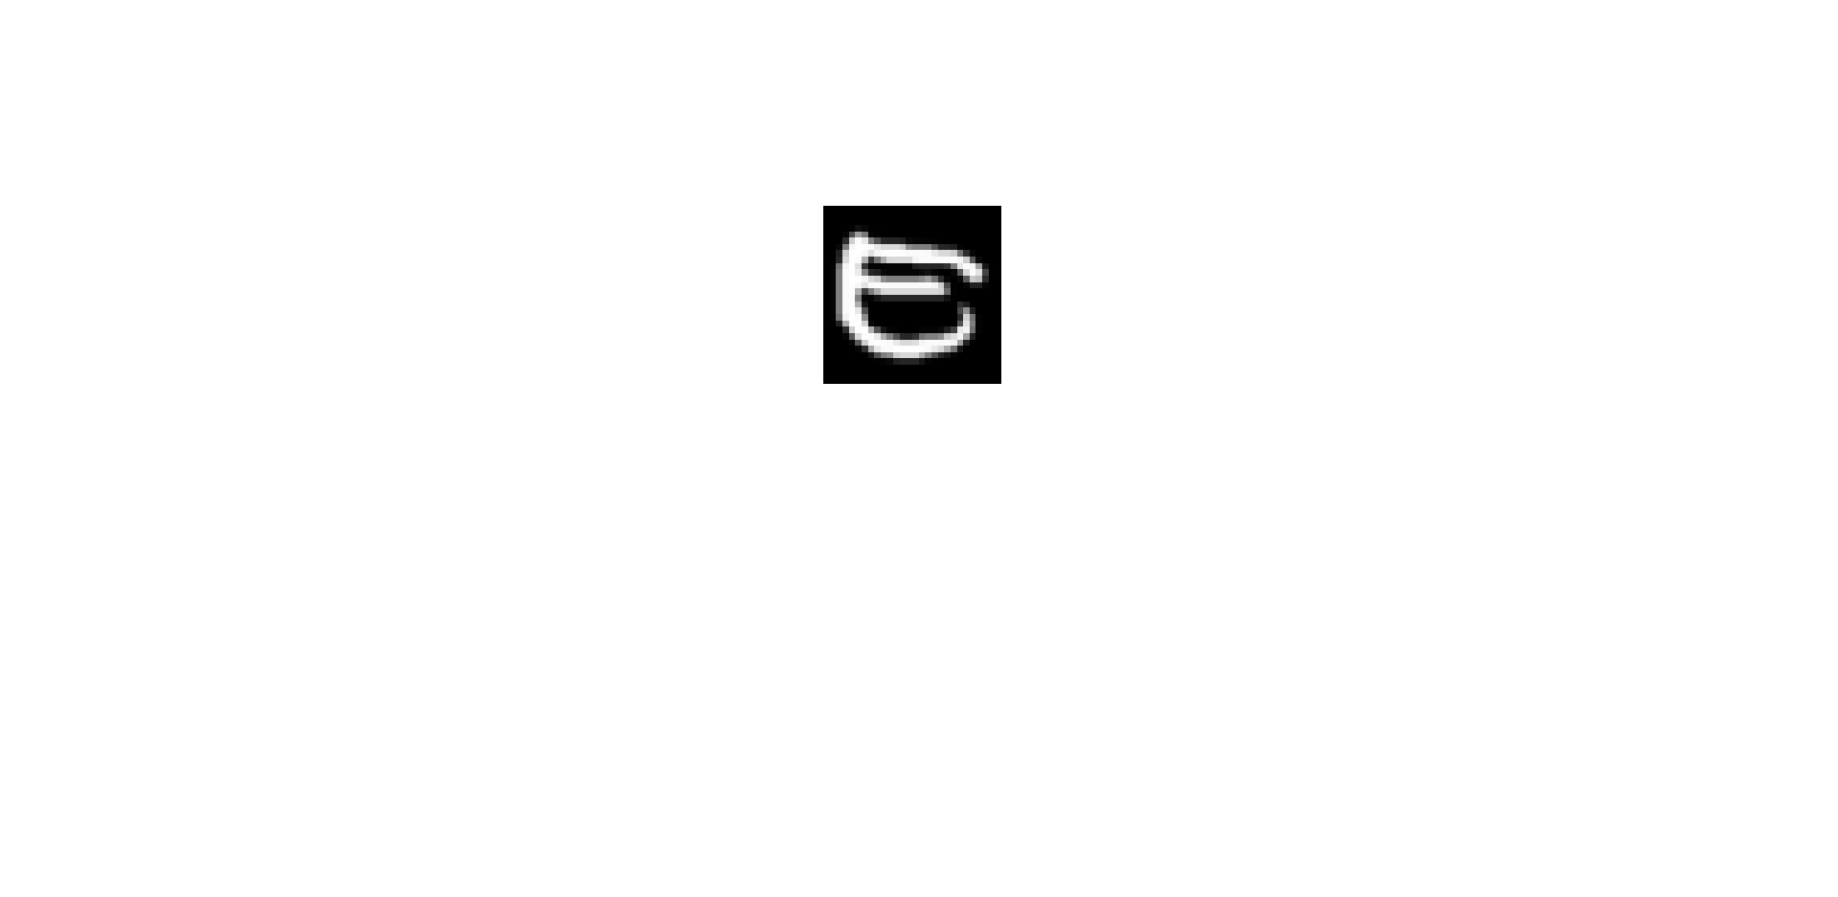

Negative samples (Letter f/F, 28*28)

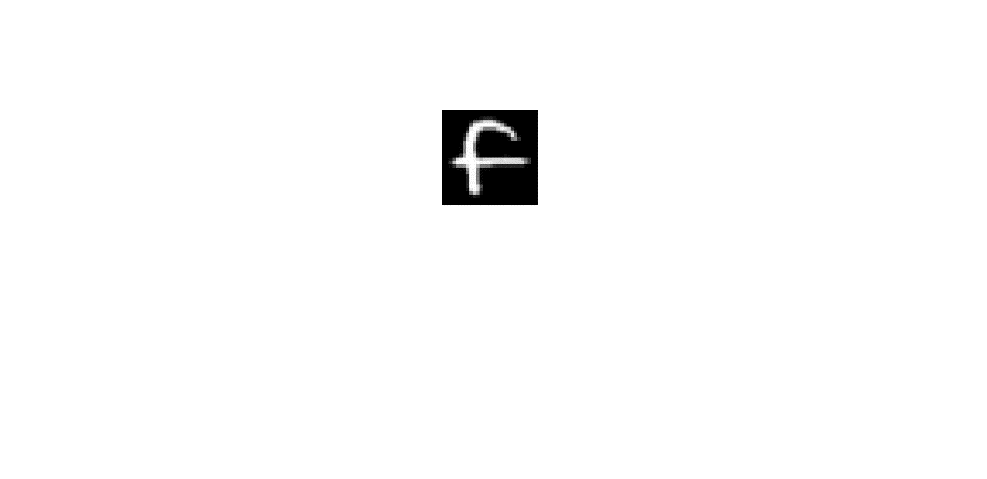 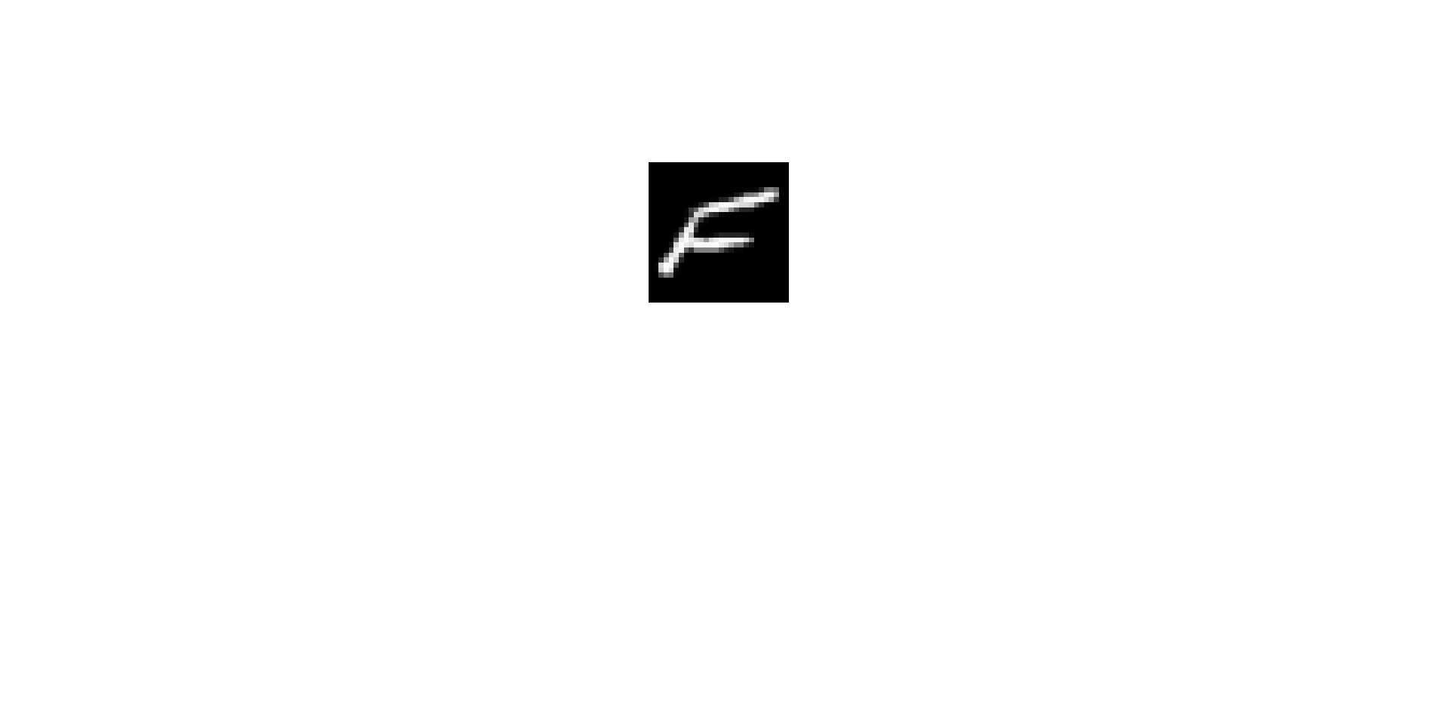

* **Experimental setting:**

Training data: 10 (5 per class)

Validation data (for SVM): 10 (5 per class)

Test data: 1000 (500 per class)

All experiments are repeat 10 times.

* **Results:**

SVM vs. SVM+GL

CNN vs. CNN+GL

* **Binary classification 4 (positive vs. negative samples):**

Positive samples (Letter y/Y, 28*28)

 

Negative samples (Letter z/Z, 28*28)

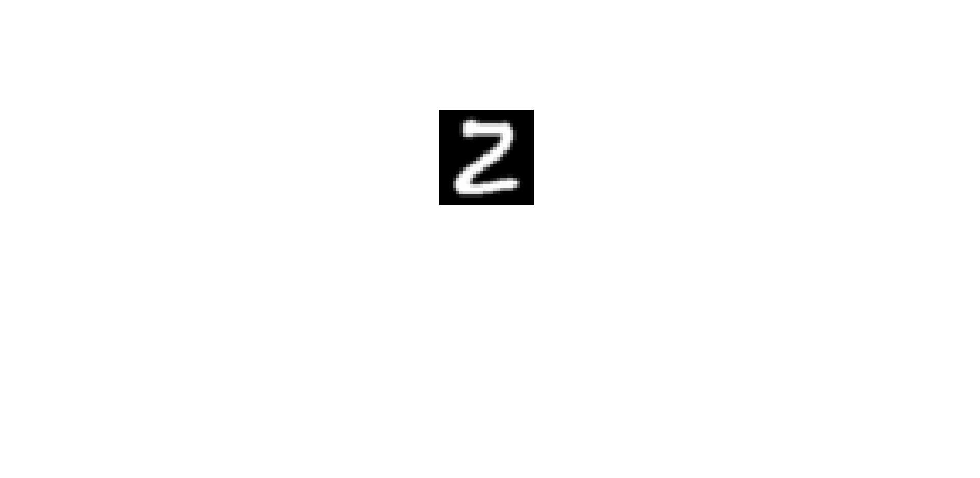 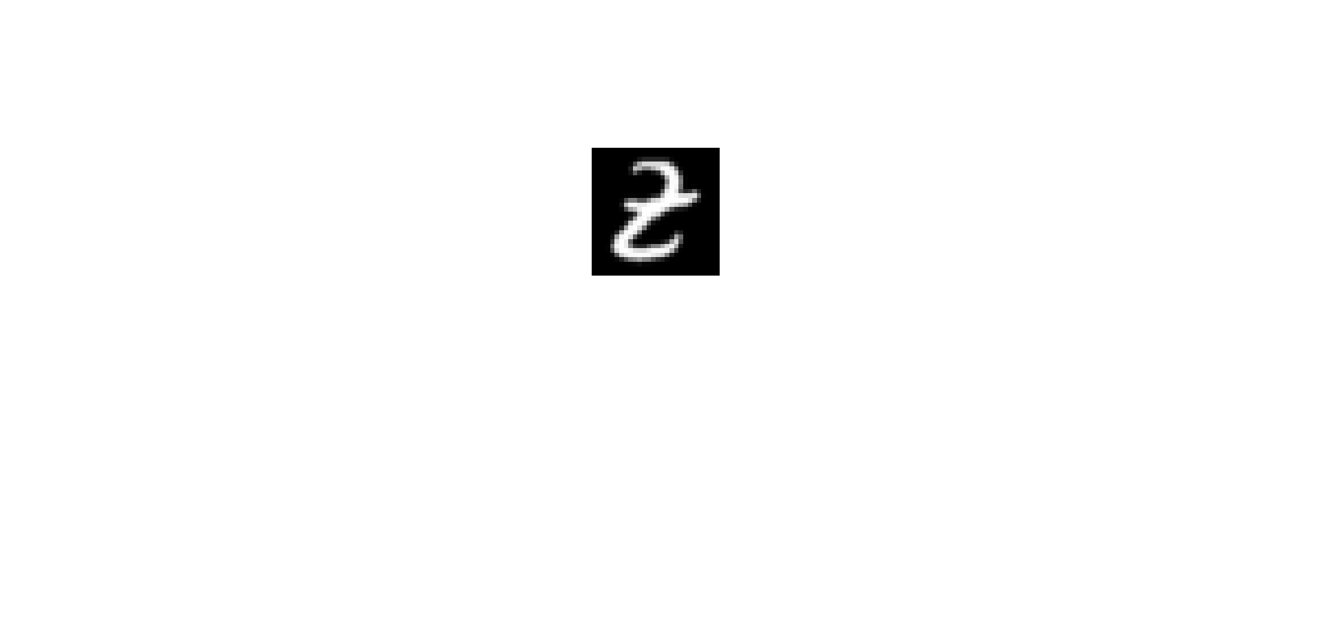

* **Experimental setting:**

Training data: 10 (5 per class)

Validation data (for SVM): 10 (5 per class)

Test data: 1000 (500 per class)

All experiments are repeat 10 times.

* **Results:**

SVM vs. SVM+GL

CNN vs. CNN+GL

* **Handwritten digits/letters images**

**Binary classification 5 (positive vs. negative samples):**

Positive samples (digits randomly chosen from EMNIST dataset, 28*28)

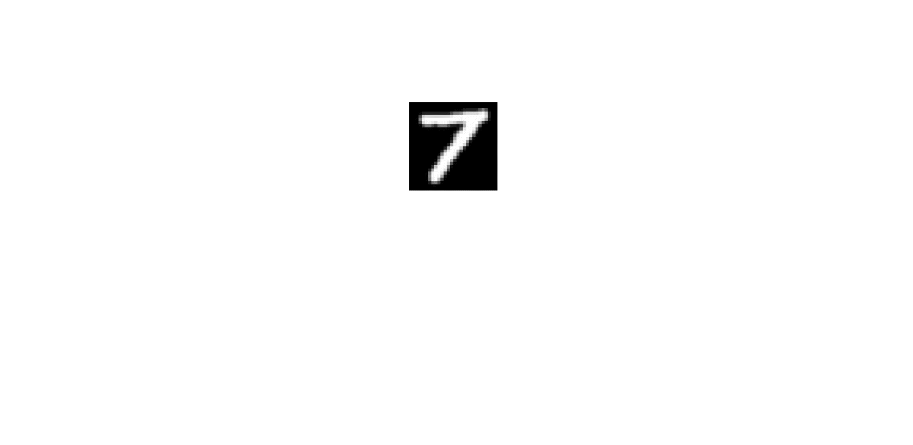 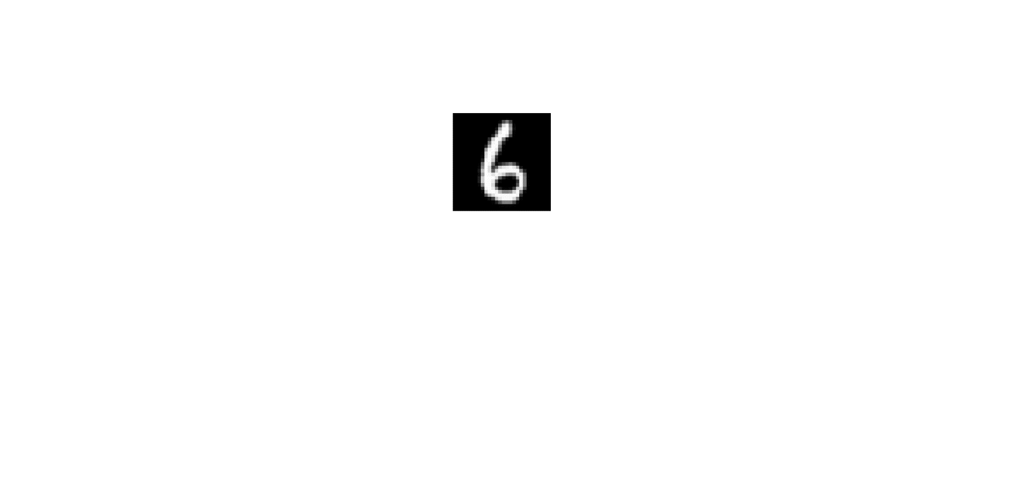 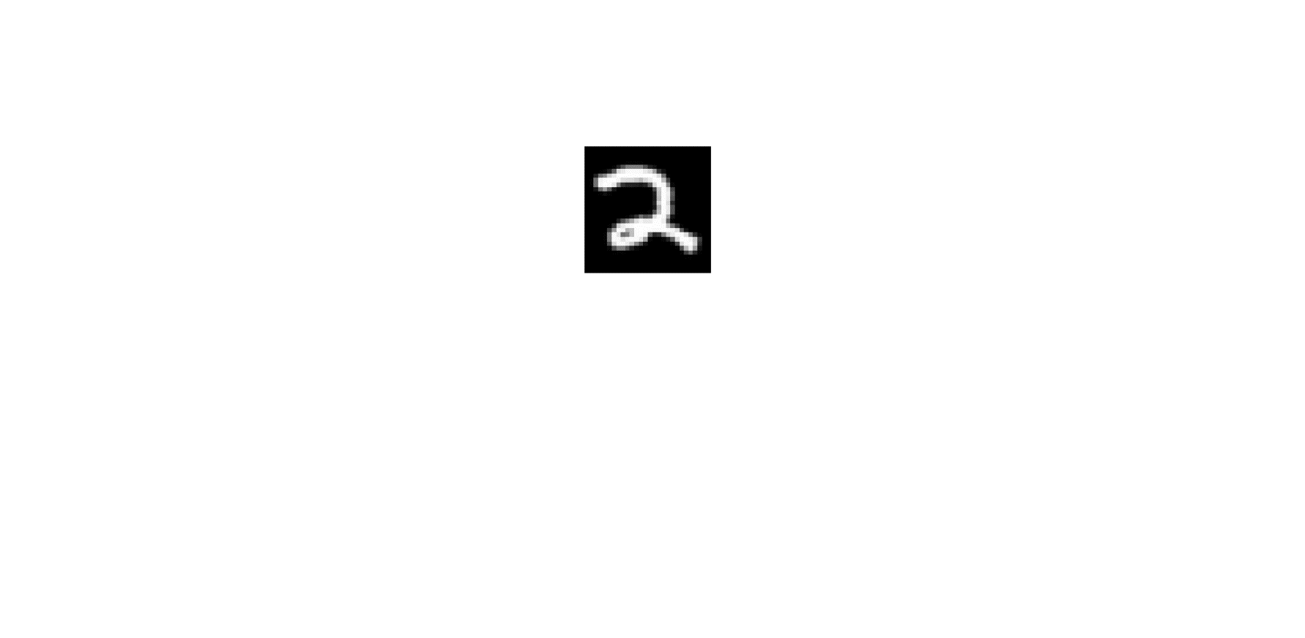 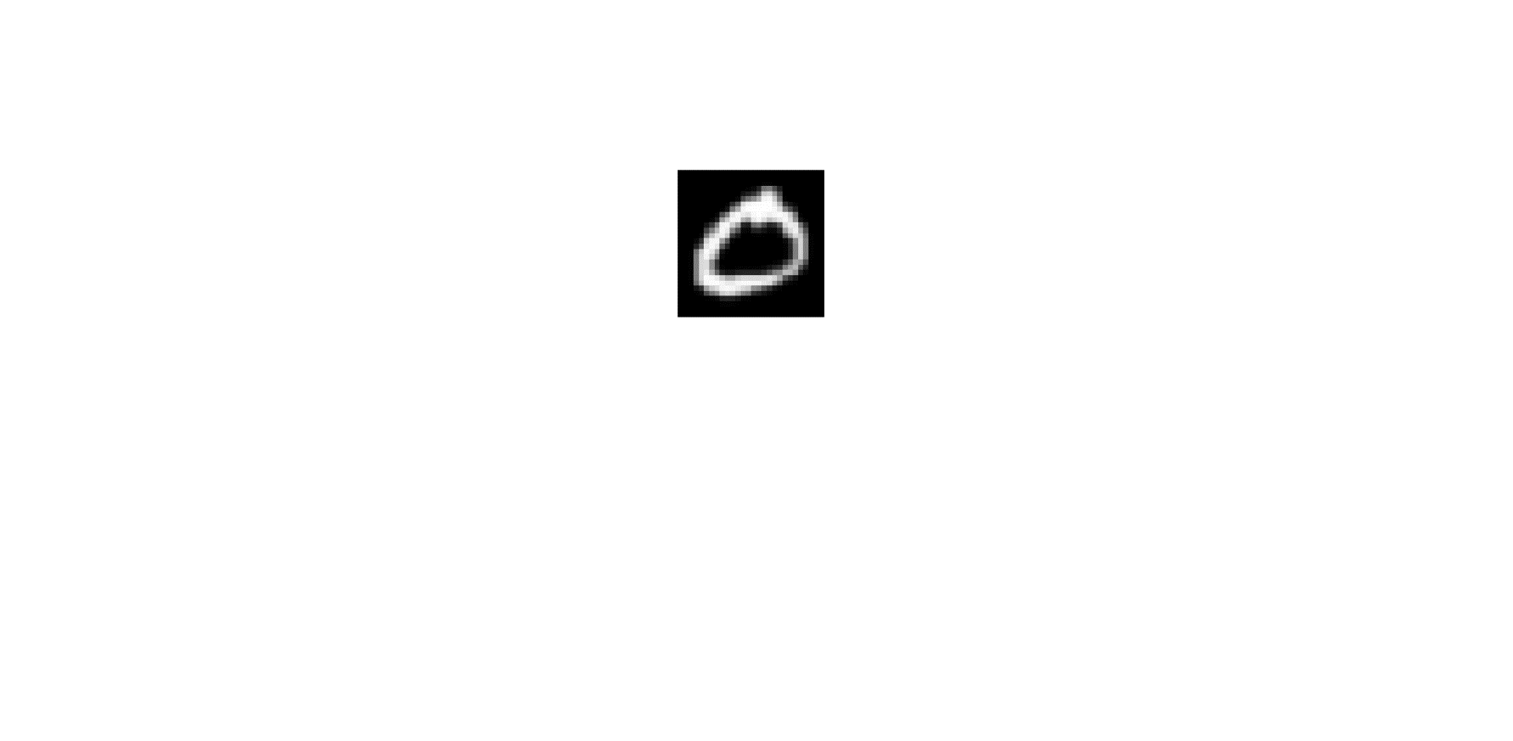 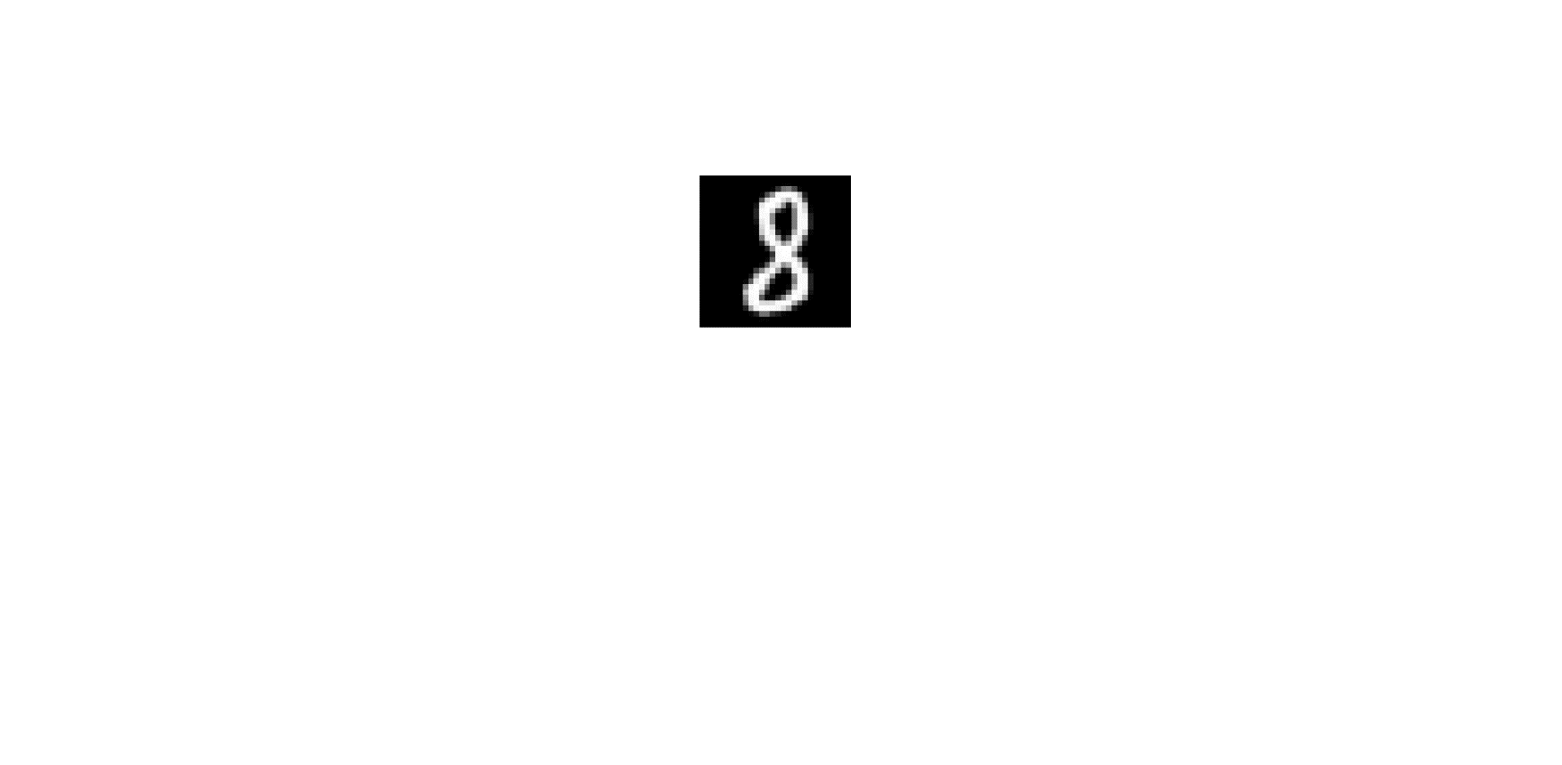

Negative samples (letters randomly chosen from EMNIST dataset, 28*28)

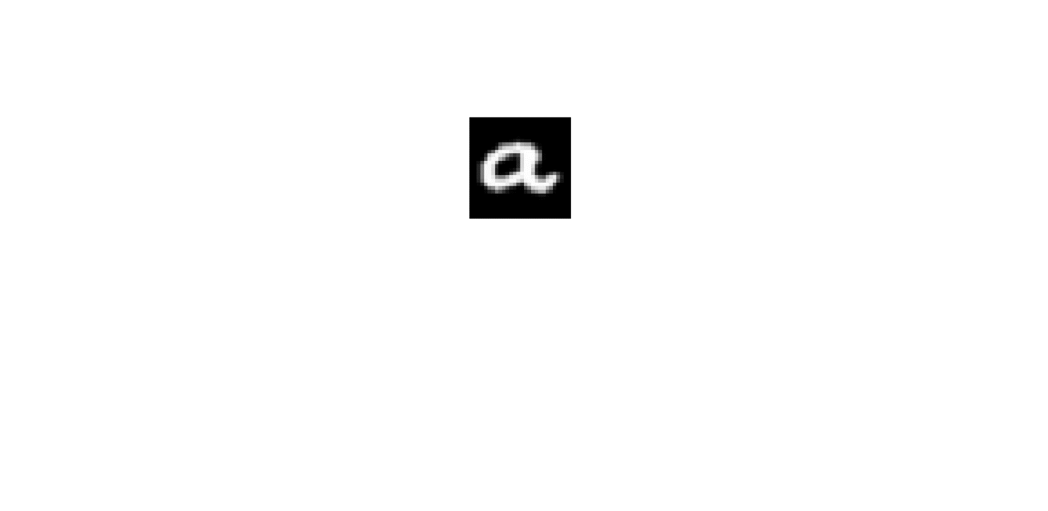 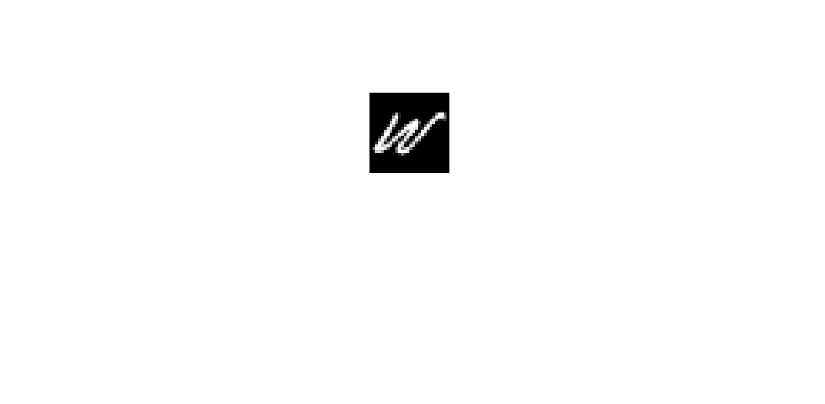  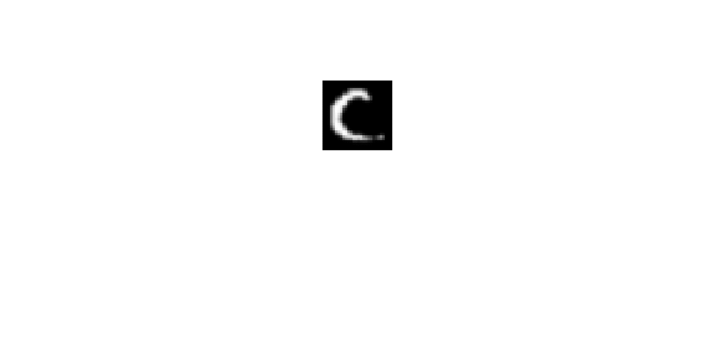 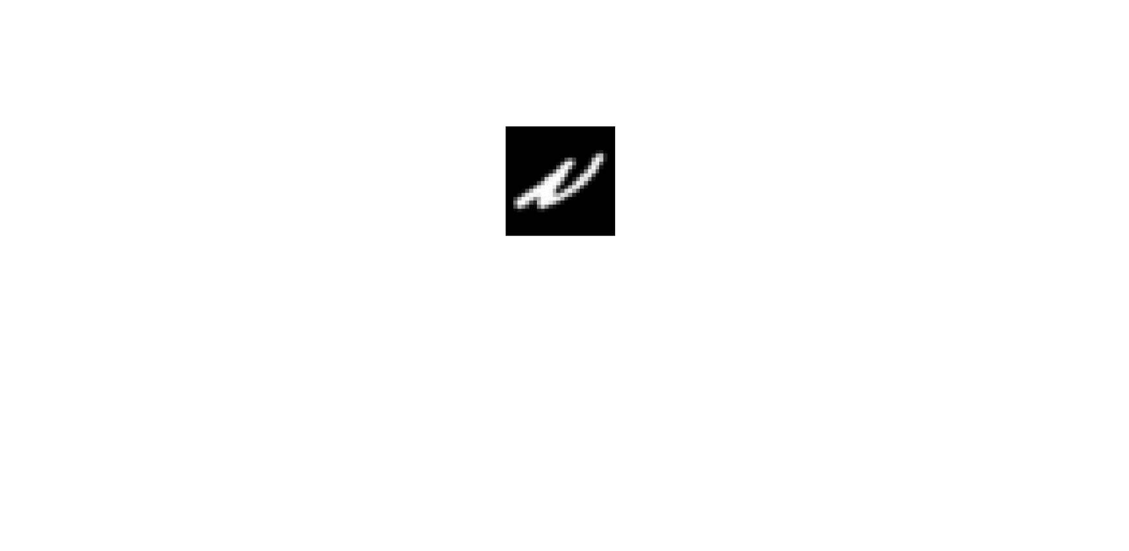

* **Experimental setting:**

Training data: 30 (15 per class)

Validation data (for SVM): 30 (15 per class)

Test data: 1000 (500 per class)

* **Results:**

SVM vs. SVM+GL

CNN vs. CNN+GL

**Binary classification 6 (positive vs. negative samples):**

Positive samples (randomly choose two digits, 7&5 are chosen, from EMNIST dataset, 28*28)

 

Negative samples (randomly choose two letters, J&R are chosen, from EMNIST dataset, 28*28)

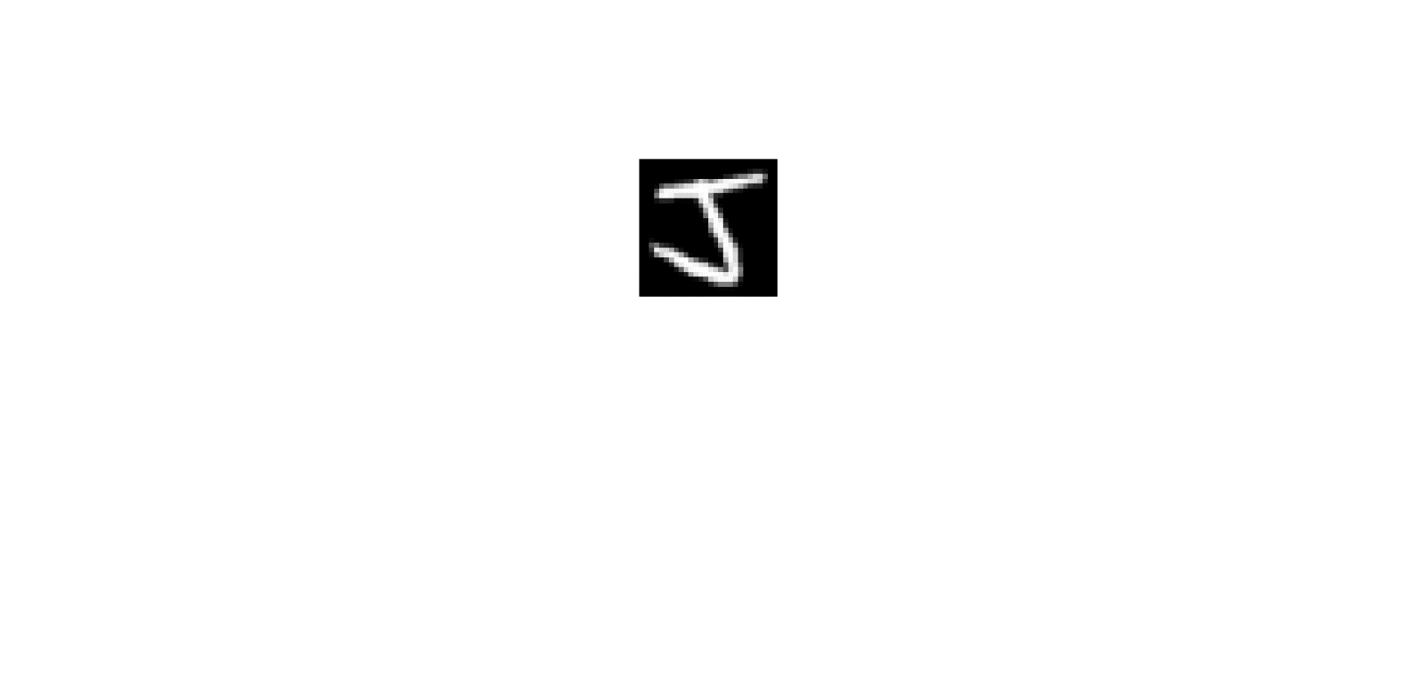   

* **Experimental setting:**

Training data: 30 (15 per class)

Validation data (for SVM): 30 (15 per class)

Test data: 1000 (500 per class)

* **Results:**

CNN vs. CNN+GL