**Group Learning with different window size**

* **Handwritten digit images**
* **Binary classification 1 (positive vs. negative samples):**

Positive samples (digit 8, 28*28)

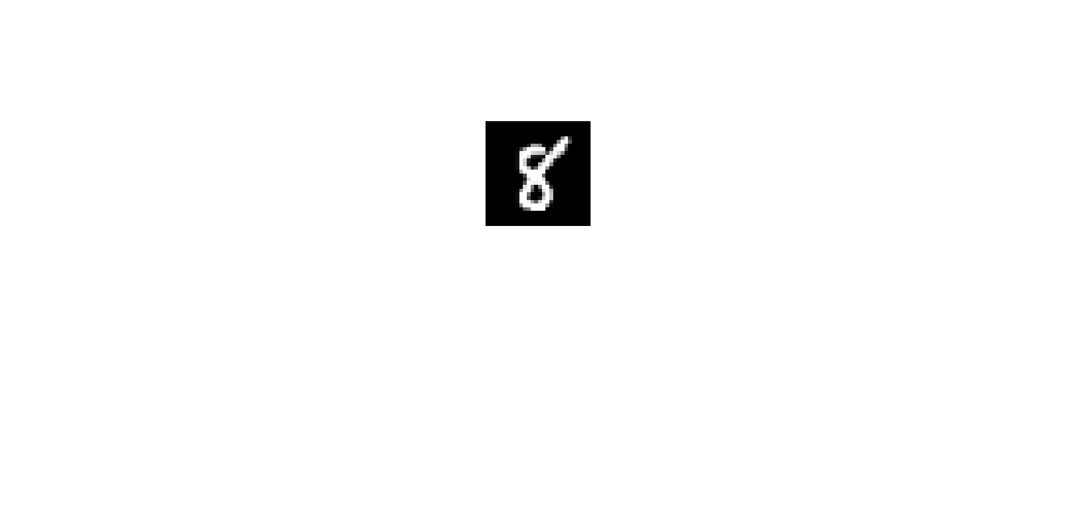

Negative samples (digit 5, 28*28)

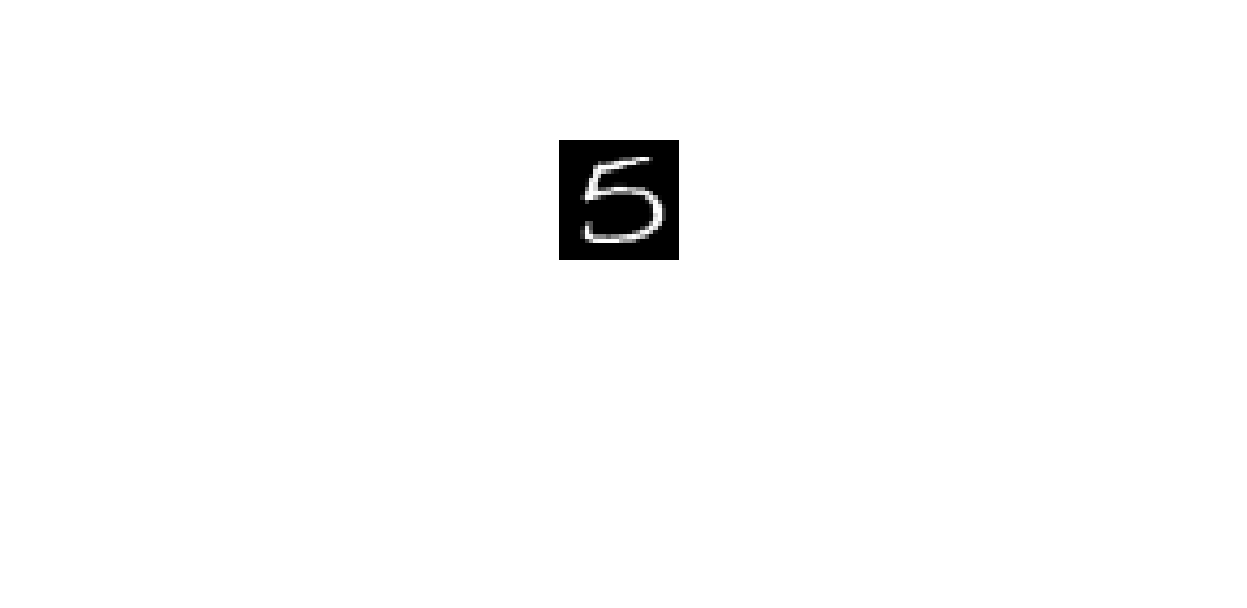

* **Experimental setting:**

Training data: 10 (5 per class)

Validation data (for SVM): 10 (5 per class)

Test data: 1000 (500 per class)

All experiments are repeat 10 times.

* **Results:**

SVM vs. SVM+GL

CNN vs. CNN+GL

* **Binary classification 2 (positive vs. negative samples):**

Positive samples (digit 3, 28*28)

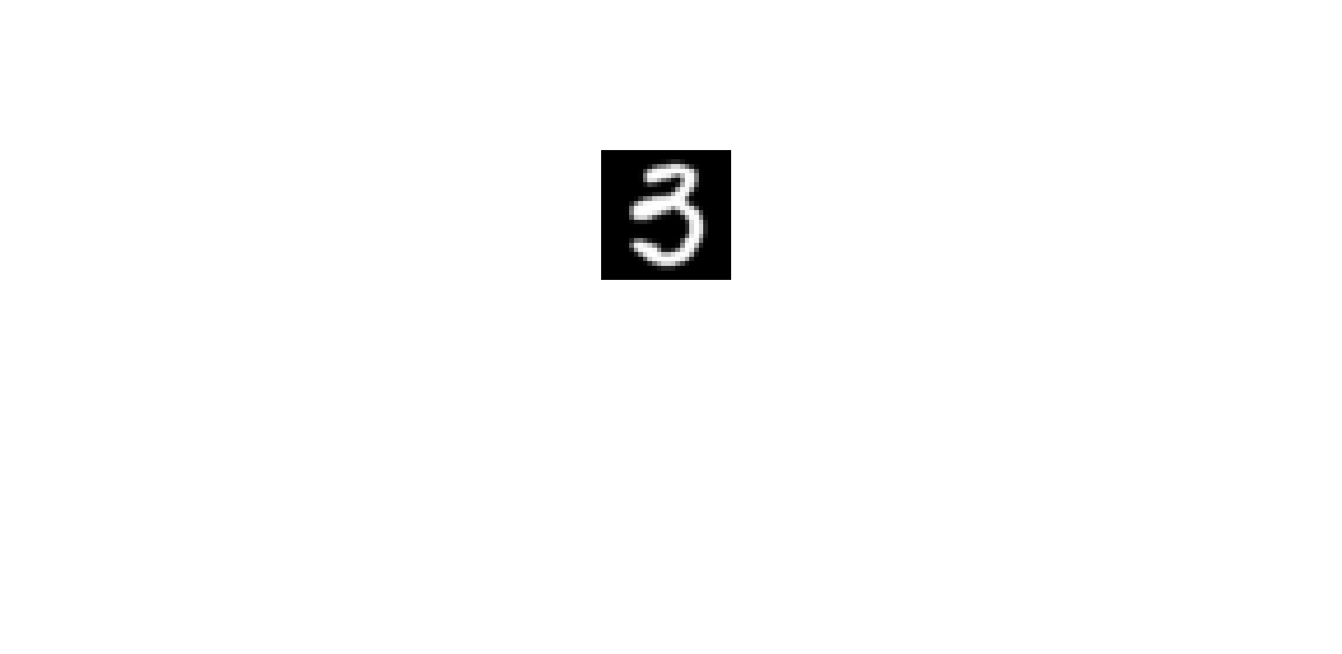

Negative samples (digit 5, 28*28)

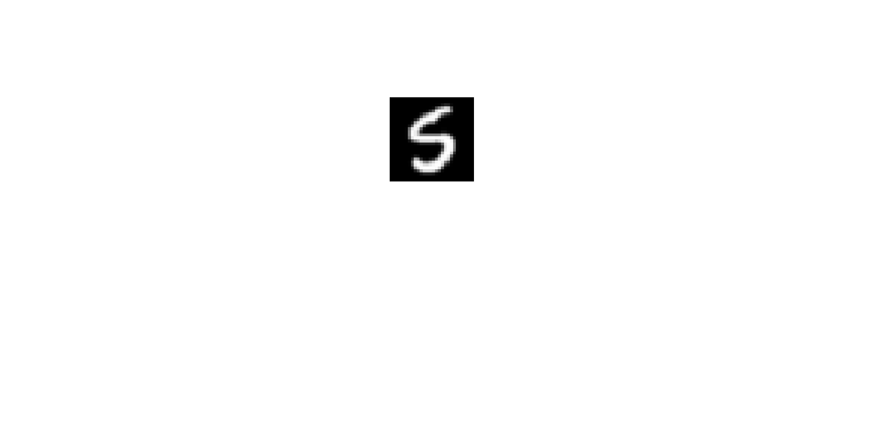

* **Experimental setting:**

Training data: 10 (5 per class)

Validation data (for SVM): 10 (5 per class)

Test data: 1000 (500 per class)

All experiments are repeat 10 times.

* **Results:**

SVM vs. SVM+GL

CNN vs. CNN+GL

* **Binary classification 3 (positive vs. negative samples):**

Positive samples (Letter e/E, 28*28)

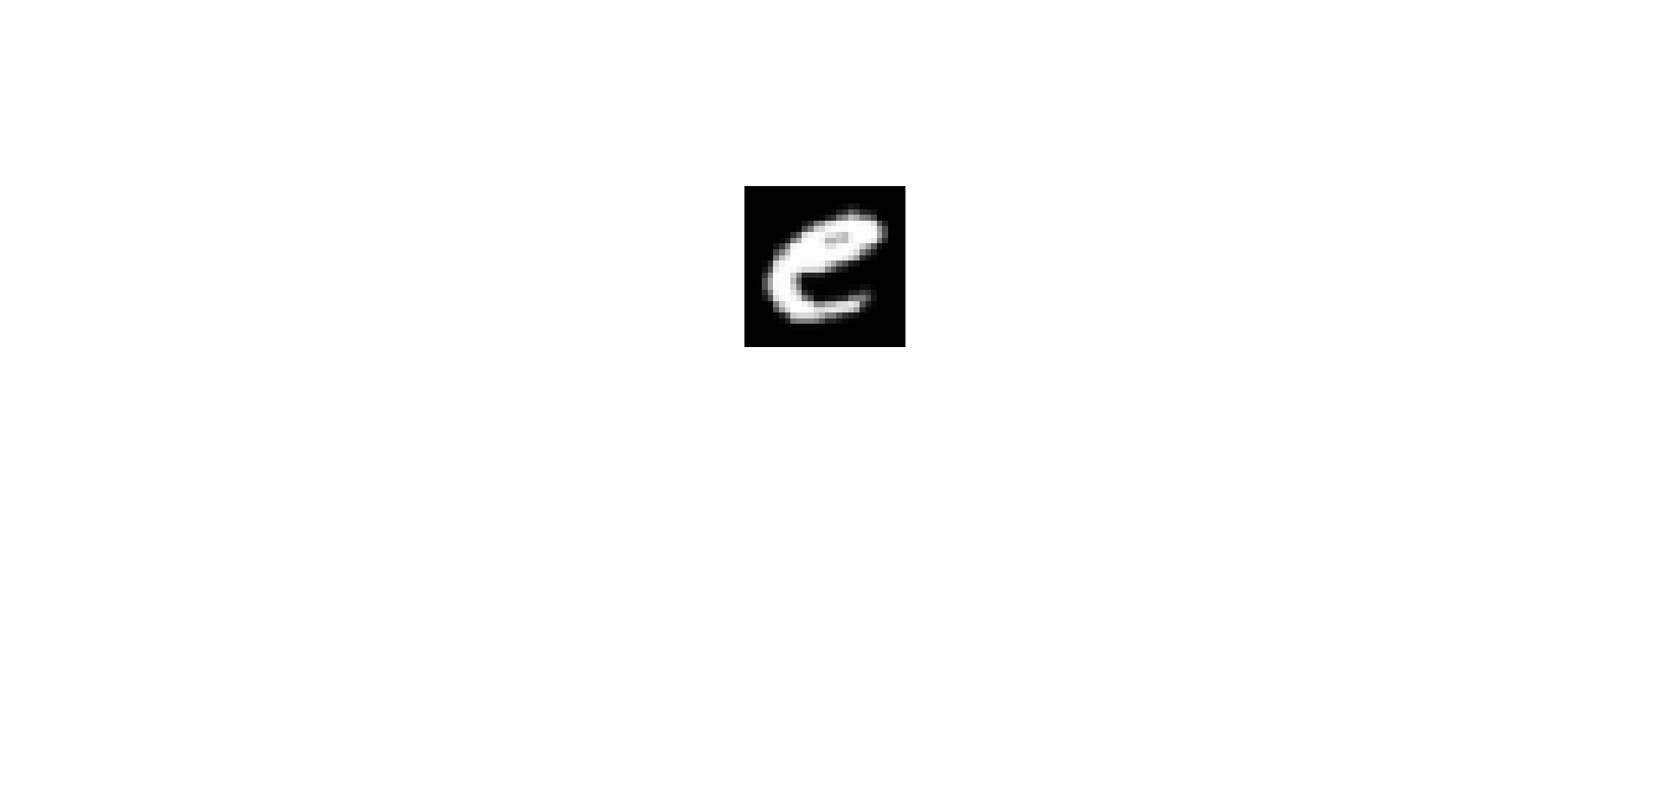 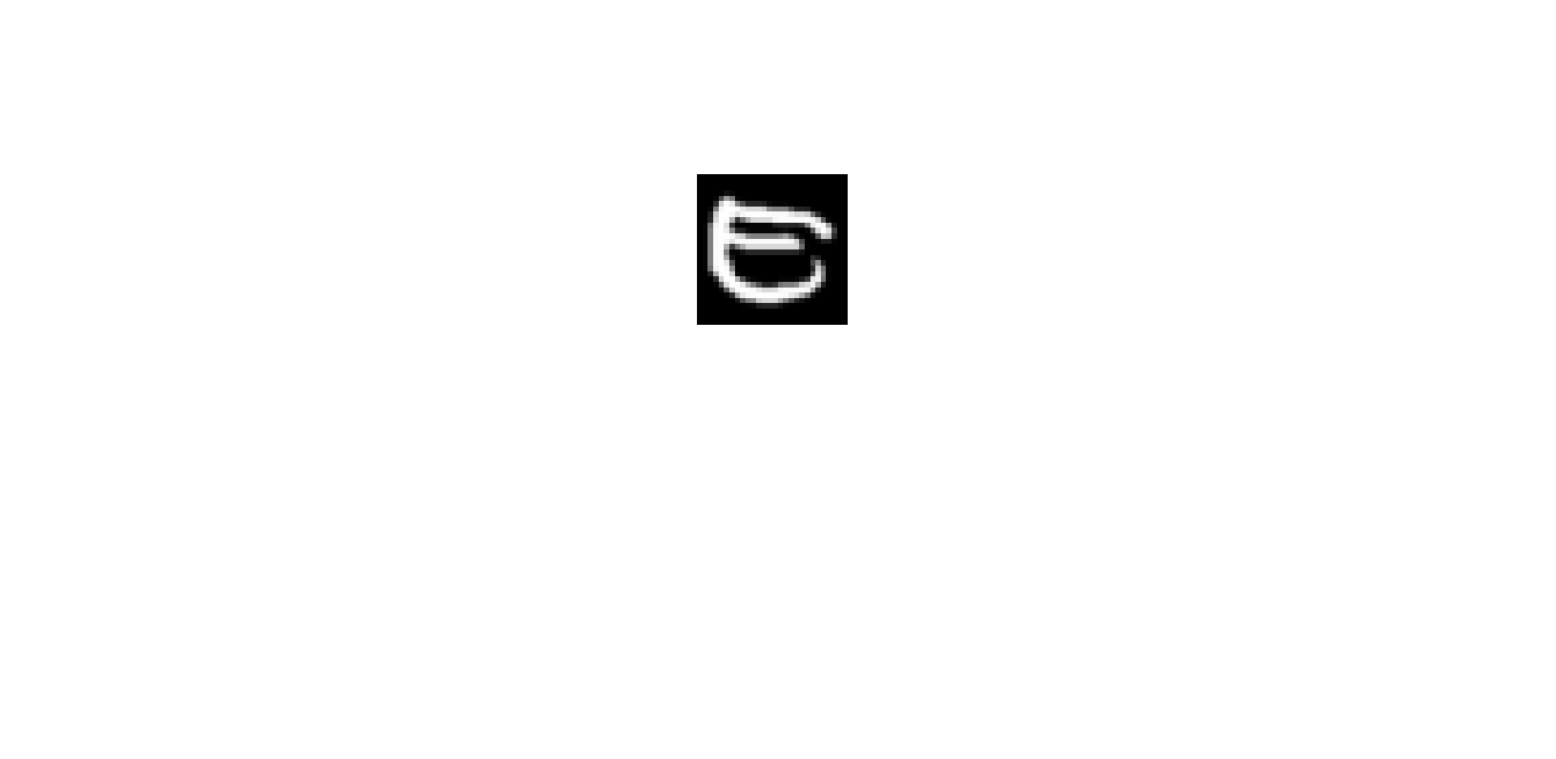

Negative samples (Letter f/F, 28*28)

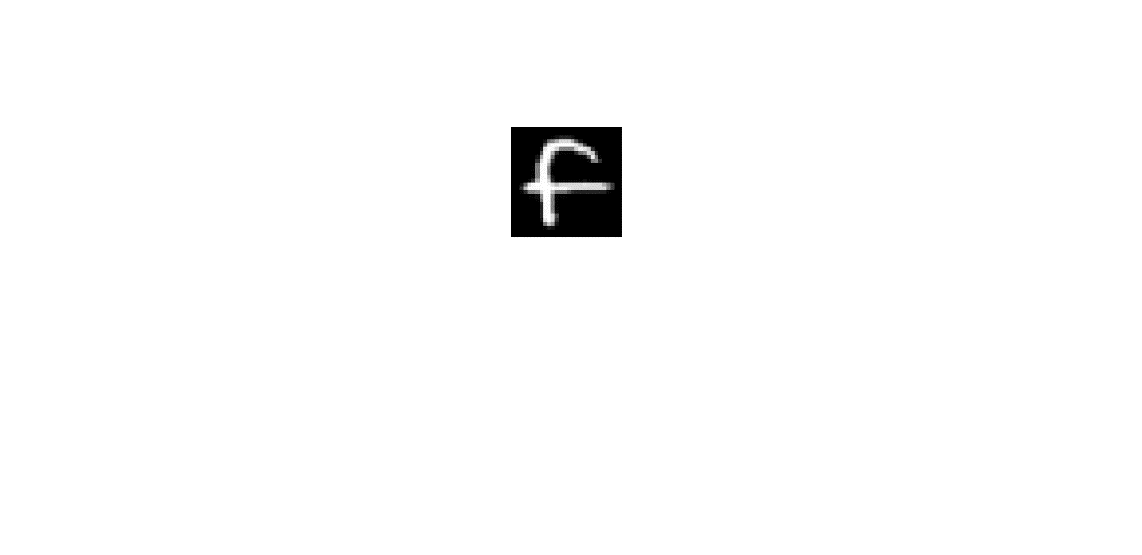 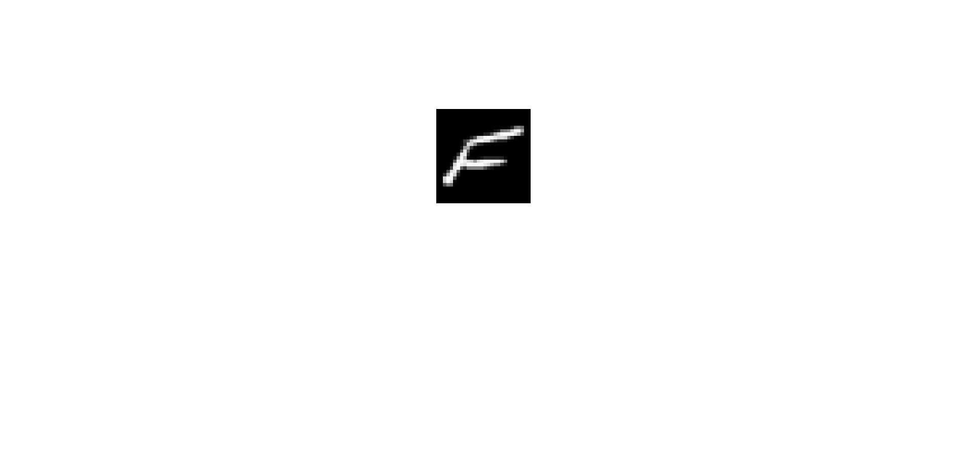

* **Experimental setting:**

Training data: 10 (5 per class)

Validation data (for SVM): 10 (5 per class)

Test data: 1000 (500 per class)

All experiments are repeat 10 times.

* **Results:**

SVM vs. SVM+GL

CNN vs. CNN+GL

* **Binary classification 4 (positive vs. negative samples):**

Positive samples (Letter y/Y, 28*28)

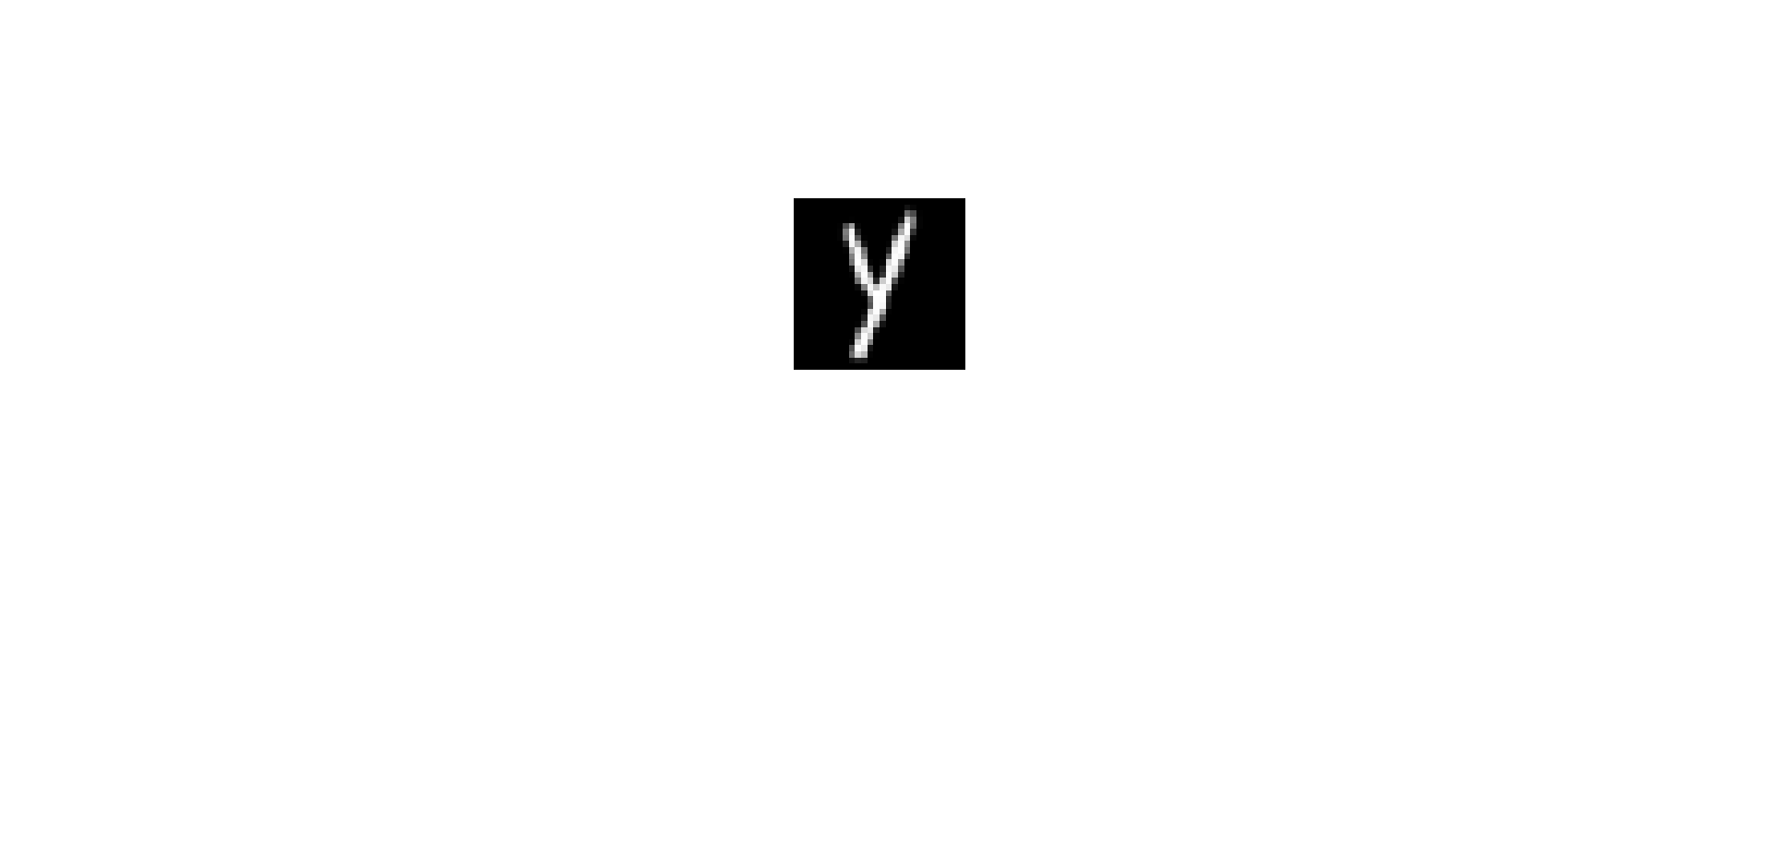 

Negative samples (Letter z/Z, 28*28)

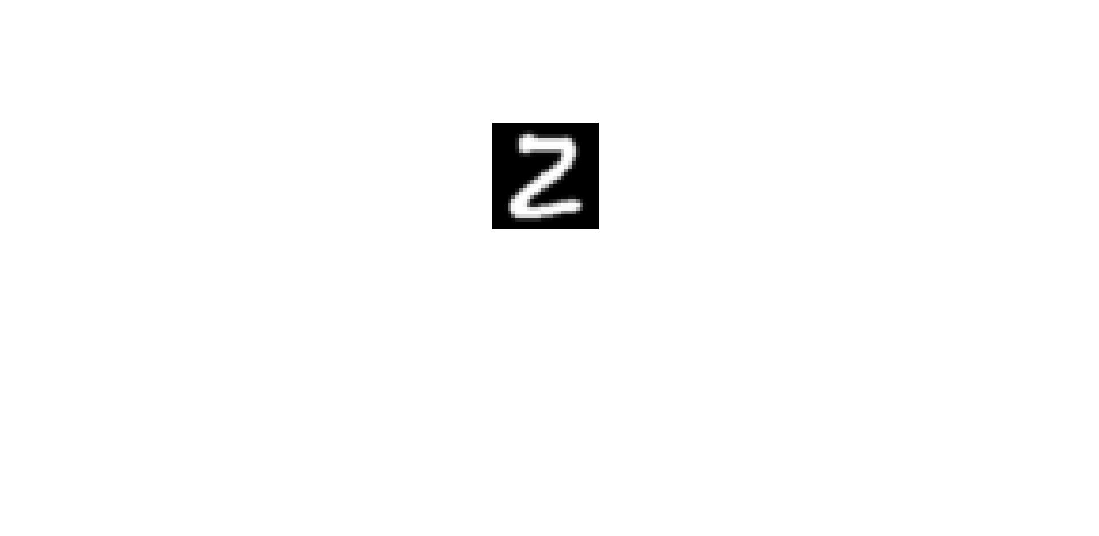 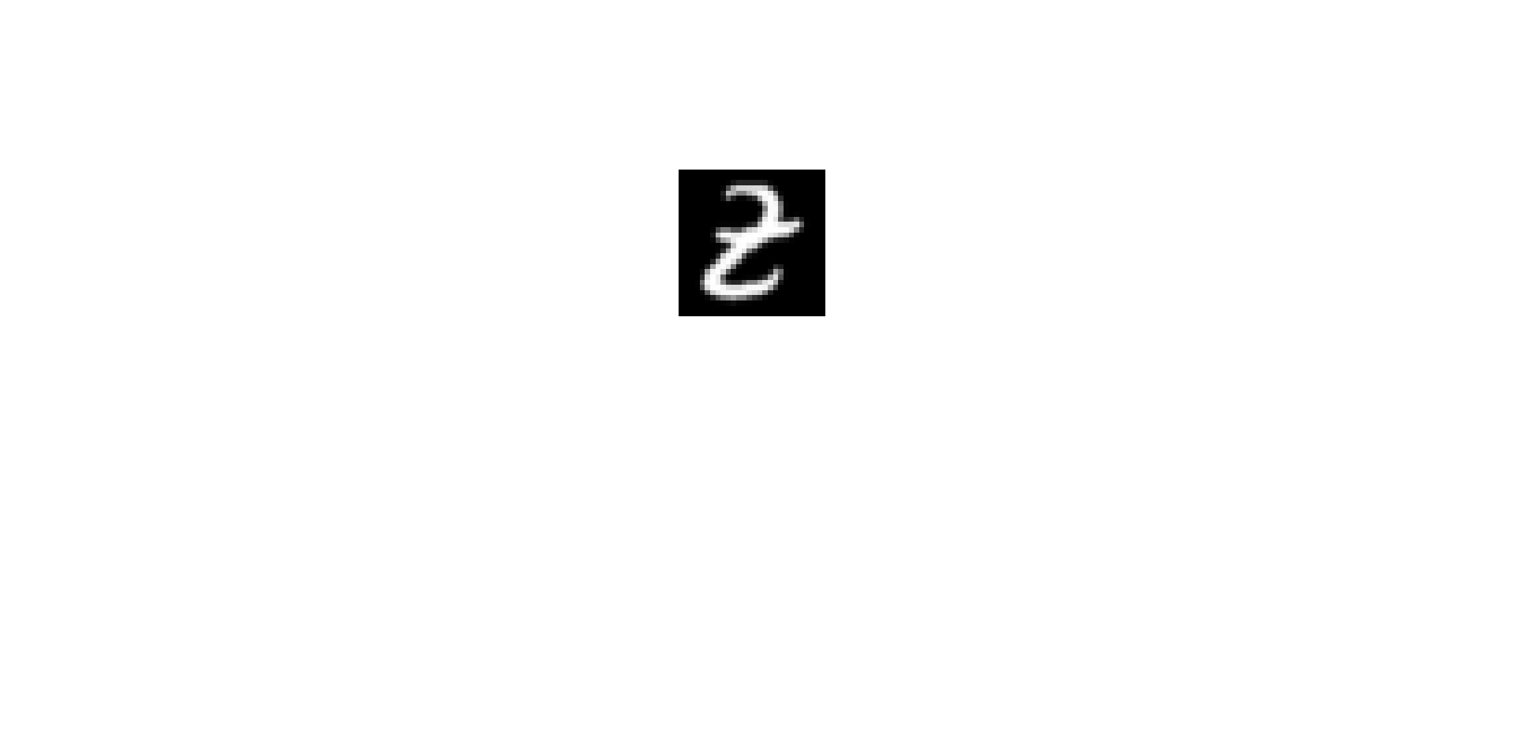

* **Experimental setting:**

Training data: 10 (5 per class)

Validation data (for SVM): 10 (5 per class)

Test data: 1000 (500 per class)

All experiments are repeat 10 times.

* **Results:**

SVM vs. SVM+GL

CNN vs. CNN+GL

* **Handwritten digits/letters images**

**Binary classification 5 (positive vs. negative samples):**

Positive samples (digits randomly chosen from EMNIST dataset, 28*28)

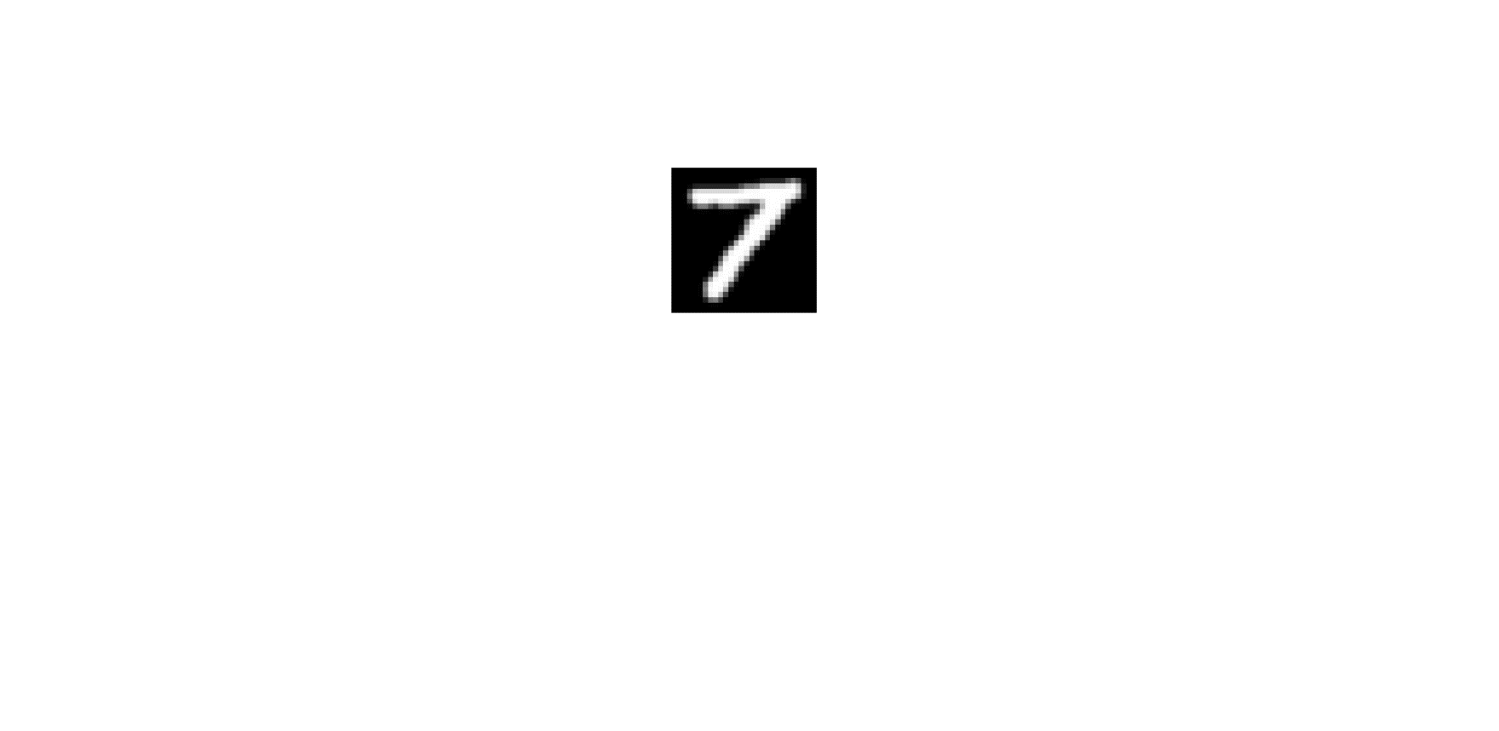 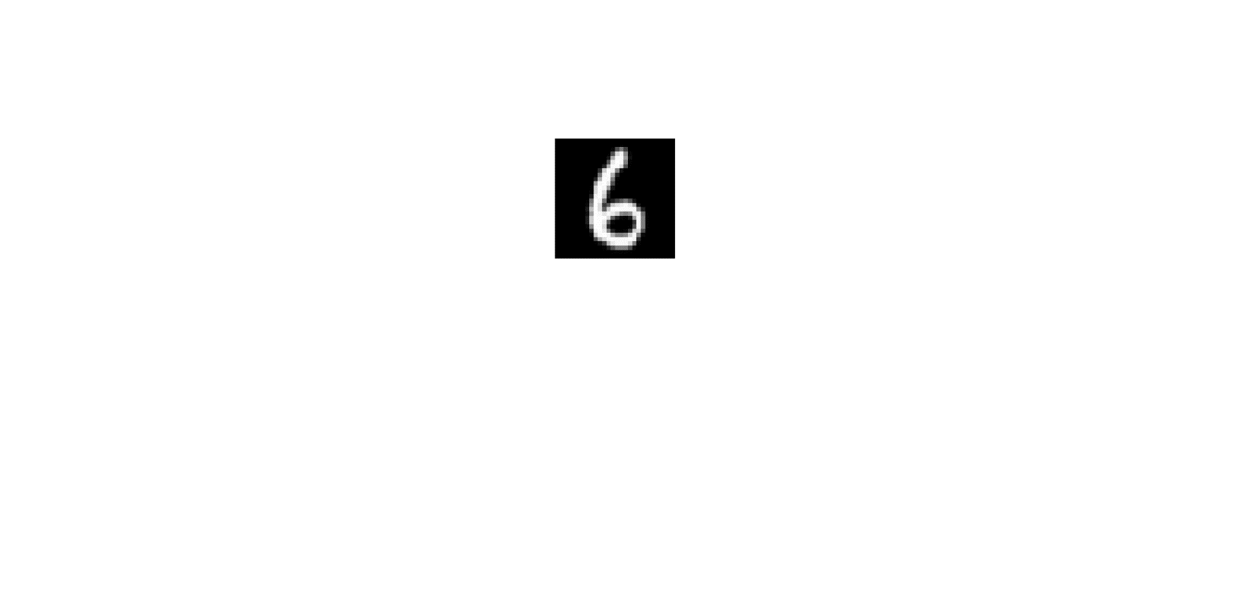 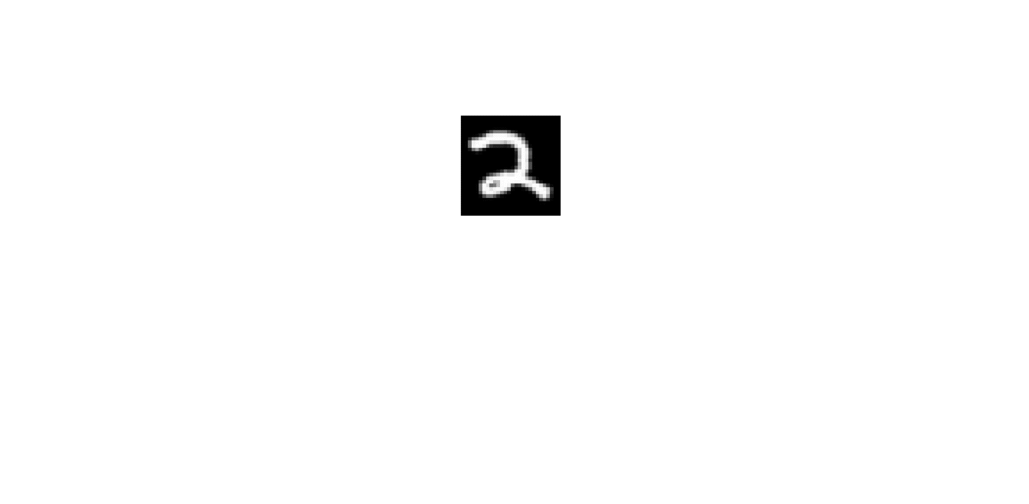 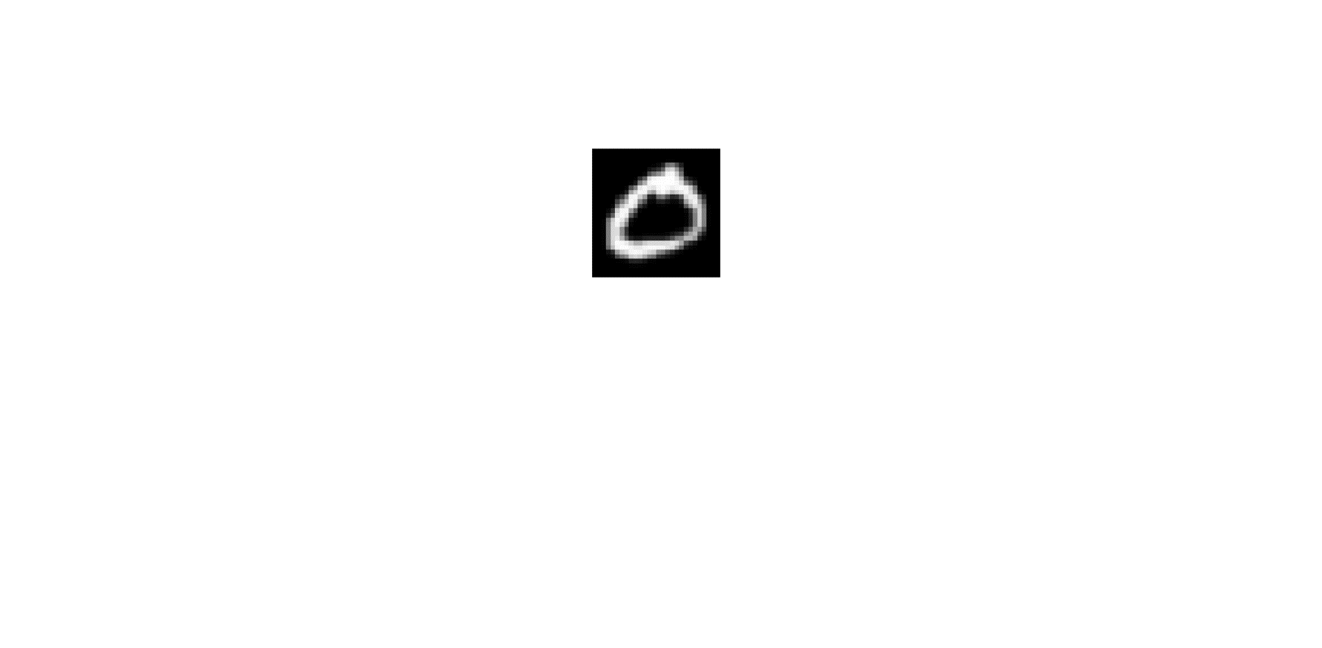 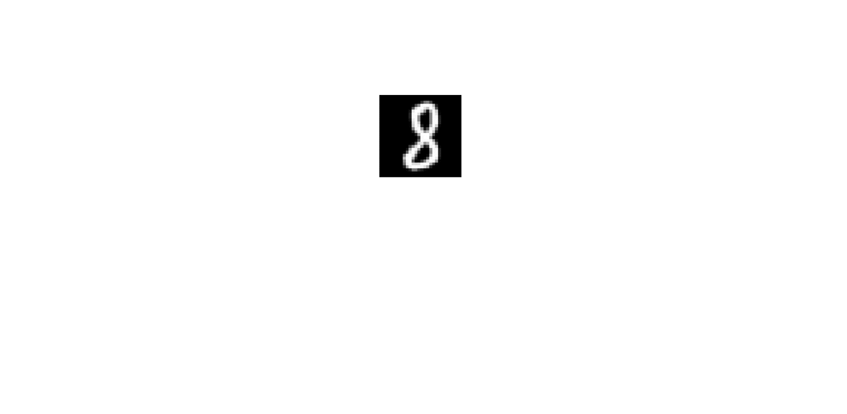

Negative samples (letters randomly chosen from EMNIST dataset, 28*28)

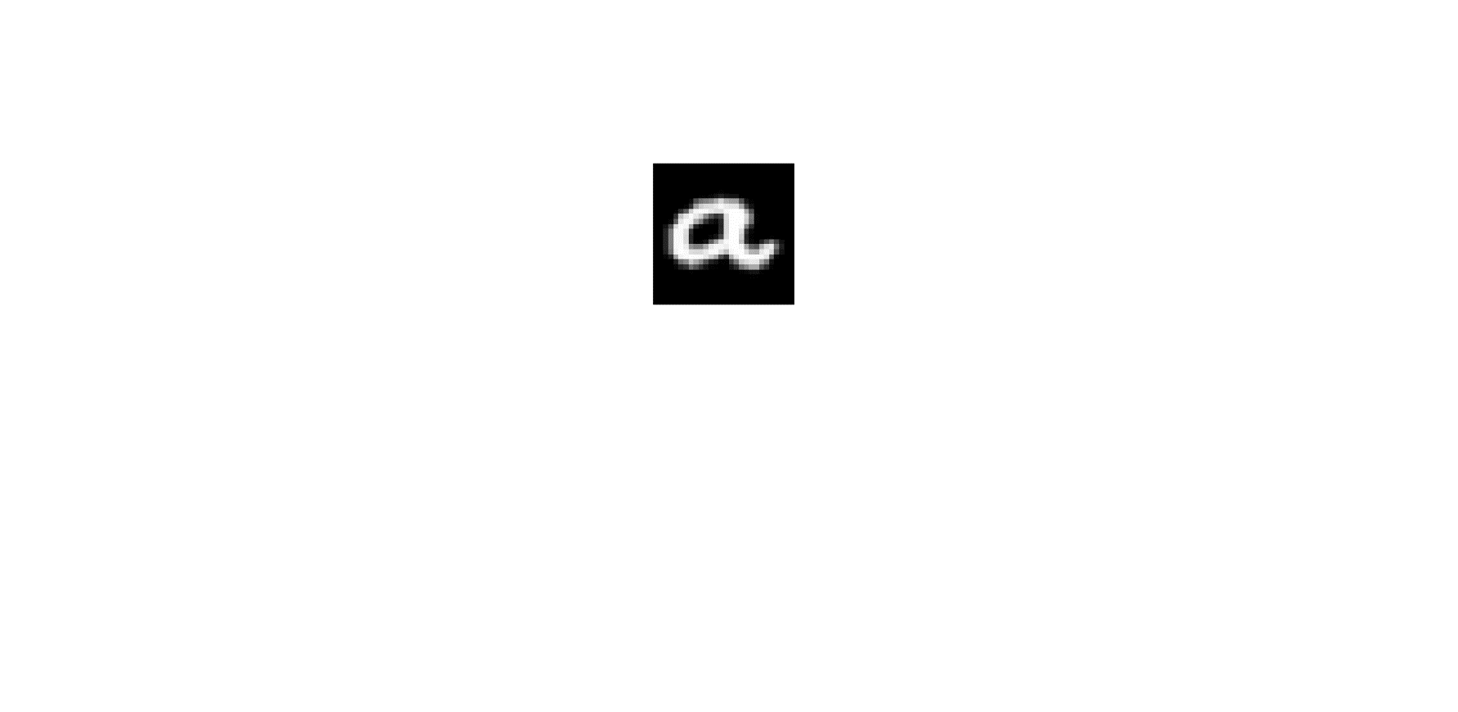 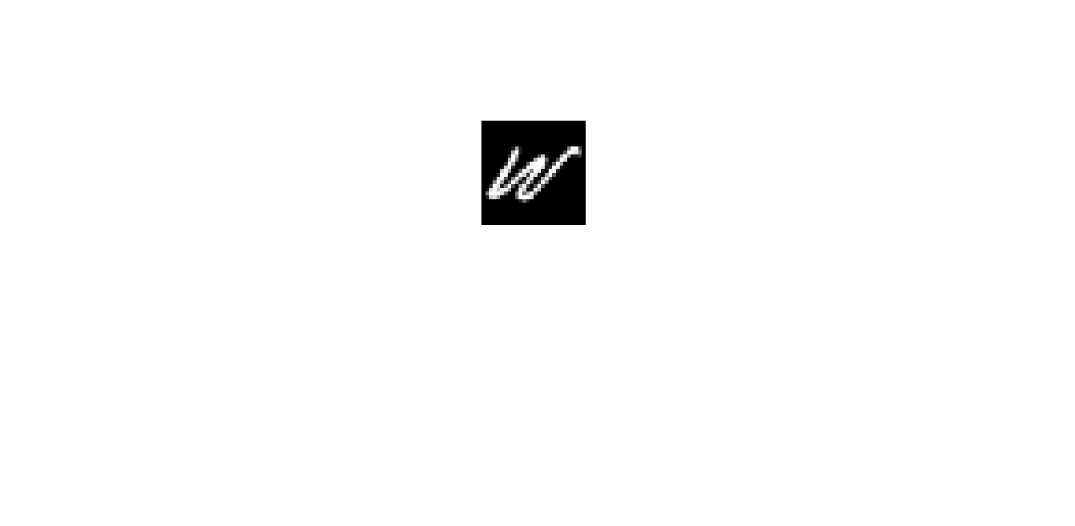  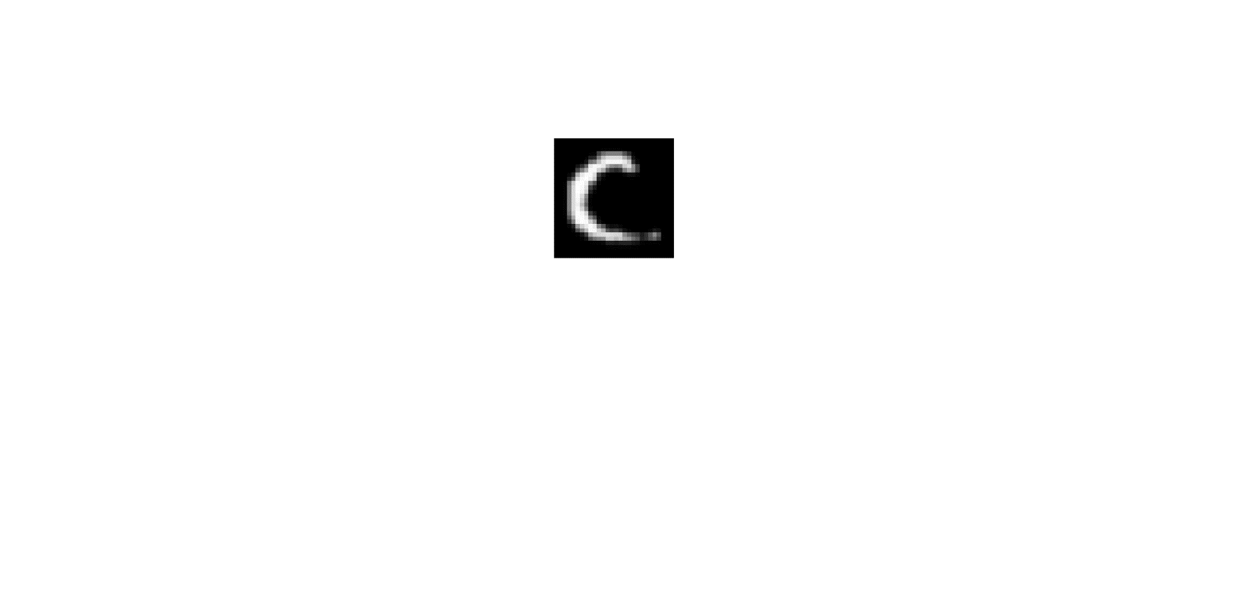 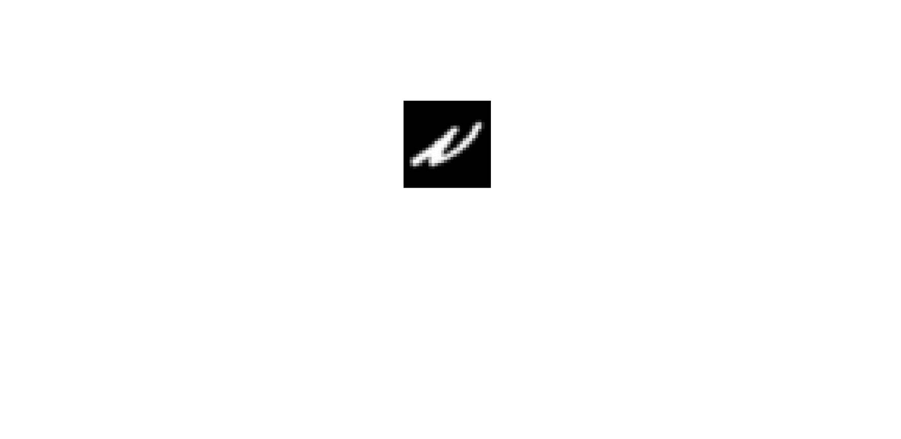

* **Experimental setting:**

Training data: 30 (15 per class)

Validation data (for SVM): 30 (15 per class)

Test data: 1000 (500 per class)

* **Results:**

SVM vs. SVM+GL

CNN vs. CNN+GL

**Binary classification 6 (positive vs. negative samples):**

Positive samples (randomly choose two digits, 7&5 are chosen, from EMNIST dataset, 28*28)

 

Negative samples (randomly choose two letters, J&R are chosen, from EMNIST dataset, 28*28)

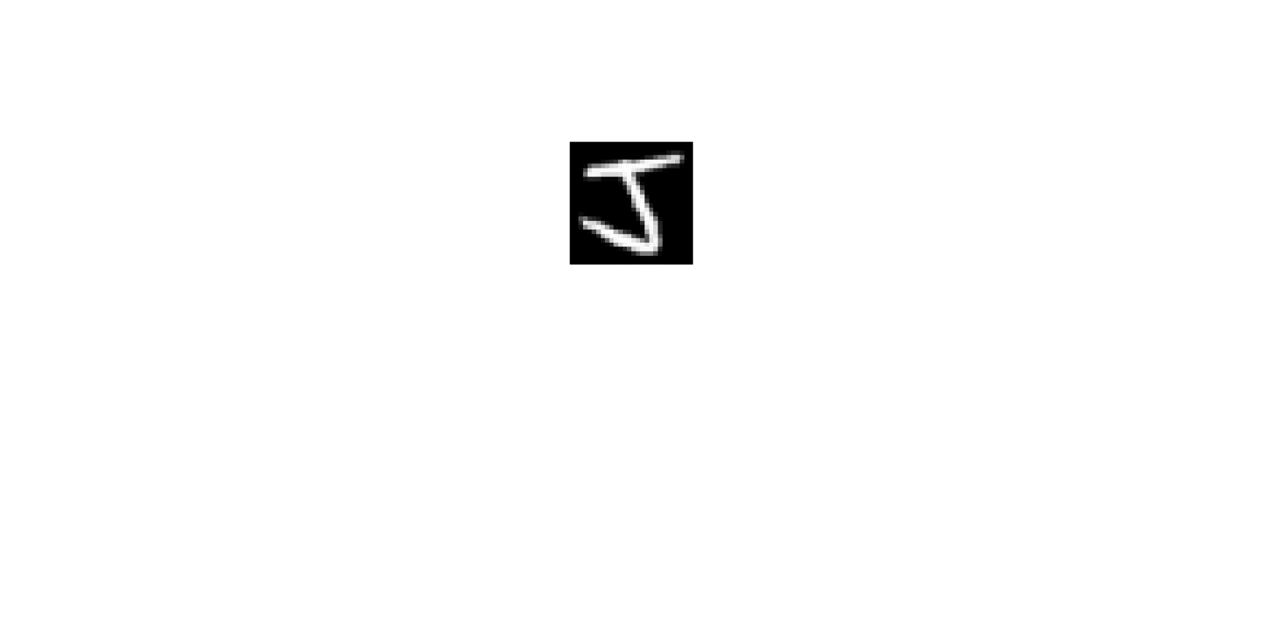 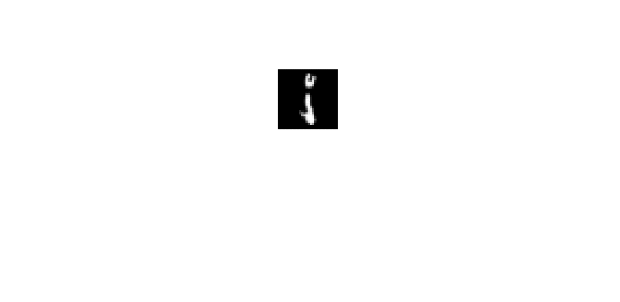  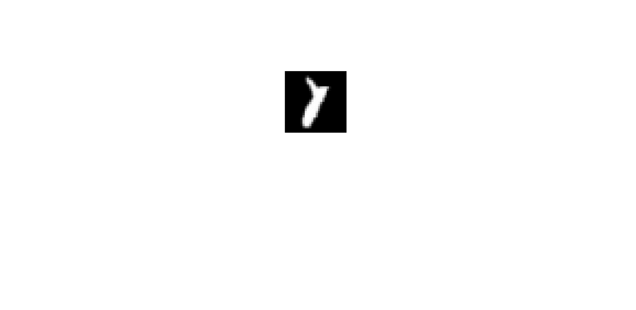

* **Experimental setting:**

Training data: 30 (15 per class)

Validation data (for SVM): 30 (15 per class)

Test data: 1000 (500 per class)

* **Results:**

CNN vs. CNN+GL

To do list

###########################################################

Training data: 200 (100 per class)

Validation data (for SVM): 200 (100 per class)

Test data: 1000 (500 per class)

Fix the test scale

Histogram

STD

MV vs Adaptive (just for first two three experiments)

For the rest only show Adaptive with STD

Similar distribution and different distribution. (by viewing histograms)

Face dataset (female vs. male) – gray scale

###########################################################