**Group Learning for improving performance of classifiers**

**Experiment list:**

* **Handwritten digit images:**
* **Digits 8 vs. 5**
* **Digits 3 vs. 5**
* **Handwritten letter images:**
* **letters e(E) vs. f(F)**
* **letters y(Y) vs. z(Z)**
* **Handwritten digit & letter images:**
* **Digits 7, 5 vs. letters j(J), r(R)**
* **Face images (yale dataset):**
* **Individuals 7 vs. 19**
* **Individuals 30 vs. 25**
* **Handwritten digit images**
* **Binary classification 1 (positive vs. negative samples):**

Positive samples (digit 8, 28*28)

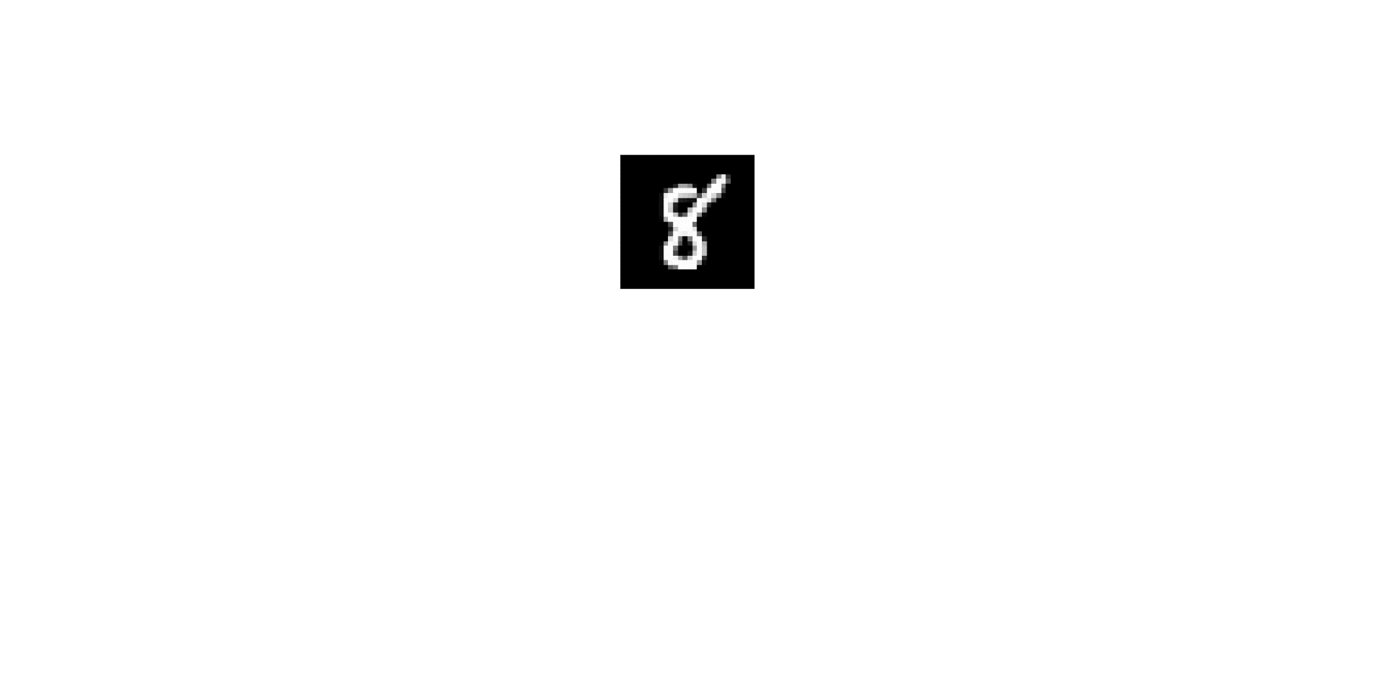

Negative samples (digit 5, 28*28)

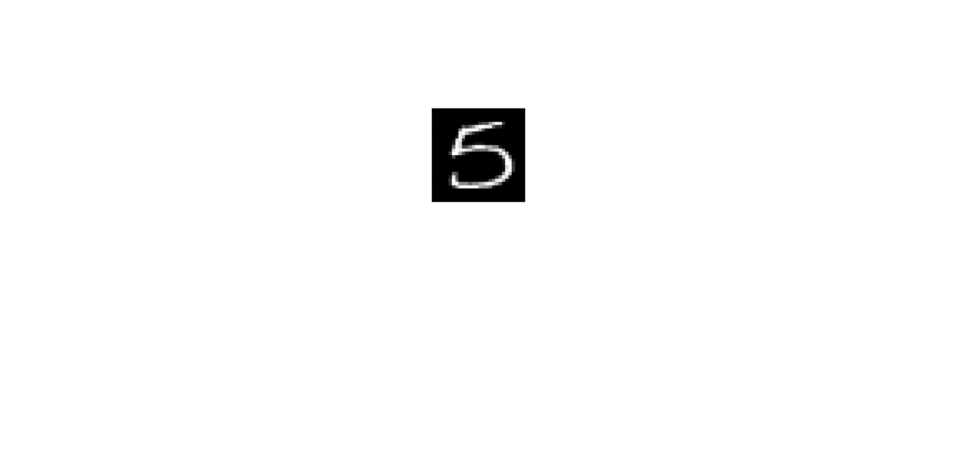

* **Experimental setting:**

Training data: 10 (5 per class)

Validation data (for SVM): 10 (5 per class)

Test data: 1000 (500 per class)

All experiments are repeat 10 times.

* **Results:**

SVM vs. SVM+GL

CNN vs. CNN+GL

* **Binary classification 2 (positive vs. negative samples):**

Positive samples (digit 3, 28*28)

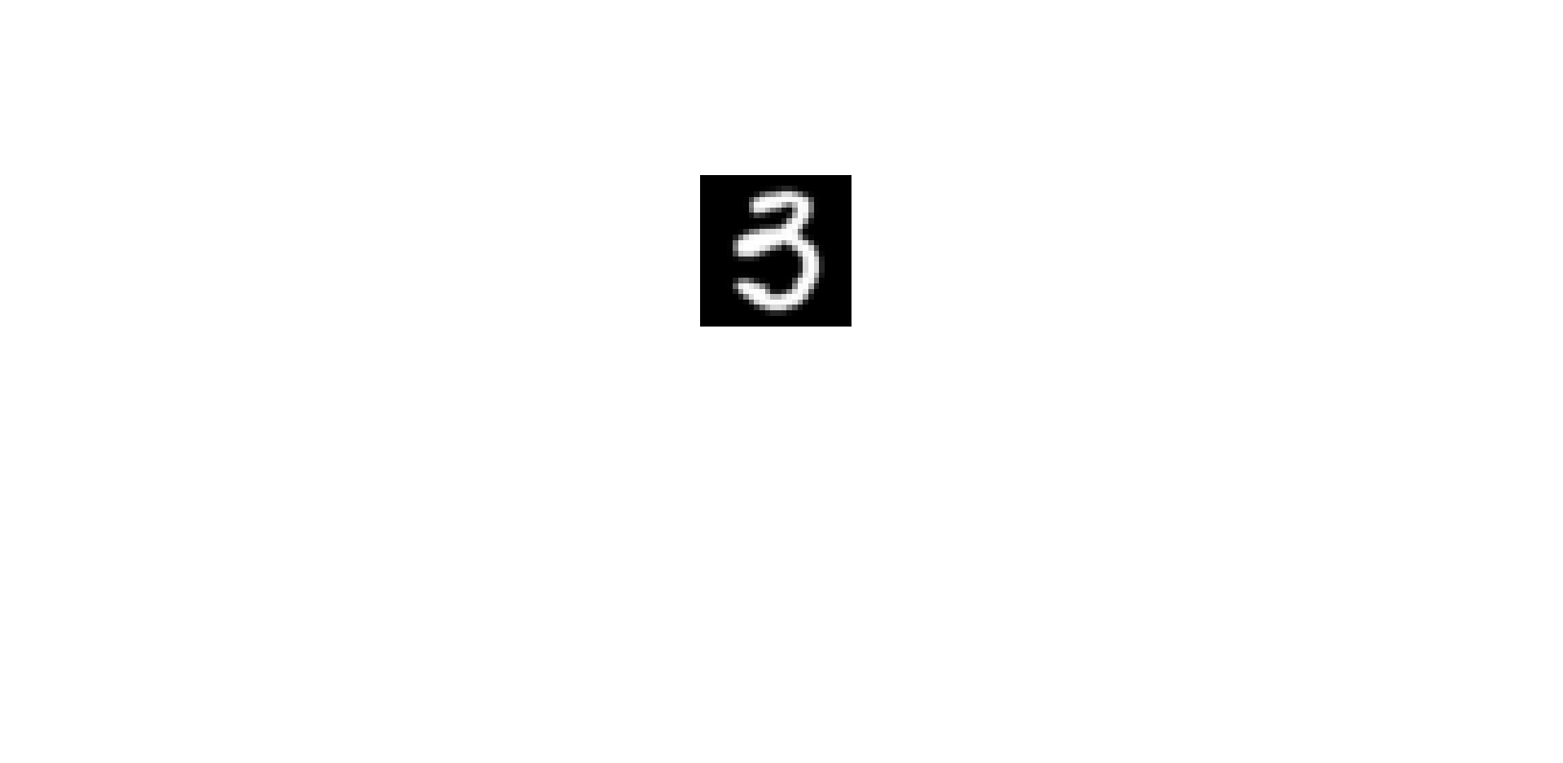

Negative samples (digit 5, 28*28)

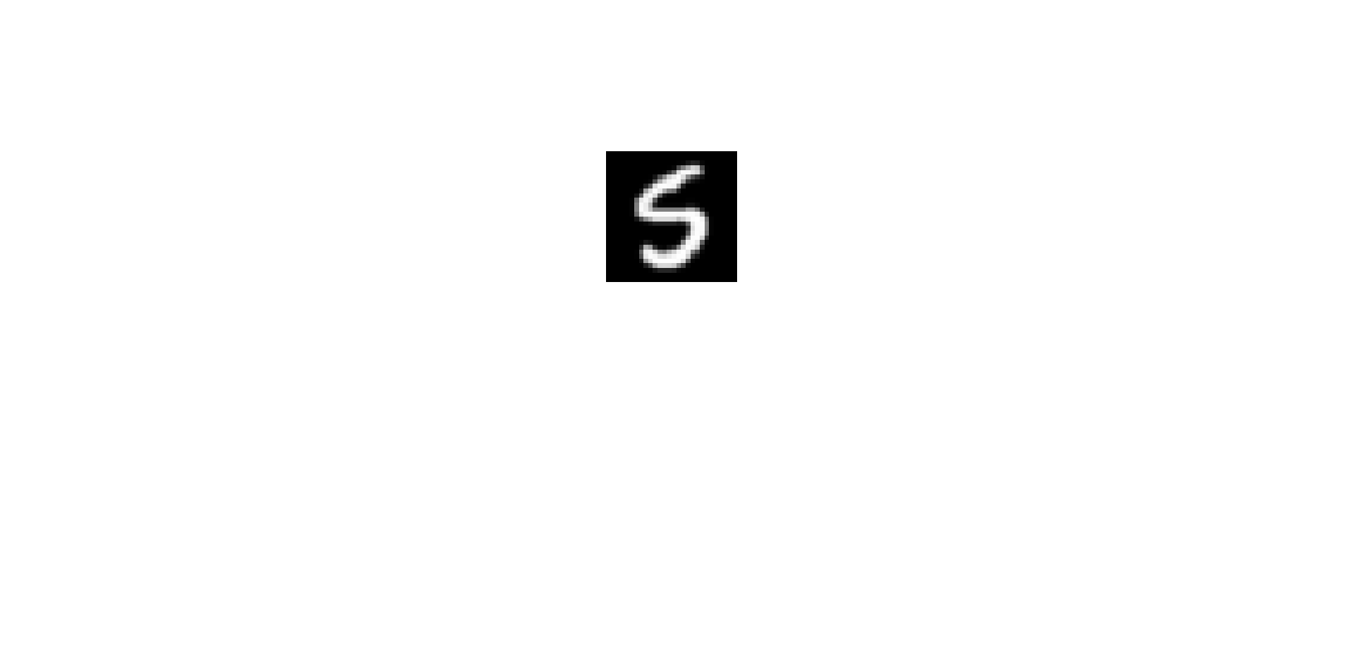

* **Experimental setting:**

Training data: 10 (5 per class)

Validation data (for SVM): 10 (5 per class)

Test data: 1000 (500 per class)

All experiments are repeat 10 times.

* **Results:**

SVM vs. SVM+GL

CNN vs. CNN+GL

* **Binary classification 3 (positive vs. negative samples):**

Positive samples (Letter e/E, 28*28)

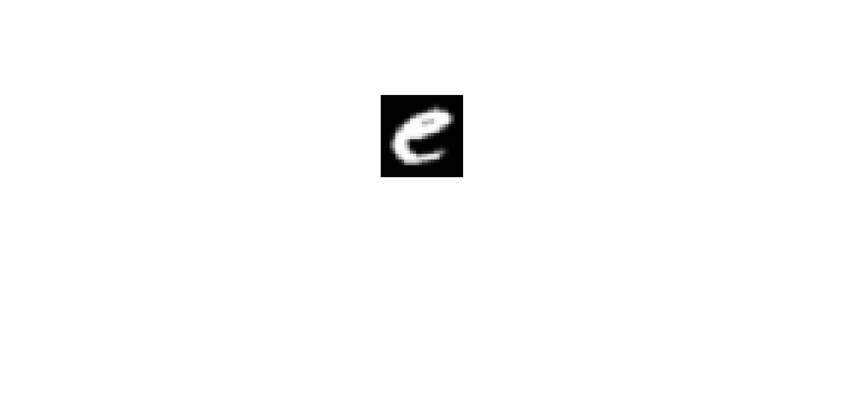 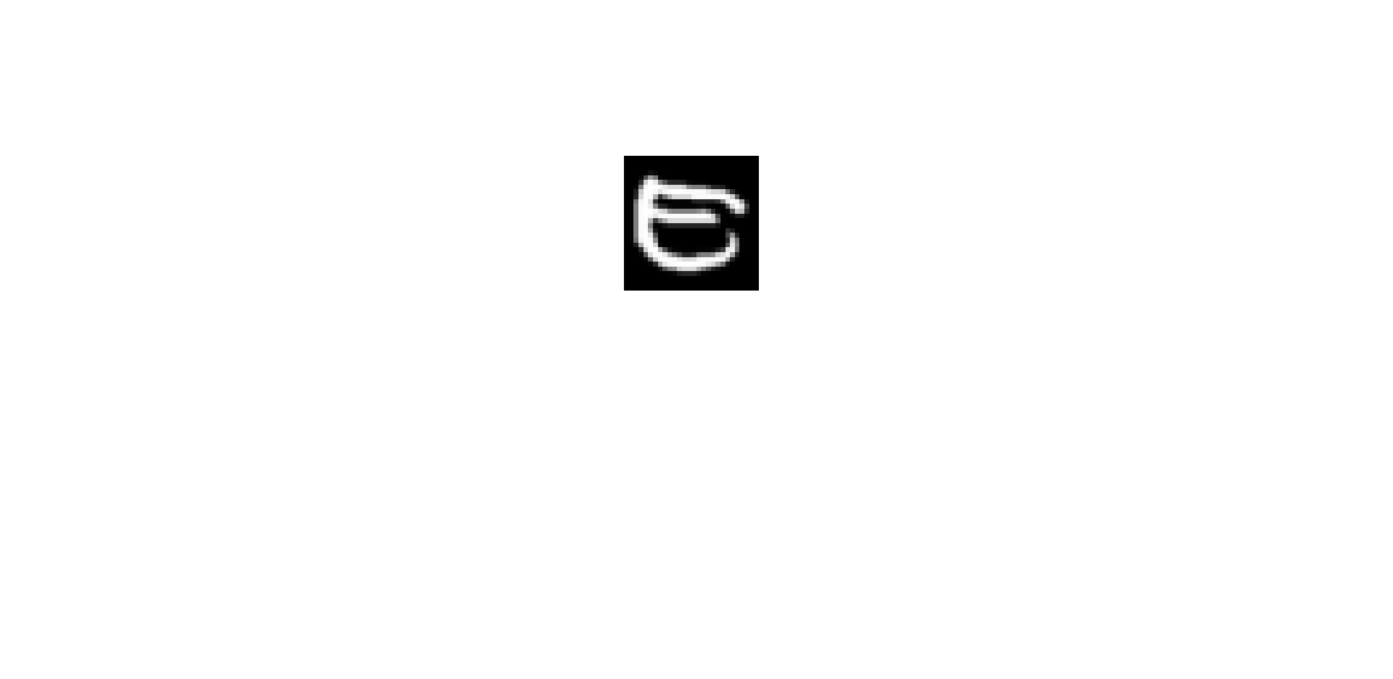

Negative samples (Letter f/F, 28*28)

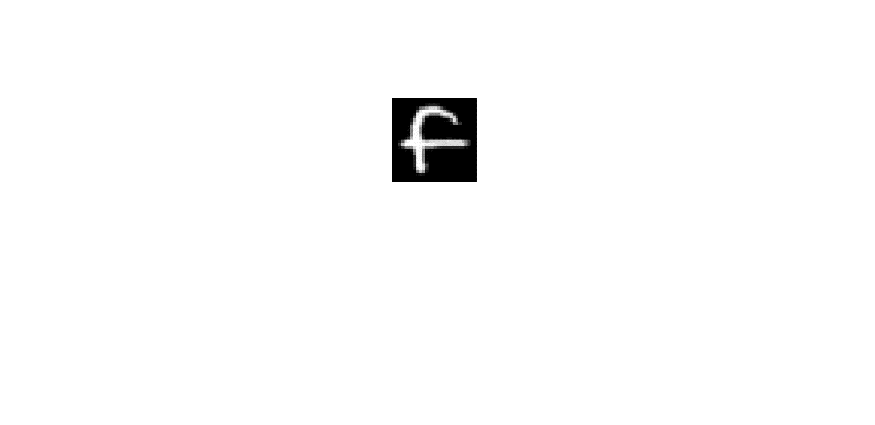 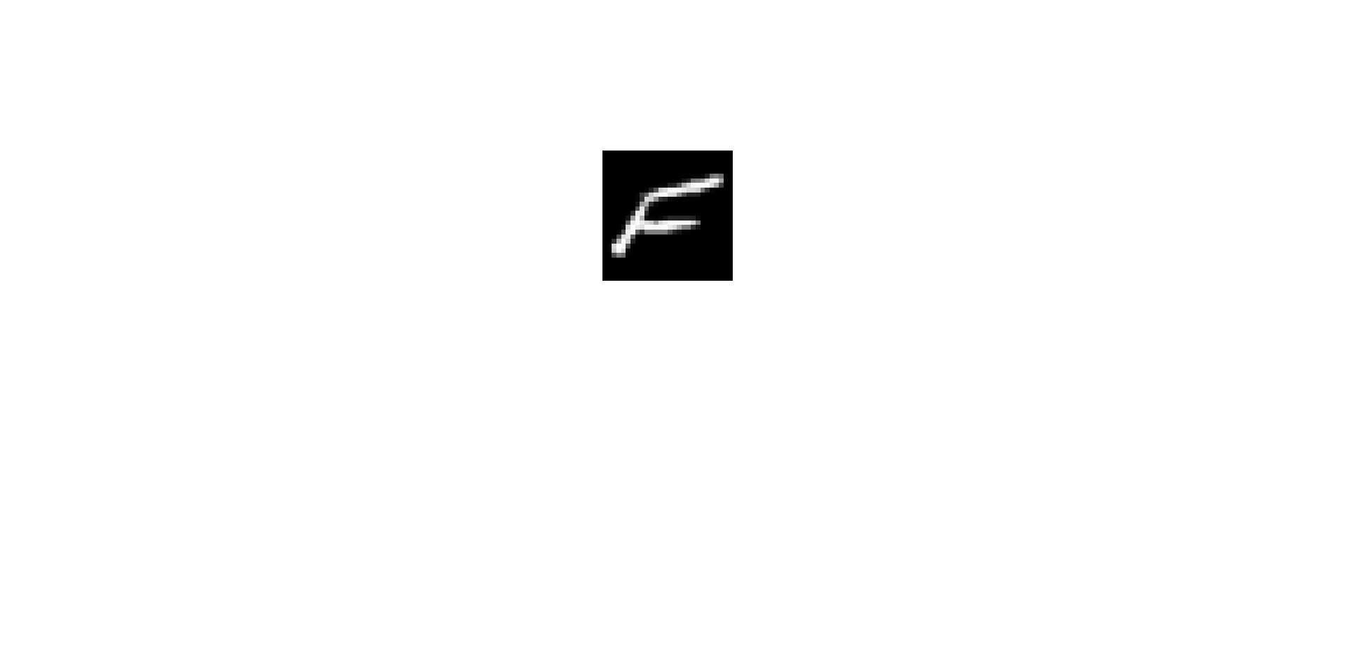

* **Experimental setting:**

Training data: 10 (5 per class)

Validation data (for SVM): 10 (5 per class)

Test data: 1000 (500 per class)

All experiments are repeat 10 times.

* **Results:**

SVM vs. SVM+GL

CNN vs. CNN+GL

* **Binary classification 4 (positive vs. negative samples):**

Positive samples (Letter y/Y, 28*28)

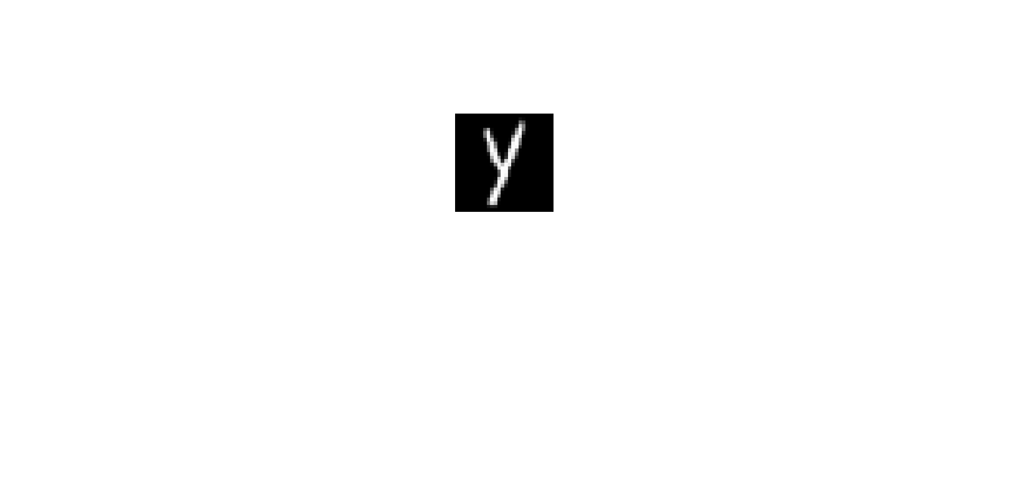 

Negative samples (Letter z/Z, 28*28)

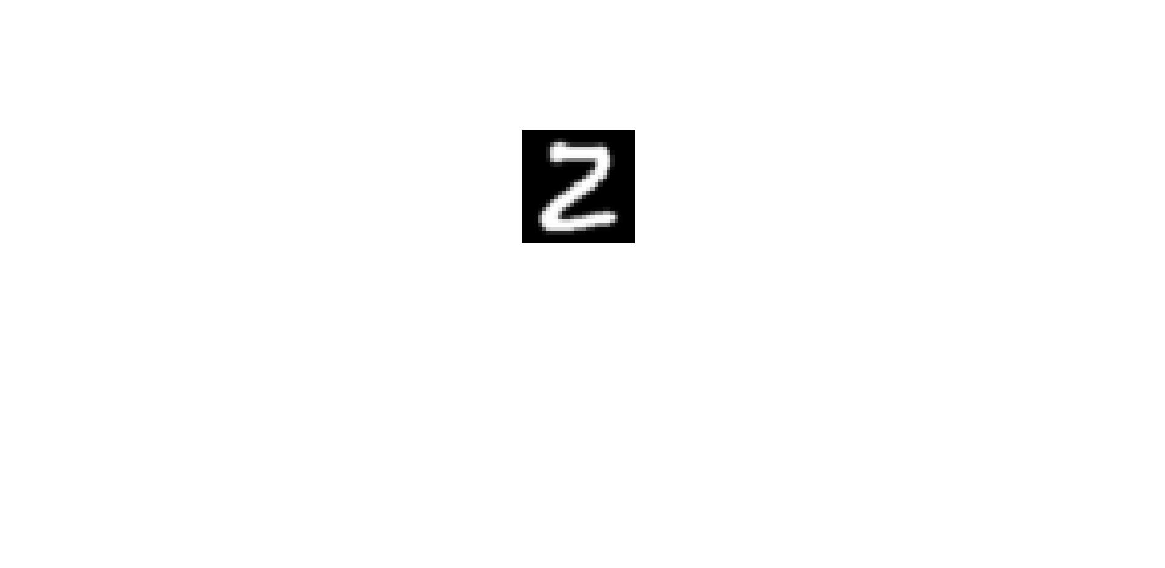 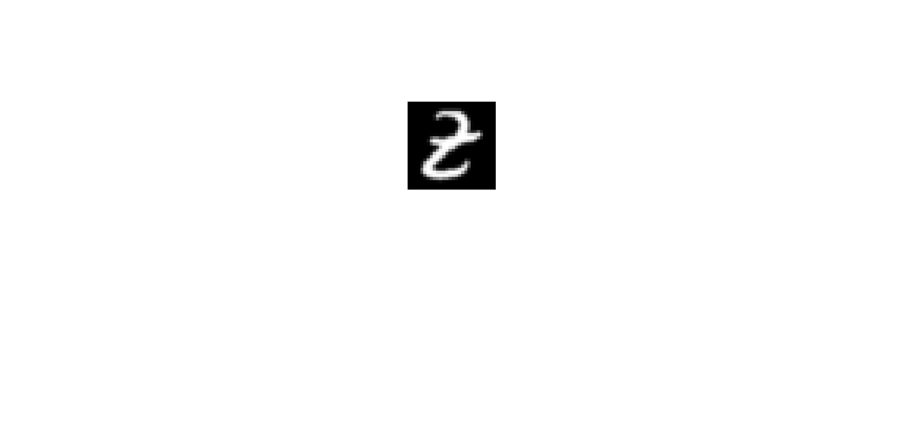

* **Experimental setting:**

Training data: 10 (5 per class)

Validation data (for SVM): 10 (5 per class)

Test data: 1000 (500 per class)

All experiments are repeat 10 times.

* **Results:**

SVM vs. SVM+GL

CNN vs. CNN+GL

* **Handwritten digits/letters images**

**Binary classification 5 (positive vs. negative samples):**

Positive samples (randomly choose two digits, 7&5 are chosen, from EMNIST dataset, 28*28)

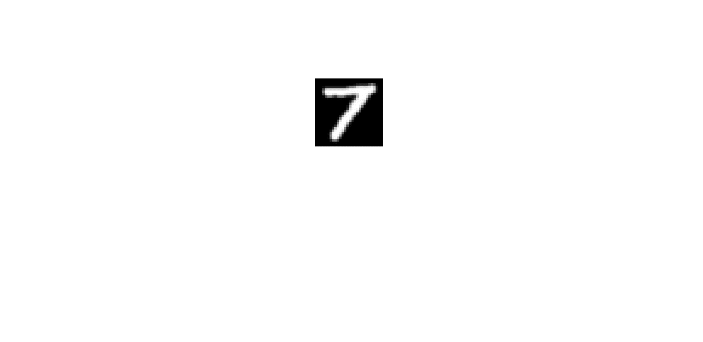 

Negative samples (randomly choose two letters, J&R are chosen, from EMNIST dataset, 28*28)

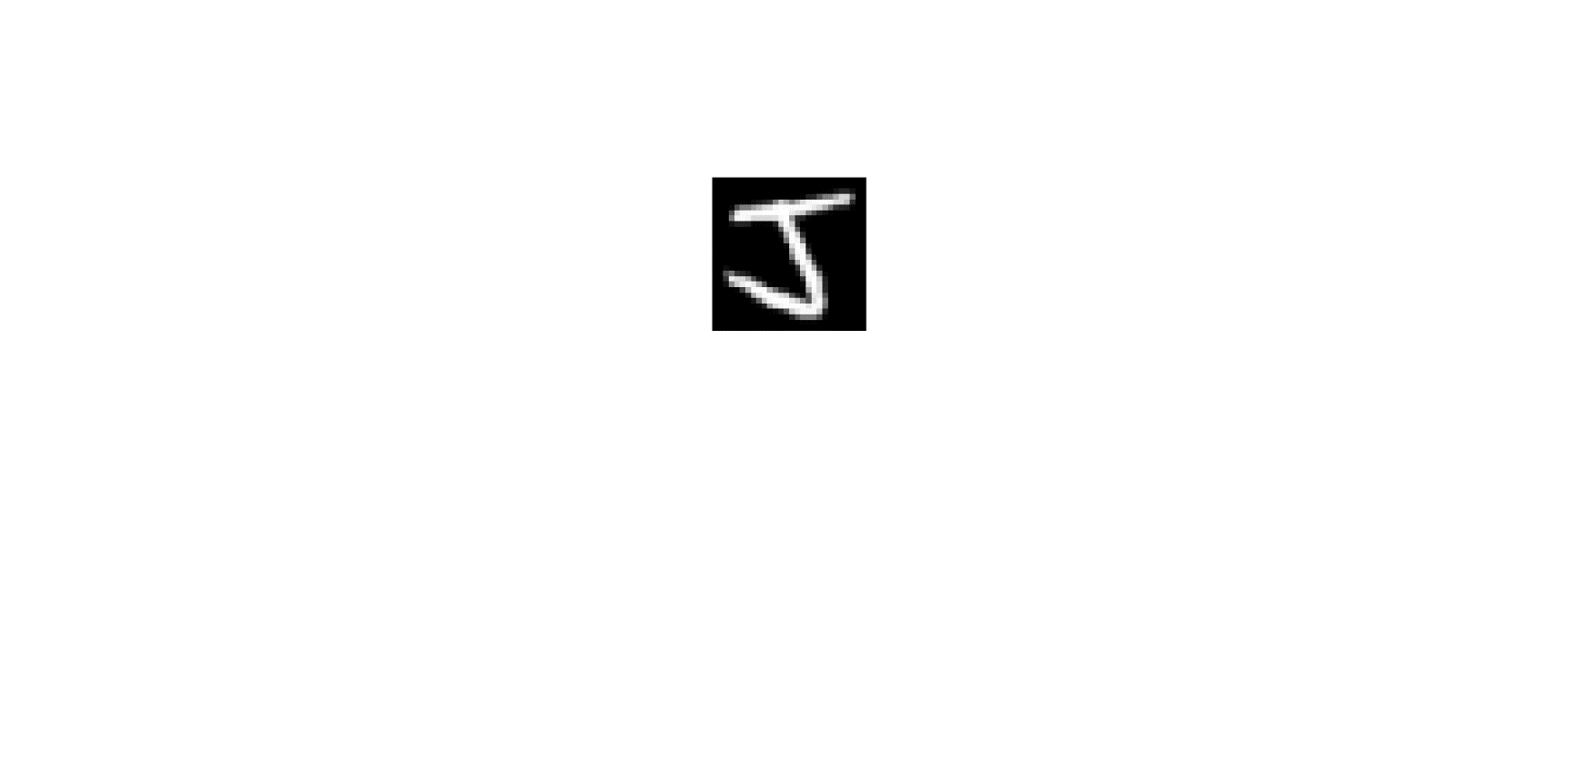 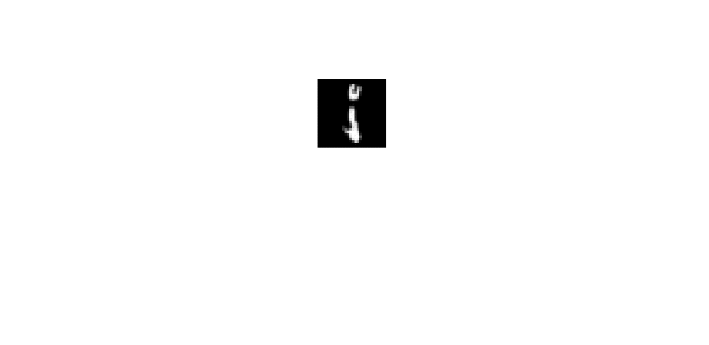 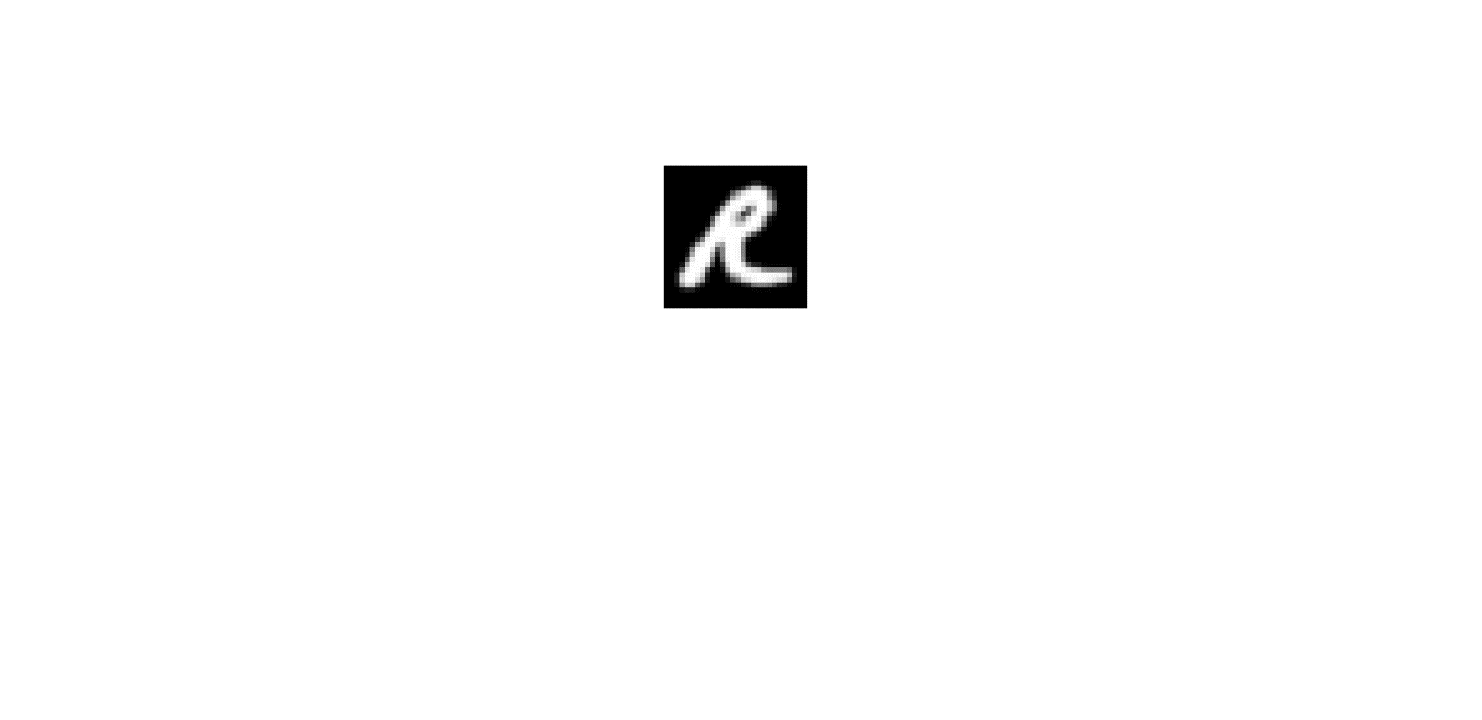 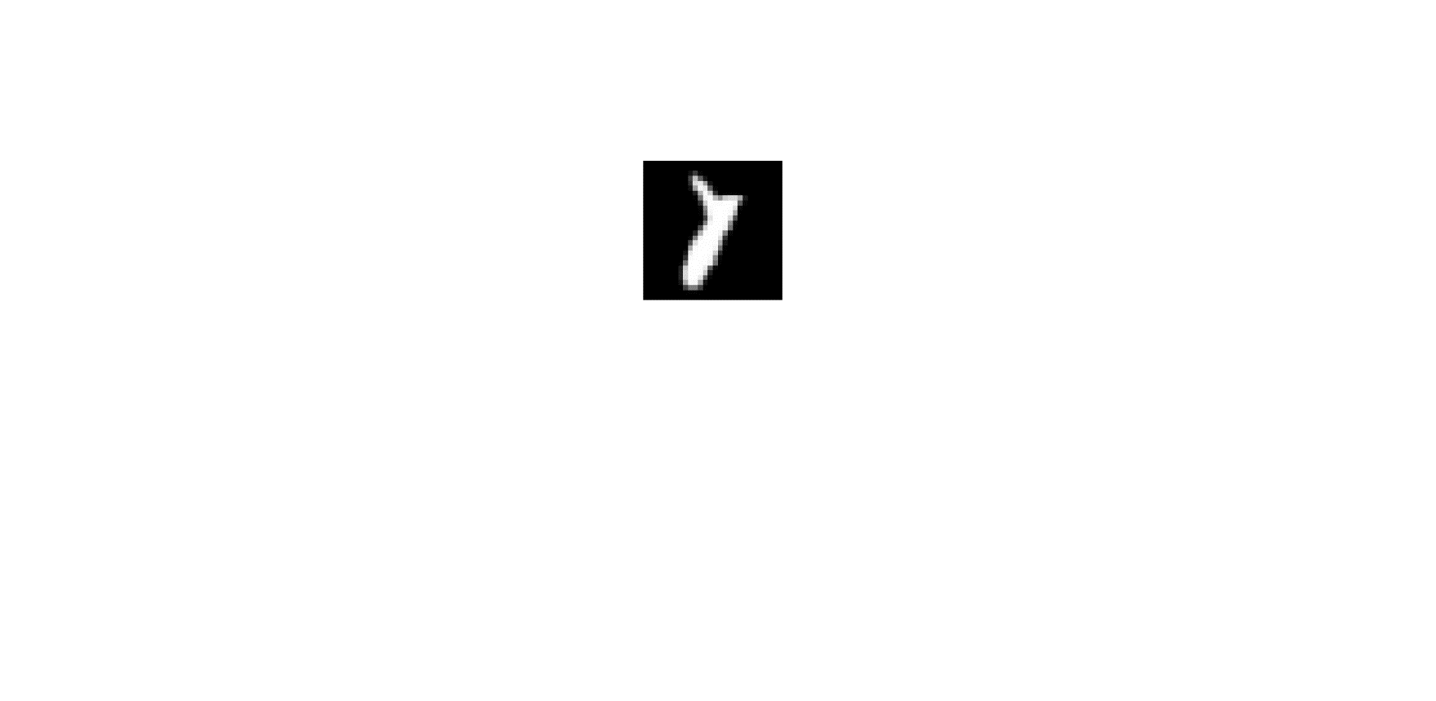

* **Experimental setting:**

Training data: 30 (15 per class)

Validation data (for SVM): 30 (15 per class)

Test data: 1000 (500 per class)

* **Results:**

SVM vs. SVM+GL

CNN vs. CNN+GL

* **Face images**

**Binary classification 6 (positive vs. negative samples):**

Positive samples (randomly choose face images of an individual, individual 7 is selected, from yale dataset, cropped to 160*160)

Negative samples (randomly choose face images of an individual, individual 19 is selected, from yale dataset, cropped to 160*160)

* **Experimental setting:**

Training data: 20 (10 per class)

Validation data (for SVM): 20 (10 per class)

Test data (all the rest): 88 (44 per class)

* **Results:**

SVM vs. SVM+GL

CNN vs. CNN+GL

**Binary classification 7 (positive vs. negative samples):**

Positive samples (randomly choose face images of an individual, individual 30 is selected, from yale dataset, cropped to 160*160)

Negative samples (randomly choose face images of an individual, individual 25 is selected, from yale dataset, cropped to 160*160)

* **Experimental setting:**

Training data: 20 (10 per class)

Validation data (for SVM): 20 (10 per class)

Test data (all the rest): 88 (44 per class)

* **Results:**

SVM vs. SVM+GL

CNN vs. CNN+GL

To do list

###########################################################

Training data: 200 (100 per class)

Validation data (for SVM): 200 (100 per class)

Test data: 1000 (500 per class)

Fix the test scale

Histogram

STD

MV vs Adaptive (just for first two three experiments)

For the rest only show Adaptive with STD

Similar distribution and different distribution. (by viewing histograms)

Face dataset (recognizing individuals) – gray scale

###########################################################

General rule for window size

Add description of how to generate group data

Try 1 or 2 more samples to see the optimal window size.

Sent the report and link to the CNN methods