**Group Learning with different window size**

* **Handwritten digit images**
* **Binary classification 1 (positive vs. negative samples):**

Positive samples (digit 8)



Negative samples (digit 5)

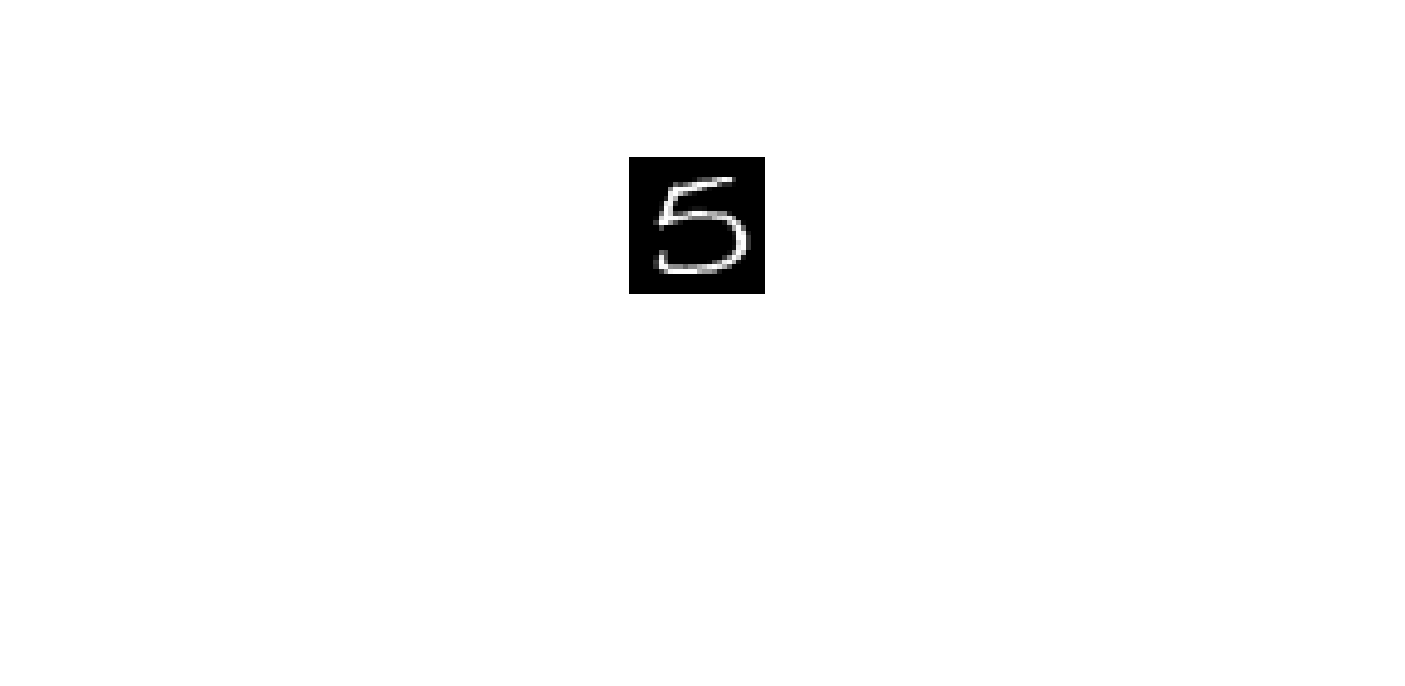

* **Experimental setting:**

Training data: 10 (5 per class)

Validation data (for SVM): 10 (5 per class)

Test data: 1000 (500 per class)

* **Results:**

SVM vs. SVM+GL

* **Binary classification 2 (positive vs. negative samples):**

Positive samples (digit 1)



Negative samples (digit 7)



* **Experimental setting:**

Training data: 10 (5 per class)

Validation data (for SVM): 10 (5 per class)

Test data: 1000 (500 per class)

* **Results:**

SVM vs. SVM+GL

* **Handwritten CN/JP character images**

Positive samples (Japanese characters randomly chosen from ETL dataset)

 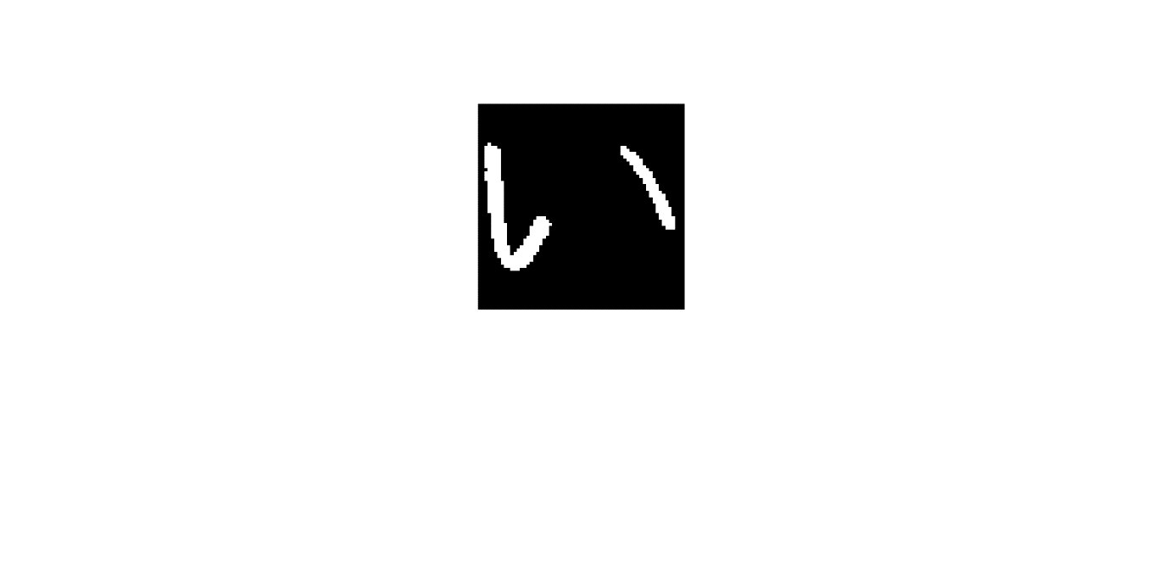

Negative samples (Chinese characters randomly chosen from ETL dataset)

* **Experimental setting:**

Training data: 10 (5 per class)

Validation data (for SVM): 10 (5 per class)

Test data: 1000 (500 per class)

* **Results:**

SVM vs. SVM+GL

* **Handwritten Digit Matrix**
* **Binary classification (positive vs. negative samples):**

Positive samples (8 ‘digit 2’, 8 ‘digit 3’, 8 ‘digit 4’, 4 ‘digit 1’, 4 ‘digit 7’)

Negative samples (8 ‘digit 2’, 8 ‘digit 3’, 8 ‘digit 4’, 8 ‘digit 1’)

* **Experimental setting:**

Training data: 20 (10 per class)

Validation data (for SVM): 20 (10 per class)

Test data: 200 (100 per class)

* **Partition data for Group Learning (with different window sizes):**

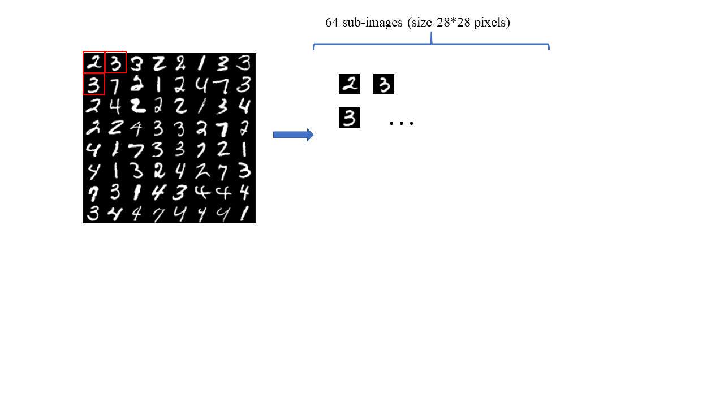

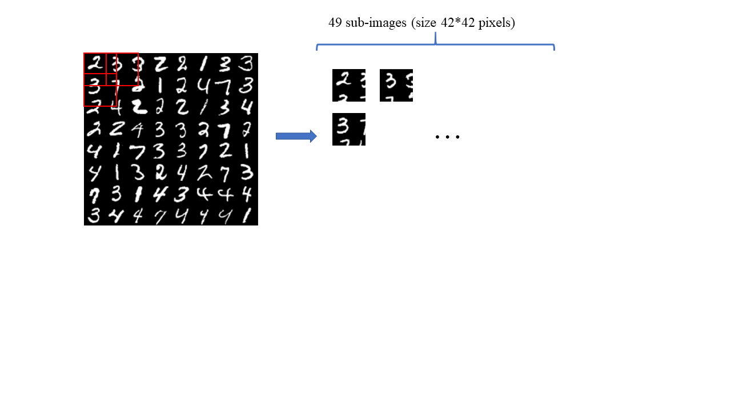

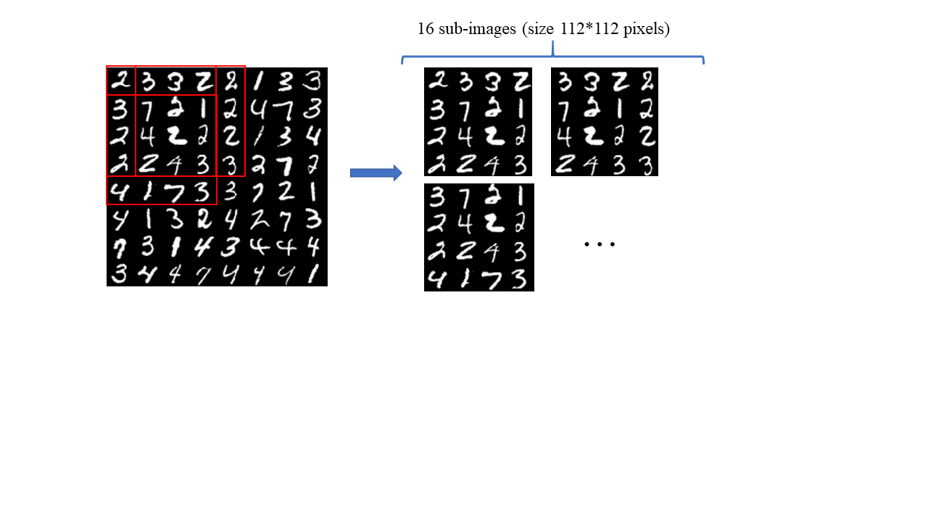

* **Results:**

1. SVM vs. SVM+GL
2. CNN vs. CNN+GL