**Prediction performance on permuted 16-digit matrix**

There are three types of 16-digit matrix data used in this experiment: (1) ordered digit matrix – see Fig. 1, (2) random permuted digit matrix (fixed random order) – see Fig. 2, (3) random permuted digit matrix (varied random order) – see Fig. 3. Note that (2) is generated by randomly permuting pixels in (1), and the random order is fixed for all samples. Similarly, (3) is generated by randomly permuting pixels in (1), and the random order is varied for each sample. SVM and group learning are applied to each data set to investigate the effect of prediction performance on different permutations. The detailed experimental settings are as follows:

- *positive class:* 16-digit matrix composed of digits ‘7’, ‘2’, ‘8’, ‘6’ (4 images for each digit, see Fig. 1);

- *negative class:* 16-digit matrix composed of digits ‘1’, ‘2’, ‘3’, ‘4’ (4 images for each digit, see Fig. 1);

- *feature vector (for group learning)*: real-valued vector of size 784 (representing a single image (28*28 pixel) in the digit matrix)

- number of training inputs/matrices: 20 (10 per class);

- number of validation matrices: 20 (10 per class);

- number of test matrices: 1000 (500 per class)

**Results:**

The prediction results on test data of three data sets are shown in Table 1. Traditional SVM shows perfect prediction on both datasets (1) and (2). Group learning shows good prediction performance on dataset (1) (SS = 1 and SP = 0.94). The prediction performance of Group Learning on dataset (2) slightly decays comparing with the performance on dataset (1) (SP decreases to 0.90 from 0.94). However, the performance of Group Learning on dataset (2) is still good. The local information may be preserved from the random permutation of pixels because the random order is fixed for all samples. Both methods show poor prediction performance on dataset (3) (SVM: SS = 0.74, SP = 0.28; Group Learning: SS = 0.87, SP = 0.27), since the pixels is randomly permuted for each sample (in varied order).

**Table 1.** Prediction performance of SVM and Group Learning on test data of three data sets (average of five repeats)

|  |  |  |  |  |
| --- | --- | --- | --- | --- |
| Data set | SVM | | Group Learning | |
| SS | SP | SS | SP |
| Ordered, (1) | 1 | 1 | 1 | 0.94 |
| Fixed random, (2) | 1 | 1 | 1 | 0.90 |
| Varied random, (3) | 0.74 | 0.28 | 0.87 | 0.27 |

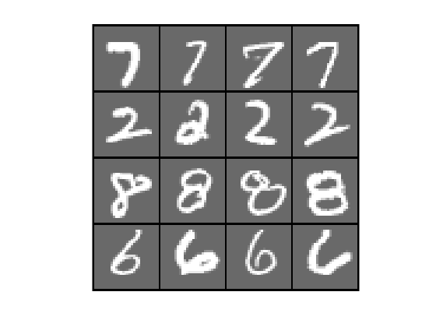 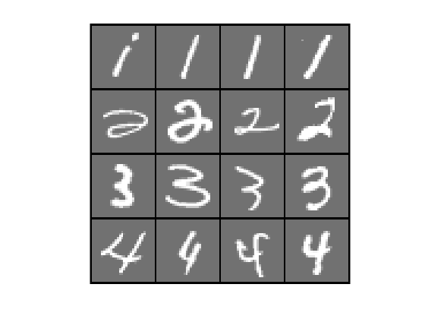

Fig. 1. Ordered digit matrix, examples in positive (left) and negative (right)

Fig. 2. Random permuted digit matrix (fixed random order), examples in positive (left) and negative (right)

Fig. 3. Random permuted digit matrix (varied random order), examples in positive (left) and negative (right)