Term Project: ChocAn

Design Document
Table of Contents
1 Introduction 2
1.1 Purpose and Scope 2
1.2 Target Audience 2
1.3 Terms and Definitions 2
2 Design Considerations 3
2.1 Constraints and Dependencies 3
2.2 Methodology 3
3 System Overview 4
4 System Architecture 5
4.1 Interactive mode 5
4.1.1 GUI 5
4.1.2 Chatroom 5
4.2 Data/Files 5
4.3 Client Server 5
5 Detailed System Design 6
5.1 Interactive mode 6
5.1.1 GUI 6
5.1.2 Chatroom 6
5.2 Data/files 6
5.3 Client Server 6

Introduction
This document will outline the design for a chat application. The chat application will allow users to communicate with each other over real internet time. Users will be able to message each other. All the user’s information such as username, password, contacts and messages will be stored on the server.

Purpose and Scope
The purpose of this document is to provide and structure and outline of how to design the chat application. Design considerations will be talked about. We will also be discussing important terms and definitions for this document. The system will be analyzed for the best performance for the chat application. Overall the purpose of this documentation will guide the software developers on how to implement the application.

Target Audience
The target audience for this document are the developers. This document will guide the developers in the process of implementing this application. High-level descriptions of the system will be discussed to get a better view of the application. The audience will be able to reference this document to get an overview and idea of how the application should work.

Terms and Definitions
Java | Programming language
Application | Software Program
ChocAn | Chat application

Design Considerations
Constraints on the application are listed below. This will discuss the constraints on the system. Functionality will be explained. The methodology subsection will examine the framework and structure for the program.

Constraints and Dependencies
The system needs to be running for the users to use the application. If the server is down or not running users will not be able to chat. The system is one of the constraints. The system will need to read and write to a text file to add new users or validate users. Sensitive information by the user will be stored onto the server. The server will only allow authorized users to view these. The system keeps track of each users chat history and must update the history every time before the user logs off. The history needs to be grabbed from a file on the server in order for the user to see it.

Methodology
The waterfall model is what we will be going off for this application. This is a sequential process for the development of the chat application. Requirements have been documented in the previous document. After the design document, we will move on to the next phase. The next phase is testing and implementing the application. The testing will examine and analyze for bugs in the application. This waterfall method gives us a step by step process guide for the application.

System Overview
The system will be a server allows users to chat with one another. The server will allow will manage user logs and chat history. 3 subsystems will be detailed below in section 4 to get a better understanding of how this application works.

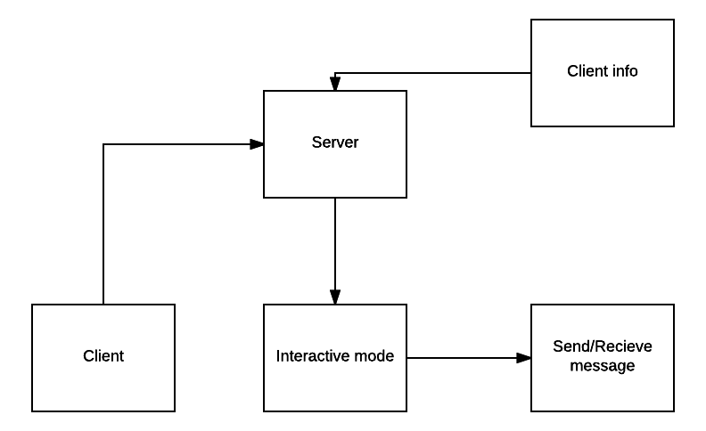

System Architecture
The system will contain 3 subsystems. The first subsystem will hold all the user’s information such as password and chat history. This subsystem will keep a log of all the user’s actions during the session. The second subsystem is the interactive mode. This lets the user communicate with the server to initiate an action. The interactive mode allows the server to update the system. The user works with the third subsystem to send and receive messages to other users. This will send the message in real time.

Interactive mode

The first subsystem is the interactive mode. This subsystem helps the user interact with the server. Interactive mode helps the system update the chat history and user info. This subsystem also goes and retrieves information for the user.

GUI
This is part of the interactive mode. GUI is responsible for receiving information such as messages and commands from the user. The GUI acts as a sender to both the server and all users who are using this application service

Chatroom
Chatroom allows users to see all clients who are online and available to receive or send messages.

Data/files
Data and files will hold and process information from both the user and server to be stored.

Client server
Allows connection between users to each other and chat application.

Detailed System Design

Interactive mode
This allows the user to communicates with the server. A detailed design of this will be discussed below in the following sections.

GUI
The GUI will be built using a java built in library. This will be used via inheritance. A client will inherit the jframe components from the java class.

Chatroom
The chatroom will be built like the GUI. The chatroom will be contained in the server side of the program. The user will be able to see the chatroom via the server. All the users will be stored in hashtable that will be displayed. The hashtable will contain nodes of users and their information. Each message in a chatroom will be stored in a node containing a string that will implement a stack. The chatroom is responsible to send message and receive message to users.

Data/files
All the data will be stored in a text file. Each conversation the user has with another user will be stored in a node. This node will be contained in a binary search tree. All the chat history will be maintained in a tree and written to a text file when the user terminates the program.

Client Server
The client server will contain a socket to connect to the server and other users online. Each client server will be kept track of in a arraylist. The arraylist keeps track of connections of each user to the server and with each other.

