Repository architecture & deployment
This is the map of the whole system: what each piece is, where it runs, how the pieces talk to each other, which environment variable does what, and where to look when something breaks. Read this first if you're new to the project or you're trying to figure out "which thing is down."
About the screenshots. This doc references four dashboard screenshots that live
in images/. If they're not there yet, save the four captures into
docs/images/ with these exact names:
| File | What it shows |
|---|---|
| render-flask-env.png | Render → Calculator-code (Flask) → Environment |
| vercel-overview.png | Vercel → calculator-ai-ui → Overview |
| render-auth-env.png | Render → Calculator-code-auth (Node) → Environment |
| vercel-env.png | Vercel → calculator-ai-ui → Environment Variables |
The captions below describe each one in full, so the doc is still complete even
before the images are dropped in.

The big picture
There are four moving parts plus the git repo. Three are hosted services; one is a database.
Mermaid diagram source:
flowchart TD
User([Lawyer's browser])
subgraph Vercel["Vercel — calculator-ai-ui (React / CRA)"]
UI[app.cloudforlawfirms.com<br/>the SPA]
end
subgraph RenderAuth["Render — Calculator-code-auth (Node/Express + Prisma)"]
AUTH[calculator-code-auth.onrender.com<br/>/api/* auth + /v1 data]
end
subgraph RenderFlask["Render — Calculator-code (Python/Flask)"]
FLASK[calculator-code-x2b4.onrender.com<br/>AI chat + report PDFs]
end
subgraph AWS["AWS RDS — PostgreSQL"]
DB[(matters, forms, folders,<br/>users, tasks)]
end
Graph[[Microsoft Graph<br/>email sending]]
User --> UI
UI -->|REACT_APP_API_BASE_URL<br/>login, matters, forms, folders| AUTH
UI -->|CALCULATOR_API<br/>/chat, /intake-chat, /download-report| FLASK
AUTH -->|DATABASE_URL Prisma/pg over SSL| DB
AUTH -->|EMAIL_MICROSOFT_*| Graph
Piece | Tech | Host | In this repo | Public URL
Frontend UI | React (create-react-app) | Vercel (calculator-ai-ui) | cloudact-ui/ | app.cloudforlawfirms.com (+ calculator-ai-ui.vercel.app)
Auth + data API | Node.js / Express 5 / Prisma | Render (Calculator-code-auth) | auth-server/ | calculator-code-auth.onrender.com
AI / report backend | Python / Flask / gunicorn | Render (Calculator-code) | app.py + calculators | calculator-code-x2b4.onrender.com
Database | PostgreSQL | AWS RDS | schema in auth-server/prisma/ | (private, via DATABASE_URL)

Everything deploys off the `main` branch of cloudactai/Calculator-code. In the screenshots all three services are on the same commit (e6e814b, "Merge pull request
#58 from cloudactai/marc"), which is what "everything is in sync" looks like.

1. Frontend — Vercel (calculator-ai-ui)
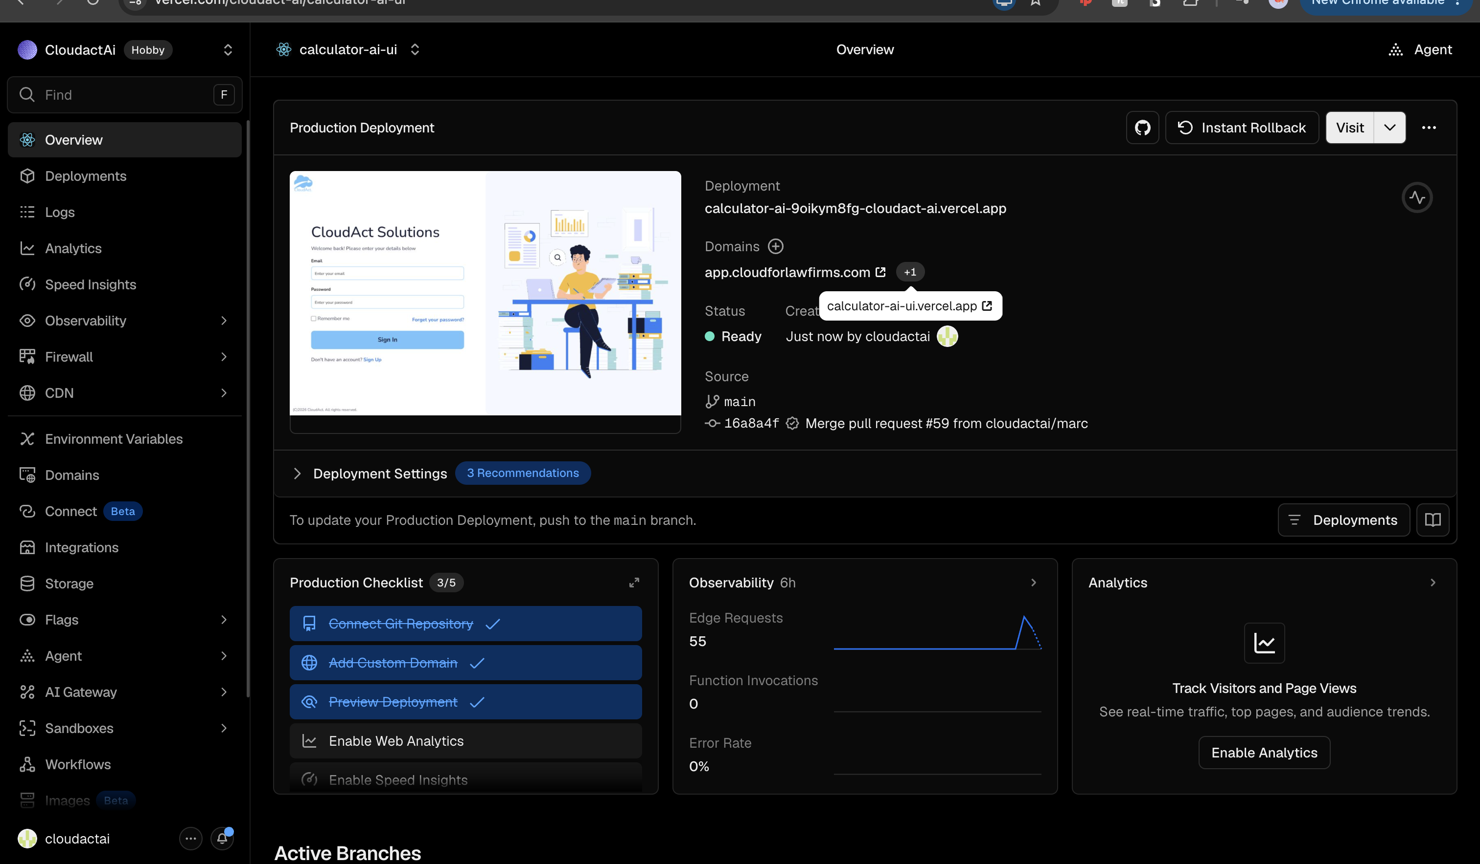
Vercel — calculator-ai-ui Overview
The React SPA (built from cloudact-ui/). It's the CloudAct Solutions sign-in + the whole app the lawyer uses (Matters, Forms, calculators). Key facts from the Overview screenshot:
- Project: calculator-ai-ui under the CloudactAi Vercel team (Hobby plan).
- Production domain: app.cloudforlawfirms.com (with calculator-ai-ui.vercel.app
as the Vercel-generated alias).
- Deploys on push to `main` — "To update your Production Deployment, push to the
main branch." Each merged PR triggers a build.
- It's a create-react-app build, not Vite. This matters: env vars are
process.env.REACT_APP_*, inlined at build time. Changing an env var in Vercel does nothing until you redeploy.
- SPA routing is handled by vercel.json, which rewrites every path to
/index.html so client-side React Router works on refresh.
Hobby-plan deploy quirk: only commits by the account owner auto-deploy. If a
teammate's merge doesn't deploy ("commit author does not have contributing access"),
the owner has to push/redeploy, or the team upgrades to Pro.

Frontend environment variables
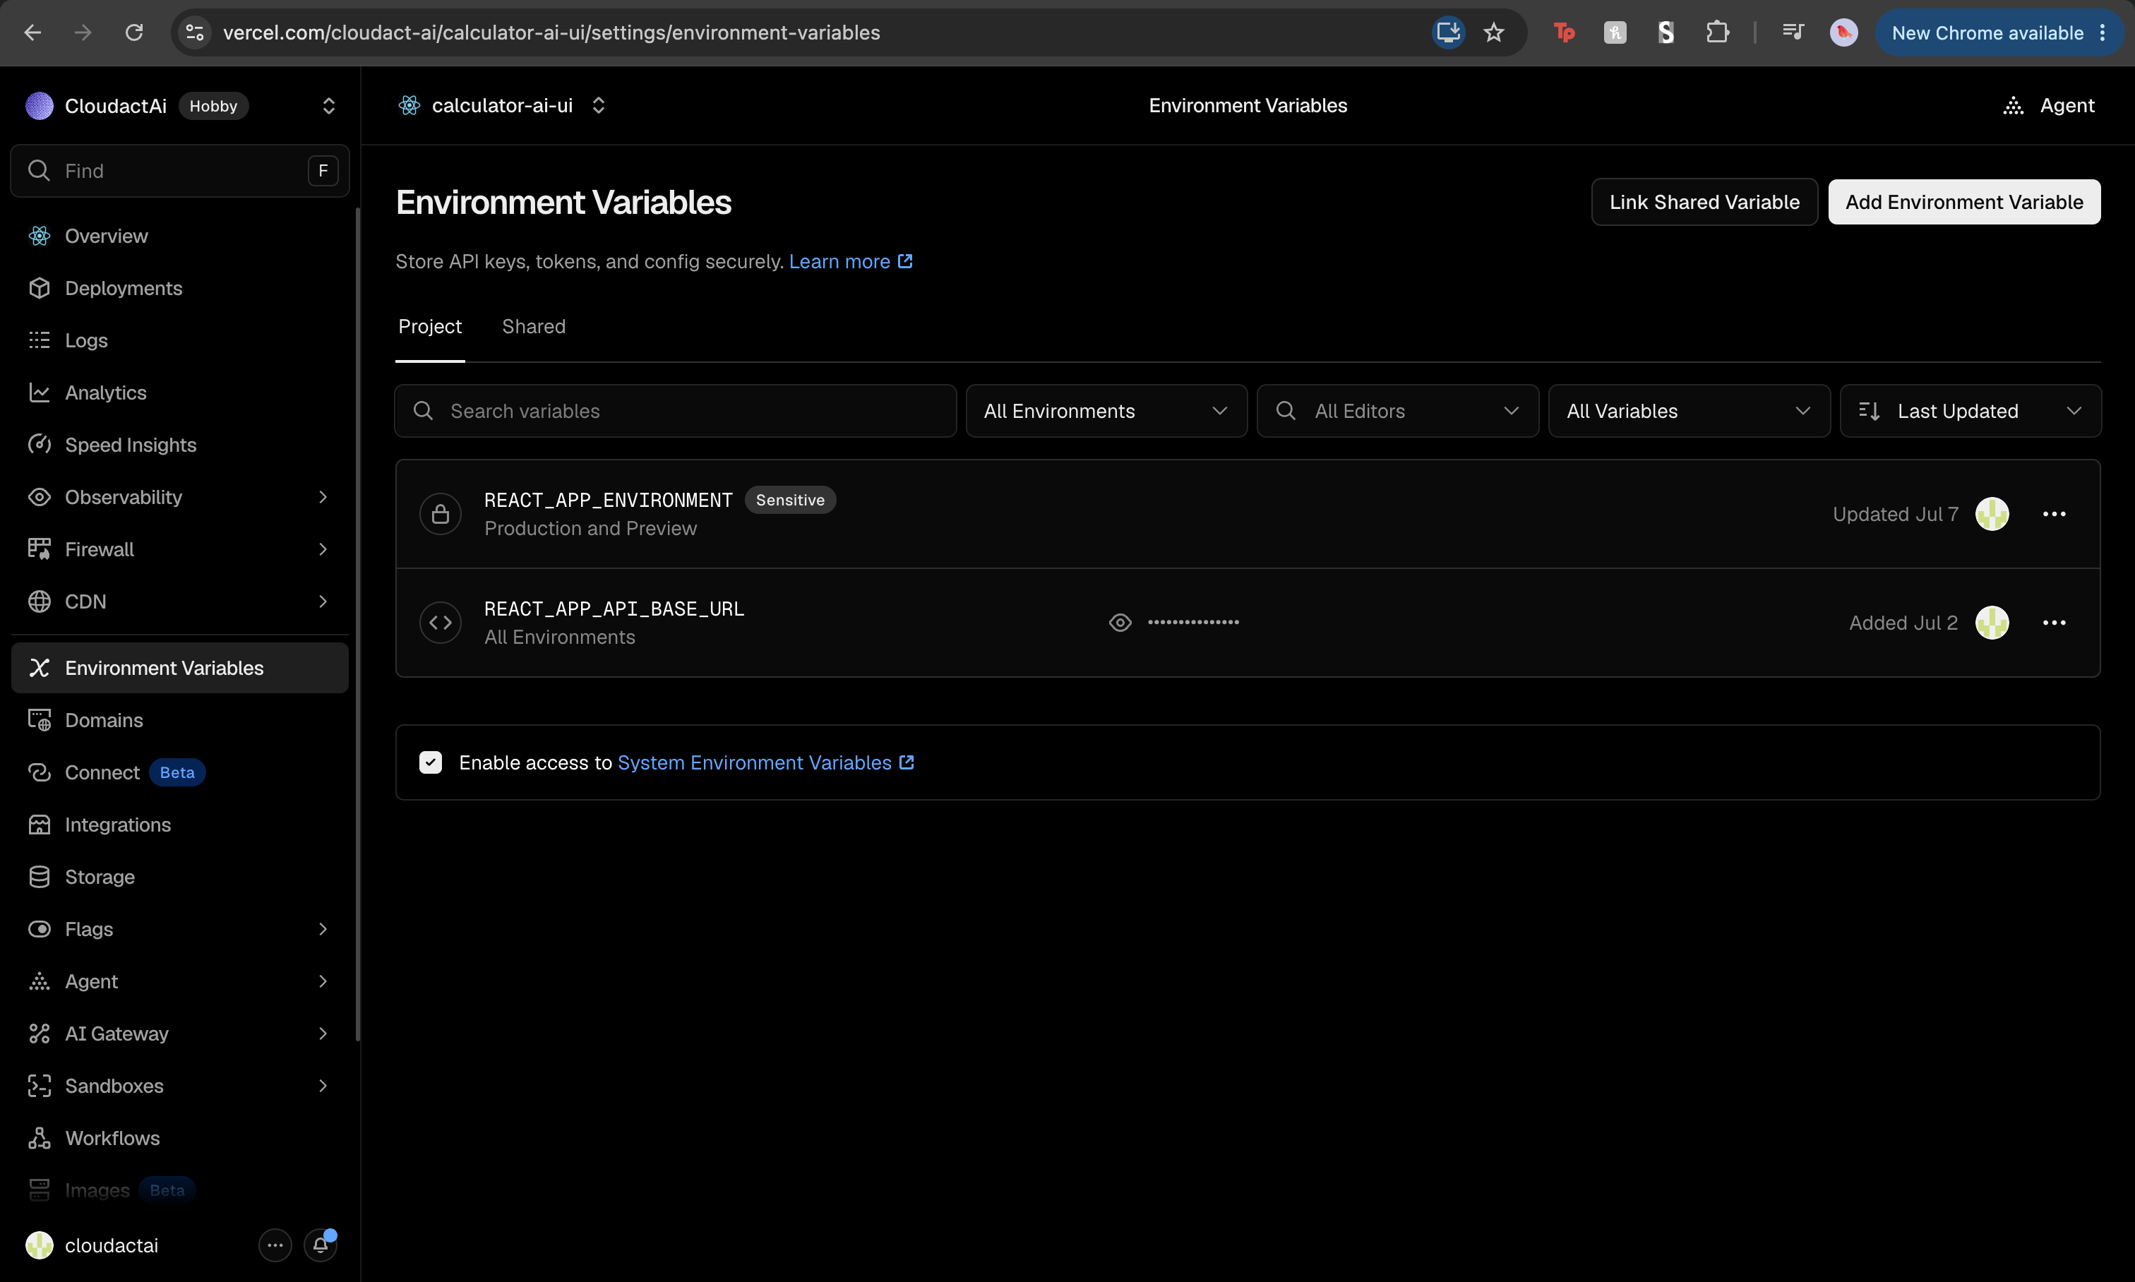
Vercel — Environment Variables
Only two are set (screenshot 4), and that's by design — the frontend has smart defaults in cloudact-ui/src/config.ts and cloudact-ui/src/utils/dataAxios.js:
Variable | Purpose
REACT_APP_API_BASE_URL | Base URL of the auth-server (the Node service). Everything the app loads/saves — login, matters, forms, folders, task states — goes here. dataAxios.js normalizes it to the /v1 data API and the same host serves /api/* for auth. If unset in production it falls back to https://calculator-code-auth.onrender.com/v1.
REACT_APP_ENVIRONMENT | Build environment tag: DEV / QA / PROD / LOCAL (marked *Sensitive*). Read in config.ts; selects which environment profile the app assumes.

Two more that are not set here but exist as optional overrides in config.ts:
- REACT_APP_CALCULATOR_API_URL → the Flask backend. Unset, so it uses the baked-in
default https://calculator-code-x2b4.onrender.com. This is the CALCULATOR_API the AI chat panels and report download use.
- REACT_APP_SETUP_WIZARD_API_URL → a legacy Report-Creation Node backend
(report-creation.onrender.com), only used by the setup wizard.
Doc mismatch to be aware of: the older handoff doc
AUTH_HANDOFF/ENV_VARS.md talks about VITE_* variables
and "Render Postgres." That was written for a Vite build against a Render database.
The current app uses **CRA (REACT_APP_*) and an AWS** database. Trust this
doc and the screenshots over the Vite references.

2. AI / report backend — Render (Calculator-code, Flask)
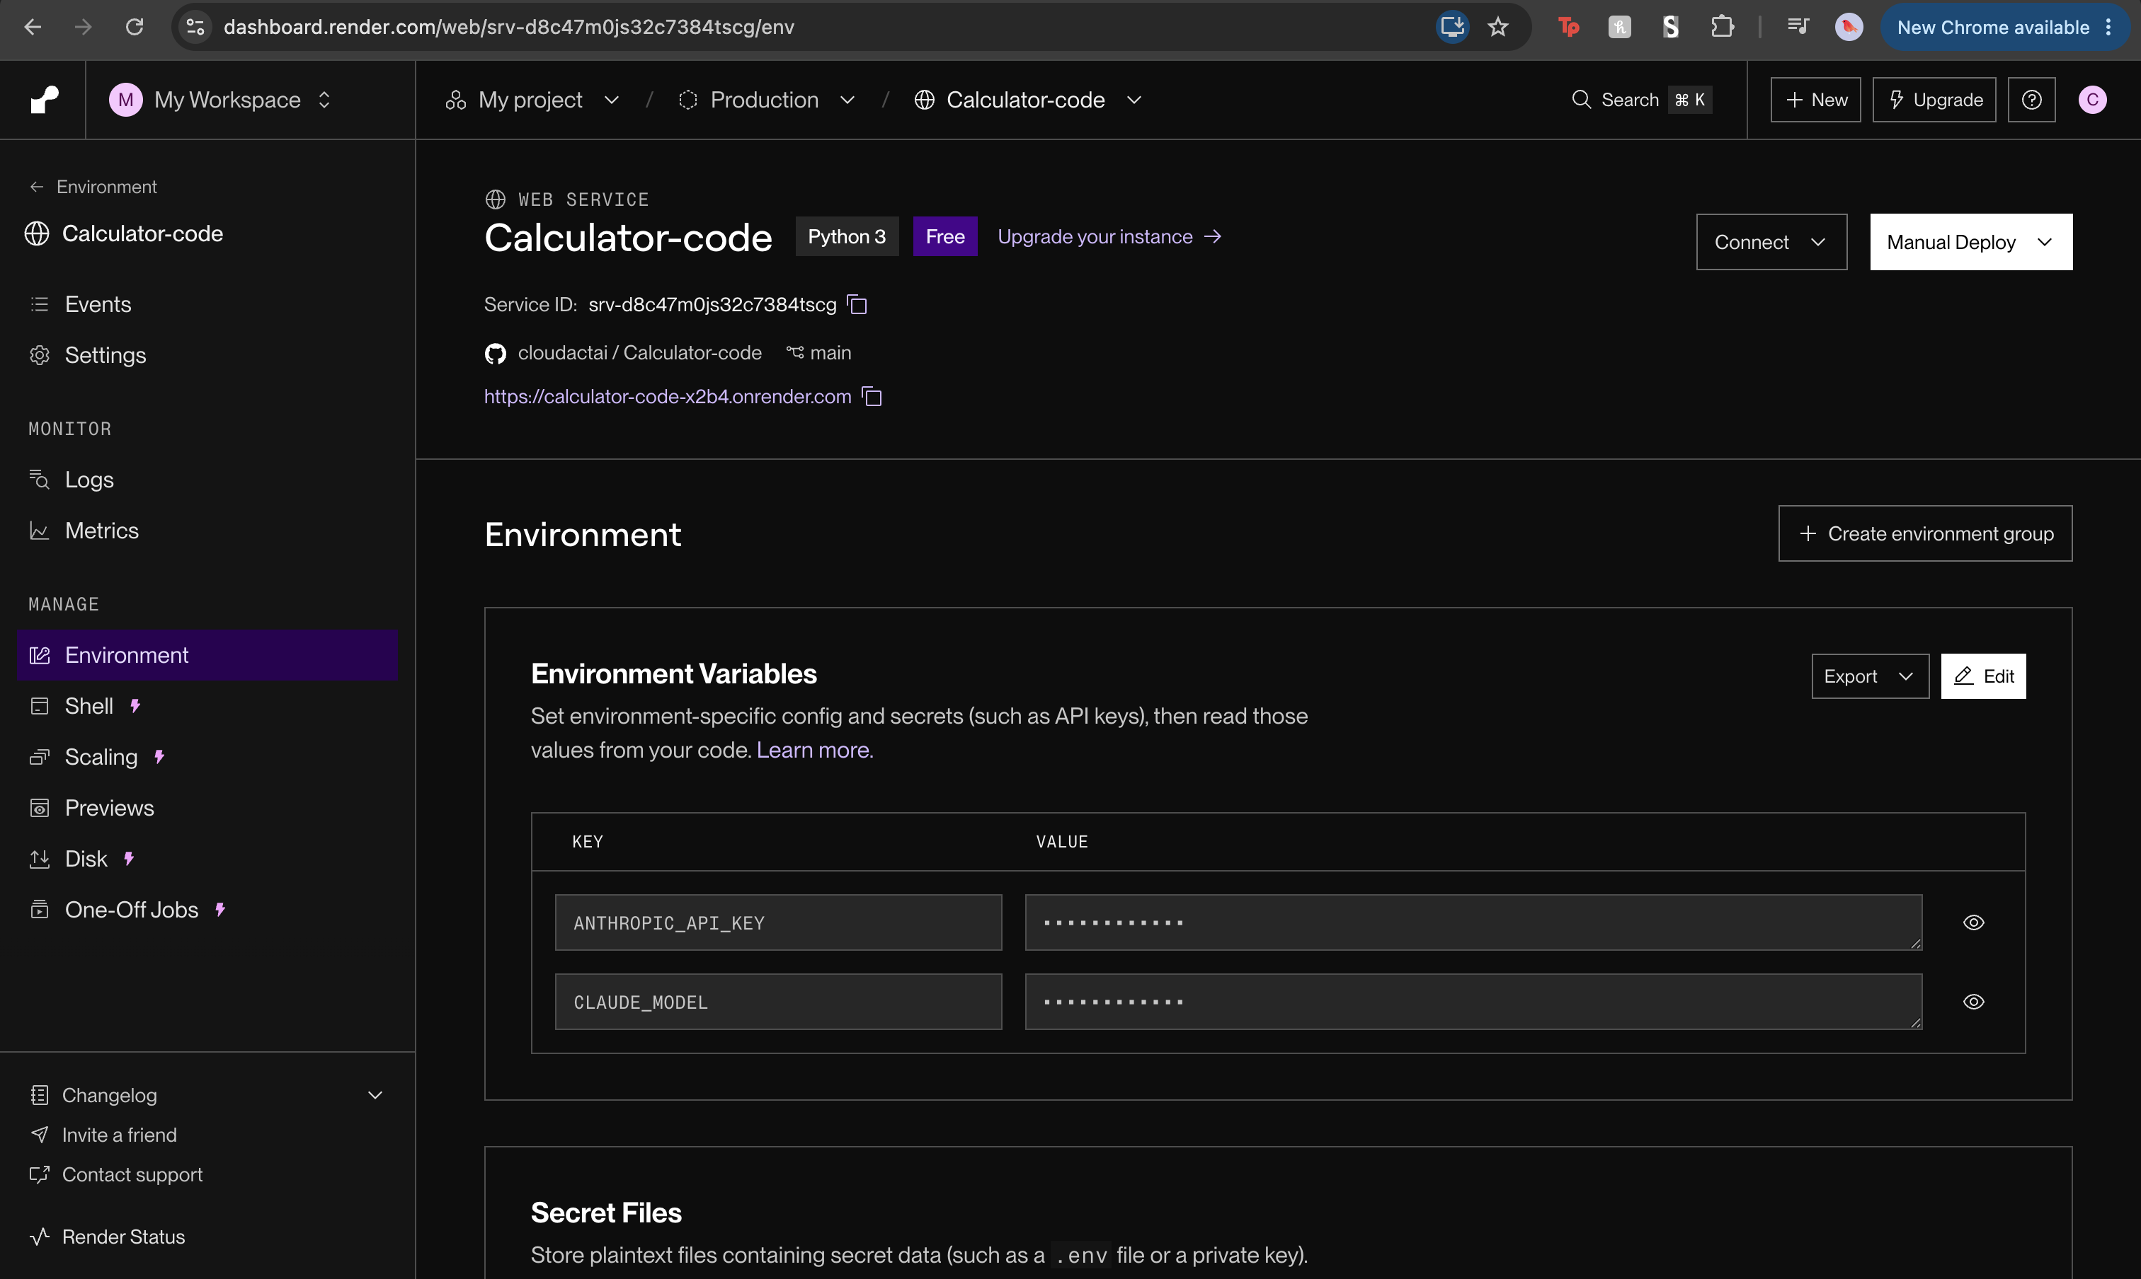
Render — Calculator-code (Flask) Environment
The Python service (app.py, started with web: gunicorn app:app via Procfile). It powers everything conversational and every generated PDF — the child/spousal support calculators, the matter-intake agent, and the downloadable reports. It is stateless and talks only to Anthropic; it does not touch the database (all persistence is the frontend calling the auth-server). From the screenshot:
- Service name: Calculator-code · Type: Web Service · Runtime: Python 3 ·
Instance: Free.
- Service ID: srv-d8c47m0js32c7384tscg.
- Public URL: https://calculator-code-x2b4.onrender.com (this is the frontend's
CALCULATOR_API default).
- Deploys from cloudactai/Calculator-code, branch main.

Its environment variables
Variable | Purpose
ANTHROPIC_API_KEY | Auth for the Anthropic API. Every chat/report call uses it. If it's missing, expired, or over quota, all AI features fail (chat replies error, reports won't generate).
CLAUDE_MODEL | Which Claude model to call. Read in app.py as os.getenv("CLAUDE_MODEL", "claude-sonnet-4-6") — so if unset it defaults to claude-sonnet-4-6. Set it here to pin/upgrade the model without a code change.

Free-instance cold starts. A Free Render web service spins down when idle and
takes ~30–60s to wake. That's exactly why the chat panels show *"Warming up the
server — first reply can take ~30s…"* and why the frontend axios timeout is 75s
(utils/axios.js). A slow first message after
a quiet period is normal, not a bug.

3. Auth + data API — Render (Calculator-code-auth, Node)
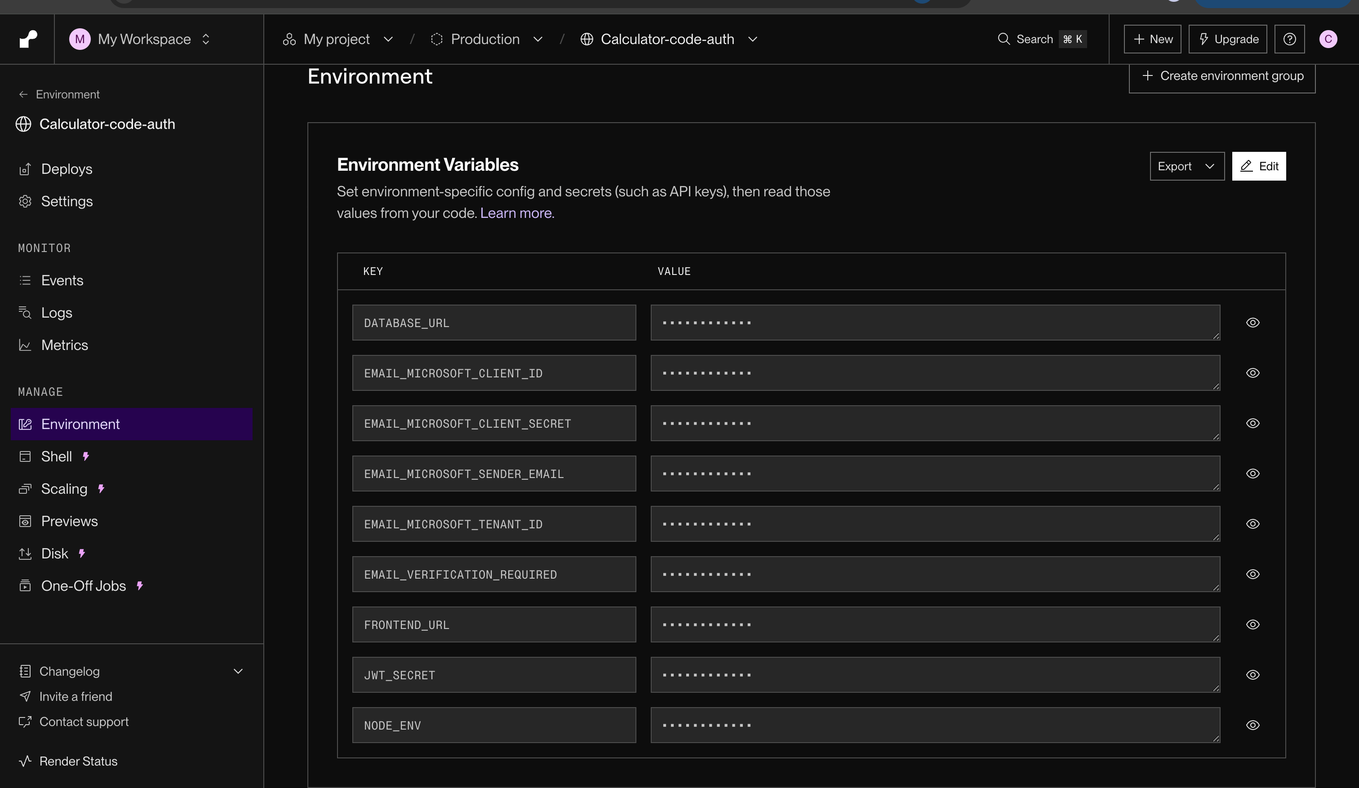
Render — Calculator-code-auth Environment
The Node/Express + Prisma service (auth-server/, entry auth-server/server.js). This is the only thing that reads and writes the database. It serves two families of routes:
- /api/* — accounts & sessions: signup, login, verify-email, forgot/reset password,
/api/me, logout. Sessions are JWTs in a cross-domain cookie.
- /v1/* — the app data: matters, forms, folders, task states, form-template PDFs
(everything cloudact-ui/src/services/formsService.js and the matter Redux actions call).
From the screenshot: Service ID srv-d939g4vavr4c73bma26g, name Calculator-code-auth. Its start command runs migrations then boots: npx prisma migrate deploy && node server.js (see package.json).

Its environment variables
Variable | Purpose
DATABASE_URL | Postgres connection string → the AWS RDS database (see §4). Prisma/pg connect through it; SSL is auto-enabled for *.rds.amazonaws.com hosts (prismaClient.js). This is the single most critical secret — if it's wrong/expired, the whole app can't load or save anything.
JWT_SECRET | Long random secret that signs session JWTs. Rotating it logs everyone out.
FRONTEND_URL | The exact Vercel origin (https://app.cloudforlawfirms.com, no trailing slash). Used for CORS *and* as the base of links in verification/reset emails.
NODE_ENV | Must be production in prod — otherwise the cross-domain session cookie is dropped by the browser and logins silently don't stick.
EMAIL_MICROSOFT_TENANT_ID | Microsoft Graph (Entra) tenant ID — used to send transactional email (verify, reset).
EMAIL_MICROSOFT_CLIENT_ID | The Graph app-registration client ID.
EMAIL_MICROSOFT_CLIENT_SECRET | The Graph app client secret. This one expires (see the caveat below).
EMAIL_MICROSOFT_SENDER_EMAIL | The from-address, notifications@cloudforlawfirms.com.
EMAIL_VERIFICATION_REQUIRED | true/false — whether new signups must verify email before use. false is a dev convenience, not a login bypass.

Email uses Microsoft Graph. The four EMAIL_MICROSOFT_* values authenticate an
app-only (client-credentials) Microsoft Graph call with Mail.Send on the shared
mailbox — that's how the auth-server sends verification/reset email. A separate
doc will cover the Graph email flow in depth; for here, just know these four vars are
the email sender's credentials and they were copied from the older report-creation
Render service.
Shared-secret caveat: the client secret is currently shared with that other
service, so when it expires both stop sending at once — the tell is
Microsoft Graph token request failed: 401 in the logs. Record its expiry and set a
reminder.

4. Database — AWS RDS (PostgreSQL)
The database is PostgreSQL on AWS RDS, reached only by the auth-server via DATABASE_URL. The schema is Prisma-managed:
- Schema: auth-server/prisma/schema.prisma — datasource db
is provider = "postgresql", url = env("DATABASE_URL").
- Connection: auth-server/prismaClient.js wires Prisma
through the pg Pool, and auto-enables SSL when the host matches *.rds.amazonaws.com (also *.render.com / *.neon.tech).
- Migrations are applied on every deploy by the start command
(npx prisma migrate deploy).
It holds users/sessions plus all matter data: matters, intake sections, forms, folders, and per-matter task states.

If the AWS database credential/token "expires"
The connection string is a standard user/password (+ SSL) URL, so nothing expires on a timer *inside the app*. A failure means the credential in DATABASE_URL stopped working at the AWS side — a rotated master password, a revoked/expired IAM database-auth token (if IAM auth is used, those are valid ~15 min and must be regenerated), an RDS endpoint change, or the security group/SSL requirement changing.
How to recognize it (symptoms, from the outside in):
- In the browser, the app loads the shell but Matters/Forms show "Unable to
load…", and network calls to …/v1/* return 500 (not 401 — a 401 is a *login/session* problem, i.e. JWT_SECRET/cookie, not the DB).
- In the auth-server Render logs (§ logs below) you'll see Prisma/pg connection
errors — e.g. password authentication failed for user, no pg_hba.conf entry, SSL required, getaddrinfo ENOTFOUND …rds.amazonaws.com, or connection timeouts. The Flask service and its AI chat keep working (it has no DB), which is a quick way to confirm the fault is DB-only.
- If the start command can't migrate, the deploy itself fails at
prisma migrate deploy.
Where to fix it: update DATABASE_URL in Render → Calculator-code-auth → Environment with the new/rotated credential (or a freshly minted IAM token), verify the RDS endpoint/port and that its security group allows Render's egress, and redeploy.
The exact AWS auth mechanism (static password vs. IAM database authentication vs.
Secrets Manager rotation) isn't encoded in this repo — confirm which one this RDS
instance uses so the runbook above can name the precise regeneration step. The
symptoms and the "update DATABASE_URL + redeploy" fix hold either way.

Where to look for logs
You're debugging… | Go to
A page not loading, save failing, login issues, DB errors | Render → Calculator-code-auth → Logs (and Events for deploy/crash history). This is the busiest log.
AI chat not replying, report PDF not generating, Anthropic/model errors | Render → Calculator-code → Logs. Look for Anthropic 401/429 or model-name errors.
Email not arriving (verify/reset) | Render → Calculator-code-auth → Logs — search for Microsoft Graph. A 401 there = expired EMAIL_MICROSOFT_CLIENT_SECRET.
Build failed, wrong env var baked in, routing/404 on refresh | Vercel → calculator-ai-ui → Deployments (build logs) and Logs/Observability (runtime/edge). Remember CRA inlines env vars at build — rebuild after changing them.
Slow first request after idle | Expected Free-tier cold start on the Render services; check Events to confirm a spin-up, not a crash.
Database-level (slow queries, storage, connections) | AWS RDS console → the instance's Monitoring/CloudWatch and Logs & events.

Both Render services also have Shell and Metrics tabs; the auth-server's Shell is handy for running one-off Prisma commands against the live DB.

How a request actually flows
- Sign in / load matters / save a form → browser → REACT_APP_API_BASE_URL
(auth-server on Render) → Prisma → AWS RDS. Response comes back through the same chain.
- Ask the AI / download a support report → browser → CALCULATOR_API (Flask on
Render) → Anthropic → PDF/text back. No database involved.
- Sign up / reset password → auth-server writes the user + calls **Microsoft
Graph** to email the link (whose base is FRONTEND_URL).
So a useful triage shortcut: if the AI chat works but data won't load, it's the auth-server or the DB; if data loads but AI is dead, it's the Flask service or Anthropic.

Deploying
- Merge to `main` on cloudactai/Calculator-code.
- Vercel auto-builds the frontend from cloudact-ui/.
- Render builds both backend services from the same repo (each service has its own
root/branch config). The auth-server runs prisma migrate deploy on boot. You can also Manual Deploy from each Render service.
- Sanity check: the commit hash shown as Live on both Render services and as the
Production Deployment on Vercel should match (they were all e6e814b in the screenshots).

Quick reference
Thing | Value
Repo | cloudactai/Calculator-code, branch main
Frontend (Vercel) | calculator-ai-ui → app.cloudforlawfirms.com
Auth/data API (Render) | Calculator-code-auth → calculator-code-auth.onrender.com · srv-d939g4vavr4c73bma26g
AI/report API (Render) | Calculator-code → calculator-code-x2b4.onrender.com · srv-d8c47m0js32c7384tscg
Database | PostgreSQL on AWS RDS (via DATABASE_URL)
Email | Microsoft Graph (EMAIL_MICROSOFT_*), sender notifications@cloudforlawfirms.com

See also: MATTERS.md, FORMS.md, and the auth handoff notes in AUTH_HANDOFF/. </content>

