Idea Generator and Validator

Overview
This project integrates CrewAI agents, tasks, and processes to generate and validate business ideas using an external N8N workflow for idea generation. The system is designed to be invoked via Microsoft Agent framework and follows a structured workflow.

Idea Generator and Validator workflow
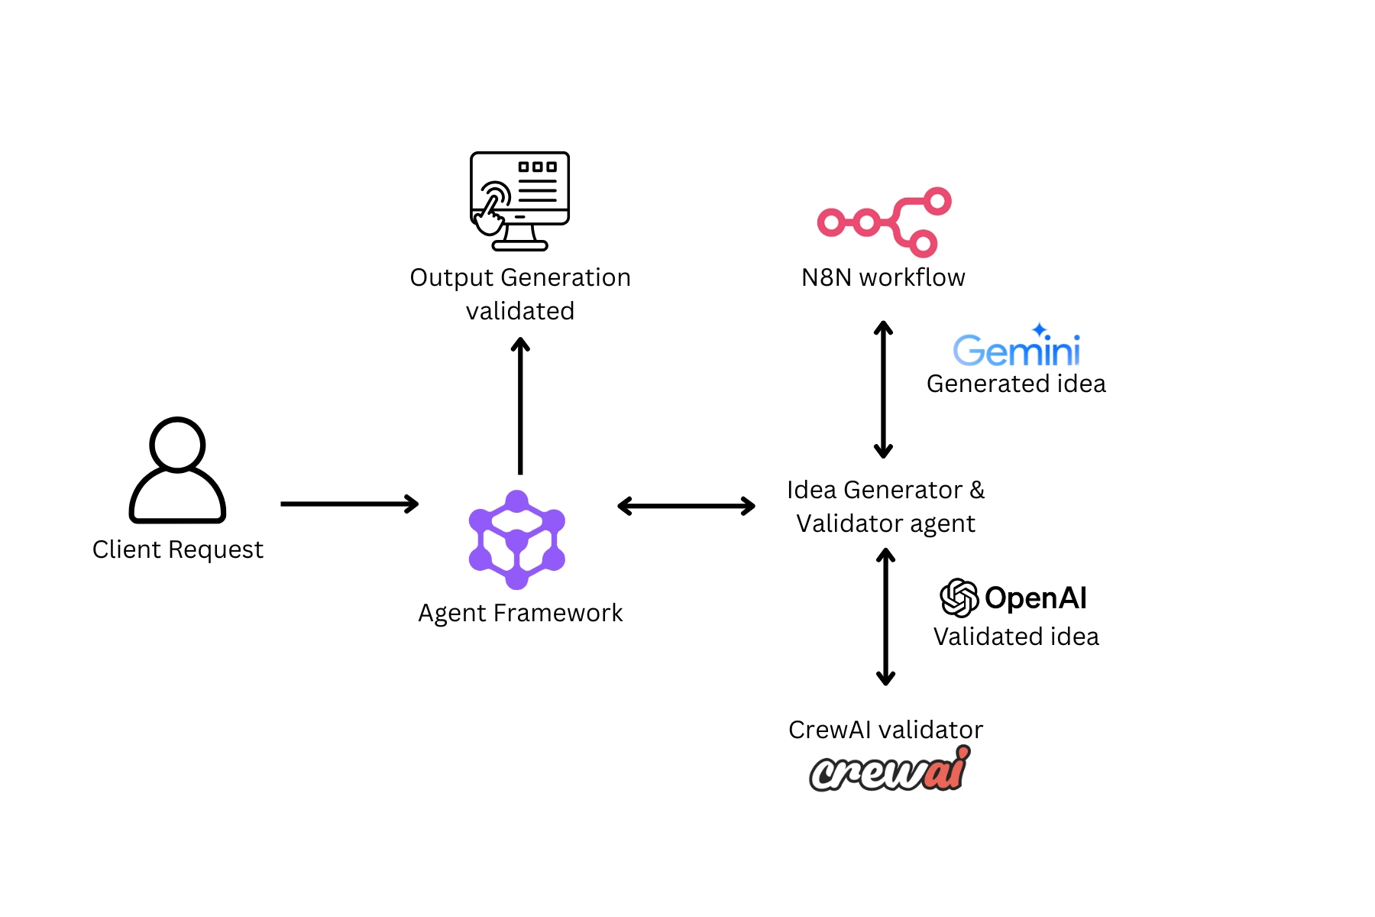
Key Features
- Automated Idea Generation : Uses an N8N webhook to generate business ideas from user prompts.
- Structured Validation : Evaluates ideas based on market demand, uniqueness, scalability, revenue potential, and risks.
- CrewAI Integration : Leverages CrewAI agents, tasks, and sequential process orchestration for smooth execution.
- Modular Design : Separates idea generation, validation, and workflow execution for maintainability and scalability.
- Runs via Agent Framework : Fully integrated with Microsoft Agent Framework for effortless Agentic communication.
Prerequisites
Before starting, make sure you have:
- Python 3.8 or higher.
- Pip for installing packages.
- Google API key for N8N setup.
- OpenAI model name and API key set in an environment variable.
Project Structure
Your project should look like this :
→ A2a inspector
→ remote_agent
→ __init__.py
→ agent.py
→ agent_executor.py
→ __main__.py
→ utils.py
→ .env
N8N Webhook Setup
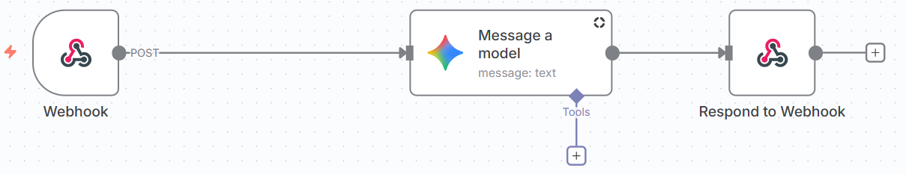
- Visit https://n8n.io/ and login or start a new trial(14 days).
- Start the workspace.
- Click the “start from scratch” option.
- Click on “ Add first step” and select “Webhook” from the dropdown. Setup the parameters as follows :

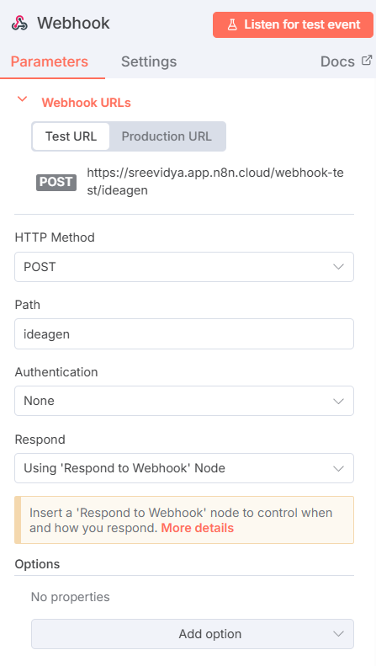
- Copy the Test URL from the parameters and add it in the .env file.
Eg : N8N_WEBHOOK_URL=https://sreevidya.app.n8n.cloud/webhook-test/ideagen

- Click on the + button on the right side of the webhook. Select AI → Google Gemini → Message a model. Set the parameters as follows : 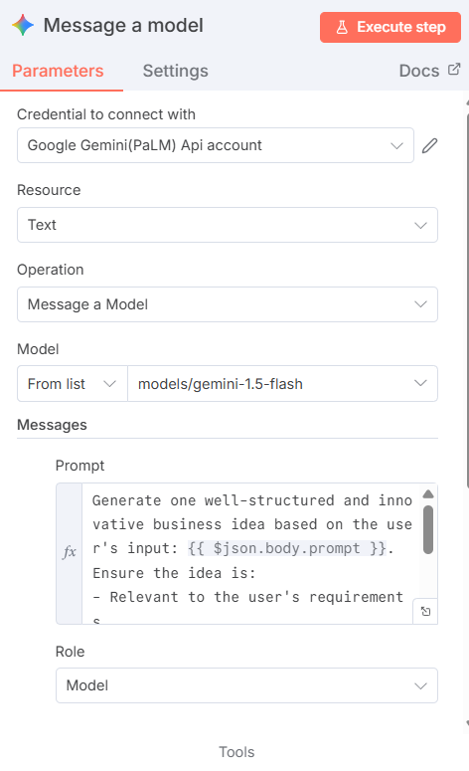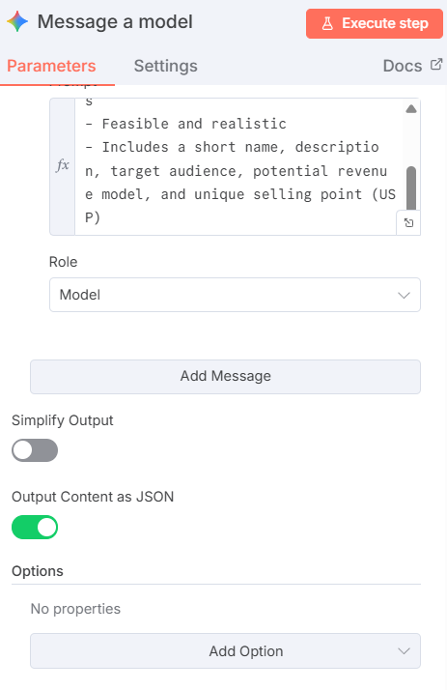
Prompt :
‘ ‘ ‘
Generate one well-structured and innovative business idea based on the user's input: {{ $json.body.prompt }}.
Ensure the idea is:
- Relevant to the user's requirements
- Feasible and realistic
- Includes a short name, description, target audience, potential revenue model, and unique selling point (USP)
‘ ‘ ‘
In settings, turn on Always output data option.
- Click on the + to add another node on the message a model node to add Respond to webhook node with the following parameters :
Response body : {{ $json.candidates[0].content.parts[0].text }}
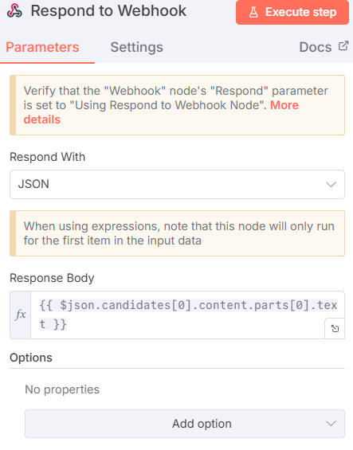
- Click “Execute workflow” to get the app up and running.
Remote agent (N8N + CrewAI) setup
- Business idea generator tool :
  - Acts as an external tool for AI agents.
  - Calls an N8N workflow to generate business ideas and returns the raw response from the webhook.
- BusinessIdeaAgent Class :
  - Encapsulates the idea validation workflow.
  - It combines agent logic, task definition and execution flow.
- Validator agent :
  - Act as a business idea validator agent.
  - Call a business idea generator tool and validate the idea and return the validation results.
Running the system
- Setup and activate the virtual environment.
- In the terminal run “ pip install -r requirements.txt” to install the requirements.
- Make sure the N8N workflow is executed (mandatory for each prompt).
- Make sure the .env file has the necessary values.
Eg :
MODEL=gpt-4o-mini
OPENAI_API_KEY=your_api_key
N8N_WEBHOOK_URL=https://yourapp.app.n8n.cloud/webhook-test/appname
A2A_AGENT_HOST=http://localhost:10011/ #URL of the remote agent

- From the parent directory, run
python -m remote_agent

- Now that the server is up and running, make sure N8N is Executing Workflow, and run agent_with_a2a.py in a new terminal.
#Execute the agent framework
python agent_with_a2a.py

- Now we can enter our prompt to the Agent framework.

