Study Scheduler agent using A2A

Overview
The calendar is generated using the Microsoft Agent Framework (MAF). When requested, the study-schedule agent creates a customized schedule based on user requirements while considering the calendar, through the Google ADK. In this setup, the A2A agent is integrated as an MAF agent.

A2A Integration Workflow
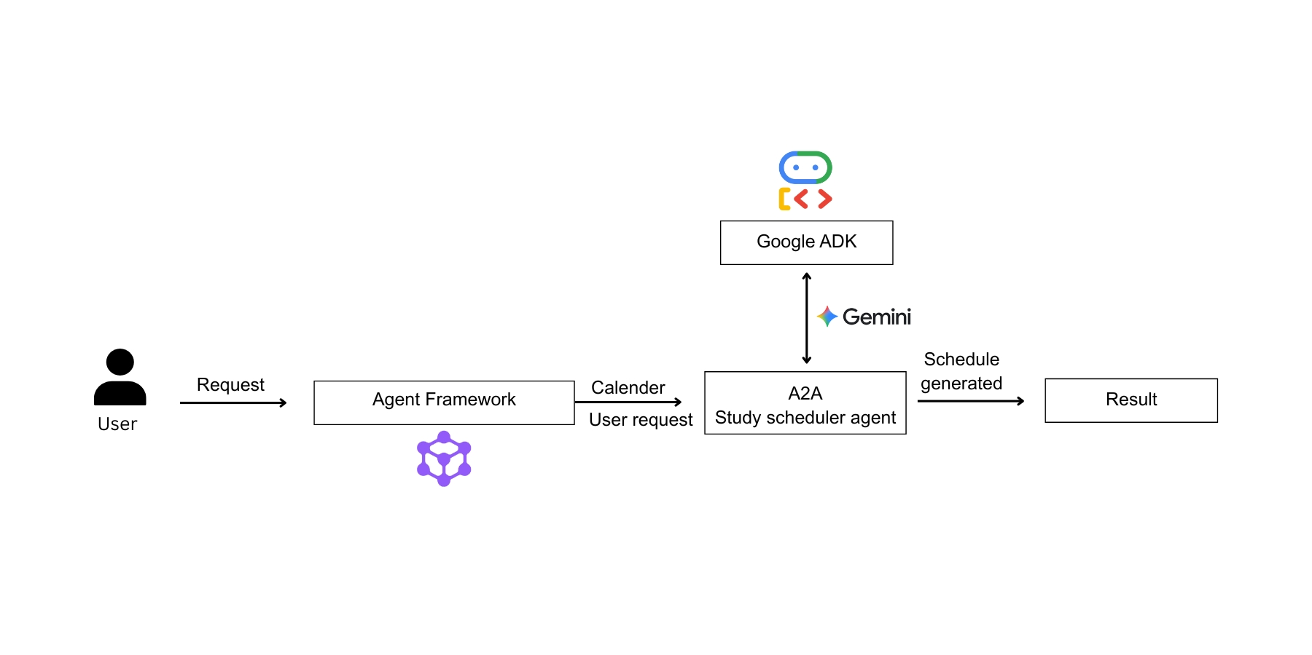
Key Features
- Google ADK
- Gemini API Key
- Agent framework
- A2A
Prerequisites
Before starting, make sure you have:
- Remote agent URL and Google API key set in environment variable.
  - A2A_AGENT_HOST="http://localhost:10001"
  - GOOGLE_API_KEY="Your API Key"

- Agent-framework installed.
  - pip install agent-framework
Project Structure
Your project should look like this :
→ A2A_remote_agent
→ agent.py
→ init.py
→ agent_executor.py
→ __main__.py
→ agent_with_a2a.py
→ .env
Agent framework setup and execution
- Setup and activate the virtual environment.
- In the terminal run “ pip install -r requirements.txt” to install the requirements.
- Make sure necessary environment variables are set in the .env file.
- From the parent directory, run
cd A2A_remote_agent

- Run the A2A remote server
python __main__.py

- Now the A2A server is up and running. Make sure the Remote agent server URL is given in the environment variable. Then redirect to parent directory and run agent_with_a2a.py
python agent_with_a2a.py

- Enter the input.
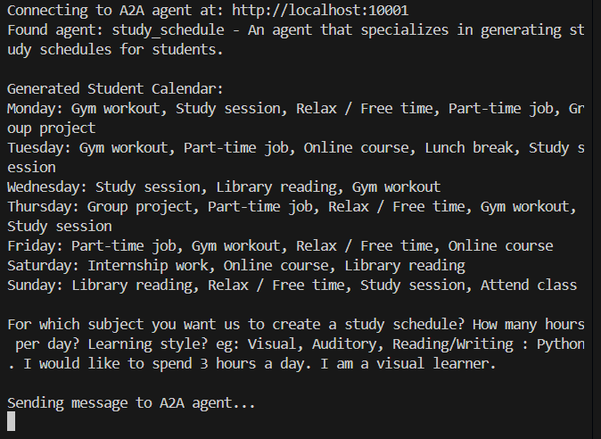
I want to learn Python and I would like to spend 3 hours a day. Also, I am a visual learner.

