AI Science Tutor

Overview
This implementation demonstrates streaming and non-streaming examples of AzureOpenAIResponsesClient with agent-framework where we are building an AI Science Tutor which explains complex science topics to students using analogies and examples.

Workflow
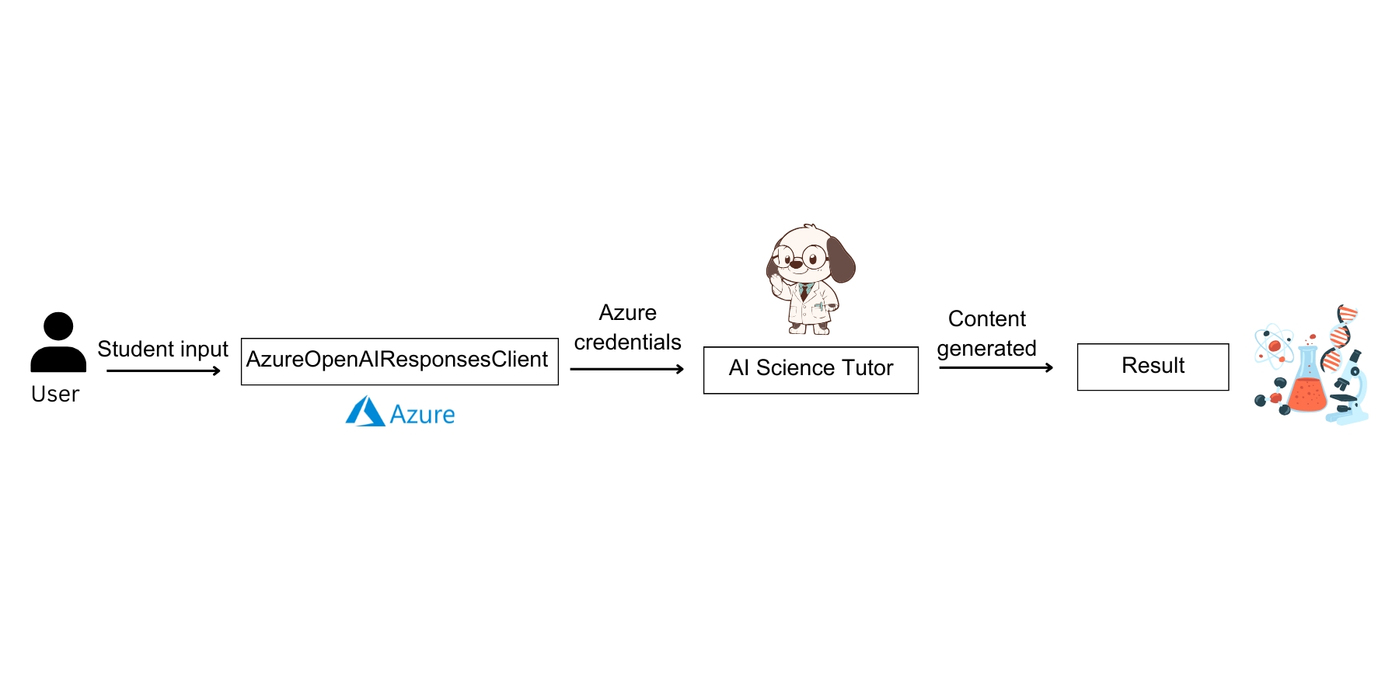
Key Features
- AzureOpenAIResponsesClient
- Azure credentials
Prerequisites
Before starting, make sure you have:
- Azure Credentials in env.
  - AZURE_AI_PROJECT_ENDPOINT ="your_endpoint"
  - AZURE_OPENAI_RESPONSES_DEPLOYMENT_NAME ="your_deployment_name"

- Agent-framework installed.
  - pip install agent-framework==1.0.0rc2

