Legacy Quiz
User Guide & Documentation

Celebrating 100 Years of God's Grace

Legacy Quiz Mobile App currently available only for Android users
All other users can access the Web App version on
https://smartorganiser.online/legacy_quiz
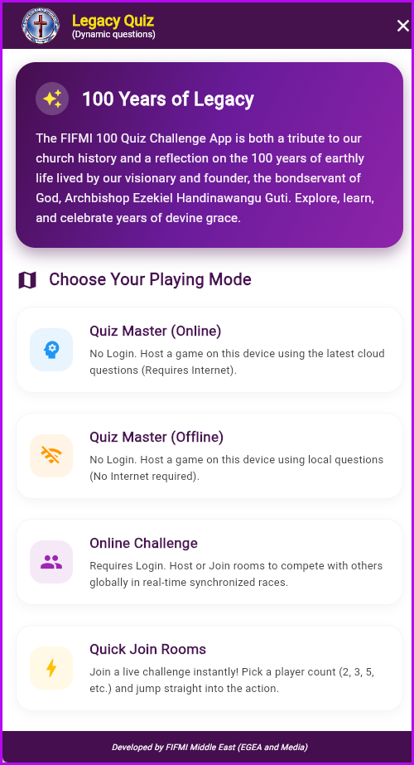 | INSTRUCTIONS  Guidance on playing Game versions, which include:  - Offline Single Player  - Offline Multiple Players  - Online Single Player  - Online Individual Challenge  - Online Team Challenge
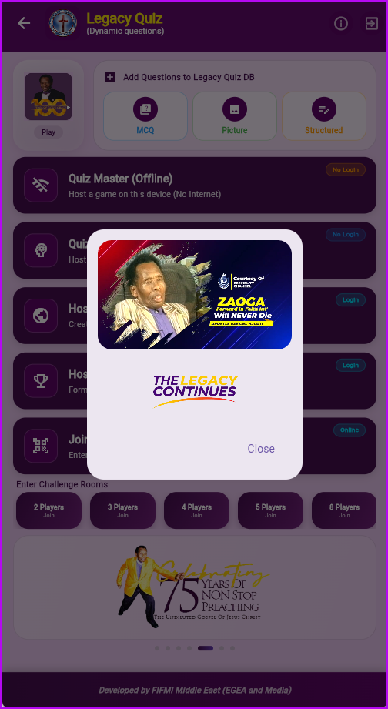 | LEGACY CONTINUES  Message from Archbishop Professor Ezekiel H. Guti.
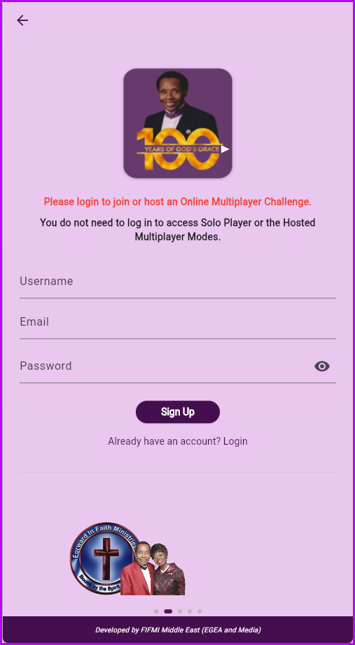 | REGISTRATION  Though registration is not required to play some of the Games, you will not be able to play others which require registration.  What Games Can I Play Without Registration?  - Offline (Quiz Master) – Single or Multiple Player hosting  - Online (Quiz Master) – Single or Multiple Player hosting  What I Cannot Do Without Registration?  - Can’t play or host Online Individual Games.  - Can’t play or host Online Team Games.  - Can’t add questions to the Questions Database.
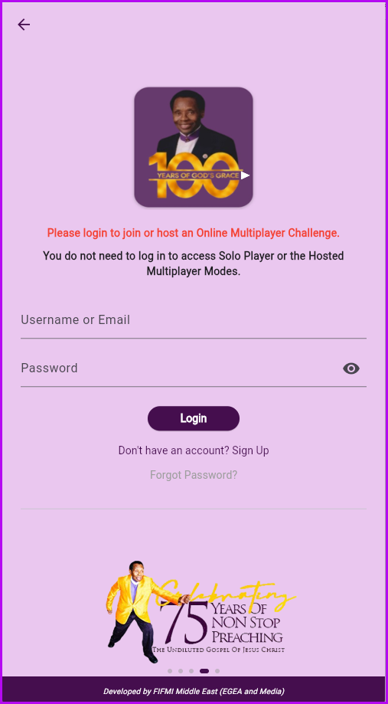 | LOG IN  If registered, log in to play any game and/or add questions to the question Database
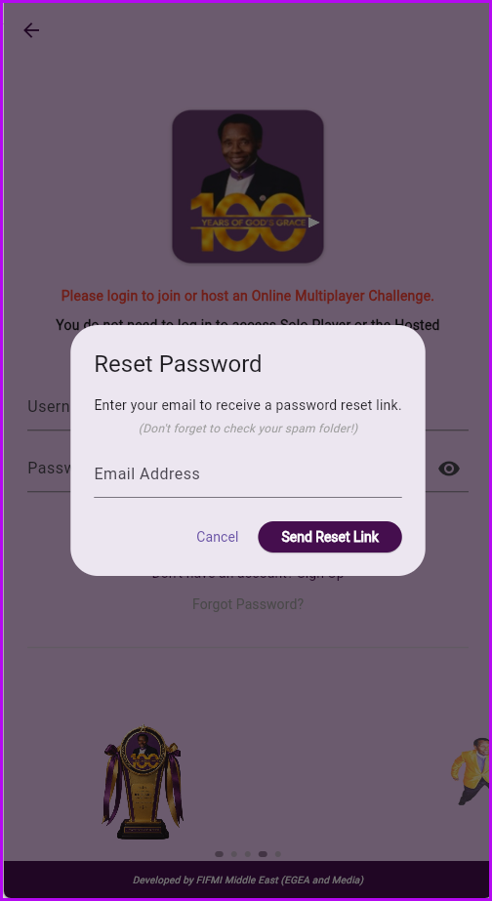 | FORGOT PASSWORD  Use the page if you have forgotten your password. Remember to check you spam folder for the link to reset your password.
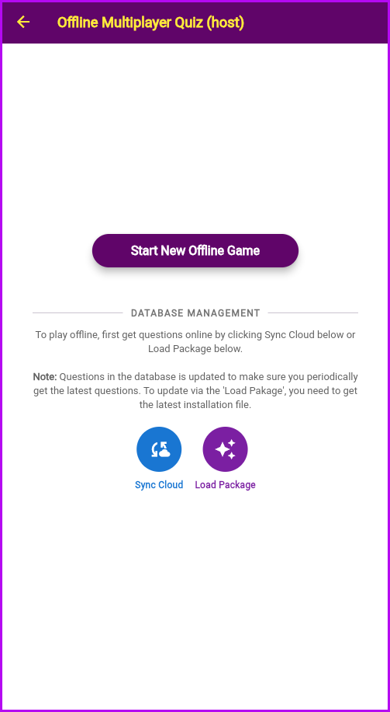 | OFFLINE GAME  Offline Game: Synchronize your local database by clicking any of the 2 buttons below. Once done you do not need internet connection to enjoy the game, just start the game.
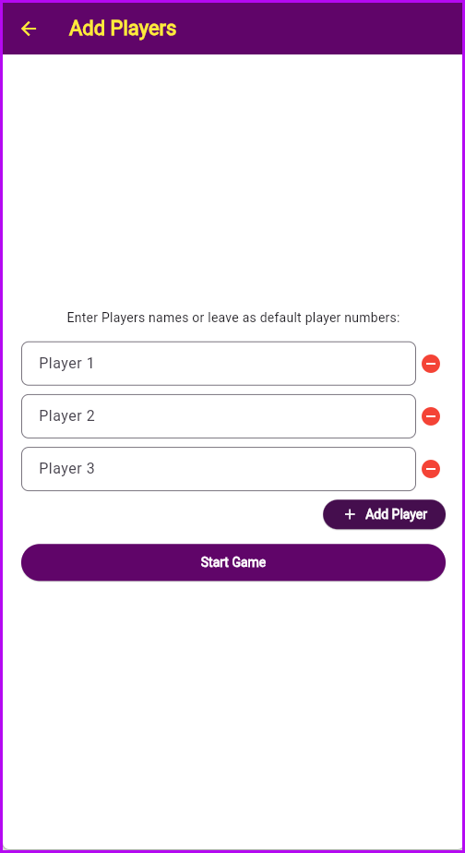 | ADDING PLAYERS AND RENAMING PLAYERS  Add number of players to play a Game Session.  Renaming players is optional.
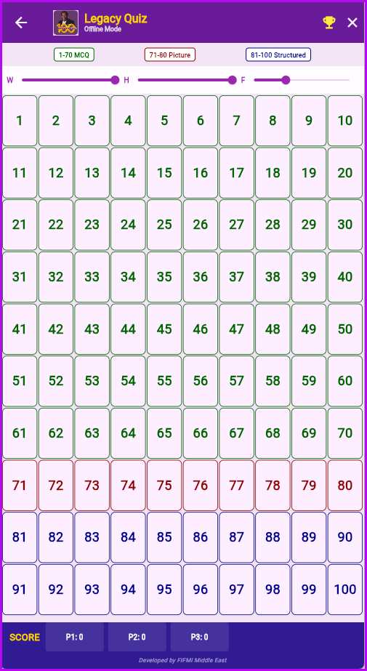 | OFFLINE QUIZ GRID  Quiz Grid consist of 100 randomly chosen question from the questions database, the questions will consist of;  - 1-70 Multiple Choice Questions  - 71 -80 Image Based Questions  - 81- 100 Open ended/Structures Questions.  Scoreboard is located at the bottom of the questions grid.  You can change the grid's width, height or font size by using the sliders above.  The trophy icon will give you a dynamic leaderboard status for your live game.  Note all other questions grid though they may appear different to this, the functionality is the same.
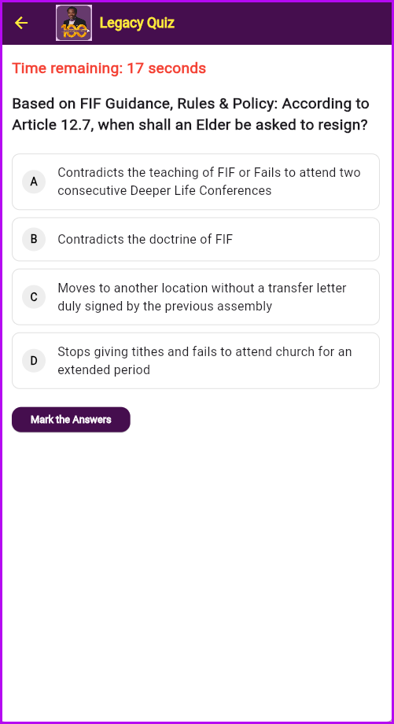 | MULITPLE CHOICE QUESTIONS  Multiple Choice: Select the correct answer from the options provided. Immediate feedback will be shown in solo mode.
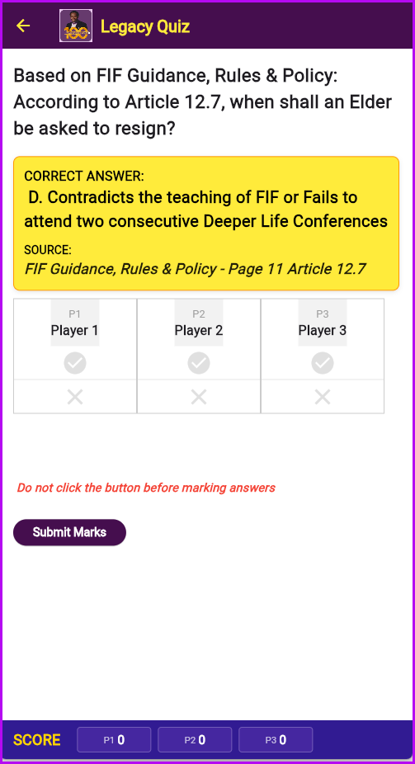 | MARKING ANSWERS  Correct answer and source of the answer is highlighted for your further reading.  If Managed by Quiz Master or if marking requires manual marking, use the grid below to mark participants' answers.
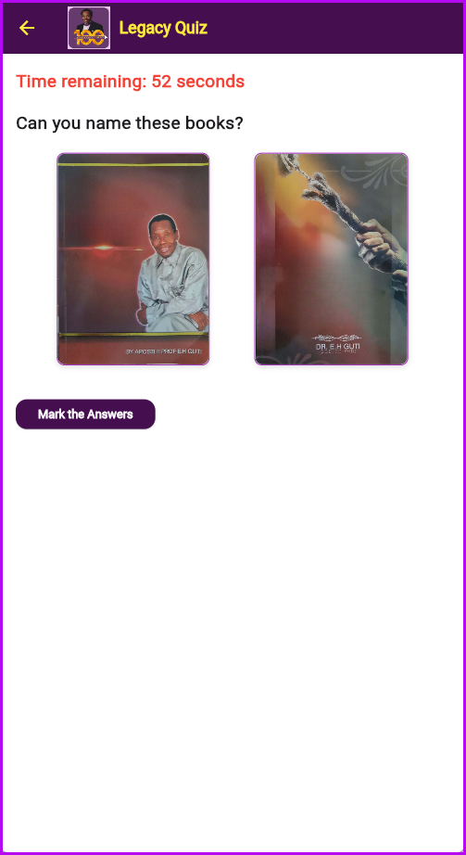 | IMAGE BASED QUESTIONS  Picture Questions: Identify key historical figures, events, or artifacts. These can include book images from our official library.  Image Based questions are marked manually as documented above.
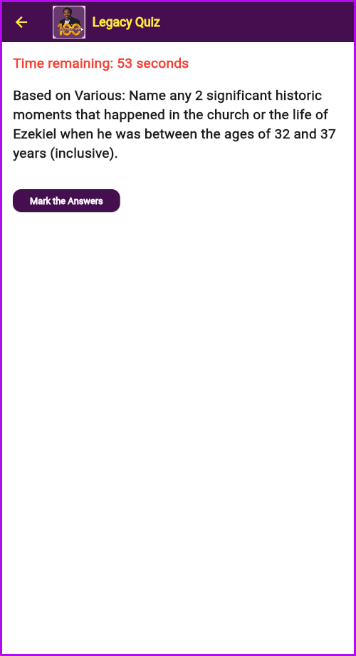 | OPEN OR STRUCTURED QUESTIONS  Answer open-ended questions based on deep study of the Legacy materials.  Open Ended or Structured Questions are marked manually as documented above.
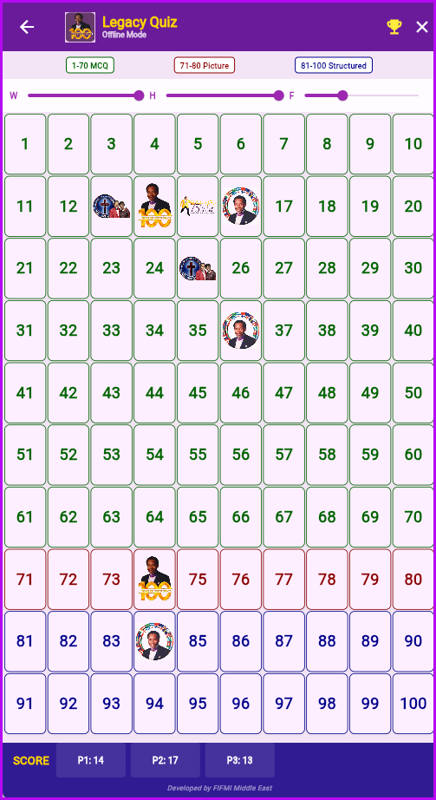 | QUESTION SELECTION AND PROGRESSION  Questions are randomly selected from the grid by the player or Quiz Master.  All players in a quiz session will answer the same questions.  Questions that would been attempted will not be available for selections with the same quiz session, the flip side of the card of such questions will be shown on the grid instead.
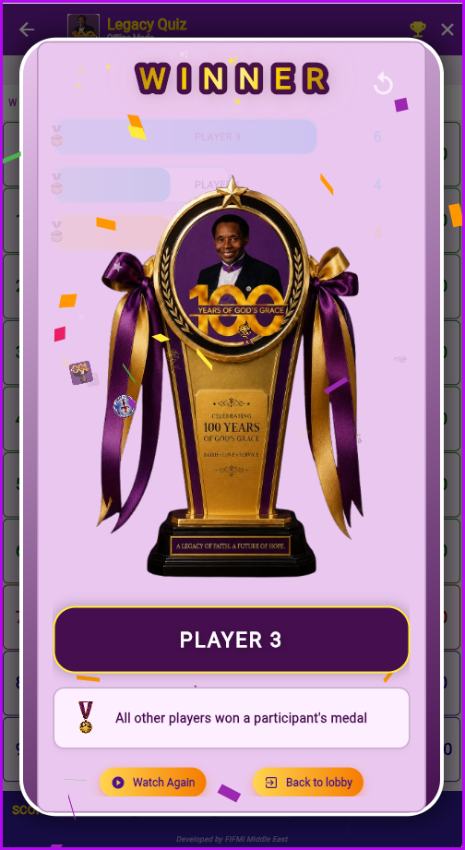 | WINNER REVEAL  At the end of each game session a dynamic bar chart is displayed showing participants’ cumulative scores.  The bars are orders with the highest point bar at the top.  After the animation of the bars, the trophy presentation and reveal of the Winner(s) is done.  The animation can be replayed whistly the session is still active.
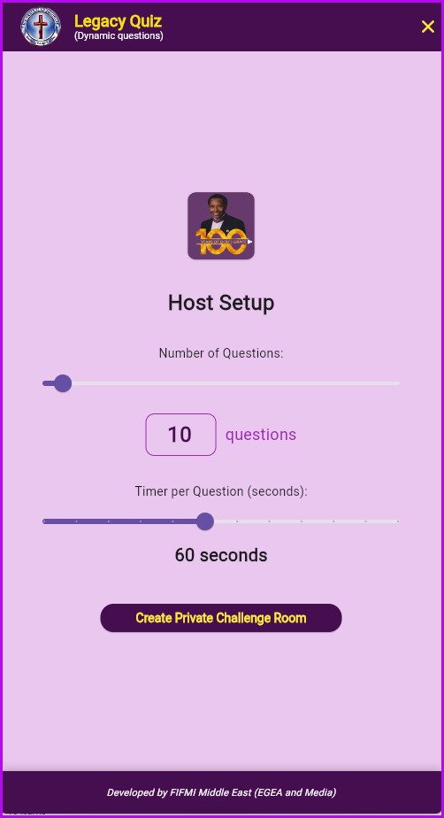 | HOSTING AN INDIVIDUAL’S CHALLENGE  This is an online challenge which can be created by any registered person. Meaning anyone who is registered can host a game!  Host set up the game by selecting number of questions the game will be and the time participants will have to answer the questions.  Once this is set you click create a “Private Challenge” – the game is private only people with the session code can join.
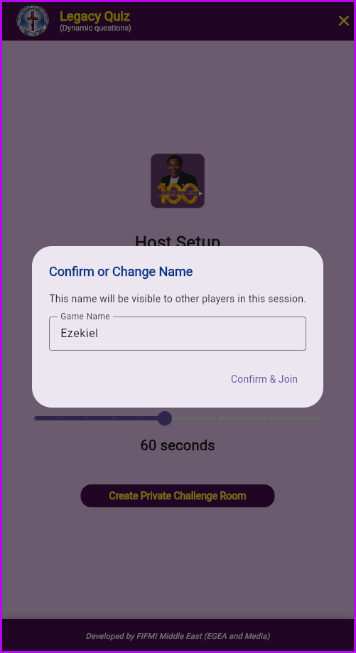 | HOSTING AN INDIVIDUAL’S CHALLENGE – Game Username  You can confirm the name you want to use for the game, the default is your log in username but you can change it and use a different name for the game.
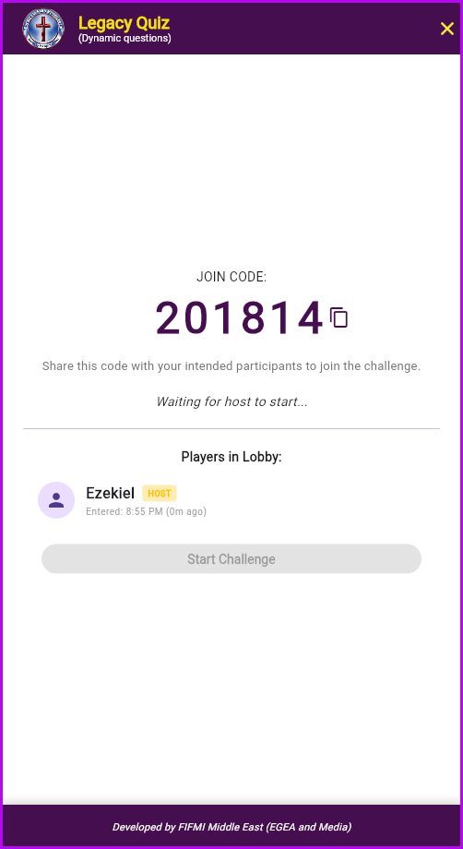 | HOSTING AN INDIVIDUAL’S CHALLENGE – Game Code  A game session code is generated; send this code to the people you will want to join the quiz.  If one has the code, they have to click “Join A Challenge” and insert the game code.  From here on, everything (playing the game) follows the same online challenge as documented above.  Players will receive the same questions as selected by the Host.

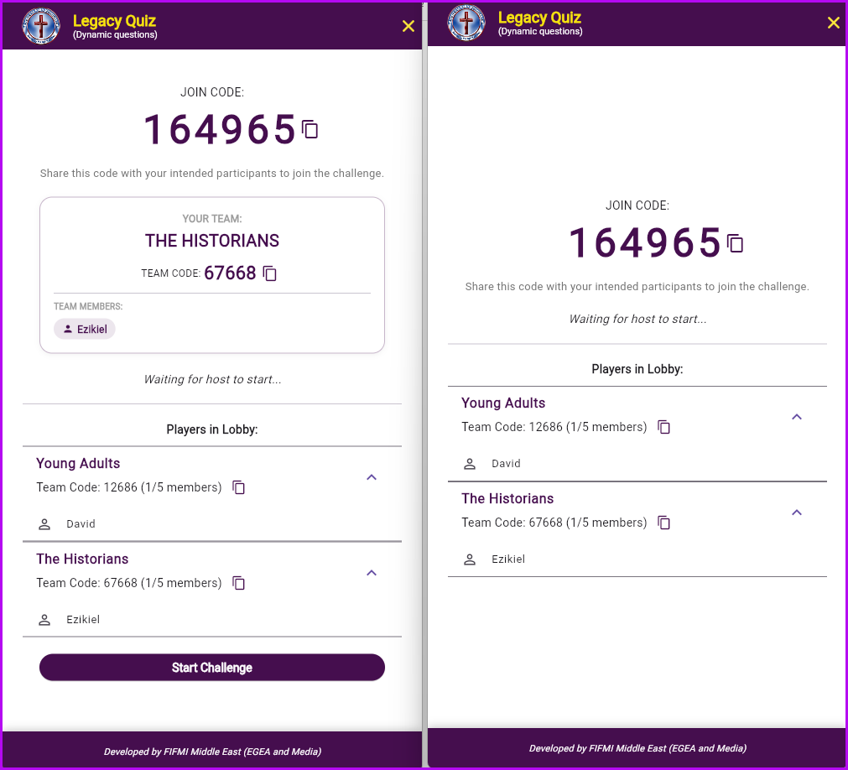 | TEAM CHALLENGE  The host create session the same way as individual challenge with the additional step of creating team names.  Recipients of the code can either create their own team to compete or join an existing one.  Maximum Team members is five (5)  Individual scores in a team are aggregated and winner is determined on the Teams’ aggregate scores
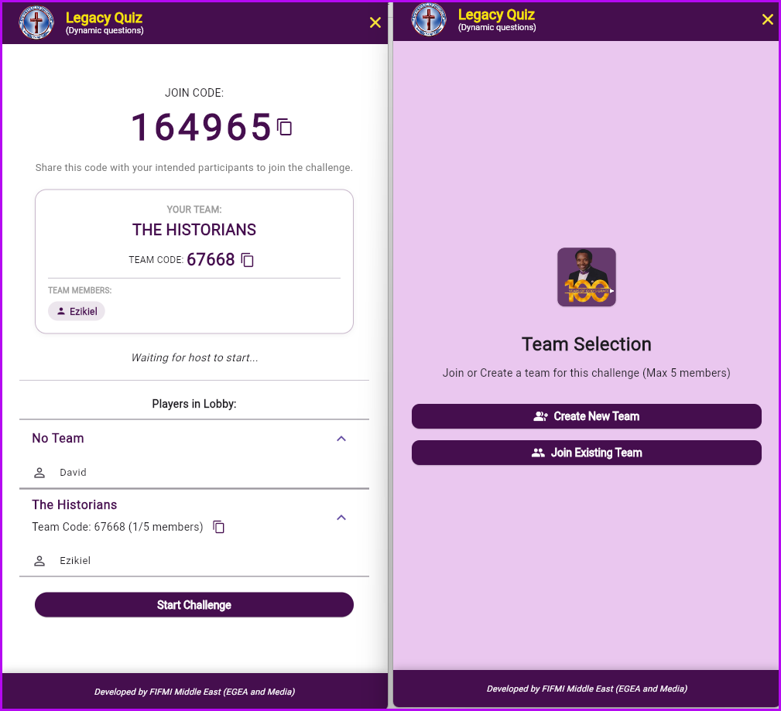 | We can have cell group challenges, ministry challenges, Assembly challenges or which ever way you want to play it.  MOI BOT  Member 1 Member 2 Member 3 Member 4 Member 5 Member 1 Member 2 Member 3 Member 4 Member 5  To join a Team, one needs both the session code (game code) and Team Code. – which can be provided by the Host or Team Leader (Team Host)

 | TEAM CHALLENGE  The host create session the same way as individual challenge with the additional step of creating team names.  Recipients of the code can either create their own team to compete or join an existing one.  Maximum Team members is five (5)  Individual scores in a team are aggregated and winner is determined on the Teams’ aggregate scores
 | We can have cell group challenges, ministry challenges, Assembly challenges or which ever way you want to play it.  MOI BOT  Member 1 Member 2 Member 3 Member 4 Member 5 Member 1 Member 2 Member 3 Member 4 Member 5  To join a Team, one needs both the session code (game code) and Team Code. – which can be provided by the Host or Team Leader (Team Host)

.

